Structure of Compounds

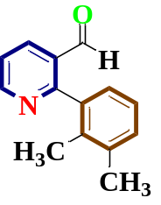

Figure S1: Uv-Visible spectrum of 2-(2, 3-dimethylphenyl) nicotinaldehyde.

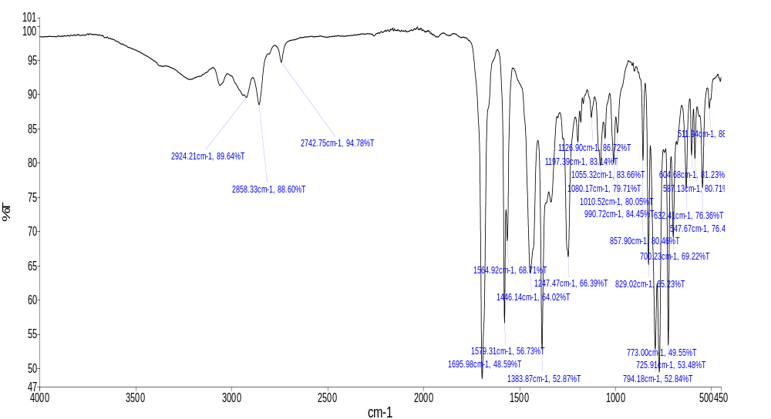
Figure S2: FTIR of 2-(2, 3-dimethylphenyl) nicotinaldehyde.

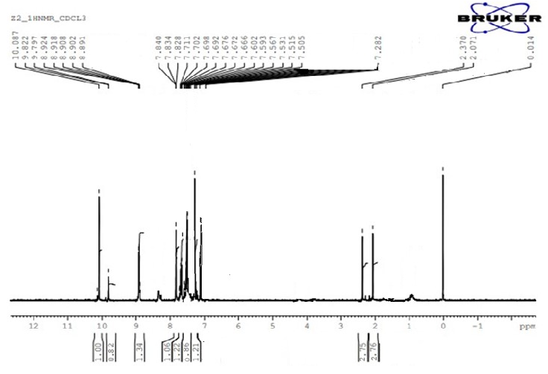

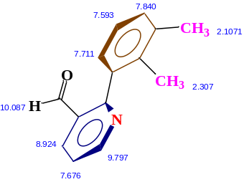

Figure S3: ¹HNMR of 2-(2,3-dimethylphenyl) nicotinaldehyde (M1)

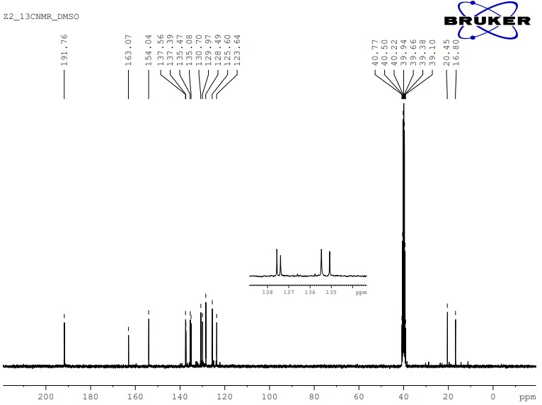

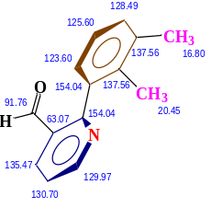

Figure S4: ¹³CNMR of 2-(2, 3-dimethylphenyl) nicotinaldehyde.

Figure S5; Uv-Visible spectrum of 2-(3-bromophenyl) nicotinaldehyde(M2)

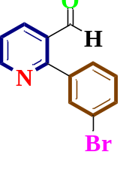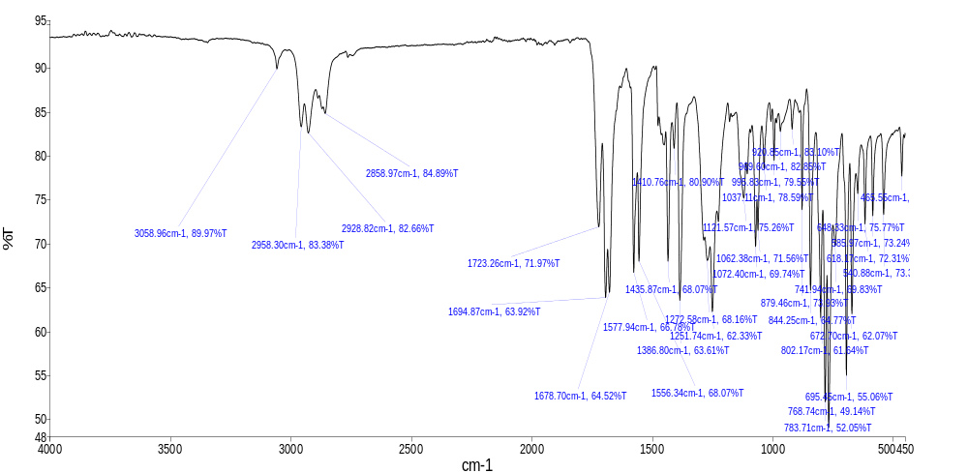
Figure S6: FTIR of 2-(3-bromophenyl) nicotinaldehyde (M2).

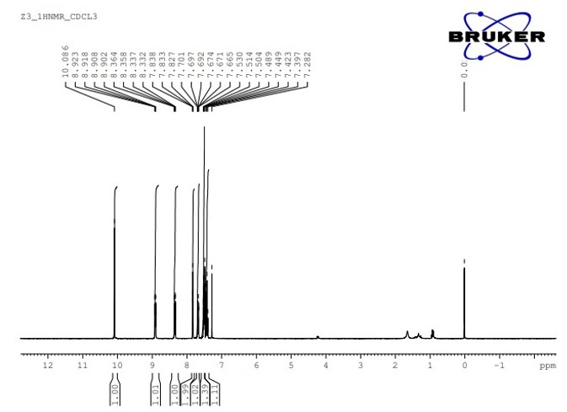

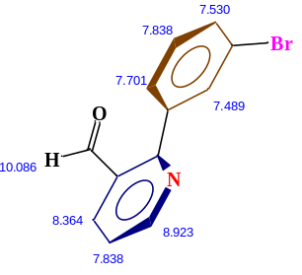

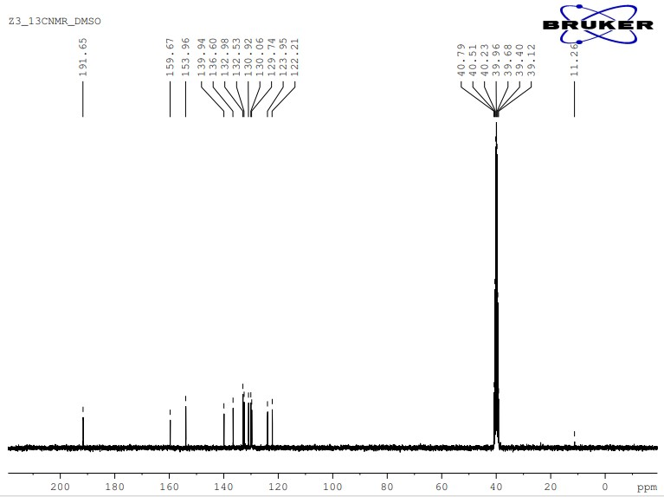
Figure S7: ¹HNMR of 2-(3-bromophenyl) nicotinaldehyde(M2).

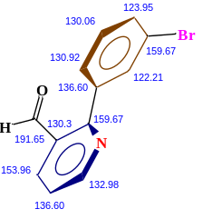

Figure S8: ¹³CNMR of 2-(3-bromophenyl) nicotinaldehyde(M2).

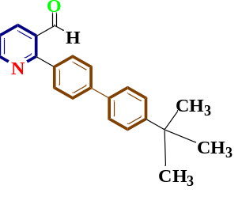
Figure S9. Uv-Visible spectra of 2-(4-(tert-butyl)-[1, 1-biphenyl]-4-yl) nicotinaldehyde

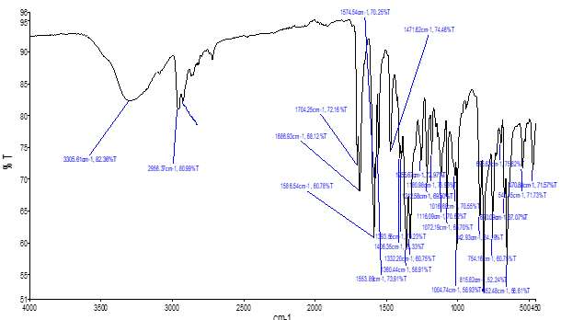
Figure S10. FTIR of 2-(4-(tert-butyl)-[1, 1-biphenyl]-4-yl) nicotinaldehyde

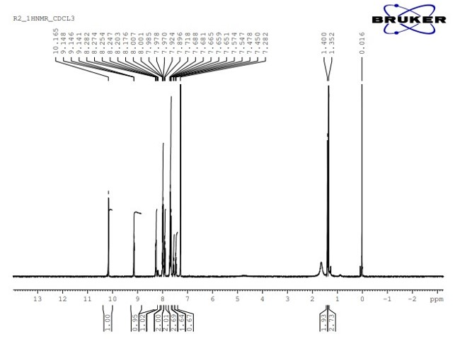

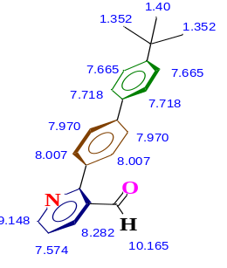

Figure S11: ¹HNMR of 2-(4-(tert-butyl)-[1, 1-biphenyl]-4-yl) nicotinaldehyde
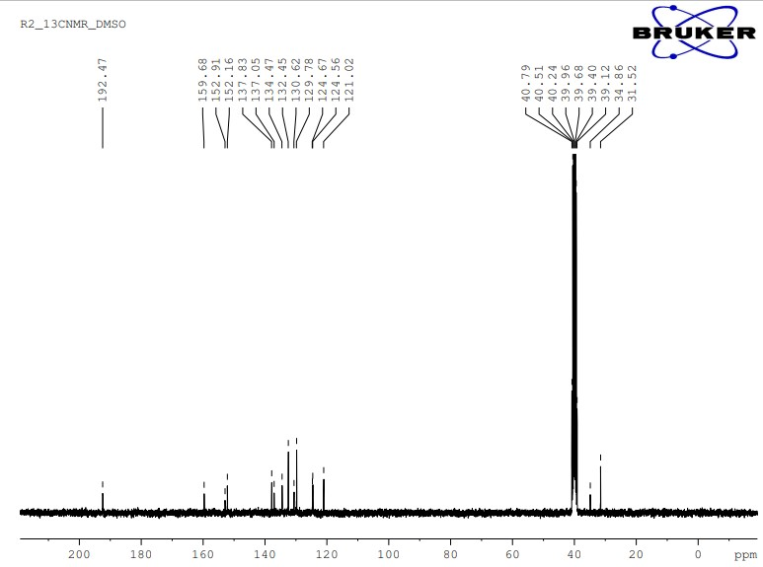

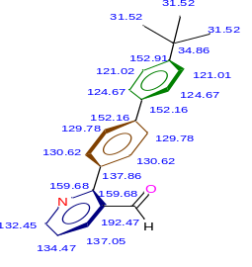

Figure S12: ¹³CNMR of 2-(4-(tert-butyl)-[1, 1-biphenyl]-4-yl) nicotinaldehyde.

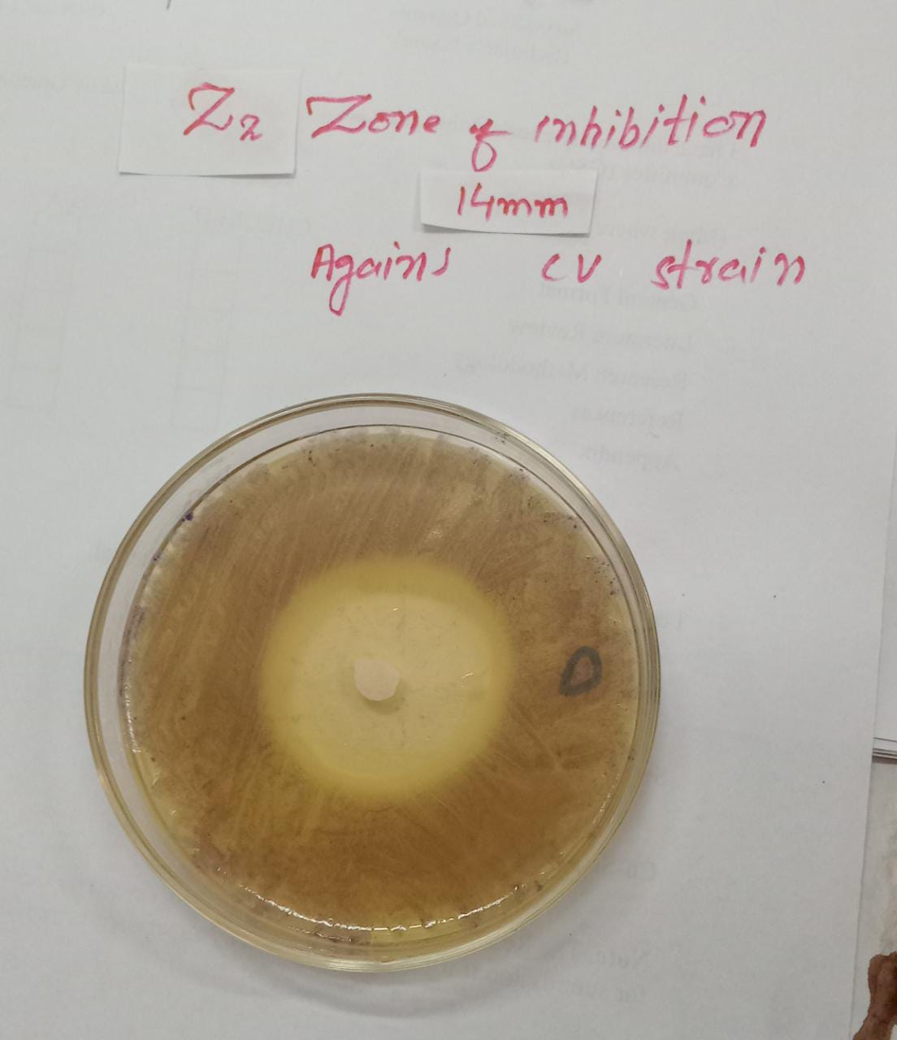
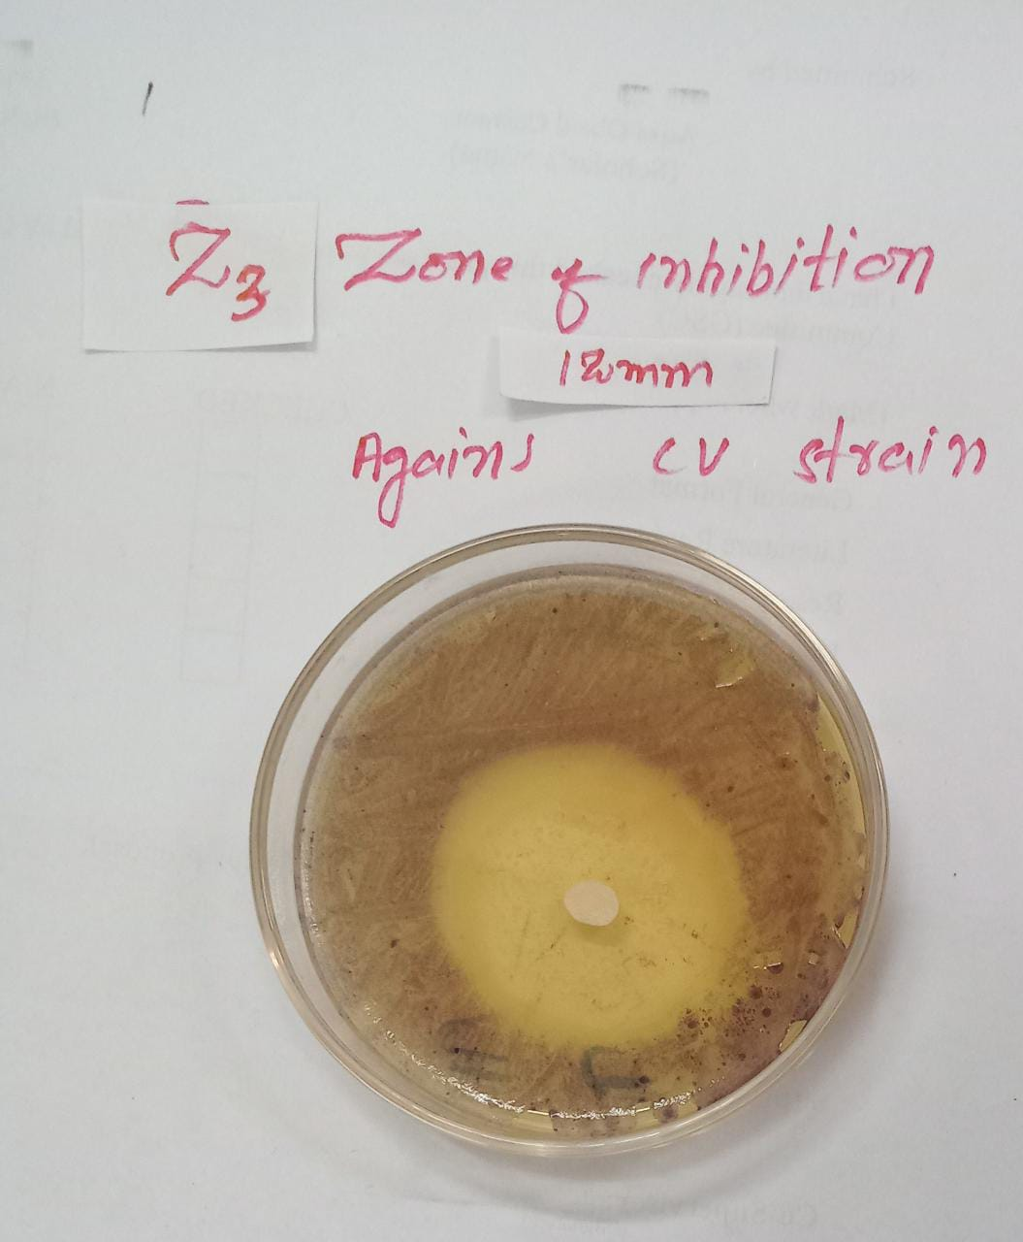
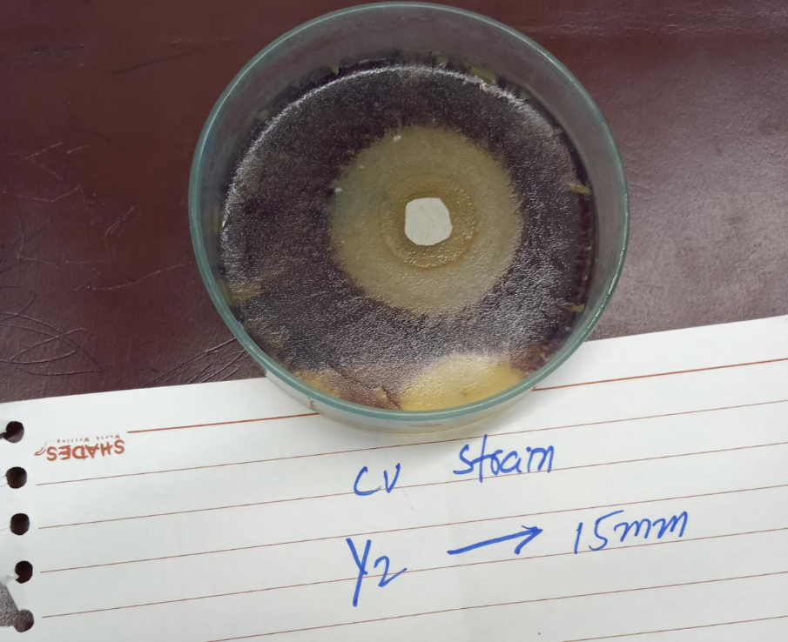
BrPN
DMPN
R2

tBuBPN

Figure S13: Antiquorum sensing activity of structural analogues

