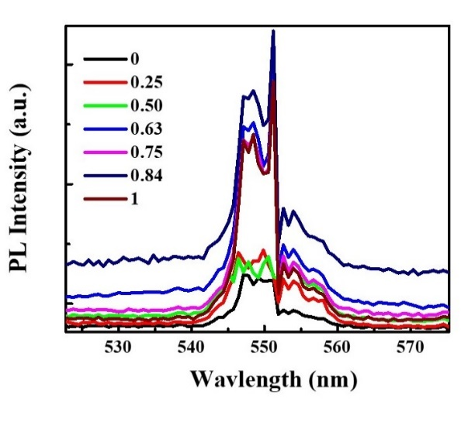
Figure 1SU: The PL peak of the BaTiO₃ at 350 nm.

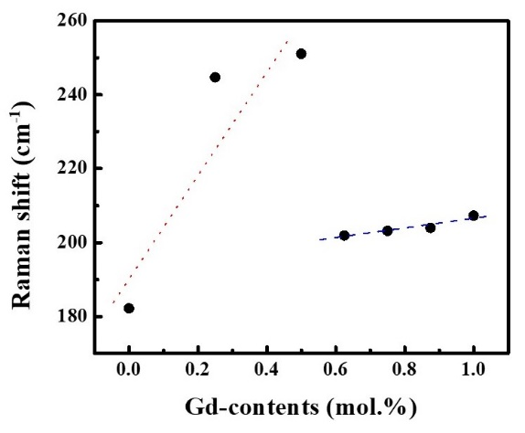
Figure 2SU: The Raman shift as funcation of the Gd-contents.

