Figure S1: Density plot to validate the overlap assumption underlying PSM

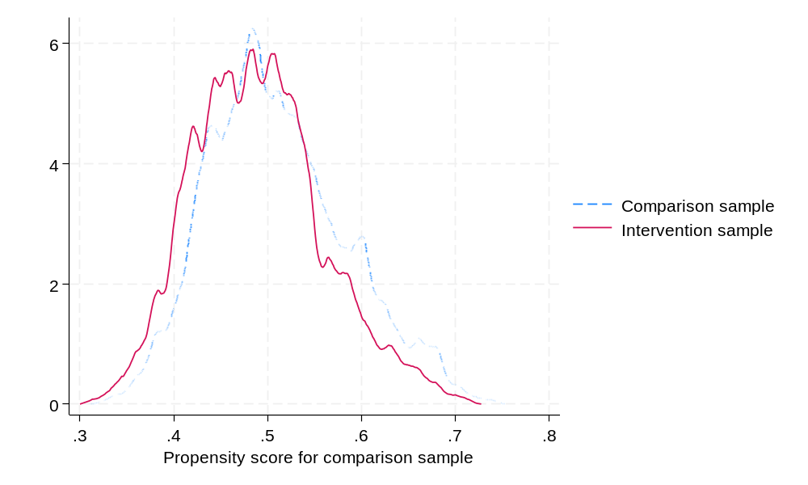

Figure S2: Box plot to validate the propensity score balance

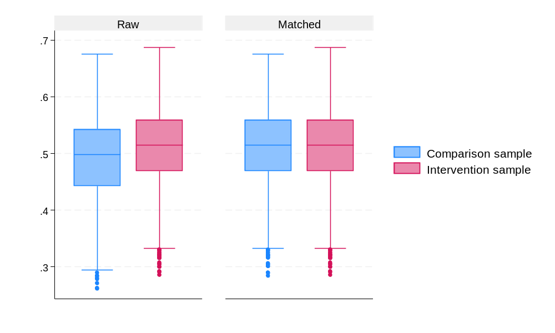

Figure S3: Box plot to validate the propensity score balance

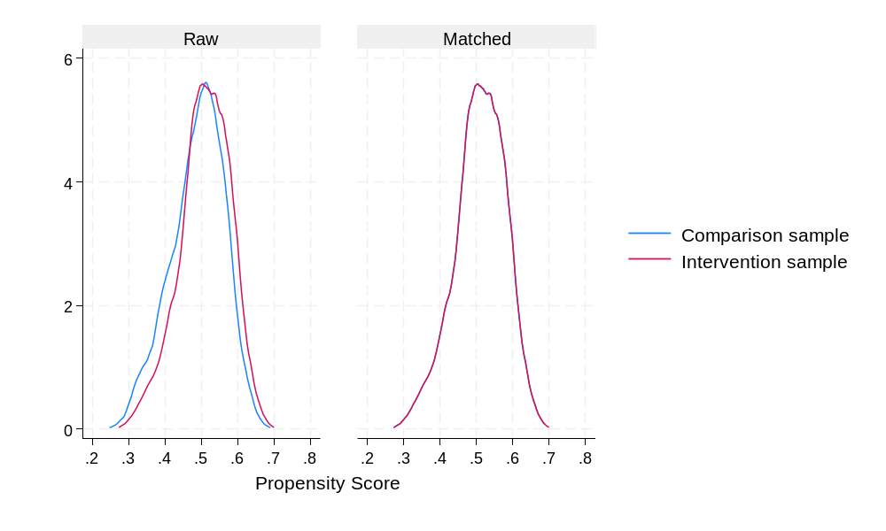

Table S1: Background characteristics of the sample from comparison and intervention areas

Background Characteristics | Intervention |  | Comparison
Background Characteristics | N | % | N | %
Religion*
Hindu | 1752 | 80.0 | 1592 | 72.6
Non-Hindu | 438 | 20.0 | 601 | 27.4
Social group*
SC/ST | 447 | 20.4 | 354 | 16.1
OBC | 1514 | 69.1 | 1487 | 67.8
Others | 229 | 10.5 | 352 | 16.1
Age (in years)
less than 21 years | 462 | 21.1 | 438 | 20.0
21 to 30 years | 623 | 28.5 | 635 | 29.0
31 to 40 years | 451 | 20.6 | 458 | 20.9
41 to 50 years | 288 | 13.1 | 281 | 12.8
More than 50 years | 366 | 16.7 | 381 | 17.4
Occupation
Agri based | 519 | 23.7 | 530 | 24.2
Non-Agri based | 1279 | 58.4 | 1237 | 56.4
Salaried | 369 | 16.9 | 407 | 18.6
Unemployed | 11 | 0.6 | 11 | 0.6
Other | 12 | 0.6 | 8 | 0.4
Type of Family
Joint | 1239 | 56.6 | 1274 | 58.1
Nuclear | 951 | 43.4 | 919 | 41.9
Toilet accessibility
Yes | 1137 | 51.9 | 1222 | 55.7
No | 1053 | 48.1 | 971 | 44.3
Sex
Male | 629 | 28.7 | 645 | 29.4
Female | 1561 | 71.3 | 1548 | 70.6
Education
No formal schooling | 257 | 11.7 | 209 | 9.5
Up to Primary | 229 | 10.5 | 227 | 10.4
More than primary | 1032 | 47.1 | 1005 | 45.8
Don't know | 672 | 30.7 | 752 | 34.3
Mobile phone accessibility
Yes | 1243 | 56.8 | 1280 | 58.4
No | 947 | 43.2 | 913 | 41.6
Vulnerable groups
Yes | 438 | 20 | 438 | 20
No | 1752 | 80 | 1755 | 80
COVID Certificate
Yes | 1323 | 60.4 | 909 | 41.5
No | 867 | 39.6 | 1284 | 58.6
Lactating Women
Yes | 144 | 13.2 | 120 | 11.0
No | 950 | 86.8 | 974 | 89.0
Differently abled
Yes | 75 | 3.4 | 62 | 2.8
No | 2115 | 96.6 | 2131 | 97.2
Chronically ill
Yes | 242 | 11.1 | 276 | 12.6
No | 1948 | 88.9 | 1917 | 87.4
Ration card in the Household
Yes | 1398 | 63.8 | 1384 | 63.1
No | 792 | 36.2 | 809 | 36.9
MNREGS employment card
Yes | 538 | 24.6 | 539 | 24.6
No | 1652 | 75.4 | 1654 | 75.4
Health Insurance Card
Yes | 247 | 11.3 | 261 | 11.9
No | 1943 | 88.7 | 1932 | 88.1
Wealth Quintile
Poorest | 488 | 22.3 | 392 | 17.9
Poorer | 433 | 19.8 | 441 | 20.1
Middle | 452 | 20.6 | 425 | 19.4
Richer | 430 | 19.6 | 446 | 20.3
Richest | 387 | 17.7 | 489 | 22.3

Table S2: Association between demographic characteristics and uptake of two or more doses of COVID-19 vaccine

Background Characteristics | Intervention |  | Comparison |  | p-value
Background Characteristics | N | % | N | %
Religion*
Hindu | 1496 | 82.3 | 1225 | 75.3
Non-Hindu | 321 | 17.7 | 401 | 24.7 | P<0.05
Social group*
SC/ST | 379 | 20.9 | 278 | 17.1
OBC | 1257 | 69.2 | 1088 | 66.9
Others | 181 | 10.0 | 260 | 16.0 | P<0.05
Age (in years)
less than 21 years | 304 | 16.7 | 203 | 12.5
21 to 30 years | 501 | 27.6 | 466 | 28.7
31 to 40 years | 425 | 23.4 | 391 | 24.1
41 to 50 years | 268 | 14.8 | 252 | 15.5
More than 50 years | 319 | 17.6 | 314 | 19.3 | P<0.05
Occupation
Agri based | 446 | 24.6 | 405 | 24.9
Non-Agri based | 1049 | 57.7 | 905 | 55.7
Salaried | 307 | 16.9 | 304 | 18.7
Unemployed | 5 | 0.3 | 7 | 0.4
Other | 10 | 0.6 | 5 | 0.3
Type of Family
Joint | 1010 | 55.6 | 929 | 57.3
Nuclear | 807 | 44.4 | 697 | 42.8
Toilet accessibility
Yes | 938 | 51.6 | 910 | 56.0
No | 879 | 48.4 | 716 | 44.0 | P<0.05
Sex
Male | 525 | 28.9 | 467 | 28.7
Female | 1292 | 71.1 | 1159 | 71.3
Education
No formal schooling | 214 | 11.8 | 164 | 10.1
Up to Primary | 192 | 10.6 | 171 | 10.5
More than primary | 818 | 45.0 | 697 | 42.9
Don't know | 593 | 32.6 | 594 | 36.5
Mobile phone accessibility
Yes | 1046 | 57.6 | 965 | 59.4
No | 771 | 42.4 | 661 | 40.6
Vulnerable groups
Yes | 328 | 18.1 | 287 | 17.7
No | 1489 | 81.9 | 1339 | 82.3
COVID Certificate
Yes | 1449 | 63.2 | 723 | 44.5
No | 668 | 36.8 | 903 | 55.5 | P<0.05
Lactating Women
Yes | 80 | 8.7 | 48 | 5.7
No | 840 | 91.3 | 793 | 94.3 | P<0.05
Differently abled
Yes | 62 | 3.4 | 41 | 2.5
No | 1755 | 96.6 | 1585 | 97.5
Chronically ill
Yes | 199 | 10.9 | 207 | 12.7
No | 1618 | 89.1 | 1419 | 87.3
Ration card in the Household
Yes | 1165 | 64.12 | 1037 | 63.8
No | 652 | 35.9 | 589 | 36.2
MNREGS employment card
Yes | 461 | 25.4 | 422 | 26.0
No | 1356 | 74.6 | 1204 | 74.0
Health Insurance Card
Yes | 211 | 11.6 | 208 | 12.8
No | 1606 | 88.4 | 1418 | 87.2
Wealth Quintile
Poorest | 405 | 22.3 | 272 | 16.7
Poorer | 360 | 19.8 | 336 | 20.7
Middle | 379 | 20.9 | 314 | 19.3
Richer | 354 | 19.5 | 335 | 20.6
Richest | 319 | 17.6 | 369 | 22.7 | P<0.05

Table S3: Standardized differences and variance ratios for raw and matched sample

 | Standardized Differences |  | Variance Ratios
 | Raw | Matched | Raw | Matched
Age (in years)
21 to 30 years | -0.011 | -0.031 | 0.989 | 0.972
31 to 40 years | -0.007 | -0.044 | 0.990 | 0.940
41 to 50 years | 0.010 | 0.081 | 1.022 | 1.210
More than 50 years | -0.018 | 0.002 | 0.970 | 1.004
Education
Up to Primary | 0.003 | 0.062 | 1.009 | 1.187
More than primary | 0.026 | -0.044 | 1.004 | 0.997
Don’t know | -0.077 | -0.011 | 0.944 | 0.991
Sex
Female | 0.015 | -0.052 | 0.986 | 1.054
Wealth Index Quintile
Second | -0.008 | -0.008 | 0.987 | 0.988
Middle | 0.031 | 0.017 | 1.048 | 1.025
Fourth | -0.018 | 0.002 | 0.974 | 1.004
Highest | -0.116 | -0.042 | 0.840 | 0.934
Religion
Hindu | 0.175 | -0.042 | 0.804 | 1.068
Social group
OBC | 0.029 | -0.050 | 0.978 | 1.045
Others | -0.166 | 0.007 | 0.695 | 1.020
Mobile phone accessibility
Yes | -0.033 | -0.042 | 1.010 | 1.013
Lactating Women
Yes | 0.046 | -0.015 | 1.188 | 0.951
Differently abled person
Yes | 0.034 | 0.021 | 1.204 | 1.115
Patient with chronic illness
Yes | -0.048 | 0.046 | 0.893 | 1.129
Any health insurance
Yes | -0.019 | 0.034 | 0.954 | 1.090
Employment
Agriculture | -0.011 | 0.025 | 0.987 | 1.032
Others | 0.044 | -0.047 | 0.985 | 1.020

Table S4: Household assets used for the construction of wealth quintile using PCA

Asset item | N | % | SD | Min | Max
Electricity | 4,383 | 98.8% | 0.109 | 0 | 1
Mattress | 4,383 | 99.1% | 0.096 | 0 | 1
Pressure cooker | 4,383 | 40.6% | 0.491 | 0 | 1
Chair | 4,383 | 75.1% | 0.433 | 0 | 1
Cot/Bed | 4,383 | 98.4% | 0.125 | 0 | 1
Table | 4,383 | 51.7% | 0.500 | 0 | 1
Electric fan | 4,383 | 94.7% | 0.224 | 0 | 1
Radio/transistor | 4,383 | 1.5% | 0.123 | 0 | 1
Black & white television | 4,383 | 2.3% | 0.149 | 0 | 1
Colour television | 4,383 | 22.3% | 0.416 | 0 | 1
Sewing machine | 4,383 | 23.4% | 0.423 | 0 | 1
Mobile telephone | 4,383 | 97.1% | 0.168 | 0 | 1
Landline telephone | 4,383 | 0.1% | 0.037 | 0 | 1
Internet | 4,383 | 67.9% | 0.467 | 0 | 1
Computer | 4,383 | 2.5% | 0.155 | 0 | 1
Refrigerator | 4,383 | 9.7% | 0.296 | 0 | 1
Air conditioner | 4,383 | 2.7% | 0.161 | 0 | 1
Washing machine | 4,383 | 2.1% | 0.144 | 0 | 1
Watch/clock | 4,383 | 40.8% | 0.491 | 0 | 1
Bicycle | 4,383 | 62.2% | 0.485 | 0 | 1
motorcycle/scooter | 4,383 | 36.1% | 0.480 | 0 | 1
animal-drawn cart | 4,383 | 0.7% | 0.084 | 0 | 1
Car | 4,383 | 1.5% | 0.121 | 0 | 1
Water pump | 4,383 | 21.8% | 0.413 | 0 | 1
Thresher | 4,383 | 1.8% | 0.132 | 0 | 1
Tractor | 4,383 | 2.5% | 0.157 | 0 | 1
Clean cooking fuel | 4,383 | 21.9% | 0.414 | 0 | 1
Improved sanitation | 4,383 | 53.8% | 0.499 | 0 | 1

A Note of RECOVER Bihar Project Intervention

Spread across 10 districts of Bihar, RECOVER Bihar was a project conceived to support the State in vaccinating the lowest coverage rural areas and communities through seamless convergence between the supply and demand sides while ensuring equitable inclusion. Along with vaccinating the willing and ambivalent groups, the project’s focus was to develop stakeholder specific solutions for special groups and vulnerable communities. Recognizing the need for rapid response and recovery, the project relied on the Adaptive Implementation (AI) approach that went through three distinct phases – Immersion, Ideation, and Implementation.

Immersion where the project delved deep into understanding the problem context and needs of the people closest to the challenge. The project team began with secondary research to better understand the implementation landscape in terms of people, their culture, geographical contexts and ongoing vaccination program. The program team synthesized the secondary research data points using a visual medium and collaborative tool and listed out the areas of inquiry separately for supply side challenges, three phases of vaccine implementation – pre-vaccination, during vaccination and post vaccination and demand side issues. It was followed by creating a visual map of stakeholders that influence or were influenced by the RECOVER project. Alongside, the project team broke down the intended beneficiaries into segments based on structural and behavioural commonalities instead of the usual demographic segmentation through interactions with people who delivered the vaccination services as well as those who were supposed to receive or received it. The project team also interacted with experts, practitioners and government officials. It led to development of a framework to create the action plan in which the interplay between three tenets of ‘trust’, ‘fear’ and the ‘ability’ defined the barriers to decision building and presented the opportunities in the uptake of vaccination.

Ideation, where the project tried to make sense of the learnings, identified areas of opportunities for intervention, ideated, developed prototypes and tested possible solutions tailored to the needs of the people. To test the prototypes, the project team began with geography selection. Out of the 10 project districts, the team selected Sitamarhi due to its representative population (Scheduled Castes, Other Backward Castes, Muslim Minority) and Madhepura due to extreme physical barriers, riverine and migrant populations. With the support of the block and district level government officials, the team conducted focus-group testing with participants from the JEEViKA (Bihar State Rural Livelihood Mission) cadre across five non-intervention villages. These women were Community Mobilizers (CMs) with high school education. This gave clarity if a Village Mobilization Coordinator (VMC) with similar background and capabilities would be able to use the collaterals easily and effectively. The testing focussed on conceptual clarity, content localization, usability, and impact scoping.

Implementation, where the project team brought the tested solutions to life and scaled them in the intervention villages across 10 districts. During the implementation phase, the primary focus was on drawing convergence between supply of and demand for the vaccination services in the villages. The implementation phase started with a line listing and identification of due beneficiaries along with their reasons for not taking the vaccination. The Village Mobilization Coordinators (VMCs) undertook the line listing for their respective villages. The prototype solutions suggested to break the vaccination journey of the intended recipients into three distinct phases – pre-vaccination, during vaccination and post-vaccination and in each phase, the implementation team followed specific activities to strengthen the supply side and demand side processes. During the Pre-Vaccination phase, the supply side intervention included the following activities. The Block Coordinators (BCs), hired by the project, developed a micro-plan for 3-4 villages with the help of Primary Health Center (PHC) Data Operator for their respective blocks. The Block Health Manager (BHM) calculated the injection load and confirmed the availability of the Auxiliary Nurse Midwives (ANMs) for administering 200 vaccines to the eligible recipients by each ANM. The micro plan was presented to the Medical Officer in Charge (MoIC) in each intervention block for approval. PCI arrange an Alternate Vaccine Delivery (AVD) vehicle to deliver the vaccination team with requisite vials to hard-to-reach and far off villages as per the micro-plan.

On the demand side, the VMCs created a due list of general and special beneficiary groups – pregnant & lactating women, chronically ill, the disabled, elderly and migrant workers. The VMCs and the Verifiers appointed by PCI went door to door and pasted home stickers as per the due list. All follow up visits were recorded on the sticker for tracking the progress with individual beneficiaries. PCI developed a counselling guide for the VMCs who used it for mobilizing the community with the support of trusted family members and community influencers. During the community mobilization, the VMCs distributed tokens to acquaint the beneficiaries with the session site details and also shared with them preparedness tips. The HCD solutions suggested to identify a fixed vaccination site after carefully analysing the vaccination load appeared in the micro-plan for improving access of the vaccination services. Once the vaccines were delivered in the fixed sites, the vaccination team went door-to-door to deliver vaccines to those who could not come to the site. In addition, where the houses were at a distance from each other, the vaccination team organized hyper-local camps – a middle ground between door-to-door vaccination and fixed session sites. Once the vaccination was over, the beneficiaries were given the certificates at the session sites. In case of door-to-door vaccination, the VMCs delivered the certificates to them after a few days. The VMCs also checked in with the vaccinated beneficiaries, prioritizing the chronically ill and the elderly. The VMCs referred the individuals who complained of Adverse Events Following Immunization (AEFI) to the nearest PHCs. The following diagram gives a snapshot of the intervention activities.

Conceptual Framework for Vaccination Roll Out in RECOVER Bihar

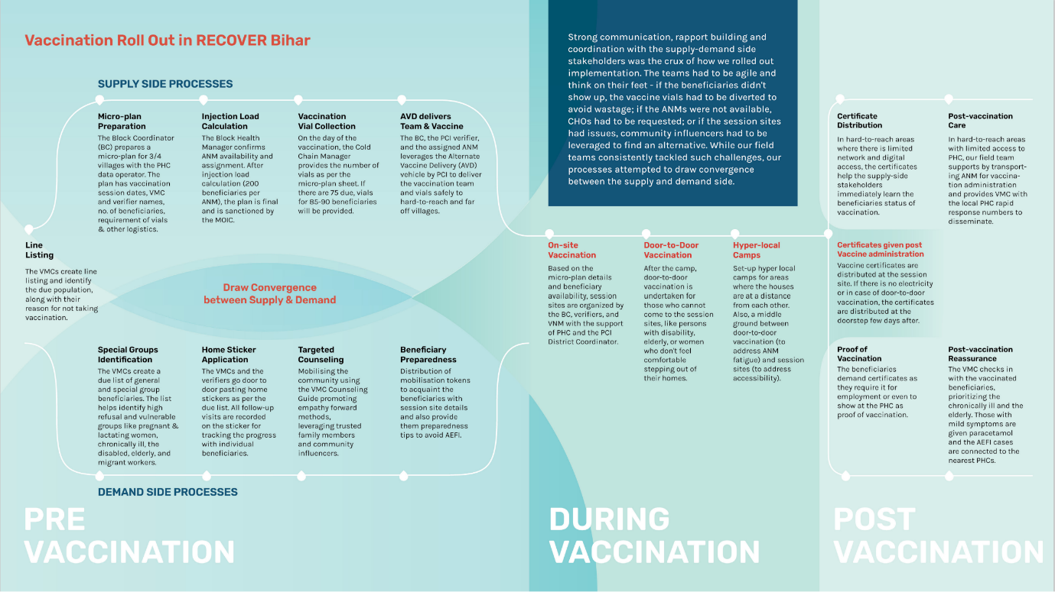

Source: Project Concern International (PCI)

