Supplementary Information
Scalable route to N-trifluoromethyl amides via radical trifluoromethylamination
Ru Zhong Zhang, Yang Liu, Cong Xu,* and Mang Wang*
Jilin Province Key Laboratory of Organic Functional Molecular Design & Synthesis, College of Chemistry, Northeast Normal University, 5268 Renmin Street, Changchun, 130024, China
*Corresponding author Email: xuc348@nenu.edu.cn; wangm452@nenu.edu.cn.

Table of Contents

I. General Information…………………………………………………………………………S3
II. Mechanistic studies…………………………………...……………………………S4
III. Screening Reaction Conditions………………………………………………………S8
IV. Preparation of Substrates……………………………………………………………S10
V. Synthetic Procedures/Analytical Data………………………………………………………S23
Synthesis of 1…………………………………………………………………...……………S23
Synthesis of 3…………………………………………………………………………………S34
Side product 4…………………………………………………………………………………S54
Synthesis of 6…………………………………………………………………………………S54
Synthesis of 8…………………………………………………………………………………S66
Synthesis of 10…………………………………………………………………………………S73
Synthesis of 12…………………………………………………………………………………S74
Synthesis of 14…………………………………………………………………………………S75
Synthesis of 16…………………………………………………………………………………S76
Synthesis of 18…………………………………………………………………………………S77
Synthesis of 20…………………………………………………………………………………S77
VI. Crystallographic data……………………………………………………………………S79
VII. Computational Details and Cartesian coordinates of optimized structure……………S83
VIII. References………….………………..…………………….…………………………S92
IX.NMR Spectra of Products…….………………….…….………………….……………S95

I. General Information

Unless otherwise noted, all reagents were purchased from commercial sources and were used as received. Anhydrous 1,4-Dioxane, DMF (N,N-dimethylformamide), THF (tetrahydrofuran), MeCN (acetonitrile), DCE (1,2-dichloroethane) and DCM (dichloromethane) were purchased from Energy Chemical Co. Ltd. The products were purified by column chromatography over silica gel (particle size 300-400 mesh ASTM, purchased from Taizhou, China). ¹H NMR, ¹³C NMR were recorded at 25 ºC on a Bruker 600 MHz or Varian 500 MHz, 400 MHz, and 151 MHz or 125 MHz spectrometer, respectively by using TMS as internal standard. ¹⁹F NMR were recorded at 25 ºC on a Bruker 565 MHz or Varian 470 MHz spectrometer by using (trifluoromethyl)benzene (δ -62.8 ppm) as internal standard. Data for ¹H, ¹³C, ¹⁹F were recorded as follows: chemical shift (δ, ppm), multiplicity (s = singlet, d = doublet, t = triplet, q = quartet, m = multiplet, dd = doublet of doublets, dt = doublet of triplets, td = triplet of doublets, br = broad). High-resolution mass spectra (HRMS) were obtained using a Bruker micro TOF II focus spectrometer (ESI). Melting points were measured with WRR digital point apparatus and not corrected. Blue LED lights were commercial from Taobao (18W), Crystallographic data of 1i, 3ah, 4b, 8g were collected on an Oxford Diffraction Gemini R Ultra diffractometer with graphite-monochromated Moka radiation (λ = 0.71071 Å). Products 3b¹, para-3c², 3ah³ are known compounds.

II. Mechanistic studies
- Cyclic Voltammetry Studies

A three-electrode system connected to an electrochemical station was used: (1) the reference electrode (Ag/AgCl in 0.1 M KCl); (2) a glassy carbon electrode as working electrode; (3) a Pt wire as counter electrode. All electrochemical measurements were performed in degassed dry DMF (containing 0.1 M n-Bu₄NPF₆) under N₂ atmosphere.

Reagent 1a: E_{1a} = -0.94 V vs Ag/Ag⁺
Figure 1. CV for reagent 1a

Reagent 1b: E_{1b} = -0.76 V vs Ag/Ag⁺
Figure 2. CV for reagent 1b

Reagent 1c: E_{1c} = -0.89 V vs Ag/Ag⁺
Figure 3. CV for reagent 1c

Reagent 1d: E_{1d} = -1.09 V vs Ag/Ag⁺
Figure 4. CV for reagent 1d

Reagent 1e: E_{1e} = -0.67 V vs Ag/Ag⁺
Figure 5. CV for reagent 1e

Ir(dFppy)₃: E = -0.8 V vs Ag/Ag⁺
Figure 6. CV for reagent Ir(dFppy)₃

- Emission quenching experiments

Emission intensities were recorded using Full-featured fluorescence spectroscopy system (Edinburgh FLS920P010404) at ambient temperature. Firstly, the emission spectrum of a 5×10⁻² mM solution of Ir(dFppy)₃ in DCM was collected. Then, appropriate amount of quencher was added to the measured solution and the emission spectrum was collected. The Stern-Volmer emission quenching studies telled us that the 1e is easy to quench the excited photosensitizer.

Figure 7. Emission quenching of Ir(dFppy)₃ (5×10⁻² mM) with 1e in DCM

III. Screening Reaction Conditions
Table S1. C-H Trifluoromethylamination of 1e and 2aª
Entry | 1e: 2a [mmol] | PC [mol%] | Sol. [mL] | Temp. [℃] | Yield of 3a [%]^{b}
1 | 0.1: 0.3 | - | DCM/ 2 | RT | N. R.
2 ^{c} | 0.1: 0.3 | Ir(dFppy)₃ / 1 | DCM /2 | RT | N. R.
3 | 0.1: 0.3 | Ir(ppy)₃/ 1 | DCM/ 2 | RT | 70
4 | 0.1: 0.3 | Ir(ppy)₂(dtbbpy)PF₆/ 1 | DCM/ 2 | RT | 62
5 | 0.1: 0.3 | 4CzIPN/ 1 | DCM/ 2 | RT | 28
6 | 0.1: 0.3 | 4CzIPN/ 5 | DCM/ 2 | RT | 58
7 | 0.1: 0.3 | Ir(dFppy)₃ / 1 | DCM/ 2 | RT | 77
8 | 0.1: 0.3 | Ru(bpy)₃Cl₂/ 1 | DCM/ 2 | RT | 54
9 | 0.1: 0.3 | Ir(dFppy)₃ / 1 | DCE/ 2 | RT | 64
10 | 0.1: 0.3 | Ir(dFppy)₃ / 1 | MeCN/ 2 | RT | 44
11 | 0.1: 0.3 | Ir(dFppy)₃ / 1 | EtOAc/ 2 | RT | 25
12 | 0.1: 0.3 | Ir(dFppy)₃ / 1 | DMF/ 2 | RT | Trace
13 | 0.1: 0.3 | Ir(dFppy)₃ / 1 | DCM/ 1 | RT | 72
14 | 0.1: 0.3 | Ir(dFppy)₃ / 1 | DCM/ 3 | RT | 82 (78)^{d}
15 | 0.1: 0.3 | Ir(dFppy)₃ / 1 | DCM/ 4 | RT | 80
16 | 0.1: 0.2 | Ir(dFppy)₃ / 1 | DCM/ 3 | RT | 64
17 | 0.1: 0.4 | Ir(dFppy)₃ / 1 | DCM/ 3 | RT | 81
18 | 0.2: 0.1 | Ir(dFppy)₃ / 1 | DCM/ 3 | RT | 61
19 | 0.1: 0.3 | Ir(dFppy)₃ / 1 | DCM/ 3 | 50 | 78
ªReaction conditions: Blue LEDs (18 W), 12 h. ^{b}Detected by ¹⁹F NMR spectroscopy PhCF₃ as internal standard. ^{c}Without blue LEDs’ irradiation. ^{d}Isolated yield.

Table S2. Radical [4+2] cyclization of 1i and 5aª
Entry | 1i: 5a [mmol] | PC [mol%] | Sol. [mL] | Temp. [℃] | Yield of 6a [%]^{b}
1 | 0.1: 0.3 | - | DCM/ 2 | RT | N. R.
2 ^{c} | 0.1: 0.3 | Ir(dFppy)₃ / 1 | DCM /2 | RT | N. R.
3 | 0.1: 0.3 | Ir(ppy)₃/ 1 | DCM/ 2 | RT | 52
4 | 0.1: 0.3 | Ir(ppy)₂(dtbbpy)PF₆/ 1 | DCM/ 2 | RT | 41
5 | 0.1: 0.3 | 4CzIPN/ 1 | DCM/ 2 | RT | 8
6 | 0.1: 0.3 | 4CzIPN/ 5 | DCM/ 2 | RT | 40
7 | 0.1: 0.3 | Ir(dFppy)₃ / 1 | DCM/ 2 | RT | 66
8 | 0.1: 0.3 | Ru(bpy)₃Cl₂/ 1 | DCM/ 2 | RT | 46
9 | 0.1: 0.3 | Ir(dFppy)₃ / 1 | DCE/ 2 | RT | 44
10 | 0.1: 0.3 | Ir(dFppy)₃ / 1 | MeCN/ 2 | RT | 40
11 | 0.1: 0.3 | Ir(dFppy)₃ / 1 | EtOAc/ 2 | RT | 18
12 | 0.1: 0.3 | Ir(dFppy)₃ / 1 | DCM/ 1 | RT | 64
13 | 0.1: 0.3 | Ir(dFppy)₃ / 1 | DCM/ 3 | RT | 69 (66)^{d}
14 | 0.1: 0.3 | Ir(dFppy)₃ / 1 | DCM/ 4 | RT | 64
15 | 0.1: 0.2 | Ir(dFppy)₃ / 1 | DCM/ 3 | RT | 56
16 | 0.1: 0.4 | Ir(dFppy)₃ / 1 | DCM/ 3 | RT | 69
17 | 0.2: 0.1 | Ir(dFppy)₃ / 1 | DCM/ 3 | RT | 42
18 | 0.1: 0.3 | Ir(dFppy)₃ / 1 | DCM/ 3 | 50 | 69
ªReaction conditions: Blue LEDs (18 W), 12 h. ^{b}Detected by ¹⁹F NMR spectroscopy PhCF₃ as internal standard. ^{c}Without blue LEDs’ irradiation. ^{d}Isolated yield.

IV. Preparation of Substrates
These compounds are commercially available: 2a-2c, 2f-2r, 2u-2x, 2ac, 2ad, 5a-5d, 5m, 5n, 5p-5r, 7a-7c, 7f-7m, 11, 13.

These are known compounds, synthesized following general methods: 2d, 2e, 2s, 2t, 2y, 2z, 2aa, 2ab, 2ac, 5e, 5f-5l, 5o, 5s-5w, 7d, 7e, 9, 15, 17, 19.
General procedure for the synthesis of compounds 2d, 2e (Prepared according to literature procedure⁴)
To a solution of Phenol (5.0 mmol) in THF were added NaH (6.0 mmol, 1.2 equiv.) with ice-bath, the mixture was stirred at 0 ºC for 0.5 h. Then MeH (15.0 mmol, 3 equiv.) were added. The mixture was stirred at RT for 4 h. After completion, the mixture was quenched with H₂O. The aqueous layers were extracted with DCM (20 mL × 3). The combined organic layer was washed with brine, dried over anhydrous Na₂SO₄, concentrated in vacuo and purified through column chromatography to afford products.

1-methoxy-4-(2,4,4-trimethylpentan-2-yl)benzene (2d)
90% yield, as a white soild.
¹H NMR (600 MHz, CDCl₃): δ = 0.72 (s, 9H), 1.34 (s, 6H), 1.70 (s, 2H), 3.79 (s, 3H), 6.82 (d, J = 8.4 Hz, 2H), 7.27 (d, J = 9.0 Hz, 2H).

1-(4-methoxyphenyl)adamantane (2e)
84% yield, as a white soild.
¹H NMR (600 MHz, CDCl₃): δ = 1.76 (q, J = 12.6 Hz, 3H), 1.89 (s, 6H), 2.08 (s, 3H), 3.79 (s, 3H), 6.86 (d, J = 9.0 Hz, 2H), 7.28 (d, J = 8.4 Hz, 2H).

General procedure for the synthesis of compounds 2s, 2t (Prepared according to literature procedure⁵)
To a solution of DMAP (0.5 mmol) and indole (5.0 mmol) in DCM were added Et₃N (2.0 equiv.) and (Boc)₂O (6.0 mmol, 1.2 equiv.) in ice-bath. Then the mixture was stirred at RT for 2 h. After completion, the mixture was quenched with saturated aqueous NH₄Cl solution. The aqueous layers were extracted with DCM (20 mL × 3). The combined organic layer was washed with brine, dried over anhydrous Na₂SO₄, concentrated in vacuo and purified through column chromatography to afford products.

tert-butyl 1H-indole-1-carboxylate (2s)
94% yield, as a colorless oil.
¹H NMR (600 MHz, CDCl₃): δ = 1.67 (s, 9H), 6.56 (d, J = 3.6 Hz, 1H), 7.22 (t, J = 7.5 Hz, 1H), 7.31 (t, J = 7.8 Hz, 1H), 7.56 (d, J = 7.2 Hz, 1H), 7.59 (br, 1H), 8.14 (br, 1H).

tert-butyl 3-methyl-1H-indole-1-carboxylate (2t)
94% yield, as a colorless oil.
¹H NMR (600 MHz, CDCl₃): δ = 1.64 (s, 9H), 2.24 (s, 3H), 7.22 (t, J = 7.5 Hz, 1H), 7.30 (t, J = 7.8 Hz, 1H), 7.34 (br, 1H), 7.46 (d, J = 7.8 Hz, 1H), 8.12 (br, 1H).

Preparation of methyl (S)-2-(6-methoxynaphthalen-2-yl)propanoate (2y)
Prepared according to literature procedure⁶, 87% yield, as a white soild.
¹H NMR (600 MHz, CDCl₃): δ = 1.57 (d, J = 7.2 Hz, 3H), 3.66 (s, 3H), 3.86 (q, J = 7.2 Hz, 1H), 3.91 (s, 3H), 7.11 (d, J = 1.8 Hz, 1H), 7.14 (dd, J₁ = 2.4 Hz, J₂ = 9.0 Hz, 1H), 7.40 (d, J = 8.4 Hz, 1H), 7.66 (s, 1H), 7.70 (d, J = 8.4 Hz, 2H).

General procedure for the synthesis of compounds 2z, 2aa, 5l, 5d, 5e (Prepared according to literature procedure⁷)
To a solution of DMAP (0.5 mmol) and alcohol (5.5 mmol) in DCM were added Et₃N (2.0
equiv.) and acyl chlorides (5.0 mmol) in ice-bath. Then the mixture was stirred at RT for 2 h. After completion, the mixture was quenched with saturated aqueous NH₄Cl solution. The aqueous layers were extracted with DCM (20 mL × 3). The combined organic layer was washed with brine, dried over anhydrous Na₂SO₄, concentrated in vacuo and purified through column chromatography to afford products.

(1S,2R,5S)-2-isopropyl-5-methylcyclohexyl furan-2-carboxylate (2z)
84% yield, as a colorless oil.
¹H NMR (600 MHz, CDCl₃): δ = 0.80 (d, J = 7.2 Hz, 3H), 0.90–0.93 (m, 7H), 1.11 (q, J = 12.0 Hz, 2H), 1.51–1.55 (m, 2H), 1.70–1.73 (m, 2H), 1.91–1.97 (m, 1H), 2.08–2.12 (m, 1H), 4.92 (dt, J₁ = 4.2 Hz, J₂ = 10.8 Hz, 1H), 6.50 (dd, J₁ = 1.8 Hz, J₂ = 3.6 Hz, 1H), 7.16 (dd, J₁ = 0.6 Hz, J₂ = 3.6 Hz, 1H), 7.58 (t, J = 1.2 Hz, 1H).
(8S,9S,10R,13R,14S,17R)-10,13-dimethyl-17-((R)-6-methylheptan-2-yl)-2,3,4,7,8,9,10,11,12,13,14,15,16,17-tetradecahydro-1H-cyclopenta[a]phenanthren-3-yl furan-2-carboxylate (2aa)
87% yield, as a white soild; mp 105.6–106.4℃.
¹H NMR (600 MHz, CDCl₃): δ = 0.68 (s, 3H), 0.86 (d, J = 6.6 Hz, 3H), 0.87 (d, J = 6.6 Hz, 3H), 0.92 (d, J = 6.6 Hz, 3H), 0.95–1.03 (m, 3H), 1.05 (s, 3H), 1.07–1.27 (m, 8H), 1.33–1.39 (m, 3H), 1.43–1.58 (m, 6H), 1.70–1.77 (m, 1H), 1.80–1.86 (m, 1H), 1.88–1.92 (m, 1H), 1.96–2.04 (m, 3H), 2.42–2.46 (m, 2H), 4.82–4.88 (m, 1H), 5.41 (d, J = 4.8 Hz, 1H), 6.49 (dd, J₁ = 1.8 Hz, J₂ = 3.6 Hz, 1H), 7.16 (d, J = 3.0 Hz, 1H), 7.56 (s, 1H). ¹³C NMR (151 MHz, CDCl₃): δ = 11.8, 18.7, 19.3, 21.0, 22.5, 22.8, 23.8, 24.2, 27.8, 28.0, 28.2, 31.8, 31.9, 35.8, 36.1, 36.6, 36.9, 38.1, 39.5, 39.7, 42.3, 50.0, 56.1, 56.6, 74.6, 111.7, 117.6, 122.9, 139.4, 145.1, 146.0, 158.1. HRMS (ESI-TOF) Calc’d for C₃₂H₄₈NaO₃ [M+Na]⁺: 503.3496; found: 503.3505.

Preparation of 1,3,7-trimethyl-3,7-dihydro-1H-purine-2,6-dione (2ab)
Prepared according to literature procedure⁸, 82% yield, as a white soild.
¹H NMR (600 MHz, CDCl₃): δ = 3.41 (s, 3H), 3.59 (s, 3H), 4.00 (s, 3H), 7.51 (s, 1H).

Preparation of 2-(but-3-en-1-yl)isoindoline-1,3-dione (5e)
Prepared according to literature procedure⁹, 86% yield, as a white soild.
¹H NMR (600 MHz, CDCl₃): δ = 2.45 (q, J = 7.2 Hz, 2H), 3.77 (t, J = 7.2 Hz, 2H), 5.02 (d, J = 10.2 Hz, 1H), 5.07 (d, J = 17.4 Hz, 1H), 5.76–5.83 (m, 1H), 7.69–7.73 (m, 2H), 7.82–7.85 (m, 2H).

General procedure for the synthesis of compounds 5f-5k (Prepared according to literature procedure¹⁰)
To a solution of DMAP (0.5 mmol) and alcohol (5.5 mmol) in DCM were added Et₃N (2.0
equiv.) and sulfonyl chlorides (5.0 mmol) in ice-bath. Then the mixture was stirred at RT for 2 h. After completion, the mixture was quenched with saturated aqueous NH₄Cl solution. The aqueous layers were extracted with DCM (20 mL × 3). The combined organic layer was washed with brine, dried over anhydrous Na₂SO₄, concentrated in vacuo and purified through column chromatography to afford products.

pent-4-en-1-yl 4-methoxybenzenesulfonate (5f)
86% yield, as a colorless oil.
¹H NMR (600 MHz, CDCl₃): δ = 1.72–1.77 (m, 2H), 2.09 (q, J = 7.2 Hz, 2H), 3.89 (s, 3H), 4.02 (t, J = 6.3 Hz, 2H), 4.95 (s, 1H), 4.97 (d, J = 7.8 Hz, 1H), 5.66–5.73 (m, 1H), 7.01 (d, J = 9.0 Hz, 2H), 7.84 (d, J = 9.0 Hz, 2H). ¹³C NMR (151 MHz, CDCl₃): δ = 28.0, 29.4, 55.7, 69.6, 114.4 (2C), 115.8, 127.6, 130.0 (2C), 136.6, 163.7.

pent-4-en-1-yl 4-(tert-butyl)benzenesulfonate (5g)
88% yield, as a colorless oil.
¹H NMR (600 MHz, CDCl₃): δ = 1.35 (s, 9H), 1.73–1.78 (m, 2H), 2.09 (q, J = 7.2 Hz, 2H), 4.06 (t, J = 6.6 Hz, 2H), 4.93 (d, J = 5.4 Hz, 1H), 4.95 (s, 1H), 5.65–5.72 (m, 1H), 7.56 (d, J = 8.4 Hz, 2H), 7.83 (d, J = 8.4 Hz, 2H). ¹³C NMR (151 MHz, CDCl₃): δ = 28.0, 29.3, 31.0 (3C), 35.3, 69.7, 115.8, 126.2 (2C), 127.7 (2C), 133.1, 136.6, 157.6. HRMS (ESI-TOF) Calc’d for C₁₅H₂₂NaO₃S [M+Na]⁺: 305.1182; found: 305.1188.

pent-4-en-1-yl 4-(trifluoromethyl)benzenesulfonate (5h)
88% yield, as a colorless oil.
¹H NMR (600 MHz, CDCl₃): δ = 1.77–1.81 (m, 2H), 2.11 (q, J = 7.2 Hz, 2H), 4.12 (t, J = 6.3 Hz, 2H), 4.95 (d, J = 4.8 Hz, 1H), 4.98 (s, 1H), 5.66–5.73 (m, 1H), 7.84 (d, J = 8.4 Hz, 2H), 8.06 (d, J = 8.4 Hz, 2H). ¹³C NMR (151 MHz, CDCl₃): δ = 27.9, 29.2, 70.6, 116.0, 123.0 (q, J = 273.1 Hz), 126.4 (q, J = 3.7 Hz, 2C), 128.4 (2C), 135.3 (q, J = 33.2 Hz), 136.3, 139.8. ¹⁹F NMR (151 MHz, CDCl₃): δ = -63.3 (s, 3F). HRMS (ESI-TOF) Calc’d for C₁₂H₁₃F₃NaO₃S [M+Na]⁺: 317.0430; found: 317.0432.

but-3-en-1-yl 4-methylbenzenesulfonate (5i)
91% yield, as a colorless oil.
¹H NMR (600 MHz, CDCl₃): δ = 2.39 (q, J = 6.8 Hz, 2H), 2.45 (s, 3H), 4.06 (t, J = 6.6 Hz, 2H), 5.05–5.09 (m, 2H), 5.63–5.71 (m, 1H), 7.35 (d, J = 7.8 Hz, 2H), 7.78 (d, J = 7.8 Hz, 2H).

pent-4-en-1-yl 4-methylbenzenesulfonate (5j)
88% yield, as a colorless oil.
¹H NMR (600 MHz, CDCl₃): δ = 1.72–1.77 (m, 2H), 2.08 (q, J = 7.2 Hz, 2H), 2.45 (s, 3H), 4.04 (t, J = 6.3 Hz, 2H), 4.94 (s, 1H), 4.97 (d, J = 5.4 Hz, 1H), 5.66–5.72 (m, 1H), 7.35 (d, J = 7.8 Hz, 2H), 7.79 (d, J = 7.8 Hz, 2H).

hex-5-en-1-yl 4-methylbenzenesulfonate (5k)
88% yield, as a colorless oil.
¹H NMR (600 MHz, CDCl₃): δ = 1.39–1.44 (m, 2H), 1.63–1.68 (m, 2H), 2.00 (q, J = 7.2 Hz, 2H), 2.45 (s, 3H), 4.03 (t, J = 6.6 Hz, 2H), 4.93–4.97 (m, 2H), 5.68–5.74 (m, 1H), 7.35 (d, J = 8.4 Hz, 2H), 7.79 (d, J = 8.4 Hz, 2H).

pent-4-en-1-yl benzoate (5l)
96% yield, as a colorless oil.
¹H NMR (600 MHz, CDCl₃): δ = 1.85–1.90 (m, 2H), 2.22 (q, J = 7.2 Hz, 2H), 4.34 (t, J = 6.6 Hz, 2H), 5.02 (d, J = 10.2 Hz, 1H), 5.07 (d, J = 17.4 Hz, 1H), 5.82–5.88 (m, 1H), 7.43 (t, J = 7.8 Hz, 2H), 7.55 (t, J = 7.2 Hz, 1H), 8.04 (d, J = 7.8 Hz, 2H).

General procedure for the synthesis of compounds 5s-5w (Prepared according to literature procedure¹¹)
To a solution of DMAP (0.5 mmol) and alcohol (5.5 mmol), EDCI (2.0 equiv) in DCM were added acid (5.0 mmol) in ice-bath. Then the mixture was stirred at RT for 2 h. After completion, the mixture was quenched with saturated aqueous NH₄Cl solution. The aqueous layers were extracted with DCM (20 mL × 3). The combined organic layer was washed with brine, dried over anhydrous Na₂SO₄, concentrated in vacuo and purified through column chromatography to afford products.

(1S,2R,5S)-2-isopropyl-5-methylcyclohexyl pent-4-enoate (5s)
84% yield, as a colorless oil.
¹H NMR (500 MHz, CDCl₃): δ = 0.73 (d, J = 7.0 Hz, 3H), 0.85–0.90 (m, 7H), 0.93 (q, J = 11.0 Hz, 1H), 0.97–1.07 (m, 1H), 1.31–1.37 (m, 1H), 1.42–1.49 (m, 1H), 1.62–1.67 (m, 2H), 1.81–1.87 (m, 1H), 1.93–1.97 (m, 1H), 2.32–2.37 (m, 4H), 4.66 (dd, J₁ = 4.5 Hz, J₂ = 11.0 Hz, 1H), 4.97 (d, J = 11.0 Hz, 1H), 5.03 (d, J = 17.0 Hz, 1H), 5.75–5.83 (m, 1H).

but-3-en-1-yl 2-(3-cyano-4-isobutoxyphenyl)-4-methylthiazole-5-carboxylate (5t)
92% yield, as a white soild; mp 121.3–122.2 ℃.
¹H NMR (600 MHz, CDCl₃): δ = 1.09 (d, J = 6.6 Hz, 6H), 2.17–2.23 (m, 1H), 2.51 (q, J = 6.6 Hz, 2H), 2.76 (s, 3H), 3.90 (d, J = 6.0 Hz, 2H), 4.36 (t, J = 6.6 Hz, 2H), 5.13 (d, J = 10.2 Hz, 1H), 5.18 (d, J = 16.8 Hz, 1H), 5.82–5.89 (m, 1H), 7.01 (d, J = 9.0 Hz, 1H), 8.09 (dd, J₁ = 2.4 Hz, J₂ = 9.0 Hz, 1H), 8.17 (d, J = 2.4 Hz, 1H). ¹³C NMR (151 MHz, CDCl₃): δ = 17.5, 19.0 (2C), 28.1, 33.1, 64.3, 75.7, 102.0, 112.6, 115.4, 117.6, 121.8, 126.0, 132.1, 132.5, 133.7, 161.2, 162.0, 162.5, 167.2. HRMS (ESI-TOF) Calc’d for C₂₀H₁₃N₂NaO₃S [M+Na]⁺: 393.1243; found: 393.1239.

pent-4-en-1-yl 2-(4-isobutylphenyl)propanoate (5u)
95% yield, as a colorless oil.
¹H NMR (600 MHz, CDCl₃): δ = 0.89 (d, J = 6.6 Hz, 6H), 1.48 (d, J = 7.2 Hz, 3H), 1.64–1.69 (m, 2H), 1.80–1.87 (m, 1H), 2.00 (q, J = 7.2 Hz, 2H), 2.44 (d, J = 7.2 Hz, 2H), 3.68 (q, J = 7.2 Hz, 1H), 4.04–4.08 (m, 2H), 4.92 (s, 1H), 4.94 (d, J = 4.2 Hz, 1H), 5.68–5.75 (m, 1H), 7.09 (d, J = 7.8 Hz, 2H), 7.20 (d, J = 7.8 Hz, 2H). ¹³C NMR (151 MHz, CDCl₃): δ = 18.4, 22.3 (2C), 27.7, 29.9, 30.1, 45.0, 45.2, 63.9, 115.2, 127.1 (2C), 129.2 (2C), 137.4, 137.8, 140.4, 174.7. HRMS (ESI-TOF) Calc’d for C₁₈H₂₆N₂NaO₂ [M+Na]⁺: 297.1825; found: 297.1831.

Preparation of but-3-en-1-yl 2-(4-(4-chlorobenzoyl)phenoxy)-2-methylpropanoate (5v)
90% yield, as a white soild; mp 86.8–87.7 ℃.
¹H NMR (600 MHz, CDCl₃): δ = 1.67 (s, 6H), 2.37 (q, J = 6.8 Hz, 2H), 4.23 (t, J = 6.6 Hz, 2H), 5.02 (d, J = 10.2 Hz, 1H), 5.06 (d, J = 17.4 Hz, 1H), 5.64–5.71 (m, 1H), 6.86 (d, J = 8.4 Hz, 2H), 7.45 (d, J = 8.4 Hz, 2H), 7.70 (d, J = 8.4 Hz, 2H), 7.73 (d, J = 8.4 Hz, 2H). ¹³C NMR (151 MHz, CDCl₃): δ = 25.4 (2C), 32.8, 64.5, 79.3, 117.3 (2C), 117.4, 128.4 (2C), 130.3, 131.1 (2C), 131.9 (2C), 133.4, 136.3, 138.3, 159.5, 173.5, 194.0. HRMS (ESI-TOF) Calc’d for C₂₁H₂₁ClNaO₄ [M+Na]⁺: 395.1021; found: 395.1026.

Preparation of but-3-en-1-yl 2-(11-oxo-6,11-dihydrodibenzo[b,e]oxepin-9-yl)acetate (5w)
94% yield, as a white soild; mp 92.4–93.3 ℃
¹H NMR (600 MHz, CDCl₃): δ = 2.36 (q, J = 6.6 Hz, 2H), 3.62 (s, 2H), 4.14 (t, J = 6.6 Hz, 2H), 5.03–5.09 (m, 2H), 5.12 (s, 2H), 5.70–5.77 (m, 1H), 6.99 (d, J = 8.4 Hz, 1H), 7.30 (d, J = 7.2 Hz, 1H), 7.39–7.43 (m, 2H), 7.50 (t, J = 7.2 Hz, 1H), 7.86 (d, J = 7.2 Hz, 1H), 8.11 (s, 1H). ¹³C NMR (151 MHz, CDCl₃): δ = 32.8, 39.9, 64.7, 73.3, 117.1, 120.1, 124.8, 127.5, 127.6, 128.9, 129.2, 132.2, 132.5, 133.6, 135.3, 136.1, 140.1, 160.2, 171.0, 190.4. HRMS (ESI-TOF) Calc’d for C₂₀H₁₈NaO₄ [M+Na]⁺: 345.1097; found: 345.1094.

Preparation of p-tolyl pent-4-ynoate (7d)
90% yield, as a colorless oil.
¹H NMR (600 MHz, CDCl₃): δ = 1.93–1.99 (m, 2H), 2.01 (t, J = 2.4 Hz, 1H), 2.33–2.35 (m, 5H), 2.70 (t, J = 7.5 Hz, 2H), 6.96 (d, J = 7.8 Hz, 2H), 7.16 (d, J = 7.8 Hz, 2H). ¹³C NMR (151 MHz, CDCl₃): δ = 17.8, 20.8, 23.5, 32.9, 69.3, 83.1, 121.1 (2C), 129.9 (2C), 135.4, 148.3, 171.7. HRMS (ESI-TOF) Calc’d for C₁₃H₁₄NaO₂ [M+Na]⁺: 225.0886; found: 225.0882.

Preparation of 4-chlorophenyl pent-4-ynoate (7e)
86% yield, as a colorless oil.
¹H NMR (600 MHz, CDCl₃): δ = 1.94–1.98 (m, 2H), 2.02 (t, J = 2.4 Hz, 1H), 2.35 (dt, J₁ = 3.0 Hz, J₂ = 7.2 Hz, 2H), 2.71 (t, J = 7.5 Hz, 2H), 7.03 (d, J = 8.4 Hz, 2H), 7.33 (d, J = 8.4 Hz, 2H). ¹³C NMR (151 MHz, CDCl₃): δ = 17.7, 23.4, 32.8, 69.5, 82.9, 122.9 (2C), 129.4 (2C), 131.1, 149.0, 171.3. HRMS (ESI-TOF) Calc’d for C₁₂H₁₁ClNaO₂ [M+Na]⁺: 245.0340; found: 245.0336.

Preparation of 2-isocyano-1,1'-biphenyl (9a)
Prepared according to literature procedure¹², 75% yield, as a black oil.
¹H NMR (600 MHz, CDCl₃): δ = 7.36 (td, J = 7.8 Hz, J = 2.3 Hz, 1H), 7.52–7.41 (m, 8H).

Preparation of 2-isocyano-4',5-dimethyl-1,1'-biphenyl (9b)
Prepared according to literature procedure¹², 75% yield, as a red solid.
¹H NMR (600 MHz, CDCl₃): δ = 2.40 (s, 3H), 2.41 (s, 3H), 7.13 (d, J = 8.4 Hz, 1H), 7.20 (s, 1H), 7.27 (d, J = 7.8 Hz, 2H), 7.35 (d, J = 8.4 Hz, 1H), 7.39 (d, J = 7.8 Hz, 2H).

Preparation of ((1-(4-bromophenyl)vinyl)oxy)triisopropylsilane (11b)
Prepared according to literature procedure¹³, 82% yield, as a colorless oil.
¹H NMR (600 MHz, CDCl₃): δ = 1.12 (d, J = 7.1 Hz, 18H), 1.21–1.37 (m, 3H), 4.42 (d, J = 2.0 Hz, 1H), 4.83 (d, J = 2.0 Hz, 1H), 7.42–7.45 (m, 2H), 7.48–7.52 (m, 2H).

Preparation of 2,2-dimethyl-4-phenylpent-4-enoic acid (15)
Prepared according to literature procedure¹⁴, 86% yield, as a white solid.
¹H NMR (600 MHz, CDCl₃): δ = 1.10 (s, 6H), 2.82 (s, 2H), 5.10 (s, 1H), 5.27 (s, 1H), 7.23 (t, J = 7.2 Hz, 1H), 7.26 (s, 1H), 7.28 (t, J = 7.5 Hz, 2H), 7.35 (d, J = 7.2 Hz, 2H).

Preparation of 2,2-dimethyl-4-phenyl-N-tosylpent-4-enamide (17)
To a solution of 15 (6.2 mmol) and (COCl)₂ (7.4 mmol, 1.2 equiv.), DMF (2 drops) in DCM (10 mL) under N₂. Then the mixture was stirred at RT for 2 h. After completion, the mixture was concentrated in vacuo. Then, TsNH₂ (6.2 mmol), KOH (18.6 mmol, 3 equiv.) and DCM (20 mL) were added, the the mixture was stirred at RT for 2 h. After completion, the mixture was quenched with 1N HCl solution. The aqueous layers were extracted with EtOAc (20 mL × 3). The combined organic layer was washed with brine, dried over anhydrous Na₂SO₄, concentrated in vacuo and purified through column chromatography to afford products. 75% yield, as a white solid. mp 91.4–92.3 ºC. ¹H NMR (600 MHz, CDCl₃): δ = 1.02 (s, 6H), 2.44 (s, 3H), 2.72 (s, 2H), 4.83 (s, 1H), 5.10 (s, 1H), 7.20–7.32 (m, 5H), 7.33 (d, J = 7.8 Hz, 2H), 7.93 (d, J = 7.8 Hz, 2H), 8.80 (br, 1H). ¹³C NMR (151 MHz, CDCl₃): δ = 21.6, 24.9 (2C), 44.3, 117.5, 126.3 (2C), 127.4, 128.3 (2C), 128.5 (2C), 129.4 (2C), 135.5, 142.2, 144.6, 144.9, 175.3. HRMS (ESI-TOF) Calc’d for C₁₉H₂₃NNaO₂S [M+Na]⁺: 352.1342; found: 352.1346.

Preparation of 1,1-diphenylprop-2-en-1-ol (19)
Prepared according to literature procedure¹⁶, 88% yield, as a white solid.
¹H NMR (600 MHz, CDCl₃): δ = 2.32 (s, 1H), 5.29 (s, 1H), 5.31 (d, J = 6.6 Hz, 1H), 6.47–6.52 (m, 1H), 7.25 (t, J = 7.2 Hz, 2H), 7.31 (t, J = 7.5 Hz, 4H), 7.37 (t, J = 7.8 Hz, 4H).

Preparation of N-CF₃ imidoyl chlorides according to our previous reported methods:

(Z)-N-(trifluoromethyl)cyclohexanecarbimidoyl chloride (S-1g)
¹H NMR (600 MHz, CDCl₃): δ = 0.84–0.90 (m, 1H), 1.19–1.33 (m, 2H), 1.44–1.50 (m, 2H), 1.69–1.71 (m, 1H), 1.83 (td, J₁ = 3.6 Hz, J₂ = 13.8 Hz, 2H), 2.04 (d, J = 12.0 Hz, 2H), 2.59 (t, J = 11.4 Hz, 1H). ¹³C NMR (151 MHz, CDCl₃): δ = 25.4 (2C), 25.5, 30.4 (2C), 52.3, 121.2 (q, J = 262.9 Hz), 166.2 (q, J = 10.4 Hz). ¹⁹F NMR (565 MHz, CDCl₃): δ = -58.6 (s, 3F). HRMS (ESI-TOF) Calc’d for C₈H₁₂ClF₃N [M+H]⁺: 214.0605; found: 214.0609.

V. Synthetic Procedures/Analytical Data

Synthesis of 1

Supplementary Fig. 8. Unsuccessful substrates of N-O reagents

General procedure for the synthesis of compounds 1a, 1b (taking 1a as an example):
A 10 mL Schlenk tube was charged with PhICF₃Cl (462 mg, 1.5 mmol), MeCN (3.5 mL) and a stir bar under N₂. The reaction mixture was stirred at 80 °C for 2 h and cooled to room temperature. Then, N-hydroxyphthalimide (1 mmol), DMAP (12.2 mg, 0.1 mmol), Et₃N (280 μl, 2 mmol) were added for reacting additional 1 h at room temperature. Then, resulting mixture was added to H₂O (15 mL) and extracted with DCM (20 mL × 3). The organic layers were washed with brine, dried over anhydrous Na₂SO₄, concentrated in vacuo and purified by silica column chromatography (PE: DCM = 5: 1) to give 1a (231 mg, 88%) as white soild.

1,3-dioxoisoindolin-2-yl (E)-N-(trifluoromethyl)acetimidate (1a)
White solid, mp 64.8–65.7 ℃. R_{f} = 0.45 (PE: EA = 6: 1). ¹H NMR (600 MHz, CDCl₃): δ = 2.45 (s, 3H), 7.80–7.82 (m, 2H), 7.89–7.92 (m, 2H). ¹³C NMR (151 MHz, CDCl₃): δ = 15.8 (q, J = 1.9 Hz), 122.6 (q, J = 259.3 Hz), 124.1 (2C), 128.6 (2C), 134.9 (2C), 161.3 (2C), 169.6 (q, J = 6.5 Hz). ¹⁹F NMR (565 MHz, CDCl₃): δ = -54.3 (s, 3F). HRMS (ESI-TOF) Calc’d for C₁₁H₇F₃N₂NaO₃ [M+Na]⁺: 295.0301; found: 295.0310.

4,5,6,7-tetrachloro-1,3-dioxoisoindolin-2-yl (E)-N-(trifluoromethyl)acetimidate (1b)
White solid, mp 88.6–89.5 ℃. R_{f} = 0.45 (PE: EA = 6: 1). ¹H NMR (600 MHz, CDCl₃): δ = 2.50 (s, 3H). ¹³C NMR (151 MHz, CDCl₃): δ = 15.8 (q, J = 2.7 Hz), 122.3 (q, J = 257.8 Hz), 124.4 (2C), 130.6 (2C), 141.2 (2C), 156.8 (2C), 169.2 (q, J = 6.4 Hz). ¹⁹F NMR (565 MHz, CDCl₃): δ = -54.4 (s, 3F). HRMS (ESI-TOF) Calc’d for C₁₁H₃Cl₄F₃N₂NaO₃ [M+Na]⁺: 430.8742; found: 430.8745.

Method A: General procedure for the synthesis of compounds 1c-1f (taking 1c as an example):
A 10 mL Schlenk tube was charged with PhICF₃Cl (462 mg, 1.5 mmol), MeCN (3.5 mL) and a stir bar under N₂. The reaction mixture was stirred at 80 °C for 2 h and cooled to room temperature. Then, 2-methylpyridine-N-oxide (109 mg, 1.0 mmol) and NaPF₆ (334 mg, 2.0 mmol) were added for reacting additional 12 h at room temperature. Then, resulting mixture was added to H₂O (15 mL) and extracted with DCM (20 mL × 3). The organic layers were washed with brine, dried over anhydrous Na₂SO₄, concentrated in vacuo, followed by adding diethyl ether (20 mL). The resulting precipitate was washed by diethyl ether to give 1c (313 mg, 86%) as white soild.

(E)-2-methyl-1-(1-((trifluoromethyl)imino)ethoxy)pyridin-1-ium hexafluorophosphate (V) (1c)
White solid, mp 124.8–125.7 ℃. ¹H NMR (600 MHz, Acetone-D₆): δ = 2.78 (s, 3H), 2.94 (s, 3H), 8.29 (t, J = 7.2 Hz, 1H), 8.38 (d, J = 8.4 Hz, 1H), 8.79 (t, J = 7.8 Hz, 1H), 9.22 (d, J = 6.6 Hz, 1H). ¹³C NMR (151 MHz, Acetone-D₆): δ = 15.8, 16.8, 122.0 (q, J = 259.3 Hz), 127.3, 131.0, 142.2, 147.5, 154.3, 171.8 (q, J = 6.4 Hz). ¹⁹F NMR (565 MHz, Acetone-D₆): δ = -55.5 (s, 3F), -71.6 (s, 3F), -72.8 (s, 3F). HRMS (ESI-TOF) Calc’d for C₉H₁₀F₃N₂O [M-PF₆]⁺: 219.0740; found: 219.0743.

(E)-4-methyl-1-(1-((trifluoromethyl)imino)ethoxy)pyridin-1-ium hexafluorophosphate (V) (1d)
White solid, mp 142.4–143.3 ℃. ¹H NMR (600 MHz, Acetone-D₆): δ = 2.67 (s, 3H), 2.85 (s, 3H), 8.30 (d, J = 6.0 Hz, 2H), 9.15 (d, J = 6.0 Hz, 2H). ¹³C NMR (151 MHz, Acetone-D₆): δ = 15.9, 21.5, 122.1 (q, J = 259.0 Hz), 129.9 (2C), 141.1 (2C), 163.1, 172.5 (q, J = 6.8 Hz). ¹⁹F NMR (565 MHz, Acetone-D₆): δ = -55.4 (s, 3F), -71.5 (s, 3F), -72.7 (s, 3F). HRMS (ESI-TOF) Calc’d for C₉H₁₀F₃N₂O [M-PF₆]⁺: 219.0740; found: 219.0746.

(E)-1-(1-((trifluoromethyl)imino)ethoxy)pyridin-1-ium hexafluorophosphate (V) (1e)
White solid, mp 132.4–133.3 ℃. ¹H NMR (600 MHz, Acetone-D₆): δ = 2.71 (s, 3H), 8.55 (t, J = 7.5 Hz, 2H), 8.99 (t, J = 7.8 Hz, 1H), 9.40 (d, J = 6.6 Hz, 2H). ¹³C NMR (151 MHz, Acetone-D₆): δ = 16.0, 122.1 (q, J = 259.0 Hz), 129.9 (2C), 142.7 (2C), 148.3, 172.6 (q, J = 6.4 Hz). ¹⁹F NMR (565 MHz, Acetone-D₆): δ = -55.5 (s, 3F), -71.7 (s, 3F), -72.9 (s, 3F). HRMS (ESI-TOF) Calc’d for C₈H₈F₃N₂O [M-PF₆]⁺: 205.0583; found: 205.0585.

(E)-1-(3-chloro-1-((trifluoromethyl)imino)propoxy)pyridin-1-ium trifluoromethanesulfonate (1f)
White solid, mp 132.4–133.3 ℃. ¹H NMR (600 MHz, Acetone-D₆): δ = 3.62 (t, J = 6.6 Hz, 2H), 4.18 (t, J = 6.6 Hz, 2H), 8.55 (t, J = 6.9 Hz, 2H), 9.00 (t, J = 7.5 Hz, 1H), 9.34 (d, J = 6.0 Hz, 2H). ¹³C NMR (151 MHz, Acetone-D₆): δ = 33.9, 37.9, 120.9 (q, J = 321.7 Hz), 121.5 (q, J = 259.9 Hz), 130.0 (2C), 142.5 (2C), 148.5, 170.3 (q, J = 5.9 Hz). ¹⁹F NMR (565 MHz, Acetone-D₆): δ = -53.6 (s, 3F), -78.9 (s, 3F). HRMS (ESI-TOF) Calc’d for C₉H₉ClF₃N₂O [M-OTf]⁺: 253.0350; found: 253.0350.

Method B: General procedure for the synthesis of compounds 1g-1w (taking 1g as an example):
A 10 mL Schlenk tube was charged with N-(trifluoromethyl)cyclohexanecarbimidoyl chloride (213 mg, 1 mmol), pyridine-N-oxide (95 mg, 1.0 mmol), NaPF₆ (334 mg, 2.0 mmol) and a stir bar in MeCN (3 mL). The reaction mixture was stirred at room temperature for 12 h. Then, resulting mixture was added to H₂O (15 mL) and extracted with DCM (20 mL × 3). The organic layers were washed with brine, dried over anhydrous Na₂SO₄, concentrated in vacuo, followed by adding diethyl ether (20 mL). The resulting precipitate was washed by diethyl ether to give 1g (364 mg, 87%) as white soild.

(E)-1-(cyclohexyl((trifluoromethyl)imino)methoxy)pyridin-1-ium hexafluorophosphate (V) (1g)
White solid, mp 134.6–135.5 ℃. ¹H NMR (600 MHz, Acetone-D₆): δ = 1.32–1.39 (m, 1H), 1.42–1.51 (m, 2H), 1.76–1.79 (m, 1H), 1.85–1.93 (m, 4H), 2.22 (d, J = 12.0 Hz, 2H), 3.14–3.19 (m, 1H), 8.54 (t, J = 7.5 Hz, 2H), 9.00 (t, J = 7.8 Hz, 1H), 9.47 (d, J = 6.6 Hz, 2H). ¹³C NMR (151 MHz, Acetone-D₆): δ = 25.0 (2C), 25.1, 28.8 (2C), 41.3, 121.9 (q, J = 259.2 Hz), 129.8 (2C), 142.9 (2C), 148.3, 175.8 (q, J = 6.2 Hz). ¹⁹F NMR (565 MHz, Acetone-D₆): δ = -54.0 (s, 3F), -71.7 (s, 3F), -73.0 (s, 3F). HRMS (ESI-TOF) Calc’d for C₁₃H₁₆F₃N₂O [M-OTf]⁺: 273.1209; found: 273.1216

1-(((1E,2E)-3-phenyl-1-((trifluoromethyl)imino)allyl)oxy)pyridin-1-ium trifluoromethanesulfonate (1h)
White solid, mp 149.6–150.5 ℃. ¹H NMR (600 MHz, Acetone-D₆): δ = 7.05 (d, J = 16.8 Hz, 1H), 7.54 (t, J = 7.5 Hz, 2H), 7.58 (t, J = 7.2 Hz, 1H), 7.87 (d, J = 7.2 Hz, 2H), 8.35 (d, J = 16.2 Hz, 1H), 8.54 (t, J = 7.2 Hz, 2H), 8.98 (t, J = 7.8 Hz, 1H), 9.64 (d, J = 6.6 Hz, 2H). ¹³C NMR (151 MHz, Acetone-D₆): δ = 108.6, 121.2 (q, J = 321.3 Hz), 122.1 (q, J = 259.0 Hz), 129.3 (2C), 129.4 (2C), 129.7 (2C), 132.3, 133.3, 143.2 (2C), 148.1, 149.3, 165.4 (q, J = 6.5 Hz). ¹⁹F NMR (565 MHz, Acetone-D₆): δ = -53.1 (s, 3F), -78.8 (s, 3F). HRMS (ESI-TOF) Calc’d for C₁₅H₁₂F₃N₂O [M-OTf]⁺: 293.0896; found: 293.0902.

(E)-1-(phenyl((trifluoromethyl)imino)methoxy)pyridin-1-ium trifluoromethanesulfonate (1i)
White solid, mp 150.9–151.8 ℃. ¹H NMR (600 MHz, Acetone-D₆): δ = 7.71 (t, J = 7.8 Hz, 2H), 7.83 (t, J = 7.5 Hz, 1H), 8.07 (d, J = 7.8 Hz, 2H), 8.60 (t, J = 7.2 Hz, 2H), 9.05 (t, J = 7.5 Hz, 1H), 9.81 (d, J = 6.6 Hz, 2H). ¹³C NMR (151 MHz, Acetone-D₆): δ = 121.4 (q, J = 321.5 Hz), 121.5 (q, J = 258.7 Hz), 125.0, 128.9 (2C), 129.6 (2C), 129.9 (2C), 134.1, 143.2 (2C), 148.4, 168.0 (q, J = 6.8 Hz). ¹⁹F NMR (565 MHz, Acetone-D₆): δ = -52.5 (s, 3F), -78.9 (s, 3F). HRMS (ESI-TOF) Calc’d for C₁₃H₁₀F₃N₂O [M-OTf]⁺: 267.0740; found: 267.0742.

(E)-1-(p-tolyl((trifluoromethyl)imino)methoxy)pyridin-1-ium trifluoromethanesulfonate (1j)
White solid, mp 159.2–160.1 ℃. ¹H NMR (500 MHz, Acetone-D₆): δ = 2.47 (s, 3H), 7.51 (d, J = 8.5 Hz, 2H), 7.96 (d, J = 8.0 Hz, 2H), 8.58 (t, J = 7.5 Hz, 2H), 9.02 (t, J = 7.8 Hz, 1H), 9.78 (d, J = 6.0 Hz, 2H). ¹³C NMR (125 MHz, Acetone-D₆): δ = 20.8, 121.3 (q, J = 319.5 Hz), 121.5 (q, J = 256.7 Hz), 121.9, 129.5 (2C), 129.7 (2C), 129.8 (2C), 143.2 (2C), 145.4, 148.3, 168.1 (q, J = 6.7 Hz). ¹⁹F NMR (470 MHz, Acetone-D₆): δ = -52.4 (s, 3F), -78.9 (s, 3F). HRMS (ESI-TOF) Calc’d for C₁₄H₁₂F₃N₂O [M-OTf]⁺: 281.0896; found: 281.0898.

(E)-1-((4-methoxyphenyl)((trifluoromethyl)imino)methoxy)pyridin-1-ium trifluoromethanesulfonate (1k)
White solid, mp 144.7–145.6 ℃. ¹H NMR (600 MHz, Acetone-D₆): δ = 3.97 (s, 3H), 7.24 (d, J = 9.0 Hz, 2H), 8.04 (d, J = 9.0 Hz, 2H), 8.60 (t, J = 7.2 Hz, 2H), 9.04 (t, J = 7.8 Hz, 1H), 9.76 (d, J = 6.0 Hz, 2H). ¹³C NMR (151 MHz, Acetone-D₆): δ = 55.5, 114.5 (2C), 116.2, 121.4 (q, J = 321.7 Hz), 121.6 (q, J = 257.8 Hz), 129.8 (2C), 132.3 (2C), 143.3 (2C), 148.2, 164.7, 167.4 (q, J = 6.7 Hz). ¹⁹F NMR (565 MHz, Acetone-D₆): δ = -52.3 (s, 3F), -78.9 (s, 3F). HRMS (ESI-TOF) Calc’d for C₁₄H₁₂F₃N₂O₂ [M-OTf]⁺: 297.0845; found: 297.0848.

(E)-1-((4-(tert-butyl)phenyl)((trifluoromethyl)imino)methoxy)pyridin-1-ium trifluoromethanesulfonate (1l)
White solid, mp 166.1–167.0 ℃. ¹H NMR (600 MHz, Acetone-D₆): δ = 1.38 (s, 9H), 7.76 (d, J = 8.4 Hz, 2H), 8.03 (d, J = 8.4 Hz, 2H), 8.58 (t, J = 7.8 Hz, 2H), 9.03 (t, J = 7.8 Hz, 1H), 9.79 (d, J = 6.0 Hz, 2H). ¹³C NMR (151 MHz, Acetone-D₆): δ = 30.3 (3C), 35.0, 121.2 (q, J = 321.1 Hz), 121.4 (q, J = 258.5 Hz), 121.9, 125.9 (2C), 129.6 (2C), 129.8 (2C), 143.1 (2C), 148.2, 157.9, 168.0 (q, J = 6.7 Hz). ¹⁹F NMR (565 MHz, Acetone-D₆): δ = -52.3 (s, 3F), -78.8 (s, 3F). HRMS (ESI-TOF) Calc’d for C₁₇H₁₈F₃N₂O [M-OTf]⁺: 323.1366; found: 323.1364.

(E)-1-([1,1'-biphenyl]-4-yl((trifluoromethyl)imino)methoxy)pyridin-1-ium trifluoromethanesulfonate (1m)
White solid, mp 178.4–179.3 ℃. ¹H NMR (600 MHz, Acetone-D₆): δ = 7.47 (t, J = 7.5 Hz, 1H), 7.54 (t, J = 7.8 Hz, 2H), 7.78 (d, J = 7.2 Hz, 2H), 7.96 (d, J = 8.4 Hz, 2H), 8.21 (d, J = 7.8 Hz, 2H), 8.55 (t, J = 7.2 Hz, 2H), 9.00 (t, J = 7.5 Hz, 1H), 9.83 (d, J = 6.6 Hz, 2H). ¹³C NMR (151 MHz, Acetone-D₆): δ = 121.2 (q, J = 321.1 Hz), 121.4 (q, J = 258.9 Hz), 123.4, 127.0 (2C), 127.1 (2C), 128.7, 129.1 (2C), 129.7 (2C), 130.4 (2C), 138.6, 143.0 (2C), 146.1, 148.1, 167.7 (q, J = 6.7 Hz). ¹⁹F NMR (565 MHz, Acetone-D₆): δ = -52.2 (s, 3F), -78.7 (s, 3F). HRMS (ESI-TOF) Calc’d for C₁₉H₁₄F₃N₂O [M-OTf]⁺: 343.1053; found: 343.1050.

(E)-1-(((trifluoromethyl)imino)(4-(trifluoromethyl)phenyl)methoxy)pyridin-1-ium trifluoromethanesulfonate (1n)
White solid, mp 167.9–168.8 ℃. ¹H NMR (600 MHz, Acetone-D₆): δ = 8.07 (d, J = 8.4 Hz, 2H), 8.37 (d, J = 8.4 Hz, 2H), 8.63 (t, J = 7.2 Hz, 2H), 9.08 (t, J = 7.8 Hz, 1H), 9.86 (d, J = 6.0 Hz, 2H). ¹³C NMR (151 MHz, Acetone-D₆): δ = 121.1 (q, J = 320.8 Hz), 121.2 (q, J = 259.6 Hz), 123.6 (q, J = 272.3 Hz), 125.8 (q, J = 3.8 Hz, 2C), 129.0, 130.0 (2C), 130.6 (2C), 134.4 (q, J = 32.8 Hz), 143.1 (2C), 148.6, 166.8 (q, J = 6.8 Hz). ¹⁹F NMR (565 MHz, Acetone-D₆): δ = -52.7 (s, 3F), -63.9 (s, 3F), -79.0 (s, 3F). HRMS (ESI-TOF) Calc’d for C₁₄H₉F₆N₂O [M-OTf]⁺: 335.0614; found: 335.0616.

(E)-1-((4-fluorophenyl)((trifluoromethyl)imino)methoxy)pyridin-1-ium trifluoromethanesulfonate (1o)
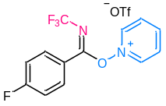
White solid, mp 152.0–152.9 ℃. ¹H NMR (500 MHz, Acetone-D₆): δ = 7.50 (tt, J₁ = 2.5 Hz, J₁ = 9.0 Hz, 2H), 8.19 (dd, J₁ = 5.5 Hz, J₁ = 9.0 Hz, 2H), 8.60 (tt, J₁ = 2.3 Hz, J₁ = 7.3 Hz, 2H), 9.05 (t, J = 7.8 Hz, 1H), 9.81 (d, J = 5.5 Hz, 2H). ¹³C NMR (125 MHz, Acetone-D₆): δ = 116.3 (d, J = 22.3 Hz, 2C), 121.2 (q, J = 321.1 Hz), 121.3 (d, J = 3.6 Hz), 121.4 (q, J =257.0 Hz), 129.9 (2C), 132.9 (d, J = 9.6 Hz, 2C), 143.2 (2C), 148.4, 165.8 (d, J =253.6 Hz), 167.1 (q, J = 6.9 Hz). ¹⁹F NMR (470 MHz, Acetone-D₆): δ = -52.6 (s, 3F), -79.0 (s, 3F), -104.5–-104.6 (m, 1F). HRMS (ESI-TOF) Calc’d for C₁₃H₉F₄N₂O [M-OTf]⁺: 285.0646; found: 285.0645.

(E)-1-((4-chlorophenyl)((trifluoromethyl)imino)methoxy)pyridin-1-ium trifluoromethanesulfonate (1p)
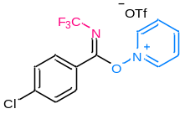
White solid, mp 164.6–165.5 ℃. ¹H NMR (600 MHz, Acetone-D₆): δ = 7.75 (d, J = 8.4 Hz, 2H), 8.13 (d, J = 8.4 Hz, 2H), 8.60 (t, J = 7.5 Hz, 2H), 9.05 (t, J = 7.8 Hz, 1H), 9.81 (d, J = 6.0 Hz, 2H). ¹³C NMR (151 MHz, Acetone-D₆): δ = 121.1 (q, J = 320.9 Hz), 121.3 (q, J = 259.0 Hz), 123.7, 129.1 (2C), 129.8 (2C), 131.5 (2C), 139.8, 143.1 (2C), 148.4, 167.0 (q, J = 6.7 Hz). ¹⁹F NMR (565 MHz, Acetone-D₆): δ = -52.5 (s, 3F), -78.9 (s, 3F). HRMS (ESI-TOF) Calc’d for C₁₃H₉ClF₃N₂O [M-OTf]⁺: 301.0350; found: 301.0350.

(E)-1-((4-bromophenyl)((trifluoromethyl)imino)methoxy)pyridin-1-ium trifluoromethanesulfonate (1q)
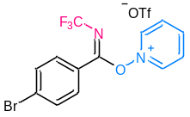
White solid, mp 172.8–173.7 ℃. ¹H NMR (500 MHz, Acetone-D₆): δ = 7.90 (d, J = 8.5 Hz, 2H), 8.05 (d, J = 8.5 Hz, 2H), 8.59 (t, J = 7.5 Hz, 2H), 9.05 (t, J = 7.8 Hz, 1H), 9.81 (d, J = 6.0 Hz, 2H). ¹³C NMR (125 MHz, Acetone-D₆): δ = 121.1 (q, J = 319.1 Hz), 121.2 (q, J = 257.4 Hz), 124.1, 128.4, 129.8 (2C), 131.4 (2C), 132.1 (2C), 143.0 (2C), 148.4, 167.1 (q, J = 6.7 Hz). ¹⁹F NMR (470 MHz, Acetone-D₆): δ = -52.5 (s, 3F), -78.9 (s, 3F). HRMS (ESI-TOF) Calc’d for C₁₃H₉BrF₃N₂O [M-OTf]⁺: 344.9845; found: 344.9851.

(E)-1-((3-bromophenyl)((trifluoromethyl)imino)methoxy)pyridin-1-ium trifluoromethanesulfonate (1r)
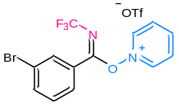
White solid, mp 156.2–157.1 ℃. ¹H NMR (600 MHz, Acetone-D₆): δ = 7.68 (t, J = 7.8 Hz, 1H), 7.99 (d, J = 8.4 Hz, 1H), 8.10 (d, J = 7.8 Hz, 1H), 8.30 (s, 1H), 8.60 (t, J = 7.8 Hz, 2H), 9.05 (t, J = 7.8 Hz, 1H), 9.84 (d, J = 6.0 Hz, 2H). ¹³C NMR (151 MHz, Acetone-D₆): δ = 121.0 (q, J = 321.0 Hz), 121.1 (q, J = 259.4 Hz), 121.9, 126.9, 128.5, 129.8 (2C), 130.8, 131.9, 136.7, 143.0 (2C), 148.4, 166.3 (q, J = 6.7 Hz). ¹⁹F NMR (565 MHz, Acetone-D₆): δ = -52.6 (s, 3F), -78.8 (s, 3F). HRMS (ESI-TOF) Calc’d for C₁₃H₉BrF₃N₂O [M-OTf]⁺: 344.9845; found: 344.9851.

(E)-1-((2-bromophenyl)((trifluoromethyl)imino)methoxy)pyridin-1-ium trifluoromethanesulfonate (1s)
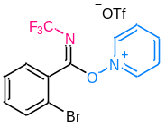
White solid, mp 165.9–166.8 ℃. ¹H NMR (600 MHz, Acetone-D₆): δ = 7.72–7.77 (m, 2H), 7.94 (dd, J₁ = 1.5 Hz, J₁ = 7.5 Hz, 1H), 8.11 (dd, J₁ = 1.8 Hz, J₁ = 7.2 Hz, 1H), 8.65 (t, J = 7.2 Hz, 2H), 9.11 (t, J = 7.5 Hz, 1H), 9.75 (d, J = 6.6 Hz, 2H). ¹³C NMR (151 MHz, Acetone-D₆): δ = 120.2, 120.9 (q, J = 260.7 Hz), 121.2 (q, J = 321.1 Hz), 127.0, 128.1, 130.3 (2C), 131.1, 133.0, 134.8, 142.6 (2C), 148.9, 167.2 (q, J = 6.7 Hz). ¹⁹F NMR (565 MHz, Acetone-D₆): δ = -54.6 (s, 3F), -78.8 (s, 3F). HRMS (ESI-TOF) Calc’d for C₁₃H₉BrF₃N₂O [M-OTf]⁺: 344.9845; found: 344.9839.

(E)-1-((3,5-dimethylphenyl)((trifluoromethyl)imino)methoxy)pyridin-1-ium trifluoromethanesulfonate (1t)
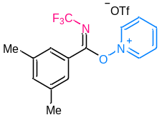
White solid, mp 164.0–164.9 ℃. ¹H NMR (600 MHz, Acetone-D₆): δ = 2.43 (s, 6H), 7.47 (s, 1H), 7.66 (s, 2H), 8.62 (t, J = 7.5 Hz, 2H), 9.05 (t, J = 7.8 Hz, 1H), 9.79 (t, J = 7.2 Hz, 2H). ¹³C NMR (151 MHz, Acetone-D₆): δ = 20.3 (2C), 121.4 (q, J = 321.5 Hz), 121.5 (q, J = 258.5 Hz), 124.9, 127.0 (2C), 130.0 (2C), 135.6, 138.9 (2C), 143.2 (2C), 148.4, 168.4 (q, J = 6.8 Hz). ¹⁹F NMR (565 MHz, Acetone-D₆): δ = -52.5 (s, 3F), -78.9 (s, 3F). HRMS (ESI-TOF) Calc’d for C₁₅H₁₄F₃N₂O [M-OTf]⁺: 295.1053; found: 295.1055.

(E)-1-(naphthalen-2-yl((trifluoromethyl)imino)methoxy)pyridin-1-ium trifluoromethanesulfonate (1u)
White solid, mp 182.6–183.5 ℃. ¹H NMR (500 MHz, Acetone-D₆): δ = 7.70 (t, J = 7.5 Hz, 1H), 7.76 (t, J = 7.5 Hz, 1H), 8.04–8.08 (m, 2H), 8.18 (t, J = 8.3 Hz, 2H), 8.55 (t, J = 7.2 Hz, 2H), 8.81 (s, 1H), 9.00 (t, J = 7.8 Hz, 1H), 9.83 (d, J = 6.0 Hz, 2H). ¹³C NMR (125 MHz, Acetone-D₆): δ = 121.3 (q, J = 319.1 Hz), 121.5 (q, J = 257.3 Hz), 122.1, 124.4, 127.7, 128.0, 128.7, 129.3, 129.5, 129.7 (2C), 131.7, 131.9, 135.3, 143.1 (2C), 148.2, 168.0 (q, J = 6.7 Hz). ¹⁹F NMR (470 MHz, Acetone-D₆): δ = -52.3 (s, 3F), -78.8 (s, 3F). HRMS (ESI-TOF) Calc’d for C₁₇H₁₂F₃N₂O [M-OTf]⁺: 317.0896; found: 317.0904.

(E)-1-(thiophen-2-yl((trifluoromethyl)imino)methoxy)pyridin-1-ium trifluoromethanesulfonate (1v)
White solid, mp 138.9–139.8 ℃. ¹H NMR (600 MHz, Acetone-D₆): δ = 7.50 (t, J = 4.5 Hz, 1H), 8.28 (d, J = 4.2 Hz, 1H), 8.38 (dd, J₁ = 1.2 Hz, J₁ = 5.4 Hz, 1H), 8.62 (t, J = 7.2 Hz, 2H), 9.06 (t, J = 7.8 Hz, 1H), 9.74 (d, J = 6.0 Hz, 2H). ¹³C NMR (151 MHz, Acetone-D₆): δ = 121.3 (q, J = 321.2 Hz), 121.6 (q, J = 257.8 Hz), 122.9, 129.2, 129.9 (2C), 138.2, 138.7 (q, J = 3.1 Hz), 143.3 (2C), 148.4, 160.5 (q, J = 7.0 Hz). ¹⁹F NMR (565 MHz, Acetone-D₆): δ = -53.6 (s, 3F), -78.9 (s, 3F). HRMS (ESI-TOF) Calc’d for C₁₁H₈F₃N₂OS [M-OTf]⁺: 273.0304; found: 273.0306.

(E)-1-(benzofuran-2-yl((trifluoromethyl)imino)methoxy)pyridin-1-ium trifluoromethanesulfonate (1w)
White solid, mp 166.9–167.8 ℃. ¹H NMR (600 MHz, Acetone-D₆): δ = 7.53 (t, J = 7.8 Hz, 1H), 7.73 (t, J = 7.8 Hz, 1H), 7.80 (d, J = 8.4 Hz, 1H), 8.03 (d, J = 7.8 Hz, 1H), 8.38 (s, 1H), 8.64 (t, J = 7.5 Hz, 2H), 9.08 (t, J = 7.8 Hz, 1H), 9.76 (d, J = 6.0 Hz, 2H). ¹³C NMR (151 MHz, Acetone-D₆): δ = 112.2, 120.5, 121.3 (q, J = 321.4 Hz), 121.4 (q, J = 258.8 Hz), 124.3, 125.1, 126.2, 130.0 (2C), 130.3, 138.5, 143.3 (2C), 148.5, 156.3 (q, J = 6.9 Hz), 156.9. ¹⁹F NMR (565 MHz, Acetone-D₆): δ = -53.4 (s, 3F), -78.9 (s, 3F). HRMS (ESI-TOF) Calc’d for C₁₅H₁₀F₃N₂O₂ [M-OTf]⁺: 307.0689; found: 307.0694.

Synthesis of 3

Supplementary Fig. 9. Unsuccessful substrates of (hetero)arenes.

General procedure for the synthesis of compounds 3 (taking 3a as an example):
A 35 mL flask was charged with 1e (105 mg, 0.3 mmol), Ir(dFppy)₃ (2.4 mg, 0.003 mmol) and a stir bar under N₂, then a solution of 2a (158 µL, 0.9 mmol) in DCM (9 mL) was added. The reaction mixture was stirred for 12 h under the irradiation of blue LED light (18 W) at room temperature. After the completion of the reaction as indicated by TLC, resulting mixture was added to H₂O (15 mL) and extracted with DCM (20 mL × 3). The organic layers were washed with brine, dried over anhydrous Na₂SO₄, concentrated in vacuo, and purified by silica column chromatography (petroleum ether: ethyl acetate = 15: 1) to give 3a (66 mg, 76%) as white solid.

N-(5-(tert-butyl)-2-methoxyphenyl)-N-(trifluoromethyl)acetamide (3a)
Colorless solid, mp 112.9–113.8 ℃. R_{f} = 0.40 (PE: EA = 8: 1). ¹H NMR (600 MHz, CDCl₃): δ = 1.31 (s, 9H), 1.93 (br, 3H), 3.85 (s, 3H), 6.94 (d, J = 9.0 Hz, 1H), 7.21 (d, J = 2.4 Hz, 1H), 7.44 (dd, J₁ = 2.4 Hz, J₂ = 8.4 Hz, 1H). ¹³C NMR (151 MHz, CDCl₃): δ = 23.2 (q, J = 2.5 Hz), 31.3 (3C), 34.1, 55.8, 111.6, 119.9 (q, J = 264.4 Hz), 124.1, 127.7, 127.9, 144.4, 153.6, 170.7. ¹⁹F NMR (565 MHz, CDCl₃): δ = -55.9 (br, 3F). HRMS (ESI-TOF) Calc’d for C₁₄H₁₈F₃NNaO₂ [M+Na]⁺: 312.1182; found: 312.1180.

Table S3. Preparation of 3a in a large scale.
Entry | Product | Yield of Product^{c} [%]
1ª | 1e | 96  (3.69 g)
2^{b} | 2a | 65  (1.89 g)
ªReaction conditions: PhICF₃Cl (15 mmol), MeCN (30 mL), pyridine-N-oxide (11 mmol), NaPF₆ (22 mmol). ^{b}Reaction conditions: 1e (10 mmol), 2a (30 mmol), Ir(dFppy)₃ (0.1 mmol), DCM (60 mL), RT, Blue LEDs (18 W), 36 h.

N-phenyl-N-(trifluoromethyl)acetamide (3b)
Colorless oil. R_{f} = 0.50 (PE: EA = 10: 1). ¹H NMR (500 MHz, CDCl₃): δ = 1.93 (s, 3H), 7.20–7.22 (m, 2H), 7.41–7.43 (m, 3H). ¹³C NMR (151 MHz, CDCl₃): δ = 24.1 (q, J = 2.7 Hz), 120.0 (q, J = 263.6 Hz), 129.3 (2C), 129.8, 129.9 (2C), 135.9, 170.2. ¹⁹F NMR (565 MHz, CDCl₃): δ = -54.3 (br, 3F). HRMS (ESI-TOF) Calc’d for C₉H₈F₃NNaO [M+Na]⁺: 226.0450; found: 226.0448.

N-(4-methoxyphenyl)-N-(trifluoromethyl)acetamide (para-3c) and N-(2-methoxyphenyl)-N-(trifluoromethyl)acetamide (ortho-3c)
Colorless oil. R_{f} = 0.30 (PE: EA = 10: 1). ¹H NMR (600 MHz, CDCl₃): δ = 1.94–1.99 (m, 3H), 3.85 (s, 2.16H), 3.88 (s, 0.84H), 6.97 (td, J₁ = 2.7 Hz, J₁ = 8.4 Hz, 1.42H), 7.01–7.04 (m, 0.54H), 7.19 (td, J₁ = 2.7 Hz, J₁ = 8.4 Hz, 1.42H), 7.23 (d, J = 6.6 Hz, 0.29H), 7.44 (t, J = 7.8 Hz, 0.29H). ¹³C NMR (151 MHz, CDCl₃): δ = 23.2 (q, J = 2.6 Hz), 24.0 (q, J = 2.6 Hz), 55.5, 55.7, 112.1 (2C), 115.0, 120.1 (q, J = 263.5 Hz), 121.0, 124.6, 128.4, 130.3 (2C), 130.8, 131.4, 156.0, 160.3, 170.7. ¹⁹F NMR (565 MHz, CDCl₃): δ = -54.8 (br, 2.27F), -56.1 (br, 0.73F). HRMS (ESI-TOF) Calc’d for C₁₀H₁₀F₃NNaO₂ [M+Na]⁺: 256.0556; found: 256.0557.

N-(2-methoxy-5-(2,4,4-trimethylpentan-2-yl)phenyl)-N-(trifluoromethyl)acetamide (3d)
Colorless solid, mp 94.7–95.6 ℃. R_{f} = 0.40 (PE: EA = 8: 1). ¹H NMR (600 MHz, CDCl₃): δ = 0.71 (s, 9H), 1.36 (s, 6H), 1.70–1.74 (m, 2H), 1.91 (br, 3H), 3.85 (s, 3H), 6.93 (d, J = 8.4 Hz, 1H), 7.20 (d, J = 2.4 Hz, 1H), 7.44 (dd, J₁ = 2.4 Hz, J₂ = 9.0 Hz, 1H). ¹³C NMR (151 MHz, CDCl₃): δ = 23.2 (q, J = 2.4 Hz), 31.3, 31.7 (3C), 31.8, 32.3, 37.9, 55.8, 56.9, 111.4, 119.9 (q, J = 263.5 Hz), 124.0, 128.7, 128.8, 143.2, 153.5, 170.8. ¹⁹F NMR (565 MHz, CDCl₃): δ = -55.9 (br, 3F). HRMS (ESI-TOF) Calc’d for C₁₈H₂₆F₃NNaO₂ [M+Na]⁺: 368.1808; found: 368.1814.

N-(5-((3r,5r,7r)-adamantan-1-yl)-2-methoxyphenyl)-N-(trifluoromethyl)acetamide (3e)
Colorless solid, mp 127.9–128.7 ℃. R_{f} = 0.40 (PE: EA = 8: 1). ¹H NMR (600 MHz, CDCl₃): δ = 1.73–1.81 (m, 6H), 1.87–1.92 (m, 9H), 2.10 (s, 3H), 3.84 (s, 3H), 6.95 (d, J = 8.4 Hz, 1H), 7.18 (d, J = 2.4 Hz, 1H), 7.41 (dd, J₁ = 2.4 Hz, J₂ = 9.0 Hz, 1H). ¹³C NMR (151 MHz, CDCl₃): δ = 23.2 (q, J = 2.6 Hz), 28.8 (3C), 35.6, 36.6 (3C), 43.2 (3C), 55.8, 111.6, 119.9 (q, J = 267.0 Hz), 124.2, 127.4, 127.5, 144.7, 153.6, 170.8. ¹⁹F NMR (565 MHz, CDCl₃): δ = -55.9 (br, 3F). HRMS (ESI-TOF) Calc’d for C₂₀H₂₄F₃NNaO₂ [M+Na]⁺: 390.1651; found: 390.1648.

N-(5-bromo-2-methoxyphenyl)-N-(trifluoromethyl)acetamide (3f)
Colorless oil. R_{f} = 0.40 (PE: EA = 4: 1). ¹H NMR (600 MHz, CDCl₃): δ = 2.01 (br, 3H), 3.86 (s, 3H), 6.91 (d, J = 9.0 Hz, 1H), 7.38 (d, J = 2.4 Hz, 1H), 7.54 (dd, J₁ = 2.4 Hz, J₂ = 9.0 Hz, 1H), ¹³C NMR (151 MHz, CDCl₃): δ = 23.1 (q, J = 2.7 Hz), 56.1, 112.4, 113.6, 119.8 (q, J = 263.0 Hz), 125.7, 133.7, 134.2, 155.4, 169.9. ¹⁹F NMR (565 MHz, CDCl₃): δ = -55.6 (br, 3F). HRMS (ESI-TOF) Calc’d for C₁₀H₉BrF₃NNaO₂ [M+Na]⁺: 333.9661; found: 333.9652.

N-(2,5-dimethylphenyl)-N-(trifluoromethyl)acetamide (3g)
Colorless oil. R_{f} = 0.45 (PE: EA = 10: 1). ¹H NMR (600 MHz, CDCl₃): δ = 1.95 (br, 3H), 2.24 (s, 3H), 2.35 (s, 3H), 7.00 (s, 1H), 7.17 (d, J = 7.8 Hz, 1H), 7.21 (d, J = 7.8 Hz, 1H). ¹³C NMR (151 MHz, CDCl₃): δ = 17.1, 20.7, 23.5 (q, J = 2.7 Hz), 120.1 (q, J = 263.6 Hz), 129.8, 130.8, 131.3, 134.1, 134.8, 137.5, 170.2. ¹⁹F NMR (565 MHz, CDCl₃): δ = -55.0 (br, 3F). HRMS (ESI-TOF) Calc’d for C₁₁H₁₂F₃NNaO [M+Na]⁺: 254.0763; found: 254.0757.

N-mesityl-N-(trifluoromethyl)acetamide (3h)
Colorless solid, mp 68.9–69.8 ℃. R_{f} = 0.40 (PE: EA = 10: 1). ¹H NMR (600 MHz, CDCl₃): δ = 1.78 (s, 3H), 2.23 (s, 6H), 2.31 (s, 3H), 6.98 (s, 2H). ¹³C NMR (151 MHz, CDCl₃): δ = 17.8 (2C), 20.9, 22.8 (q, J = 2.5 Hz), 119.8 (q, J = 260.2 Hz), 129.8 (2C), 131.9, 137.1 (2C), 139.8, 170.6. ¹⁹F NMR (565 MHz, CDCl₃): δ = -50.4 (s, 0.5F), -55.6 (s, 2.5F). HRMS (ESI-TOF) Calc’d for C₁₂H₁₄F₃NNaO [M+Na]⁺: 268.0920; found: 268.0910.

N-(trifluoromethyl)-N-(2,4,6-trimethoxyphenyl)acetamide (3i)
Colorless solid, mp 80.8–81.6 ℃. R_{f} = 0.40 (PE: EA = 5: 1). ¹H NMR (600 MHz, CDCl₃): δ = 1.82 (s, 3H), 3.83 (s, 6H), 3.85 (s, 3H), 6.16 (s, 2H). ¹³C NMR (151 MHz, CDCl₃): δ = 22.5, 55.5, 56.0 (2C), 90.7, 108.9, 157.9, 159.1, 162.3, 172.0. ¹⁹F NMR (565 MHz, CDCl₃): δ = -57.4 (s, 3F). HRMS (ESI-TOF) Calc’d for C₁₂H₁₄F₃NNaO₄ [M+Na]⁺: 316.0767; found: 316.0770.

N-(naphthalen-1-yl)-N-(trifluoromethyl)acetamide (α-3j) and N-(naphthalen-2-yl)-N-(trifluoromethyl)acetamide (β-3j)
Colorless solid, R_{f} = 0.50 (PE: EA = 10: 1). ¹H NMR (600 MHz, CDCl₃): δ = 1.89 (s, 2.78H), 2.03 (s, 0.22H), 7.34 (d, J = 7.5 Hz, 0.07H), 7.48 (d, J = 7.2 Hz, 0.92H), 7.54 (t, J = 7.8 Hz, 0.92H), 7.57–7.60 (m, 1H), 7.64 (t, J = 7.8 Hz, 0.92H), 7.80 (s, 0.07H), 7.87 (d, J = 9.0 Hz, 0.07H), 7.91 (d, J = 8.4 Hz, 0.07H), 7.94–7.96 (m, 1.84H), 7.98 (d, J = 8.4 Hz, 0.92H). ¹³C NMR (151 MHz, CDCl₃): δ = 23.4 (q, J = 2.3 Hz), 24.1, 120.2 (q, J = 264.5 Hz), 121.8, 125.5, 126.2, 127.0, 127.2, 127.6, 127.8, 128.1, 128.2, 128.5, 128.6, 130.1, 130.6, 131.3, 132.3, 133.2, 133.3, 134.6, 170.3, 170.6. ¹⁹F NMR (565 MHz, CDCl₃): δ = -54.2 (s, 0.32F), -55.0 (s, 2.68F). HRMS (ESI-TOF) Calc’d for C₁₃H₁₀F₃NNaO [M+Na]⁺: 276.0607; found: 276.0605.

N-(2-methoxynaphthalen-1-yl)-N-(trifluoromethyl)acetamide (3k)
Colorless solid, mp 124.8–125.7 ℃. R_{f} = 0.45 (PE: EA = 10: 1). ¹H NMR (600 MHz, CDCl₃): δ = 1.77 (br, 3H), 4.01 (s, 3H), 7.36 (d, J = 9.0 Hz, 1H), 7.43 (t, J = 7.5 Hz, 1H), 7.59 (t, J = 7.8 Hz, 1H), 7.83–7.86 (m, 2H), 7.98 (d, J = 9.0 Hz, 1H). ¹³C NMR (151 MHz, CDCl₃): δ = 22.7, 56.5, 113.0, 117.7, 120.0 (q, J = 275.1 Hz), 120.9, 124.5, 128.3, 128.7, 129.0, 131.9, 132.5, 154.1, 171.4. ¹⁹F NMR (565 MHz, CDCl₃): δ = -56.3 (s, 3F). HRMS (ESI-TOF) Calc’d for C₁₄H₁₂F₃NNaO₂ [M+Na]⁺: 306.0712; found: 306.0709.

methyl 1-methyl-5-(N-(trifluoromethyl)acetamido)-1H-pyrrole-2-carboxylate (3l)
Colorless solid, mp 52.1–53.0 ℃. R_{f} = 0.55 (PE: EA = 10: 1). ¹H NMR (600 MHz, CDCl₃): δ = 1.98 (s, 3H), 3.80 (s, 3H), 3.86 (s, 3H), 6.21 (d, J = 4.2 Hz, 1H), 6.96 (d, J = 4.2 Hz, 1H). ¹³C NMR (151 MHz, CDCl₃): δ = 22.9 (q, J = 2.5 Hz), 31.5, 51.4, 108.3, 116.3, 119.5 (q, J = 265.2 Hz), 122.7, 128.2, 161.1, 170.0. ¹⁹F NMR (565 MHz, CDCl₃): δ = -56.6 (s, 3F). HRMS (ESI-TOF) Calc’d for C₁₀H₁₁F₃N₂NaO₃ [M+Na]⁺: 287.0614; found: 287.0604.

tert-butyl 2-(N-(trifluoromethyl)acetamido)-1H-pyrrole-1-carboxylate (3m)
Colorless solid, mp 62.1–63.0 ℃. R_{f} = 0.50 (PE: EA = 10: 1). ¹H NMR (600 MHz, CDCl₃): δ = 1.58 (s, 9H), 2.02 (s, 3H), 6.21 (t, J = 3.6 Hz, 1H), 6.30 (dd, J₁ = 1.8 Hz, J₂ = 3.6 Hz, 1H), 7.35 (dd, J₁ = 1.8 Hz, J₂ = 3.6 Hz, 1H). ¹³C NMR (151 MHz, CDCl₃): δ = 22.9 (q, J = 2.3 Hz), 27.8 (3C), 85.7, 109.5, 114.8, 119.4 (q, J = 264.1 Hz), 122.5, 122.7, 147.8, 170.3. ¹⁹F NMR (565 MHz, CDCl₃): δ = -56.9 (s, 3F). HRMS (ESI-TOF) Calc’d for C₁₂H₁₅F₃N₂NaO₃ [M+Na]⁺: 315.0927; found: 315.0923.

N-(1-phenyl-1H-pyrrol-2-yl)-N-(trifluoromethyl)acetamide (3n)
Colorless solid, mp 58.6–59.5 ℃. R_{f} = 0.50 (PE: EA = 10: 1). ¹H NMR (600 MHz, CDCl₃): δ = 1.89 (s, 3H), 6.31 (d, J = 2.4 Hz, 2H), 6.88 (t, J = 2.7 Hz, 1H), 7.25 (d, J = 7.8 Hz, 2H), 7.40 (t, J = 7.2 Hz, 1H), 7.45 (t, J = 7.8 Hz, 2H). ¹³C NMR (151 MHz, CDCl₃): δ = 23.1 (q, J = 2.3 Hz), 108.6, 109.6, 119.8 (q, J = 264.6 Hz), 122.6, 123.0, 125.6 (2C), 128.3, 129.5 (2C), 137.7, 171.0. ¹⁹F NMR (565 MHz, CDCl₃): δ = -56.3 (s, 3F). HRMS (ESI-TOF) Calc’d for C₁₃H₁₁F₃N₂NaO [M+Na]⁺: 291.0716; found: 291.0712.

methyl 5-(N-(trifluoromethyl)acetamido)furan-2-carboxylate (3o)
Colorless solid, mp 55.6–56.4 ℃. R_{f} = 0.55 (PE: EA = 10: 1). ¹H NMR (600 MHz, CDCl₃): δ = 2.09 (s, 3H), 3.93 (s, 3H), 6.56 (d, J = 3.6 Hz, 1H), 7.24 (d, J = 3.6 Hz, 1H). ¹³C NMR (151 MHz, CDCl₃): δ = 22.8 (q, J = 2.4 Hz), 52.3, 111.2, 118.8, 118.9 (q, J = 266.2 Hz), 143.4, 143.5, 158.2, 168.8. ¹⁹F NMR (565 MHz, CDCl₃): δ = -56.5 (s, 3F). HRMS (ESI-TOF) Calc’d for C₉H₈F₃NNaO₄ [M+Na]⁺: 274.0298; found: 274.0295.

N-(3,4-dimethoxythiophen-2-yl)-N-(trifluoromethyl)acetamide (3p)
Colorless solid, mp 64.2–65.0 ℃. R_{f} = 0.30 (PE: EA = 10: 1). ¹H NMR (600 MHz, CDCl₃): δ = 2.08 (s, 3H), 3.86 (s, 3H), 3.92 (s, 3H), 6.23 (s, 1H). ¹³C NMR (151 MHz, CDCl₃): δ = 23.0 (q, J = 2.3 Hz), 56.9, 60.1, 95.9, 117.9, 119.5 (q, J = 265.4 Hz), 144.5, 148.7, 170.7. ¹⁹F NMR (565 MHz, CDCl₃): δ = -56.5 (s, 3F). HRMS (ESI-TOF) Calc’d for C₉H₁₀F₃NNaO₃S [M+Na]⁺: 292.0226; found: 292.0222.

N-(4-oxo-4,5,6,7-tetrahydrobenzo[b]thiophen-2-yl)-N-(trifluoromethyl)acetamide (3q)
Colorless solid, mp 109.7–110.6 ℃. R_{f} = 0.40 (PE: EA = 10: 1). ¹H NMR (600 MHz, CDCl₃): δ = 2.17 (s, 3H), 2.25–2.30 (m, 2H), 2.60 (t, J = 6.3 Hz, 2H), 3.04 (d, J = 6.0 Hz, 2H), 7.31 (s, 1H). ¹³C NMR (151 MHz, CDCl₃): δ = 23.5 (q, J = 2.5 Hz), 24.0, 25.4, 37.5, 119.5 (q, J = 265.5 Hz), 126.4, 133.8, 136.0, 156.8, 169.7, 192.0. ¹⁹F NMR (565 MHz, CDCl₃): δ = -55.9 (s, 3F). HRMS (ESI-TOF) Calc’d for C₁₁H₁₀F₃NNaO₂S [M+Na]⁺: 300.0277; found: 300.0286.

N-(5'-bromo-[2,2'-bithiophen]-5-yl)-N-(trifluoromethyl)acetamide (3r)
Yellow solid, mp 123.1–124.0 ℃. R_{f} = 0.45 (PE: EA = 10: 1). ¹H NMR (600 MHz, CDCl₃): δ = 2.17 (s, 3H), 6.94 (t, J = 3.6 Hz, 2H), 6.98 (d, J = 3.6 Hz, 1H), 7.00 (d, J = 4.2 Hz, 1H). ¹³C NMR (151 MHz, CDCl₃): δ = 23.5 (q, J = 2.3 Hz), 112.5, 119.5 (q, J = 265.7 Hz), 122.2, 124.9, 129.8, 130.8, 134.6, 137.4, 138.2, 170.1. ¹⁹F NMR (565 MHz, CDCl₃): δ = -56.2 (s, 3F). HRMS (ESI-TOF) Calc’d for C₁₁H₇BrF₃NNaOS₂ [M+Na]⁺: 391.8997; found: 391.8969.

tert-butyl 2-(N-(trifluoromethyl)acetamido)-1H-indole-1-carboxylate (3s)
Colorless solid, mp 107.6–108.5 ℃. R_{f} = 0.40 (PE: EA = 10: 1). ¹H NMR (600 MHz, CDCl₃): δ = 1.64 (s, 9H), 2.11 (s, 3H), 6.71 (s, 1H), 7.30 (t, J = 7.5 Hz, 1H), 7.43 (t, J = 7.8 Hz, 1H), 7.59 (d, J = 7.8 Hz, 1H), 8.23 (d, J = 8.4 Hz, 1H). ¹³C NMR (151 MHz, CDCl₃): δ = 23.2 (q, J = 2.3 Hz), 28.0 (3C), 85.6, 110.7, 115.9, 119.5 (q, J = 264.7 Hz), 121.4, 123.5, 126.1, 126.2, 128.2, 135.5, 148.7, 169.8. ¹⁹F NMR (565 MHz, CDCl₃): δ = -56.6 (s, 3F). HRMS (ESI-TOF) Calc’d for C₁₆H₁₇F₃N₂NaO₃ [M+Na]⁺: 365.1083; found: 365.1073.

tert-butyl 3-methyl-2-(N-(trifluoromethyl)acetamido)-1H-indole-1-carboxylate (3t)
Colorless solid, mp 116.2–117.1 ℃. R_{f} = 0.40 (PE: EA = 10: 1). ¹H NMR (600 MHz, CDCl₃): δ = 1.55 (s, 9H), 1.94 (br, 3H), 2.16 (s, 3H), 7.23 (t, J = 7.5 Hz, 1H), 7.35 (t, J = 7.8 Hz, 1H), 7.48 (d, J = 7.8 Hz, 1H), 8.15 (d, J = 8.4 Hz, 1H). ¹³C NMR (151 MHz, CDCl₃): δ = 7.8, 23.0 (q, J = 2.3 Hz), 28.0 (3C), 85.2, 115.9, 118.6, 119.5 (q, J = 263.1 Hz), 119.6, 123.1, 124.8, 126.5, 127.3, 134.9, 148.9, 170.1. ¹⁹F NMR (565 MHz, CDCl₃): δ = -56.7 (s, 3F). HRMS (ESI-TOF) Calc’d for C₁₇H₁₉F₃N₂NaO₃ [M+Na]⁺: 379.1240; found: 379.1240.

N-(3-methylbenzofuran-2-yl)-N-(trifluoromethyl)acetamide (3u)
Colorless solid, mp 80.1–80.9 ℃. R_{f} = 0.40 (PE: EA = 10: 1). ¹H NMR (600 MHz, CDCl₃): δ = 2.04 (s, 3H), 2.24 (s, 3H), 7.32 (t, J = 7.5 Hz, 1H), 7.41 (t, J = 7.5 Hz, 1H), 7.47 (d, J = 8.4 Hz, 1H), 7.57 (d, J = 7.8 Hz, 1H). ¹³C NMR (151 MHz, CDCl₃): δ = 7.40, 22.7 (q, J = 2.2 Hz), 111.6, 114.4, 119.3 (q, J = 266.3 Hz), 120.3, 123.2, 126.2, 128.3, 139.6, 152.3, 169.6. ¹⁹F NMR (565 MHz, CDCl₃): δ = -56.8 (s, 3F). HRMS (ESI-TOF) Calc’d for C₁₂H₁₀F₃NNaO₂ [M+Na]⁺: 280.0556; found: 280.0547.

N-(3-methylbenzo[b]thiophen-2-yl)-N-(trifluoromethyl)acetamide (3v)
Colorless solid, mp 54.6–55.5 ℃. R_{f} = 0.35 (PE: EA = 10: 1). ¹H NMR (600 MHz, CDCl₃): δ = 2.09 (s, 3H), 2.36 (s, 3H), 7.44–7.47 (m, 2H), 7.74–7.77 (m, 1H), 7.78–7.81 (m, 1H). ¹³C NMR (151 MHz, CDCl₃): δ = 10.9, 23.3 (q, J = 2.3 Hz), 119.6 (q, J = 263.1 Hz), 122.6, 123.0, 124.8, 126.3, 130.6, 133.2, 137.5, 138.1, 170.2. ¹⁹F NMR (565 MHz, CDCl₃): δ = -55.9 (s, 3F). HRMS (ESI-TOF) Calc’d for C₁₂H₁₀F₃NNaOS [M+Na]⁺: 296.0327; found: 296.0317.

N-(7-methoxy-2-oxo-2H-chromen-3-yl)-N-(trifluoromethyl)acetamide (3w)
Colorless solid, mp 110.6–111.5 ℃. R_{f} = 0.35 (PE: EA = 2: 1). ¹H NMR (600 MHz, CDCl₃): δ = 2.23 (br, 3H), 3.83 (s, 3H), 6.79 (d, J = 2.4 Hz, 1H), 6.84 (dd, J₁ = 2.4 Hz, J₂ = 8.4 Hz, 1H), 7.37 (d, J = 8.4 Hz, 1H), 7.68 (s, 1H). ¹³C NMR (151 MHz, CDCl₃): δ = 23.0 (q, J = 3.4 Hz), 55.9, 100.8, 111.5, 113.5, 119.1, 120.0 (q, J = 264.0 Hz), 129.7, 144.2, 155.7, 158.5, 164.1, 169.3. ¹⁹F NMR (565 MHz, CDCl₃): δ = -53.7 (s, 3F). HRMS (ESI-TOF) Calc’d for C₁₃H₁₀F₃NNaO₄ [M+Na]⁺: 324.0454; found: 324.0460.

N-(2,6-dimethoxypyridin-3-yl)-N-(trifluoromethyl)acetamide (3x)
White solid, mp 91.2–92.1 ℃. R_{f} = 0.40 (PE: EA = 8: 1). ¹H NMR (600 MHz, CDCl₃): δ = 2.00 (s, 3H), 3.96 (s, 3H), 3.99 (s, 3H), 6.37 (d, J = 8.4 Hz, 1H), 7.40 (d, J = 8.4 Hz, 1H). ¹³C NMR (151 MHz, CDCl₃): δ = 23.2 (q, J = 2.6 Hz), 53.9 (2C), 102.0, 110.9, 119.9 (q, J = 263.8 Hz), 141.6, 159.0, 163.5, 170.5. ¹⁹F NMR (565 MHz, CDCl₃): δ = -55.8 (s, 3F). HRMS (ESI-TOF) Calc’d for C₁₀H₁₁F₃N₂NaO₃ [M+Na]⁺: 287.0614; found: 287.0624.

methyl (S)-2-(6-methoxy-5-(N-(trifluoromethyl)acetamido)naphthalen-2-yl)propanoate (3y)
White solid, mp 104.8–105.6 ℃. R_{f} = 0.45 (PE: EA = 10: 1). ¹H NMR (600 MHz, CDCl₃): δ = 1.60 (d, J = 7.2 Hz, 3H), 1.77 (br, 3H), 3.69 (s, 3H), 3.90 (q, J = 7.2 Hz, 1H), 4.00 (s, 3H), 7.36 (d, J = 9.6 Hz, 1H), 7.56 (t, J = 6.0 Hz, 1H), 7.76 (s, 1H), 7.80 (d, J = 7.2 Hz, 1H), 7.95 (d, J = 9.6 Hz, 1H). ¹³C NMR (151 MHz, CDCl₃): δ = 18.4, 22.7, 45.1, 52.1, 56.5, 113.2, 117.6, 119.9 (q, J = 278.7 Hz), 121.4, 126.5, 128.7, 129.1, 131.7, 131.8, 136.7, 154.0, 171.3, 174.1. ¹⁹F NMR (565 MHz, CDCl₃): δ = -56.3 (s, 3F). HRMS (ESI-TOF) Calc’d for C₁₈H₁₈F₃NNaO₄ [M+Na]⁺: 392.1080; found: 392.1088.

(1S,2R,5S)-2-isopropyl-5-methylcyclohexyl 5-(N-(trifluoromethyl)acetamido)furan-2-carboxylate (3z)
Colorless solid, mp 97.5–98.4 ℃. R_{f} = 0.45 (PE: EA = 10: 1). ¹H NMR (600 MHz, CDCl₃): δ = 0.81 (d, J = 6.6 Hz, 3H), 0.89–0.96 (m, 7H), 1.12 (q, J = 12.0 Hz, 2H), 1.52–1.57 (m, 2H), 1.71–1.75 (m, 2H), 1.88–1.93 (m, 1H), 2.09–2.12 (m, 4H), 4.93 (dt, J₁ = 4.8 Hz, J₂ = 10.8 Hz, 1H), 6.54 (d, J = 3.6 Hz, 1H), 7.18 (d, J = 3.6 Hz, 1H). ¹³C NMR (151 MHz, CDCl₃): δ = 16.5, 20.6, 21.9, 22.9 (q, J = 2.4 Hz), 23.7, 26.5, 31.4, 34.1, 40.8, 47.0, 75.8, 111.0, 118.2, 119.0 (q, J = 266.4 Hz), 143.3, 144.1, 157.4, 168.8. ¹⁹F NMR (565 MHz, CDCl₃): δ = -56.5 (s, 3F). HRMS (ESI-TOF) Calc’d for C₁₈H₂₄F₃NNaO₄ [M+Na]⁺: 398.1550; found: 398.1556.

(8S,9S,10R,13R,14S,17R)-10,13-dimethyl-17-((R)-6-methylheptan-2-yl)-2,3,4,7,8,9,10,11,12,13,14,15,16,17-tetradecahydro-1H-cyclopenta[a]phenanthren-3-yl 5-(N-(trifluoromethyl)acetamido)furan-2-carboxylate (3aa)
Yellow solid, mp 147.7–148.5 ℃. R_{f} = 0.45 (PE: EA = 10: 1). ¹H NMR (600 MHz, CDCl₃): δ = 0.69 (s, 3H), 0.87 (dd, J₁ = 2.4 Hz, J₂ = 6.6 Hz, 6H), 0.92 (d, J = 6.6 Hz, 3H), 0.96–1.03 (m, 3H), 1.06 (s, 3H), 1.08–1.28 (m, 8H), 1.32–1.40 (m, 3H), 1.44–1.62 (m, 6H), 1.71–1.78 (m, 1H), 1.81–1.87 (m, 1H), 1.92 (td, J₁ = 3.3 Hz, J₂ = 7.2 Hz, 1H), 1.96–2.04 (m, 3H), 2.08 (s, 3H), 2.42–2.48 (m, 2H), 4.83–4.89 (m, 1H), 5.41–5.43 (m, 1H), 6.52 (d, J = 3.6 Hz, 1H), 7.19 (d, J = 3.0 Hz, 1H). ¹³C NMR (151 MHz, CDCl₃): δ = 11.8, 18.7, 19.3, 21.0, 22.5, 22.8, 22.9 (q, J = 2.4 Hz), 23.8, 24.3, 27.7, 28.0, 28.2, 31.8, 31.9, 35.8, 36.2, 36.6, 36.9, 38.0, 39.5, 39.7, 42.3, 50.0, 56.1, 56.7, 75.5, 111.1, 118.3, 119.0 (q, J = 266.4 Hz), 123.1, 139.2, 143.3, 144.2, 157.3, 168.9. ¹⁹F NMR (565 MHz, CDCl₃): δ = -56.5 (s, 3F). HRMS (ESI-TOF) Calc’d for C₃₅H₅₀F₃NNaO₄ [M+Na]⁺: 628.3584; found: 628.3576.

N-(trifluoromethyl)-N-(1,3,7-trimethyl-2,6-dioxo-2,3,6,7-tetrahydro-1H-purin-8-yl)acetamide (3ab)
White solid, mp 150.6–151.5 ℃. R_{f} = 0.35 (PE: EA = 1: 1). ¹H NMR (600 MHz, CDCl₃): δ = 2.23 (s, 3H), 3.42 (s, 3H), 3.57 (s, 3H), 3.89 (s, 3H). ¹³C NMR (151 MHz, CDCl₃): δ = 22.9 (q, J = 2.9 Hz), 28.0, 29.9, 31.7, 108.0, 119.2 (q, J = 266.2 Hz), 138.7, 146.3, 151.2, 155.2, 168.3. ¹⁹F NMR (565 MHz, CDCl₃): δ = -54.8 (s, 3F). HRMS (ESI-TOF) Calc’d for C₁₁H₁₂F₃N₅NaO₃ [M+Na]⁺: 342.0784; found: 342.0777.

N-(3,7-dimethyl-2,6-dioxo-1-(5-oxohexyl)-2,3,6,7-tetrahydro-1H-purin-8-yl)-N-(trifluoromethyl)acetamide (3ac)
White solid, mp 133.2–134.1 ℃. R_{f} = 0.35 (PE: EA = 1: 1). ¹H NMR (600 MHz, CDCl₃): δ = 1.64–1.70 (m, 4H), 2.15 (s, 3H), 2.24 (s, 3H), 2.51 (t, J = 7.2 Hz, 2H), 3.55 (s, 3H), 3.88 (s, 3H), 4.02 (t, J = 8.1 Hz, 2H). ¹³C NMR (151 MHz, CDCl₃): δ = 20.9, 22.9 (q, J = 2.9 Hz), 27.3, 29.8, 29.9, 31.7, 41.0, 43.1, 108.0, 119.2 (q, J = 266.3 Hz), 138.7, 146.3, 151.0, 155.0, 168.4, 208.6. ¹⁹F NMR (565 MHz, CDCl₃): δ = -54.8 (s, 3F). HRMS (ESI-TOF) Calc’d for C₁₆H₂₀F₃N₅NaO₄ [M+Na]⁺: 426.1360; found: 426.1365.

N-(1,3-dimethyl-2,4-dioxo-1,2,3,4-tetrahydropyrimidin-5-yl)-N-(trifluoromethyl)acetamide (3ad)
Colorless solid, mp 142.8–143.6 ℃. R_{f} = 0.40 (PE: EA = 1: 1). ¹H NMR (600 MHz, CDCl₃): δ = 2.28 (s, 3H), 3.38 (s, 3H), 3.47 (s, 3H), 7.44 (s, 1H). ¹³C NMR (151 MHz, CDCl₃): δ = 22.8 (q, J = 2.8 Hz), 28.5, 37.4, 110.1, 120.2 (q, J = 263.2 Hz), 144.6, 150.8, 160.2, 169.8. ¹⁹F NMR (565 MHz, CDCl₃): δ = -53.9 (s, 3F). HRMS (ESI-TOF) Calc’d for C₉H₁₀F₃N₃NaO₃ [M+Na]⁺: 288.0566; found: 288.0569.

methyl 5-(3-chloro-N-(trifluoromethyl)propanamido)-1-methyl-1H-pyrrole-2-carboxylate (3ae)
White solid, mp 65.9–66.8 ℃. R_{f} = 0.30 (PE: EA = 10: 1). ¹H NMR (500 MHz, CDCl₃): δ = 2.39 (td, J₁ = 6.8 Hz, J₂ = 17.5 Hz, 1H), 2.71 (td, J₁ = 6.0 Hz, J₂ = 17.0 Hz, 1H), 3.67–3.71 (m, 1H), 3.76–3.80 (m, 1H), 3.81 (s, 3H), 3.87 (s, 3H), 6.24 (d, J = 4.5 Hz, 1H), 6.98 (d, J = 4.5 Hz, 1H). ¹³C NMR (125 MHz, CDCl₃): δ = 31.7, 37.8, 38.0, 51.5, 108.9, 116.4, 119.3 (q, J = 264.5 Hz), 123.1, 126.9, 161.6, 169.7. ¹⁹F NMR (470 MHz, CDCl₃): δ = -57.0 (s, 3F). HRMS (ESI-TOF) Calc’d for C₁₁H₁₂ClF₃N₂NaO₃ [M+Na]⁺: 335.0381; found: 335.0375.

methyl 1-methyl-5-(N-(trifluoromethyl)cyclohexanecarboxamido)-1H-pyrrole-2-carboxylate (3af)
White solid, mp 74.1–75.0 ℃. R_{f} = 0.45 (PE: EA = 10: 1). ¹H NMR (600 MHz, CDCl₃): δ = 0.97–1.11 (m, 2H), 1.16–1.23 (m, 1H), 1.42–1.49 (m, 1H), 1.53–1.61 (m, 2H), 1.65–1.75 (m, 4H), 1.93 (tt, J₁ = 3.3 Hz, J₂ = 11.4 Hz, 1H), 3.78 (s, 3H), 3.87 (s, 3H), 6.21 (d, J = 4.2 Hz, 1H), 6.97 (d, J = 4.2 Hz, 1H). ¹³C NMR (151 MHz, CDCl₃): δ = 25.0, 25.1, 25.2, 28.8, 29.4, 31.6, 42.8 (q, J = 1.8 Hz), 51.4, 108.6, 116.3, 119.6 (q, J = 265.7 Hz), 122.7, 127.9, 161.2, 176.1. ¹⁹F NMR (565 MHz, CDCl₃): δ = -56.7 (s, 3F). HRMS (ESI-TOF) Calc’d for C₁₁H₁₂ClF₃N₂NaO₃ [M+Na]⁺: 355.1240; found: 355.1245.

methyl 1-methyl-5-(N-(trifluoromethyl)cinnamamido)-1H-pyrrole-2-carboxylate (3ag)
White solid, mp 81.6–82.5 ℃. R_{f} = 0.40 (PE: EA = 10: 1). ¹H NMR (600 MHz, CDCl₃): δ = 3.82 (s, 3H), 3.88 (s, 3H), 6.04 (d, J = 15.6 Hz, 1H), 6.28 (d, J = 4.2 Hz, 1H), 7.01 (d, J = 4.2 Hz, 1H), 7.33–7.39 (m, 5H), 7.85 (d, J = 15.6 Hz, 1H). ¹³C NMR (151 MHz, CDCl₃): δ = 31.7, 51.5, 109.4, 115.0 (q, J = 2.4 Hz), 116.5, 119.7 (q, J = 263.2 Hz), 122.9, 127.6, 128.4 (2C), 128.9 (2C), 131.0, 133.7, 147.5, 161.2, 165.2. ¹⁹F NMR (565 MHz, CDCl₃): δ = -56.5 (s, 3F). HRMS (ESI-TOF) Calc’d for C₁₇H₁₅F₃N₂NaO₃ [M+Na]⁺: 375.0927; found: 375.0925.

N-(5-(tert-butyl)-2-methoxyphenyl)-N-(trifluoromethyl)benzamide (3ah)
Colorless solid, mp 122.0–112.8 ℃. R_{f} = 0.45 (PE: EA = 8: 1). ¹H NMR (600 MHz, CDCl₃): δ = 1.20 (s, 9H), 3.73 (s, 3H), 6.68 (d, J = 9.0 Hz, 1H), 7.15 (t, J = 7.8 Hz, 2H), 7.19 (d, J = 2.4 Hz, 1H), 7.22 (dd, J₁ = 2.4 Hz, J₂ = 8.4 Hz, 1H), 7.25 (tt, J₁ = 1.2 Hz, J₂ = 7.5 Hz, 1H), 7.40 (dd, J₁ = 1.5 Hz, J₂ = 8.1 Hz, 2H). ¹³C NMR (151 MHz, CDCl₃): δ = 31.2 (3C), 33.9, 55.6, 111.3, 120.3 (q, J = 264.7 Hz), 124.7, 127.3, 127.5 (2C), 128.0 (2C), 128.9, 130.8, 134.2, 143.9, 153.4, 170.8. ¹⁹F NMR (565 MHz, CDCl₃): δ = -57.4 (br, 3F). HRMS (ESI-TOF) Calc’d for C₁₉H₂₀F₃NNaO₂ [M+Na]⁺: 374.1338; found: 374.1339.

N-mesityl-N-(trifluoromethyl)benzamide (3ai)
Colorless solid, mp 78.2–79.1 ℃. R_{f} = 0.45 (PE: EA = 10: 1). ¹H NMR (600 MHz, CDCl₃): δ = 2.22 (s, 3H), 2.26 (s, 6H), 6.83 (s, 2H), 7.19 (t, J = 7.2 Hz, 2H), 7.32 (t, J = 7.5 Hz, 1H), 7.35 (d, J = 7.2 Hz, 2H). ¹³C NMR (151 MHz, CDCl₃): δ = 18.2 (2C), 20.9, 120.5 (q, J = 264.7 Hz), 127.7 (4C), 129.7 (2C), 131.1, 132.0, 133.9, 137.2 (2C), 139.4, 169.5. ¹⁹F NMR (565 MHz, CDCl₃): δ = -56.3 (s, 3F). HRMS (ESI-TOF) Calc’d for C₁₇H₁₆F₃NNaO [M+Na]⁺: 330.1076; found: 330.1071.

methyl 5-(N-(trifluoromethyl)benzamido)furan-2-carboxylate (3aj)
Colorless solid, mp 73.4–74.2 ℃. R_{f} = 0.55 (PE: EA = 10: 1). ¹H NMR (600 MHz, CDCl₃): δ = 3.90 (s, 3H), 6.28 (d, J = 3.6 Hz, 1H), 7.00 (d, J = 3.6 Hz, 1H), 7.32 (t, J = 7.8 Hz, 2H), 7.44 (t, J = 7.5 Hz, 1H), 7.56 (dd, J₁ = 1.2 Hz, J₂ = 8.4 Hz, 2H). ¹³C NMR (151 MHz, CDCl₃): δ = 52.2, 111.6, 118.7, 119.5 (q, J = 267.3 Hz), 128.3 (2C), 128.4 (2C), 132.2, 132.5, 143.1, 143.7, 158.2, 167.9. ¹⁹F NMR (565 MHz, CDCl₃): δ = -58.2 (s, 3F). HRMS (ESI-TOF) Calc’d for C₁₄H₁₀F₃NNaO₄ [M+Na]⁺: 336.0454; found: 336.0460.

N-(3,4-dimethoxythiophen-2-yl)-N-(trifluoromethyl)benzamide (3ak)
Colorless solid, mp 81.3–82.2 ℃. R_{f} = 0.30 (PE: EA = 10: 1). ¹H NMR (600 MHz, CDCl₃): δ = 3.71 (s, 3H), 3.82 (s, 3H), 6.06 (s, 1H), 7.29 (t, J = 7.8 Hz, 2H), 7.39 (tt, J₁ = 1.4 Hz, J₂ = 7.5 Hz, 1H), 7.62 (dd, J₁ = 1.5 Hz, J₂ = 7.8 Hz, 2H). ¹³C NMR (151 MHz, CDCl₃): δ = 56.7, 60.0, 96.1, 119.1, 120.0 (q, J = 265.9 Hz), 127.9 (2C), 128.4 (2C), 131.8, 133.0, 144.4, 148.4, 170.0. ¹⁹F NMR (565 MHz, CDCl₃): δ = -58.4 (s, 3F). HRMS (ESI-TOF) Calc’d for C₁₄H₁₂F₃NNaO₃S [M+Na]⁺: 354.0382; found: 354.0379.

methyl 1-methyl-5-(N-(trifluoromethyl)benzamido)-1H-pyrrole-2-carboxylate (3al)
White solid, mp 66.4–67.2 ℃. R_{f} = 0.40 (PE: EA = 10: 1). ¹H NMR (600 MHz, CDCl₃): δ = 3.79 (s, 3H), 3.85 (s, 3H), 6.05 (d, J = 4.2 Hz, 1H), 6.78 (d, J = 4.2 Hz, 1H), 7.28 (t, J = 7.8 Hz, 2H), 7.38–7.40 (m, 3H). ¹³C NMR (151 MHz, CDCl₃): δ = 32.1, 51.3, 109.5, 116.2, 120.0 (q, J = 266.2 Hz), 122.3, 127.8 (2C), 128.3 (2C), 128.5, 132.0, 132.7, 161.1, 168.9. ¹⁹F NMR (565 MHz, CDCl₃): δ = -58.1 (s, 3F). HRMS (ESI-TOF) Calc’d for C₁₅H₁₃F₃N₂NaO₃ [M+Na]⁺: 349.0770; found: 349.0780.

methyl 1-methyl-5-(4-methyl-N-(trifluoromethyl)benzamido)-1H-pyrrole-2-carboxylate (3am)
White solid, mp 77.3–78.2 ℃. R_{f} = 0.40 (PE: EA = 10: 1). ¹H NMR (500 MHz, CDCl₃): δ = 2.30 (s, 3H), 3.80 (s, 3H), 3.84 (s, 3H), 6.06 (d, J = 4.5 Hz, 1H), 6.80 (d, J = 4.0 Hz, 1H), 7.07 (d, J = 8.0 Hz, 2H), 7.28 (d, J = 8.5 Hz, 2H). ¹³C NMR (125 MHz, CDCl₃): δ = 21.4, 32.1, 51.3, 109.4, 116.2, 120.1 (q, J = 264.1 Hz), 122.2, 128.1 (2C), 128.8, 129.0 (2C), 129.7, 142.9, 161.2, 168.9. ¹⁹F NMR (470 MHz, CDCl₃): δ = -58.1 (s, 3F). HRMS (ESI-TOF) Calc’d for C₁₆H₁₅F₃N₂NaO₃ [M+Na]⁺: 363.0927; found: 363.0937.

methyl 5-(4-methoxy-N-(trifluoromethyl)benzamido)-1-methyl-1H-pyrrole-2-carboxylate (3an)
White solid, mp 84.6–85.5 ℃. R_{f} = 0.40 (PE: EA = 10: 1). ¹H NMR (600 MHz, CDCl₃): δ = 3.78 (s, 3H), 3.82 (s, 3H), 3.85 (s, 3H), 6.07 (d, J = 4.2 Hz, 1H), 6.76 (td, J₁ = 2.6 Hz, J₂ = 9.0 Hz, 2H), 6.82 (d, J = 4.2 Hz, 1H), 7.37 (td, J₁ = 2.6 Hz, J₂ = 9.0 Hz, 2H). ¹³C NMR (151 MHz, CDCl₃): δ = 32.1, 51.3, 55.3, 109.3, 113.6 (2C), 116.3, 120.1 (q, J = 265.9 Hz), 122.2, 124.4, 129.1, 130.5 (2C), 161.2, 162.7, 168.2. ¹⁹F NMR (565 MHz, CDCl₃): δ = -58.1 (s, 3F). HRMS (ESI-TOF) Calc’d for C₁₆H₁₅F₃N₂NaO₄ [M+Na]⁺: 379.0876; found: 379.0886.

methyl 5-(4-(tert-butyl)-N-(trifluoromethyl)benzamido)-1-methyl-1H-pyrrole-2-carboxylate (3ao)
White solid, mp 69.7–70.6 ℃. R_{f} = 0.40 (PE: EA = 10: 1). ¹H NMR (600 MHz, CDCl₃): δ = 1.26 (s, 9H), 3.82 (s, 3H), 3.87 (s, 3H), 6.06 (d, J = 4.2 Hz, 1H), 6.81 (d, J = 4.2 Hz, 1H), 7.29 (d, J = 8.4 Hz, 2H), 7.33 (d, J = 9.0 Hz, 2H). ¹³C NMR (151 MHz, CDCl₃): δ = 30.9 (3C), 32.1, 34.9, 51.3, 109.4, 116.3, 120.1 (q, J = 266.0 Hz), 122.3, 125.3 (2C), 128.1 (2C), 128.8, 129.5, 156.0, 161.2, 168.6. ¹⁹F NMR (565 MHz, CDCl₃): δ = -58.0 (s, 3F). HRMS (ESI-TOF) Calc’d for C₁₉H₂₁F₃N₂NaO₃ [M+Na]⁺: 405.1396; found: 405.1404.

methyl 1-methyl-5-(N-(trifluoromethyl)-[1,1'-biphenyl]-4-carboxamido)-1H-pyrrole-2-
carboxylate (3ap)
White solid, mp 105.9–106.8 ℃. R_{f} = 0.40 (PE: EA = 10: 1). ¹H NMR (600 MHz, CDCl₃): δ = 3.79 (s, 3H), 3.88 (s, 3H), 6.10 (d, J = 4.2 Hz, 1H), 6.80 (d, J = 4.2 Hz, 1H), 7.35 (t, J = 7.5 Hz, 1H), 7.41 (t, J = 7.8 Hz, 2H), 7.45 (d, J = 8.4 Hz, 2H), 7.49–7.52 (m, 4H). ¹³C NMR (151 MHz, CDCl₃): δ = 32.2, 51.3, 109.5, 116.3, 120.0 (q, J = 266.1 Hz), 122.4, 126.8 (2C), 127.1 (2C), 128.2, 128.6 (3C), 128.8 (2C), 131.2, 139.3, 144.8, 161.1, 168.6. ¹⁹F NMR (565 MHz, CDCl₃): δ = -58.0 (s, 3F). HRMS (ESI-TOF) Calc’d for C₂₁H₁₇F₃N₂NaO₃ [M+Na]⁺: 425.1083; found: 425.1075.

methyl 5-(N,4-bis(trifluoromethyl)benzamido)-1-methyl-1H-pyrrole-2-carboxylate (3aq)
White solid, mp 73.6–74.4 ℃. R_{f} = 0.40 (PE: EA = 10: 1). ¹H NMR (600 MHz, CDCl₃): δ = 3.82 (s, 3H), 3.87 (s, 3H), 6.07 (d, J = 4.2 Hz, 1H), 6.79 (d, J = 4.2 Hz, 1H), 7.49 (d, J = 7.8 Hz, 2H), 7.56 (d, J = 8.4 Hz, 2H). ¹³C NMR (151 MHz, CDCl₃): δ = 32.1, 51.4, 109.7, 116.3, 119.8 (q, J = 266.7 Hz), 122.8, 123.2 (q, J = 272.9 Hz), 125.4 (q, J = 3.8 Hz, 2C), 127.7, 128.7 (2C), 133.5 (q, J = 33.0 Hz), 136.1, 161.0, 167.7. ¹⁹F NMR (565 MHz, CDCl₃): δ = -58.3 (s, 3F), -63.3 (s, 3F). HRMS (ESI-TOF) Calc’d for C₁₆H₁₂F₆N₂NaO₃ [M+Na]⁺: 417.0644; found: 417.0643.

methyl 5-(4-fluoro-N-(trifluoromethyl)benzamido)-1-methyl-1H-pyrrole-2-carboxylate (3ar)
White solid, mp 81.9–82.8 ℃. R_{f} = 0.40 (PE: EA = 10: 1). ¹H NMR (500 MHz, CDCl₃): δ = 3.81 (s, 3H), 3.85 (s, 3H), 6.07 (d, J = 4.0 Hz, 1H), 6.81 (d, J = 4.0 Hz, 1H), 6.97 (t, J = 8.5 Hz, 2H), 7.40–7.43 (m, 2H). ¹³C NMR (125 MHz, CDCl₃): δ = 32.1, 51.3, 109.5, 115.6 (d, J = 21.9 Hz, 2C), 116.8, 120.0 (q, J = 264.8 Hz), 122.5, 128.4, 128.7, 130.6 (d, J = 9.0 Hz, 2C), 161.1, 164.7 (d, J = 253.6 Hz), 167.7. ¹⁹F NMR (470 MHz, CDCl₃): δ = -58.2 (s, 3F), -105.4–-105.5 (m, 1F). HRMS (ESI-TOF) Calc’d for C₁₅H₁₂F₄N₂NaO₃ [M+Na]⁺: 367.0676; found: 367.0678.

methyl 5-(4-chloro-N-(trifluoromethyl)benzamido)-1-methyl-1H-pyrrole-2-carboxylate (3as)
White solid, mp 91.4–92.3 ℃. R_{f} = 0.40 (PE: EA = 10: 1). ¹H NMR (600 MHz, CDCl₃): δ = 3.82 (s, 3H), 3.84 (s, 3H), 6.06 (d, J = 4.2 Hz, 1H), 6.80 (d, J = 4.2 Hz, 1H), 7.26 (td, J₁ = 2.1 Hz, J₂ = 8.4 Hz, 2H), 7.32 (td, J₁ = 2.1 Hz, J₂ = 8.4 Hz, 2H). ¹³C NMR (125 MHz, CDCl₃): δ = 23.1, 51.4, 109.6, 116.3, 119.9 (q, J = 266.5 Hz), 122.6, 128.2, 128.7 (2C), 129.4 (2C), 131.0, 138.5, 161.1, 167.9. ¹⁹F NMR (565 MHz, CDCl₃): δ = -58.2 (s, 3F). HRMS (ESI-TOF) Calc’d for C₁₅H₁₂ClF₃N₂NaO₃ [M+Na]⁺: 383.0381; found: 383.0380.

methyl 5-(4-bromo-N-(trifluoromethyl)benzamido)-1-methyl-1H-pyrrole-2-carboxylate (3at)
White solid, mp 94.1–95.0 ℃. R_{f} = 0.40 (PE: EA = 10: 1). ¹H NMR (500 MHz, CDCl₃): δ = 3.82 (s, 3H), 3.84 (s, 3H), 6.07 (d, J = 4.5 Hz, 1H), 6.80 (d, J = 4.0 Hz, 1H), 7.24 (td, J₁ = 2.3 Hz, J₂ = 8.5 Hz, 2H), 7.43 (td, J₁ = 2.3 Hz, J₂ = 8.5 Hz, 2H). ¹³C NMR (125 MHz, CDCl₃): δ = 32.1, 51.4, 109.6, 116.3, 119.9 (q, J = 264.7 Hz), 122.6, 127.0, 128.1, 129.4 (2C), 131.4, 131.6 (2C), 161.0, 168.0. ¹⁹F NMR (470 MHz, CDCl₃): δ = -58.2 (s, 3F). HRMS (ESI-TOF) Calc’d for C₁₅H₁₂BrF₃N₂NaO₃ [M+Na]⁺: 426.9876; found: 426.9882.

methyl 5-(3-bromo-N-(trifluoromethyl)benzamido)-1-methyl-1H-pyrrole-2-carboxylate (3au)
White solid, mp 86.8–87.7 ℃. R_{f} = 0.40 (PE: EA = 10: 1). ¹H NMR (600 MHz, CDCl₃): δ = 3.81 (s, 3H), 3.85 (s, 3H), 6.07 (d, J = 4.2 Hz, 1H), 6.80 (d, J = 4.2 Hz, 1H), 7.14 (t, J = 7.8 Hz, 1H), 7.24 (d, J = 7.8 Hz, 1H), 7.52 (d, J = 7.8 Hz, 1H), 7.59 (t, J = 1.8 Hz, 1H). ¹³C NMR (151 MHz, CDCl₃): δ = 32.2, 51.4, 109.7, 116.3, 119.8 (q, J = 266.6 Hz), 122.4, 122.6, 126.0, 127.9, 129.8, 131.2, 134.5, 135.0, 161.0, 167.4. ¹⁹F NMR (565 MHz, CDCl₃): δ = -58.2 (s, 3F). HRMS (ESI-TOF) Calc’d for C₁₅H₁₂BrF₃N₂NaO₃ [M+Na]⁺: 426.9876; found: 426.9859.

methyl 5-(2-bromo-N-(trifluoromethyl)benzamido)-1-methyl-1H-pyrrole-2-carboxylate (3av)
White solid, mp 82.7–83.6 ℃. R_{f} = 0.40 (PE: EA = 10: 1). ¹H NMR (600 MHz, CDCl₃): δ = 3.78 (s, 3H), 3.84 (s, 3H), 6.31 (d, J = 4.2 Hz, 1H), 6.74 (d, J = 4.2 Hz, 1H), 7.15–7.23 (m, 3H), 7.50 (d, J = 8.4 Hz, 1H). ¹³C NMR (151 MHz, CDCl₃): δ = 32.3, 51.3, 109.1, 116.0, 119.3, 119.6 (q, J = 266.7 Hz), 122.7, 126.7, 126.8, 127.0, 131.4, 133.1, 135.6, 161.0, 167.5. ¹⁹F NMR (565 MHz, CDCl₃): δ = -57.0 (s, 3F). HRMS (ESI-TOF) Calc’d for C₁₅H₁₂BrF₃N₂NaO₃ [M+Na]⁺: 426.9876; found: 426.9886.

methyl 5-(3,5-dimethyl-N-(trifluoromethyl)benzamido)-1-methyl-1H-pyrrole-2-carboxylate (3aw)
White solid, mp 85.7–86.6 ℃. R_{f} = 0.40 (PE: EA = 10: 1). ¹H NMR (600 MHz, CDCl₃): δ = 2.22 (s, 6H), 3.80 (s, 3H), 3.84 (s, 3H), 6.06 (d, J = 4.2 Hz, 1H), 6.79 (d, J = 4.2 Hz, 1H), 7.00 (s, 2H), 7.01 (s, 1H). ¹³C NMR (151 MHz, CDCl₃): δ = 21.0 (2C), 32.2, 51.3, 109.4, 116.2, 120.0 (q, J = 265.9 Hz), 122.1, 125.6 (2C), 128.7, 132.6, 133.8, 137.9 (2C), 161.2, 167.4. ¹⁹F NMR (565 MHz, CDCl₃): δ = -58.0 (s, 3F). HRMS (ESI-TOF) Calc’d for C₁₇H₁₇F₃N₂NaO₃ [M+Na]⁺: 377.1083; found: 377.1075.

methyl 1-methyl-5-(N-(trifluoromethyl)-2-naphthamido)-1H-pyrrole-2-carboxylate (3ax)
White solid, mp 113.5–114.4 ℃. R_{f} = 0.35 (PE: EA = 10: 1). ¹H NMR (500 MHz, CDCl₃): δ = 3.76 (s, 3H), 3.91 (s, 3H), 6.10 (d, J = 4.5 Hz, 1H), 6.75 (d, J = 4.5 Hz, 1H), 7.37 (dd, J₁ = 1.7 Hz, J₂ = 7.8 Hz, 1H), 7.47–7.55 (m, 2H), 7.70 (d, J = 8.0 Hz, 1H), 7.77 (t, J = 8.0 Hz, 2H), 8.00 (s, 1H). ¹³C NMR (125 MHz, CDCl₃): δ = 32.2, 51.3, 109.6, 116.3, 120.1 (q, J = 264.3 Hz), 122.4, 123.4, 127.0, 127.6, 128.1, 128.4, 128.6, 129.0, 129.6, 129.9, 132.1, 134.6, 161.1, 169.0. ¹⁹F NMR (470 MHz, CDCl₃): δ = -58.1 (s, 3F). HRMS (ESI-TOF) Calc’d for C₁₉H₁₅F₃N₂NaO₃ [M+Na]⁺: 399.0927; found: 399.0922.

methyl 1-methyl-5-(N-(trifluoromethyl)thiophene-2-carboxamido)-1H-pyrrole-2-carboxylate (3ay)
White solid, mp 61.1–62.0 ℃. R_{f} = 0.35 (PE: EA = 10: 1). ¹H NMR (600 MHz, CDCl₃): δ = 3.81 (s, 3H), 3.88 (s, 3H), 6.29 (d, J = 4.2 Hz, 1H), 6.96–6.99 (m, 2H), 7.20 (dd, J₁ = 1.2 Hz, J₂ = 3.6 Hz, 1H), 7.51 (dd, J₁ = 1.5 Hz, J₂ = 5.1 Hz, 1H). ¹³C NMR (151 MHz, CDCl₃): δ = 31.8, 51.5, 110.3, 116.5, 120.0 (q, J = 265.9 Hz), 123.0, 127.5, 127.6, 133.6, 134.5, 135.1, 161.0, 161.2. ¹⁹F NMR (565 MHz, CDCl₃): δ = -57.3 (s, 3F). HRMS (ESI-TOF) Calc’d for C₁₃H₁₁F₃N₂NaO₃S [M+Na]⁺: 355.0335; found: 355.0338.

methyl 1-methyl-5-(N-(trifluoromethyl)benzofuran-2-carboxamido)-1H-pyrrole-2-carboxylate (3az)
White solid, mp 97.3–98.2 ℃. R_{f} = 0.30 (PE: EA = 10: 1). ¹H NMR (600 MHz, CDCl₃): δ = 3.89 (s, 3H), 3.94 (s, 3H), 6.23 (d, J = 4.2 Hz, 1H), 6.68 (s, 1H), 6.94 (d, J = 4.2 Hz, 1H), 7.25 (t, J = 7.5 Hz, 1H), 7.37 (d, J = 8.4 Hz, 1H), 7.41 (t, J = 7.5 Hz, 1H), 7.57 (d, J = 7.8 Hz, 1H). ¹³C NMR (151 MHz, CDCl₃): δ = 32.0, 51.5, 109.1, 112.0, 115.0, 116.3, 119.7 (q, J = 265.9 Hz), 123.0, 123.1, 124.0, 126.4, 127.5, 128.4, 145.4, 155.2, 158.3, 161.2. ¹⁹F NMR (565 MHz, CDCl₃): δ = -58.2 (s, 3F). HRMS (ESI-TOF) Calc’d for C₁₇H₁₃F₃N₂NaO₄ [M+Na]⁺: 389.0720; found: 389.0730.

Side product 4
N-(trifluoromethyl)benzamide (4b)
White soild, mp 83.2–83.7 ℃. ¹H NMR (600 MHz, DMSO-d₆): δ = 7.54 (t, J = 7.8 Hz, 2H), 7.65 (t, J = 7.2 Hz, 1H), 7.93 (d, J = 7.8 Hz, 2H), 11.2 (s, 1H). ¹³C NMR (151 MHz, DMSO-d₆): δ = 120.7 (q, J = 259.2 Hz), 128.6 (2C), 129.1 (2C), 132.2, 133.6, 166.4. ¹⁹F NMR (470 MHz, DMSO-d₆): δ = -55.4 (s, 3F). HRMS (ESI-TOF) Calc’d for C₈H₇F₃NO [M+H]⁺: 190.0474; found 190.0475.

Synthesis of 6

General procedure for the synthesis of compounds 6 (taking 6a as an example):
A 35 mL flask was charged with 1i (126 mg, 0.3 mmol), Ir(dFppy)₃ (2.4 mg, 0.003 mmol) and a stir bar under N₂, then a solution of 5a (170 µL, 0.9 mmol) in DCM (9 mL) was added. The reaction mixture was stirred for 12 h under the irradiation of blue LED light (18 W) at room temperature. After the completion of the reaction as indicated by TLC, resulting mixture was added to H₂O (15 mL) and extracted with DCM (20 mL × 3). The organic layers were washed with brine, dried over anhydrous Na₂SO₄, concentrated in vacuo, and purified by silica column chromatography (petroleum ether: ethyl acetate = 30: 1) to give 6a (65 mg, 66%) as colorless oil.

4-octyl-2-(trifluoromethyl)-3,4-dihydroisoquinolin-1(2H)-one (6a)
Colorless oil, R_{f} = 0.45 (PE: EA = 10: 1). ¹H NMR (600 MHz, CDCl₃): δ = 0.88 (t, J = 7.2 Hz, 3H), 1.26–1.43 (m, 12H), 1.64–1.72 (m, 2H), 2.90–2.92 (m, 1H), 3.78–3.86 (m, 2H), 7.22 (d, J = 7.2 Hz, 1H), 7.38 (dt, J₁ = 1.2 Hz, J₂ = 7.8 Hz, 1H), 7.52 (dt, J₁ = 1.3 Hz, J₂ = 7.5 Hz, 1H), 8.13 (dd, J₁ = 1.2 Hz, J₂ = 7.8 Hz, 1H). ¹³C NMR (151 MHz, CDCl₃): δ = 14.0, 22.6, 27.1, 29.2, 29.3, 29.4, 31.8, 33.2, 37.6, 46.3 (q, J = 2.4 Hz), 120.8 (q, J = 263.6 Hz), 127.1 (2C), 127.4, 129.2, 133.3, 143.2, 163.6. ¹⁹F NMR (565 MHz, CDCl₃): δ = -58.1 (s, 3F). HRMS (ESI-TOF) Calc’d for C₁₈H₂₄F₃NNaO [M+Na]⁺: 350.1702; found: 350.1721.

4-propyl-2-(trifluoromethyl)-3,4-dihydroisoquinolin-1(2H)-one (6b)
Colorless oil, R_{f} = 0.45 (PE: EA = 10: 1). ¹H NMR (600 MHz, CDCl₃): δ = 0.96 (t, J = 7.5 Hz, 3H), 1.32–1.38 (m, 1H), 1.43–1.49 (m, 1H), 1.61–1.71 (m, 2H), 2.91–2.94 (m, 1H), 3.78–3.86 (m, 2H), 7.22 (d, J = 7.8 Hz, 1H), 7.38 (dt, J₁ = 1.3 Hz, J₂ = 7.5 Hz, 1H), 7.52 (dt, J₁ = 1.3 Hz, J₂ = 7.5 Hz, 1H), 8.13 (dd, J₁ = 1.2 Hz, J₂ = 7.8 Hz, 1H). ¹³C NMR (151 MHz, CDCl₃): δ = 13.9, 20.3, 35.4, 37.3, 46.4 (q, J = 2.4 Hz), 120.8 (q, J = 263.6 Hz), 127.1 (2C), 127.4, 129.2, 133.3, 143.1, 163.6. ¹⁹F NMR (565 MHz, CDCl₃): δ = -58.1 (s, 3F). HRMS (ESI-TOF) Calc’d for C₁₃H₁₄F₃NNaO [M+Na]⁺: 280.0920; found: 280.0925.

4-cyclohexyl-2-(trifluoromethyl)-3,4-dihydroisoquinolin-1(2H)-one (6c)
White solid, mp 62.2–63.1 ℃. R_{f} = 0.45 (PE: EA = 10: 1). ¹H NMR (600 MHz, CDCl₃): δ = 1.01–1.26 (m, 5H), 1.47–1.49 (m, 1H), 1.26–1.62 (m, 1H), 1.64–1.70 (m, 2H), 1.77–1.80 (m, 1H), 1.87–1.90 (m, 1H), 2.57–2.59 (m, 1H), 3.67–3.72 (m, 1H), 4.09 (dd, J₁ = 2.4 Hz, J₂ = 12.6 Hz, 1H), 7.18 (dd, J₁ = 1.2 Hz, J₂ = 7.8 Hz, 1H), 7.38 (dt, J₁ = 1.2 Hz, J₂ = 7.5 Hz, 1H), 7.50 (dt, J₁ = 1.2 Hz, J₂ = 7.5 Hz, 1H), 8.11 (dd, J₁ = 1.8 Hz, J₂ = 7.8 Hz, 1H). ¹³C NMR (151 MHz, CDCl₃): δ = 26.0, 26.1, 26.2, 30.6, 31.2, 39.4, 43.5, 44.4 (q, J = 2.4 Hz), 120.7 (q, J = 263.7 Hz), 127.4, 127.6, 128.4, 129.1, 132.6, 141.8, 163.8. ¹⁹F NMR (565 MHz, CDCl₃): δ = -58.0 (s, 3F). HRMS (ESI-TOF) Calc’d for C₁₆H₁₈F₃NNaO [M+Na]⁺: 320.1233; found: 320.1240.

4-benzyl-2-(trifluoromethyl)-3,4-dihydroisoquinolin-1(2H)-one (6d)
Colorless oil, R_{f} = 0.45 (PE: EA = 10: 1). ¹H NMR (600 MHz, CDCl₃): δ = 2.88–2.99 (m, 2H), 3.16–3.19 (m, 1H), 3.66–3.76 (m, 2H), 7.12 (d, J = 7.8 Hz, 1H), 7.15 (d, J = 7.2 Hz, 2H), 7.26 (t, J = 7.5 Hz, 1H), 7.33 (t, J = 7.5 Hz, 2H), 7.40 (t, J = 7.5 Hz, 1H), 7.49 (t, J = 7.5 Hz, 1H), 8.17 (d, J = 7.8 Hz, 1H). ¹³C NMR (151 MHz, CDCl₃): δ = 39.9, 40.0, 45.1 (q, J = 2.4 Hz), 120.8 (q, J = 263.9 Hz), 126.9, 127.0, 127.2, 127.7, 128.7 (2C), 129.0 (2C), 129.3, 133.4, 138.2, 142.2, 163.5. ¹⁹F NMR (565 MHz, CDCl₃): δ = -57.9 (s, 3F). HRMS (ESI-TOF) Calc’d for C₁₇H₁₄F₃NNaO [M+Na]⁺: 328.0920; found: 328.0918.

2-(2-(1-oxo-2-(trifluoromethyl)-1,2,3,4-tetrahydroisoquinolin-4-yl)ethyl)isoindoline-1,3-
Dione (6e)
White solid, mp 93.2–94.0 ℃. R_{f} = 0.40 (PE: EA = 4: 1). ¹H NMR (600 MHz, CDCl₃): δ = 2.04–2.15 (m, 2H), 2.97–3.00 (m, 1H), 3.76–3.87 (m, 3H), 4.03 (dd, J₁ = 3.6 Hz, J₂ = 12.6 Hz, 1H), 7.36 (d, J = 7.8 Hz, 1H), 7.41 (dt, J₁ = 1.2 Hz, J₂ = 7.5 Hz, 1H), 7.55 (dt, J₁ = 1.6 Hz, J₂ = 7.5 Hz, 1H), 7.74–7.76 (m, 2H), 7.86–7.87 (m, 2H), 8.14 (dd, J₁ = 1.2 Hz, J₂ = 7.8 Hz, 1H). ¹³C NMR (151 MHz, CDCl₃): δ = 31.9, 34.9, 35.4, 46.0 (q, J = 2.3 Hz), 120.7 (q, J = 263.8 Hz), 123.3 (2C), 127.1 (2C), 127.8, 129.5, 131.9 (2C), 133.6, 134.2 (2C), 141.8, 163.3, 168.3 (2C). ¹⁹F NMR (565 MHz, CDCl₃): δ = -58.1 (s, 3F). HRMS (ESI-TOF) Calc’d for C₂₀H₁₅F₃N₂NaO₃ [M+Na]⁺: 411.0927; found: 411.0931.

3-(1-oxo-2-(trifluoromethyl)-1,2,3,4-tetrahydroisoquinolin-4-yl)propyl 4-methoxybenzenesulfonate (6f)
Colorless oil, R_{f} = 0.35 (PE: EA = 4: 1). ¹H NMR (600 MHz, CDCl₃): δ = 1.62–1.79 (m, 4H), 2.90–2.93 (m, 1H), 3.75–3.81 (m, 2H), 3.87 (s, 3H), 4.02 (t, J = 6.0 Hz, 2H), 6.99 (d, J = 8.4 Hz, 2H), 7.17 (d, J = 7.8 Hz, 1H), 7.39 (t, J = 7.8 Hz, 1H), 7.52 (t, J = 7.5 Hz, 1H), 7.80 (d, J = 9.0 Hz, 2H), 8.10 (d, J = 7.8 Hz, 1H). ¹³C NMR (151 MHz, CDCl₃): δ = 26.4, 29.1, 36.8, 46.4 (q, J = 2.4 Hz), 55.6, 69.6, 114.4 (2C), 120.6 (q, J = 263.7 Hz), 126.9, 127.1, 127.2, 127.7, 129.3, 129.9 (2C), 133.4, 141.9, 163.2, 163.8. ¹⁹F NMR (565 MHz, CDCl₃): δ = -58.0 (s, 3F). HRMS (ESI-TOF) Calc’d for C₂₀H₂₀F₃NNaO₅S [M+Na]⁺: 466.0906; found: 466.0923.

3-(1-oxo-2-(trifluoromethyl)-1,2,3,4-tetrahydroisoquinolin-4-yl)propyl 4-(tert-butyl)benzenesulfonate (6g)
Colorless oil, R_{f} = 0.50 (PE: EA = 4: 1). ¹H NMR (600 MHz, CDCl₃): δ = 1.34 (s, 9H), 1.66–1.83 (m, 4H), 2.91–2.94 (m, 1H), 3.79 (d, J = 3.0 Hz, 2H), 4.05 (t, J = 6.0 Hz, 2H), 7.19 (d, J = 7.8 Hz, 1H), 7.39 (t, J = 7.8 Hz, 1H), 7.52 (t, J = 7.5 Hz, 1H), 7.56 (d, J = 8.4 Hz, 2H), 7.80 (d, J = 8.4 Hz, 2H), 8.11 (d, J = 7.8 Hz, 1H). ¹³C NMR (151 MHz, CDCl₃): δ = 26.4, 29.1, 30.9 (3C), 35.2, 36.8, 46.3 (q, J = 2.4 Hz), 69.8, 120.6 (q, J = 263.7 Hz), 126.2 (2C), 126.9, 127.2, 127.6 (2C), 127.7, 129.3, 132.7, 133.4, 141.9, 157.8, 163.2. ¹⁹F NMR (565 MHz, CDCl₃): δ = -58.0 (s, 3F). HRMS (ESI-TOF) Calc’d for C₂₃H₂₆F₃NNaO₄S [M+Na]⁺: 492.1427; found: 492.1440.

3-(1-oxo-2-(trifluoromethyl)-1,2,3,4-tetrahydroisoquinolin-4-yl)propyl 4-(trifluoromethyl)benzenesulfonate (6h)
Colorless oil, R_{f} = 0.45 (PE: EA = 4: 1). ¹H NMR (600 MHz, CDCl₃): δ = 1.67–1.86 (m, 4H), 2.93–2.95 (m, 1H), 3.78–3.83 (m, 2H), 4.12 (t, J = 6.0 Hz, 2H), 7.18 (d, J = 7.8 Hz, 1H), 7.40 (t, J = 7.8 Hz, 1H), 7.52 (t, J = 7.5 Hz, 1H), 7.83 (d, J = 8.4 Hz, 2H), 8.02 (d, J = 8.4 Hz, 2H), 8.11 (d, J = 7.8 Hz, 1H). ¹³C NMR (151 MHz, CDCl₃): δ = 26.5, 29.1, 36.9, 46.4 (q, J = 2.5 Hz), 70.7, 120.6 (q, J = 263.7 Hz), 122.9 (q, J = 273.2 Hz), 126.4 (q, J = 3.7 Hz, 2C), 127.0, 127.1, 127.8, 128.3 (2C), 129.4, 133.4, 135.4 (q, J = 33.2 Hz), 139.5, 141.7, 163.2. ¹⁹F NMR (565 MHz, CDCl₃): δ = -58.1 (s, 3F), -63.3 (s, 3F). HRMS (ESI-TOF) Calc’d for C₂₀H₁₇F₆NNaO₄S [M+Na]⁺: 504.0675; found: 504.0694.

2-(1-oxo-2-(trifluoromethyl)-1,2,3,4-tetrahydroisoquinolin-4-yl)ethyl 4-methylbenzenesulfonate (6i)
Colorless oil, R_{f} = 0.50 (PE: EA = 4: 1). ¹H NMR (600 MHz, CDCl₃): δ = 1.92–1.98 (m, 1H), 2.04–2.10 (m, 1H), 2.47 (s, 3H), 3.16–3.20 (m, 1H), 3.75–3.82 (m, 2H), 4.00–4.02 (m, 1H), 4.08–4.12 (m, 1H), 7.13 (d, J = 7.8 Hz, 1H), 7.38–7.41 (m, 3H), 7.47 (d, J = 7.2 Hz, 1H), 7.81 (d, J = 8.4 Hz, 2H), 8.11 (d, J = 7.8 Hz, 1H). ¹³C NMR (151 MHz, CDCl₃): δ = 21.6, 32.3, 33.4, 46.4 (q, J = 2.4 Hz), 67.1, 120.6 (q, J = 264.0 Hz), 127.0, 127.4, 127.9 (2C), 128.0, 129.5, 130.0 (2C), 132.5, 133.5, 140.8, 145.2, 163.1. ¹⁹F NMR (565 MHz, CDCl₃): δ = -58.1 (s, 3F). HRMS (ESI-TOF) Calc’d for C₁₉H₁₈F₃NNaO₄S [M+Na]⁺: 436.0801; found: 436.0816.

3-(1-oxo-2-(trifluoromethyl)-1,2,3,4-tetrahydroisoquinolin-4-yl)propyl 4-methylbenzenesulfonate (6j)
Colorless oil, R_{f} = 0.50 (PE: EA = 4: 1). ¹H NMR (600 MHz, CDCl₃): δ = 1.62–1.79 (m, 4H), 2.43 (s, 3H), 2.90–2.92 (m, 1H), 3.75–3.81 (m, 2H), 4.03 (t, J = 6.0 Hz, 2H), 7.17 (d, J = 7.8 Hz, 1H), 7.33 (d, J = 8.4 Hz, 2H), 7.39 (t, J = 7.5 Hz, 1H), 7.52 (t, J = 7.5 Hz, 1H), 7.75 (d, J = 8.4 Hz, 2H), 8.10 (d, J = 7.8 Hz, 1H). ¹³C NMR (151 MHz, CDCl₃): δ = 21.5, 26.4, 29.1, 36.8, 46.3 (q, J = 2.4 Hz), 69.8, 120.6 (q, J = 263.8 Hz), 126.9, 127.2, 127.6, 127.7 (2C), 129.3, 129.8 (2C), 132.7, 133.4, 141.9, 144.9, 163.2. ¹⁹F NMR (565 MHz, CDCl₃): δ = -58.0 (s, 3F). HRMS (ESI-TOF) Calc’d for C₂₀H₂₀F₃NNaO₄S [M+Na]⁺: 450.0957; found: 450.0978.

4-(1-oxo-2-(trifluoromethyl)-1,2,3,4-tetrahydroisoquinolin-4-yl)butyl 4-methylbenzenesulfonate (6k)
Colorless oil, R_{f} = 0.50 (PE: EA = 4: 1). ¹H NMR (600 MHz, CDCl₃): δ = 1.33–1.39 (m, 1H), 1.44–1.50 (m, 1H), 1.57–1.70 (m, 4H), 2.44 (s, 3H), 2.87–2.90 (m, 1H), 3.78 (d, J = 3.0 Hz, 2H), 4.02 (t, J = 6.3 Hz, 2H), 7.19 (d, J = 7.8 Hz, 1H), 7.34 (d, J = 7.8 Hz, 2H), 7.39 (t, J = 7.2 Hz, 1H), 7.52 (dt, J₁ = 1.4 Hz, J₂ = 7.5 Hz, 1H), 7.76 (d, J = 8.4 Hz, 2H), 8.11 (d, J = 7.2 Hz, 1H). ¹³C NMR (151 MHz, CDCl₃): δ = 21.5, 23.0, 28.6, 32.4, 37.3, 46.3 (q, J = 2.3 Hz), 69.9, 120.6 (q, J = 263.6 Hz), 126.9, 127.1, 127.5, 127.7 (2C), 129.2, 129.8 (2C), 132.9, 133.3, 142.4, 144.8, 163.3. ¹⁹F NMR (565 MHz, CDCl₃): δ = -58.0 (s, 3F). HRMS (ESI-TOF) Calc’d for C₂₁H₂₂F₃NNaO₄S [M+Na]⁺: 464.1114; found: 464.1114.

3-(1-oxo-2-(trifluoromethyl)-1,2,3,4-tetrahydroisoquinolin-4-yl)propyl benzoate (6l)
Colorless oil, R_{f} = 0.40 (PE: EA = 8: 1). ¹H NMR (600 MHz, CDCl₃): δ = 1.77–1.96 (m, 4H), 3.00–3.03 (m, 1H), 3.83–3.91 (m, 2H), 4.31–4.38 (m, 2H), 7.25 (d, J = 7.2 Hz, 1H), 7.40 (dt, J₁ = 1.2 Hz, J₂ = 7.8 Hz, 1H), 7.44 (t, J = 7.8 Hz, 2H), 7.52–7.57 (m, 2H), 8.02 (dd, J₁ = 1.8 Hz, J₂ = 7.8 Hz, 2H), 8.14 (dd, J₁ = 1.2 Hz, J₂ = 7.8 Hz, 1H). ¹³C NMR (151 MHz, CDCl₃): δ = 26.4, 29.6, 37.1, 46.2 (q, J = 2.3 Hz), 64.2, 120.7 (q, J = 263.7 Hz), 127.0, 127.1, 127.6, 128.3 (2C), 129.3, 129.4 (2C), 130.0, 132.9, 133.4, 142.3, 163.3, 166.4. ¹⁹F NMR (565 MHz, CDCl₃): δ = -58.0 (s, 3F). HRMS (ESI-TOF) Calc’d for C₂₀H₁₈F₃NNaO₃ [M+Na]⁺: 400.1131; found: 400.1136.

4,4-dimethyl-2-(trifluoromethyl)-3,4-dihydroisoquinolin-1(2H)-one (6m)
Colorless oil, R_{f} = 0.45 (PE: EA = 10: 1). ¹H NMR (600 MHz, CDCl₃): δ = 1.31 (s, 6H), 3.45 (s, 2H), 7.26–7.30 (m, 2H), 7.48 (dt, J₁ = 1.6 Hz, J₂ = 7.8 Hz, 1H), 8.06 (dd, J₁ = 1.2 Hz, J₂ = 7.8 Hz, 1H). ¹³C NMR (151 MHz, CDCl₃): δ = 26.2 (2C), 34.2, 54.0 (q, J = 2.2 Hz), 120.6 (q, J = 263.6 Hz), 123.8, 126.5, 127.1, 129.3, 133.8, 147.3, 163.6. ¹⁹F NMR (565 MHz, CDCl₃): δ = -58.2 (s, 3F). HRMS (ESI-TOF) Calc’d for C₁₂H₁₂F₃NNaO [M+Na]⁺: 266.0763; found: 266.0765.

2'-(trifluoromethyl)-2',3'-dihydro-1'H-spiro[cyclohexane-1,4'-isoquinolin]-1'-one (6n)
White solid, mp 59.1–60.0 ℃. R_{f} = 0.45 (PE: EA = 10: 1). ¹H NMR (600 MHz, CDCl₃): δ = 1.29–1.36 (m, 1H), 1.48–1.55 (m, 2H), 1.73–1.83 (m, 7H), 3.76 (s, 2H), 7.36 (t, J = 7.5 Hz, 1H), 7.43 (d, J = 7.8 Hz, 1H), 7.56 (t, J = 7.5 Hz, 1H), 8.15 (d, J = 7.8 Hz, 1H). ¹³C NMR (151 MHz, CDCl₃): δ = 21.7 (2C), 25.5, 33.4 (2C), 37.2, 47.6 (q, J = 2.3 Hz), 120.6 (q, J = 263.5 Hz), 123.2, 127.0 (2C), 129.4, 133.8, 148.2, 163.8. ¹⁹F NMR (565 MHz, CDCl₃): δ = -58.2 (s, 3F). HRMS (ESI-TOF) Calc’d for C₁₅H₁₆F₃NNaO [M+Na]⁺: 306.1076; found: 306.1090.

2-(4-methyl-1-oxo-2-(trifluoromethyl)-1,2,3,4-tetrahydroisoquinolin-4-yl)ethyl 4-methylbenzenesulfonate (6o)
Colorless oil, R_{f} = 0.50 (PE: EA = 4: 1). ¹H NMR (600 MHz, CDCl₃): δ = 1.42 (s, 3H), 1.98–2.10 (m, 2H), 2.45 (s, 3H), 3.50 (d, J = 12.0 Hz, 1H), 3.62 (d, J = 12.0 Hz, 1H), 3.96–4.03 (m, 2H), 7.23 (d, J = 7.8 Hz, 1H), 7.32 (d, J = 7.8 Hz, 2H), 7.39 (t, J = 7.5 Hz, 1H), 7.53 (t, J = 7.5 Hz, 1H), 7.70 (d, J = 8.4 Hz, 2H), 8.12 (d, J = 7.8 Hz, 1H). ¹³C NMR (151 MHz, CDCl₃): δ = 21.5, 22.9, 36.3, 36.9, 52.3 (q, J = 2.3 Hz), 66.5, 120.4 (q, J = 264.0 Hz), 124.5, 126.6, 127.6, 127.7 (2C), 129.6, 129.9 (2C), 132.5, 133.8, 144.3, 145.1, 163.1. ¹⁹F NMR (565 MHz, CDCl₃): δ = -58.2 (s, 3F). HRMS (ESI-TOF) Calc’d for C₂₀H₂₀F₃NNaO₄S [M+Na]⁺: 450.0957; found: 450.0959.

5-(trifluoromethyl)-1,3,4,4a,5,10b-hexahydrophenanthridin-6(2H)-one (6p)
Colorless oil, R_{f} = 0.45 (PE: EA = 10: 1). ¹H NMR (600 MHz, CDCl₃): δ = 1.24–1.47 (m, 3H), 1.54 (td, J₁ = 3.6 Hz, J₂ = 13.2 Hz, 1H), 1.67–1.70 (m, 1H), 1.78–1.84 (m, 2H), 2.59–2.62 (m, 1H), 3.56 (q, J = 4.2 Hz, 1H), 4.07 (td, J₁ = 4.8 Hz, J₂ = 12.0 Hz, 1H), 7.36–7.40 (m, 2H), 7.59 (dt, J₁ = 1.2 Hz, J₂ = 7.5 Hz, 1H), 8.18 (d, J = 7.8 Hz, 1H). ¹³C NMR (151 MHz, CDCl₃): δ = 19.3, 24.7, 26.4, 27.7, 36.4, 56.4 (q, J = 2.3 Hz), 120.7 (q, J = 264.7 Hz), 125.5, 126.9, 128.1, 129.4, 133.7, 138.8, 163.1. ¹⁹F NMR (565 MHz, CDCl₃): δ = -56.5 (s, 3F). HRMS (ESI-TOF) Calc’d for C₁₄H₁₄F₃NNaO [M+Na]⁺: 292.0920; found: 292.0908.

5-(trifluoromethyl)-1,3,4,4a,5,10b-hexahydro-1,4-methanophenanthridin-6(2H)-one (6q)
White solid, mp 46.2–47.1 ℃. R_{f} = 0.40 (PE: EA = 10: 1). ¹H NMR (600 MHz, CDCl₃): δ = 1.17 (d, J = 10.8 Hz, 1H), 1.37–1.42 (m, 1H), 1.46 (d, J = 10.8 Hz, 1H), 1.54–1.58 (m, 1H), 1.64–1.75 (m, 2H), 2.30 (s, 1H), 2.50 (s, 1H), 3.34 (d, J = 9.0 Hz, 1H), 4.03 (d, J = 9.0 Hz, 1H), 7.24 (d, J = 7.2 Hz, 1H), 7.31 (t, J = 7.5 Hz, 1H), 7.52 (t, J = 7.5 Hz, 1H), 8.13 (d, J = 8.4 Hz, 1H). ¹³C NMR (151 MHz, CDCl₃): δ = 26.6, 29.0, 31.7, 44.7, 45.2, 47.8, 60.9 (q, J = 1.8 Hz), 121.3 (q, J = 265.6 Hz), 125.5, 126.7, 128.0, 128.1, 133.6, 139.7, 162.3. ¹⁹F NMR (565 MHz, CDCl₃): δ = -55.7 (s, 3F). HRMS (ESI-TOF) Calc’d for C₁₅H₁₄F₃NNaO [M+Na]⁺: 304.0920; found: 304.0910.

6-(trifluoromethyl)-6a,7,8,9,10,11,12,12a-octahydrocycloocta[c]isoquinolin-5(6H)-one (6r)
(d.r. = 5: 1)
Colorless oil, R_{f} = 0.45 (PE: EA = 10: 1). Major: ¹H NMR (600 MHz, CDCl₃): δ = 1.40–1.45 (m, 1H), 1.50–1.55 (m, 2H), 1.63–1.75 (m, 5H), 1.84–1.90 (m, 1H), 1.95–2.08 (m, 2H), 2.42–2.47 (m, 1H), 3.42–3.45 (m, 1H), 4.46–4.49 (m, 1H), 7.34 (d, J = 7.8 Hz, 1H), 7.38 (t, J = 7.8 Hz, 1H), 7.57 (t, J = 7.5 Hz, 1H), 8.12 (d, J = 7.8 Hz, 1H). ¹³C NMR (151 MHz, CDCl₃): δ = 23.5, 24.5, 25.4, 26.0, 29.3, 29.5, 40.9, 54.8, 120.9 (q, J = 264.5 Hz), 125.0, 127.0, 128.7, 133.5 (2C), 140.2, 163.5. ¹⁹F NMR (565 MHz, CDCl₃): δ = -56.2 (s, 3F). HRMS (ESI-TOF) Calc’d for C₁₆H₁₈F₃NNaO [M+Na]⁺: 320.1233; found: 320.1205.

(1S,2R,5S)-2-isopropyl-5-methylcyclohexyl 3-(1-oxo-2-(trifluoromethyl)-1,2,3,4-tetrahydroisoquinolin-4-yl)propanoate (6s)
(d.r. = 1: 1)
Colorless oil, R_{f} = 0.40 (PE: EA = 6: 1). ¹H NMR (600 MHz, CDCl₃): δ = 0.76 (d, J = 7.2 Hz, 3H), 0.87–0.93 (m, 7H), 0.97–1.10 (m, 2H), 1.37–1.41 (m, 1H), 1.47–1.53 (m, 1H), 1.66–1.70 (m, 2H), 1.82–1.88 (m, 1H), 1.97–2.05 (m, 3H), 2.33–2.37 (m, 2H), 3.01–3.07 (m, 1H), 3.84–3.86 (m, 2H), 4.71–4.75 (m, 1H), 7.24 (t, J = 8.4 Hz, 1H), 7.41 (t, J = 7.5 Hz, 1H), 7.52–7.60 (m, 1H), 8.14 (d, J = 7.8 Hz, 1H). ¹³C NMR (151 MHz, CDCl₃): δ = 16.2, 20.6, 21.9, 23.4, 26.3, 28.1, 31.3, 31.5, 34.1, 36.3, 40.9, 46.5 (q, J = 2.3 Hz), 46.9, 74.5, 120.7 (q, J = 263.9 Hz), 127.1, 127.3, 127.8, 129.4, 133.3, 141.8, 163.3, 172.2. ¹⁹F NMR (565 MHz, CDCl₃): δ = -58.1 (s, 3F). HRMS (ESI-TOF) Calc’d for C₂₃H₃₀F₃NNaO₃ [M+Na]⁺: 448.2070; found: 484.2076.
Isomer: ¹H NMR (600 MHz, CDCl₃): δ = 0.76 (d, J = 7.2 Hz, 3H), 0.87–0.93 (m, 7H), 0.97–1.10 (m, 2H), 1.37–1.41 (m, 1H), 1.47–1.53 (m, 1H), 1.66–1.70 (m, 2H), 1.82–1.88 (m, 1H), 1.97–2.05 (m, 3H), 2.33–2.37 (m, 2H), 3.01–3.07 (m, 1H), 3.84–3.86 (m, 2H), 4.71–4.75 (m, 1H), 7.24 (t, J = 8.4 Hz, 1H), 7.41 (t, J = 7.5 Hz, 1H), 7.52–7.60 (m, 1H), 8.14 (d, J = 7.8 Hz, 1H). ¹³C NMR (151 MHz, CDCl₃): δ = 16.2, 20.7, 21.9, 23.4, 26.3, 28.2, 31.3, 31.6, 34.1, 36.4, 40.9, 46.5 (q, J = 2.3 Hz), 46.9, 74.5, 120.7 (q, J = 263.9 Hz), 127.1, 127.3, 127.8, 129.4, 133.4, 141.8, 163.3, 172.2. ¹⁹F NMR (565 MHz, CDCl₃): δ = -58.1 (s, 3F). HRMS (ESI-TOF) Calc’d for C₂₃H₃₀F₃NNaO₃ [M+Na]⁺: 448.2070; found: 484.2076.

2-(1-oxo-2-(trifluoromethyl)-1,2,3,4-tetrahydroisoquinolin-4-yl)ethyl 2-(3-cyano-4-isobutoxyphenyl)-4-methylthiazole-5-carboxylate (6t)
White solid, mp 114.7–115.6 ℃. R_{f} = 0.40 (PE: EA = 3: 1). ¹H NMR (600 MHz, CDCl₃): δ = 1.10 (d, J = 6.6 Hz, 6H), 2.10–2.15 (m, 1H), 2.18–2.25 (m, 2H), 2.78 (s, 3H), 3.20–3.23 (m, 1H), 3.91–3.94 (m, 4H), 4.25–4.29 (m, 1H), 4.44–4.47 (m, 1H), 7.04 (d, J = 9.0 Hz, 1H), 7.29 (d, J = 7.2 Hz, 1H), 7.43 (t, J = 7.8 Hz, 1H), 7.57 (dt, J₁ = 1.6 Hz, J₂ = 7.5 Hz, 1H), 8.10 (dd, J₁ = 2.4 Hz, J₂ = 9.0 Hz, 1H), 8.15–8.17 (m, 2H). ¹³C NMR (151 MHz, CDCl₃): δ = 17.4, 18.9 (2C), 28.0, 32.0, 34.3, 46.7, 62.2, 75.6, 102.8, 112.6, 115.2, 120.6 (q, J = 264.0 Hz), 120.9, 125.7, 127.0, 127.2, 127.9, 129.5, 131.9, 132.5, 133.6, 141.2, 161.6, 161.7, 162.5, 163.1, 167.3. ¹⁹F NMR (565 MHz, CDCl₃): δ = -58.0 (s, 3F). HRMS (ESI-TOF) Calc’d for C₂₈H₂₆F₃N₃NaO₄S [M+Na]⁺: 580.1488; found: 580.1482.

3-(1-oxo-2-(trifluoromethyl)-1,2,3,4-tetrahydroisoquinolin-4-yl)propyl 2-(4-isobutylphenyl)propanoate (6u)
(d.r. = 1: 1)
Colorless oil, R_{f} = 0.40 (PE: EA = 6: 1). ¹H NMR (600 MHz, CDCl₃): δ = 0.87 (d, J = 6.6 Hz, 6H), 1.47 (d, J = 7.2 Hz, 3H), 1.57–1.72 (m, 4H), 1.78–1.84 (m, 1H), 2.40–2.42 (m, 2H), 2.82–2.85 (m, 1H), 3.68 (q, J = 7.2 Hz, 1H), 3.72–3.74 (m, 2H), 4.05–4.15 (m, 2H), 7.07 (d, J = 7.8 Hz, 2H), 7.11 (d, J = 7.8 Hz, 1H), 7.18 (d, J = 7.8 Hz, 2H), 7.38 (t, J = 7.5 Hz, 1H), 7.50 (t, J = 7.5 Hz, 1H), 8.12 (d, J = 7.8 Hz, 1H). ¹³C NMR (151 MHz, CDCl₃): δ = 18.3, 22.3 (2C), 26.0, 29.4, 30.1, 36.8, 44.9, 45.1, 46.1 (q, J = 2.3 Hz), 63.8, 120.7 (q, J = 263.7 Hz), 127.0, 127.1 (3C), 127.5, 129.2 (2C), 129.3, 133.2, 137.6, 140.5, 142.3, 163.3, 167.6. ¹⁹F NMR (565 MHz, CDCl₃): δ = -58.0 (s, 3F). HRMS (ESI-TOF) Calc’d for C₂₆H₃₀F₃NNaO₃ [M+Na]⁺: 484.2070; found: 484.2084.
Isomer: ¹H NMR (600 MHz, CDCl₃): δ = 0.87 (d, J = 6.6 Hz, 6H), 1.48 (d, J = 7.2 Hz, 3H), 1.57–1.72 (m, 4H), 1.78–1.84 (m, 1H), 2.40–2.42 (m, 2H), 2.82–2.85 (m, 1H), 3.68 (q, J = 7.2 Hz, 1H), 3.72–3.74 (m, 2H), 4.05–4.15 (m, 2H), 7.07 (d, J = 7.8 Hz, 2H), 7.11 (d, J = 7.8 Hz, 1H), 7.18 (d, J = 7.8 Hz, 2H), 7.38 (t, J = 7.5 Hz, 1H), 7.50 (t, J = 7.5 Hz, 1H), 8.12 (d, J = 7.8 Hz, 1H). ¹³C NMR (151 MHz, CDCl₃): δ = 18.3, 22.3 (2C), 26.0, 29.5, 30.1, 36.8, 44.9, 45.1, 46.2 (q, J = 2.3 Hz), 63.9, 120.7 (q, J = 263.7 Hz), 127.0, 127.1 (3C), 127.5, 129.2 (2C), 129.3, 133.2, 137.6, 140.5, 142.4, 163.3, 167.6. ¹⁹F NMR (565 MHz, CDCl₃): δ = -58.1 (s, 3F). HRMS (ESI-TOF) Calc’d for C₂₆H₃₀F₃NNaO₃ [M+Na]⁺: 484.2070; found: 484.2084.

2-(1-oxo-2-(trifluoromethyl)-1,2,3,4-tetrahydroisoquinolin-4-yl)ethyl 2-(4-(4-chlorobenzoyl)phenoxy)-2-methylpropanoate (6v)
Colorless oil, R_{f} = 0.40 (PE: EA = 4: 1). ¹H NMR (500 MHz, CDCl₃): δ = 1.73 (s, 6H), 1.89–1.94 (m, 1H), 1.97–2.04 (m, 1H), 2.77–2.80 (m, 1H), 3.67–3.73 (m, 2H), 4.08–4.13 (m, 1H), 4.28–4.33 (m, 1H), 6.91 (td, J₁ = 2.5 Hz, J₂ = 9.0 Hz, 2H), 6.95 (d, J = 7.5 Hz, 1H), 7.37–7.48 (m, 4H), 7.66 (d, J = 8.0 Hz, 2H), 7.76 (d, J = 7.5 Hz, 2H), 8.11 (dd, J₁ = 1.5 Hz, J₂ = 8.0 Hz, 1H). ¹³C NMR (125 MHz, CDCl₃): δ = 25.3, 25.4, 31.7, 34.0, 46.4 (q, J = 2.3 Hz), 62.5, 79.3, 116.8 (2C), 120.6 (q, J = 262.3 Hz), 127.0, 127.1, 127.9, 128.5 (2C), 129.5, 130.4, 131.0 (2C), 132.1 (2C), 133.5, 136.1, 138.4, 141.1, 159.6, 163.1, 173.5, 193.9. ¹⁹F NMR (470 MHz, CDCl₃): δ = -58.0 (s, 3F). HRMS (ESI-TOF) Calc’d for C₂₉H₂₅ClF₃NNaO₅ [M+Na]⁺: 582.1266; found: 582.1280.

2-(1-oxo-2-(trifluoromethyl)-1,2,3,4-tetrahydroisoquinolin-4-yl)ethyl 2-(11-oxo-6,11-dihydrodibenzo[b,e]oxepin-9-yl)acetate (6w)
Colorless oil, R_{f} = 0.40 (PE: EA = 4: 1). ¹H NMR (600 MHz, CDCl₃): δ = 1.93–1.99 (m, 1H), 2.05–2.10 (m, 1H), 3.01–3.04 (m, 1H), 3.64–3.68 (m, 2H), 3.80–3.87 (m, 2H), 4.04–4.08 (m, 1H), 4.24–4.27 (m, 1H), 5.17 (s, 2H), 7.05 (d, J = 8.4 Hz, 1H), 7.08 (d, J = 7.2 Hz, 1H), 7.35–7.39 (m, 2H), 7.43–7.48 (m, 3H), 7.55 (dt, J₁ = 1.4 Hz, J₂ = 7.5 Hz, 1H), 7.85 (d, J = 8.4 Hz, 1H), 8.12 (d, J = 7.2 Hz, 1H), 8.17 (d, J = 2.4 Hz, 1H). ¹³C NMR (151 MHz, CDCl₃): δ = 31.9, 34.2, 40.2, 46.5 (q, J = 2.5 Hz), 61.9, 73.5, 120.7 (q, J = 263.9 Hz), 121.1, 125.1, 127.0, 127.2, 127.5, 127.8 (2C), 129.2, 129.3, 129.4, 132.3, 132.8, 133.5, 135.4, 136.2, 140.2, 141.4, 160.5, 163.2, 171.1, 190.7. ¹⁹F NMR (565 MHz, CDCl₃): δ = -58.0 (s, 3F). HRMS (ESI-TOF) Calc’d for C₂₈H₂₂F₃NNaO₅ [M+Na]⁺: 532.1342; found: 532.1348.

Synthesis of 8

General procedure for the synthesis of compounds 8 (taking 8a as an example):
A 35 mL flask was charged with 1i (126 mg, 0.3 mmol), Ir(dFppy)₃ (2.4 mg, 0.003 mmol) and a stir bar under N₂, then a solution of 7a (112 µL, 0.9 mmol) in DCM (9 mL) was added. The reaction mixture was stirred for 12 h under the irradiation of blue LED light (18 W) at room temperature. After the completion of the reaction as indicated by TLC, resulting mixture was added to H₂O (15 mL) and extracted with DCM (20 mL × 3). The organic layers were washed with brine, dried over anhydrous Na₂SO₄, concentrated in vacuo, and purified by silica column chromatography (petroleum ether: ethyl acetate = 50: 1) to give 8a (58 mg, 65%) as colorless oil.

4-hexyl-2-(trifluoromethyl)isoquinolin-1(2H)-one (8a)
White solid, mp 55.7–56.6 ℃. R_{f} = 0.55 (PE: EA = 10: 1). ¹H NMR (600 MHz, CDCl₃): δ = 0.91 (t, J = 6.9 Hz, 3H), 1.33–1.35 (m, 4H), 1.40–1.45 (m, 2H), 1.62–1.67 (m, 2H), 2.66 (t, J = 7.8 Hz, 2H), 7.04 (s, 1H), 7.53 (t, J = 7.5 Hz, 1H), 7.64 (d, J = 7.8 Hz, 1H), 7.75 (t, J = 7.5 Hz, 1H), 8.46 (d, J = 7.8 Hz, 1H). ¹³C NMR (151 MHz, CDCl₃): δ = 14.0, 22.6, 29.1, 29.2, 29.7, 31.6, 117.7, 119.7 (q, J = 268.0 Hz), 120.1 (q, J = 4.8 Hz), 123.2, 126.3, 127.6, 128.8, 133.7, 136.3, 160.3. ¹⁹F NMR (565 MHz, CDCl₃): δ = -59.9 (s, 3F). HRMS (ESI-TOF) Calc’d for C₁₆H₁₈F₃NNaO [M+Na]⁺: 320.1233; found: 320.1248.

4-cyclohexyl-2-(trifluoromethyl)isoquinolin-1(2H)-one (8b)
White solid, mp 72.9–73.8 ℃. R_{f} = 0.55 (PE: EA = 10: 1). ¹H NMR (600 MHz, CDCl₃): δ = 1.26–1.39 (m, 3H), 1.46–1.54 (m, 2H), 1.83 (d, J = 13.2 Hz, 1H), 1.91 (d, J = 13.2 Hz, 2H), 2.02 (d, J = 13.2 Hz, 2H), 2.83 (t, J = 12.0 Hz, 1H), 7.01 (s, 1H), 7.53 (t, J = 7.8 Hz, 1H), 7.70 (d, J = 8.4 Hz, 1H), 7.75 (t, J = 7.5 Hz, 1H), 8.48 (d, J = 8.4 Hz, 1H). ¹³C NMR (151 MHz, CDCl₃): δ = 26.2, 26.8 (2C), 33.2 (2C), 37.0, 118.8 (q, J = 4.9 Hz), 119.8 (q, J = 267.9 Hz), 122.6, 122.7, 126.3, 127.5, 128.9, 133.6, 136.0, 160.1. ¹⁹F NMR (565 MHz, CDCl₃): δ = -59.9 (s, 3F). HRMS (ESI-TOF) Calc’d for C₁₆H₁₆F₃NNaO [M+Na]⁺: 318.1076; found: 318.1078.

4-(tert-butyl)-2-(trifluoromethyl)isoquinolin-1(2H)-one (8c)
White solid, mp 61.1–62.0 ℃. R_{f} = 0.55 (PE: EA = 10: 1). ¹H NMR (600 MHz, CDCl₃): δ = 1.50 (s, 9H), 7.14 (s, 1H), 7.52 (t, J = 8.1 Hz, 1H), 7.72–7.75 (m, 1H), 8.08 (d, J = 8.4 Hz, 1H), 8.54 (dd, J₁ = 1.5 Hz, J₂ = 8.1 Hz, 1H). ¹³C NMR (151 MHz, CDCl₃): δ = 30.6 (3C), 34.2, 119.4 (q, J = 5.0 Hz), 119.8 (q, J = 268.1 Hz), 125.0, 126.1, 127.0, 127.1, 129.4, 132.8, 135.7, 160.0. ¹⁹F NMR (565 MHz, CDCl₃): δ = -59.9 (s, 3F). HRMS (ESI-TOF) Calc’d for C₁₄H₁₄F₃NNaO [M+Na]⁺: 292.0920; found: 292.0933.

p-tolyl 4-(1-oxo-2-(trifluoromethyl)-1,2-dihydroisoquinolin-4-yl)butanoate (8d)
White solid, mp 57.8–58.7 ℃. R_{f} = 0.40 (PE: EA = 8: 1). ¹H NMR (600 MHz, CDCl₃): δ = 2.04–2.12 (m, 2H), 2.35 (s, 3H), 2.69 (t, J = 7.2 Hz, 2H), 2.80–2.82 (m, 2H), 6.97 (td, J₁ = 2.4 Hz, J₁ = 8.4 Hz, 2H), 7.12 (s, 1H), 7.18 (d, J = 7.8 Hz, 2H), 7.53–7.57 (m, 1H), 7.75–7.78 (m, 2H), 8.48 (d, J = 7.8 Hz, 1H). ¹³C NMR (151 MHz, CDCl₃): δ = 20.8, 24.5, 29.1, 33.5, 116.6, 119.6 (q, J = 267.9 Hz), 120.8 (q, J = 4.7 Hz), 121.1 (2C), 123.3, 126.3, 128.0, 128.9, 130.0 (2C), 134.0, 135.6, 135.9, 148.3, 160.2, 171.9. ¹⁹F NMR (565 MHz, CDCl₃): δ = -59.9 (s, 3F). HRMS (ESI-TOF) Calc’d for C₂₁H₁₈F₃NNaO₃ [M+Na]⁺: 412.1131; found: 412.1133.

4-chlorophenyl 4-(1-oxo-2-(trifluoromethyl)-1,2-dihydroisoquinolin-4-yl)butanoate (8e)
White solid, mp 61.1–62.0 ℃. R_{f} = 0.40 (PE: EA = 8: 1). ¹H NMR (600 MHz, CDCl₃): δ = 2.04–2.12 (m, 2H), 2.70 (t, J = 7.2 Hz, 2H), 2.79–2.81 (m, 2H), 7.04 (td, J₁ = 2.7 Hz, J₁ = 8.4 Hz, 2H), 7.11 (s, 1H), 7.35 (td, J₁ = 2.7 Hz, J₁ = 9.0 Hz, 2H), 7.56 (t, J = 7.5 Hz, 1H), 7.73–7.78 (m, 2H), 8.48 (d, J = 9.0 Hz, 1H). ¹³C NMR (151 MHz, CDCl₃): δ = 24.3, 29.1, 33.4, 116.5, 119.6 (q, J = 268.2 Hz), 120.8 (q, J = 4.7 Hz), 122.8 (2C), 123.2, 126.3, 127.9, 129.0, 129.5 (2C), 131.3, 134.0, 135.9, 148.9, 160.2, 171.4. ¹⁹F NMR (565 MHz, CDCl₃): δ = -59.9 (s, 3F). HRMS (ESI-TOF) Calc’d for C₂₀H₁₅ClF₃NNaO₃ [M+Na]⁺: 432.0585; found: 432.0579.

4-phenyl-2-(trifluoromethyl)isoquinolin-1(2H)-one (8f)
White solid, mp 81.5–82.4 ℃. R_{f} = 0.50 (PE: EA = 10: 1). ¹H NMR (500 MHz, CDCl₃): δ = 7.20 (s, 1H), 7.41 (td, J₁ = 1.5 Hz, J₂ = 6.5 Hz, 2H), 7.44–7.51 (m, 4H), 7.56 (t, J = 7.8 Hz, 1H), 7.67 (t, J = 8.5 Hz, 1H), 8.51 (d, J = 9.0 Hz, 1H). ¹³C NMR (151 MHz, CDCl₃): δ = 119.7 (q, J = 268.5 Hz), 120.8, 121.9 (q, J = 4.8 Hz), 125.3, 126.1, 128.0, 128.3, 128.7, 128.8 (2C), 129.8 (2C), 133.8, 135.2, 136.1, 160.0. ¹⁹F NMR (565 MHz, CDCl₃): δ = -59.9 (s, 3F). HRMS (ESI-TOF) Calc’d for C₁₆H₁₀F₃NNaO [M+Na]⁺: 312.0607; found: 312.0609.

4-(2-methoxyphenyl)-2-(trifluoromethyl)isoquinolin-1(2H)-one (8g)
White solid, mp 87.7–88.6 ℃. R_{f} = 0.35 (PE: EA = 10: 1). ¹H NMR (600 MHz, CDCl₃): δ = 3.73 (s, 3H), 7.03 (d, J = 8.4 Hz, 1H), 7.07 (t, J = 7.5 Hz, 1H), 7.16–7.18 (m, 2H), 7.25 (d, J = 7.8 Hz, 1H), 7.45 (t, J = 8.1 Hz, 1H), 7.51 (t, J = 7.5 Hz, 1H), 7.61 (t, J = 7.5 Hz, 1H), 8.48 (d, J = 7.8 Hz, 1H). ¹³C NMR (151 MHz, CDCl₃): δ = 55.4, 110.9, 117.6, 119.7 (q, J = 268.4 Hz), 120.9, 122.3 (q, J = 4.7 Hz), 123.8, 125.6, 125.8, 127.7, 128.3, 130.2, 131.8, 133.5, 136.5, 157.7, 160.3. ¹⁹F NMR (565 MHz, CDCl₃): δ = -59.9 (s, 3F). HRMS (ESI-TOF) Calc’d for C₁₇H₁₂F₃NNaO₂ [M+Na]⁺: 342.0712; found: 342.0715.

4-(3-methoxyphenyl)-2-(trifluoromethyl)isoquinolin-1(2H)-one (8h)
White solid, mp 91.1–92.0 ℃. R_{f} = 0.35 (PE: EA = 10: 1). ¹H NMR (600 MHz, CDCl₃): δ = 3.86 (s, 3H), 6.95 (t, J = 2.1 Hz, 1H), 6.98–7.01 (m, 2H), 7.21 (s, 1H), 7.40 (t, J = 7.8 Hz, 1H), 7.51 (d, J = 7.8 Hz, 1H), 7.56 (t, J = 7.5 Hz, 1H), 7.67 (t, J = 8.1 Hz, 1H), 8.51 (d, J = 7.8 Hz, 1H). ¹³C NMR (151 MHz, CDCl₃): δ = 55.3, 113.7, 115.6, 119.7 (q, J = 268.5 Hz), 120.6, 121.8 (q, J = 4.8 Hz), 122.2, 125.3, 126.0, 128.0, 128.7, 129.8, 133.8, 136.1, 136.5, 159.8, 160.0. ¹⁹F NMR (565 MHz, CDCl₃): δ = -59.9 (s, 3F). HRMS (ESI-TOF) Calc’d for C₁₇H₁₂F₃NNaO₂ [M+Na]⁺: 342.0712; found: 342.0715.

4-(p-tolyl)-2-(trifluoromethyl)isoquinolin-1(2H)-one (8i)
White solid, mp 75.5–76.4 ℃. R_{f} = 0.50 (PE: EA = 10: 1). ¹H NMR (600 MHz, CDCl₃): δ = 2.44 (s, 3H), 7.17 (s, 1H), 7.29 (s, 4H), 7.49 (d, J = 7.8 Hz, 1H), 7.55 (t, J = 7.5 Hz, 1H), 7.66 (t, J = 7.8 Hz, 1H), 8.51 (d, J = 7.8 Hz, 1H). ¹³C NMR (151 MHz, CDCl₃): δ = 21.2, 119.7 (q, J = 268.3 Hz), 120.7, 121.7 (q, J = 4.7 Hz), 125.3, 126.1, 128.0, 128.7, 129.5 (2C), 129.7 (2C), 132.2, 133.8, 136.3, 138.2, 160.0. ¹⁹F NMR (565 MHz, CDCl₃): δ = -59.9 (s, 3F). HRMS (ESI-TOF) Calc’d for C₁₇H₁₂F₃NNaO [M+Na]⁺: 326.0763; found: 326.0776.

4-(4-methoxyphenyl)-2-(trifluoromethyl)isoquinolin-1(2H)-one (8j)
White solid, mp 85.2–86.1 ℃. R_{f} = 0.35 (PE: EA = 10: 1). ¹H NMR (600 MHz, CDCl₃): δ = 3.88 (s, 3H), 7.02 (d, J = 8.4 Hz, 2H), 7.17 (s, 1H), 7.32 (d, J = 8.4 Hz, 2H), 7.48 (d, J = 7.8 Hz, 1H), 7.55 (t, J = 7.5 Hz, 1H), 7.66 (t, J = 7.5 Hz, 1H), 8.50 (d, J = 8.4 Hz, 1H). ¹³C NMR (151 MHz, CDCl₃): δ = 55.3, 114.2 (2C), 119.7 (q, J = 268.4 Hz), 120.4, 121.6 (q, J = 4.8 Hz), 125.3, 126.1, 127.4, 127.9, 128.7, 131.0 (2C), 133.8, 136.5, 159.7, 160.0. ¹⁹F NMR (565 MHz, CDCl₃): δ = -59.9 (s, 3F). HRMS (ESI-TOF) Calc’d for HRMS (ESI-TOF) Calc’d for C₁₇H₁₂F₃NNaO₂ [M+Na]⁺: 342.0712; found: 342.0721.

2-(trifluoromethyl)-4-(4-(trifluoromethyl)phenyl)isoquinolin-1(2H)-one (8k)
White solid, mp 69.8–70.7 ℃. R_{f} = 0.35 (PE: EA = 10: 1). ¹H NMR (600 MHz, CDCl₃): δ = 7.22 (s, 1H), 7.42 (d, J = 8.4 Hz, 1H), 7.57 (d, J = 8.4 Hz, 2H), 7.60 (t, J = 7.5 Hz, 1H), 7.70 (t, J = 8.1 Hz, 1H), 7.77 (d, J = 8.4 Hz, 2H), 8.53 (d, J = 8.4 Hz, 1H). ¹³C NMR (151 MHz, CDCl₃): δ = 119.5, 119.6 (q, J = 268.8 Hz), 122.4 (q, J = 4.8 Hz), 124.0 (q, J = 272.3 Hz), 124.9, 125.8 (q, J = 3.8 Hz, 2C), 126.1, 128.4, 128.9, 130.3 (2C), 130.6 (q, J = 32.7 Hz), 134.1, 135.5, 139.0, 159.8. ¹⁹F NMR (565 MHz, CDCl₃): δ = -60.0 (s, 3F), -62.7 (s, 3F). HRMS (ESI-TOF) Calc’d for C₁₇H₉F₆NNaO [M+Na]⁺: 380.0481; found: 380.0488.

4-(1-oxo-2-(trifluoromethyl)-1,2-dihydroisoquinolin-4-yl)benzonitrile (8l)
Yellow solid, mp 94.5–95.4 ℃. R_{f} = 0.30 (PE: EA = 10: 1). ¹H NMR (600 MHz, CDCl₃): δ = 7.22 (s, 1H), 7.39 (d, J = 8.4 Hz, 1H), 7.57 (d, J = 7.8 Hz, 2H), 7.61 (t, J = 7.8 Hz, 1H), 7.72 (t, J = 7.8 Hz, 1H), 7.81 (d, J = 7.8 Hz, 2H), 8.53 (d, J = 7.8 Hz, 1H). ¹³C NMR (151 MHz, CDCl₃): δ = 112.4, 118.3, 119.2, 119.6 (q, J = 269.1 Hz), 122.6 (q, J = 4.8 Hz), 124.6, 126.2, 128.6, 129.1, 130.6 (2C), 132.7 (2C), 134.2, 135.1, 140.2, 159.6. ¹⁹F NMR (565 MHz, CDCl₃): δ = -59.9 (s, 3F). HRMS (ESI-TOF) Calc’d for C₁₇H₁₀F₃N₂O [M+H]⁺: 315.0740; found: 315.0742.

3,4-dibutyl-2-(trifluoromethyl)isoquinolin-1(2H)-one (8m)
White solid, mp 83.7–84.6 ℃. R_{f} = 0.40 (PE: EA = 10: 1). ¹H NMR (600 MHz, CDCl₃): δ = 0.97 (t, J = 7.2 Hz, 3H), 1.00 (t, J = 7.2 Hz, 3H), 1.40–1.46 (m, 2H), 1.47–1.57 (m, 4H), 1.60–1.65 (m, 2H), 2.65–2.71 (m, 4H), 7.45 (t, J = 7.5 Hz, 1H), 7.57 (d, J = 8.4 Hz, 1H), 7.69 (t, J = 7.5 Hz, 1H), 8.32 (d, J = 7.8 Hz, 1H). ¹³C NMR (151 MHz, CDCl₃): δ = 13.6, 13.9, 22.9, 23.0, 27.2, 30.3 (q, J = 4.4 Hz), 31.9 (q, J = 2.3 Hz), 32.0, 118.2, 120.6 (q, J = 269.2 Hz), 123.2, 126.4, 126.9, 128.3, 133.7, 135.5, 136.4, 162.8. ¹⁹F NMR (565 MHz, CDCl₃): δ = -51.7 (s, 3F). HRMS (ESI-TOF) Calc’d for C₁₈H₂₂F₃NNaO [M+Na]⁺: 348.1546; found: 348.1561.

4-(2-methoxyphenyl)-6-methyl-2-(trifluoromethyl)isoquinolin-1(2H)-one (8n)
White solid, mp 81.6–82.5 ℃. R_{f} = 0.40 (PE: EA = 10: 1). ¹H NMR (600 MHz, CDCl₃): δ = 2.38 (s, 3H), 3.75 (s, 3H), 6.93 (s, 1H), 7.04 (d, J = 8.4 Hz, 1H), 7.07 (t, J = 7.5 Hz, 1H), 7.14 (s, 1H), 7.25 (dd, J₁ = 1.5 Hz, J₁ = 7.5 Hz, 1H), 7.33 (d, J = 8.4 Hz, 1H), 7.45–7.48 (m, 1H), 8.37 (d, J = 8.4 Hz, 1H). ¹³C NMR (151 MHz, CDCl₃): δ = 21.9, 55.4, 111.0, 117.4, 119.8 (q, J = 268.2 Hz), 120.9, 122.4 (q, J = 4.8 Hz), 123.6, 124.0, 125.4, 128.3, 129.2, 130.1, 131.9, 136.6, 144.5, 157.8, 160.2. ¹⁹F NMR (565 MHz, CDCl₃): δ = -59.7 (s, 3F). HRMS (ESI-TOF) Calc’d for C₁₈H₁₄F₃NNaO₂ [M+Na]⁺: 356.0869; found: 356.0873.

6-methoxy-4-(2-methoxyphenyl)-2-(trifluoromethyl)isoquinolin-1(2H)-one (8o)
White solid, mp 92.8–93.7 ℃. R_{f} = 0.40 (PE: EA = 8: 1). ¹H NMR (600 MHz, CDCl₃): δ = 3.76 (s, 6H), 6.54 (d, J = 2.4 Hz, 1H), 7.03 (d, J = 7.8 Hz, 1H), 7.05–7.08 (m, 2H), 7.16 (s, 1H), 7.25 (dd, J₁ = 1.8 Hz, J₁ = 7.2 Hz, 1H), 7.44–7.57 (m, 1H), 8.41 (d, J = 9.0 Hz, 1H). ¹³C NMR (151 MHz, CDCl₃): δ = 55.3, 55.4, 108.0, 110.9, 115.9, 117.3, 119.3, 119.7 (q, J = 267.9 Hz), 120.9, 123.0 (q, J = 4.8 Hz), 123.9, 130.2, 130.6, 131.9, 138.7, 157.7, 159.8, 163.8. ¹⁹F NMR (565 MHz, CDCl₃): δ = -59.6 (s, 3F). HRMS (ESI-TOF) Calc’d for C₁₈H₁₄F₃NNaO₃ [M+Na]⁺: 372.0818; found: 372.0820.

6-(tert-butyl)-4-(2-methoxyphenyl)-2-(trifluoromethyl)isoquinolin-1(2H)-one (8p)
White solid, mp 79.7–80.6 ℃. R_{f} = 0.35 (PE: EA = 10: 1). ¹H NMR (600 MHz, CDCl₃): δ = 1.17 (s, 9H), 3.66 (s, 3H), 6.95 (d, J = 8.4 Hz, 1H), 6.99 (t, J = 7.8 Hz, 1H), 7.07–7.09 (m, 2H), 7.19 (dd, J₁ = 1.8 Hz, J₁ = 7.2 Hz, 1H), 7.36–7.39 (m, 1H), 7.49 (dd, J₁ = 1.8 Hz, J₁ = 8.4 Hz, 1H), 8.32 (d, J = 8.4 Hz, 1H). ¹³C NMR (151 MHz, CDCl₃): δ = 30.9 (3C), 35.2, 55.2, 110.7, 118.1, 119.8 (q, J = 268.0 Hz), 121.0, 122.1, 122.3 (q, J = 4.7 Hz), 123.4, 124.0, 125.6, 128.1, 130.2, 131.8, 136.0, 157.2, 157.6, 160.2. ¹⁹F NMR (565 MHz, CDCl₃): δ = -59.7 (s, 3F). HRMS (ESI-TOF) Calc’d for C₂₁H₂₀F₃NNaO₂ [M+Na]⁺: 398.1338; found: 398.1346.

6-fluoro-4-(2-methoxyphenyl)-2-(trifluoromethyl)isoquinolin-1(2H)-one (8q)
White solid, mp 74.7–75.6 ℃. R_{f} = 0.40 (PE: EA = 10: 1). ¹H NMR (600 MHz, CDCl₃): δ = 3.76 (s, 3H), 6.80 (dd, J₁ = 2.4 Hz, J₁ = 9.6 Hz, 1H), 7.04 (d, J = 8.4 Hz, 1H), 7.08 (t, J = 7.5 Hz, 1H), 7.19–7.23 (m, 2H), 7.25 (dd, J₁ = 1.8 Hz, J₁ = 7.8 Hz, 1H), 7.47 (t, J = 7.8 Hz, 1H), 8.49 (dd, J₁ = 5.4 Hz, J₁ = 9.0 Hz, 1H). ¹³C NMR (151 MHz, CDCl₃): δ = 55.4, 111.0, 111.3 (d, J = 23.3 Hz), 116.2 (d, J = 23.6 Hz), 117.1, 119.6 (q, J = 268.6 Hz), 121.0, 122.4, 123.2, 123.6 (q, J = 4.8 Hz), 130.5, 131.6 (d, J = 10.3 Hz), 131.7, 139.3 (d, J = 10.3 Hz), 157.6, 159.4, 166.1 (d, J = 254.6 Hz). ¹⁹F NMR (565 MHz, CDCl₃): δ = -59.9 (s, 3F), -103.6–-103.7 (m, 1F). HRMS (ESI-TOF) Calc’d for C₁₇H₁₁F₄NNaO₂ [M+Na]⁺: 360.0618; found: 360.0623.

6-bromo-4-(2-methoxyphenyl)-2-(trifluoromethyl)isoquinolin-1(2H)-one (8r)
White solid, mp 94.2–95.1 ℃. R_{f} = 0.40 (PE: EA = 10: 1). ¹H NMR (600 MHz, CDCl₃): δ = 3.76 (s, 3H), 7.04 (d, J = 7.8 Hz, 1H), 7.08 (t, J = 7.5 Hz, 1H), 7.19 (s, 1H), 7.24 (dd, J₁ = 1.8 Hz, J₁ = 7.2 Hz, 1H), 7.30 (d, J = 1.8 Hz, 1H), 7.46–7.49 (m, 1H), 7.62 (dd, J₁ = 1.8 Hz, J₁ = 9.0 Hz, 1H), 8.32 (d, J = 9.0 Hz, 1H). ¹³C NMR (151 MHz, CDCl₃): δ = 55.4, 111.1, 116.7, 119.6 (q, J = 268.8 Hz), 121.1, 123.1, 123.6 (q, J = 4.8 Hz), 124.6, 128.4, 129.2, 130.0, 130.5, 131.1, 131.8, 137.9, 157.6, 159.7. ¹⁹F NMR (565 MHz, CDCl₃): δ = -60.0 (s, 3F). HRMS (ESI-TOF) Calc’d for C₁₇H₁₁BrF₃NNaO₂ [M+Na]⁺: 419.9817; found: 419.9822.

4-(2-methoxyphenyl)-5,7-dimethyl-2-(trifluoromethyl)isoquinolin-1(2H)-one (8s)
White solid, mp 84.4–85.3 ℃. R_{f} = 0.40 (PE: EA = 10: 1). ¹H NMR (600 MHz, CDCl₃): δ = 1.85 (s, 3H), 2.42 (s, 3H), 3.73 (s, 3H), 6.92 (d, J = 7.8 Hz, 1H), 6.95 (s, 1H), 7.01 (d, J = 7.2 Hz, 1H), 7.22 (dd, J₁ = 1.8 Hz, J₁ = 7.2 Hz, 1H), 7.25 (s, 1H), 7.40 (t, J = 7.8 Hz, 1H), 8.24 (s, 1H). ¹³C NMR (151 MHz, CDCl₃): δ = 21.0, 21.5, 55.3, 110.3, 117.1, 119.6 (q, J = 268.0 Hz), 120.5, 121.8 (q, J = 4.6 Hz), 126.8, 127.0, 128.4, 129.8, 131.4, 132.6, 135.2, 137.5, 138.7, 157.9, 160.5. ¹⁹F NMR (565 MHz, CDCl₃): δ = -60.0 (s, 3F). HRMS (ESI-TOF) Calc’d for C₁₉H₁₆F₃NNaO₂ [M+Na]⁺: 370.1025; found: 370.1030.

Synthesis of 10
N-(phenanthridin-6-yl)-N-(trifluoromethyl)acetamide (10a)
A 35 mL flask was charged with 1e (105 mg, 0.3 mmol), Ir(dFppy)₃ (2.4 mg, 0.003 mmol) and a stir bar under N₂, then a solution of 9 (161 mg, 0.9 mmol) in DCM (9 mL) was added. The reaction mixture was stirred for 12 h under the irradiation of blue LED light (18 W) at room temperature. After the completion of the reaction as indicated by TLC, resulting mixture was added to H₂O (15 mL) and extracted with DCM (20 mL × 3). The organic layers were washed with brine, dried over anhydrous Na₂SO₄, concentrated in vacuo, and purified by silica column chromatography (petroleum ether: ethyl acetate = 8: 1) to give 10a (53 mg, 58%) as a black solid. mp 125.9–126.8 ℃. ¹H NMR (600 MHz, CDCl₃): δ = 2.05 (s, 3H), 7.77–7.82 (m, 3H), 7.95 (t, J = 7.8 Hz, 1H), 8.18 (d, J = 7.8 Hz, 1H), 8.21 (d, J = 7.8 Hz, 1H), 8.62 (d, J = 7.2 Hz, 1H), 8.70 (d, J = 8.4 Hz, 1H). ¹³C NMR (151 MHz, CDCl₃): δ = 23.6 (q, J = 2.9 Hz), 120.1 (q, J = 264.6 Hz), 122.2, 122.7, 124.3, 124.8, 125.1, 128.7, 128.8, 129.4, 130.5, 131.9, 135.1, 142.9, 147.8, 169.8. ¹⁹F NMR (565 MHz, CDCl₃): δ = -54.5 (s, 3F). HRMS (ESI-TOF) Calc’d for C₁₆H₁₁F₃N₂NaO [M+Na]⁺: 327.0716; found: 327.0732.

N-(2,8-dimethylphenanthridin-6-yl)-N-(trifluoromethyl)acetamide (10b)
Black solid, mp 96.5–97.4 ℃. R_{f} = 0.30 (PE: EA = 10: 1). ¹H NMR (600 MHz, CDCl₃): δ = 2.00 (s, 3H), 2.62 (s, 3H), 2.65 (s, 3H), 7.59 (d, J = 8.4 Hz, 1H), 7.75 (d, J = 8.4 Hz, 1H), 7.91 (s, 1H), 8.07 (d, J = 8.4 Hz, 1H), 8.35 (s, 1H), 8.56 (d, J = 8.4 Hz, 1H). ¹³C NMR (151 MHz, CDCl₃): δ = 21.8, 22.0, 23.6 (q, J = 2.9 Hz), 120.1 (q, J = 264.9 Hz), 121.6, 122.6, 124.2, 124.5, 124.8, 130.2 (2C), 130.7, 132.8, 133.5, 138.9, 140.9, 146.7, 170.0. ¹⁹F NMR (565 MHz, CDCl₃): δ = -54.7 (s, 3F). HRMS (ESI-TOF) Calc’d for C₁₈H₁₅F₃N₂NaO [M+Na]⁺: 355.1029; found: 355.1033.

Synthesis of 12
N-(2-oxo-2-phenylethyl)-N-(trifluoromethyl)acetamide
A 35 mL flask was charged with 1e (105 mg, 0.3 mmol), Ir(dFppy)₃ (2.4 mg, 0.003 mmol) and a stir bar under N₂, then a solution of 11a (184 μL, 0.9 mmol) in DCM (9 mL) was added. The reaction mixture was stirred for 12 h under the irradiation of blue LED light (18 W) at room temperature. After the completion of the reaction as indicated by TLC, resulting mixture was added to H₂O (15 mL) and extracted with DCM (20 mL × 3). The organic layers were washed with brine, dried over anhydrous Na₂SO₄, concentrated in vacuo, and purified by silica column chromatography (petroleum ether: ethyl acetate = 50: 1) to give 12a (63 mg, 86%) as a colorless oil. R_{f} = 0.45 (PE: EA = 10: 1). ¹H NMR (600 MHz, CDCl₃): δ = 2.42 (s, 3H), 5.04 (s, 2H), 7.49 (t, J = 7.5 Hz, 2H), 7.61 (t, J = 7.8 Hz, 1H), 7.95 (d, J = 7.8 Hz, 2H). ¹³C NMR (151 MHz, CDCl₃): δ = 22.7 (q, J = 4.4 Hz), 49.2, 121.4 (q, J = 261.4 Hz), 127.8 (2C), 128.8 (2C), 133.9, 134.3, 169.2, 191.5. ¹⁹F NMR (565 MHz, CDCl₃): δ = -52.0 (s, 3F). HRMS (ESI-TOF) Calc’d for C₁₁H₁₀F₃NNaO₂ [M+Na]⁺: 268.0556; found: 268.0561.

N-(2-(4-bromophenyl)-2-oxoethyl)-N-(trifluoromethyl)acetamide (12b)
colorless oil. R_{f} = 0.40 (PE: EA = 10: 1). ¹H NMR (600 MHz, CDCl₃): δ = 2.42 (s, 3H), 5.00 (s, 2H), 7.65 (d, J = 8.4 Hz, 2H), 7.81 (d, J = 8.4 Hz, 2H). ¹³C NMR (151 MHz, CDCl₃): δ = 22.7 (q, J = 4.6 Hz), 49.1, 121.3 (q, J = 261.5 Hz), 129.3, 129.4 (2C), 132.3 (2C), 133.0, 169.2, 190.7. ¹⁹F NMR (565 MHz, CDCl₃): δ = -52.0 (s, 3F). HRMS (ESI-TOF) Calc’d for C₁₁H₉BrF₃NNaO₂ [M+Na]⁺: 345.9661; found: 345.9654.

Synthesis of 14
N-allyl-N-(trifluoromethyl)benzamide
A 35 mL flask was charged with 1i (126 mg, 0.3 mmol), Ir(dFppy)₃ (2.4 mg, 0.003 mmol) and a stir bar under N₂, then a solution of 13 (143 μL, 0.9 mmol) in DCM (9 mL) was added. The reaction mixture was stirred for 12 h under the irradiation of blue LED light (18 W) at room temperature. After the completion of the reaction as indicated by TLC, resulting mixture was added to H₂O (15 mL) and extracted with DCM (20 mL × 3). The organic layers were washed with brine, dried over anhydrous Na₂SO₄, concentrated in vacuo, and purified by silica column chromatography (petroleum ether: ethyl acetate = 100: 1) to give 14 (58 mg, 85%) as a colorless oil. R_{f} = 0.45 (PE: EA = 10: 1). ¹H NMR (600 MHz, CDCl₃): δ = 4.21 (d, J = 5.4 Hz, 2H), 5.24–5.28 (m, 2H), 5.85–5.92 (m, 1H), 7.42 (t, J = 7.5 Hz, 2H), 7.49 (t, J = 7.2 Hz, 1H), 7.53 (d, J = 7.8 Hz, 2H). ¹³C NMR (151 MHz, CDCl₃): δ = 47.8, 118.3, 121.3 (q, J = 263.7 Hz), 127.2 (2C), 128.3 (2C), 131.2, 132.3, 134.9, 170.5. ¹⁹F NMR (565 MHz, CDCl₃): δ = -53.3 (s, 3F). HRMS (ESI-TOF) Calc’d for C₁₁H₁₀F₃NNaO[M+Na]⁺: 252.0607; found: 252.0605.

Synthesis of 16
N-((4,4-dimethyl-5-oxo-2-phenyltetrahydrofuran-2-yl)methyl)-N-(trifluoromethyl)acetamide
A 35 mL flask was charged with 1e (158 mg, 0.45 mmol), Ir(dFppy)₃ (2.4 mg, 0.003 mmol) and a stir bar under N₂, then a solution of 15 (61.2 mg, 0.3 mmol) in DCM (9 mL) was added. The reaction mixture was stirred for 12 h under the irradiation of blue LED light (18 W) at room temperature. After the completion of the reaction as indicated by TLC, resulting mixture was added to H₂O (15 mL) and extracted with DCM (20 mL × 3). The organic layers were washed with brine, dried over anhydrous Na₂SO₄, concentrated in vacuo, and purified by silica column chromatography (petroleum ether: ethyl acetate = 50: 1) to give 16 (93 mg, 94%) as a colorless oil. R_{f} = 0.45 (PE: EA = 10: 1). ¹H NMR (600 MHz, CDCl₃): δ = 0.88 (s, 3H), 1.28 (s, 3H), 2.28–2.30 (m, 4H), 2.47 (d, J = 13.8 Hz, 1H), 3.90 (br, 1H), 4.19 (br, 1H), 7.37 (t, J = 7.2 Hz, 1H), 7.39 (t, J = 7.8 Hz, 2H), 7.45 (d, J = 7.2 Hz, 2H). ¹³C NMR (151 MHz, CDCl₃): δ = 23.0 (q, J = 4.7 Hz), 25.5, 26.2, 40.0, 45.6, 50.9, 84.6, 121.5 (q, J = 262.4 Hz), 125.1 (2C), 128.2, 128.6 (2C), 141.3, 170.0, 180.6. ¹⁹F NMR (565 MHz, CDCl₃): δ = -50.7 (s, 3F). HRMS (ESI-TOF) Calc’d for C₁₆H₁₈F₃NNaO₃ [M+Na]⁺: 352.1131; found: 352.1141.

Synthesis of 18
N-((4,4-dimethyl-5-oxo-2-phenyl-1-tosylpyrrolidin-2-yl)methyl)-N-(trifluoromethyl)acetamide
A 35 mL flask was charged with 1e (158 mg, 0.45 mmol), Ir(dFppy)₃ (2.4 mg, 0.003 mmol) and a stir bar under N₂, then a solution of 17 (107 mg, 0.3 mmol) in DCM (9 mL) was added. The reaction mixture was stirred for 12 h under the irradiation of blue LED light (18 W) at room temperature. After the completion of the reaction as indicated by TLC, resulting mixture was added to H₂O (15 mL) and extracted with DCM (20 mL × 3). The organic layers were washed with brine, dried over anhydrous Na₂SO₄, concentrated in vacuo, and purified by silica column chromatography (petroleum ether: ethyl acetate = 4: 1) to give 18 (124 mg, 86%) as a white soild. mp 114.5–115.4 ℃, R_{f} = 0.3 (PE: EA = 3: 1). ¹H NMR (600 MHz, CDCl₃): δ = 0.75 (s, 3H), 1.22 (s, 3H), 2.13 (d, J = 13.2 Hz, 1H), 2.19 (br, 3H), 2.34 (d, J = 13.8 Hz, 1H), 2.39 (s, 3H), 3.90 (br, 1H), 4.06 (br, 1H), 6.96 (d, J = 6.6 Hz, 2H), 7.15–7.20 (m, 3H), 7.26 (d, J = 7.8 Hz, 2H), 7.83 (d, J = 8.4 Hz, 2H). ¹³C NMR (151 MHz, CDCl₃): δ = 21.5, 22.9 (q, J = 4.5 Hz), 26.5, 27.1, 44.2, 45.2, 50.5, 93.2, 121.2 (q, J = 262.7 Hz), 124.8 (2C), 127.4 (2C), 128.3, 128.5 (2C), 129.2 (2C), 138.6, 139.8, 143.2, 169.9, 178.2. ¹⁹F NMR (565 MHz, CDCl₃): δ = -50.8 (s, 3F). HRMS (ESI-TOF) Calc’d for C₂₃H₂₅F₃N₂NaO₄S [M+Na]⁺: 505.1379; found: 505.1388.

Synthesis of 20
N-(3-oxo-2,3-diphenylpropyl)-N-(trifluoromethyl)acetamide
A 35 mL flask was charged with 1e (105 mg, 0.3 mmol), Ir(dFppy)₃ (2.4 mg, 0.003 mmol) and a stir bar under N₂, then a solution of 19 (63 mg, 0.3 mmol) in DCM (9 mL) was added. The reaction mixture was stirred for 12 h under the irradiation of blue LED light (18 W) at room temperature. After the completion of the reaction as indicated by TLC, resulting mixture was added to H₂O (15 mL) and extracted with DCM (20 mL × 3). The organic layers were washed with brine, dried over anhydrous Na₂SO₄, concentrated in vacuo, and purified by silica column chromatography (petroleum ether: ethyl acetate = 30: 1) to give 20 (60 mg, 60%) as a colorless oil, R_{f} = 0.4 (PE: EA = 10: 1). ¹H NMR (600 MHz, CDCl₃): δ = 2.19 (s, 3H), 4.10–4.22 (m, 2H), 5.02 (dd, J₁ = 6.0 Hz, J₁ = 8.4 Hz, 1H), 7.22–7.25 (m, 1H), 7.27–7.31 (m, 4H), 7.35 (t, J = 7.8 Hz, 2H), 7.46 (t, J = 7.2 Hz, 1H), 7.91 (d, J = 7.8 Hz, 2H). ¹³C NMR (151 MHz, CDCl₃): δ = 23.3 (q, J = 4.5 Hz), 46.8, 51.7, 121.4 (q, J = 261.7 Hz), 127.9, 128.5 (2C), 128.6 (2C), 128.8 (2C), 129.0 (2C), 133.2, 136.0 (2C), 169.8, 197.8. ¹⁹F NMR (565 MHz, CDCl₃): δ = -51.8 (s, 3F). HRMS (ESI-TOF) Calc’d for C₁₈H₁₆F₃NNaO₂ [M+Na]⁺: 358.1025; found: 358.1027.

VI. Crystallographic data
Crystal Structure of 1i
(CCDC No. 2323804)
Empirical formula | C₁₄H₁₀F₆N₂O₄S
Temperature | 239 K
Wavelength | 1.54178 Å
Unit cell dimensions | a = 8.8499(17) Å  b = 9.737(2) Å  c = 10.888(2) Å  alpha = 75.373(12) deg.  beta = 74.232(12) deg.  gamma = 79.295(12) deg.
Volume | 866.7(3) Å³
Z | 2
Calculated density | 1.595 g/cm³
Absorption coefficient | 2.489 mm⁻¹
F(000) | 420.0
Theta range for data collection | 8.638 to 128.06 deg.
Reflections collected / unique | 7460 / 2813 [R_{int} = 0.0552, R_{sigma} = 0.0579]
Data / restraints / parameters | 2813/60/273
Goodness-of-fit on F ² | 1.035
Final R indices [I>2sigma(I)] | R₁ = 0.0651, wR₂ = 0.1705
Rindices (all data) | R₁ = 0.0825, wR₂ = 0.1866

Crystal Structure of 4ak
(CCDC No. 2323803)
Empirical formula | C₁₄H₁₂F₃NO₃S
Temperature | 296.56 K
Wavelength | 1.54178 Å
Unit cell dimensions | a = 7.336(6) Å  b = 15.352(12) Å  c = 13.603(12) Å  alpha = 90 deg.  beta = 102.61(2) deg.  gamma = 90 deg.
Volume | 1495(2) Å³
Z | 4
Calculated density | 1.472 g/cm³
Absorption coefficient | 2.359 mm⁻¹
F(000) | 680.0
Theta range for data collection | 8.806 to 127.346 deg.
Reflections collected / unique | 8415 / 2407 [R_{int} = 0.0428, R_{sigma} = 0.0430]
Data / restraints / parameters | 2407/0/202
Goodness-of-fit on F ² | 1.140
Final R indices [I>2sigma(I)] | R₁ = 0.0551, wR₂ = 0.1648
Rindices (all data) | R₁ = 0.0713, wR₂ = 0.1891

Crystal Structure of 4b
(CCDC No. 1984011)
Empirical formula | C₈H₆F₃NO
Temperature | 245.0 K
Wavelength | 0.71073 Å
Unit cell dimensions | a = 17.1102(11) Å  b = 17.1102(11) Å  c = 15.1033(11) Å  alpha = 90.0 deg.  beta = 90.0 deg.  gamma = 120.0 deg.
Volume | 3829.2(6) Å³
Z | 18
Calculated density | 1.476 g/cm³
Absorption coefficient | 0.142 mm⁻¹
F(000) | 1728.0
Crystal size | 0.5 × 0.4 × 0.2 mm³
Theta range for data collection | 7.706 to 58.452 deg.
Reflections collected / unique | 9377 / 2115 [R_{int} = 0.0194]
Data / restraints / parameters | 2115/6/129
Goodness-of-fit on F ² | 1.049
Final R indices [I>2sigma(I)] | R₁ = 0.0452, wR₂ = 0.1114
Rindices (all data) | R₁ = 0.0720, wR₂ = 0.1282

Crystal Structure of 8g
(CCDC No. 2323802)
Empirical formula | C₁₇H₁₂F₃NO₂
Temperature | 293.93 K
Wavelength | 1.54178 Å
Unit cell dimensions | a = 25.707(3) Å  b = 25.707(3) Å  c = 12.7290(16) Å  alpha = 90 deg.  beta = 90 deg.  gamma = 120 deg.
Volume | 7285.0(19) Å³
Z | 6
Calculated density | 1.310 g/cm³
Absorption coefficient | 0.942 mm⁻¹
F(000) | 2952.0
Theta range for data collection | 6.876 to 127.176 deg.
Reflections collected / unique | 12590 / 2652 [R_{int} = 0.0356, R_{sigma} = 0.0281]
Data / restraints / parameters | 2652/0/210
Goodness-of-fit on F ² | 1.064
Final R indices [I>2sigma(I)] | R₁ = 0.0468, wR₂ = 0.1364
Rindices (all data) | R₁ = 0.0574, wR₂ = 0.1436

VII. Computational Details and Cartesian coordinates of optimized structures

Structural optimization and energy calculations were carried out using the Gaussian 16 program¹⁶. For geometry optimization of the reaction species, the M06-2X functional¹⁷ was employed with a basis set of def2-SVP¹⁸. Frequency calculations were performed at the same level to characterize atomic vibration modes and obtain zero-point energies (ZPE). Transition states were verified to possess only one imaginary frequency along the reaction path by intrinsic reaction coordinate (IRC) calculations. Other stable species (minimum) were located to have all positive frequencies. The polarizable continuum model (SMD)¹⁹ with a polar solvent of dichloromethane was chosen to model the solvent effect.

Int-II
C -0.75838400 -1.73078800 -0.20291700
C 0.49156900 -0.89678700 -0.03477500
O 1.53656800 -1.67231800 0.00726300
N 0.63951800 0.36830400 0.04625500
C -0.49521900 1.17935800 0.01720600
F -0.13616200 2.45791000 -0.05334200
F -1.25691200 1.04998900 1.11529000
F -1.30373800 0.94764100 -1.03022700
H -0.55218000 -2.78814800 0.00165100
H -1.52376900 -1.36123300 0.49123500
H -1.10399100 -1.61792800 -1.23903800

2b
C -1.10672400 -0.85073600 0.01374300
C 0.17332100 -1.37371800 -0.17795500
C 1.28005200 -0.52298400 -0.19163200
C 1.10670500 0.85073700 -0.01386200
C -0.17333400 1.37372100 0.17785400
C -1.28006900 0.52298300 0.19151400
H -1.97190500 -1.51568000 0.02437600
H 0.30880700 -2.44752600 -0.31714600
H 2.28068300 -0.93175600 -0.34132600
H 1.97188800 1.51567900 -0.02451800
H -0.30881600 2.44752600 0.31706900
H -2.28070700 0.93175600 0.34118400

TS
O 0.71871900 1.63328500 -1.16830300
C -0.27140800 1.29076700 -0.55736400
N -0.72018800 -0.02275300 -0.68220400
C -0.99719900 2.25469200 0.35705000
C -1.88667900 -0.44746200 -0.05510700
F -2.96620700 0.20922700 -0.51053500
F -1.91551900 -0.32060000 1.28901800
F -2.09909700 -1.74537500 -0.30014500
H -0.59358600 3.25853200 0.18740800
H -2.08081000 2.25392500 0.18718700
H -0.81937400 1.95810500 1.40146800
C 1.76758300 -1.27068900 -0.94281900
C 1.14387800 -0.59062800 1.33501000
C 2.89819600 -0.48374300 -0.86126200
H 1.55700400 -1.86006600 -1.83608700
C 2.26268900 0.21811500 1.39081800
H 0.46911000 -0.67249900 2.18829700
C 3.13902400 0.27795000 0.29377100
H 3.60154100 -0.44305000 -1.69398600
H 2.48244100 0.79212300 2.29221100
H 4.02394500 0.91456500 0.34521900
C 0.84118700 -1.29966700 0.13703300
H 0.09508200 -2.09392400 0.16230200

TS’
N -1.84116200 0.84617100 -0.19174900
C -0.60293800 0.49352500 -0.01843400
O 0.27247000 1.43100500 -0.18303300
C -0.13620700 -0.89250600 0.34153000
C -2.86097300 -0.05351700 0.02018200
F -4.03776500 0.48419000 -0.32492200
F -3.00241400 -0.44561900 1.30768300
F -2.76155300 -1.20043900 -0.69151700
H -0.88726100 -1.42240200 0.93651500
H 0.03628500 -1.46062300 -0.58413700
H 0.80034200 -0.84282900 0.90574800
C 2.25755800 1.19262300 -0.48141300
C 2.39268800 0.10473700 -1.39578700
C 2.76517500 1.05030300 0.84688000
C 2.97040100 -1.07996600 -0.98247200
H 2.03982900 0.22880400 -2.42086400
C 3.33762500 -0.14075600 1.24597300
H 2.69245100 1.89584500 1.53220800
C 3.44582600 -1.20709300 0.33428300
H 3.07144200 -1.91409800 -1.67805800
H 3.71972300 -0.25461300 2.26118500
H 3.90626800 -2.14366800 0.65307000
H 2.12996400 2.19504600 -0.88481600

Int-III
O -1.09407900 -0.27647400 -0.23102200
C -0.31119300 0.27802400 -0.96276700
N 0.81034400 0.91474400 -0.40587800
C -0.50603700 0.31491300 -2.45923200
C 1.81379500 1.48126400 -1.21994700
F 1.30543700 2.28749800 -2.15199200
F 2.54093700 0.55947500 -1.87183000
F 2.66764400 2.20438900 -0.50534600
H -1.28915400 -0.41290700 -2.69487900
H -0.83526900 1.31511100 -2.77088700
H 0.41098900 0.06617500 -3.00784800
C 0.00852900 1.34716600 1.89599400
C 1.29452300 -0.74556400 1.37353200
C -0.59802500 0.68355300 2.92028000
H -0.23461200 2.38800900 1.67103500
C 0.65436200 -1.36321000 2.40583100
H 2.02035200 -1.27950100 0.75520100
C -0.29371600 -0.67249700 3.20445700
H -1.34274700 1.20215400 3.52772500
H 0.86940600 -2.41238700 2.61942200
H -0.79819800 -1.18681200 4.02234400
C 1.06713000 0.70346500 1.04866500
H 2.01118200 1.24001200 1.24144200

Int-III’
N -1.93805100 0.89839400 -0.16361400
C -0.76692000 0.39322000 -0.29986400
O 0.21531500 1.24533800 -0.03195300
C -0.44791300 -0.99962200 -0.76309600
C -3.07046600 0.14580900 -0.43395700
F -4.16167900 0.90905600 -0.34019300
F -3.25684100 -0.87921300 0.42035500
F -3.09445900 -0.39135800 -1.66901500
H -1.29050800 -1.67275000 -0.57967000
H -0.24927100 -0.97157000 -1.84481500
H 0.44029000 -1.39741100 -0.26167900
C 1.62930300 0.91927500 -0.05598500
C 2.11450000 0.48192700 -1.40180500
C 2.02462100 0.00836500 1.06422600
C 2.95792000 -0.58144400 -1.54566000
H 1.80268500 1.08143900 -2.25998300
C 2.86867800 -1.04499600 0.86505400
H 1.64084300 0.25200700 2.05720500
C 3.35910400 -1.36033400 -0.42967300
H 3.32188400 -0.84758300 -2.53997100
H 3.16310000 -1.66585700 1.71344200
H 4.02747900 -2.20976900 -0.56844900
H 2.05748600 1.91927700 0.15109900

Ir^{IV}(dFppy)₃PF₆
Ir -0.75445000 0.36908500 -0.63149800
C -0.42483800 0.83153300 1.37964300
C -1.43708900 1.46023300 2.10665700
C 0.81668100 0.53079900 1.96468500
C -1.18349600 1.80693800 3.43002700
H -2.41354700 1.69799100 1.68076000
C 1.00294300 0.89766000 3.30506900
C 0.02631300 1.53783000 4.05296500
H 0.20865000 1.80730300 5.09267600
C 1.79529800 -0.18225600 1.12246000
C 3.10894900 -0.48513800 1.49462300
C 3.91823900 -1.19544200 0.61725600
H 3.49872700 -0.14835200 2.45001500
C 2.09286300 -1.24887000 -0.91605100
C 3.39747600 -1.60719900 -0.60276100
H 4.95195100 -1.41564400 0.88661000
H 1.66373800 -1.53881500 -1.87505100
H 3.99087300 -2.16989600 -1.32220200
N 1.31249700 -0.54778100 -0.08763900
F -2.13980500 2.41534900 4.13189500
F 2.15386800 0.62631000 3.92457100
C -2.52076600 1.10632200 -1.11145300
C -2.74944600 2.35895500 -1.69314600
C -3.61568200 0.24653100 -0.81741600
C -4.05614500 2.74282600 -1.96767700
H -1.93851500 3.04561700 -1.93912000
C -4.90449200 0.69100700 -1.12027100
C -5.14968700 1.93149800 -1.69343000
H -6.16765500 2.24980400 -1.91665700
C -3.27623000 -1.04354000 -0.19822300
C -4.16356700 -2.06039600 0.16827000
C -3.66562000 -3.22070400 0.75254100
H -5.22920800 -1.94140400 -0.00459300
C -1.46430000 -2.31018300 0.58229600
C -2.29624700 -3.35244600 0.96900000
H -4.35092500 -4.01929300 1.03959000
H -0.38254800 -2.35256500 0.72247600
H -1.86890500 -4.24241100 1.42882100
N -1.94492100 -1.20000600 0.01162800
F -4.27696100 3.93486900 -2.51741400
F -5.96069000 -0.08032000 -0.85920400
C -0.37128300 -0.42878700 -2.48196800
C -0.80161800 -1.67137300 -2.93817300
C 0.40371200 0.42936700 -3.29593100
C -0.46329400 -2.05265200 -4.23310000
H -1.39137300 -2.35434000 -2.32355600
C 0.70388400 -0.01206400 -4.58983600
C 0.28738600 -1.24456600 -5.07512900
H 0.54252500 -1.55589000 -6.08770200
C 0.83052700 1.71408600 -2.70606100
C 1.63803000 2.67502400 -3.31757400
C 1.95437400 3.84022700 -2.62815700
H 2.03086100 2.50388600 -4.31499700
C 0.67002000 3.04340100 -0.78407200
C 1.45688100 4.03838000 -1.34568600
H 2.60140400 4.58492500 -3.09291000
H 0.26254400 3.13635600 0.22411500
H 1.68946100 4.93280600 -0.76995700
N 0.36908000 1.92156600 -1.44705000
F -0.87486700 -3.23488900 -4.68784200
F 1.41415900 0.75400600 -5.41817200
P 4.85871100 2.08889600 -1.01621400
F 3.32755400 1.54061700 -0.93113400
F 4.34696200 3.58026600 -0.62606700
F 6.38301700 2.63661200 -1.10229900
F 5.06698400 1.75071000 0.55839400
F 5.37381900 0.59927900 -1.40768500
F 4.64898300 2.42682500 -2.59206200

Ir(dFppy)₃
Ir -0.78476700 0.23474700 -0.69887500
C -0.66013400 0.93558100 1.27645900
C -1.64654000 1.65701100 1.96480900
C 0.54353200 0.61157900 1.96659400
C -1.44437600 2.04550900 3.28208000
H -2.58975700 1.93383100 1.48638200
C 0.69029600 1.02794100 3.29804300
C -0.28194300 1.74455600 3.97892500
H -0.13132700 2.04968500 5.01363200
C 1.57125600 -0.15224000 1.21825000
C 2.83732400 -0.52115500 1.70271400
C 3.70367100 -1.24189100 0.88869300
H 3.14311500 -0.24478100 2.70635500
C 2.04643200 -1.19226400 -0.82098700
C 3.30904600 -1.59096300 -0.40021700
H 4.68694800 -1.52826100 1.26550600
H 1.67973700 -1.43443600 -1.82156100
H 3.95682100 -2.15555900 -1.06991800
N 1.21128600 -0.50117700 -0.03988800
F -2.39930100 2.73578200 3.91610800
F 1.80424100 0.74124400 3.98976200
C -2.60401900 0.92128900 -1.06112500
C -2.93684100 2.17283200 -1.60421800
C -3.66054200 0.03986800 -0.69110500
C -4.26924100 2.52317700 -1.75980000
H -2.17419200 2.89195100 -1.90902000
C -4.98590100 0.45222800 -0.87394800
C -5.32238300 1.68665800 -1.40416500
H -6.36295400 1.98061600 -1.53322400
C -3.23882000 -1.24846900 -0.12745200
C -4.07063700 -2.30233300 0.27993600
C -3.50723900 -3.46818700 0.78125200
H -5.14890800 -2.20305200 0.19754500
C -1.34880500 -2.50104100 0.45926300
C -2.12036100 -3.57627800 0.87439100
H -4.15072600 -4.29072400 1.09690000
H -0.25906000 -2.52907900 0.50782500
H -1.63674700 -4.47254100 1.26080300
N -1.88979700 -1.37575700 -0.02542500
F -4.56755100 3.72049600 -2.27544800
F -5.99618000 -0.35671000 -0.52821400
C -0.64974800 -0.44859000 -2.65064200
C -1.10839400 -1.66892600 -3.16450000
C 0.02136000 0.44788500 -3.52621600
C -0.89714100 -1.98357700 -4.50029000
H -1.63539400 -2.39582100 -2.54020900
C 0.20801900 0.07796900 -4.86473200
C -0.23942800 -1.13007400 -5.37771100
H -0.07946500 -1.38886400 -6.42354400
C 0.47816600 1.71662400 -2.92636900
C 1.12563800 2.76159400 -3.60230500
C 1.49162100 3.91064700 -2.91268800
H 1.33482000 2.67203500 -4.66360300
C 0.56887600 2.94709800 -0.93574200
C 1.21145800 4.01134300 -1.55243500
H 1.99229100 4.72414600 -3.43982000
H 0.31635900 2.97367200 0.12504800
H 1.47771900 4.89333700 -0.97125500
N 0.21268900 1.83785300 -1.59759500
F -1.33910300 -3.15389800 -4.97440200
F 0.84390800 0.89208900 -5.71987800

HPF₆
P 6.65608100 2.41319900 -0.51126200
F 5.10861100 2.39690300 -0.85877800
F 6.63820100 4.00081300 -0.60141500
F 8.24760500 2.45943500 -0.59594500
F 6.53268700 2.31370500 1.04946900
F 6.71569800 0.85224000 -0.79830400
F 6.81411100 2.54429300 -2.54881200
H 7.65780300 2.82297000 -2.86687400

3b
C 0.68062700 2.03646900 1.52550400
C 1.73528600 1.52215100 2.28122600
C 2.02380200 0.15700600 2.24551900
C 1.26031900 -0.69689200 1.45090300
C 0.21087700 -0.17515600 0.69380100
C -0.08727100 1.18697200 0.73019100
N -0.57615400 -1.05320000 -0.12985000
C -0.25541700 -1.34778300 -1.46127200
O -0.92701300 -2.12840500 -2.09162500
C 0.94844400 -0.63774200 -2.01591500
C -1.69721800 -1.71933400 0.43532300
F -1.87304400 -1.31984200 1.68977000
F -1.54451200 -3.04285800 0.45640900
F -2.82303300 -1.46492500 -0.22660400
H 0.45269600 3.10297300 1.55586600
H 2.33493300 2.18877900 2.90321100
H 2.84607500 -0.24580100 2.83875300
H 1.46970700 -1.76753100 1.40900500
H -0.91753800 1.56923400 0.13353100
H 1.84815800 -0.90338200 -1.44357000
H 1.06753600 -0.94060700 -3.06130900
H 0.82194000 0.45147600 -1.95016800

3b’
C -2.89400300 0.07378600 -0.66155600
C -3.22144500 1.18290300 0.11922300
C -2.38477700 1.57077100 1.16741900
C -1.22015600 0.85433200 1.43940400
C -0.91338300 -0.24814500 0.64906700
C -1.73096700 -0.65078800 -0.40043500
O 0.21304400 -1.00833700 0.94921700
C 1.40262500 -0.64950700 0.46035700
N 1.49000000 0.39000800 -0.27334000
C 2.47151200 -1.61714500 0.85924000
C 2.72557600 0.76425500 -0.79509400
F 2.57655000 1.78532000 -1.63743500
F 3.34122800 -0.21179300 -1.48356800
F 3.59539700 1.16769300 0.14608700
H -3.54666400 -0.23281900 -1.48049000
H -4.13219100 1.74642700 -0.08880800
H -2.63904500 2.43735000 1.77982200
H -0.55201700 1.13769700 2.25405100
H -1.45428300 -1.52268400 -0.99487100
H 2.50690400 -2.42205500 0.10970700
H 3.45405900 -1.13751800 0.90987800
H 2.21533800 -2.05835100 1.82892500

N-CH₃-Int-II’
C -0.77698400 -2.13268000 0.19811200
C 0.06088000 -0.91777700 -0.08340900
O 1.10676300 -0.93647700 -0.69964800
N -0.41289100 0.24952800 0.50904200
C -0.30491100 1.45228400 -0.25229300
H -0.39198000 -2.98904600 -0.36664300
H -0.74637700 -2.34741600 1.27622900
H -1.82569400 -1.93703300 -0.06867900
H -1.26101300 1.61100400 -0.78852700
H -0.15564300 2.31722000 0.40737200
H 0.49416500 1.38995800 -1.00903500

VIII. References:
- Rohm & Hass, Co. N-Phenyl-N-(Trifluoromethyl)acetamide. (1962) US3038938 Language: Undetermined, Database: CAPLUS
- Scattolin, T., Bouayad-Gervais, S., Schoenebeck, F. Straightforward access to N-trifluoromethyl amides, carbamates, thiocarbamates and ureas. Nature, 573, 102-107 (2019).
- Liu, S., Huang, Y.-G., Wang, J., Qing, F.-L. & Xu, X.-H. General Synthesis of N-Trifluoromethyl Compounds with N-Trifluoromethyl Hydroxylamine Reagents. J. Am. Chem. Soc. 144, 1962–1970 (2022).
- Nakamura, K., Tobisu, M., Chatani, N. Nickel-Catalyzed Formal Homocoupling of Methoxyarenes for the Synthesis of Symmetrical Biaryls via C-O Bond Cleavage. Org. Lett. 17, 6142–6145 (2015).
- Yao, T., Li, J., Zhao. C., N-Heterocyclic Carbene-Catalyzed Enantioselective Synthesis of N-Fused Polycyclic Dihydropyrido[1,2-α]-indolones. Org. Lett. 25, 5061–5066 (2023).
- Dewanji, A., van Dalsen, L., Rossi-Ashton, J. A., Gasson, E., Crisenza G. E. M. & Procter D. J. A General Arene C–H Functionalization Strategy via Electron Donor–acceptor Complex Photoactivation. Nat. Chem. 15, 42–53 (2023).
- Zhao, W., Li, B.-J. Directing Group Repositioning Strategy Enabled Site- and Enantioselective Addition of Heteroaromatic C–H Bonds to Acyclic Internal Alkenes. J. Am. Chem. Soc. 145, 6861–6870 (2023).
- Song, Y., Zheng, B., Yang, S., Li, Y., Liu, Q. & Pan, L. Trifluoromethylations of (Hetero)arenes and Polarized Alkenes Using Trifluoroacetic Anhydride under Photoredox Catalysis. Org. Lett. 25, 2372–2376 (2023).
- Xiang, F., Wang, D., Xu, K. & Zeng, C.-C. Paired Electrolysis Enabled Trifluoromethylheteroaromatization of Alkenes and Alkyne with Trifluoromethyl Thianthrenium Triflate (TT-CF³⁺OTf–) as a Bifunctional Reagent. Org. Lett. 26, 411–415 (2024).
- Zhang, Y., Chen, S.-S., Li, K.-D., Huang, H.-M. Cyclic Amine Synthesis via Catalytic Radical-Polar Crossover Cycloadditions. Angew. Chem. Int. Ed. 62, e202401671 (2024).
- Gao, C., Liu, Y., Zhu, H.-Y., Wang, M. Radical Thiocyano(Selenocyano)trifluoromethylations of Alkenes on Water. Eur. J. Org. Chem. 26, e202300868 (2023).
- Kamer, P. C. J., Nolte, R. J. M., Drenth, W., Screw Sense Selective Polymerization of Achiral Isocyanides Catalyzed by Optically Active Nickel(II) Complexes. J. Am. Chem. Soc. 110, 6818–6825 (1988).
- Zhao, J.-F., Tan, B.-H., Loh, T.-P. In(III)-pybox Complex Catalyzed Enantioselective Mukaiyama Aldol Reactions Between Polymeric or Hydrated Glyoxylates and Enolsilanes Derived from Aryl Ketones. Chem. Sci. 2, 349–352 (2011).
- Zhu, R., Buchwald, S. L. Enantioselective Functionalization of Radical Intermediates in Redox Catalysis: Copper-Catalyzed Asymmetric Oxytrifluoromethylation of Alkenes. Angew. Chem. Int. Ed. 52, 12655–12658 (2013).
- Liu, X., Xiong, F., Huang, X., Xu, L., Li, P., & Wu, X. Copper-Catalyzed Trifluoromethylation-Initiated Radical 1,2-Aryl Migration in α,α-Diaryl Allylic Alcohols. Angew. Chem. Int. Ed. 52, 6962–6966 (2013).
- Frisch, M. J., Trucks, G. W., Schlegel, H. B., Scuseria, G. E., Robb, M. A., Cheeseman, J. R., Scalmani, G., Barone, V., Petersson, G. A., Nakatsuji, H., Li, X., Caricato, M., Marenich, A. V., Bloino, J., Janesko, B. G., Gomperts, R., Mennucci, B., Hratchian, H. P., Ortiz, J. V., Izmaylov, A. F., Sonnenberg, J. L., Williams, Ding, F., Lipparini, F., Egidi, F., Goings, J., Peng, B., Petrone, A., Henderson, T., Ranasinghe, D., Zakrzewski, V. G., Gao, J., Rega, N., Zheng, G., Liang, W., Hada, M., Ehara, M., Toyota, K., Fukuda, R., Hasegawa, J., Ishida, M., Nakajima, T., Honda, Y., Kitao, O., Nakai, H., Vreven, T., Throssell, K., Montgomery Jr., J. A., Peralta, J. E., Ogliaro, F., Bearpark, M. J., Heyd, J. J., Brothers, E. N., Kudin, K. N., Staroverov, V. N., Keith, T. A., Kobayashi, R., Normand, J., Raghavachari, K., Rendell, A. P., Burant, J. C., Iyengar, S. S., Tomasi, J., Cossi, M., Millam, J. M., Klene, M., Adamo, C., Cammi, R., Ochterski, J. W., Martin, R. L., Morokuma, K., Farkas, O., Foresman, J. B., Fox, D. J. Gaussian 16 rev. C.01.
- Zhao, Y., Truhlar, D. G. The M06 suite of density functionals for main group thermochemistry, thermochemical kinetics, noncovalent interactions, excited states, and transition elements: Two new functionals and systematic testing of four M06-class functionals and 12 other functionals. Theor. Chem. Acc. 120, 215–241 (2008).
- Weigend, F. Accurate coulomb-fitting basis sets for H to Rn. Phys. Chem. Chem. Phys. 8, 1057–1065 (2006).
- Marenich, A. V., Cramer, C. J., Truhlar, D. G. Universal solvation model based on solute electron density and on a continuum model of the solvent defined by the bulk dielectric constant and atomic surface tensions. J. Phys. Chem. B 113, 6378-6396 (2009).

IX. NMR Spectra of Products
¹H NMR (600 MHz, CDCl₃) Spectrum of 2aa

¹³C NMR (151 MHz, CDCl₃) Spectrum of 2aa
¹H NMR (600 MHz, CDCl₃) Spectrum of 5g

¹³C NMR (151 MHz, CDCl₃) Spectrum of 5g

¹⁹F NMR (565 MHz, CDCl₃) Spectrum of 5g

¹H NMR (600 MHz, CDCl₃) Spectrum of 5h

¹³C NMR (151 MHz, CDCl₃) Spectrum of 5h

¹H NMR (600 MHz, CDCl₃) Spectrum of 5t

¹³C NMR (151 MHz, CDCl₃) Spectrum of 5t

¹H NMR (600 MHz, CDCl₃) Spectrum of 5u

¹³C NMR (151 MHz, CDCl₃) Spectrum of 5u

¹H NMR (600 MHz, CDCl₃) Spectrum of 5v

¹³C NMR (151 MHz, CDCl₃) Spectrum of 5v

¹H NMR (600 MHz, CDCl₃) Spectrum of 5w

¹³C NMR (151 MHz, CDCl₃) Spectrum of 5w

¹H NMR (600 MHz, CDCl₃) Spectrum of 7d

¹³C NMR (151 MHz, CDCl₃) Spectrum of 7d

¹H NMR (600 MHz, CDCl₃) Spectrum of 7e

¹³C NMR (151 MHz, CDCl₃) Spectrum of 7e

¹H NMR (600 MHz, CDCl₃) Spectrum of 17

¹³C NMR (151 MHz, CDCl₃) Spectrum of 17

¹H NMR (600 MHz, CDCl₃) Spectrum of S-1g

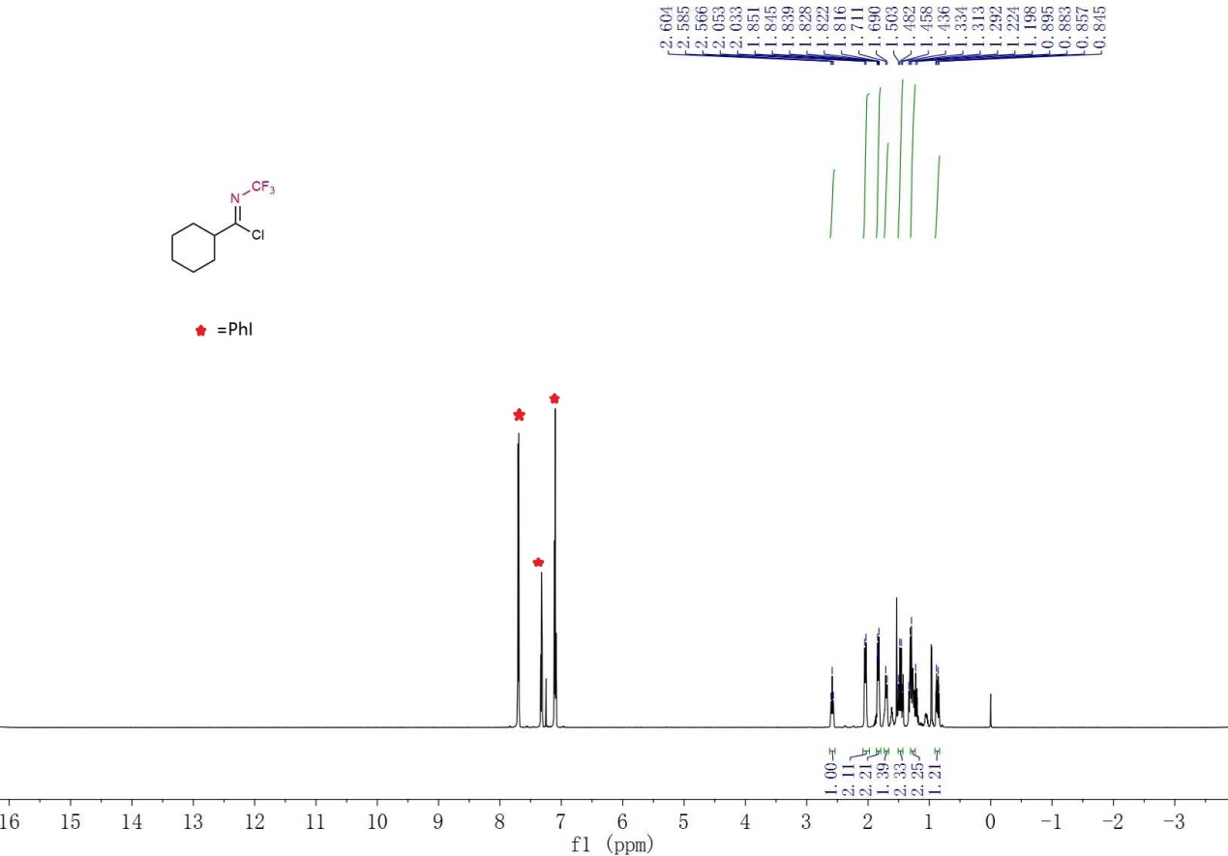

¹³C NMR (151 MHz, CDCl₃) Spectrum of S-1g

¹⁹F NMR (565 MHz, CDCl₃) Spectrum of S-1g

¹H NMR (600 MHz, CDCl₃) Spectrum of 1a

¹³C NMR (151 MHz, CDCl₃) Spectrum of 1a
¹⁹F NMR (565 MHz, CDCl₃) Spectrum of 1a

¹H NMR (600 MHz, CDCl₃) Spectrum of 1b

¹³C NMR (151 MHz, CDCl₃) Spectrum of 1b

¹⁹F NMR (565 MHz, CDCl₃) Spectrum of 1b

¹H NMR (600 MHz, Acetone-D₆) Spectrum of 1c

¹³C NMR (151 MHz, Acetone-D₆) Spectrum of 1c

¹⁹F NMR (565 MHz, Acetone-D₆) Spectrum of 1c

¹H NMR (600 MHz, Acetone-D₆) Spectrum of 1d

¹³C NMR (151 MHz, Acetone-D₆) Spectrum of 1d

¹⁹F NMR (565 MHz, Acetone-D₆) Spectrum of 1d

¹H NMR (600 MHz, Acetone-D₆) Spectrum of 1e
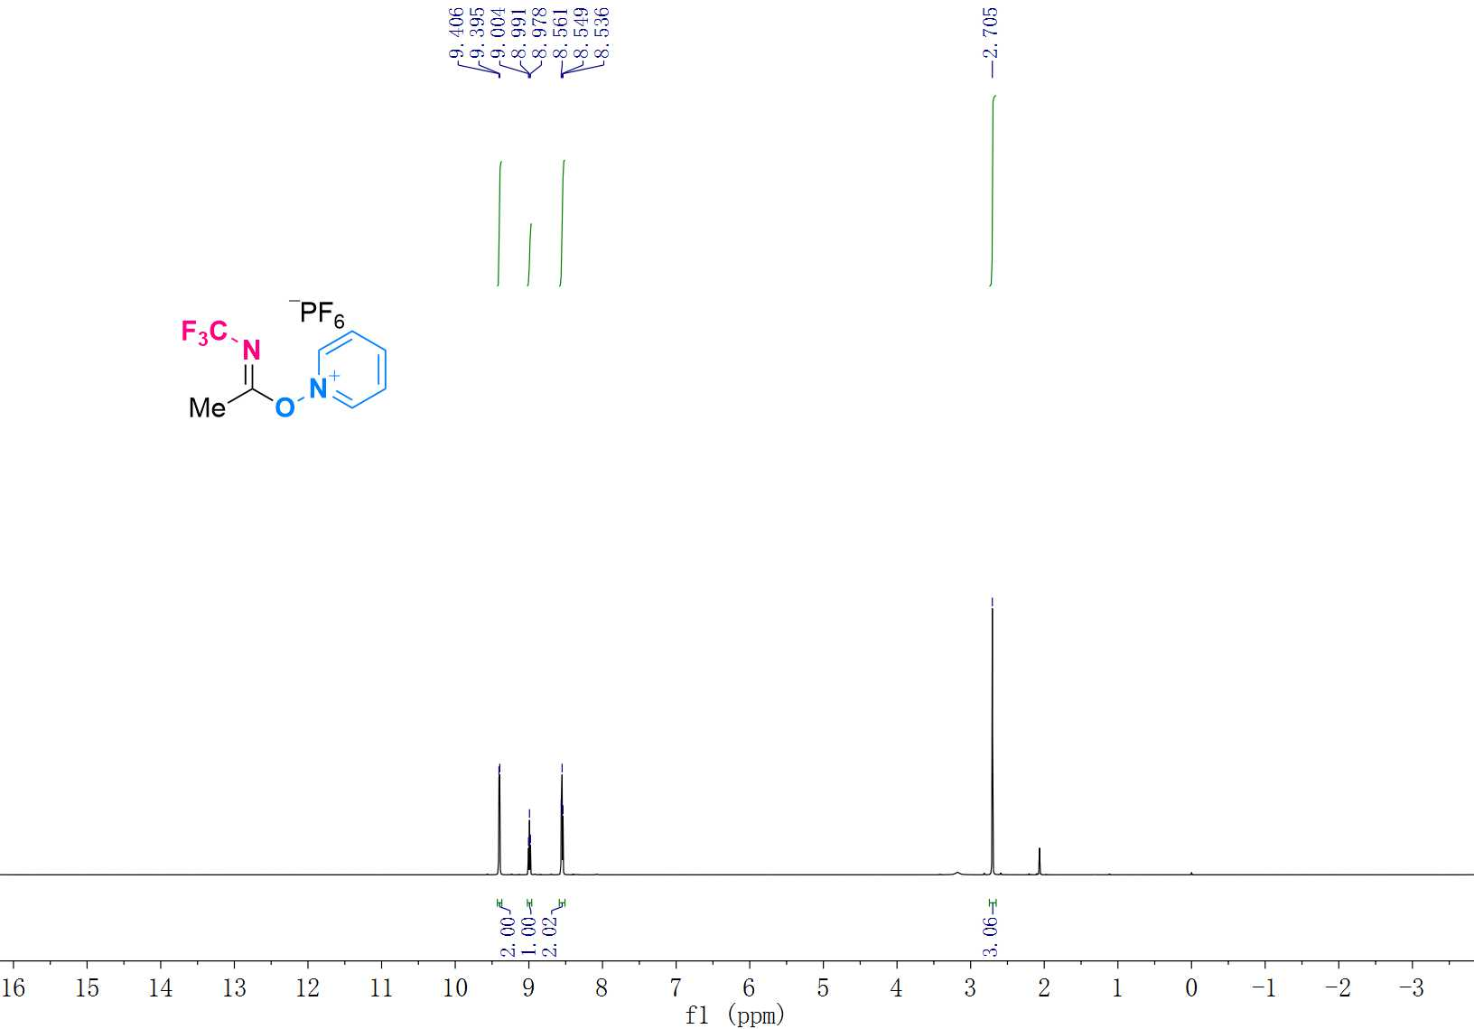

¹³C NMR (151 MHz, Acetone-D₆) Spectrum of 1e
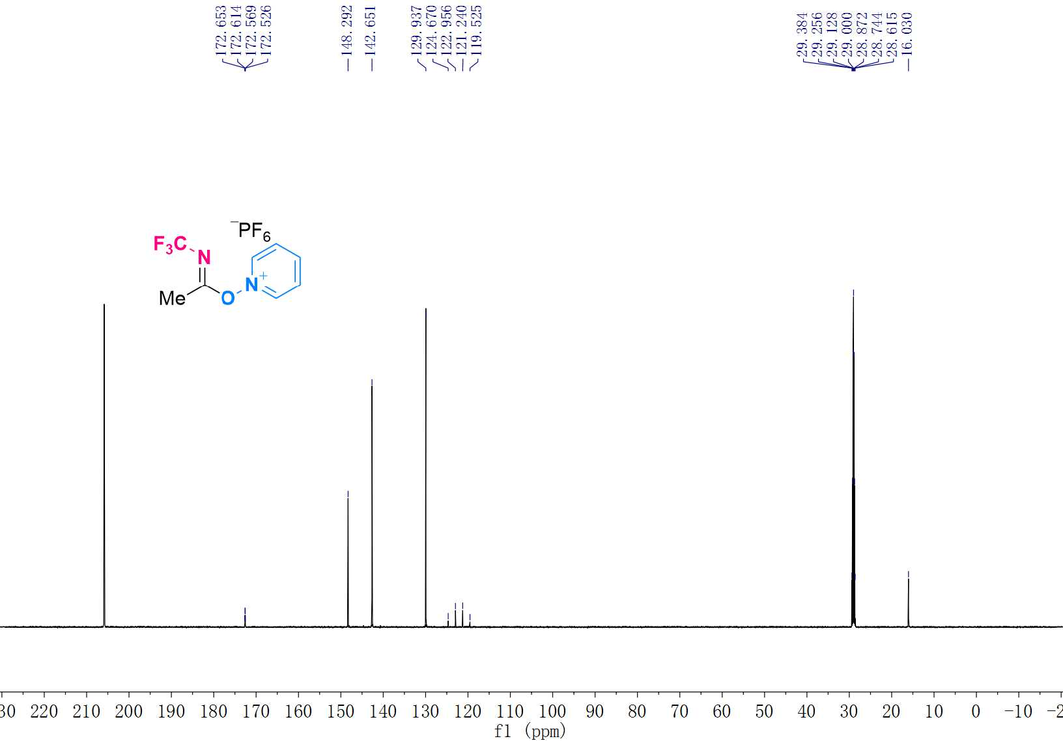

¹⁹F NMR (565 MHz, Acetone-D₆) Spectrum of 1e
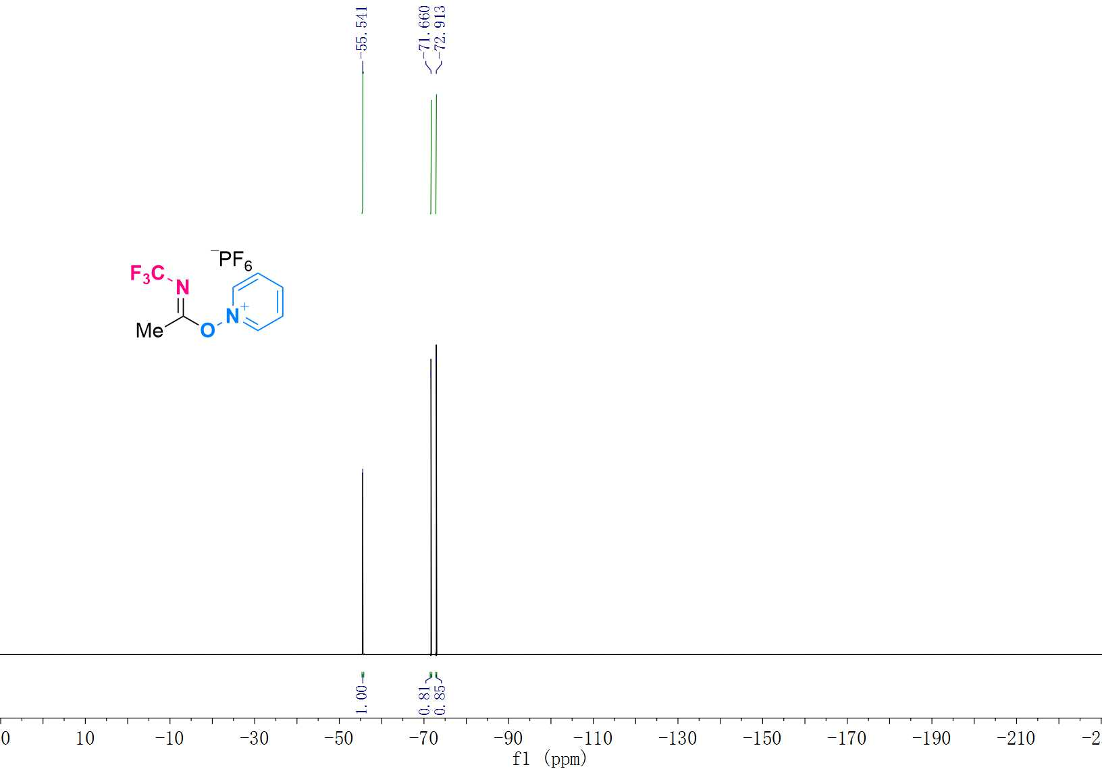

¹H NMR (600 MHz, Acetone-D₆) Spectrum of 1f
(Decomposed too quickly in Acetone-D₆)
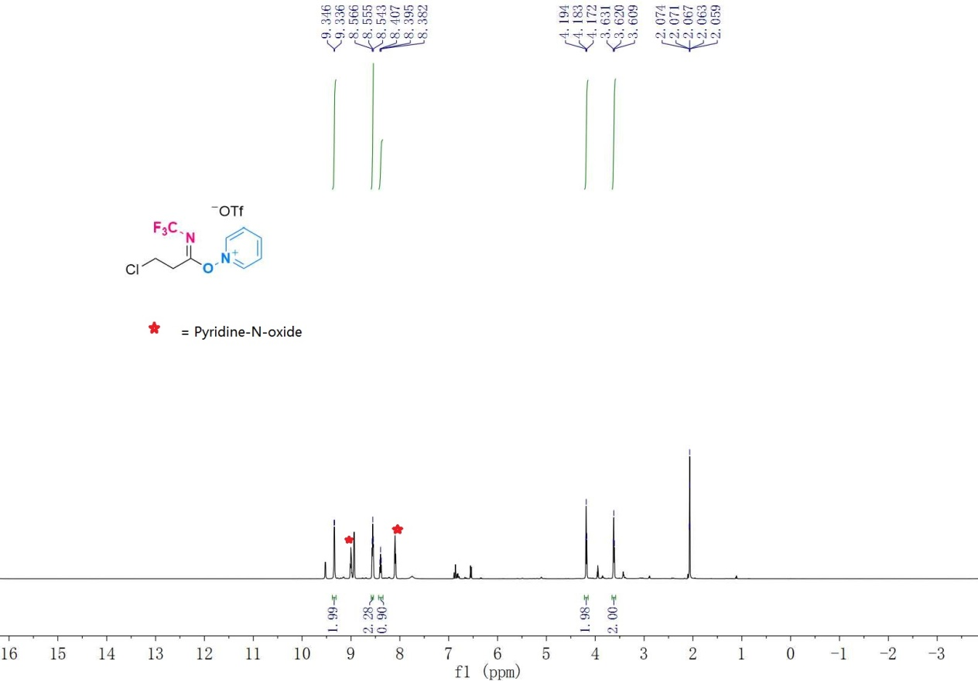
¹³C NMR (151 MHz, Acetone-D₆) Spectrum of 1f
(Decomposed too quickly in Acetone-D₆)
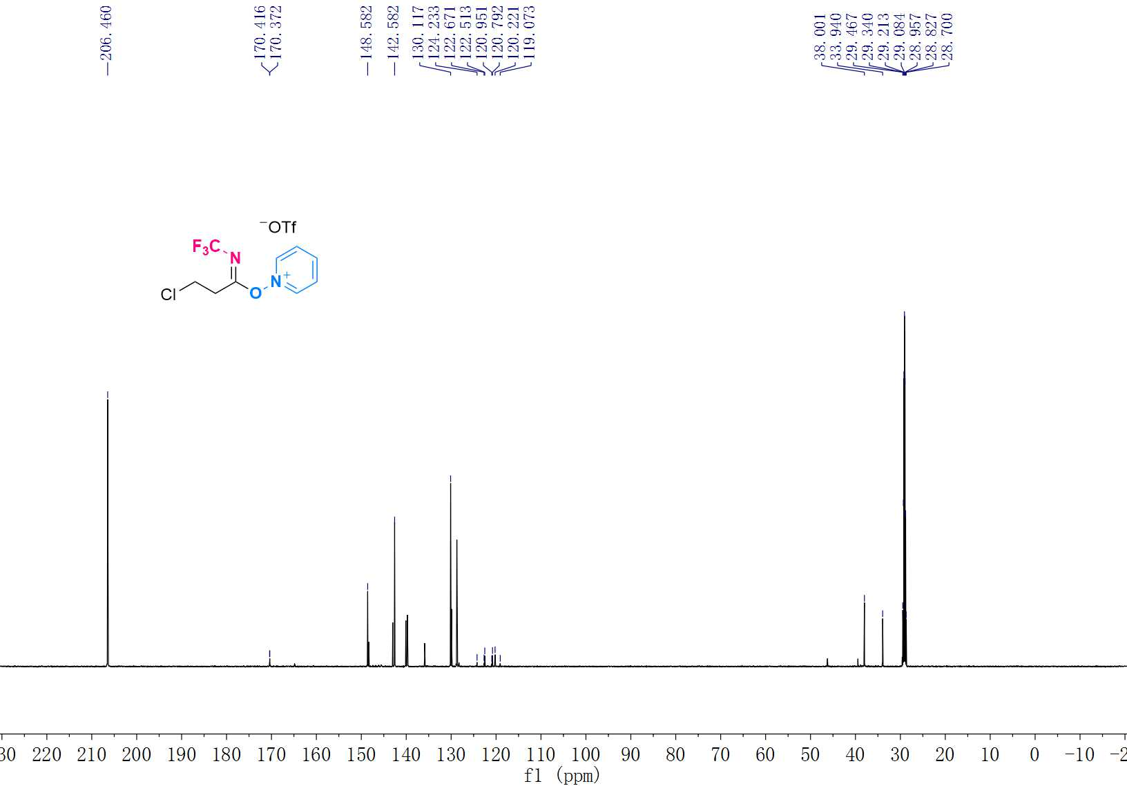

¹⁹F NMR (565 MHz, Acetone-D₆) Spectrum of 1g
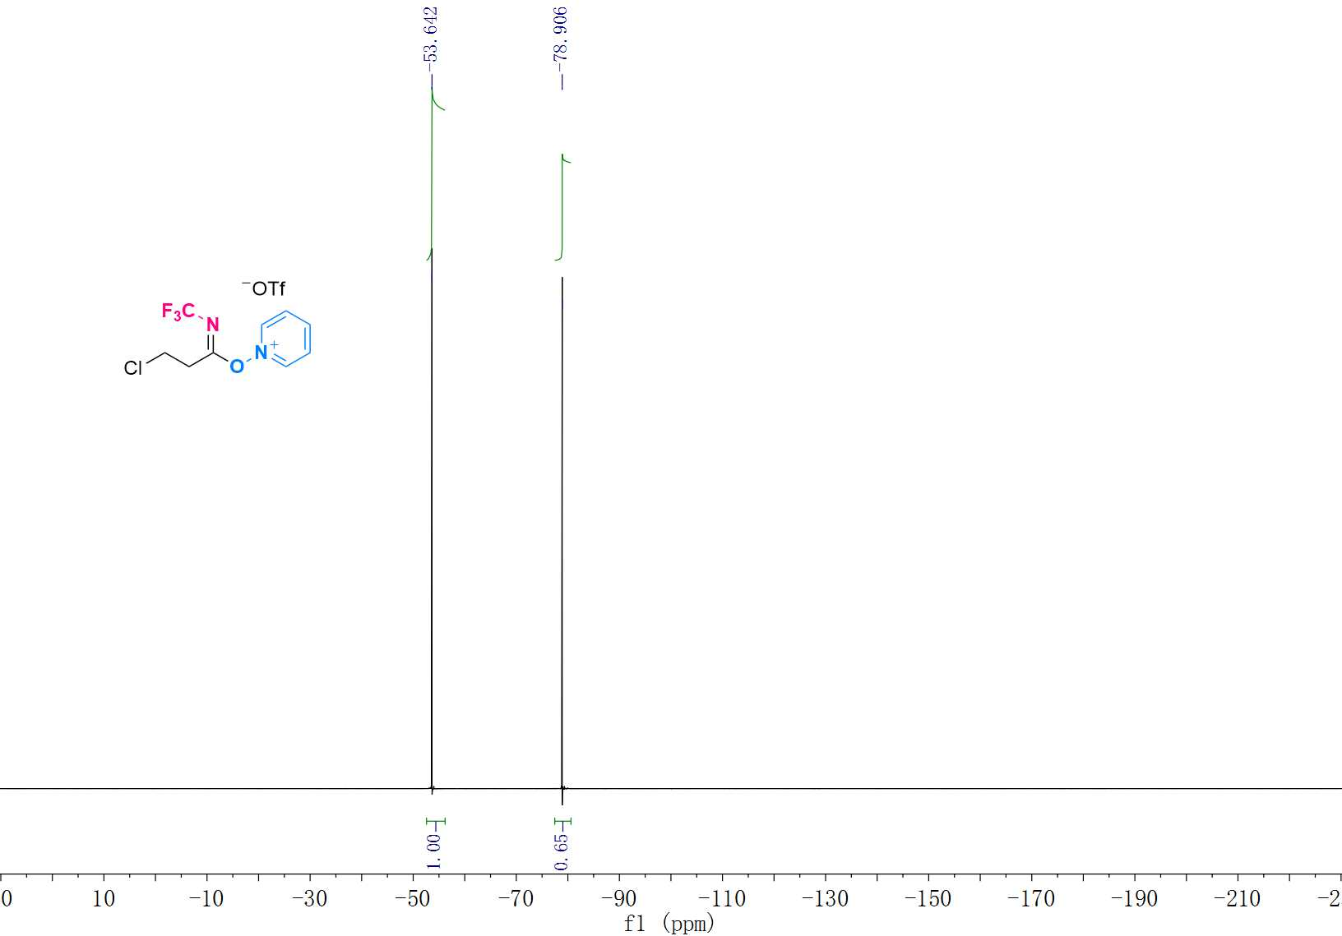

¹H NMR (600 MHz, Acetone-D₆) Spectrum of 1g
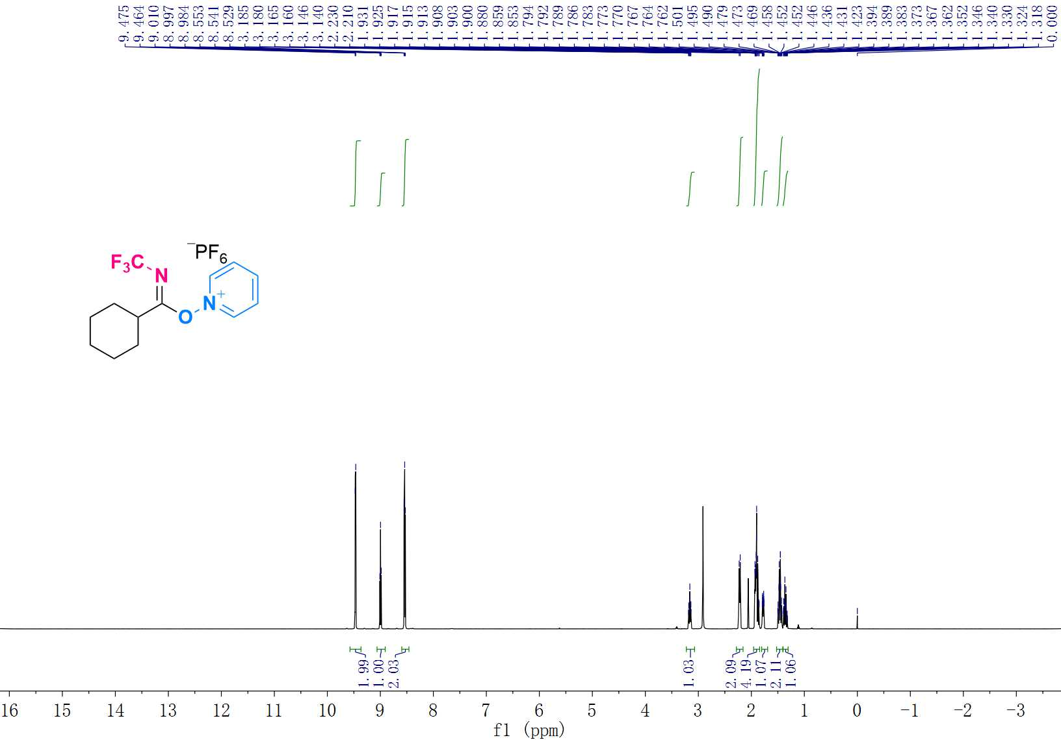

¹³C NMR (151 MHz, Acetone-D₆) Spectrum of 1g
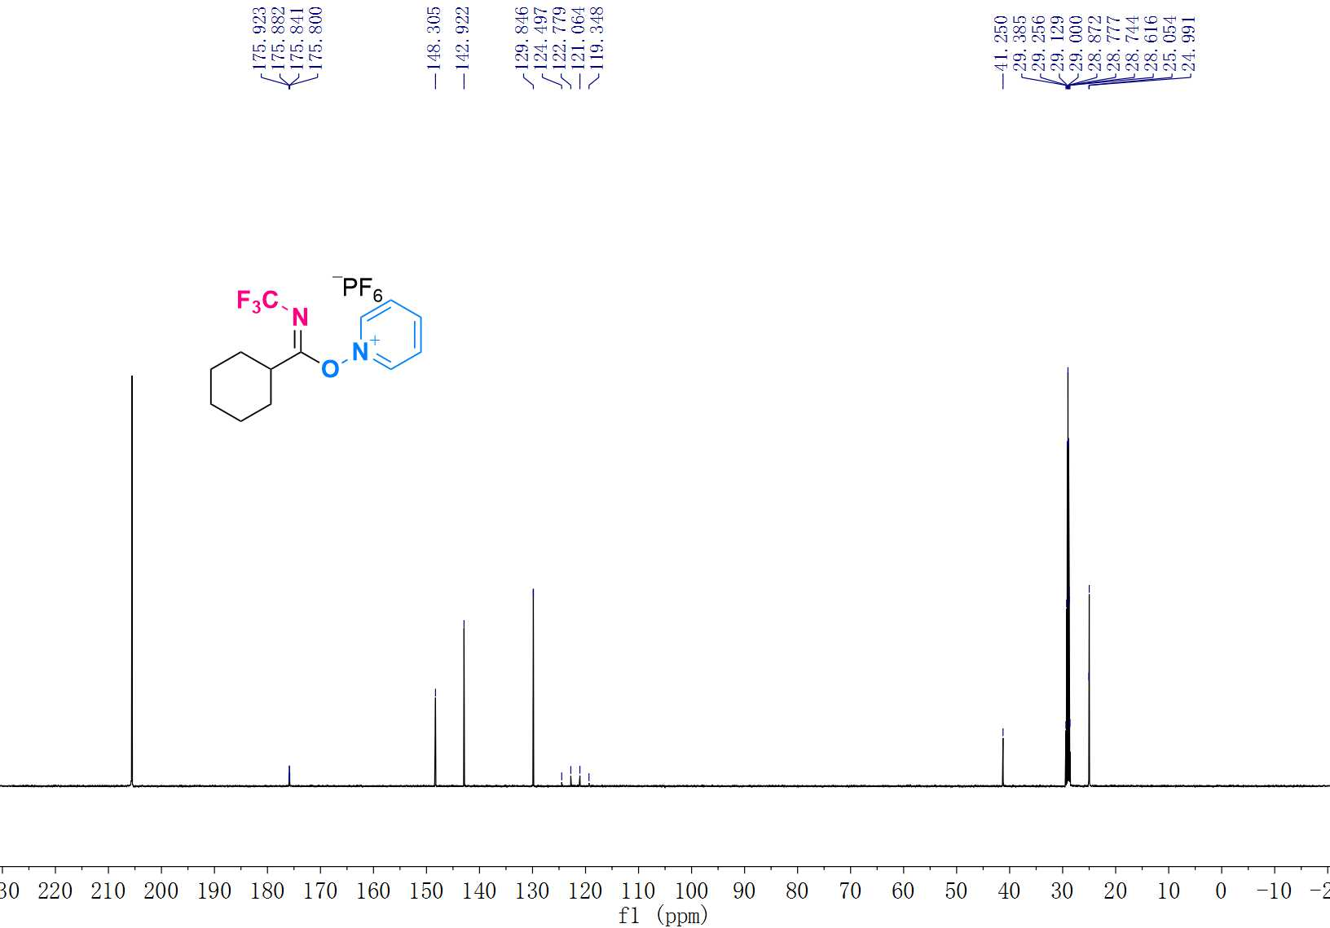

¹⁹F NMR (565 MHz, Acetone-D₆) Spectrum of 1g
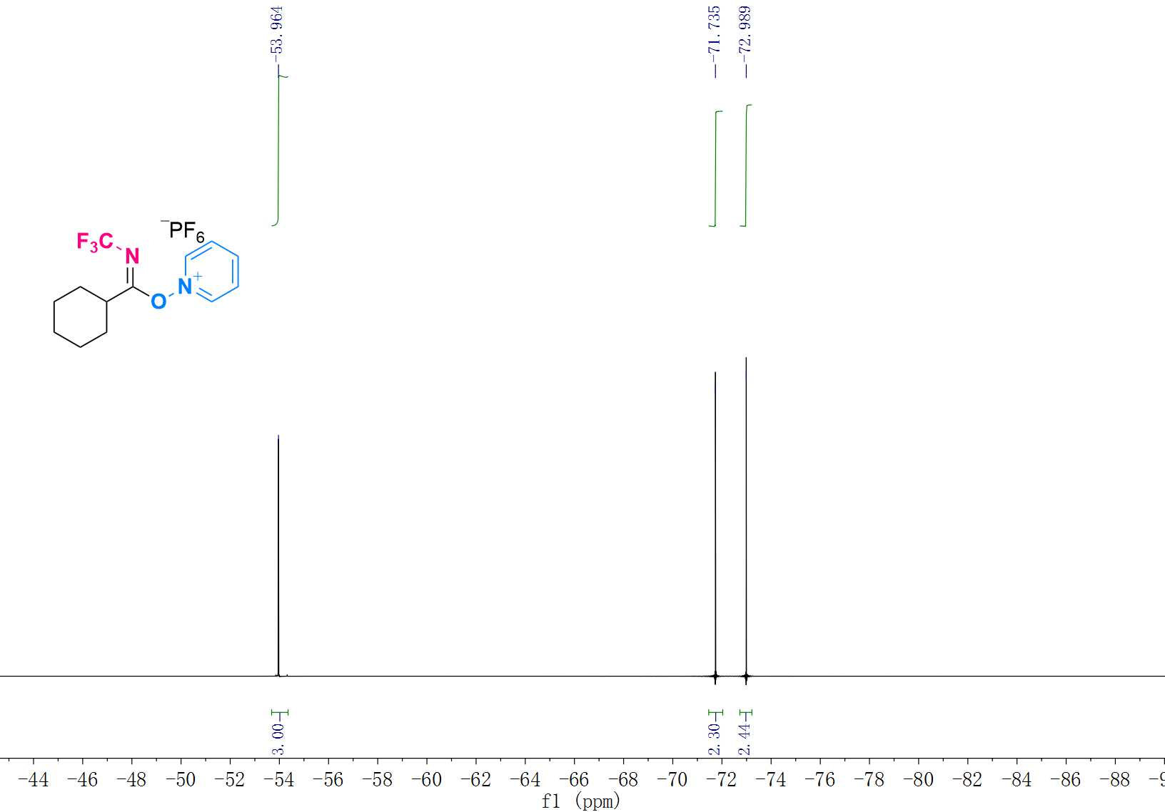

¹H NMR (600 MHz, Acetone-D₆) Spectrum of 1h
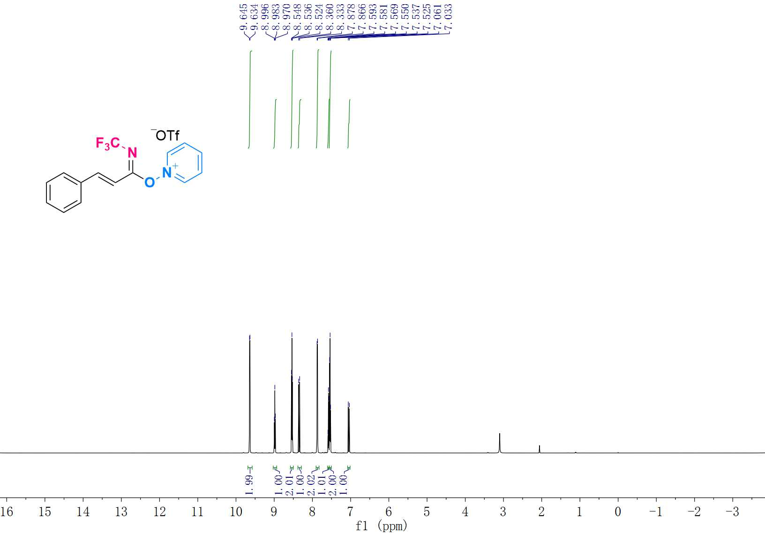

¹³C NMR (151 MHz, Acetone-D₆) Spectrum of 1h
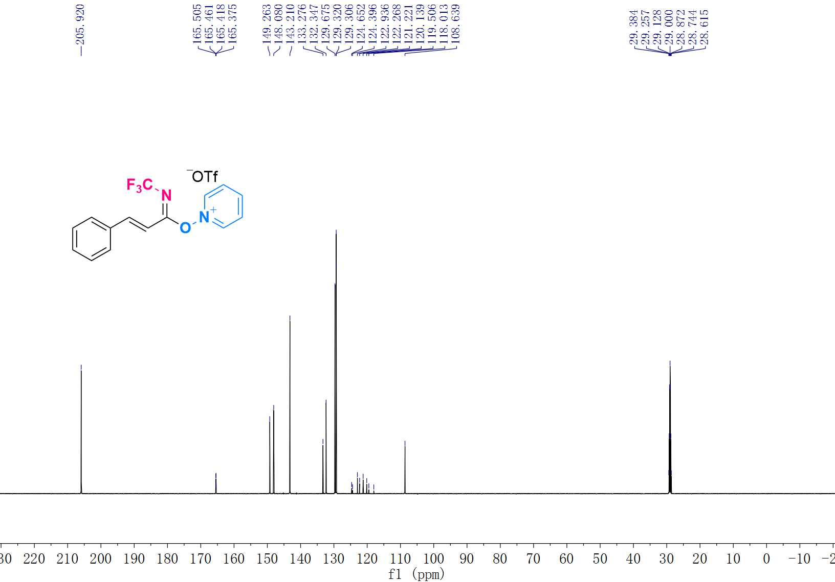

¹⁹F NMR (565 MHz, Acetone-D₆) Spectrum of 1h
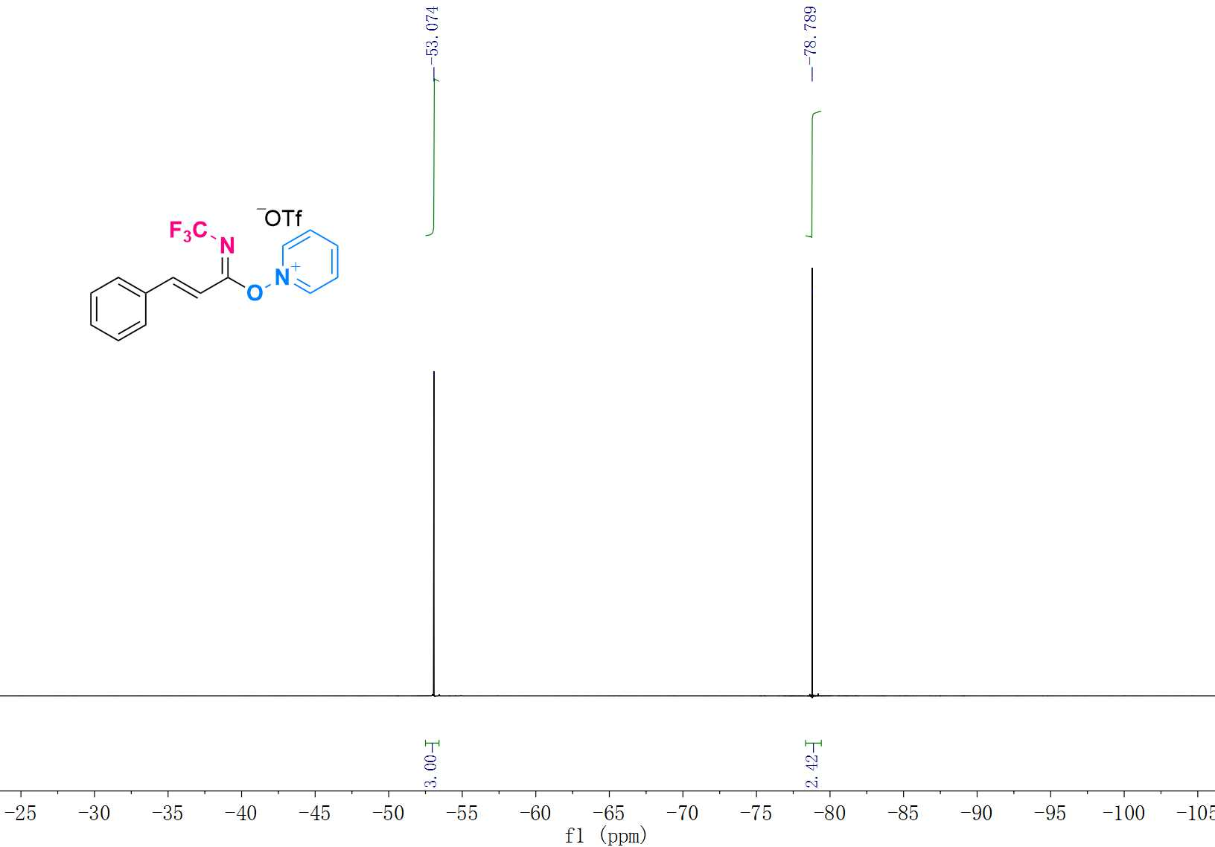

¹H NMR (600 MHz, Acetone-D₆) Spectrum of 1i
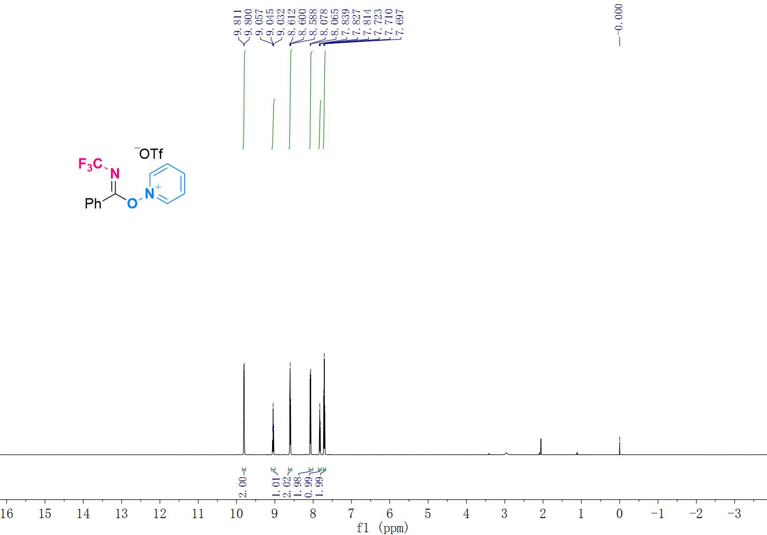

¹³C NMR (151 MHz, Acetone-D₆) Spectrum of 1i
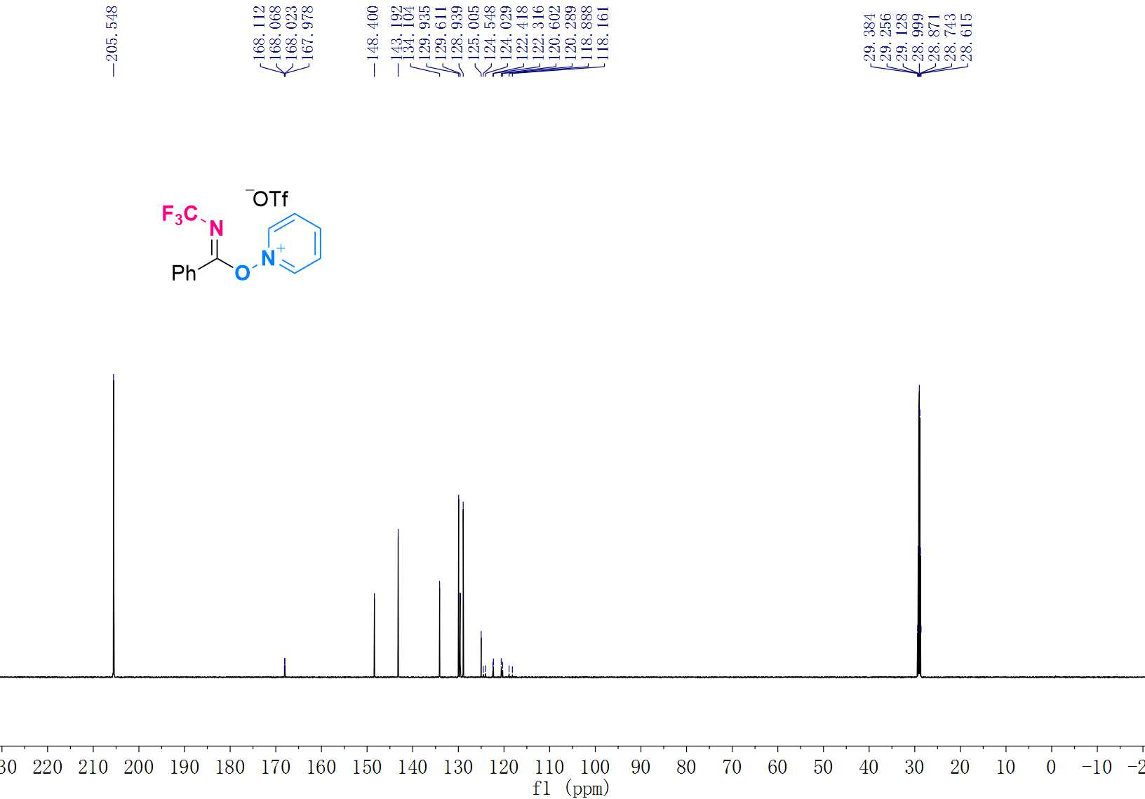

¹⁹F NMR (565 MHz, Acetone-D₆) Spectrum of 1i
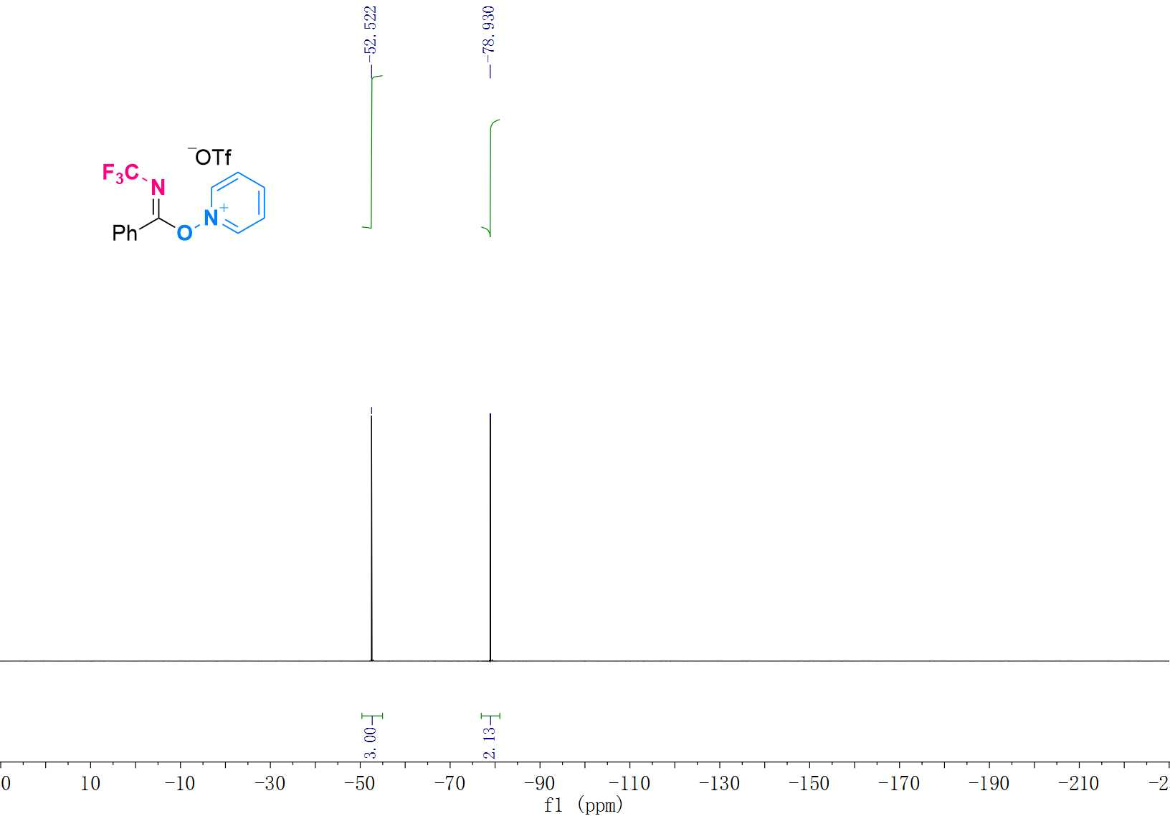

¹H NMR (500 MHz, Acetone-D₆) Spectrum of 1j
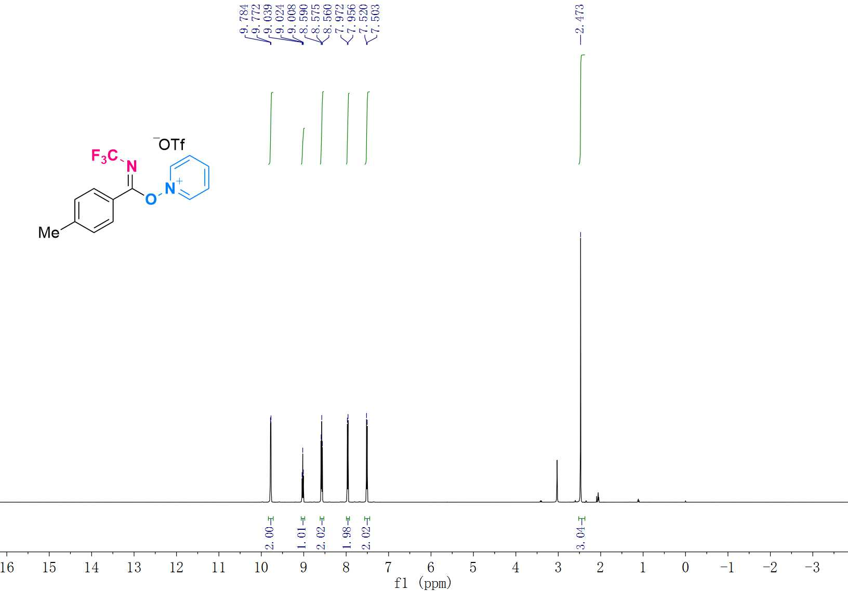

¹³C NMR (125 MHz, Acetone-D₆) Spectrum of 1j
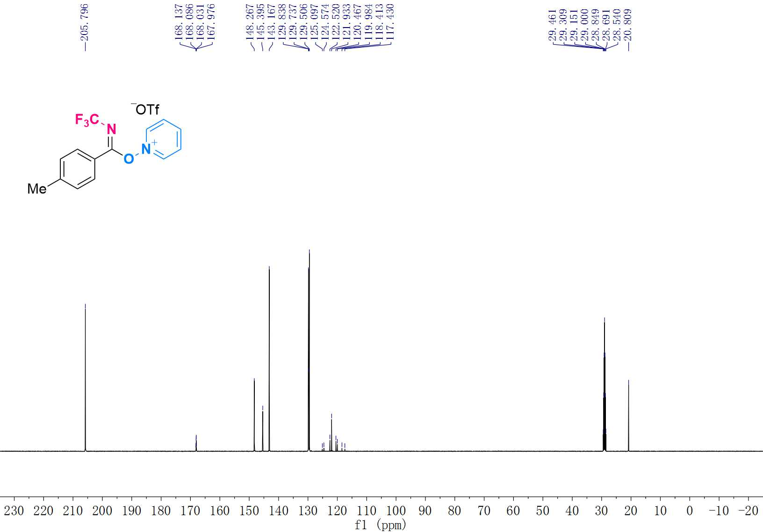

¹⁹F NMR (470 MHz, Acetone-D₆) Spectrum of 1j
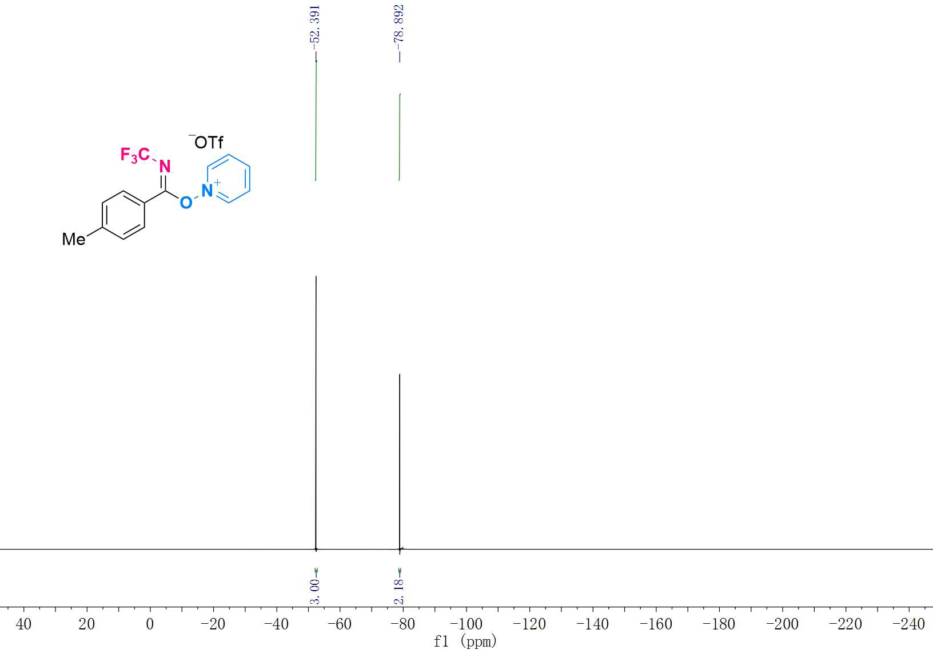

¹H NMR (600 MHz, Acetone-D₆) Spectrum of 1k
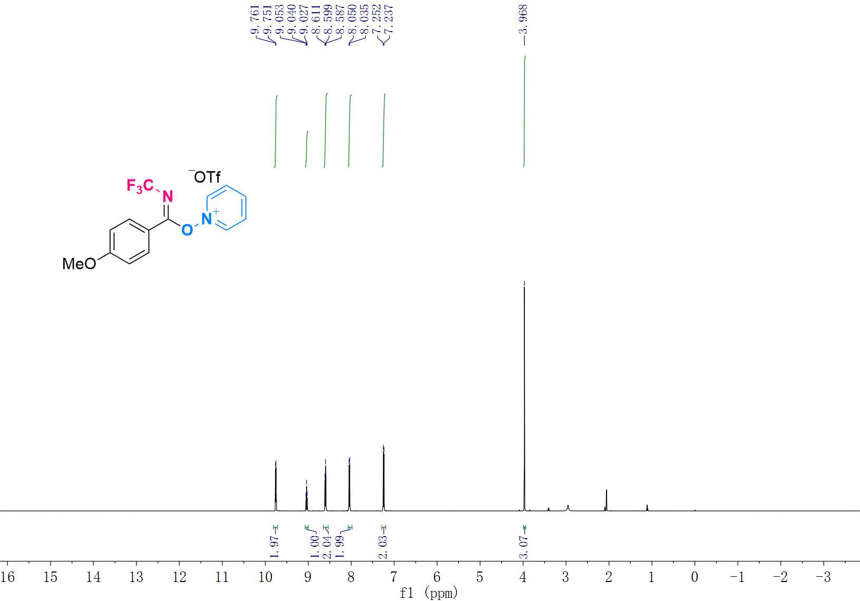
¹³C NMR (151 MHz, Acetone-D₆) Spectrum of 1k
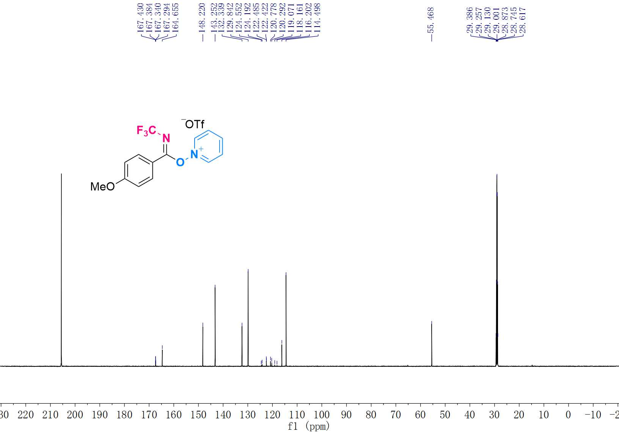

¹⁹F NMR (565 MHz, Acetone-D₆) Spectrum of 1k
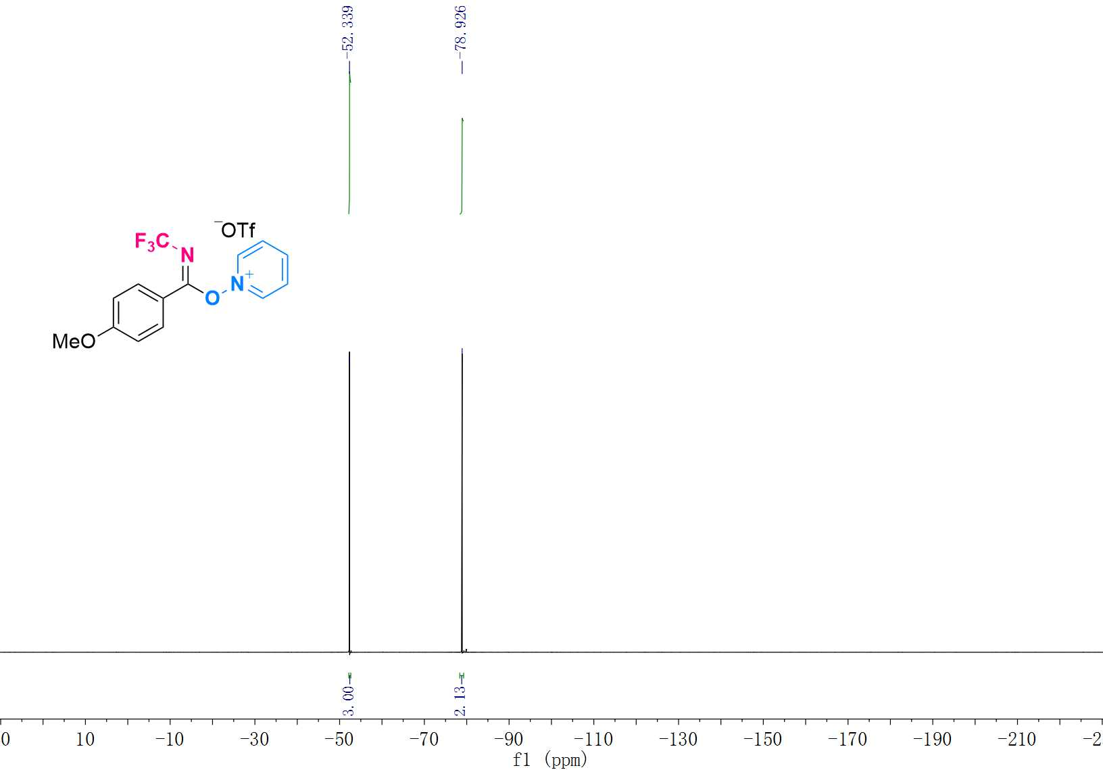

¹H NMR (600 MHz, Acetone-D₆) Spectrum of 1l
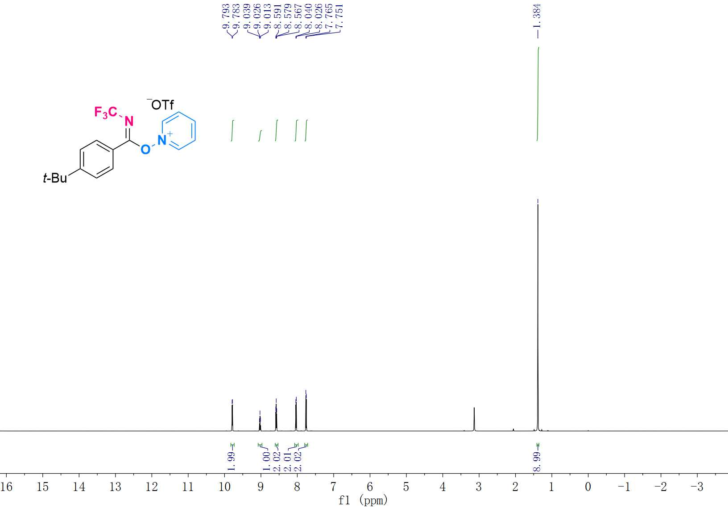

¹³C NMR (151 MHz, Acetone-D₆) Spectrum of 1l

¹⁹F NMR (565 MHz, Acetone-D₆) Spectrum of 1l

¹H NMR (600 MHz, Acetone-D₆) Spectrum of 1m

¹³C NMR (151 MHz, Acetone-D₆) Spectrum of 1m

¹⁹F NMR (565 MHz, Acetone-D₆) Spectrum of 1m

¹H NMR (600 MHz, Acetone-D₆) Spectrum of 1n

¹³C NMR (151 MHz, Acetone-D₆) Spectrum of 1n

¹⁹F NMR (565 MHz, Acetone-D₆) Spectrum of 1n

¹H NMR (500 MHz, Acetone-D₆) Spectrum of 1o

¹³C NMR (125 MHz, Acetone-D₆) Spectrum of 1o

¹⁹F NMR (470 MHz, Acetone-D₆) Spectrum of 1o

¹H NMR (600 MHz, Acetone-D₆) Spectrum of 1p

¹³C NMR (151 MHz, Acetone-D₆) Spectrum of 1p

¹⁹F NMR (565 MHz, Acetone-D₆) Spectrum of 1p

¹H NMR (500 MHz, Acetone-D₆) Spectrum of 1q

¹³C NMR (125 MHz, Acetone-D₆) Spectrum of 1q

¹⁹F NMR (470 MHz, Acetone-D₆) Spectrum of 1q

¹H NMR (600 MHz, Acetone-D₆) Spectrum of 1r

¹³C NMR (151 MHz, Acetone-D₆) Spectrum of 1r

¹⁹F NMR (565 MHz, Acetone-D₆) Spectrum of 1r

¹H NMR (600 MHz, Acetone-D₆) Spectrum of 1s

¹³C NMR (151 MHz, Acetone-D₆) Spectrum of 1s

¹⁹F NMR (565 MHz, Acetone-D₆) Spectrum of 1s

¹H NMR (600 MHz, Acetone-D₆) Spectrum of 1t

¹³C NMR (151 MHz, Acetone-D₆) Spectrum of 1t

¹⁹F NMR (565 MHz, Acetone-D₆) Spectrum of 1t

¹H NMR (500 MHz, Acetone-D₆) Spectrum of 1u

¹³C NMR (125 MHz, Acetone-D₆) Spectrum of 1u

¹⁹F NMR (470 MHz, Acetone-D₆) Spectrum of 1u

¹H NMR (600 MHz, Acetone-D₆) Spectrum of 1v

¹³C NMR (151 MHz, Acetone-D₆) Spectrum of 1v

¹⁹F NMR (565 MHz, Acetone-D₆) Spectrum of 1v

¹H NMR (600 MHz, Acetone-D₆) Spectrum of 1w

¹³C NMR (151 MHz, Acetone-D₆) Spectrum of 1w

¹⁹F NMR (565 MHz, Acetone-D₆) Spectrum of 1w

¹H NMR (600 MHz, CDCl₃) Spectrum of 3a

¹³C NMR (151 MHz, CDCl₃) Spectrum of 3a

¹⁹F NMR (565 MHz, CDCl₃) Spectrum of 3a

¹H NMR (500 MHz, CDCl₃) Spectrum of 3b

¹³C NMR (151 MHz, CDCl₃) Spectrum of 3b

¹⁹F NMR (565 MHz, CDCl₃) Spectrum of 3b

¹H NMR (600 MHz, CDCl₃) Spectrum of 3c

¹³C NMR (151 MHz, CDCl₃) Spectrum of 3c

¹⁹F NMR (565 MHz, CDCl₃) Spectrum of 3c

¹H NMR (600 MHz, CDCl₃) Spectrum of 3d

¹³C NMR (151 MHz, CDCl₃) Spectrum of 3d

¹⁹F NMR (565 MHz, CDCl₃) Spectrum of 3d

¹H NMR (600 MHz, CDCl₃) Spectrum of 3e

¹³C NMR (151 MHz, CDCl₃) Spectrum of 3e

¹⁹F NMR (565 MHz, CDCl₃) Spectrum of 3e
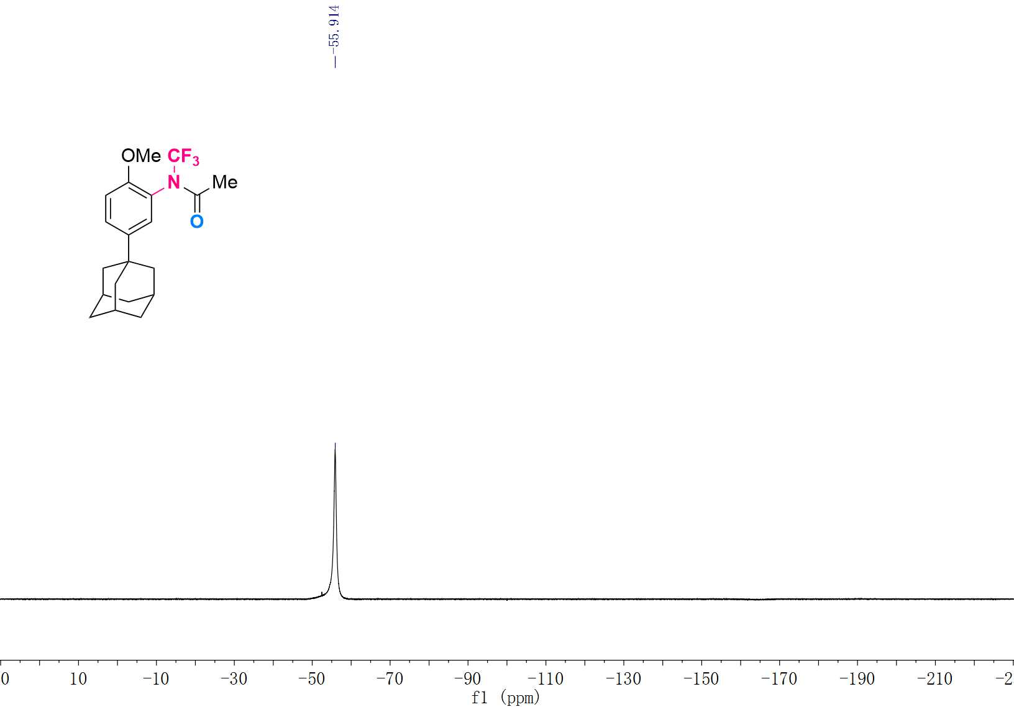

¹H NMR (600 MHz, CDCl₃) Spectrum of 3f

¹³C NMR (151 MHz, CDCl₃) Spectrum of 3f
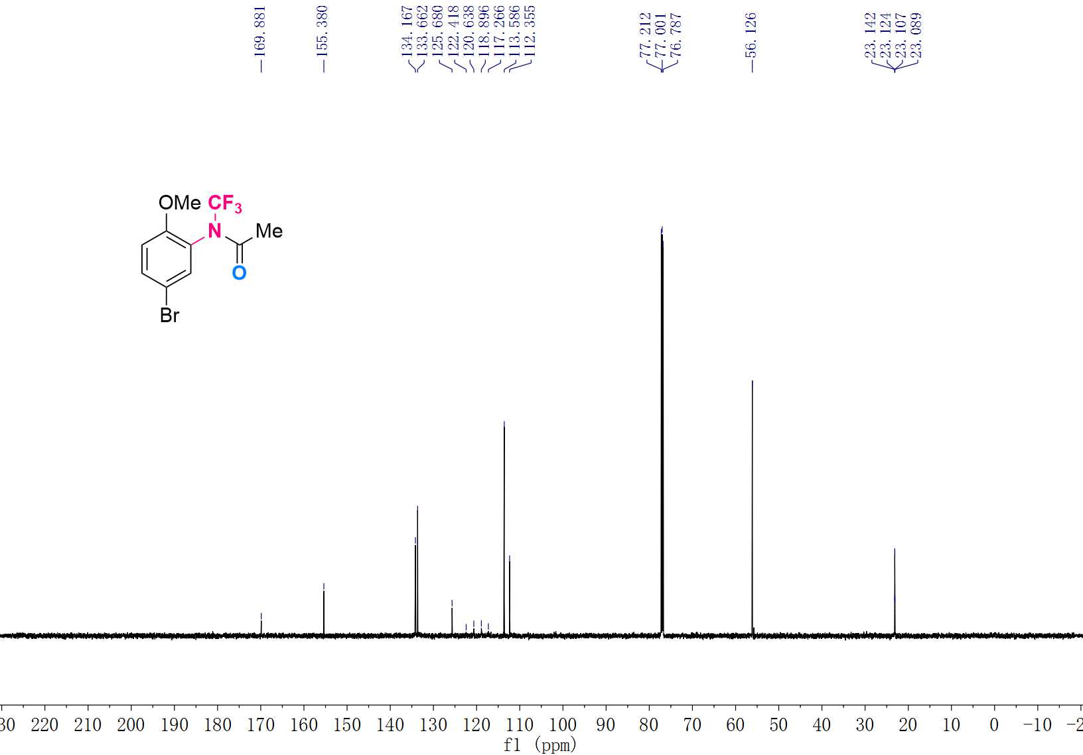

¹⁹F NMR (565 MHz, CDCl₃) Spectrum of 3f
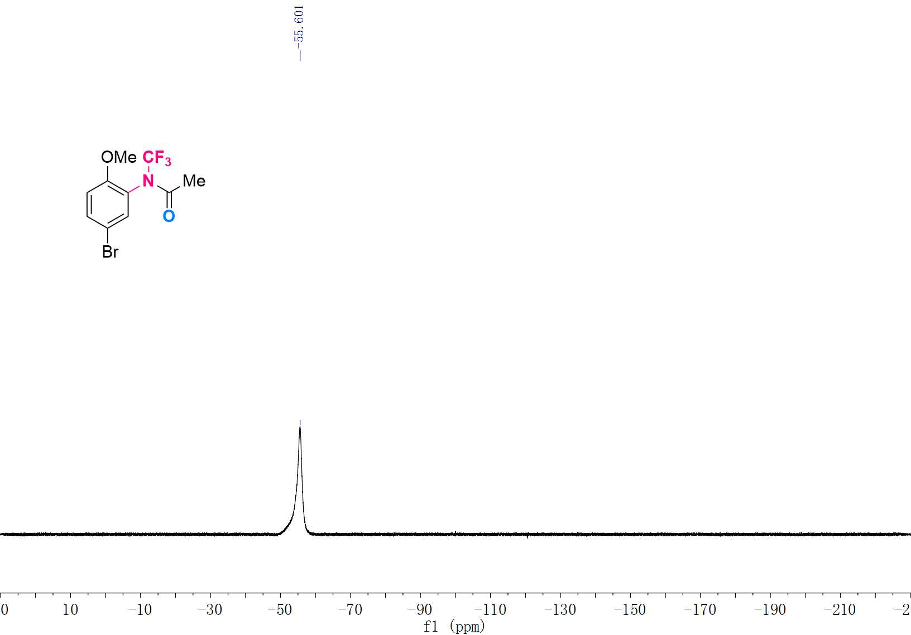

¹H NMR (600 MHz, CDCl₃) Spectrum of 3g
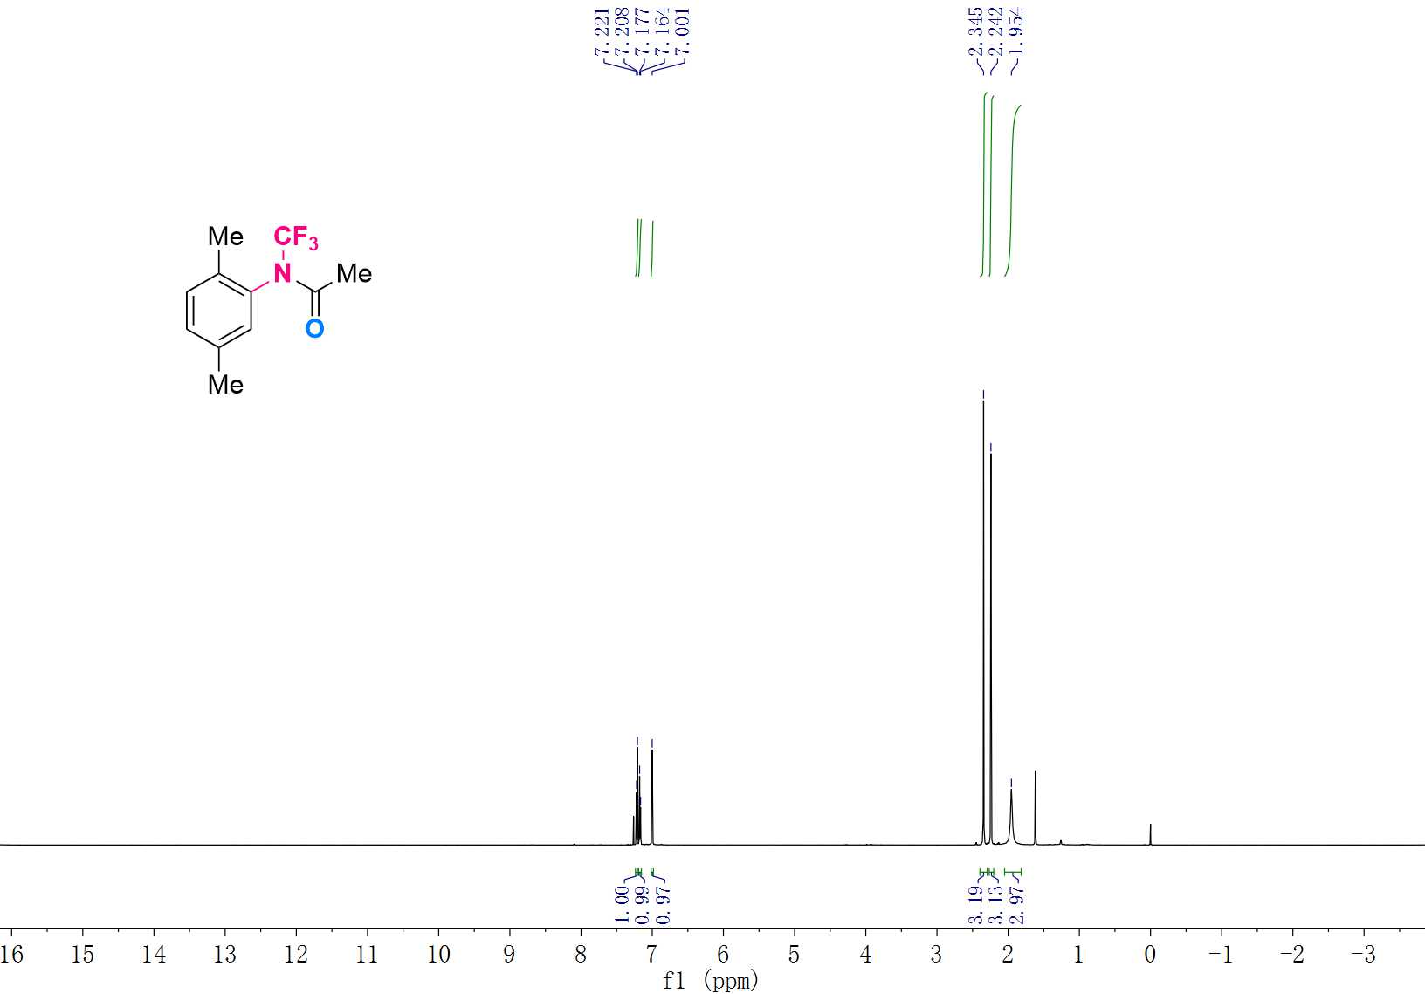

¹³C NMR (151 MHz, CDCl₃) Spectrum of 3g
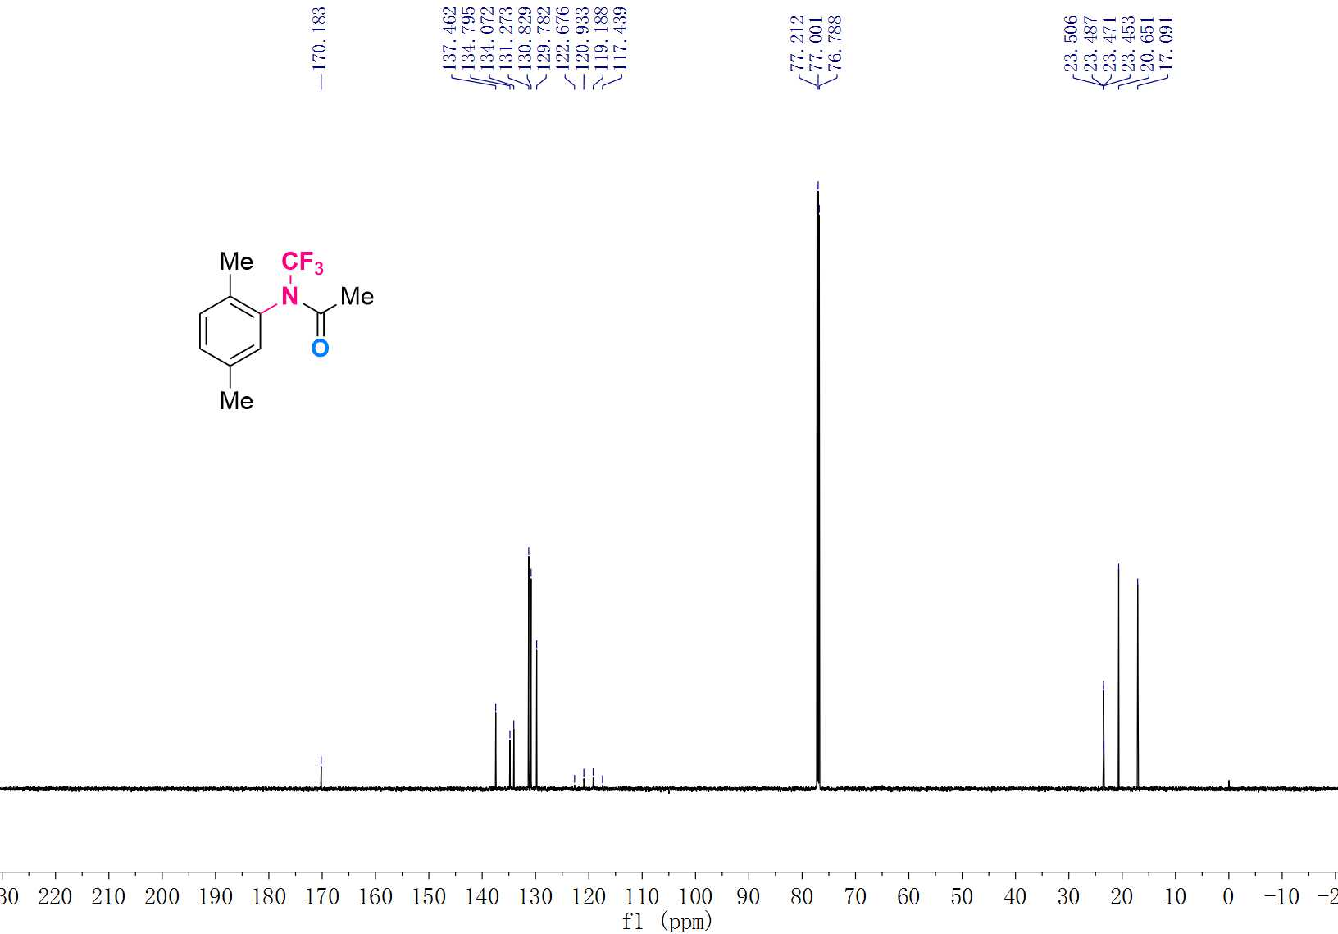

¹⁹F NMR (565 MHz, CDCl₃) Spectrum of 3g
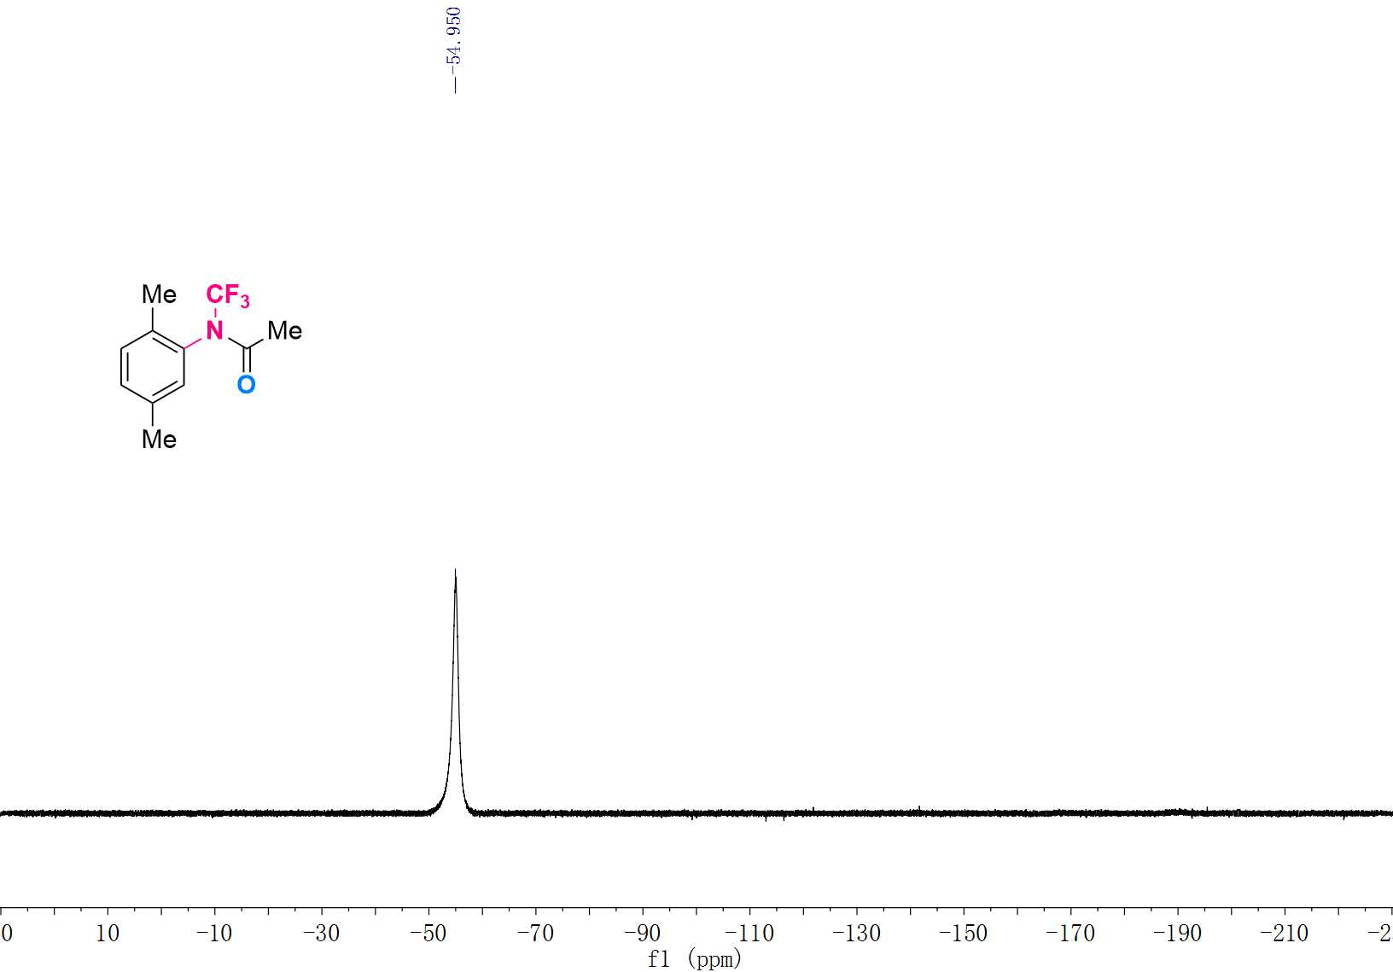

¹H NMR (600 MHz, CDCl₃) Spectrum of 3h
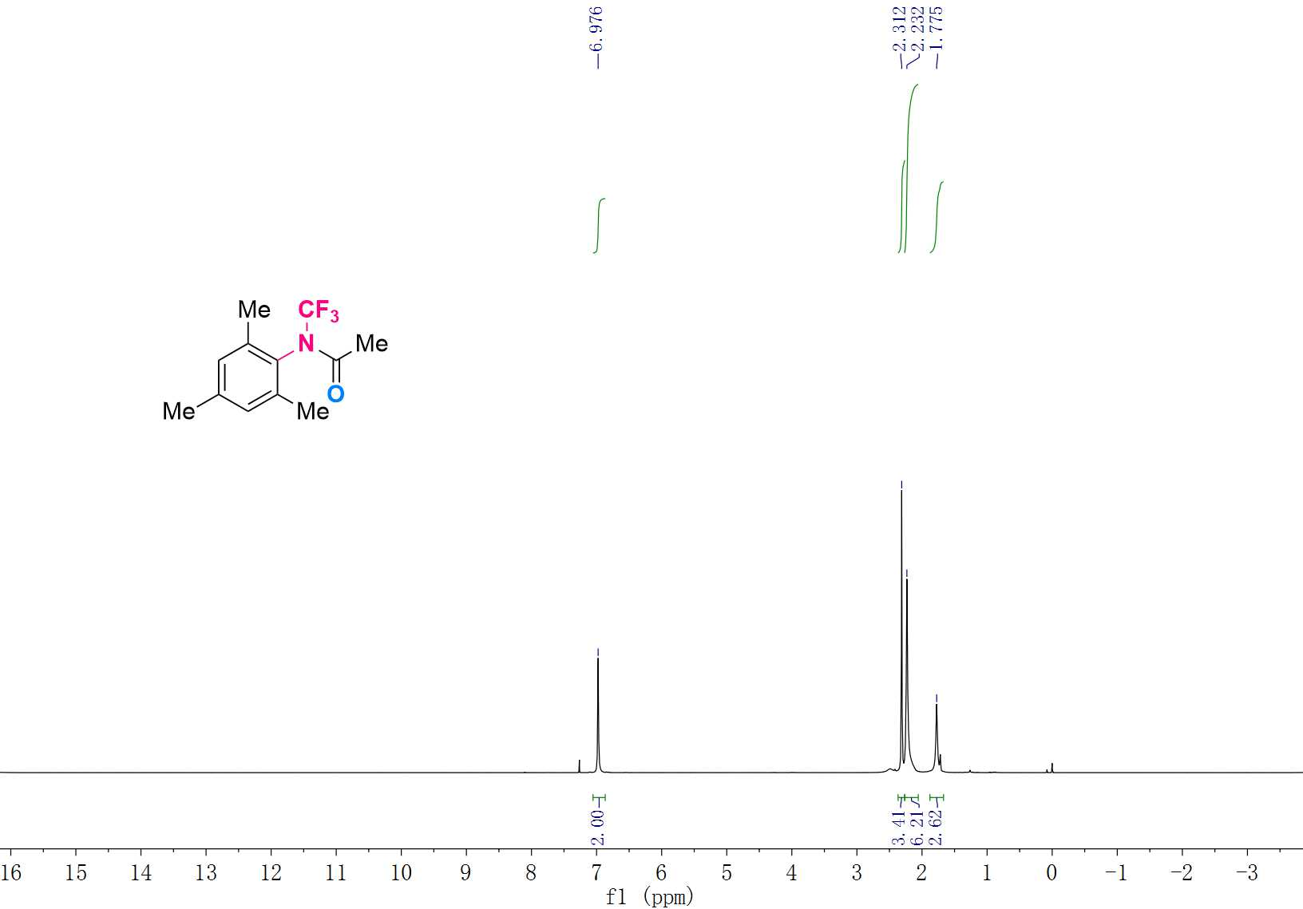

¹³C NMR (151 MHz, CDCl₃) Spectrum of 3h
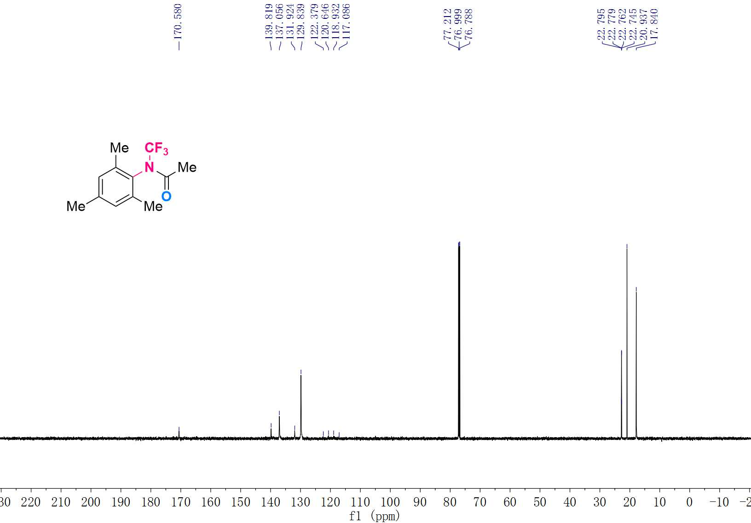

¹⁹F NMR (565 MHz, CDCl₃) Spectrum of 3h
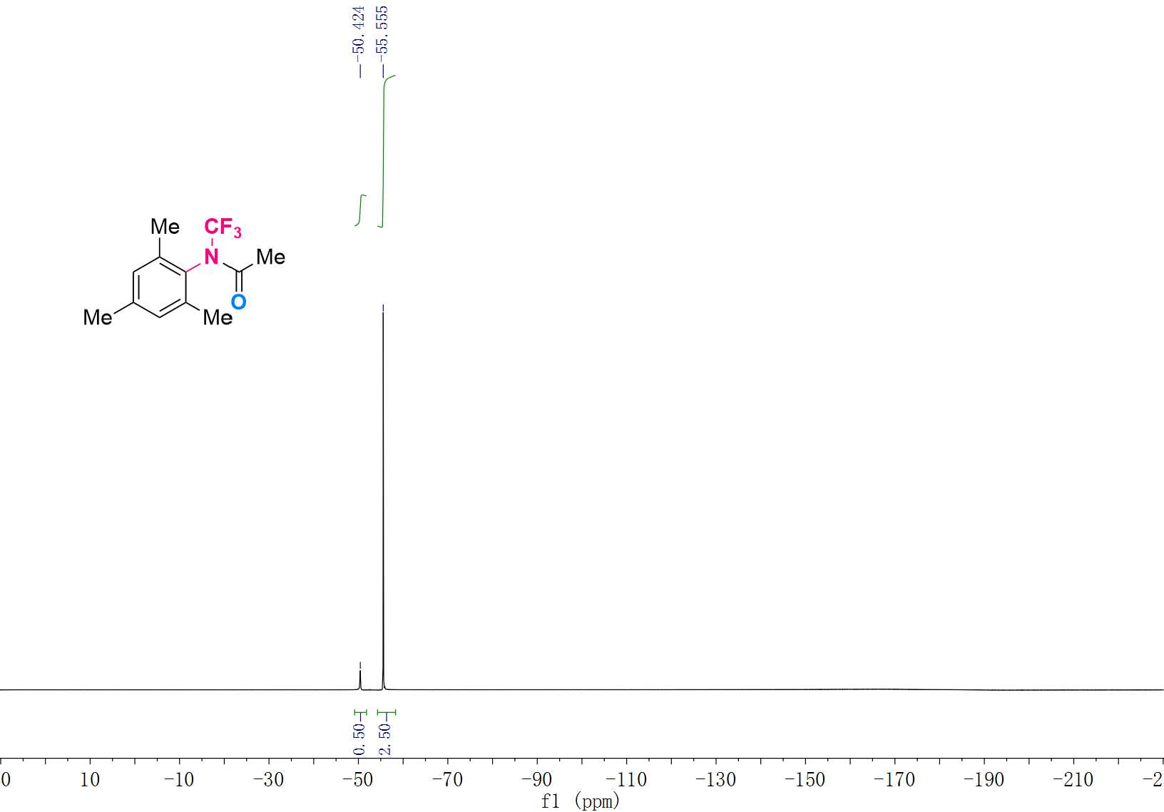

¹H NMR (600 MHz, CDCl₃) Spectrum of 3i
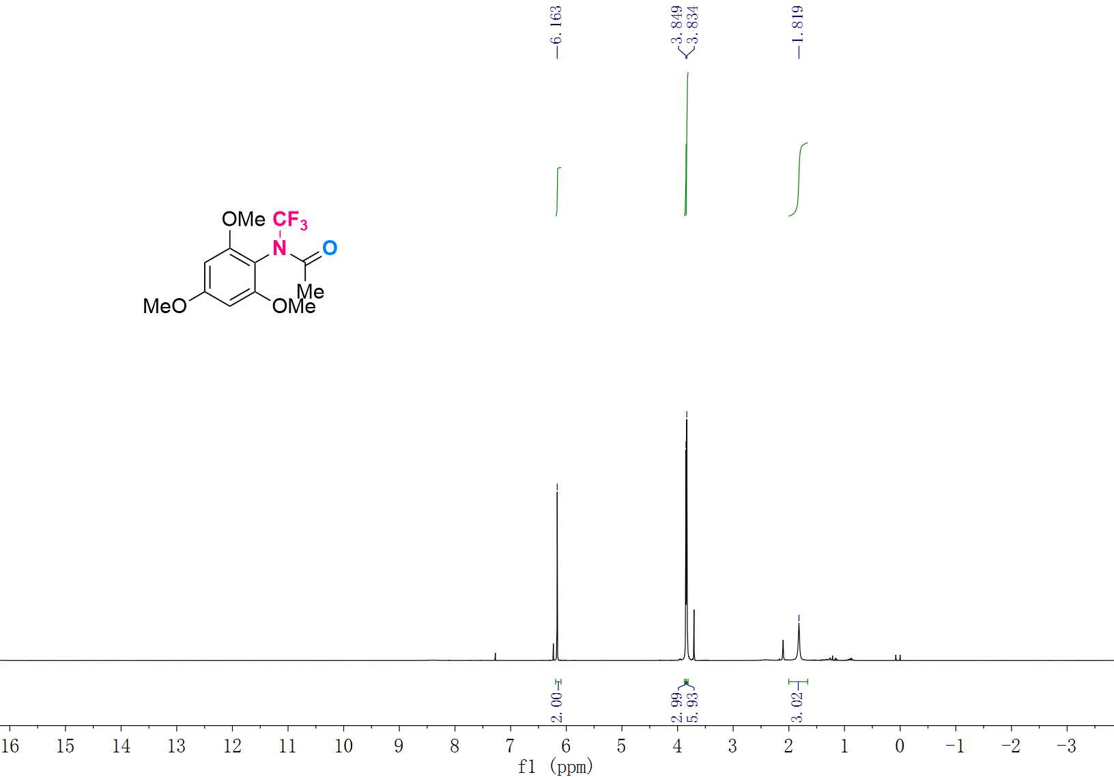

¹³C NMR (151 MHz, CDCl₃) Spectrum of 3i
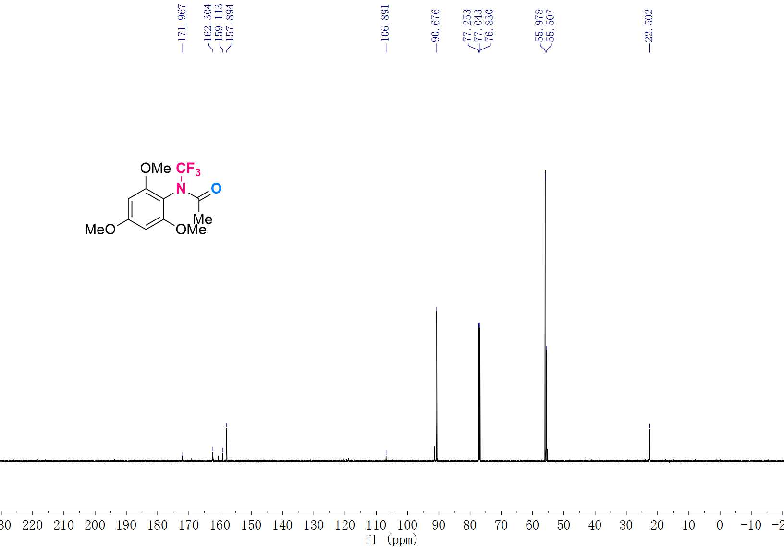

¹⁹F NMR (565 MHz, CDCl₃) Spectrum of 3i
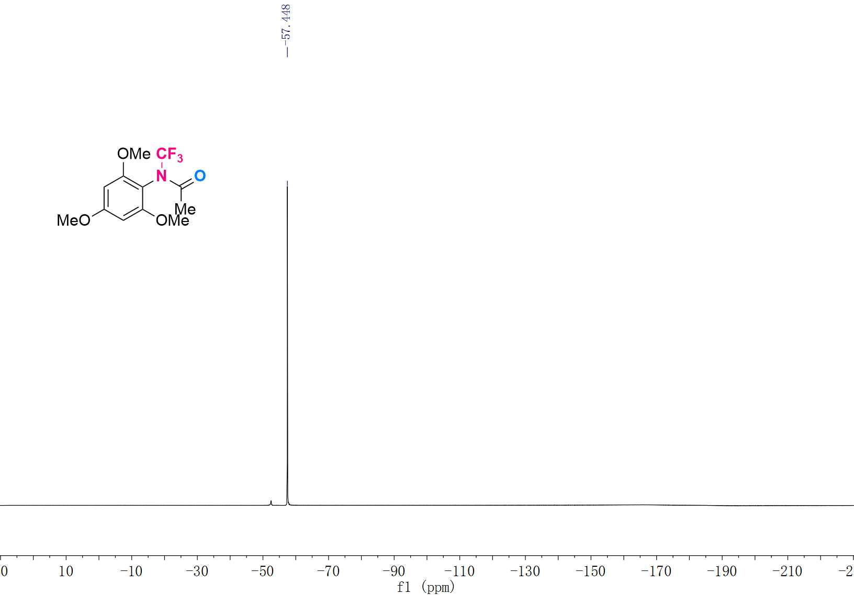

¹H NMR (600 MHz, CDCl₃) Spectrum of 3j
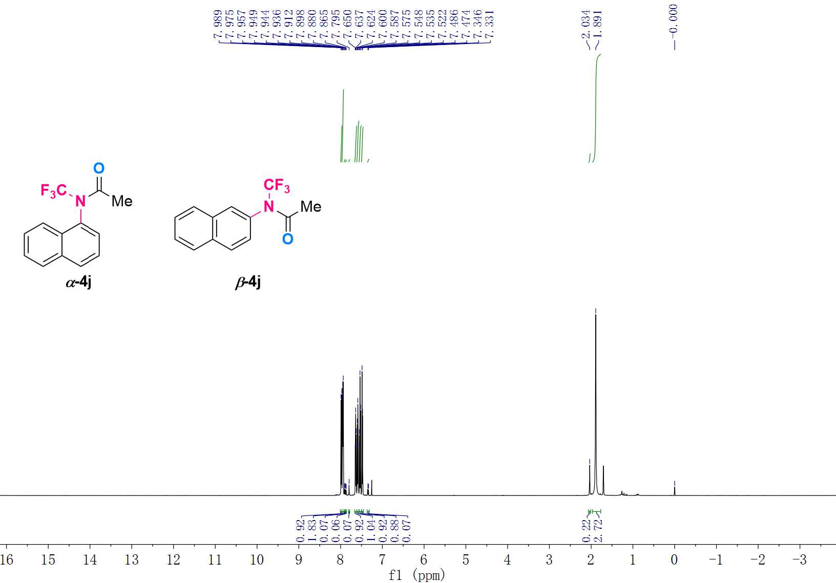

¹³C NMR (151 MHz, CDCl₃) Spectrum of 3j
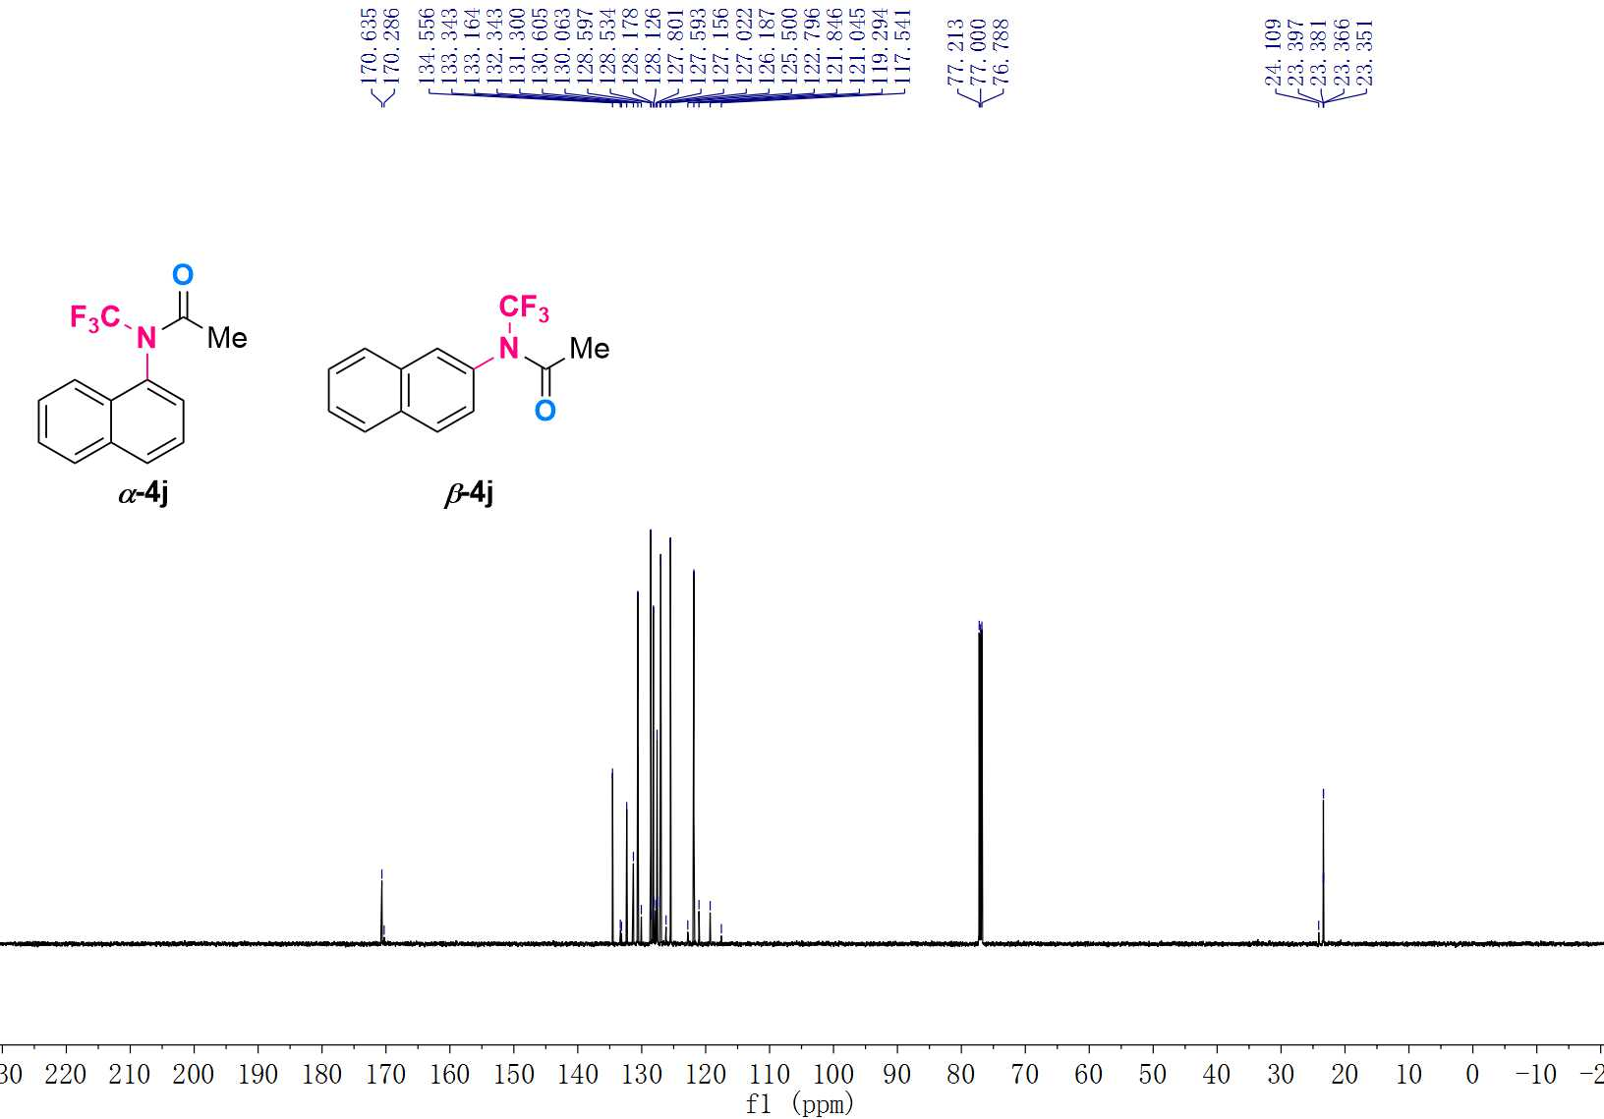

¹⁹F NMR (565 MHz, CDCl₃) Spectrum of 3j
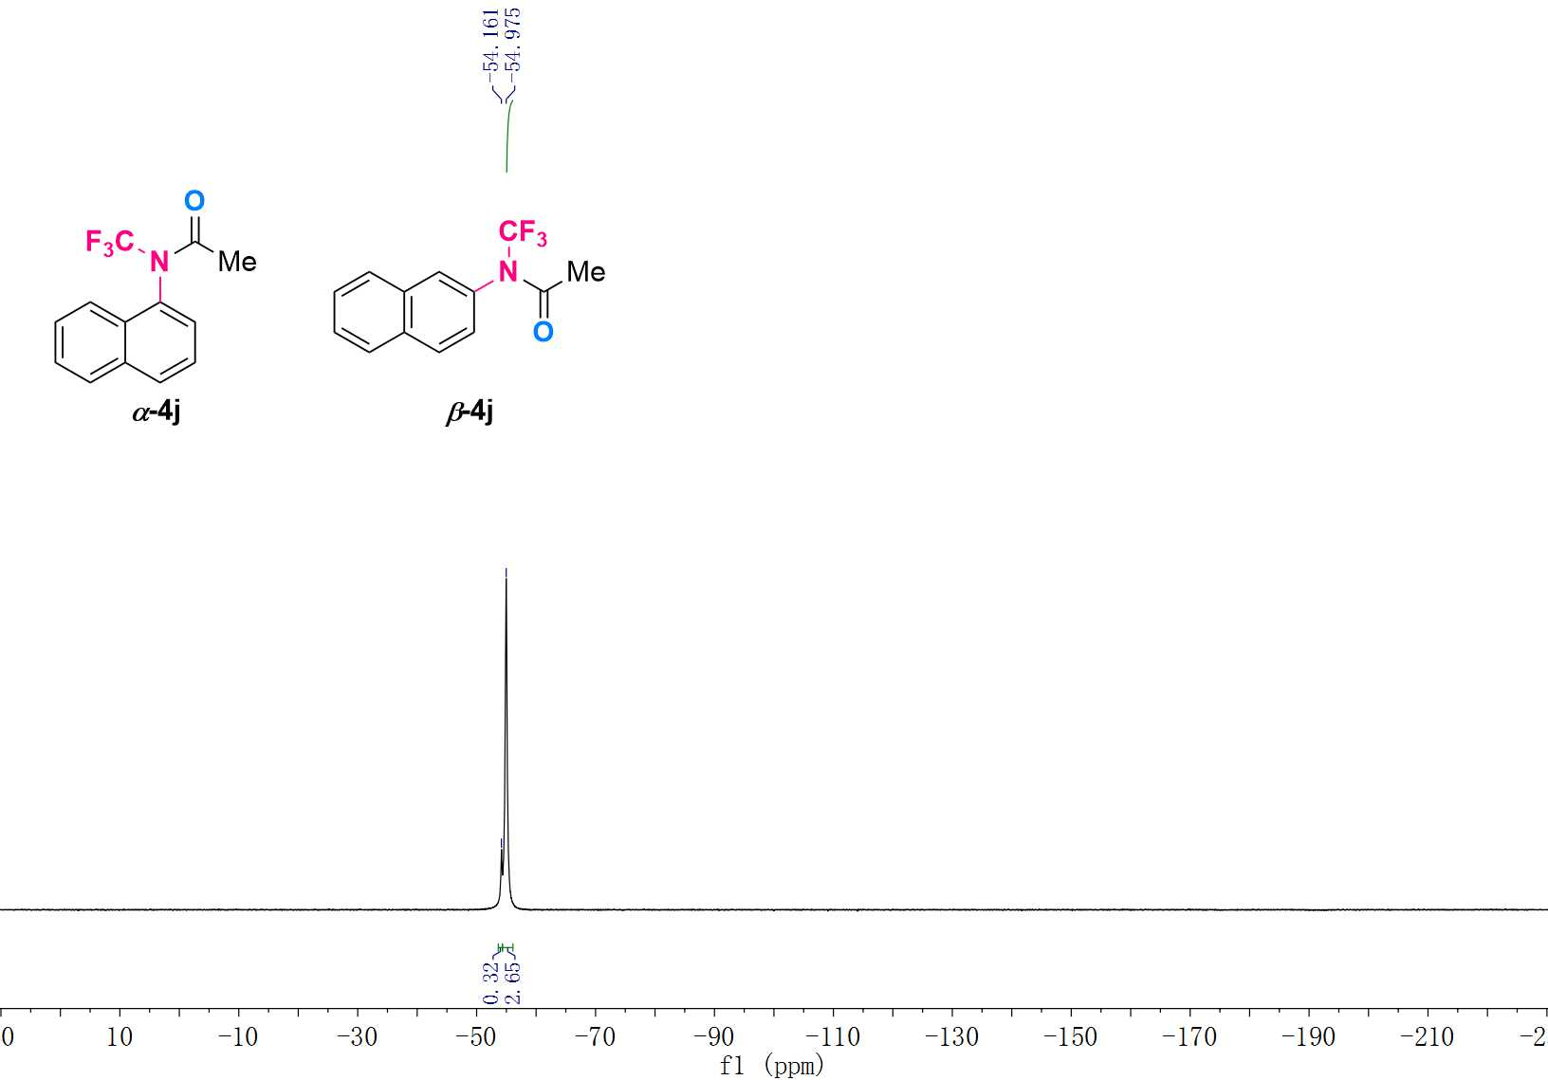

¹H NMR (600 MHz, CDCl₃) Spectrum of 3k
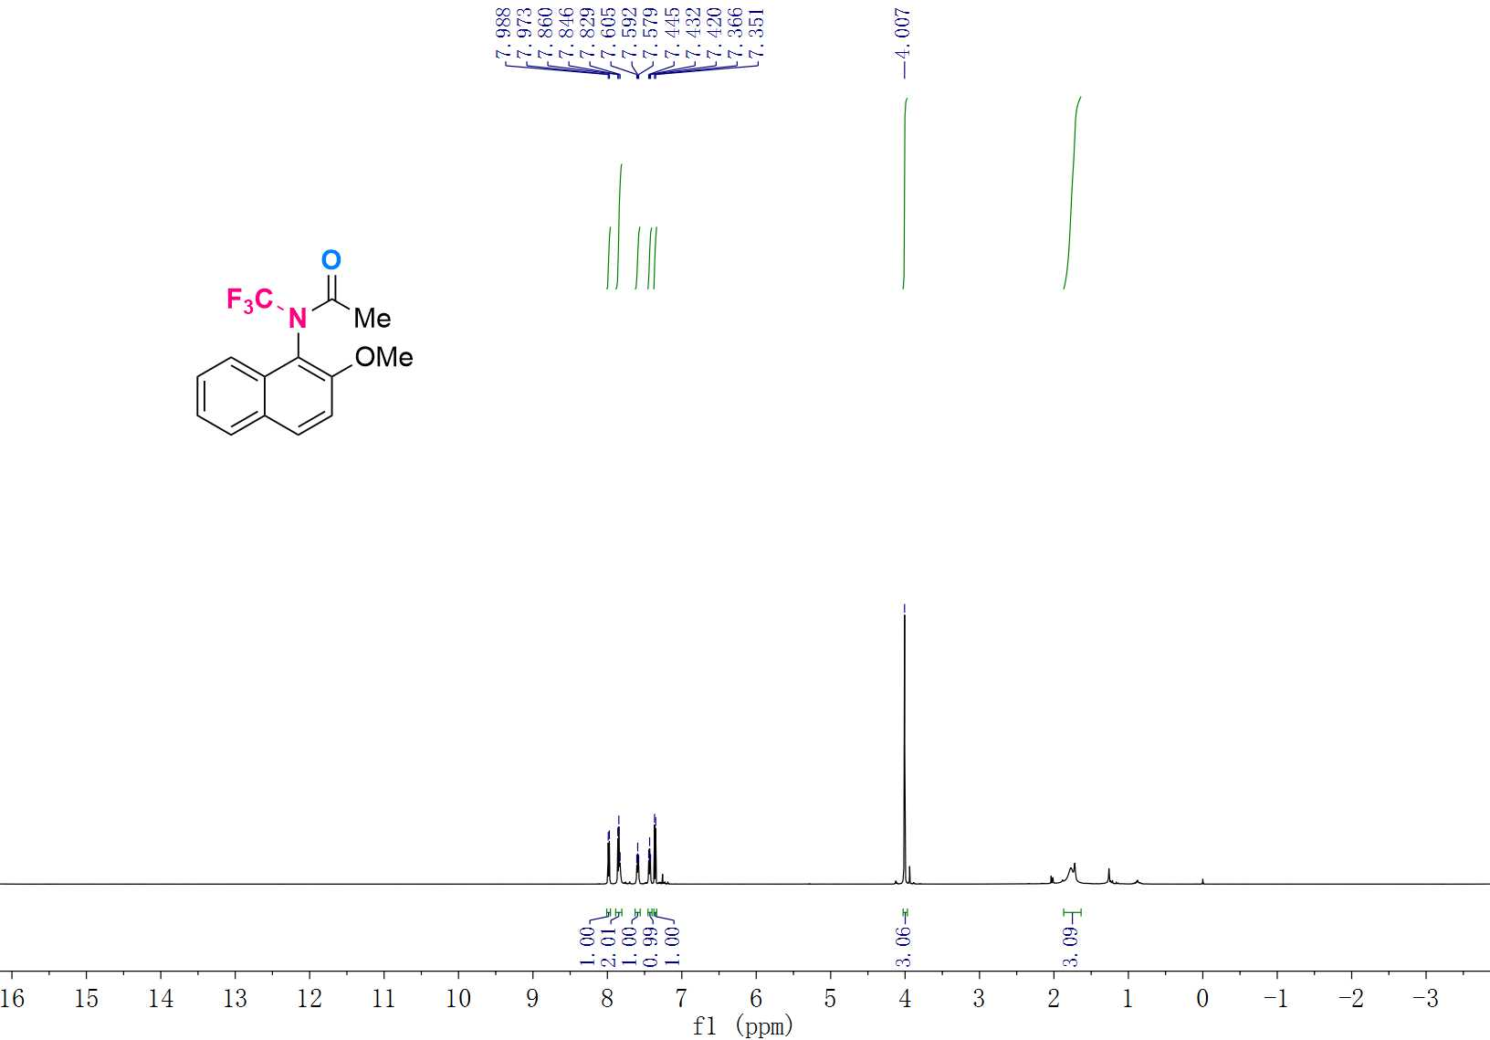

¹³C NMR (151 MHz, CDCl₃) Spectrum of 3k
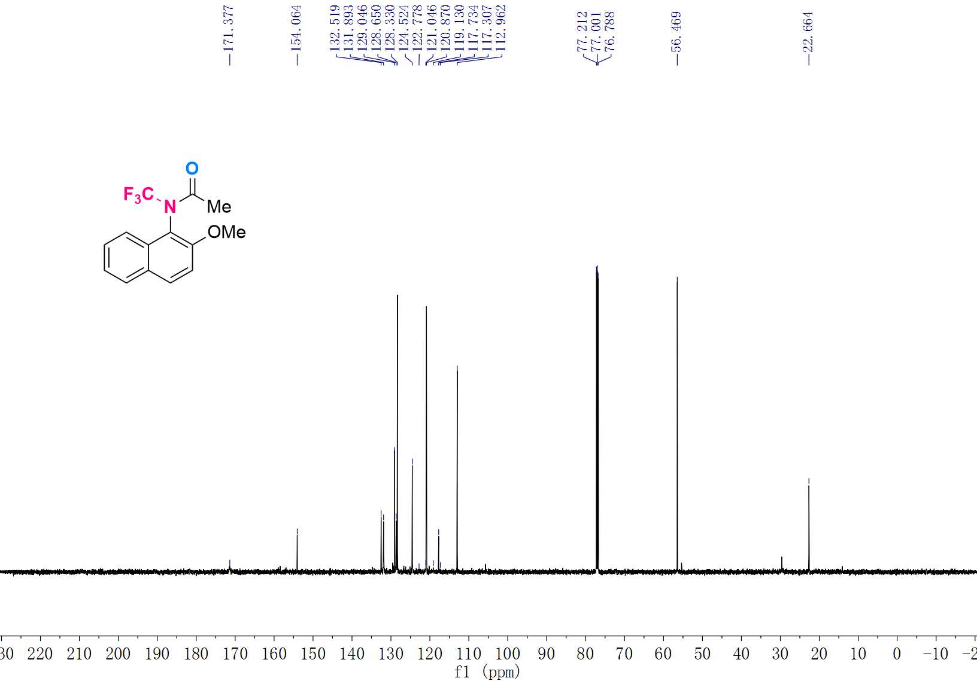

¹⁹F NMR (565 MHz, CDCl₃) Spectrum of 3k
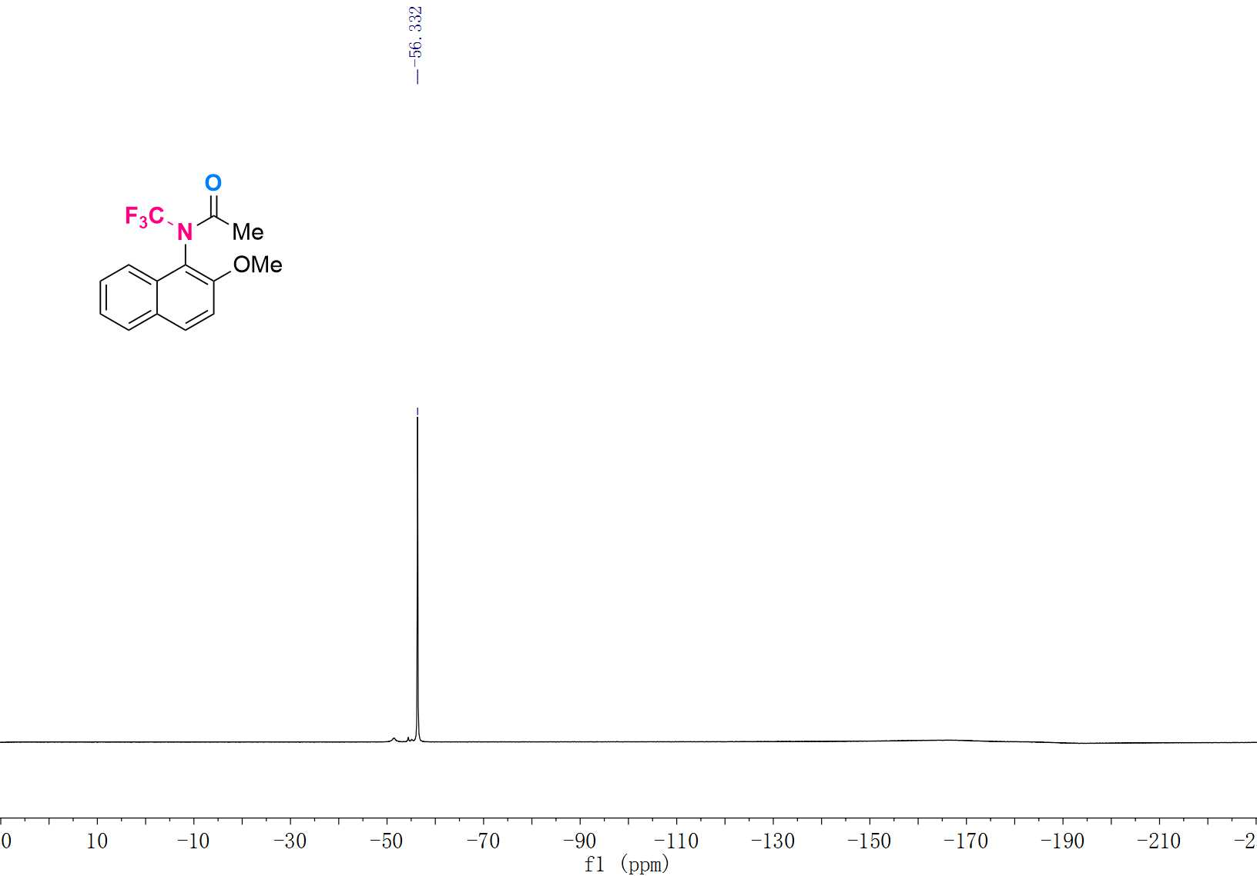

¹H NMR (600 MHz, CDCl₃) Spectrum of 3l
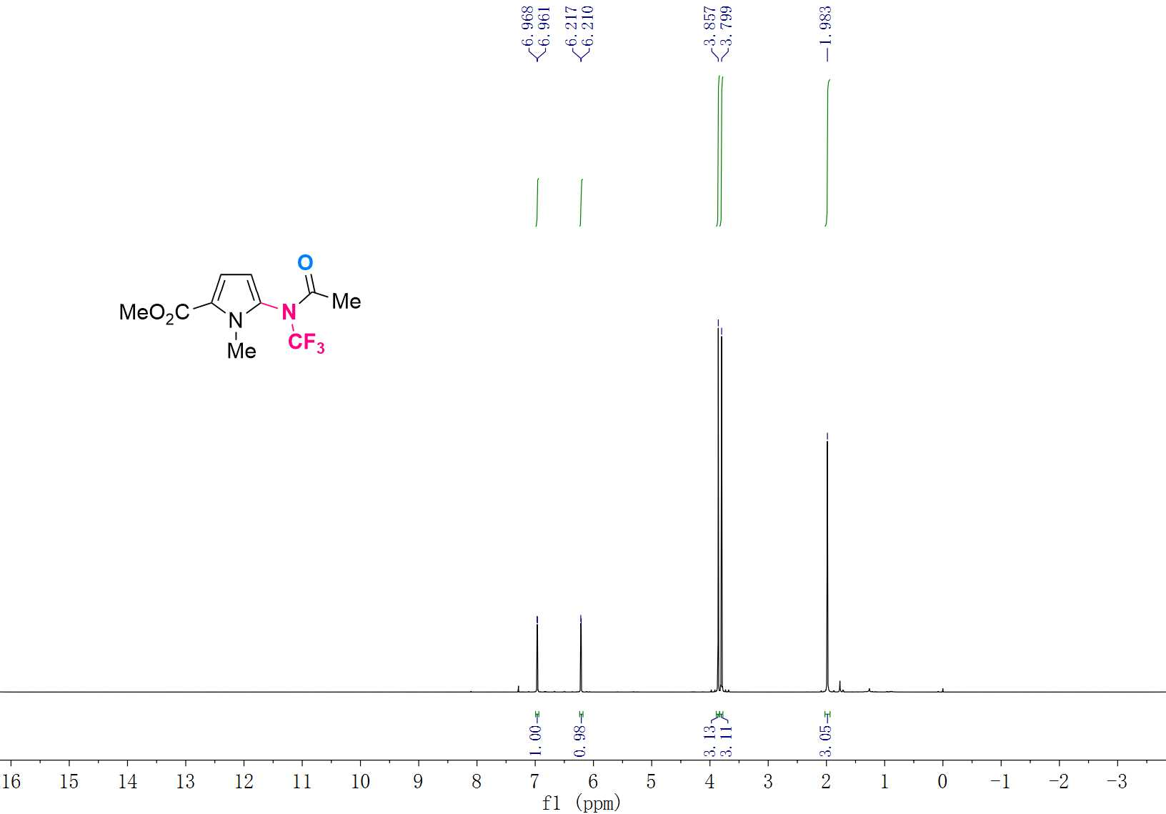

¹³C NMR (151 MHz, CDCl₃) Spectrum of 3l
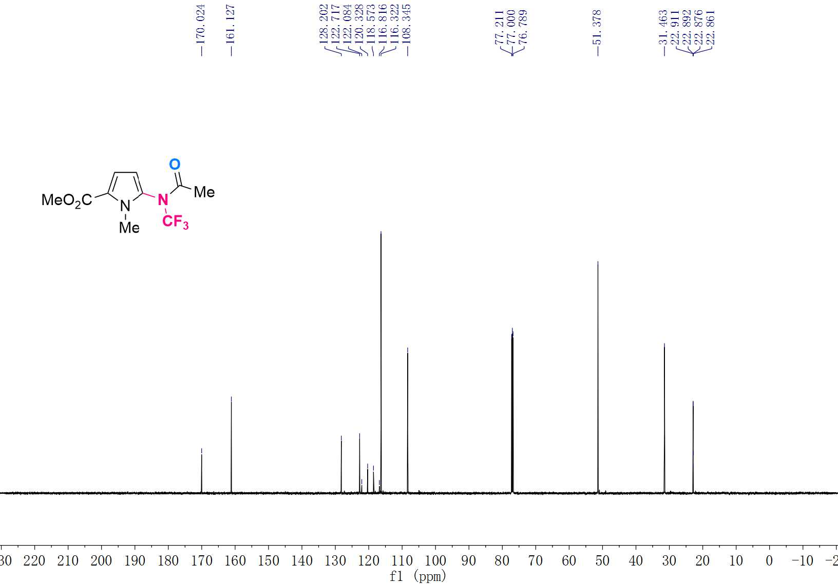

¹⁹F NMR (565 MHz, CDCl₃) Spectrum of 3l
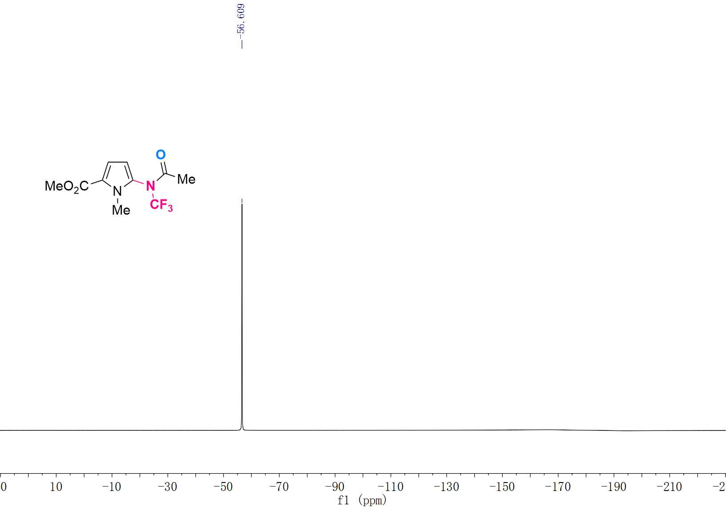

¹H NMR (600 MHz, CDCl₃) Spectrum of 3m
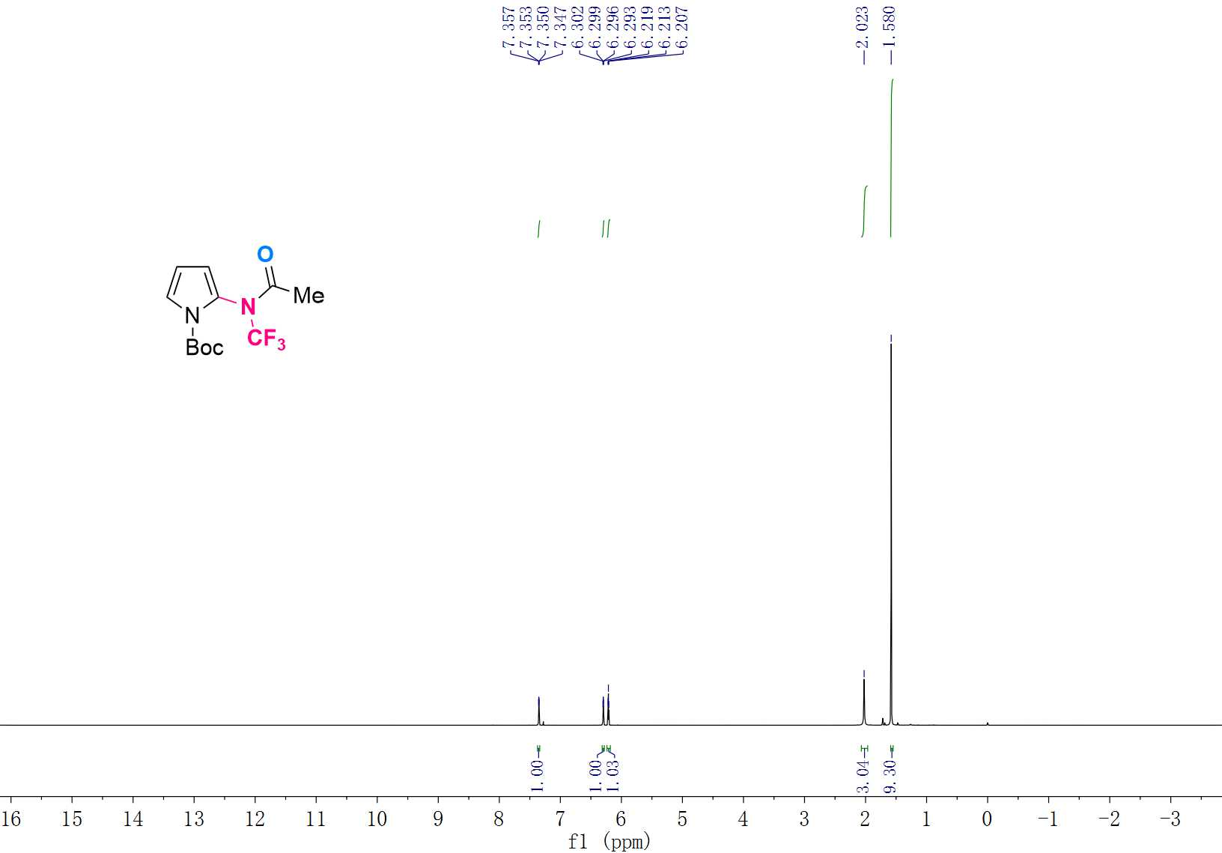

¹³C NMR (151 MHz, CDCl₃) Spectrum of 3m
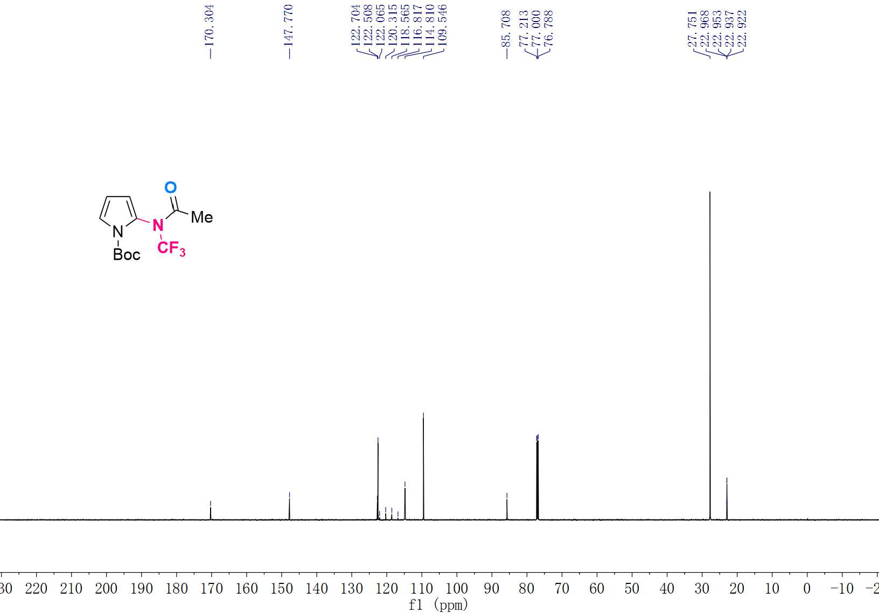

¹⁹F NMR (565 MHz, CDCl₃) Spectrum of 3m
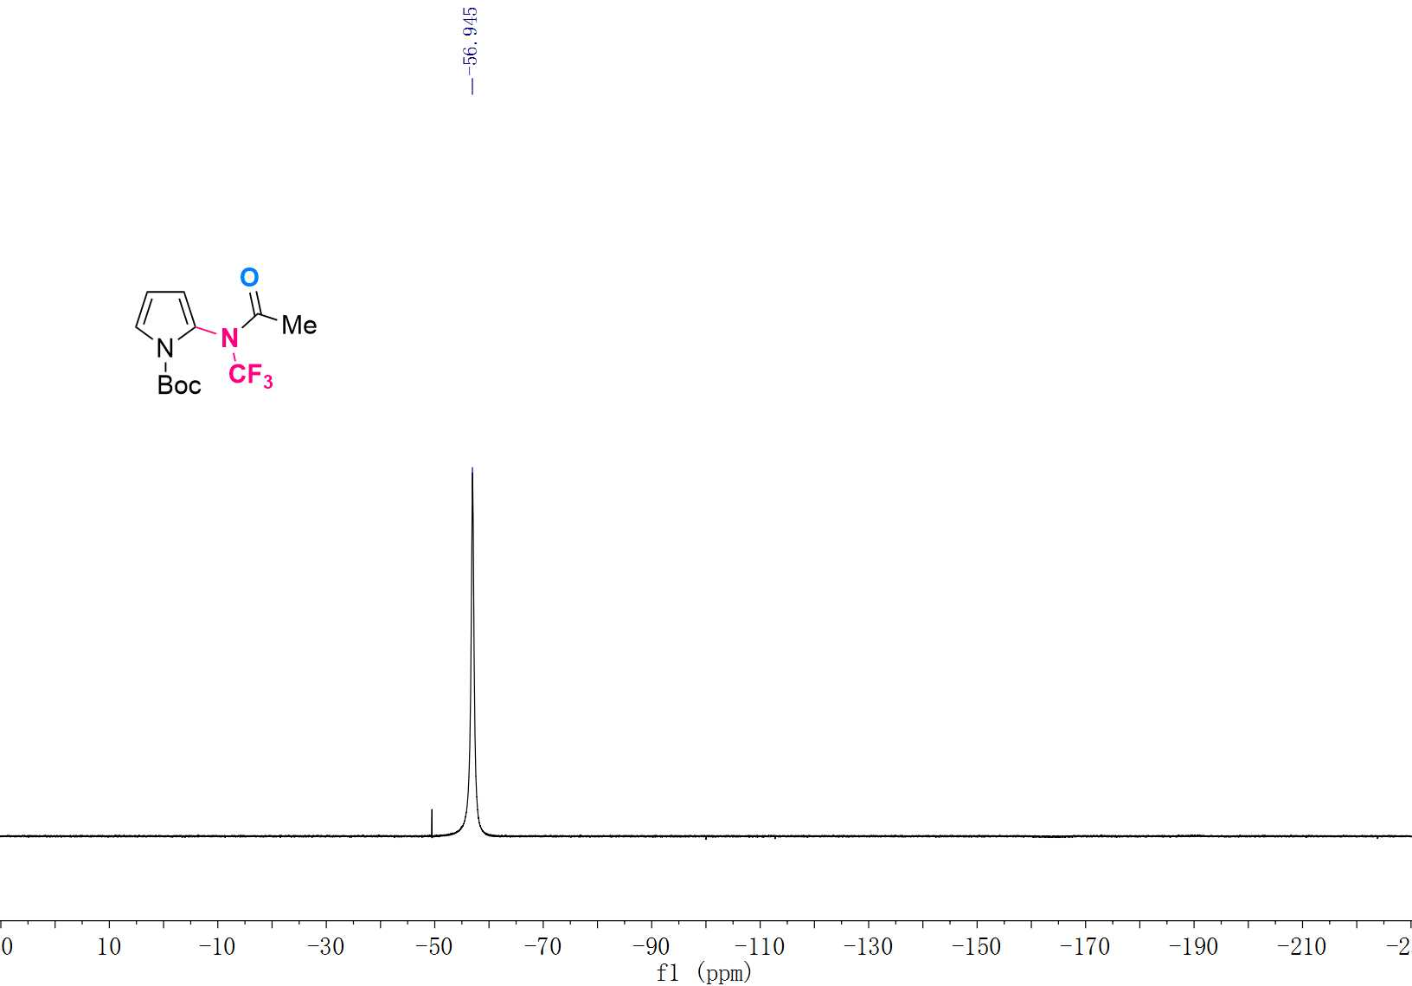

¹H NMR (600 MHz, CDCl₃) Spectrum of 3n
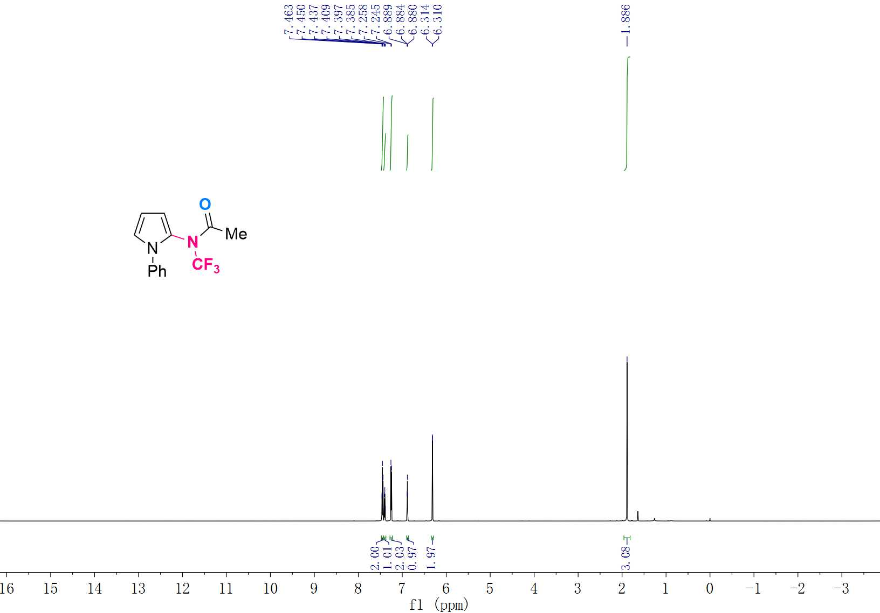

¹³C NMR (151 MHz, CDCl₃) Spectrum of 3n
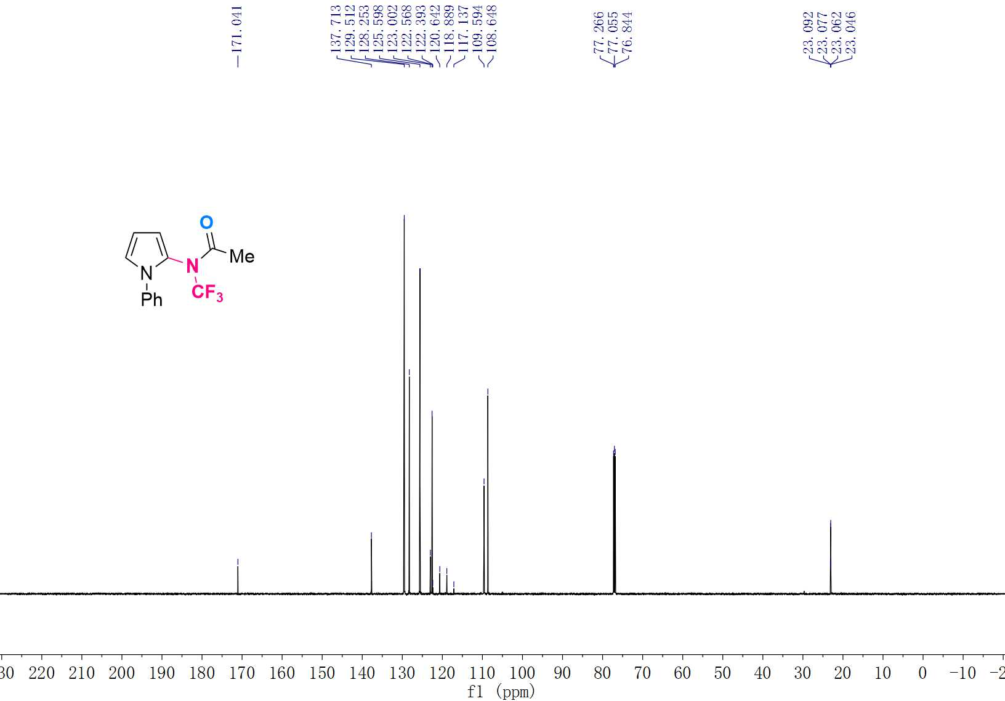

¹⁹F NMR (565 MHz, CDCl₃) Spectrum of 3n
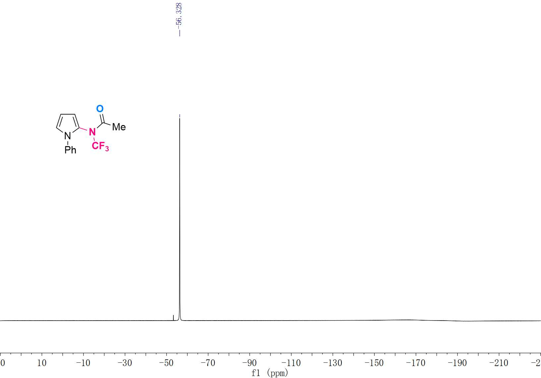

¹H NMR (600 MHz, CDCl₃) Spectrum of 3o
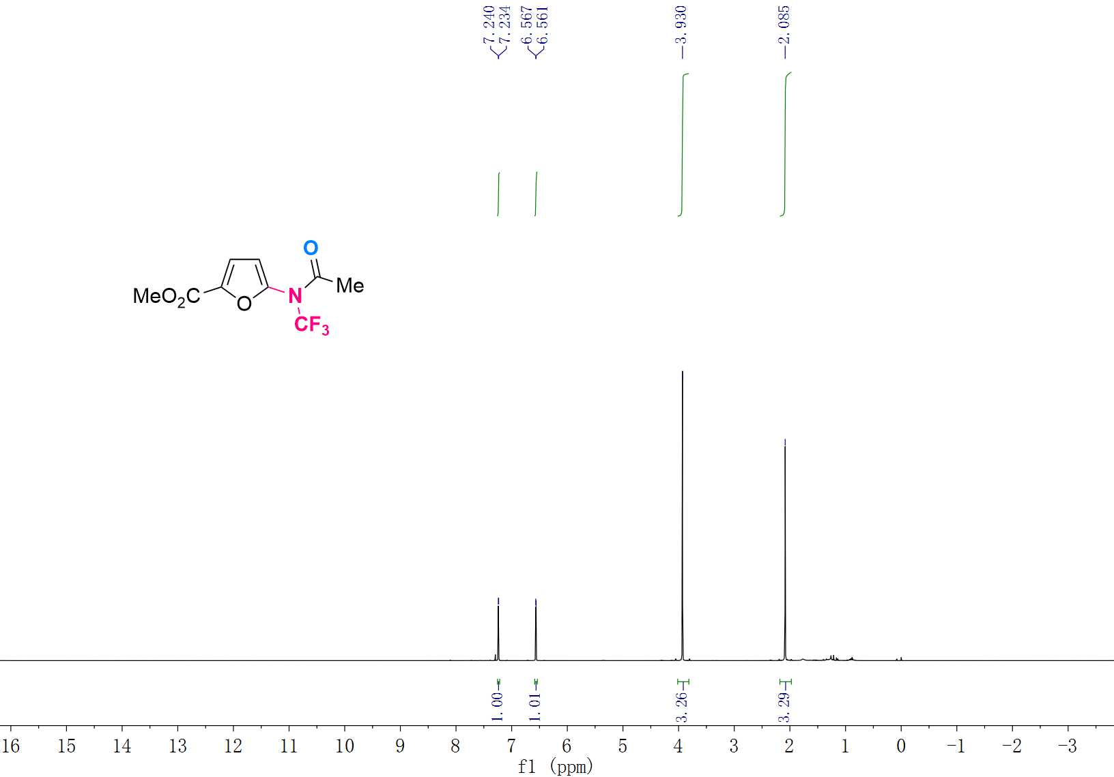

¹³C NMR (151 MHz, CDCl₃) Spectrum of 3o
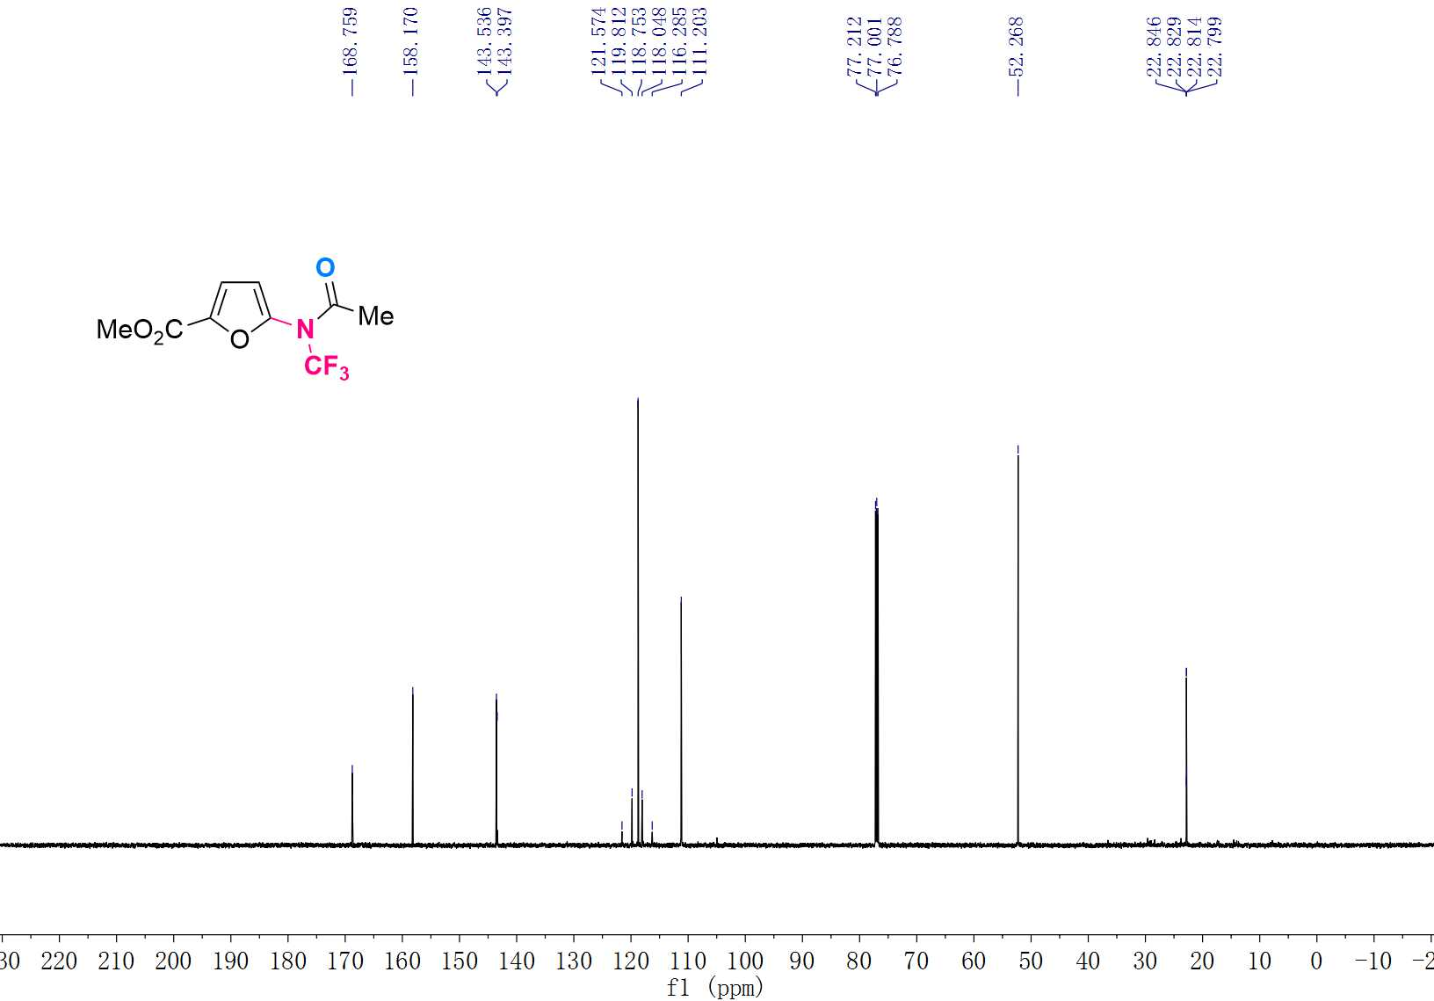

¹⁹F NMR (565 MHz, CDCl₃) Spectrum of 3o
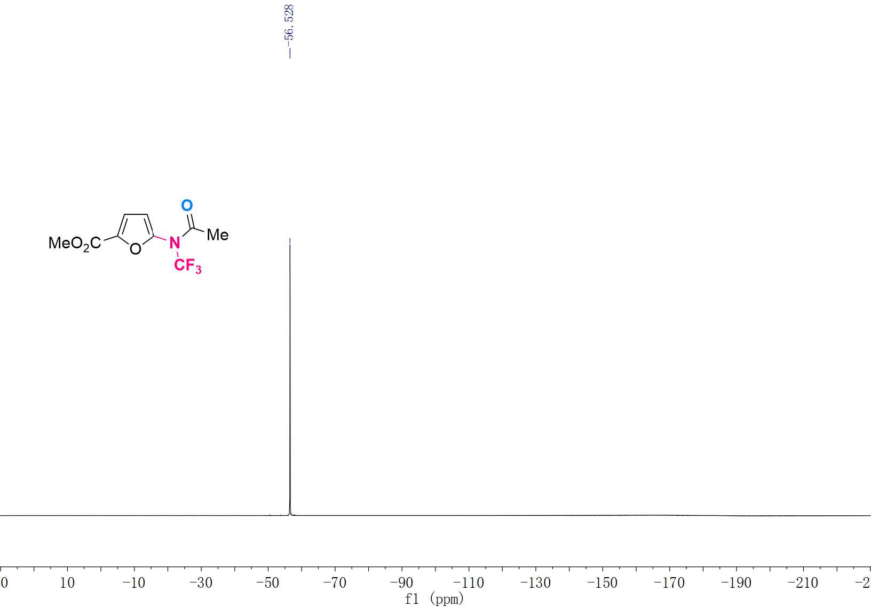

¹H NMR (600 MHz, CDCl₃) Spectrum of 3p
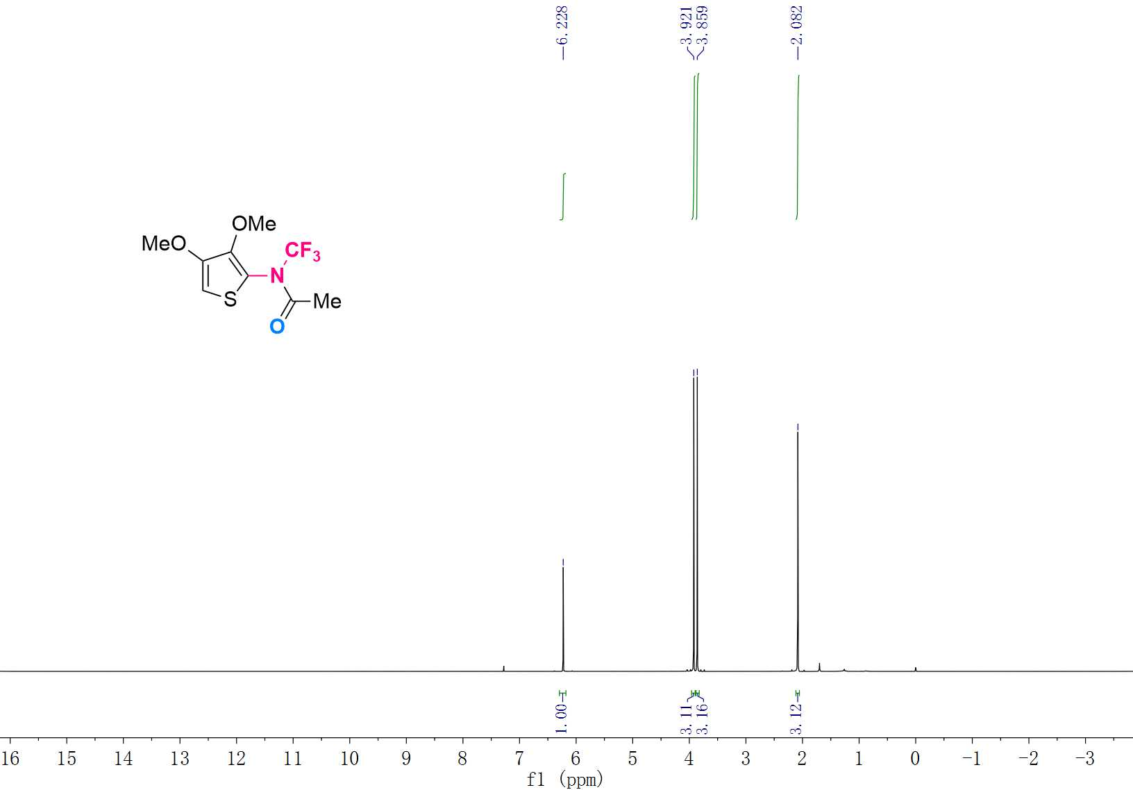

¹³C NMR (151 MHz, CDCl₃) Spectrum of 3p
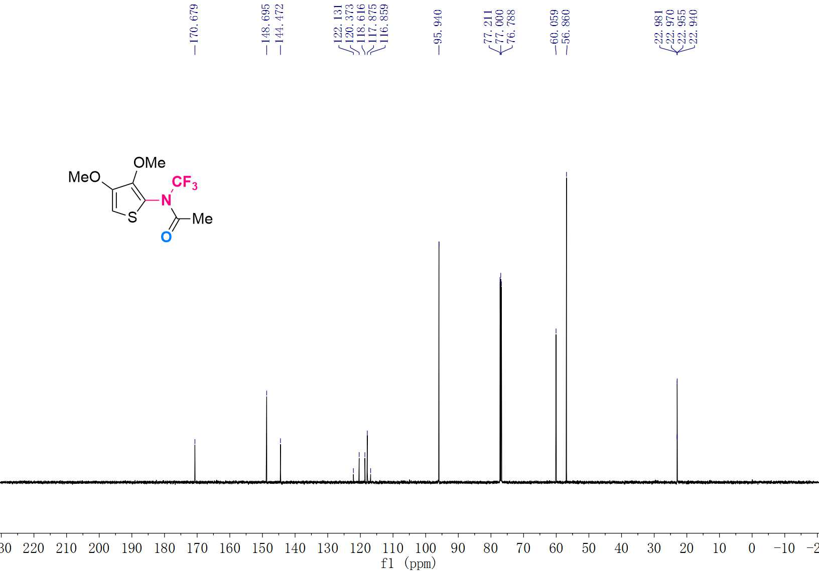

¹⁹F NMR (565 MHz, CDCl₃) Spectrum of 3p
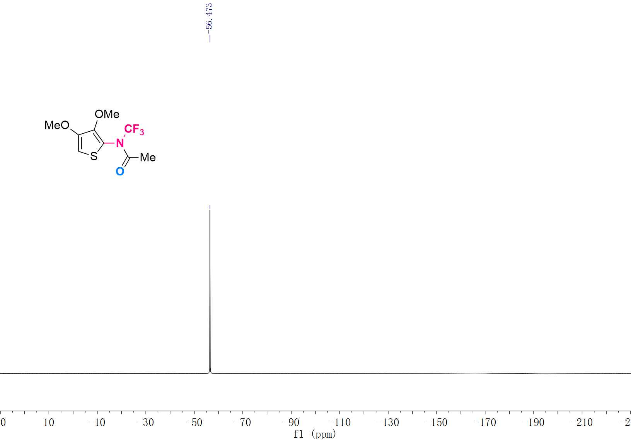

¹H NMR (600 MHz, CDCl₃) Spectrum of 3q
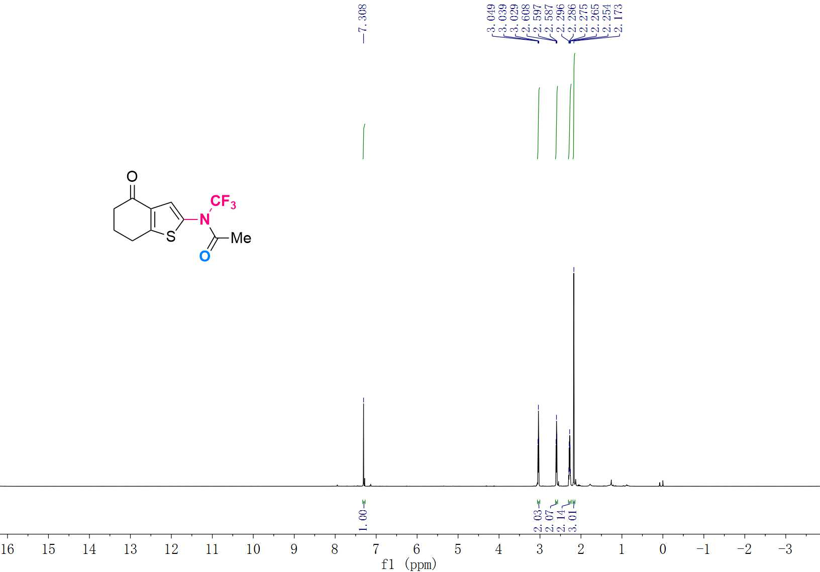

¹³C NMR (151 MHz, CDCl₃) Spectrum of 3q
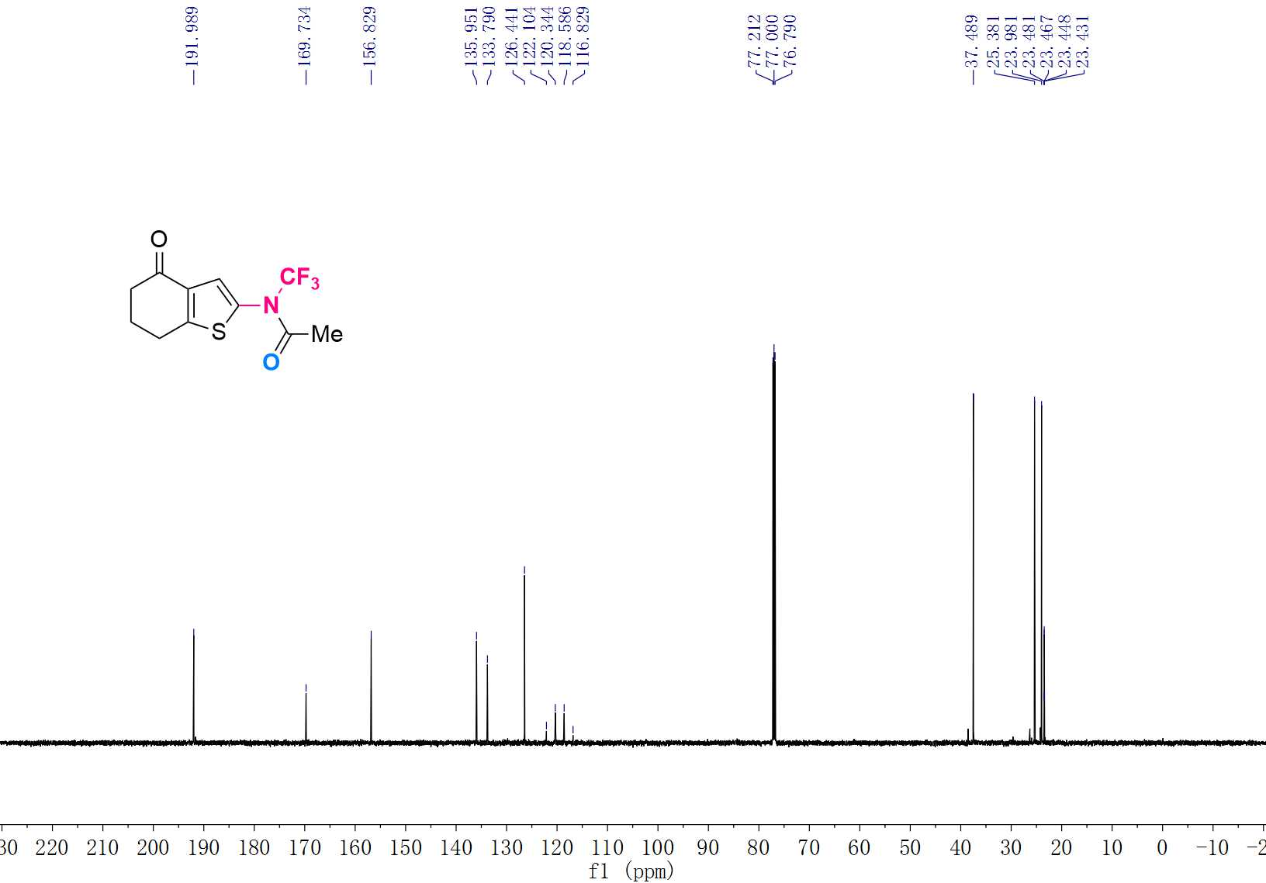

¹⁹F NMR (565 MHz, CDCl₃) Spectrum of 3q
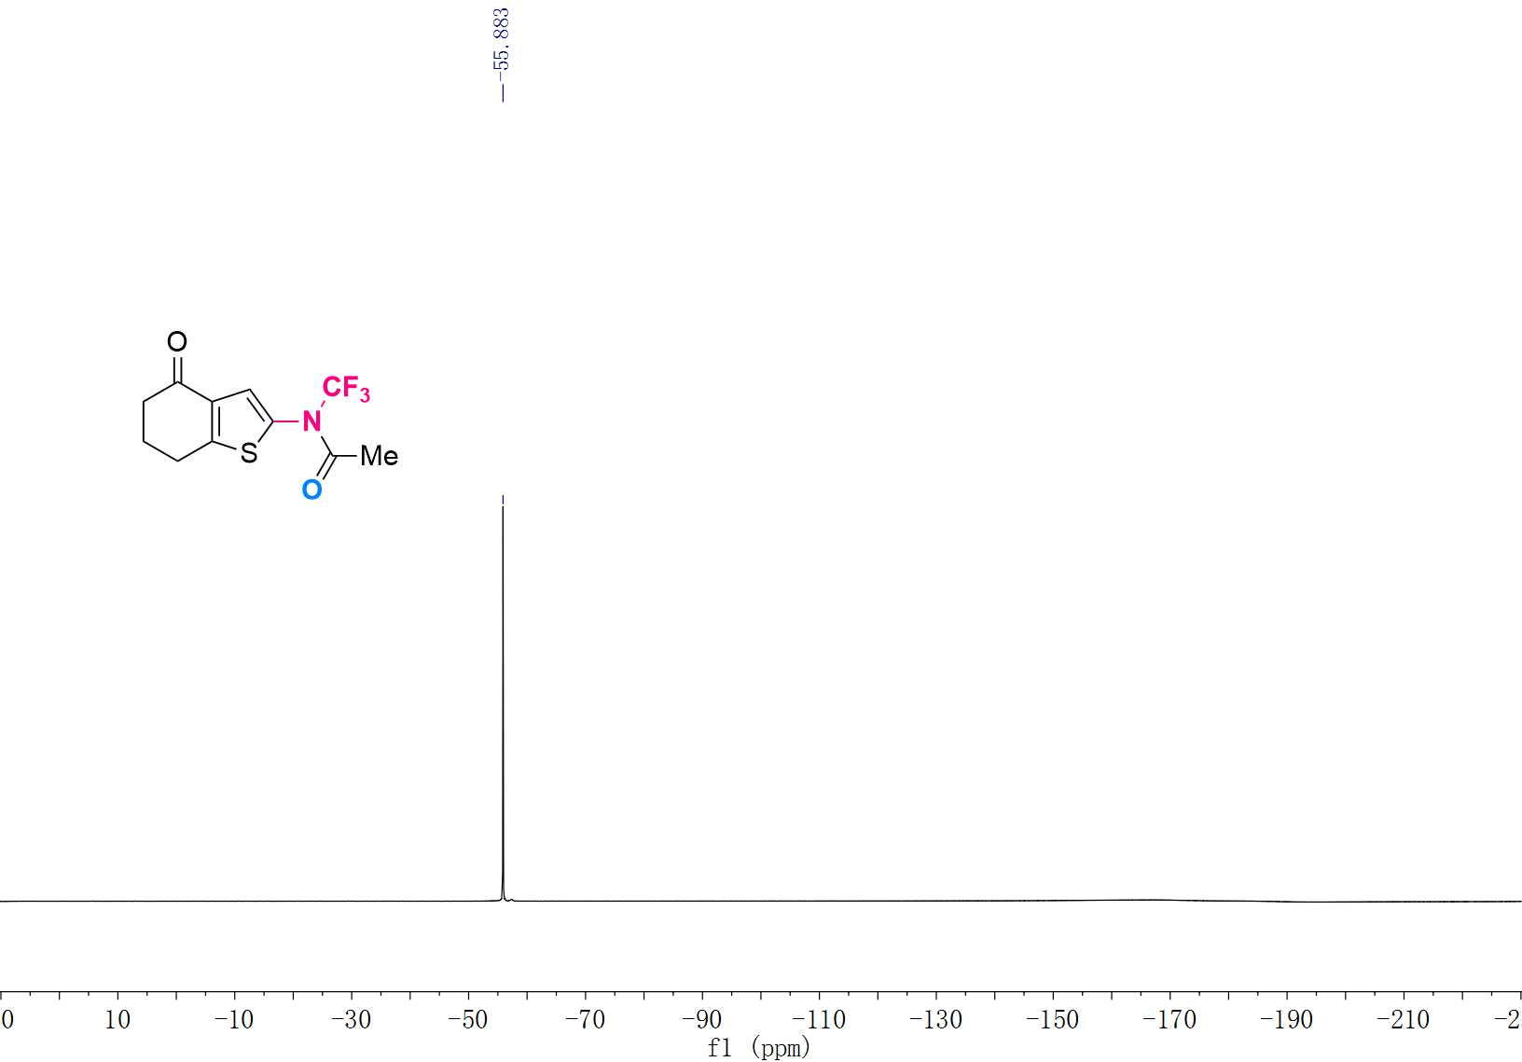

¹H NMR (600 MHz, CDCl₃) Spectrum of 3r
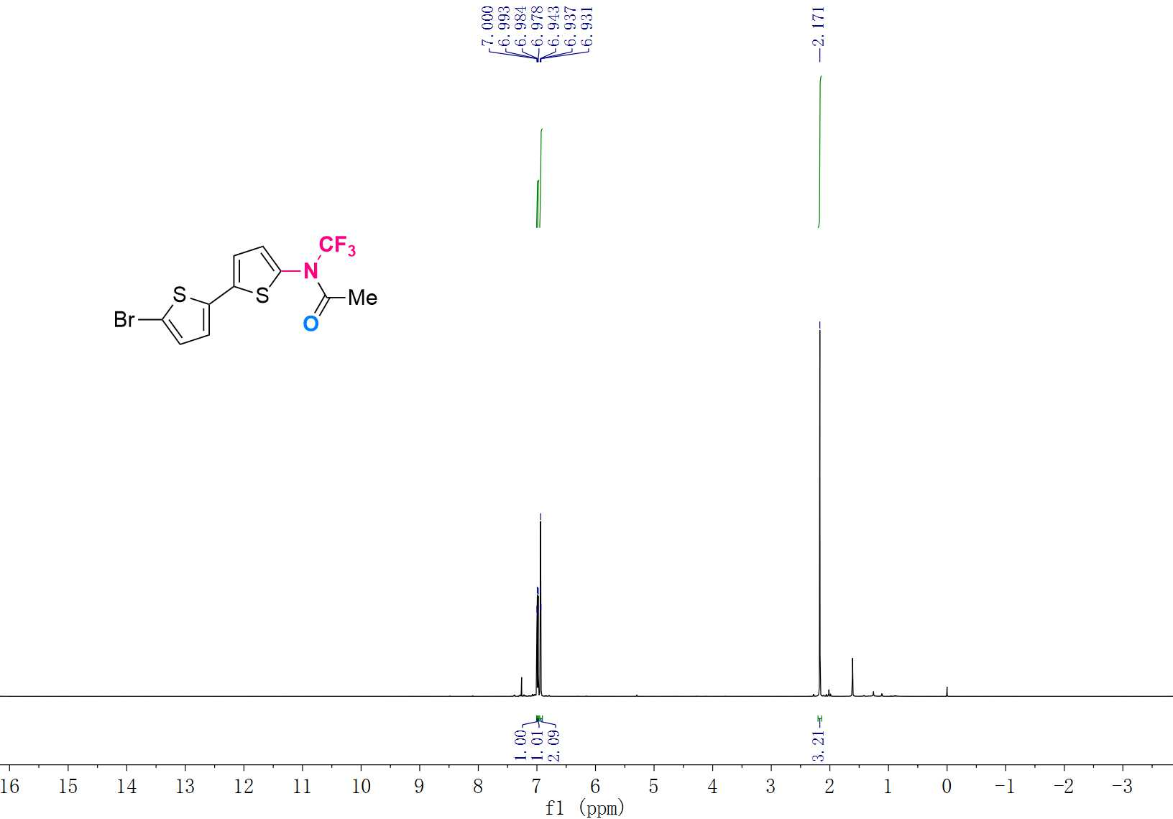

¹³C NMR (151 MHz, CDCl₃) Spectrum of 3r
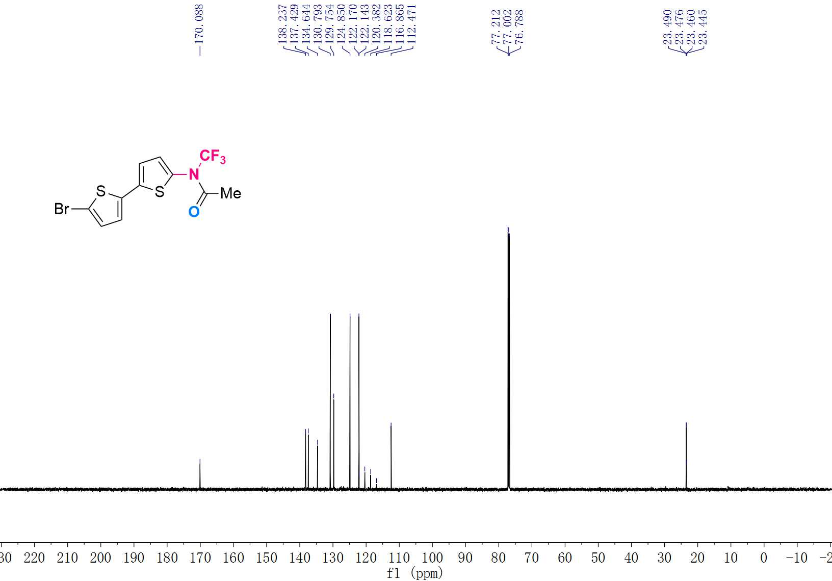

¹⁹F NMR (565 MHz, CDCl₃) Spectrum of 3r
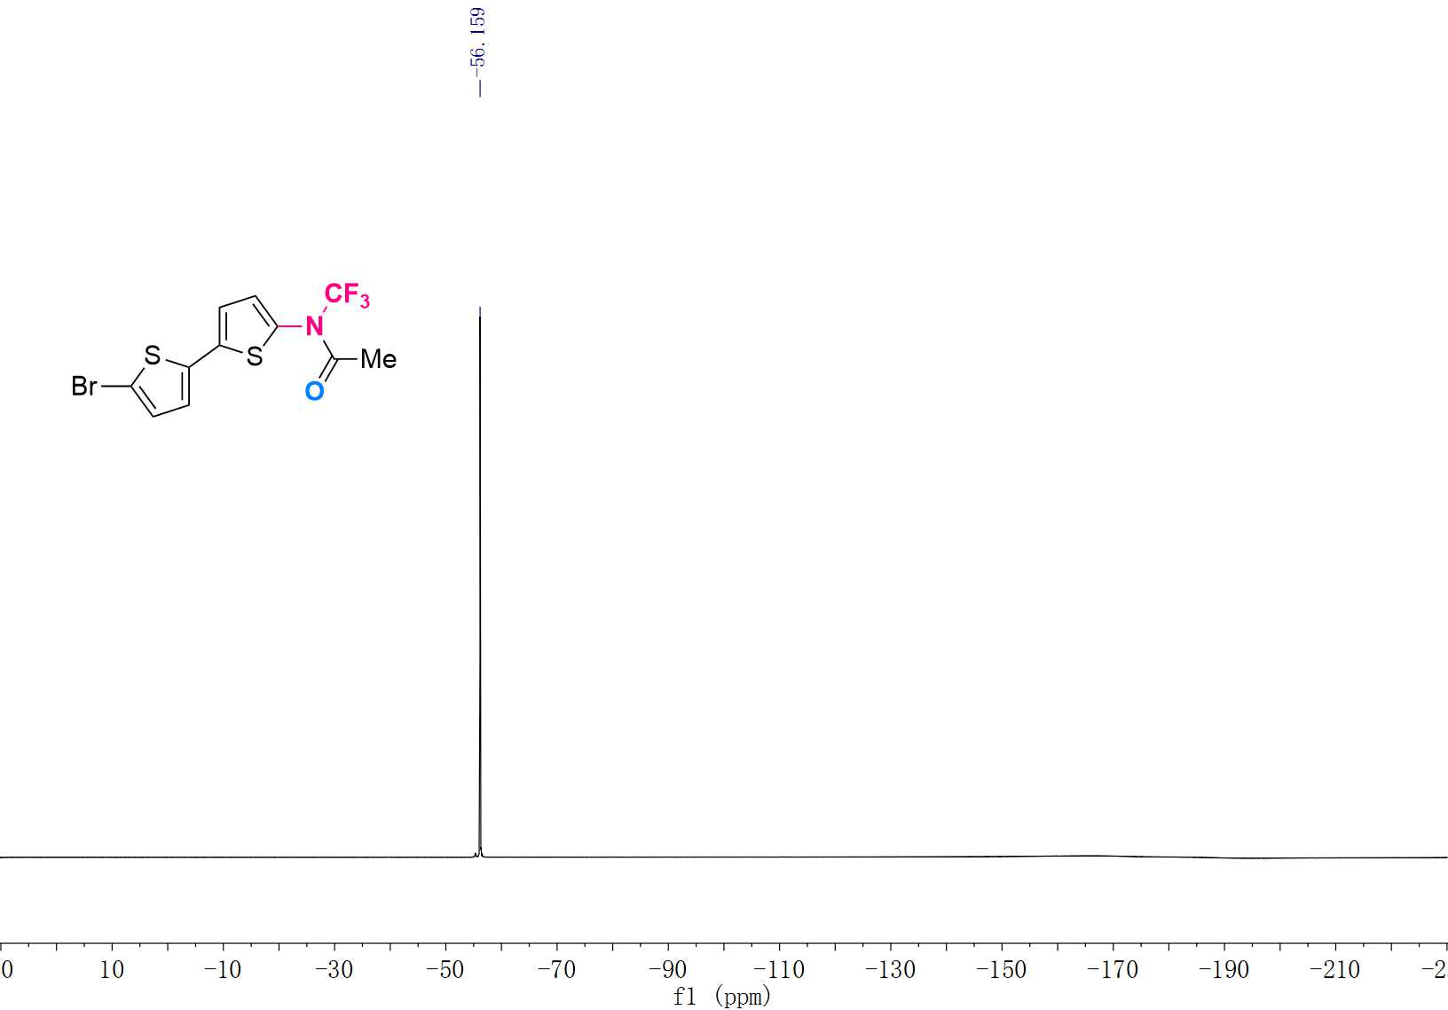

¹H NMR (600 MHz, CDCl₃) Spectrum of 3s
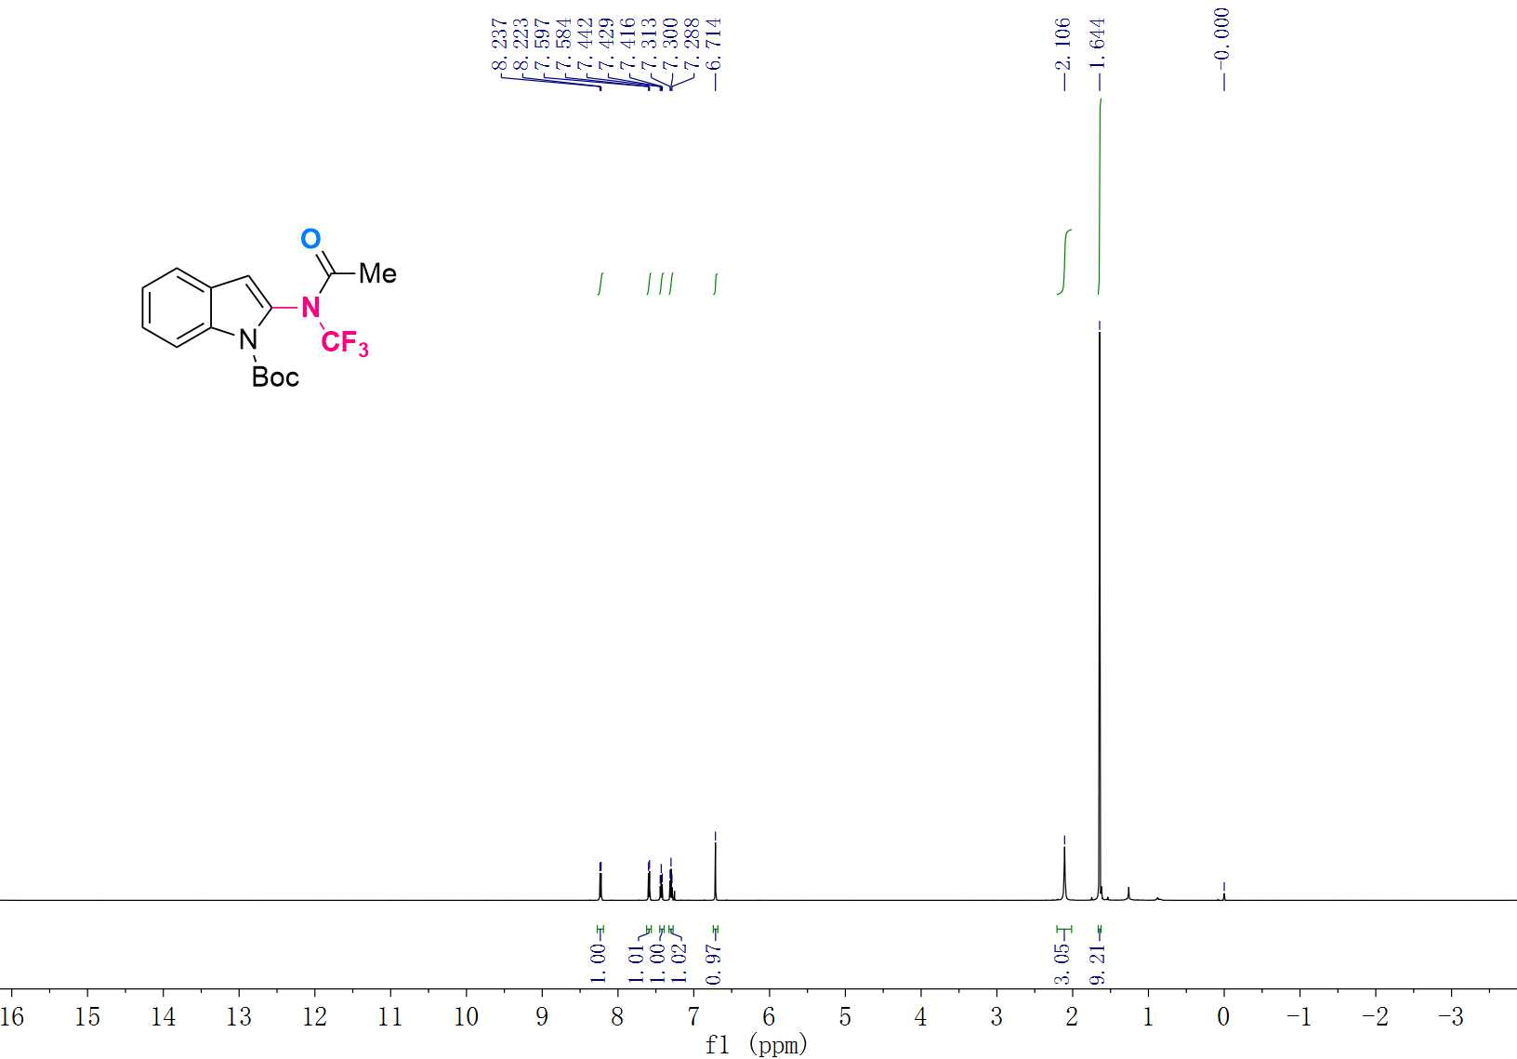

¹³C NMR (151 MHz, CDCl₃) Spectrum of 3s
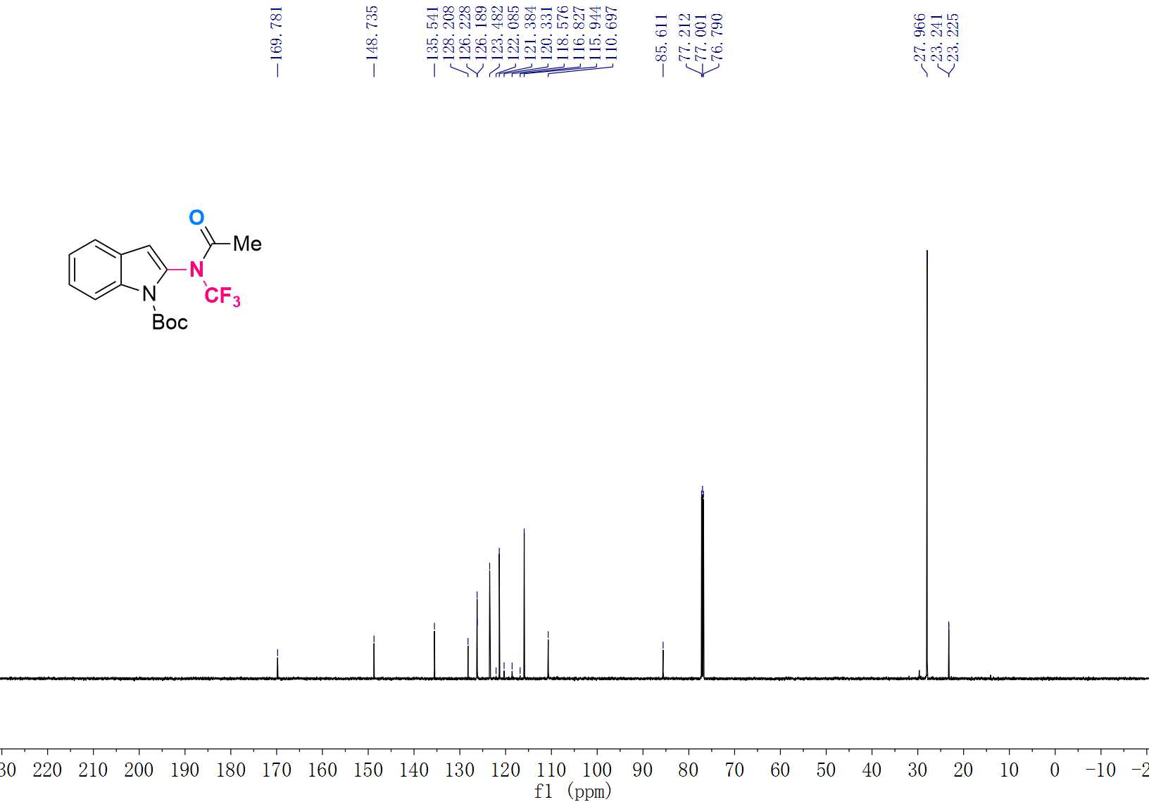

¹⁹F NMR (565 MHz, CDCl₃) Spectrum of 3s
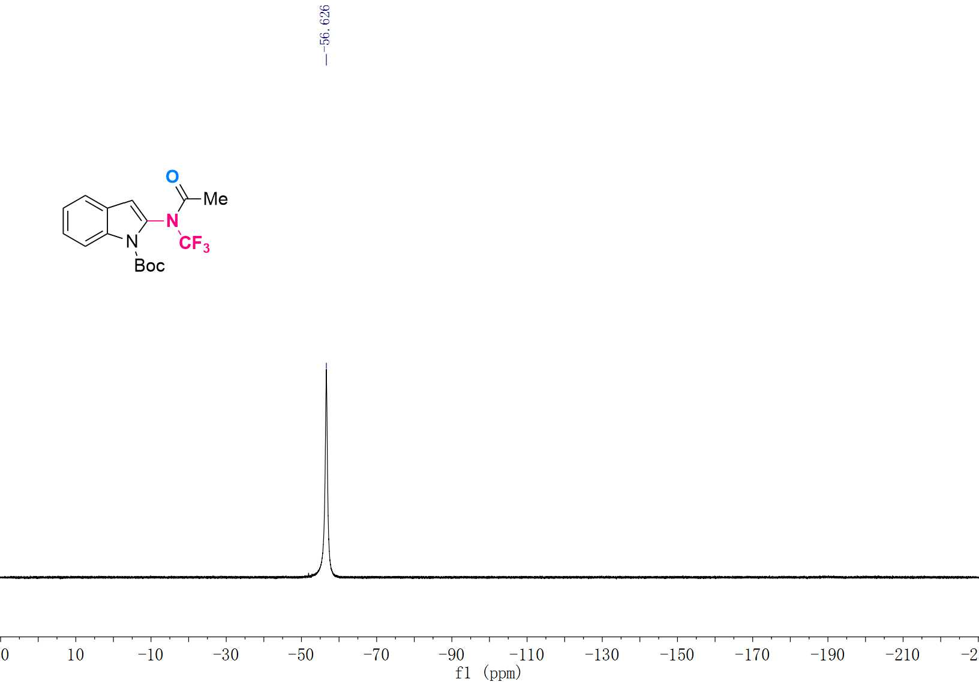

¹H NMR (600 MHz, CDCl₃) Spectrum of 3t
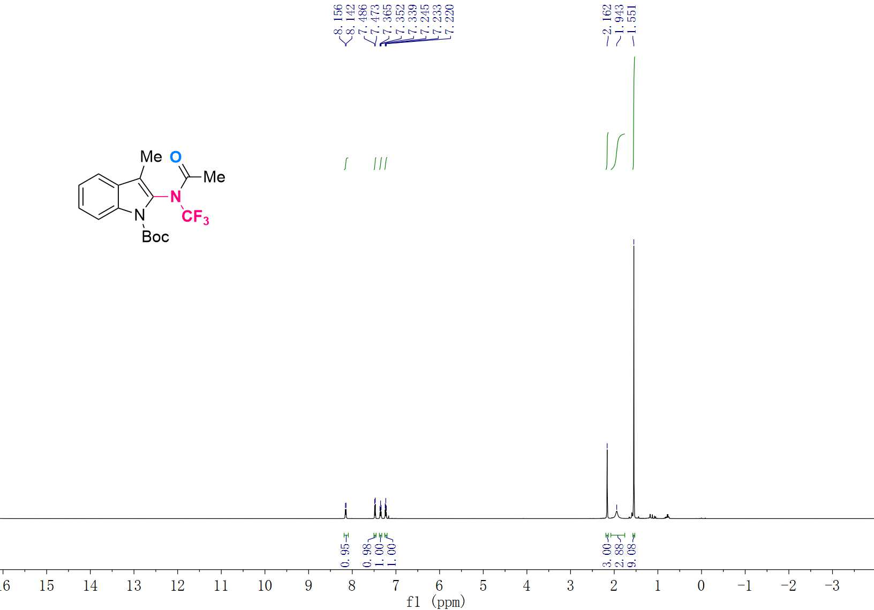

¹³C NMR (151 MHz, CDCl₃) Spectrum of 3t
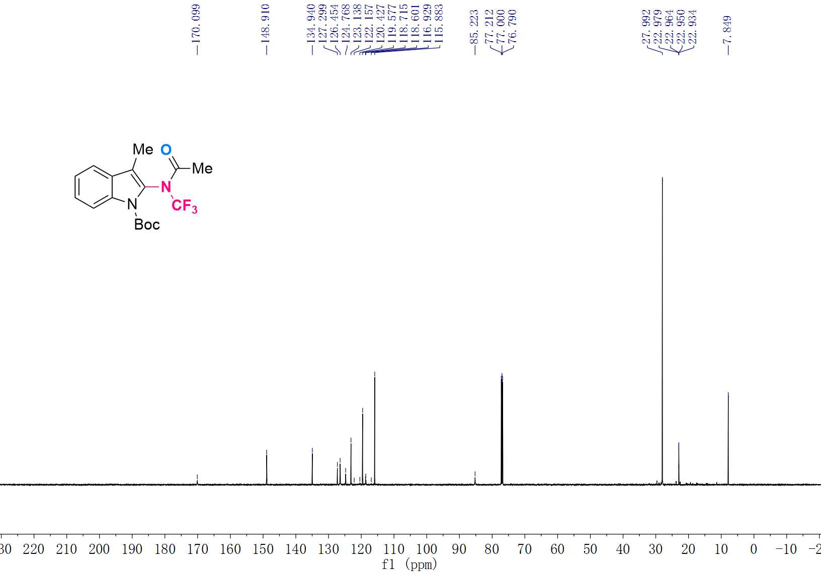

¹⁹F NMR (565 MHz, CDCl₃) Spectrum of 3t
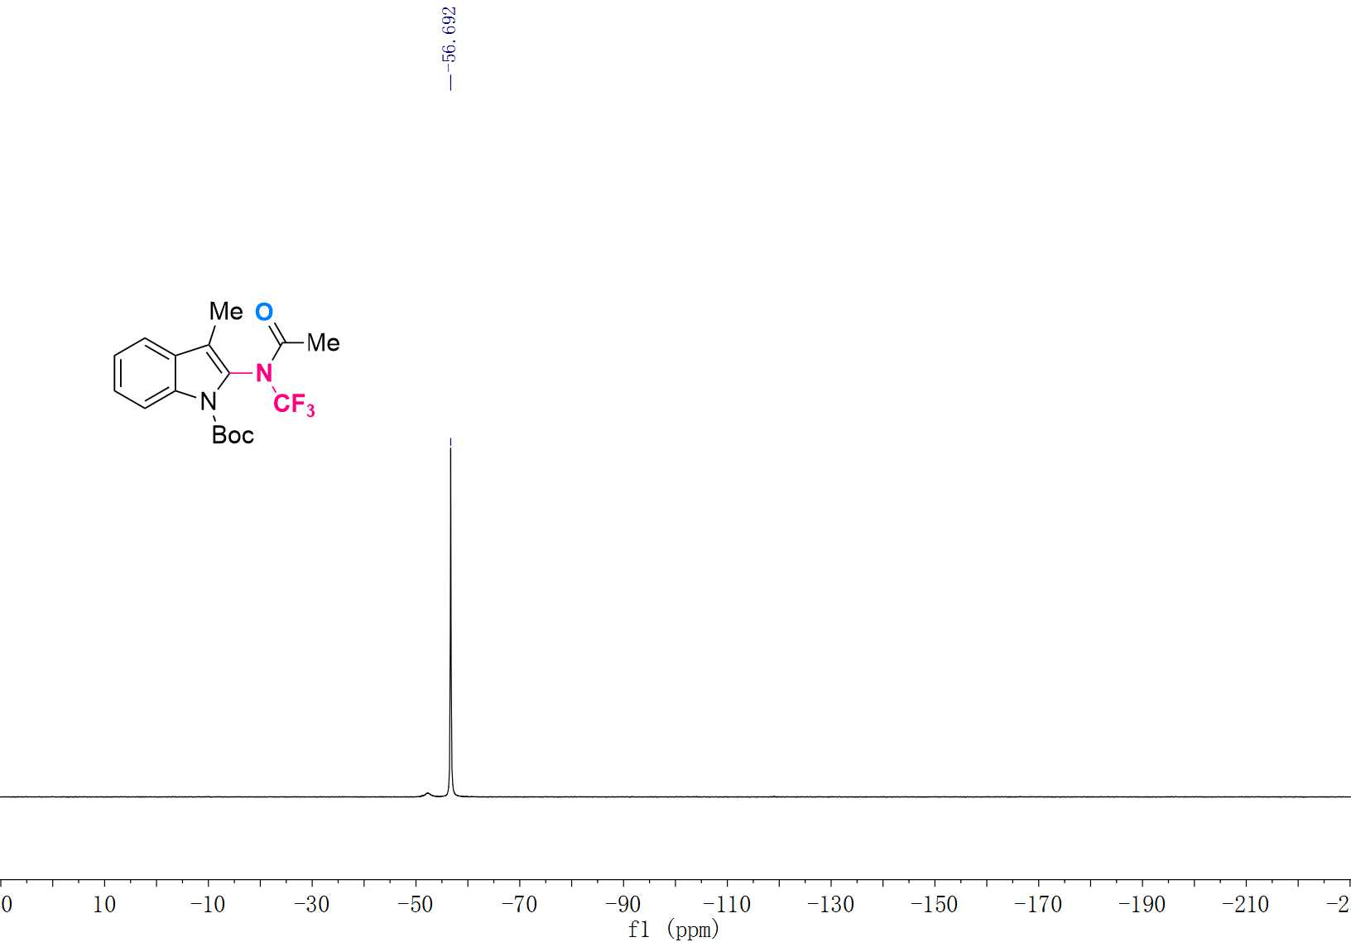

¹H NMR (600 MHz, CDCl₃) Spectrum of 3u
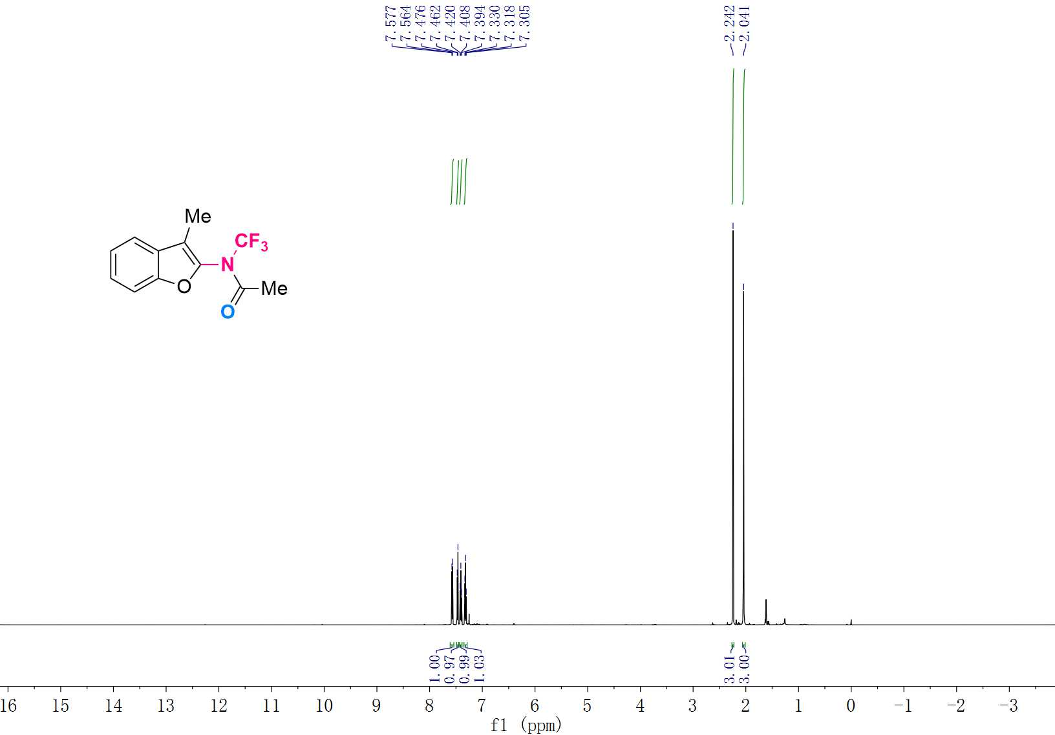

¹³C NMR (151 MHz, CDCl₃) Spectrum of 3u
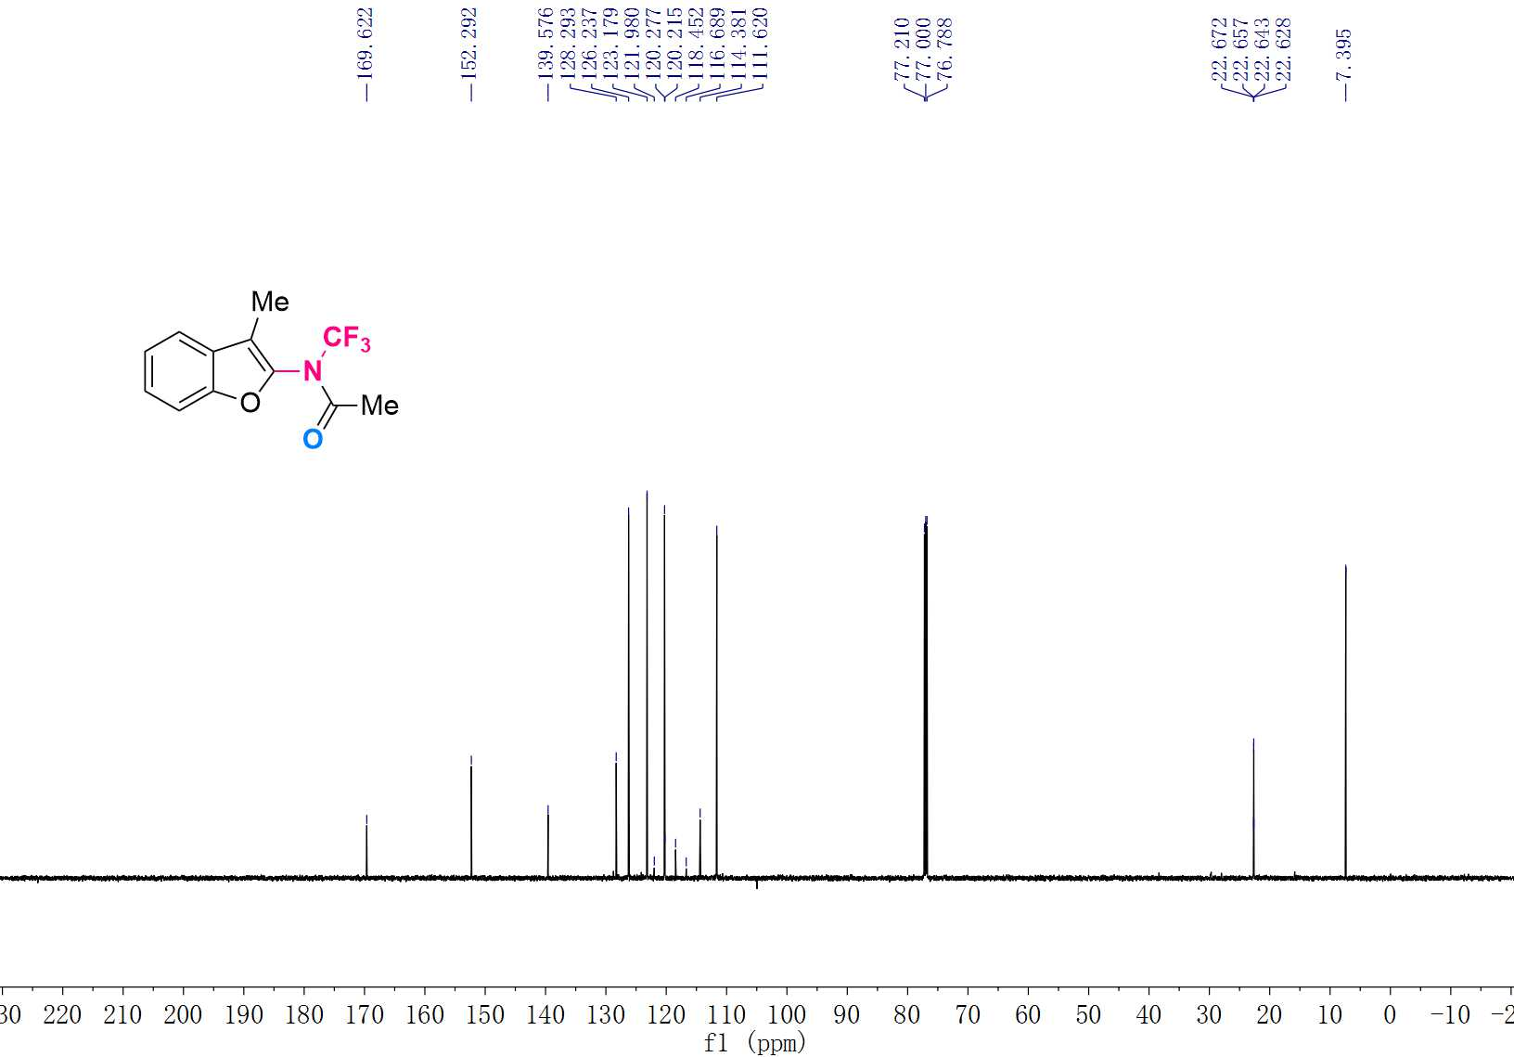

¹⁹F NMR (565 MHz, CDCl₃) Spectrum of 3u
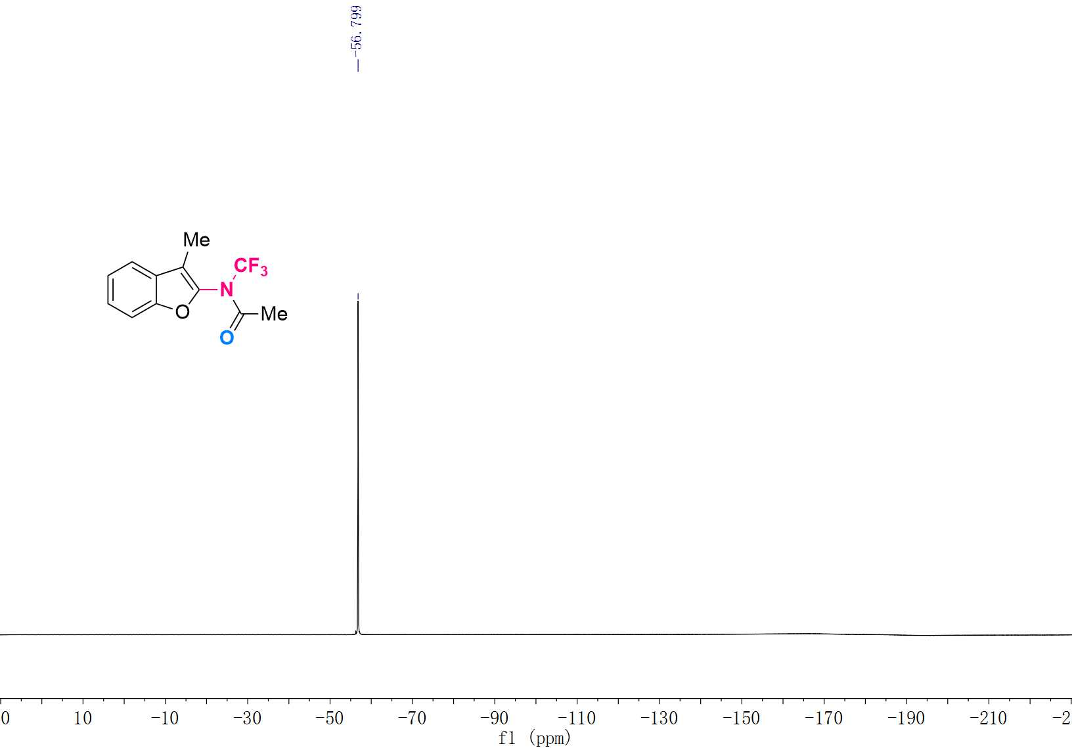

¹H NMR (600 MHz, CDCl₃) Spectrum of 3v
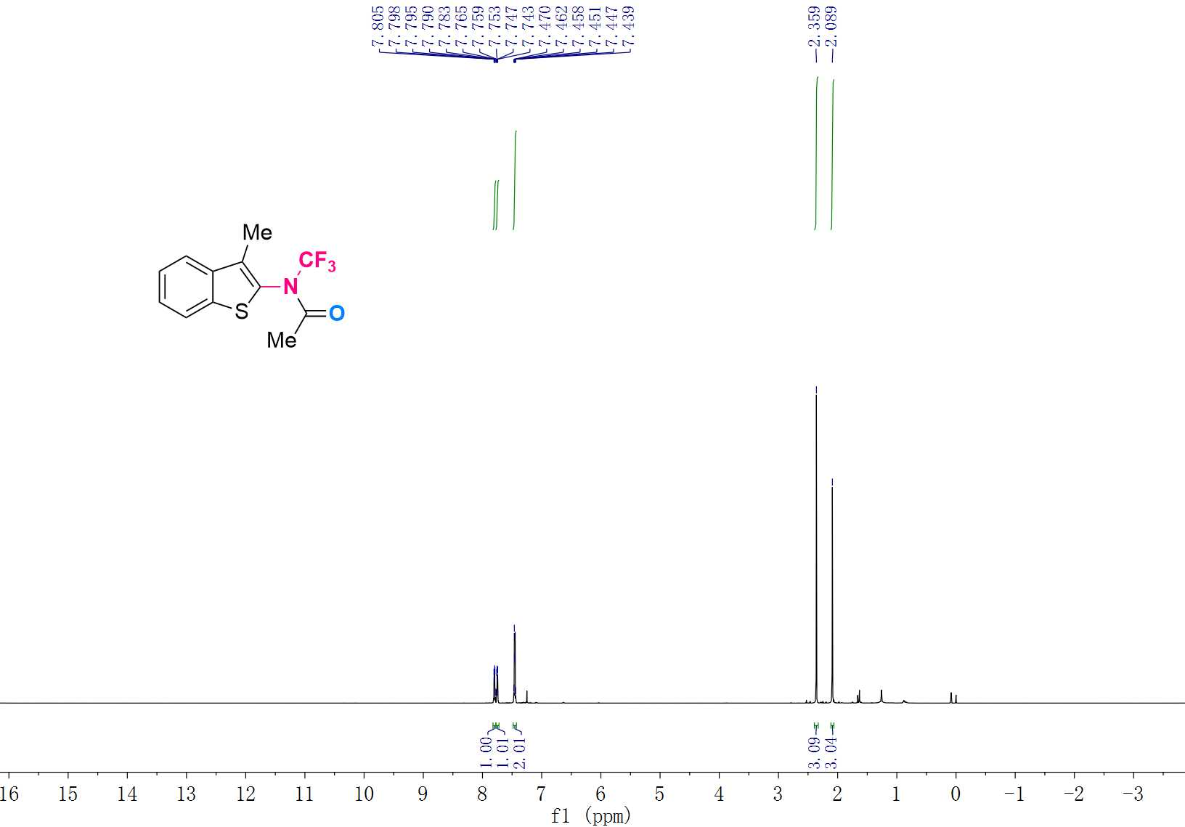

¹³C NMR (151 MHz, CDCl₃) Spectrum of 3v
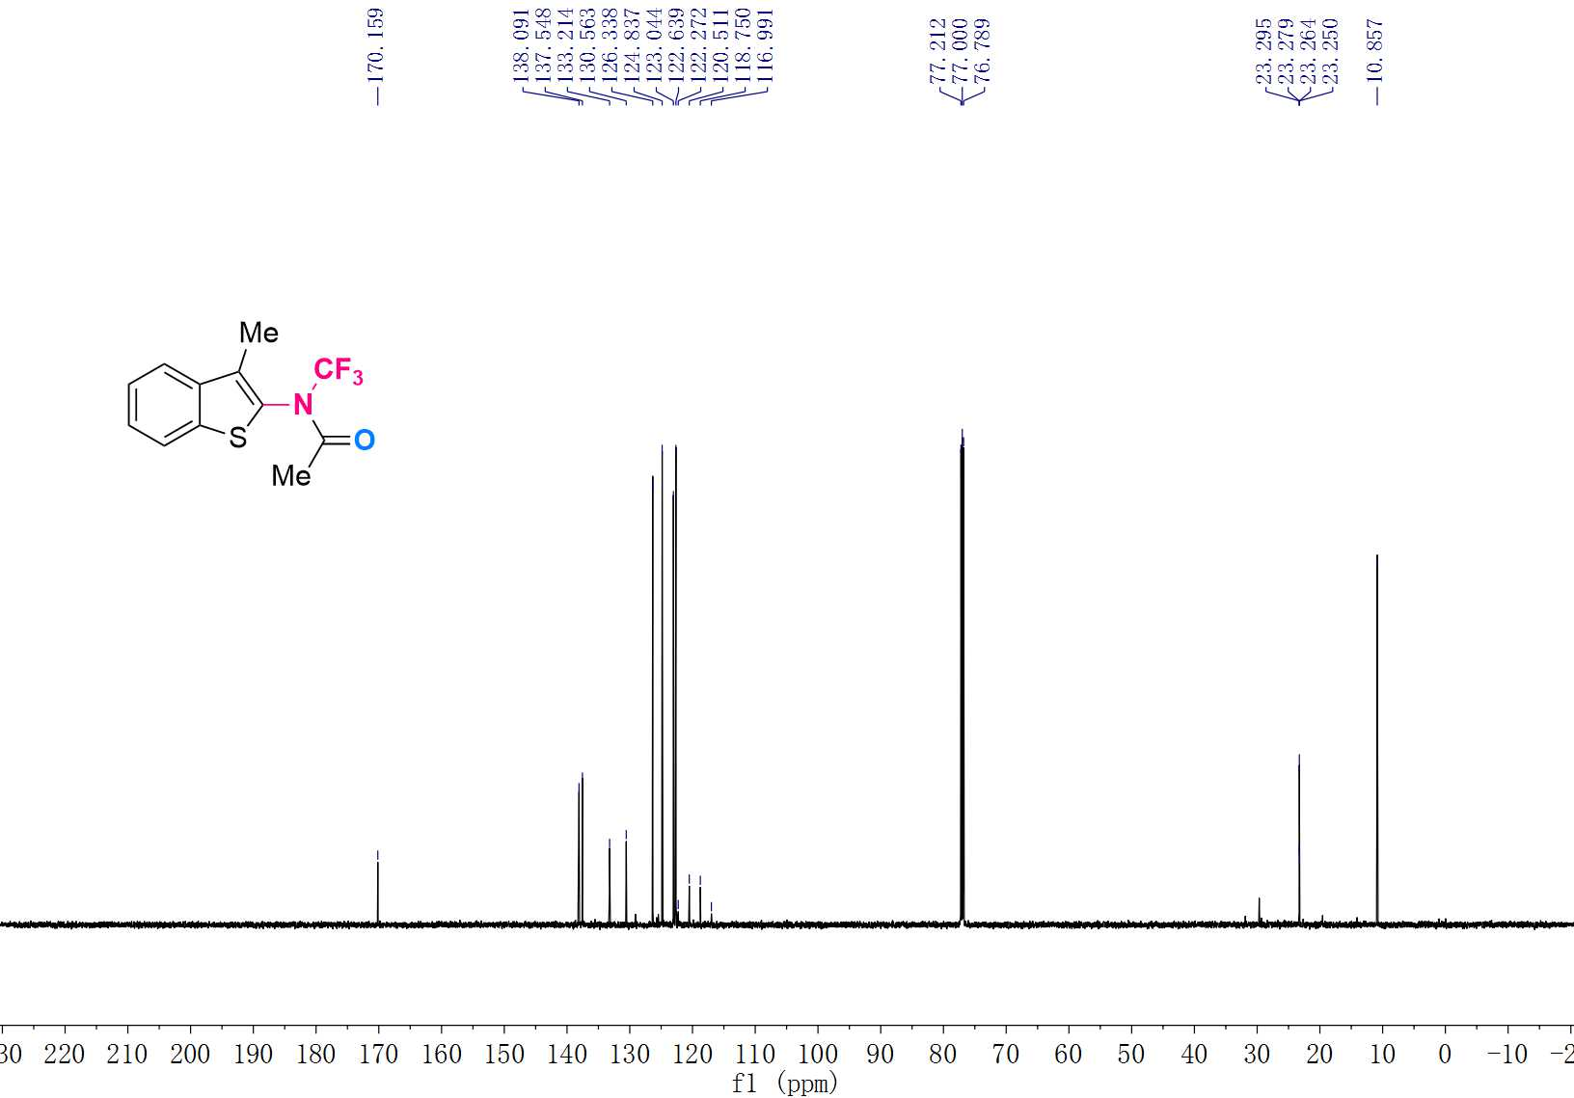

¹⁹F NMR (565 MHz, CDCl₃) Spectrum of 3v
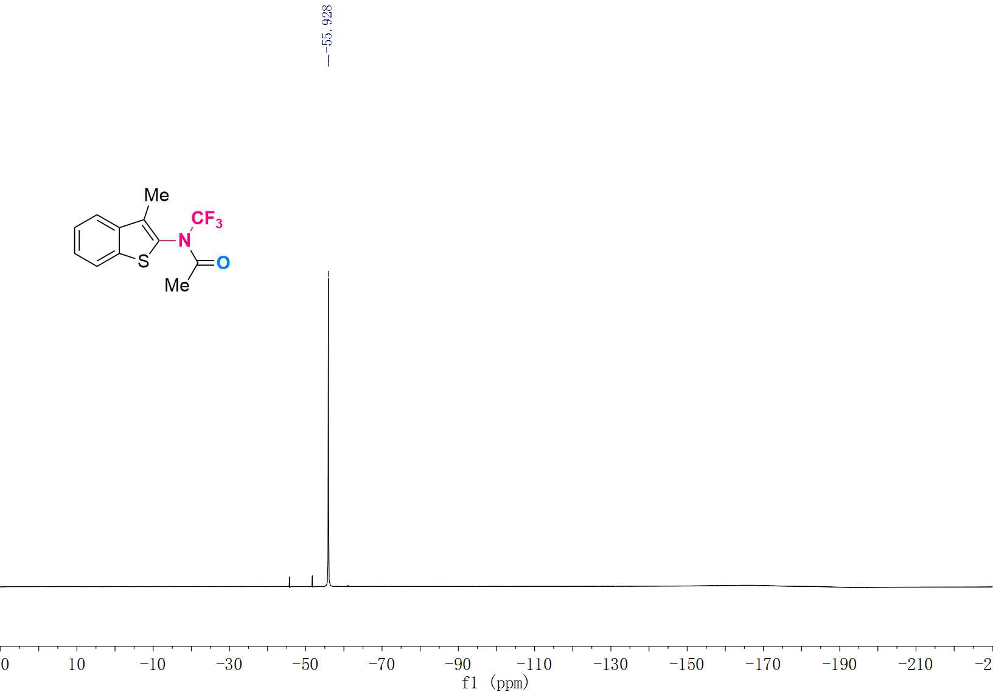

¹H NMR (600 MHz, CDCl₃) Spectrum of 3w
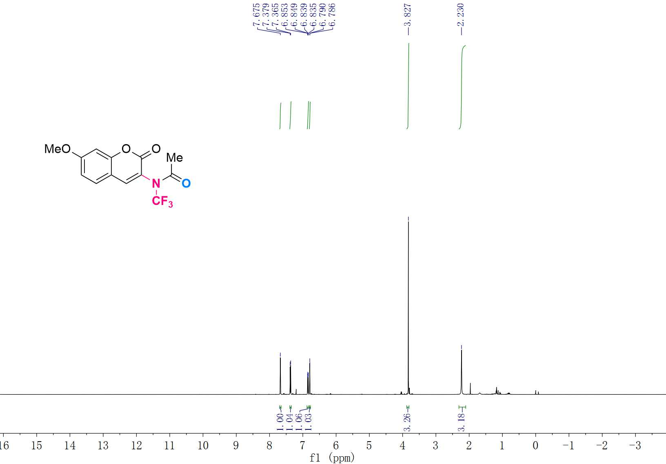

¹³C NMR (151 MHz, CDCl₃) Spectrum of 3w
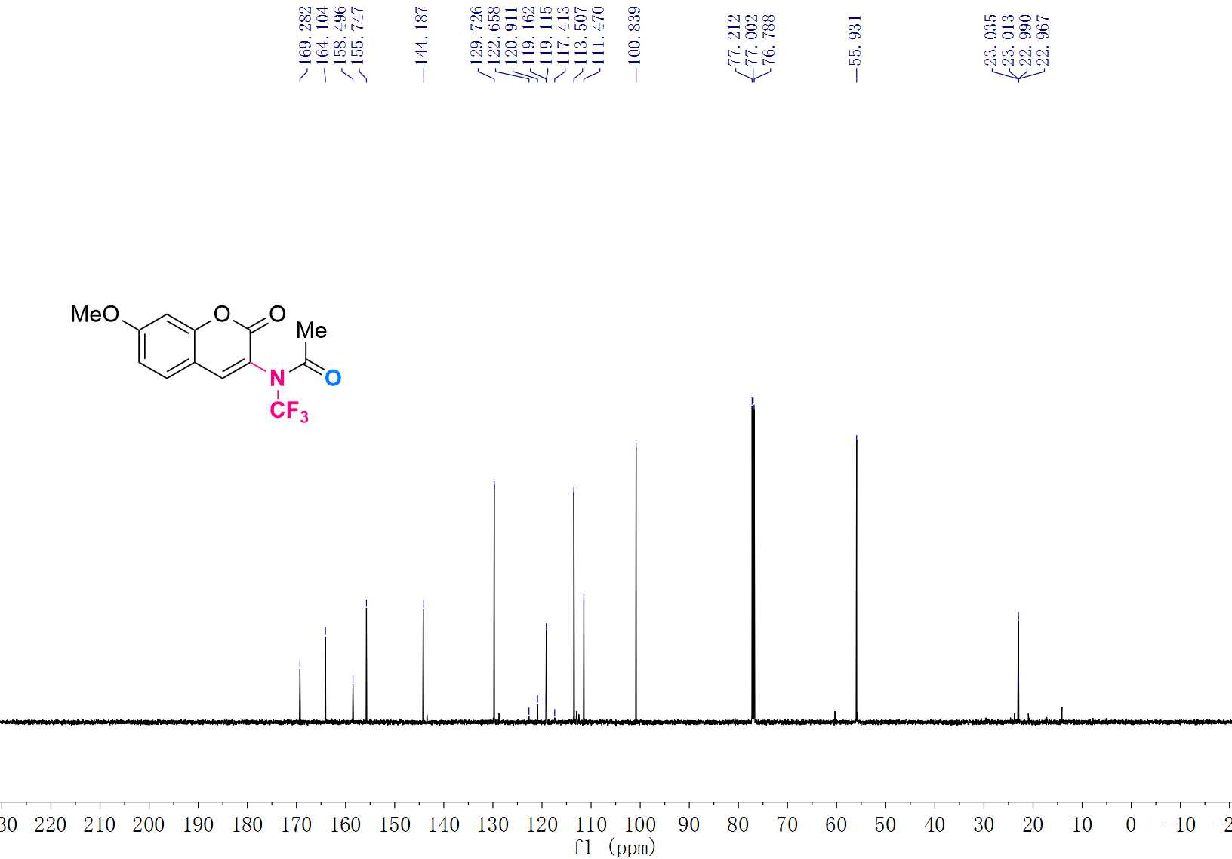

¹⁹F NMR (565 MHz, CDCl₃) Spectrum of 3w
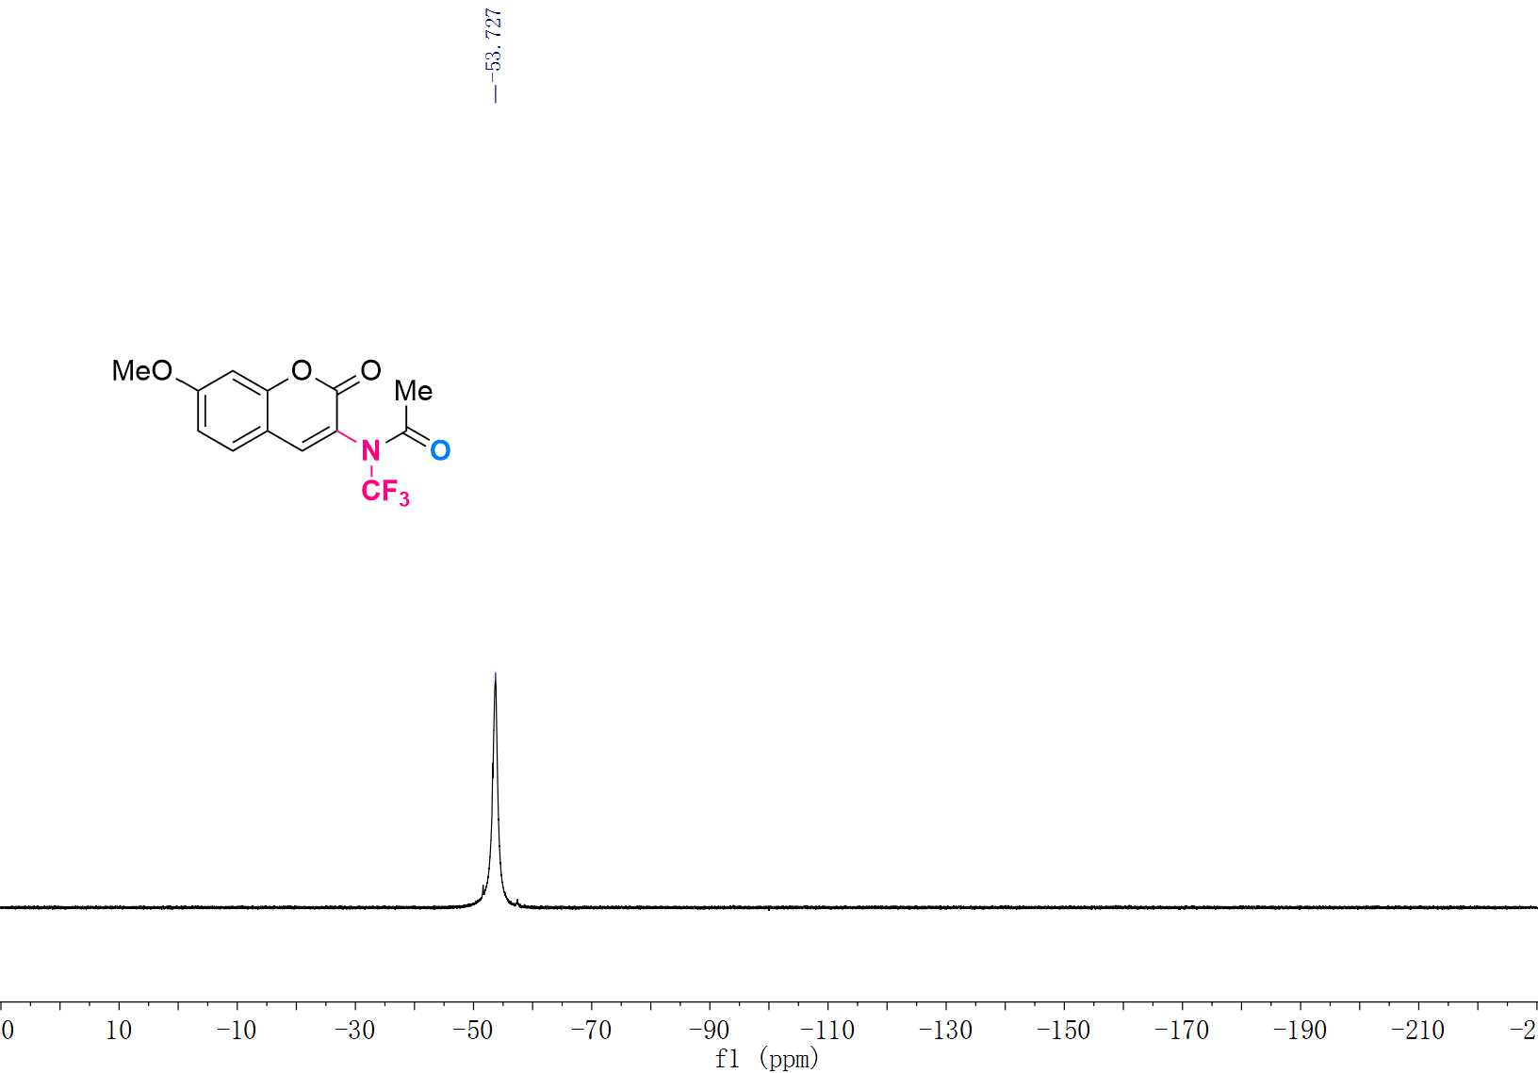

¹H NMR (600 MHz, CDCl₃) Spectrum of 3x
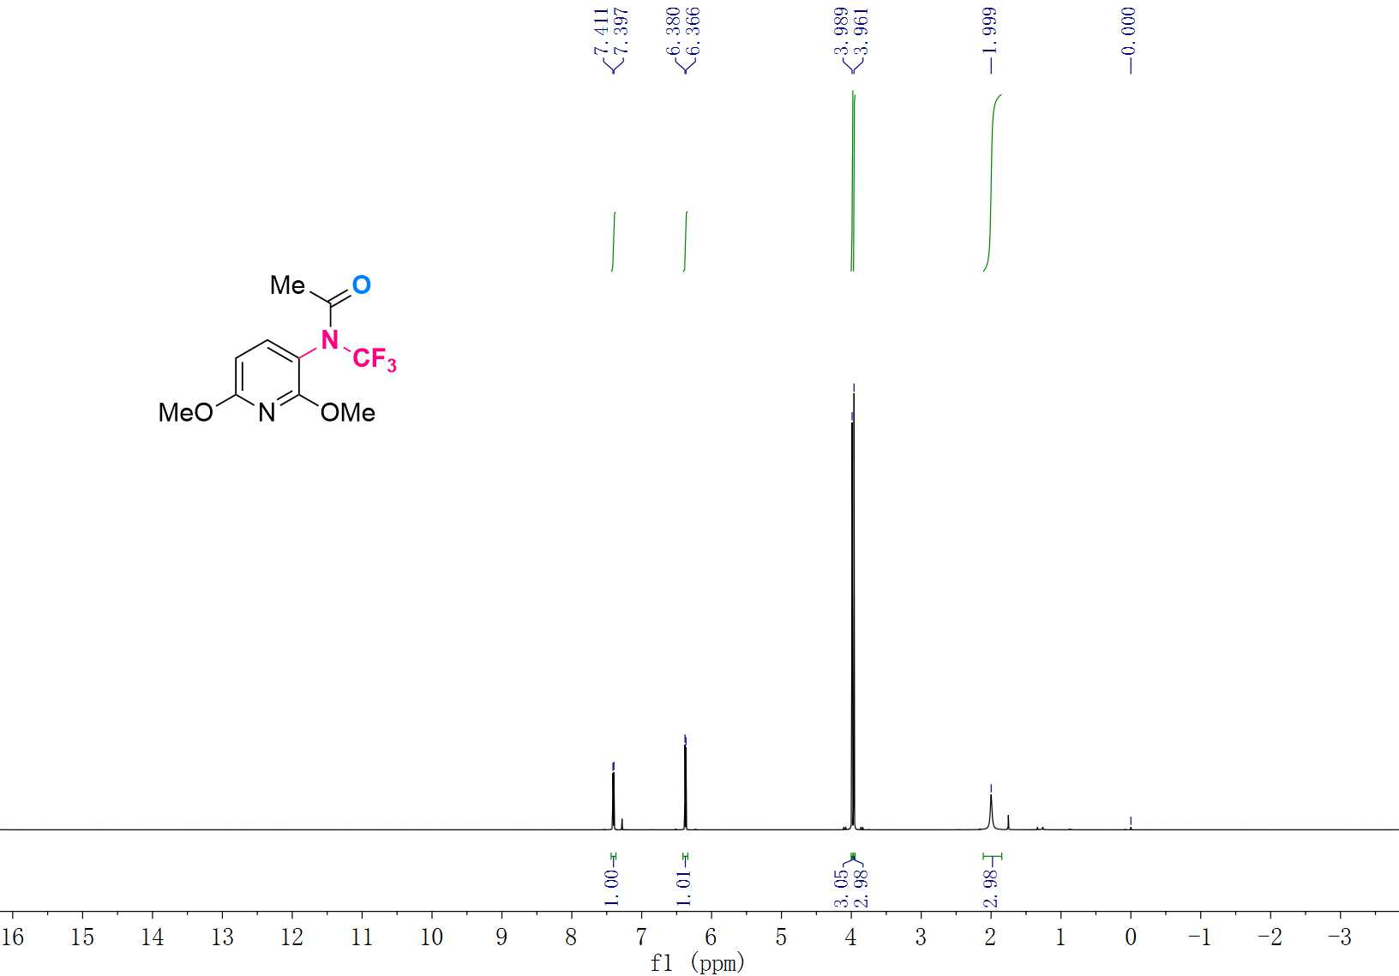

¹³C NMR (151 MHz, CDCl₃) Spectrum of 3x
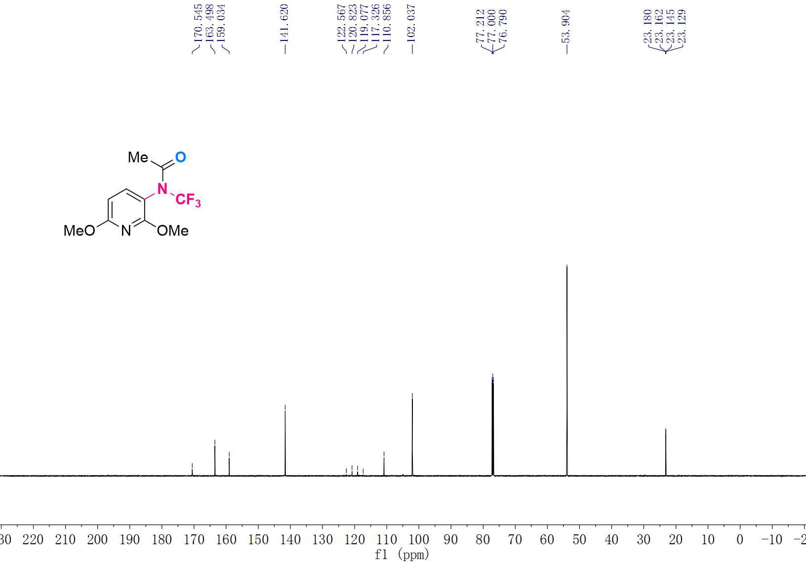

¹⁹F NMR (565 MHz, CDCl₃) Spectrum of 3x
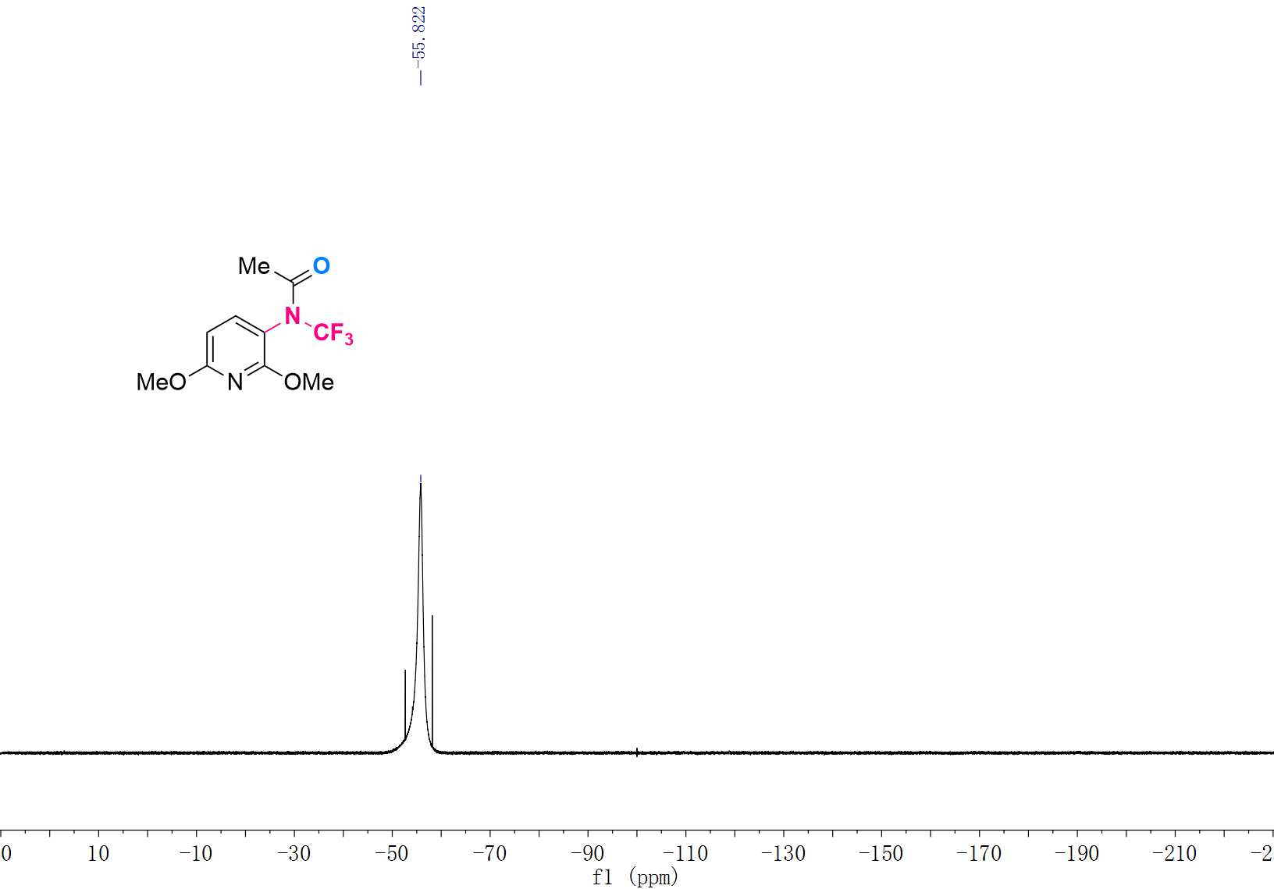

¹H NMR (600 MHz, CDCl₃) Spectrum of 3y
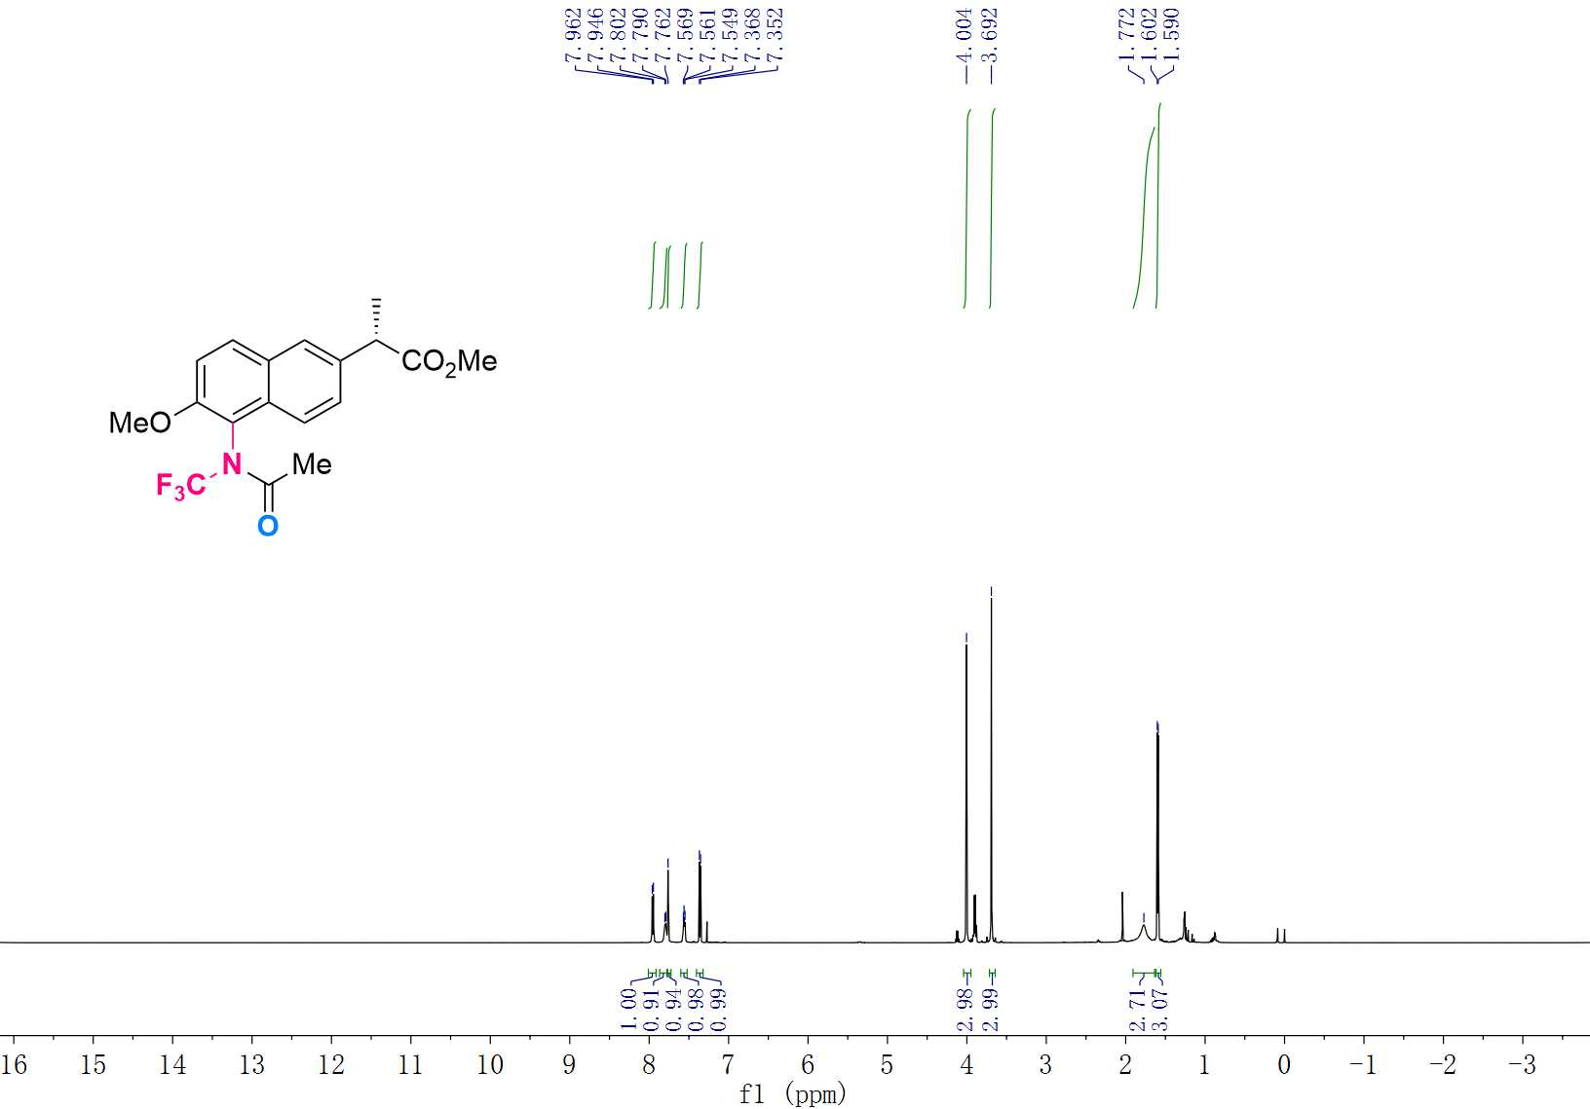

¹³C NMR (151 MHz, CDCl₃) Spectrum of 3y
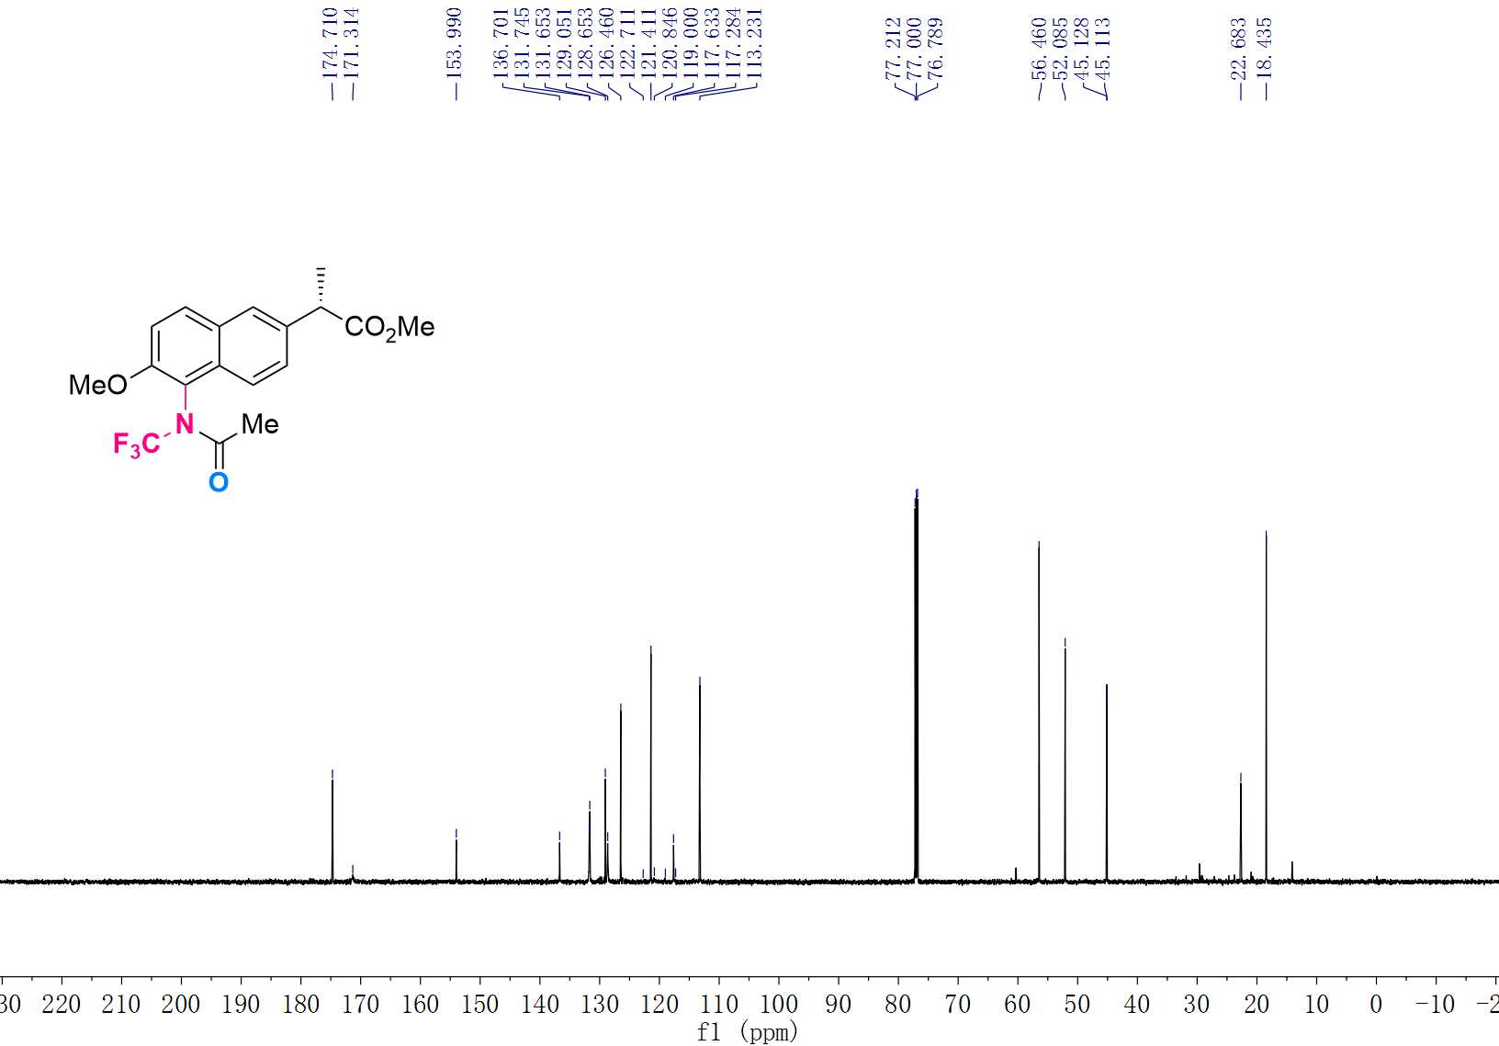

¹⁹F NMR (565 MHz, CDCl₃) Spectrum of 3y
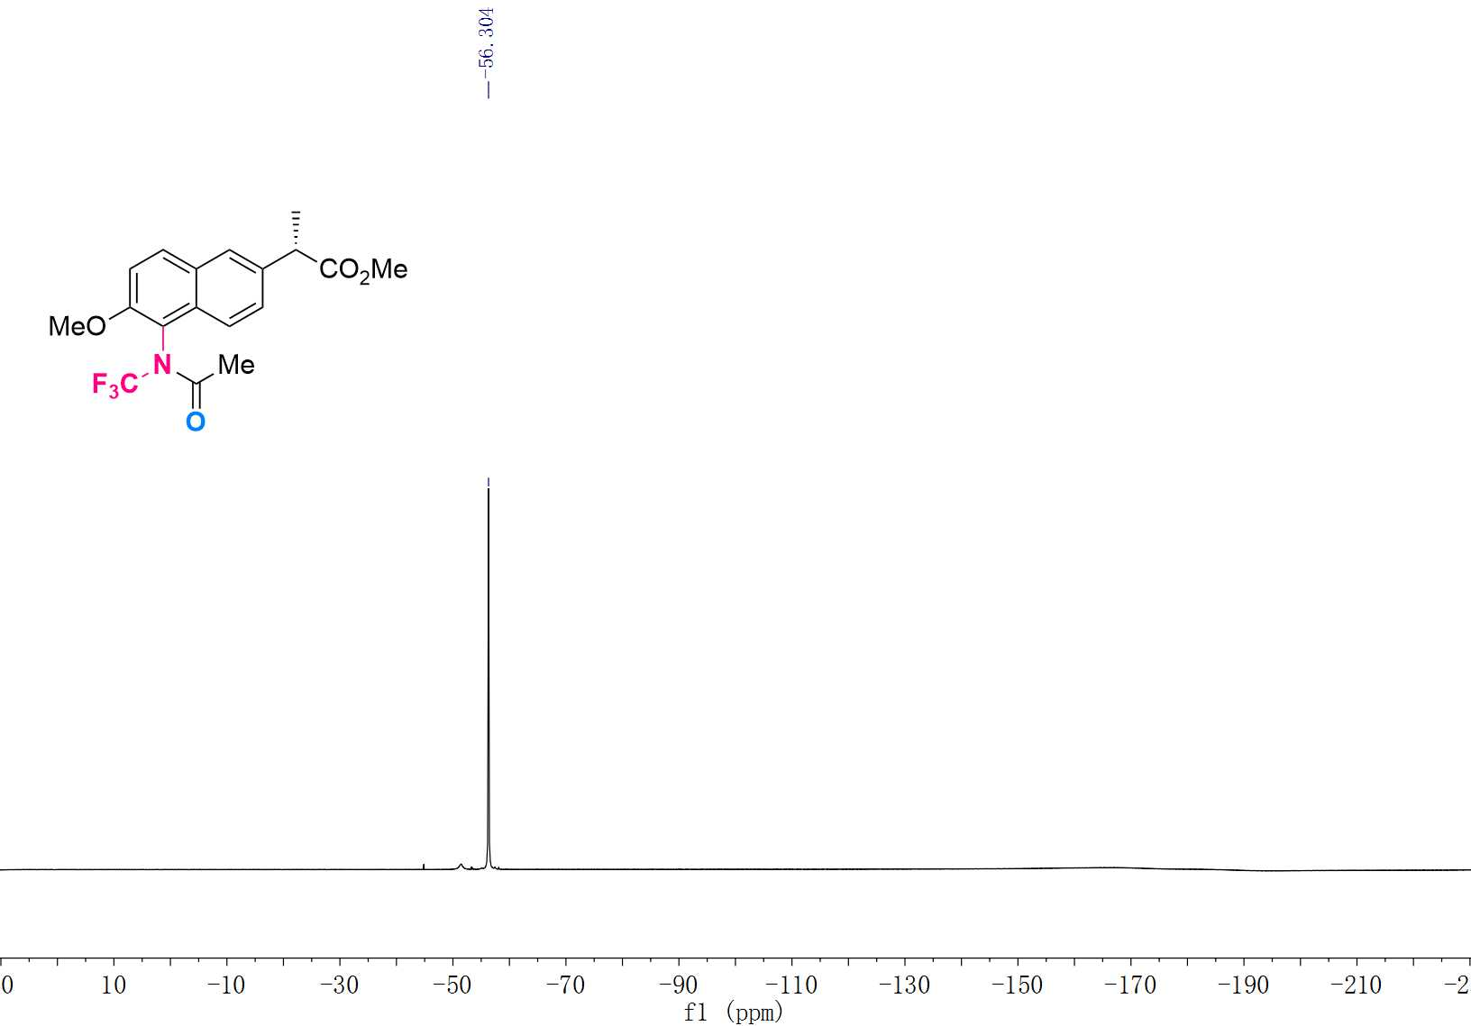

¹H NMR (600 MHz, CDCl₃) Spectrum of 3z
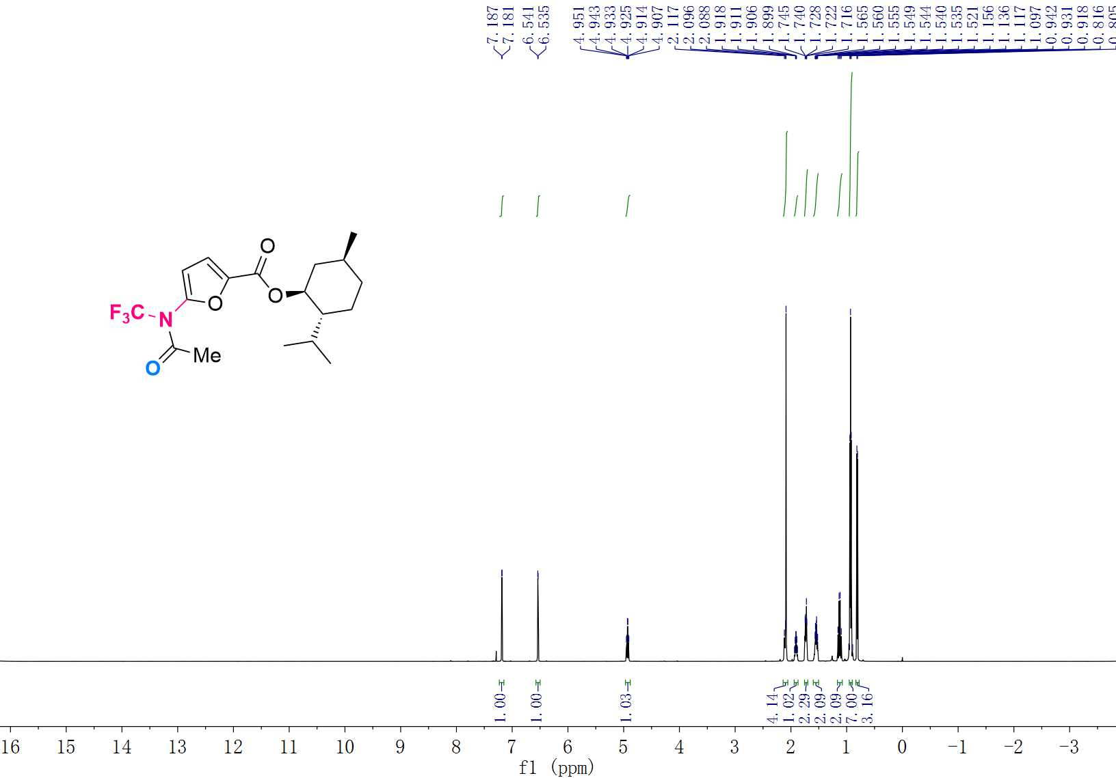

¹³C NMR (151 MHz, CDCl₃) Spectrum of 3z
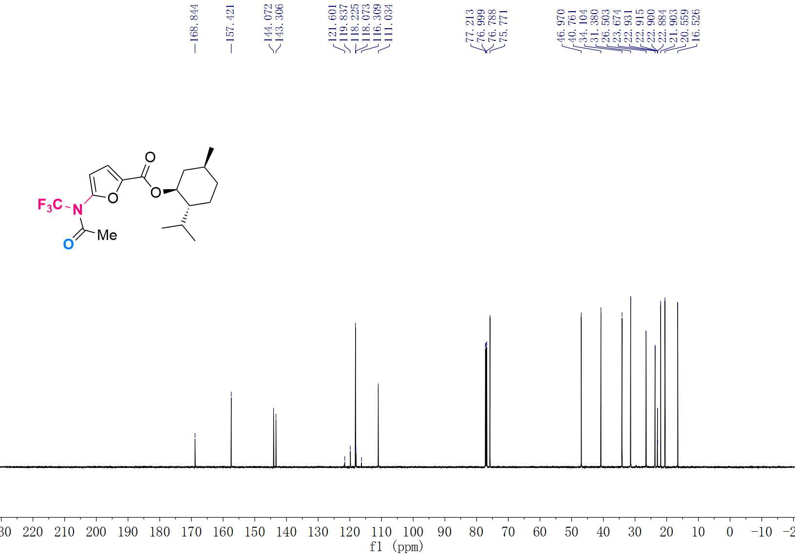

¹⁹F NMR (565 MHz, CDCl₃) Spectrum of 3z
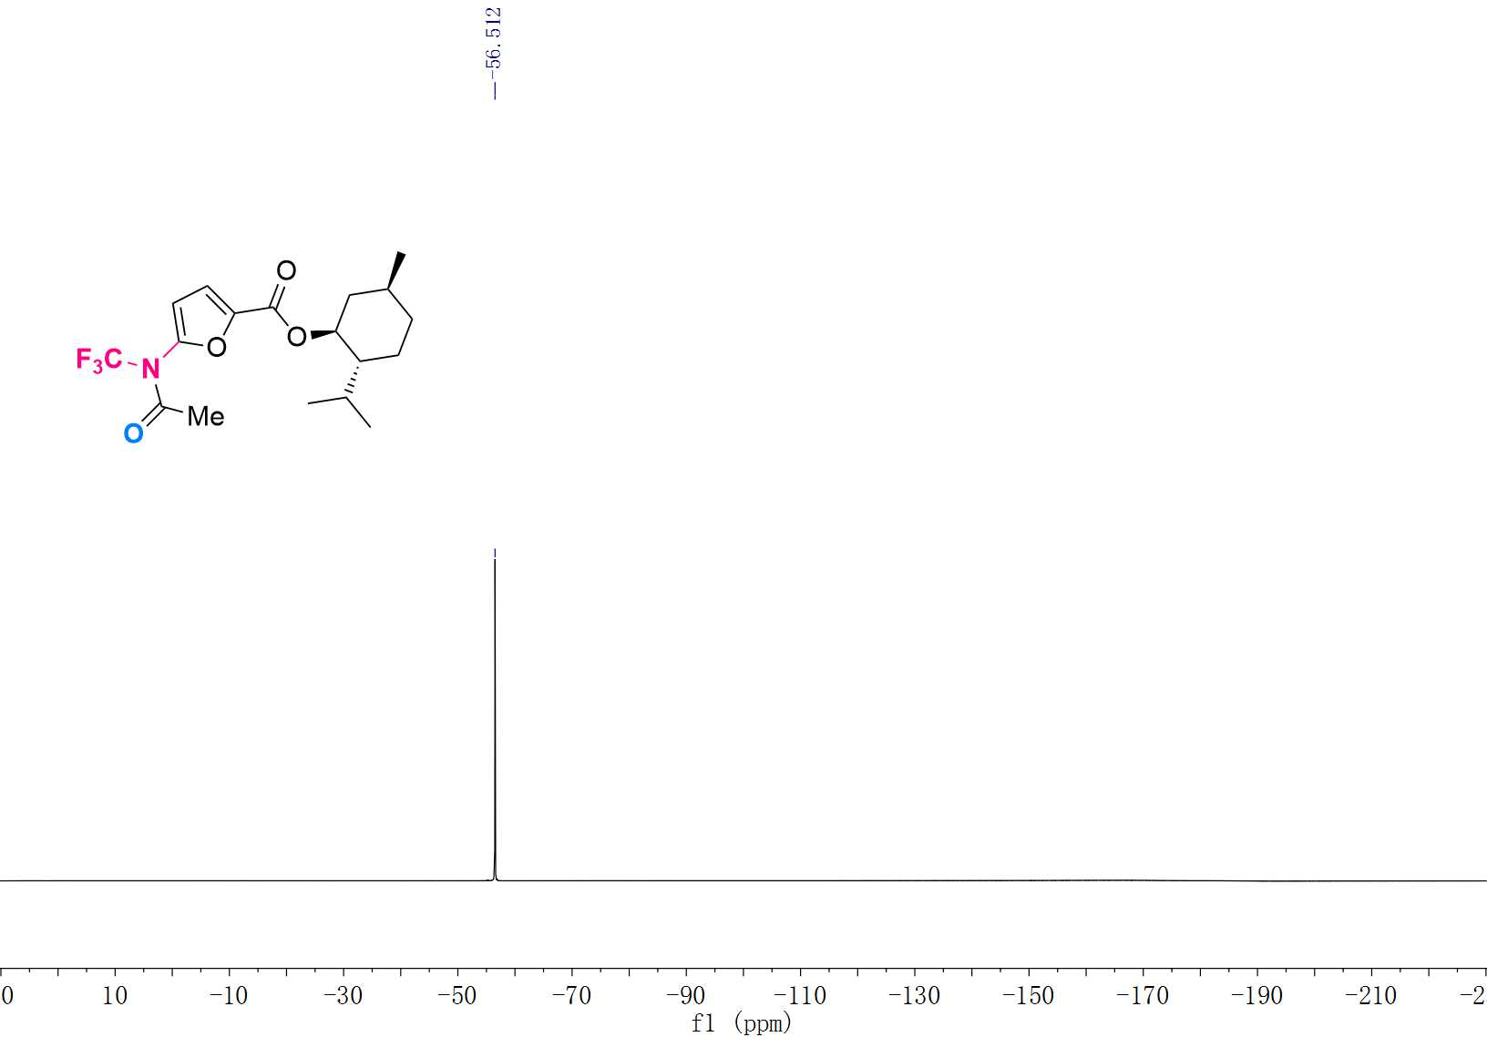

¹H NMR (600 MHz, CDCl₃) Spectrum of 3aa
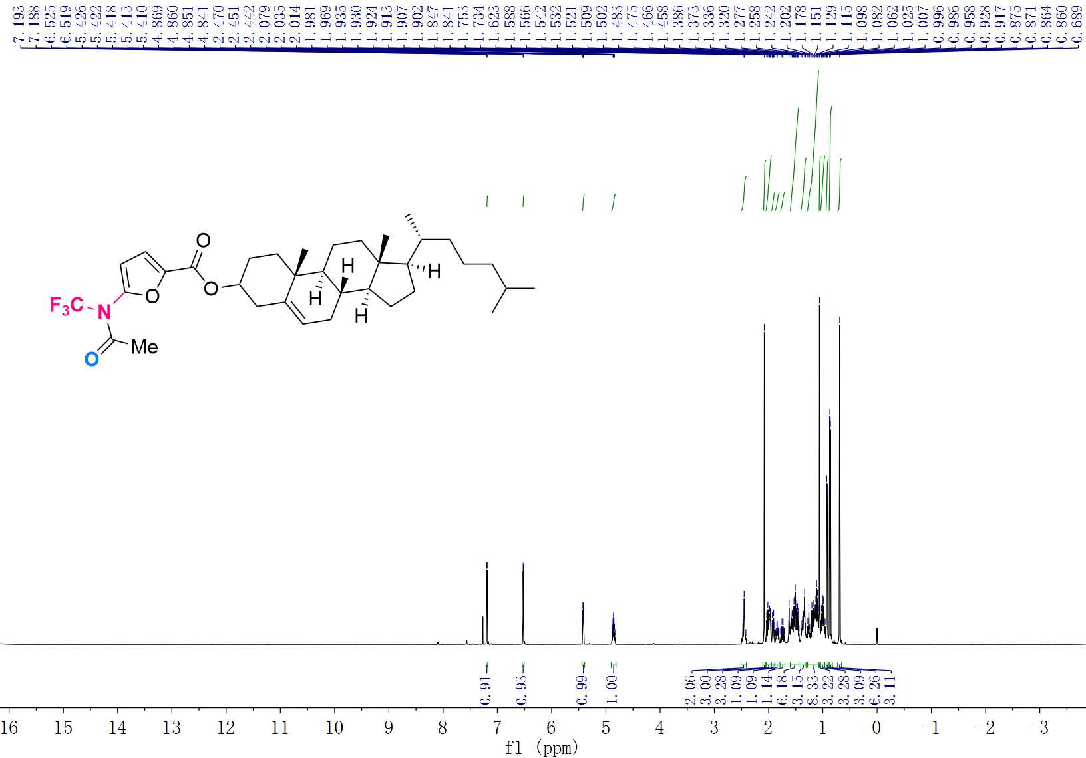

¹³C NMR (151 MHz, CDCl₃) Spectrum of 3aa
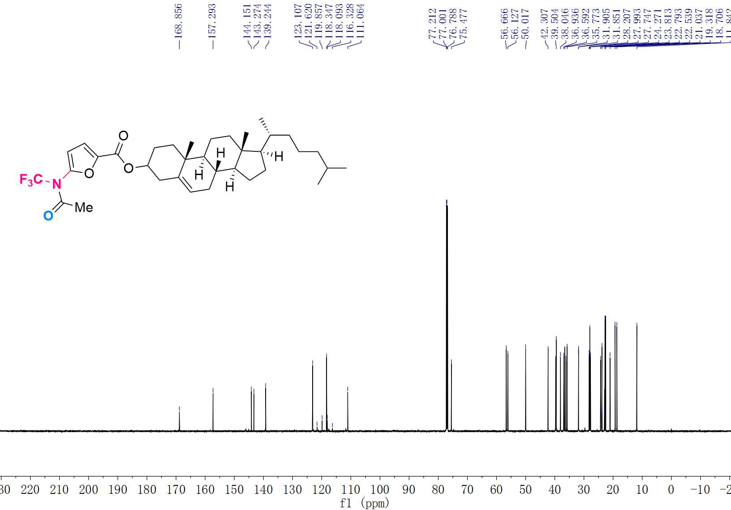

¹⁹F NMR (565 MHz, CDCl₃) Spectrum of 3aa
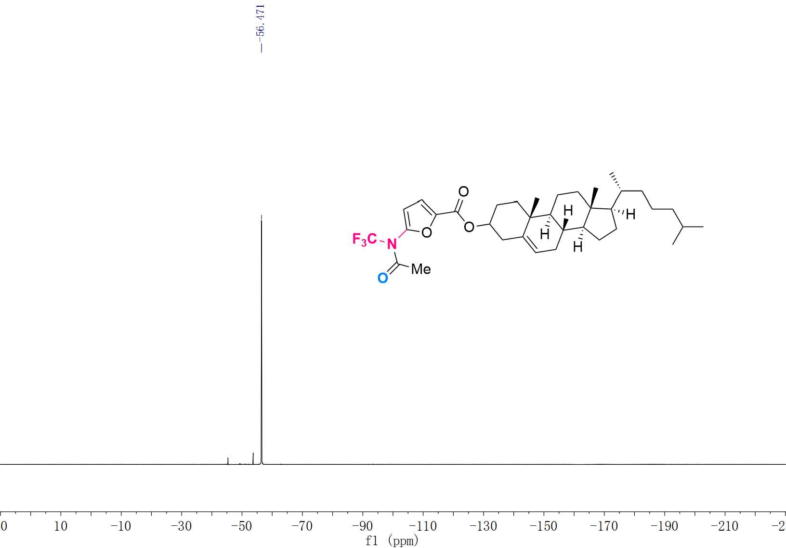

¹H NMR (600 MHz, CDCl₃) Spectrum of 3ab
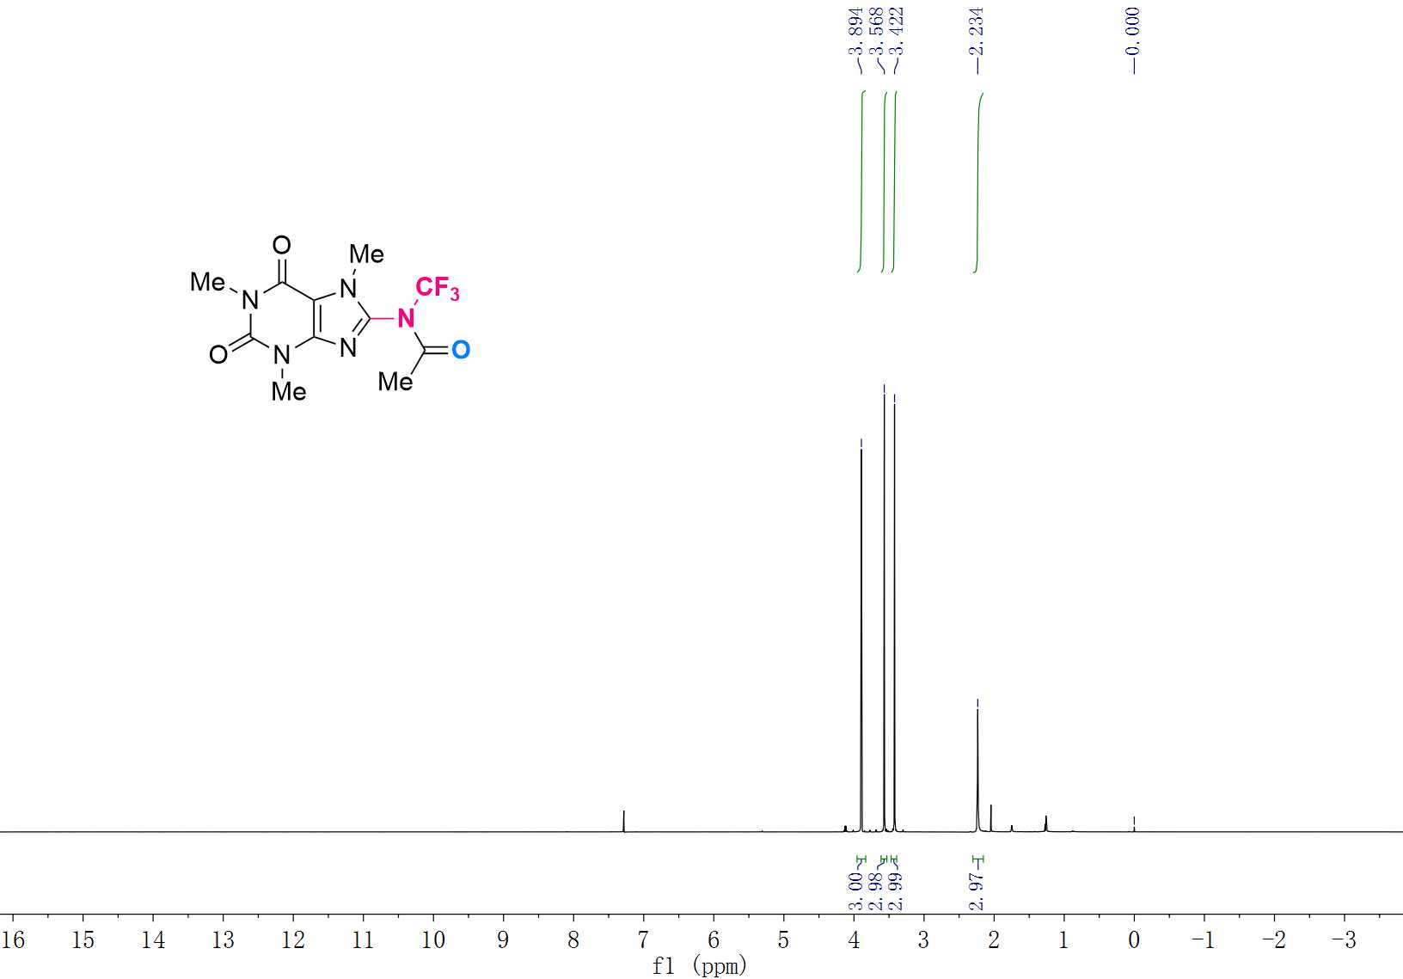

¹³C NMR (151 MHz, CDCl₃) Spectrum of 3ab
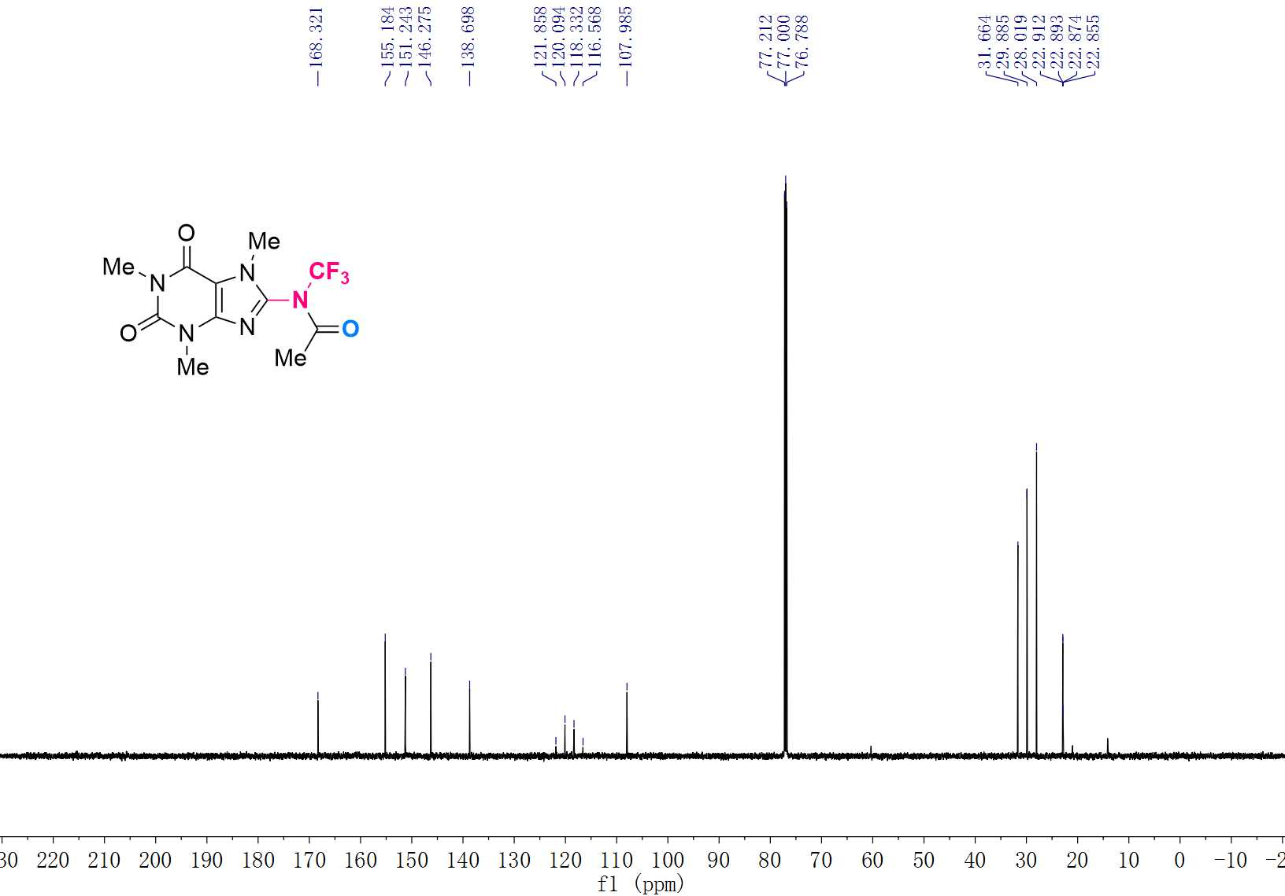

¹⁹F NMR (565 MHz, CDCl₃) Spectrum of 3ab
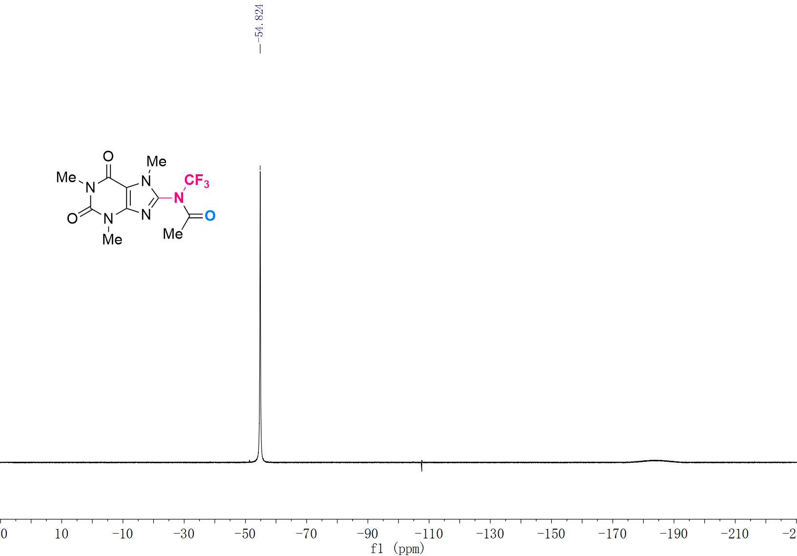

¹H NMR (600 MHz, CDCl₃) Spectrum of 3ac
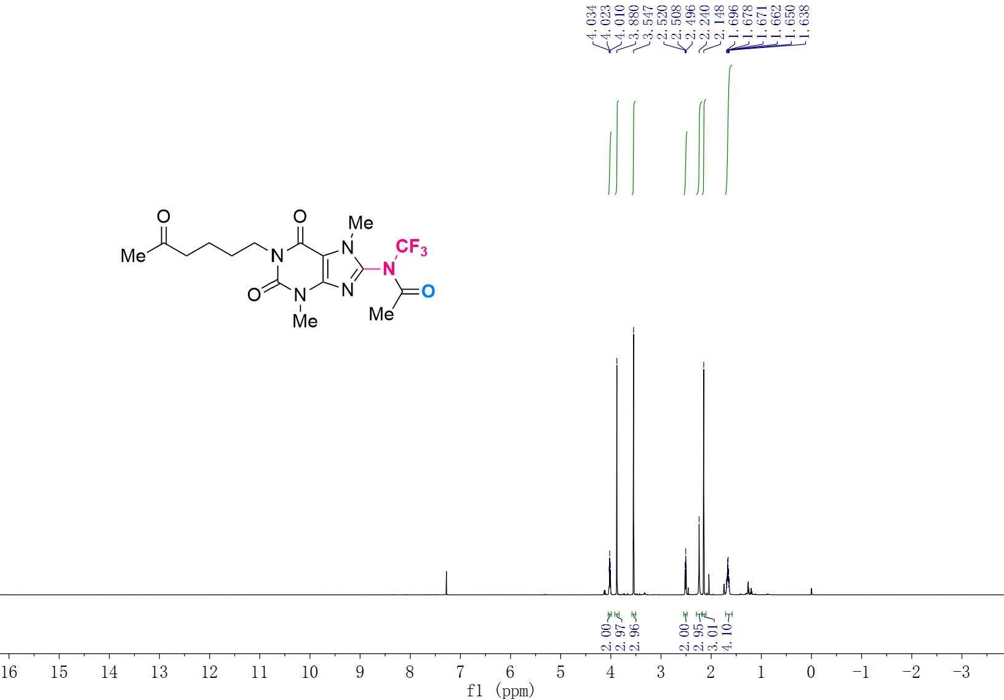

¹³C NMR (151 MHz, CDCl₃) Spectrum of 3ac
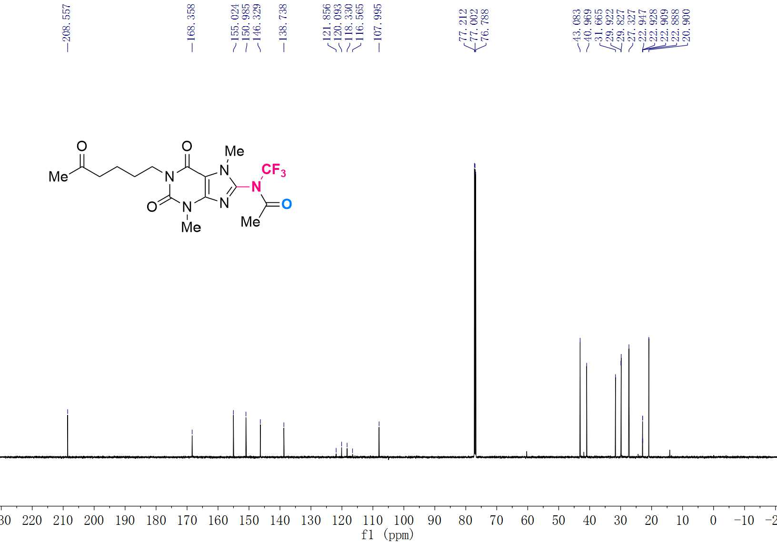

¹⁹F NMR (565 MHz, CDCl₃) Spectrum of 3ac
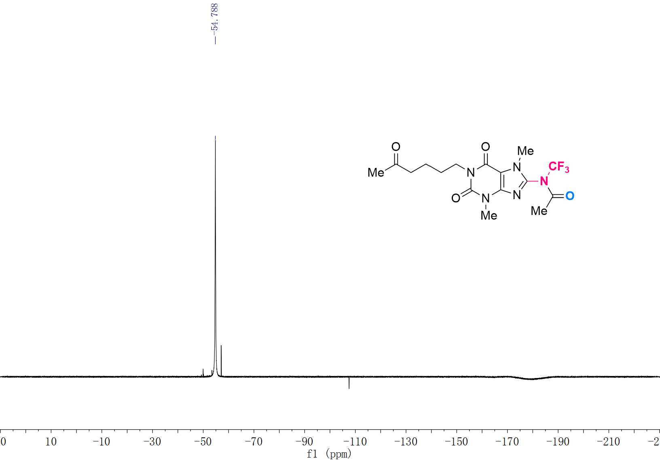

¹H NMR (600 MHz, CDCl₃) Spectrum of 3ad
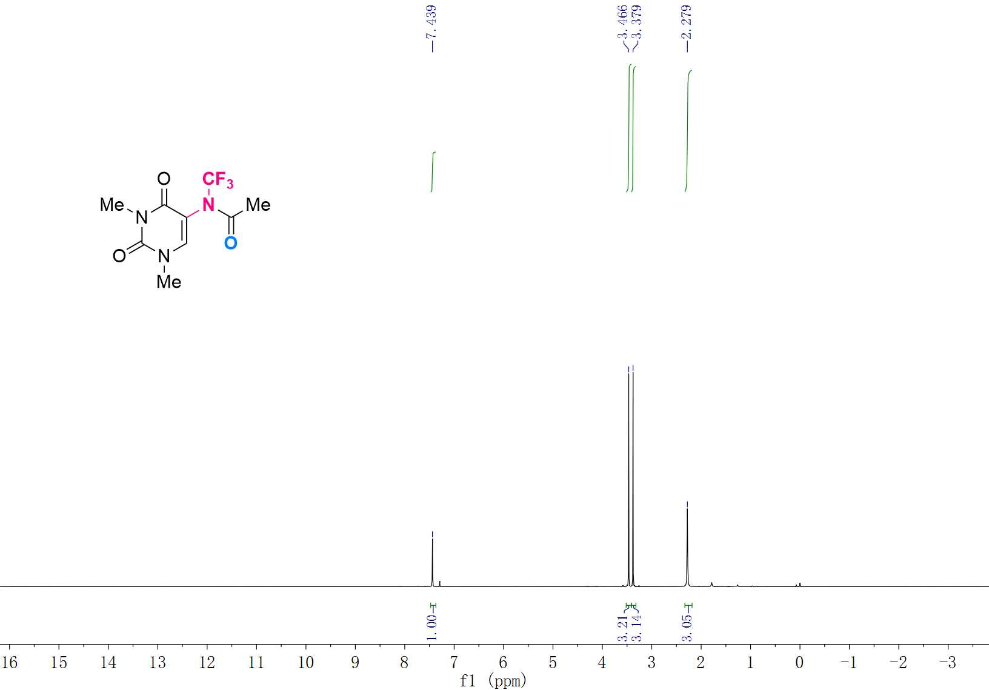

¹³C NMR (151 MHz, CDCl₃) Spectrum of 3ad
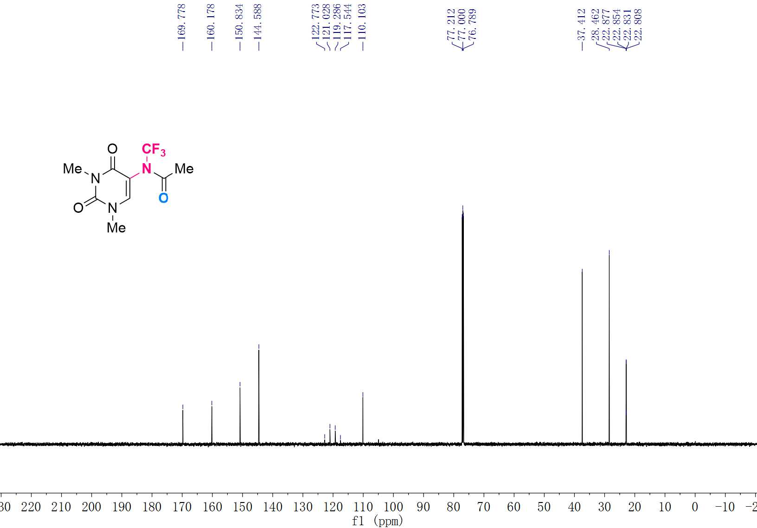

¹⁹F NMR (565 MHz, CDCl₃) Spectrum of 3ad
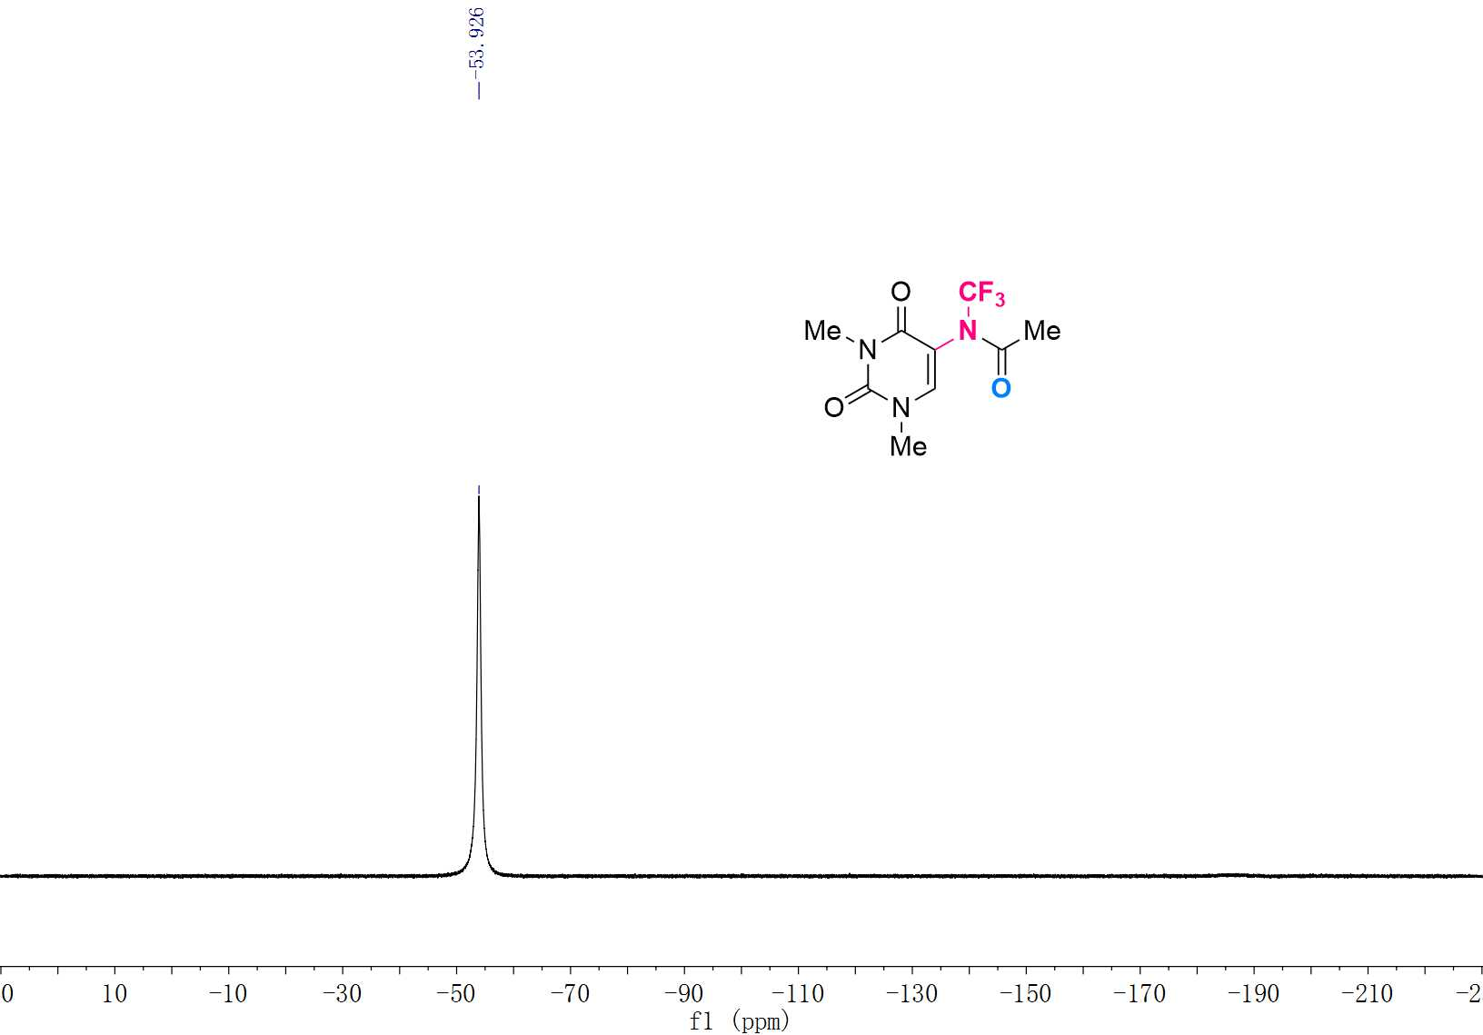

¹H NMR (600 MHz, CDCl₃) Spectrum of 3ae
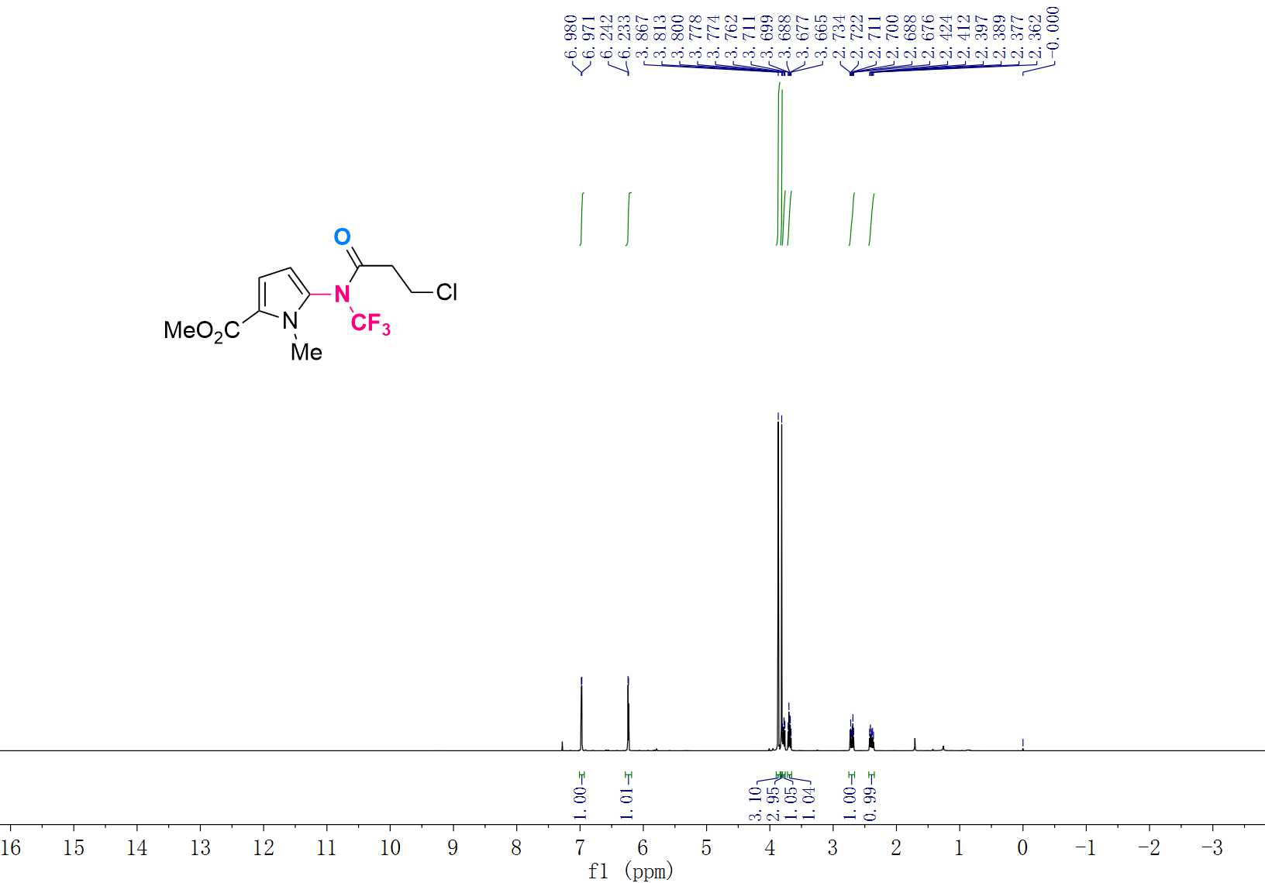

¹³C NMR (151 MHz, CDCl₃) Spectrum of 3ae
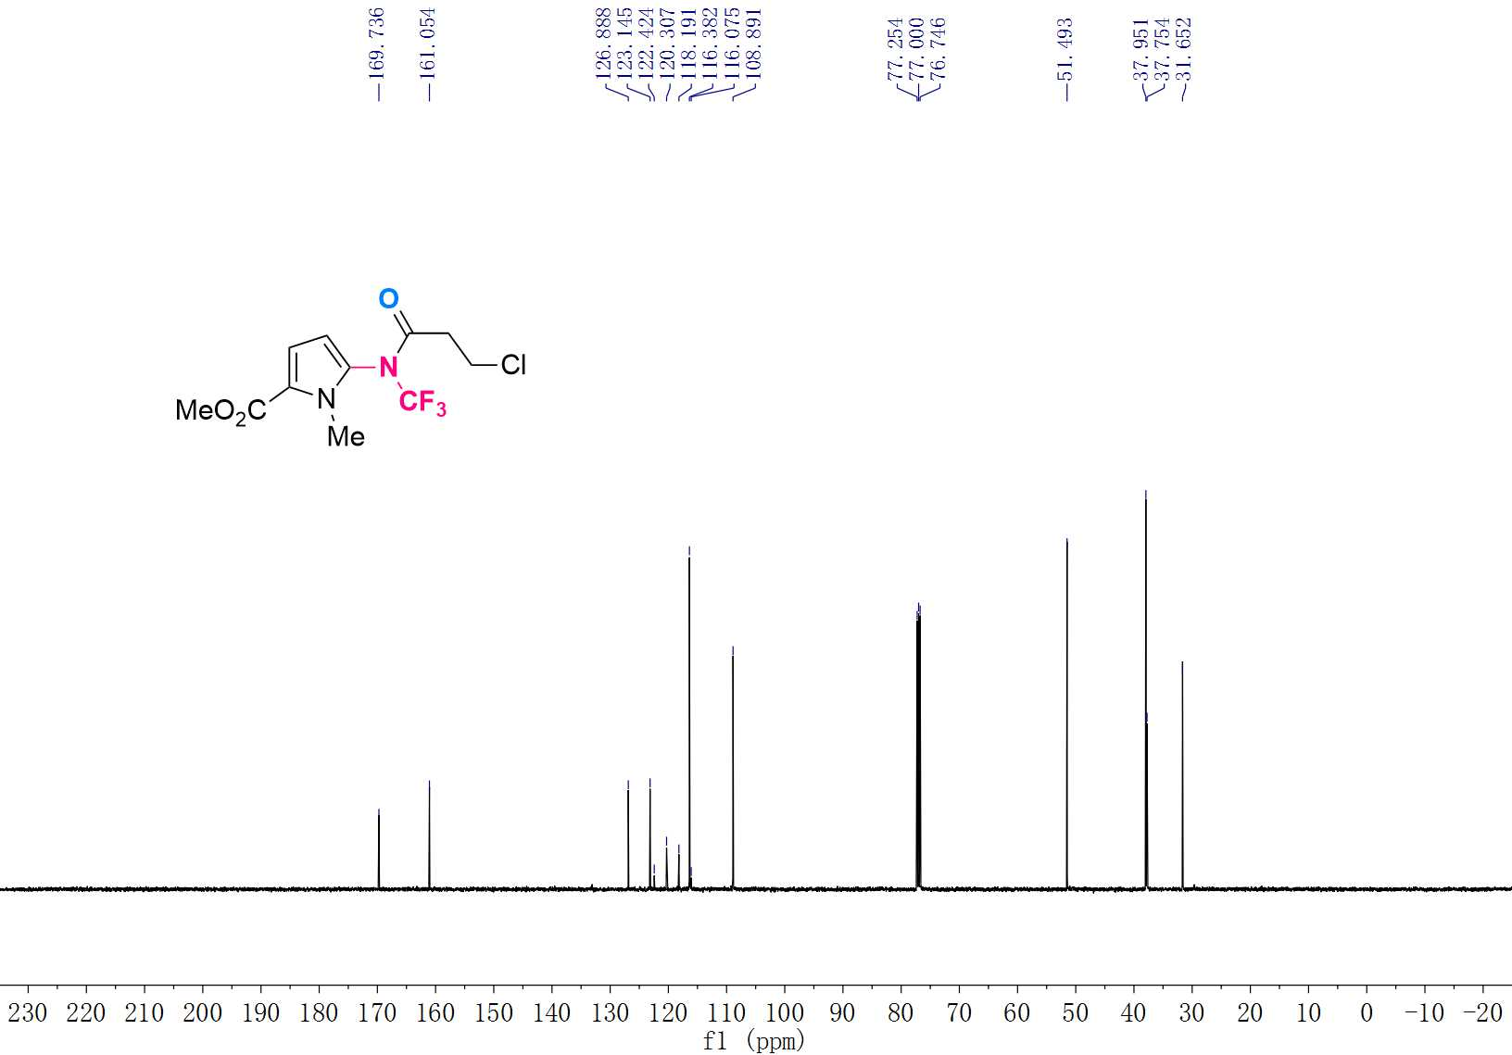

¹⁹F NMR (565 MHz, CDCl₃) Spectrum of 3ae
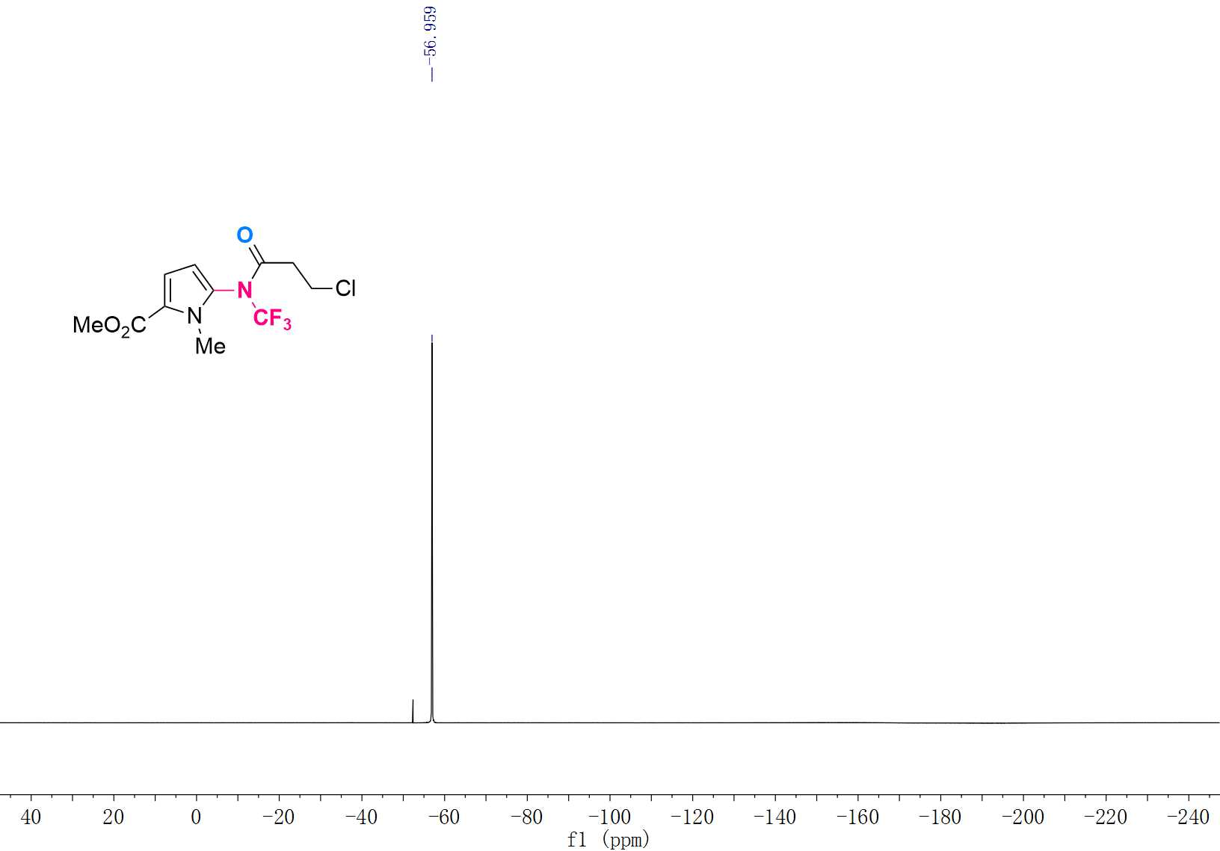

¹H NMR (600 MHz, CDCl₃) Spectrum of 3af
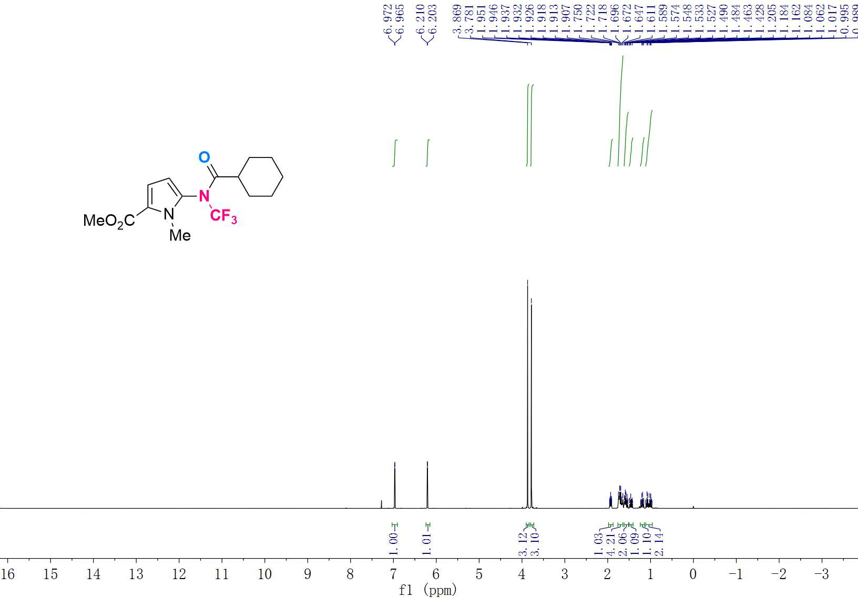

¹³C NMR (151 MHz, CDCl₃) Spectrum of 3af
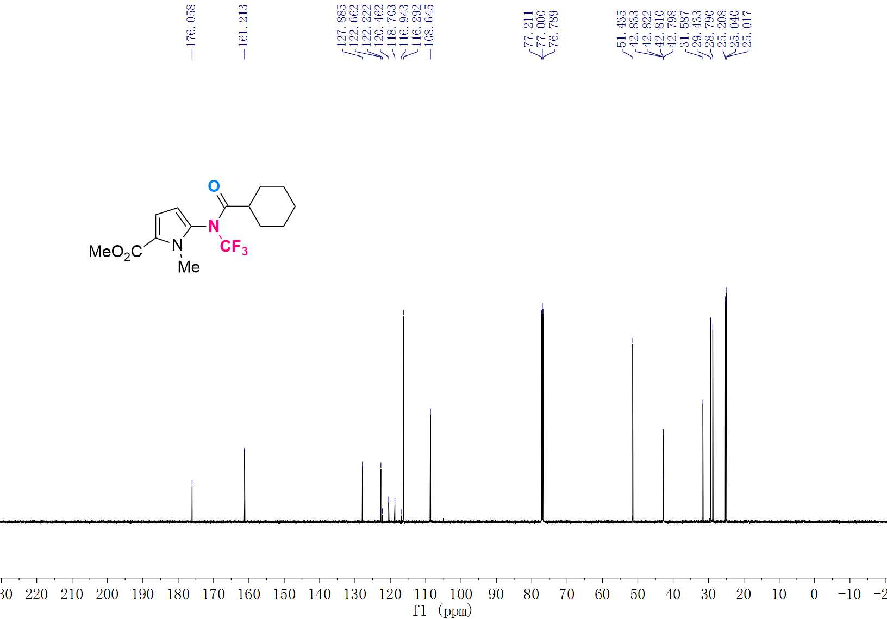

¹⁹F NMR (565 MHz, CDCl₃) Spectrum of 3af
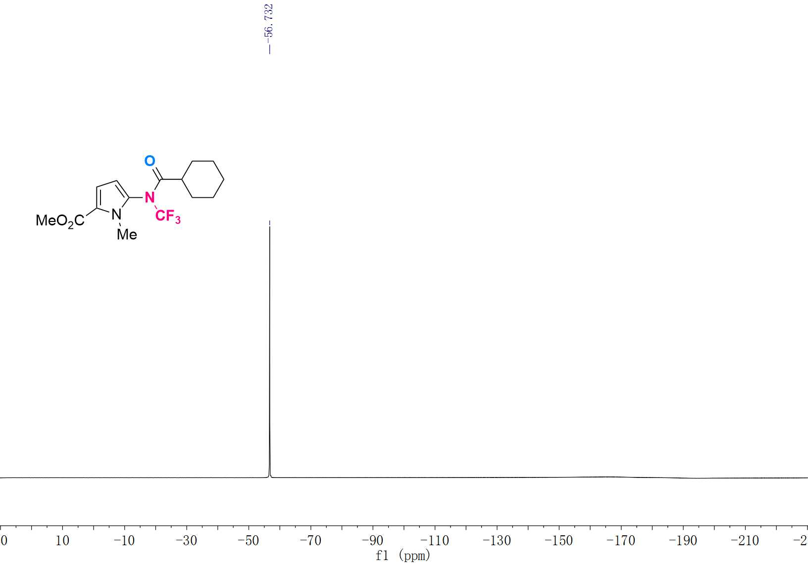

¹H NMR (600 MHz, CDCl₃) Spectrum of 3ag
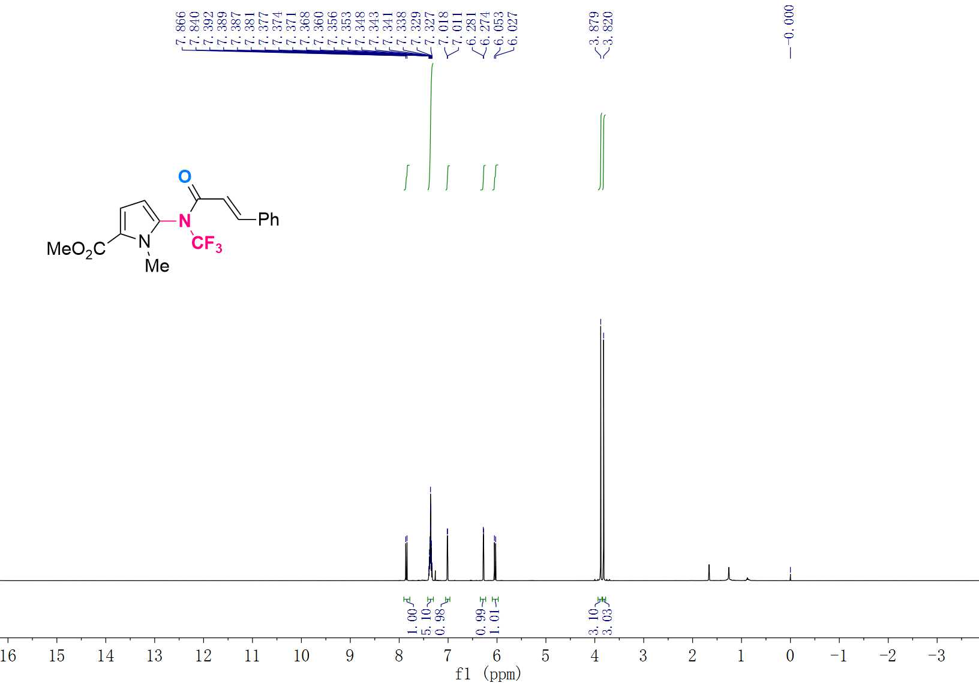

¹³C NMR (151 MHz, CDCl₃) Spectrum of 3ag
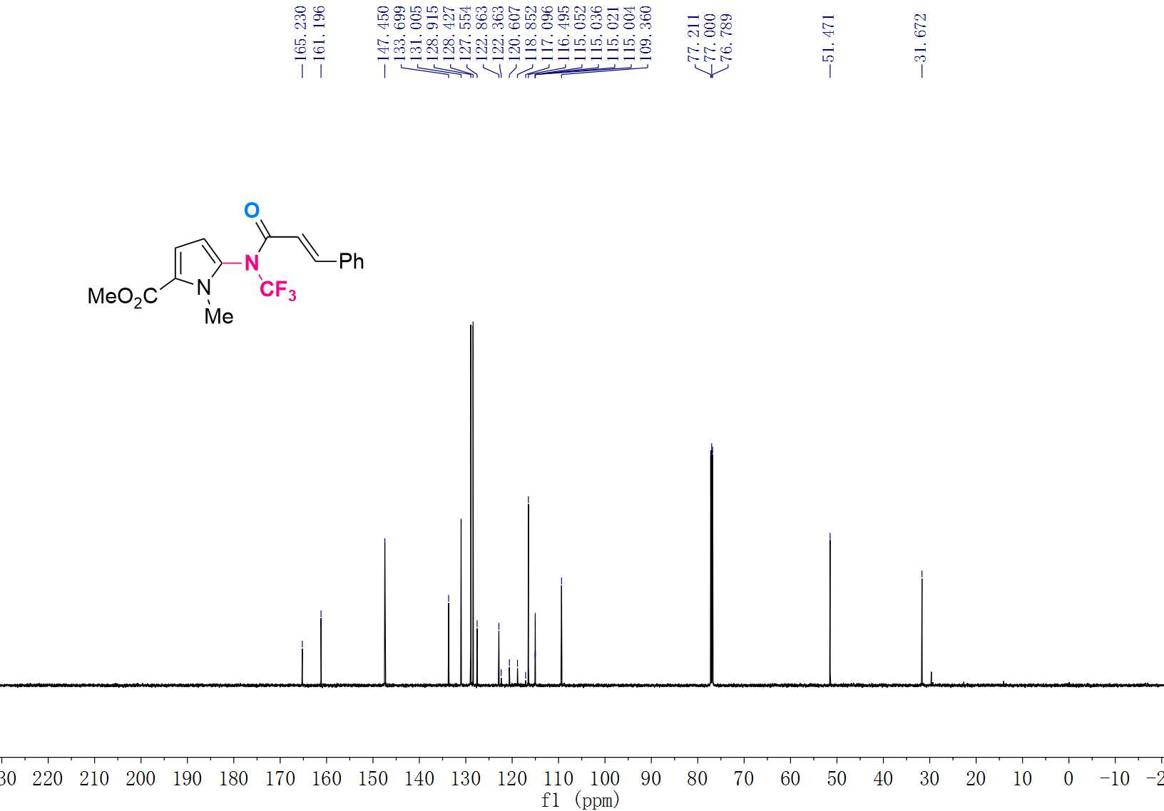

¹⁹F NMR (565 MHz, CDCl₃) Spectrum of 3ag
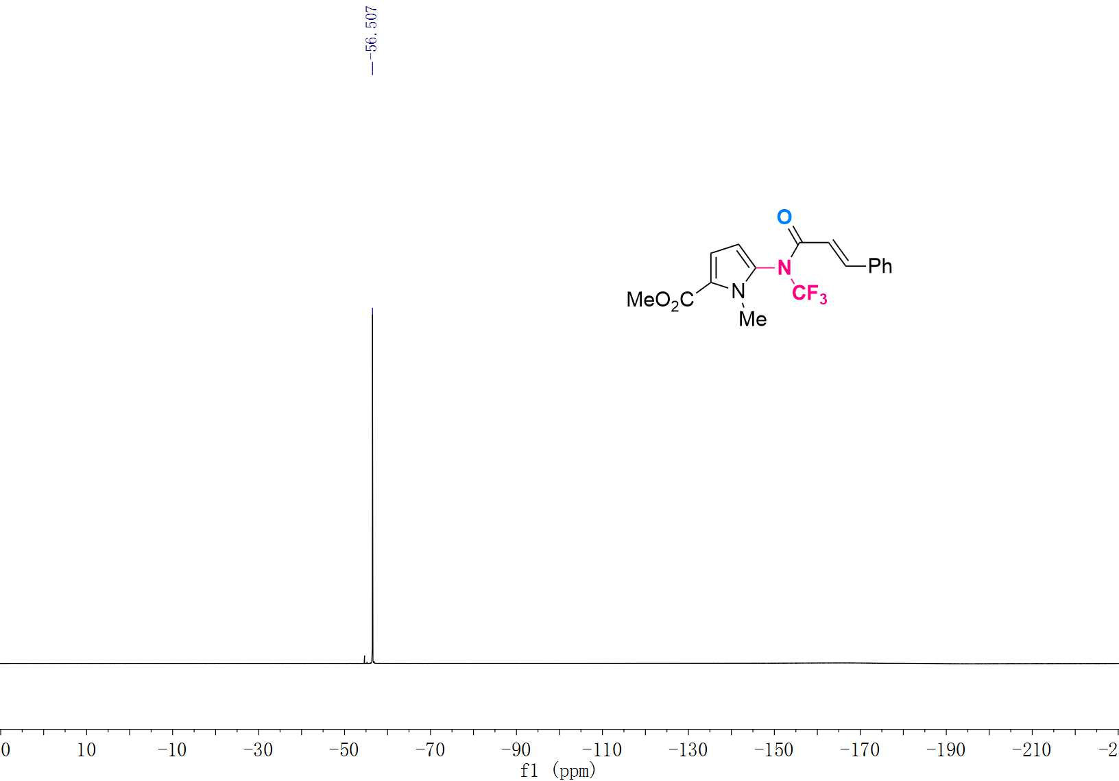

¹H NMR (600 MHz, CDCl₃) Spectrum of 3ah
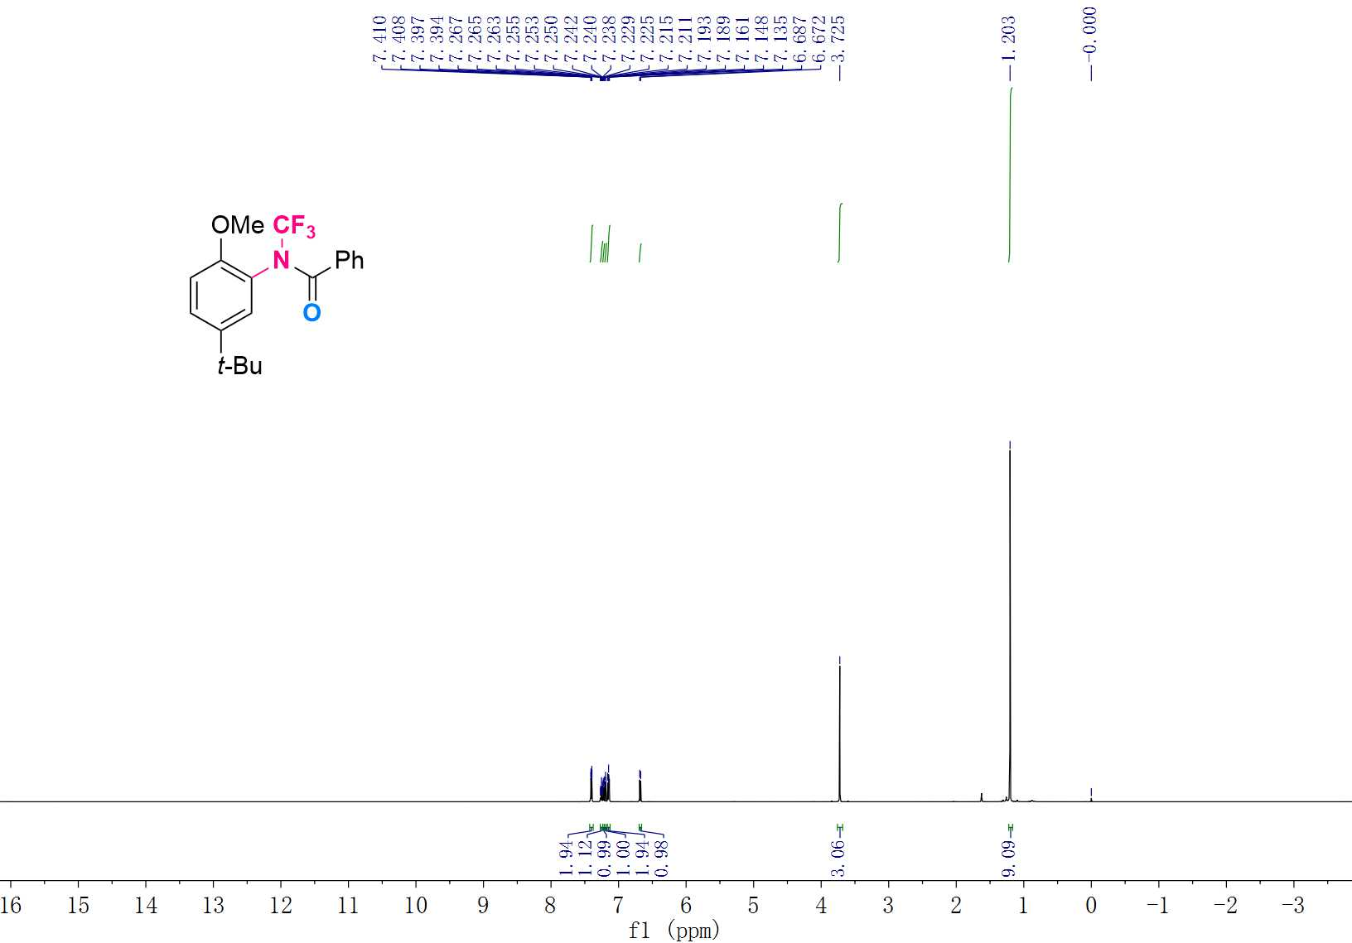

¹³C NMR (151 MHz, CDCl₃) Spectrum of 3ah
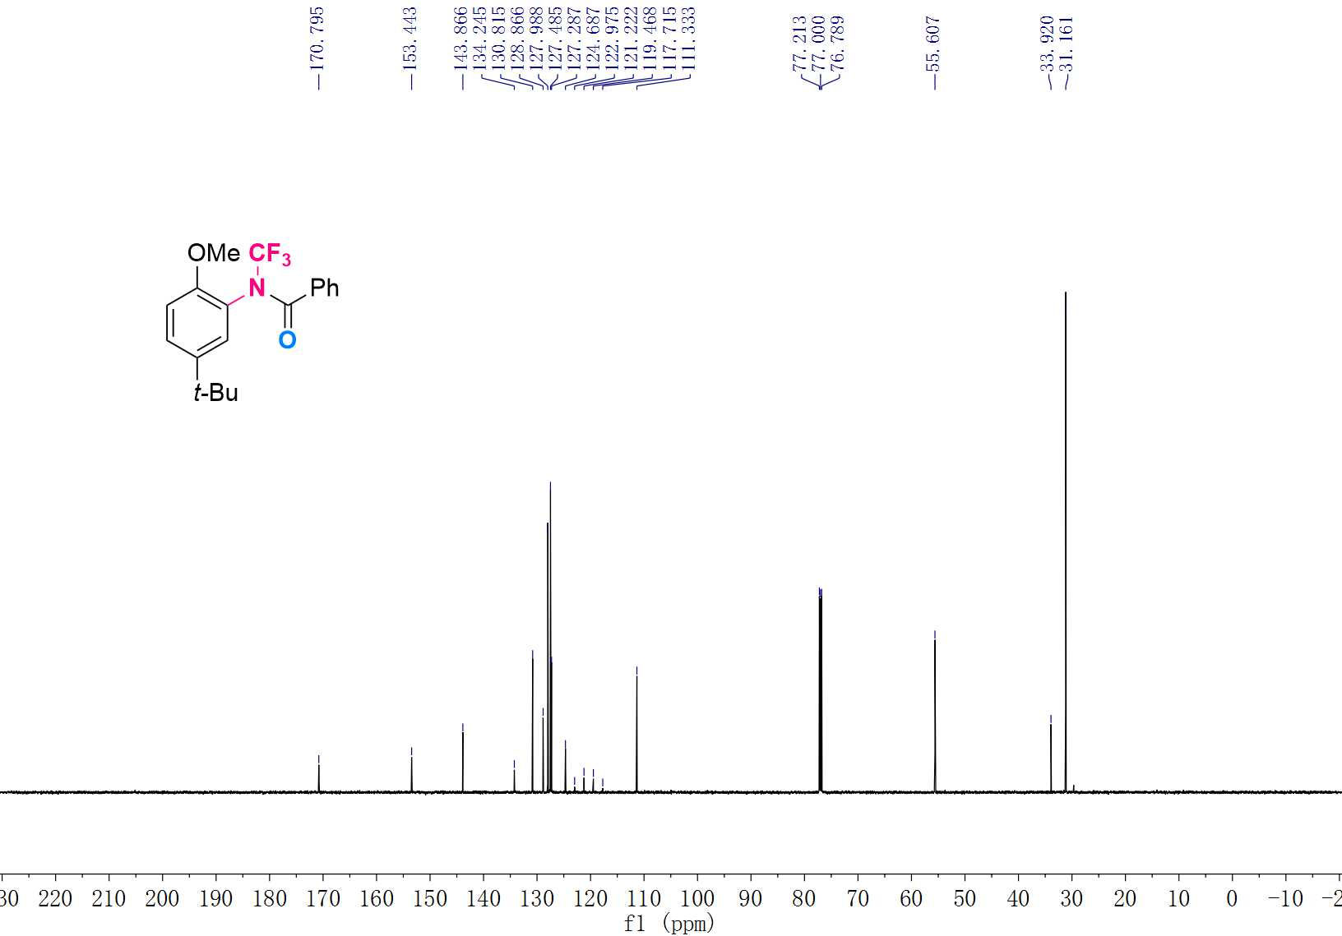

¹⁹F NMR (565 MHz, CDCl₃) Spectrum of 3ah
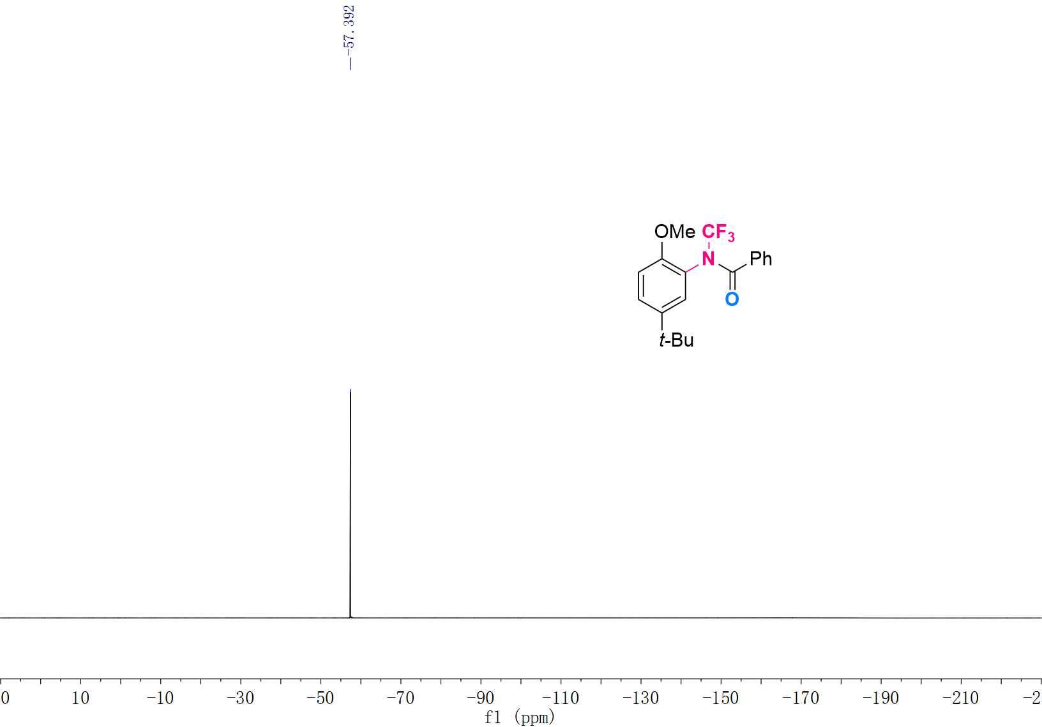

¹H NMR (500 MHz, CDCl₃) Spectrum of 3ai
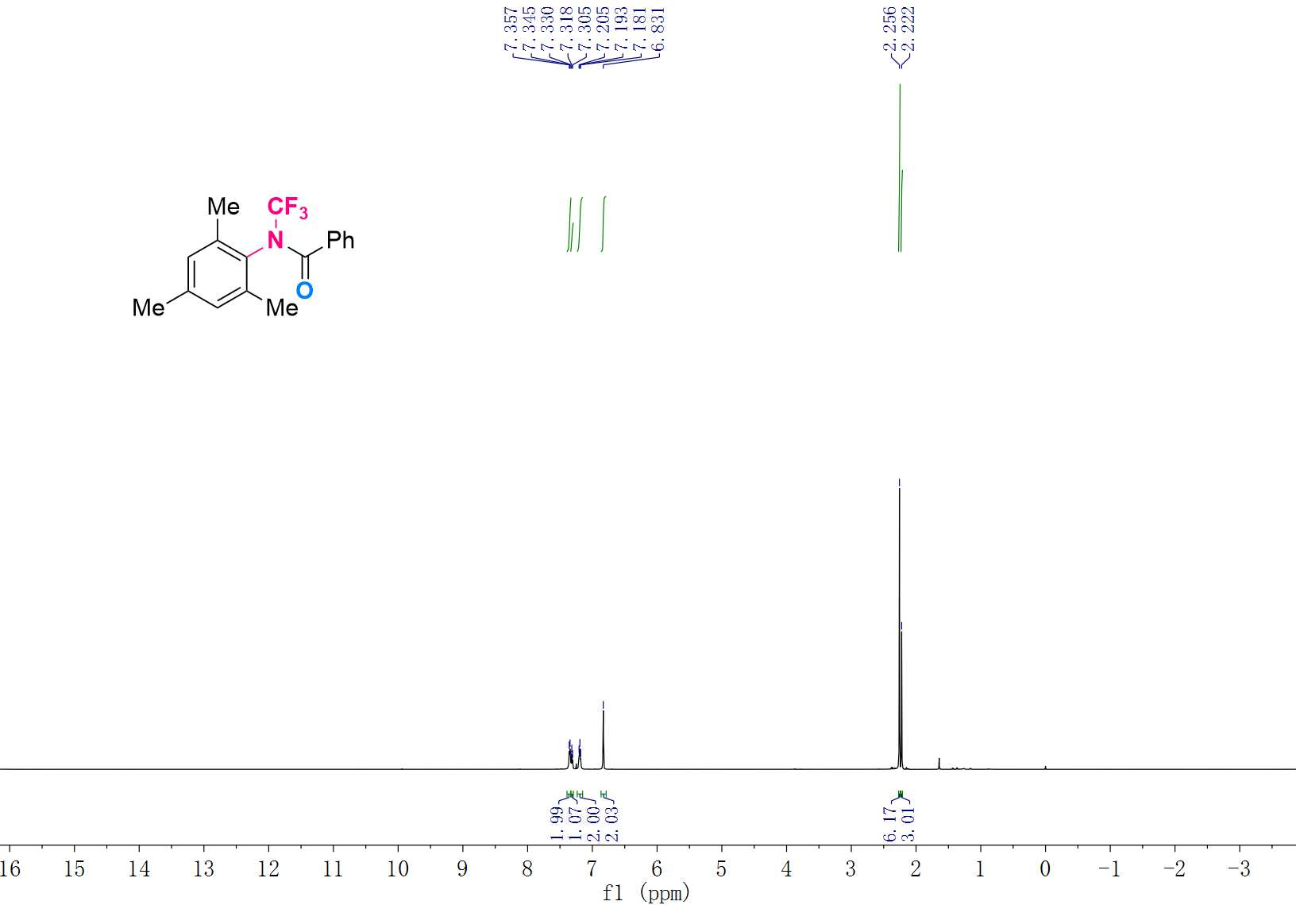

¹³C NMR (125 MHz, CDCl₃) Spectrum of 3ai
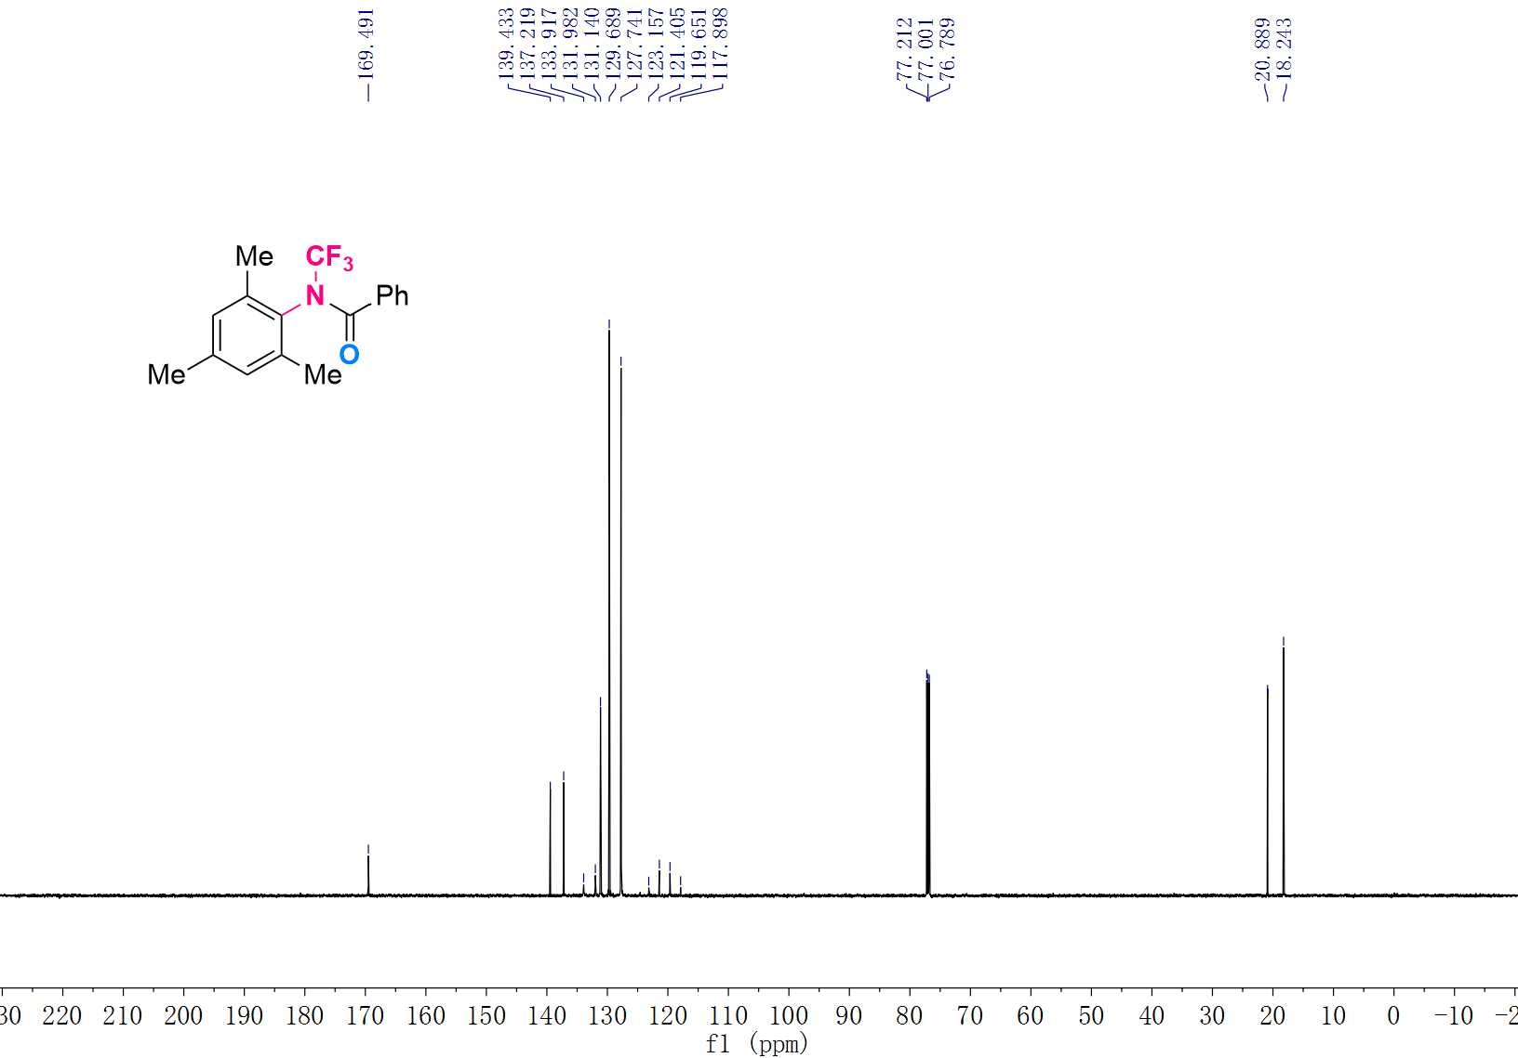

¹⁹F NMR (470 MHz, CDCl₃) Spectrum of 3ai
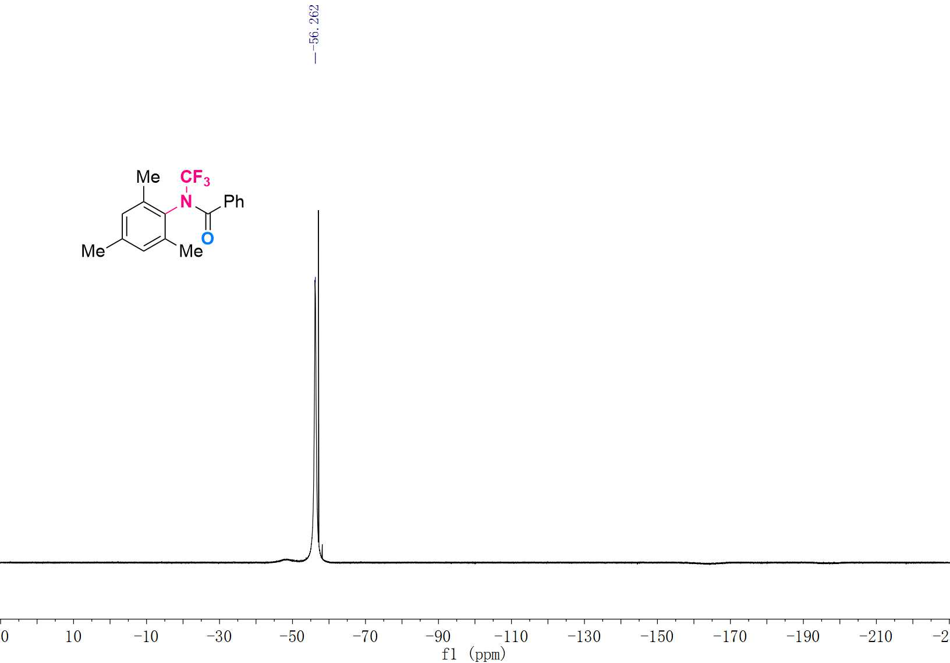

¹H NMR (600 MHz, CDCl₃) Spectrum of 3aj
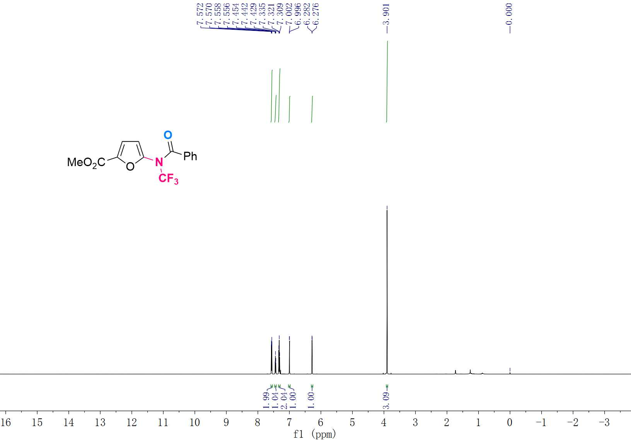

¹³C NMR (151 MHz, CDCl₃) Spectrum of 3aj
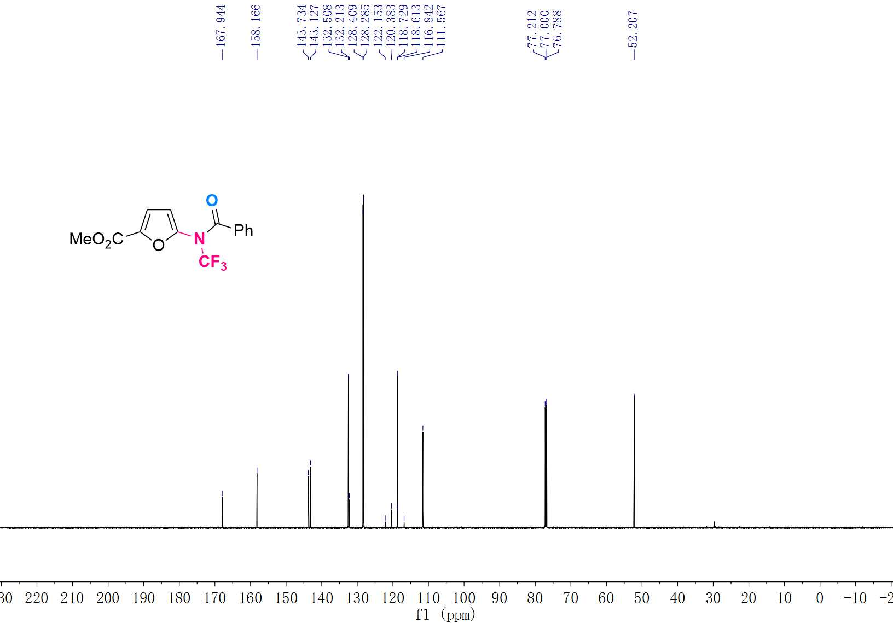

¹⁹F NMR (565 MHz, CDCl₃) Spectrum of 3aj
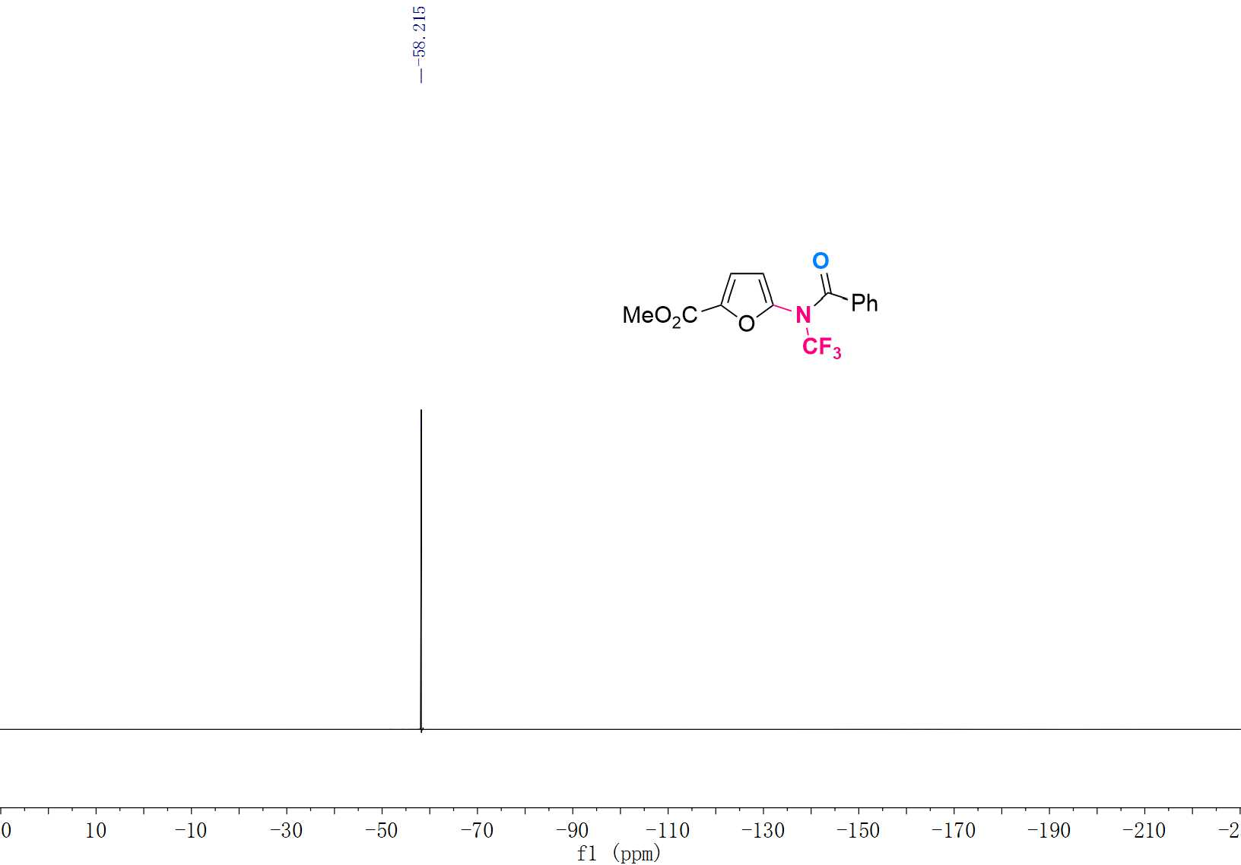

¹H NMR (600 MHz, CDCl₃) Spectrum of 3ak
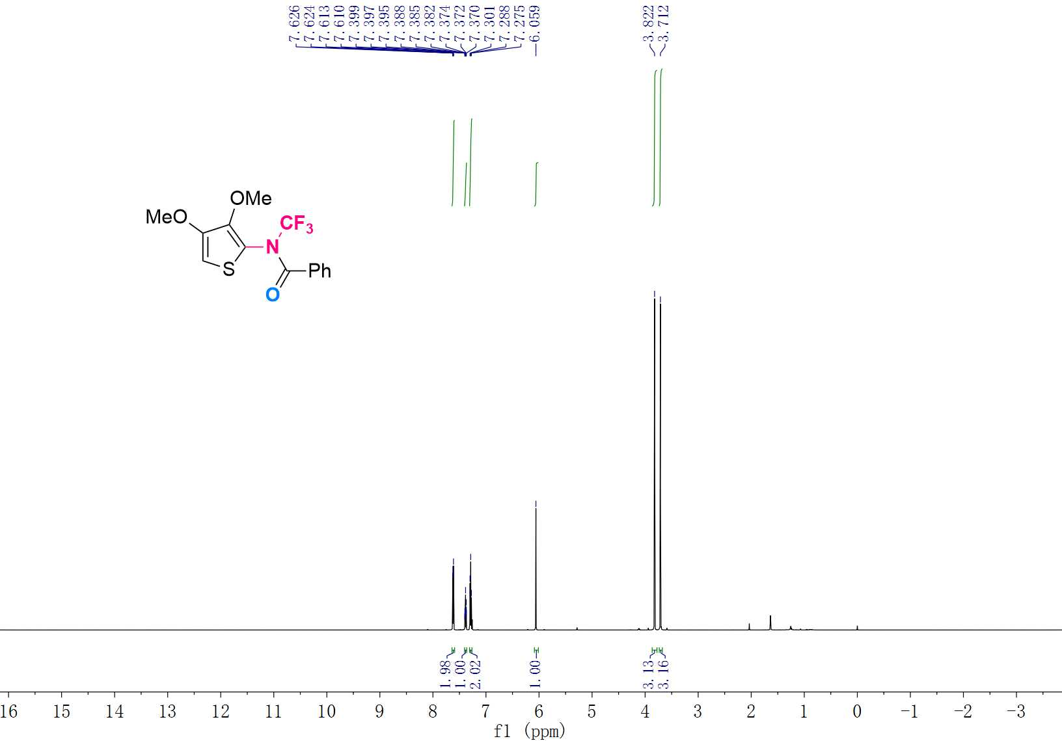

¹³C NMR (151 MHz, CDCl₃) Spectrum of 3ak
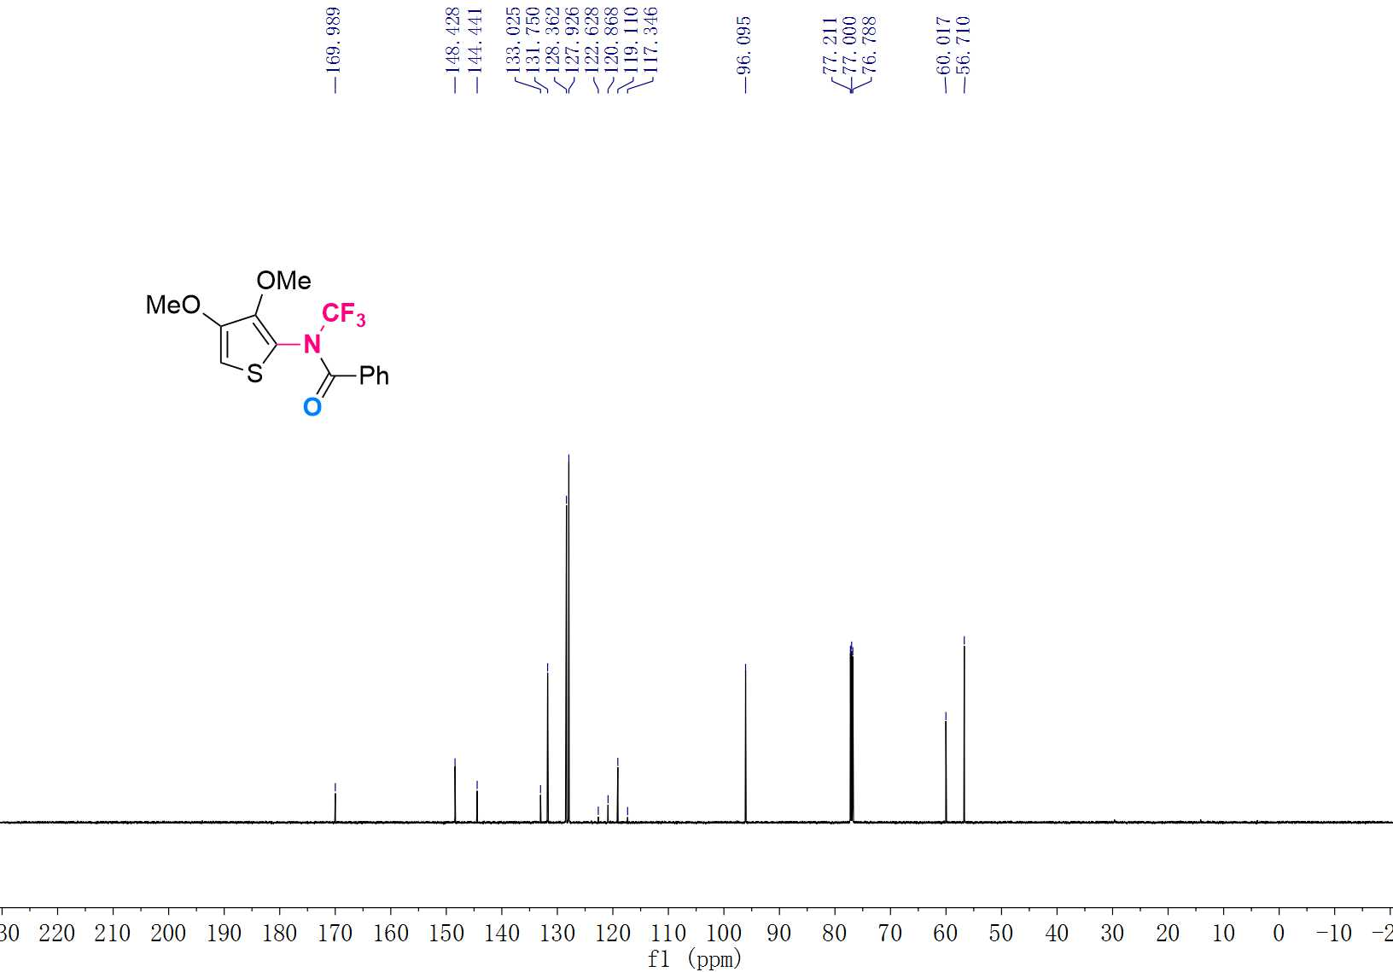

¹⁹F NMR (565 MHz, CDCl₃) Spectrum of 3ak
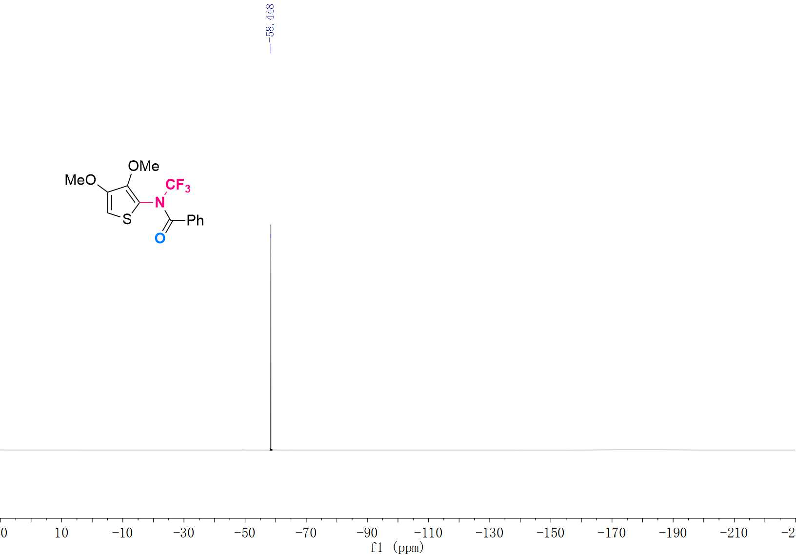

¹H NMR (600 MHz, CDCl₃) Spectrum of 3al
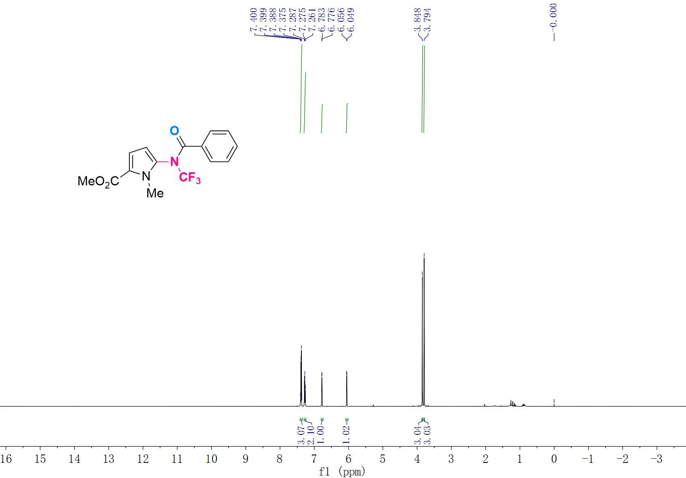

¹³C NMR (151 MHz, CDCl₃) Spectrum of 3al

¹⁹F NMR (565 MHz, CDCl₃) Spectrum of 3al

¹H NMR (500 MHz, CDCl₃) Spectrum of 3am

¹³C NMR (125 MHz, CDCl₃) Spectrum of 3am

¹⁹F NMR (470 MHz, CDCl₃) Spectrum of 3am

¹H NMR (600 MHz, CDCl₃) Spectrum of 3an

¹³C NMR (151 MHz, CDCl₃) Spectrum of 3an

¹⁹F NMR (565 MHz, CDCl₃) Spectrum of 3an

¹H NMR (600 MHz, CDCl₃) Spectrum of 3ao

¹³C NMR (151 MHz, CDCl₃) Spectrum of 3ao

¹⁹F NMR (565 MHz, CDCl₃) Spectrum of 3ao

¹H NMR (600 MHz, CDCl₃) Spectrum of 3ap

¹³C NMR (151 MHz, CDCl₃) Spectrum of 3ap

¹⁹F NMR (565 MHz, CDCl₃) Spectrum of 3ap

¹H NMR (600 MHz, CDCl₃) Spectrum of 3aq

¹³C NMR (151 MHz, CDCl₃) Spectrum of 3aq

¹⁹F NMR (565 MHz, CDCl₃) Spectrum of 3aq

¹H NMR (500 MHz, CDCl₃) Spectrum of 3ar

¹³C NMR (125 MHz, CDCl₃) Spectrum of 3ar

¹⁹F NMR (470 MHz, CDCl₃) Spectrum of 3ar

¹H NMR (600 MHz, CDCl₃) Spectrum of 3as

¹³C NMR (151 MHz, CDCl₃) Spectrum of 3as

¹⁹F NMR (565 MHz, CDCl₃) Spectrum of 3as

¹H NMR (500 MHz, CDCl₃) Spectrum of 3at

¹³C NMR (125 MHz, CDCl₃) Spectrum of 3at

¹⁹F NMR (470 MHz, CDCl₃) Spectrum of 3at

¹H NMR (600 MHz, CDCl₃) Spectrum of 3au

¹³C NMR (151 MHz, CDCl₃) Spectrum of 3au

¹⁹F NMR (565 MHz, CDCl₃) Spectrum of 3au

¹H NMR (600 MHz, CDCl₃) Spectrum of 3av

¹³C NMR (151 MHz, CDCl₃) Spectrum of 3av

¹⁹F NMR (565 MHz, CDCl₃) Spectrum of 3av

¹H NMR (600 MHz, CDCl₃) Spectrum of 3aw

¹³C NMR (151 MHz, CDCl₃) Spectrum of 3aw

¹⁹F NMR (565 MHz, CDCl₃) Spectrum of 3aw

¹H NMR (500 MHz, CDCl₃) Spectrum of 3ax

¹³C NMR (125 MHz, CDCl₃) Spectrum of 3ax

¹⁹F NMR (470 MHz, CDCl₃) Spectrum of 3ax

¹H NMR (600 MHz, CDCl₃) Spectrum of 3ay

¹³C NMR (151 MHz, CDCl₃) Spectrum of 3ay

¹⁹F NMR (565 MHz, CDCl₃) Spectrum of 3ay

¹H NMR (600 MHz, CDCl₃) Spectrum of 3az

¹³C NMR (151 MHz, CDCl₃) Spectrum of 3az

¹⁹F NMR (565 MHz, CDCl₃) Spectrum of 3az

¹H NMR (600 MHz, DMSO-D₆) Spectrum of 4b

¹³C NMR (151 MHz, DMSO-D₆) Spectrum of 4b

¹⁹F NMR (565 MHz, DMSO-D₆) Spectrum of 4b

¹H NMR (600 MHz, CDCl₃) Spectrum of 6a

¹³C NMR (151 MHz, CDCl₃) Spectrum of 6a

¹⁹F NMR (565 MHz, CDCl₃) Spectrum of 6a

¹H NMR (600 MHz, CDCl₃) Spectrum of 6b

¹³C NMR (151 MHz, CDCl₃) Spectrum of 6b

¹⁹F NMR (565 MHz, CDCl₃) Spectrum of 6b

¹H NMR (600 MHz, CDCl₃) Spectrum of 6c

¹³C NMR (151 MHz, CDCl₃) Spectrum of 6c

¹⁹F NMR (565 MHz, CDCl₃) Spectrum of 6c

¹H NMR (600 MHz, CDCl₃) Spectrum of 6d

¹³C NMR (151 MHz, CDCl₃) Spectrum of 6d

¹⁹F NMR (565 MHz, CDCl₃) Spectrum of 6d

¹H NMR (600 MHz, CDCl₃) Spectrum of 6e

¹³C NMR (151 MHz, CDCl₃) Spectrum of 6e

¹⁹F NMR (565 MHz, CDCl₃) Spectrum of 6e

¹H NMR (600 MHz, CDCl₃) Spectrum of 6f

¹³C NMR (151 MHz, CDCl₃) Spectrum of 6f

¹⁹F NMR (565 MHz, CDCl₃) Spectrum of 6f

¹H NMR (600 MHz, CDCl₃) Spectrum of 6g

¹³C NMR (151 MHz, CDCl₃) Spectrum of 6g

¹⁹F NMR (565 MHz, CDCl₃) Spectrum of 6g

¹H NMR (600 MHz, CDCl₃) Spectrum of 6h

¹³C NMR (151 MHz, CDCl₃) Spectrum of 6h

¹⁹F NMR (565 MHz, CDCl₃) Spectrum of 6h

¹H NMR (600 MHz, CDCl₃) Spectrum of 6i

¹³C NMR (151 MHz, CDCl₃) Spectrum of 6i

¹⁹F NMR (565 MHz, CDCl₃) Spectrum of 6i

¹H NMR (600 MHz, CDCl₃) Spectrum of 6j

¹³C NMR (151 MHz, CDCl₃) Spectrum of 6j

¹⁹F NMR (565 MHz, CDCl₃) Spectrum of 6j

¹H NMR (600 MHz, CDCl₃) Spectrum of 6k

¹³C NMR (151 MHz, CDCl₃) Spectrum of 6k

¹⁹F NMR (565 MHz, CDCl₃) Spectrum of 6k

¹H NMR (600 MHz, CDCl₃) Spectrum of 6l

¹³C NMR (151 MHz, CDCl₃) Spectrum of 6l

¹⁹F NMR (565 MHz, CDCl₃) Spectrum of 6l

¹H NMR (600 MHz, CDCl₃) Spectrum of 6m

¹³C NMR (151 MHz, CDCl₃) Spectrum of 6m

¹⁹F NMR (565 MHz, CDCl₃) Spectrum of 6m

¹H NMR (600 MHz, CDCl₃) Spectrum of 6n

¹³C NMR (151 MHz, CDCl₃) Spectrum of 6n

¹⁹F NMR (565 MHz, CDCl₃) Spectrum of 6n

¹H NMR (600 MHz, CDCl₃) Spectrum of 6o

¹³C NMR (151 MHz, CDCl₃) Spectrum of 6o

¹⁹F NMR (565 MHz, CDCl₃) Spectrum of 6o

¹H NMR (600 MHz, CDCl₃) Spectrum of 6p

¹³C NMR (151 MHz, CDCl₃) Spectrum of 6p

¹⁹F NMR (565 MHz, CDCl₃) Spectrum of 6p

¹H NMR (600 MHz, CDCl₃) Spectrum of 6q

¹³C NMR (151 MHz, CDCl₃) Spectrum of 6q

¹⁹F NMR (565 MHz, CDCl₃) Spectrum of 6q

¹H NMR (600 MHz, CDCl₃) Spectrum of 6r

¹³C NMR (151 MHz, CDCl₃) Spectrum of 6r

¹⁹F NMR (565 MHz, CDCl₃) Spectrum of 6r

¹H NMR (600 MHz, CDCl₃) Spectrum of 6s

¹³C NMR (151 MHz, CDCl₃) Spectrum of 6s

¹⁹F NMR (565 MHz, CDCl₃) Spectrum of 6s

¹H NMR (600 MHz, CDCl₃) Spectrum of 6t

¹³C NMR (151 MHz, CDCl₃) Spectrum of 6t

¹⁹F NMR (565 MHz, CDCl₃) Spectrum of 6t

¹H NMR (500 MHz, CDCl₃) Spectrum of 6u

¹³C NMR (125 MHz, CDCl₃) Spectrum of 6u

¹⁹F NMR (470MHz, CDCl₃) Spectrum of 6u

¹H NMR (600 MHz, CDCl₃) Spectrum of 6v

¹³C NMR (151 MHz, CDCl₃) Spectrum of 6v

¹⁹F NMR (565 MHz, CDCl₃) Spectrum of 6v

¹H NMR (600 MHz, CDCl₃) Spectrum of 6w

¹³C NMR (151 MHz, CDCl₃) Spectrum of 6w

¹⁹F NMR (565 MHz, CDCl₃) Spectrum of 6w

¹H NMR (600 MHz, CDCl₃) Spectrum of 8a

¹³C NMR (151 MHz, CDCl₃) Spectrum of 8a

¹⁹F NMR (565 MHz, CDCl₃) Spectrum of 8a

¹H NMR (600 MHz, CDCl₃) Spectrum of 8b

¹³C NMR (151 MHz, CDCl₃) Spectrum of 8b

¹⁹F NMR (565 MHz, CDCl₃) Spectrum of 8b

¹H NMR (600 MHz, CDCl₃) Spectrum of 8c

¹³C NMR (151 MHz, CDCl₃) Spectrum of 8c

¹⁹F NMR (565 MHz, CDCl₃) Spectrum of 8c

¹H NMR (600 MHz, CDCl₃) Spectrum of 8d

¹³C NMR (151 MHz, CDCl₃) Spectrum of 8d

¹⁹F NMR (565 MHz, CDCl₃) Spectrum of 8d

¹H NMR (600 MHz, CDCl₃) Spectrum of 8e

¹³C NMR (151 MHz, CDCl₃) Spectrum of 8e

¹⁹F NMR (565 MHz, CDCl₃) Spectrum of 8e

¹H NMR (500 MHz, CDCl₃) Spectrum of 8f

¹³C NMR (125 MHz, CDCl₃) Spectrum of 8f

¹⁹F NMR (470 MHz, CDCl₃) Spectrum of 8f

¹H NMR (600 MHz, CDCl₃) Spectrum of 8g

¹³C NMR (151 MHz, CDCl₃) Spectrum of 8g

¹⁹F NMR (565 MHz, CDCl₃) Spectrum of 8g

¹H NMR (600 MHz, CDCl₃) Spectrum of 8h

¹³C NMR (151 MHz, CDCl₃) Spectrum of 8h

¹⁹F NMR (565 MHz, CDCl₃) Spectrum of 8h

¹H NMR (600 MHz, CDCl₃) Spectrum of 8i

¹³C NMR (151 MHz, CDCl₃) Spectrum of 8i

¹⁹F NMR (565 MHz, CDCl₃) Spectrum of 8i

¹H NMR (600 MHz, CDCl₃) Spectrum of 8j

¹³C NMR (151 MHz, CDCl₃) Spectrum of 8j

¹⁹F NMR (565 MHz, CDCl₃) Spectrum of 8j

¹H NMR (600 MHz, CDCl₃) Spectrum of 8k

¹³C NMR (151 MHz, CDCl₃) Spectrum of 8k

¹⁹F NMR (565 MHz, CDCl₃) Spectrum of 8k

¹H NMR (600 MHz, CDCl₃) Spectrum of 8l

¹³C NMR (151 MHz, CDCl₃) Spectrum of 8l

¹⁹F NMR (565 MHz, CDCl₃) Spectrum of 8l

¹H NMR (600 MHz, CDCl₃) Spectrum of 8m

¹³C NMR (151 MHz, CDCl₃) Spectrum of 8m

¹⁹F NMR (565 MHz, CDCl₃) Spectrum of 8m

¹H NMR (600 MHz, CDCl₃) Spectrum of 8n

¹³C NMR (151 MHz, CDCl₃) Spectrum of 8n

¹⁹F NMR (565 MHz, CDCl₃) Spectrum of 8n

¹H NMR (600 MHz, CDCl₃) Spectrum of 8o

¹³C NMR (151 MHz, CDCl₃) Spectrum of 8o

¹⁹F NMR (565 MHz, CDCl₃) Spectrum of 8o

¹H NMR (600 MHz, CDCl₃) Spectrum of 8p

¹³C NMR (151 MHz, CDCl₃) Spectrum of 8p

¹⁹F NMR (565 MHz, CDCl₃) Spectrum of 8p

¹H NMR (600 MHz, CDCl₃) Spectrum of 8q

¹³C NMR (151 MHz, CDCl₃) Spectrum of 8q

¹⁹F NMR (565 MHz, CDCl₃) Spectrum of 8q

¹H NMR (600 MHz, CDCl₃) Spectrum of 8r

¹³C NMR (151 MHz, CDCl₃) Spectrum of 8r

¹⁹F NMR (565 MHz, CDCl₃) Spectrum of 8r

¹H NMR (600 MHz, CDCl₃) Spectrum of 8s

¹³C NMR (151 MHz, CDCl₃) Spectrum of 8s

¹⁹F NMR (565 MHz, CDCl₃) Spectrum of 8s

¹H NMR (600 MHz, CDCl₃) Spectrum of 10a

¹³C NMR (151 MHz, CDCl₃) Spectrum of 10a

¹⁹F NMR (565 MHz, CDCl₃) Spectrum of 10a

¹H NMR (600 MHz, CDCl₃) Spectrum of 10b

¹³C NMR (151 MHz, CDCl₃) Spectrum of 10b

¹⁹F NMR (565 MHz, CDCl₃) Spectrum of 10b

¹H NMR (600 MHz, CDCl₃) Spectrum of 12a

¹³C NMR (151 MHz, CDCl₃) Spectrum of 12a

¹⁹F NMR (565 MHz, CDCl₃) Spectrum of 12a

¹H NMR (600 MHz, CDCl₃) Spectrum of 12b

¹³C NMR (151 MHz, CDCl₃) Spectrum of 12b

¹⁹F NMR (565 MHz, CDCl₃) Spectrum of 12b

¹H NMR (600 MHz, CDCl₃) Spectrum of 14

¹³C NMR (151 MHz, CDCl₃) Spectrum of 14

¹⁹F NMR (565 MHz, CDCl₃) Spectrum of 14

¹H NMR (600 MHz, CDCl₃) Spectrum of 16

¹³C NMR (151 MHz, CDCl₃) Spectrum of 16

¹⁹F NMR (565 MHz, CDCl₃) Spectrum of 16

¹H NMR (600 MHz, CDCl₃) Spectrum of 18

¹³C NMR (151 MHz, CDCl₃) Spectrum of 18

¹⁹F NMR (565 MHz, CDCl₃) Spectrum of 18

¹H NMR (600 MHz, CDCl₃) Spectrum of 20

¹³C NMR (151 MHz, CDCl₃) Spectrum of 20

¹⁹F NMR (565 MHz, CDCl₃) Spectrum of 20
