S Table 1. WHO Ordinal scale for clinical improvement in COVID-19
Patient state | Descriptor | Score
Uninfected | No clinical or virological evidence of infection | 0
Ambulatory | No limitation of activities | 1
Ambulatory | Limitation of activities | 2
Hospitalized, mild Disease | No oxygen therapy | 3
Hospitalized, mild Disease | Oxygen by mask or nasal cannulae | 4
Hospitalized Severe Disease | Non-invasive ventilation or high-flow oxygen | 5
Hospitalized Severe Disease | Invasive mechanical ventilation without other organ support | 6
Hospitalized Severe Disease | Invasive ventilation with other organ support (e.g., ECMO, CRRT, vassopressors) | 7
Dead | Death | 8
Adapted from "WHO R&D Blueprint novel Coronavirus COVID-19 Therapeutic Trial Synopsis", World Health Organization, 2020.
ECMO; extracorporeal membrane oxygenation; CRRT, continuous renal replacement therapy

S Table 2. List of genes belonging to inflammatory and interferon-response pathways
 | Gene name
1 | AREG
2 | KLRD1
3 | BMP2K
4 | CSF1R
5 | FAM3C
6 | NAMPT
7 | SOCS3
8 | CD6
9 | CCL5
10 | CCR5
11 | CXCL16
12 | IL10RA
13 | IL16
14 | IL18
15 | IL18BP
16 | IL18RAP
17 | IL1R2
18 | IL1B
19 | IL2RB
20 | IL6R
21 | IL7R
22 | TGFBR2
23 | CXCR2
24 | CXCR1
25 | CXCL8
26 | CCL3
27 | TNFAIP2
28 | TNFAIP3
29 | IL12RB1
30 | IL12RB2
31 | TNFSF15
32 | VEGFA
33 | LTA
34 | IL1R1
35 | IL1RAP
36 | IL18R1
37 | IFNA13
38 | TNFAIP8
39 | IL13RA1
40 | TNFRSF11B
41 | IL2RA
42 | IL2RG
43 | IL4R
44 | IL5RA
45 | IL6
46 | IL10
47 | TGFBI
48 | TGFB1
49 | TGFBR3
50 | TBRG4
51 | PPBP
52 | CNP
53 | OAS2
54 | TRIM22
55 | TRIM14
56 | TRIM32
57 | USP15
58 | USP47
59 | DDX21
60 | DDX5
61 | DHX15
62 | CSF1
63 | IRF2BPL
64 | PARP12
65 | SAMD3
66 | SAMHD1
67 | IRAK3
68 | IRAK2
69 | JAK2
70 | IFNGR2
71 | SAMD9L
72 | ZBP1
73 | USP18
74 | USP41
75 | BST2
76 | OAS3
77 | DHX58
78 | IFITM10
79 | IFNAR2
80 | IRF2BP2
81 | MX1
82 | OAS1
83 | IFNA16
84 | ISG20L2
85 | IFNL2
86 | IRF2BP1
87 | MICB
88 | MAVS
89 | IFI44L
90 | IFI35
91 | IFI6
92 | IRF4
93 | IFIT1B
94 | IFI44
95 | IFIT5
96 | IFIH1

S Table 3. Differential gene expression between Asymptomatic COVID-19 cases infected with VOC or wildtype SARS-CoV-2

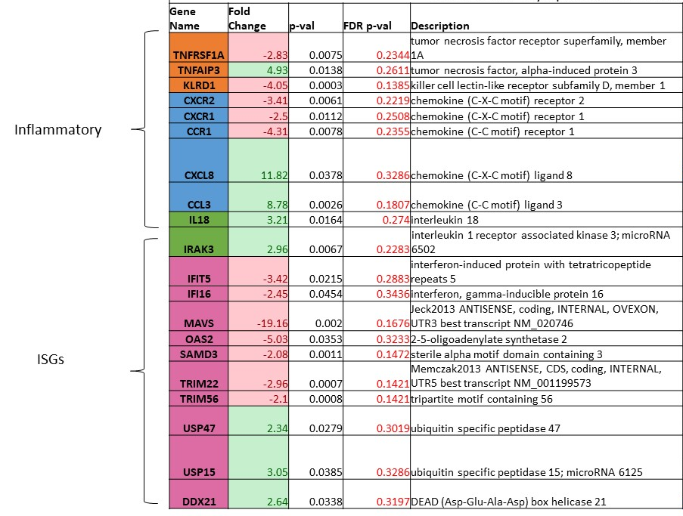

The table depicts differentially regulated genes identified by comparison of transcriptional profiles of Asymptomatic COVID-19 cases who were infected with either variants of concern (VOC) or wild type SARS-CoV-2 strains.

Supplementary Table 4. List of RNA micro arrays used in the study
Geo accession numbers | Sample ID | Severity | Variant | VOC | Vaccination status
GSM5374839 | S1 | Symptomatic | no | no | Un Vaccinated
GSM5374840 | S2 | Symptomatic | no | no | Un Vaccinated
GSM5374841 | S3 | Symptomatic | no | no | Un Vaccinated
GSM5374843 | S5 | Symptomatic | no | no | Un Vaccinated
GSM5374844 | S6 | Symptomatic | no | no | Un Vaccinated
GSM5374845 | S7 | Symptomatic | no | no | Un Vaccinated
GSM5374846 | S8 | Symptomatic | no | no | Un Vaccinated
GSM5374847 | S9 | Symptomatic | no | no | Un Vaccinated
GSM5374848 | S10 | Symptomatic | no | no | Un Vaccinated
GSM5374849 | S11 | Symptomatic | no | no | Un Vaccinated
GSM5374850 | S12 | Asymptomatic | no | no | Un Vaccinated
GSM5374851 | S13 | Asymptomatic | no | no | Un Vaccinated
GSM5374852 | S14 | Asymptomatic | no | no | Un Vaccinated
GSM5374853 | S15 | Asymptomatic | no | no | Un Vaccinated
GSM5374854 | S16 | Asymptomatic | no | no | Un Vaccinated
GSM5374855 | S17 | Asymptomatic | no | no | Un Vaccinated
GSM5374856 | S18 | Asymptomatic | no | no | Un Vaccinated
GSM5374857 | S19 | Asymptomatic | no | no | Un Vaccinated
GSM5374858 | S20 | Asymptomatic | no | no | Un Vaccinated
GSM5374859 | S21 | Asymptomatic | no | no | Un Vaccinated
GSM5374860 | S22 | Asymptomatic | no | no | Un Vaccinated
GSM5374861 | S23 | Asymptomatic | no | no | Un Vaccinated
GSM5374862 | S24 | Asymptomatic | no | no | Un Vaccinated
GSM5374863 | S25 | Asymptomatic | no | no | Un Vaccinated
GSM5374864 | S26 | Asymptomatic | no | no | Un Vaccinated
GSM5374865 | S27 | Asymptomatic | no | no | Un Vaccinated
GSM5374866 | S28 | Asymptomatic | no | no | Un Vaccinated
GSM5374867 | S29 | Asymptomatic | no | no | Un Vaccinated
GSM8327172 | Cov-Ar40 | Symptomatic | Alpha | Yes | Un Vaccinated
GSM8327173 | COV-Ar54 | Symptomatic | other | no | Un Vaccinated
GSM8327174 | COV-Ar55 | Symptomatic | Delta | Yes | Un Vaccinated
GSM8327175 | COV-Ar57 | Symptomatic | other | no | Un Vaccinated
GSM8327176 | COV-Ar58 | Symptomatic | other | no | Un Vaccinated
GSM8327177 | COV-Ar61 | Symptomatic | Delta | Yes | Un Vaccinated
GSM8327178 | COV-Ar20 | Symptomatic | wild type | no | Un Vaccinated
GSM8327179 | COV-Ar56 | Symptomatic | Delta | Yes | Un Vaccinated
GSM8327180 | COV-Ar62 | Asymptomatic | Delta | Yes | Un Vaccinated
GSM8327181 | COV-Ar63 | Asymptomatic | other | no | Un Vaccinated
GSM8327182 | COV-Ar64 | Asymptomatic | Delta | Yes | Un Vaccinated
GSM8327183 | COV-Ar65 | Asymptomatic | Delta | Yes | Un Vaccinated
GSM8327184 | COV-Ar66 | Asymptomatic | Delta | Yes | Un Vaccinated
GSM8327185 | COV-18 | Asymptomatic | Alpha | Yes | Un Vaccinated
GSM8327186 | PV-COV-23 | Asymptomatic | Delta | Yes | Vaccinated
GSM8327187 | PV-COV-35 | Asymptomatic | Delta | Yes | Vaccinated
GSM8327188 | PV-COV-19 | Asymptomatic | Delta | Yes | Vaccinated
GSM8327189 | PV-COV-22 | Asymptomatic | Delta | Yes | Vaccinated
GSM8327190 | COV-Ar34 | Asymptomatic | wild type | no | Un Vaccinated
GSM8327191 | COV-22 | Asymptomatic | wild type | no | Un Vaccinated
GSM8327192 | COV-69 | Asymptomatic | Omicron | Yes | Vaccinated
GSM8327193 | COV-70 | Asymptomatic | Omicron | Yes | Vaccinated

