S Table 6. Differential gene expression between Asymptomatic COVID-19 cases infected with VOC or wildtype SARS-CoV-2

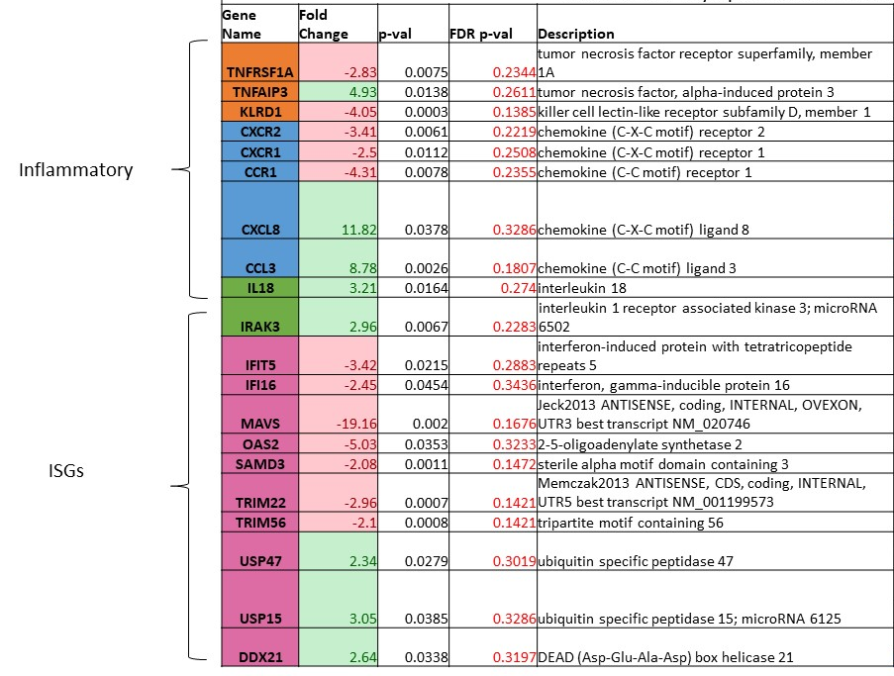

The table depicts differentially regulated genes identified by comparison of transcriptional profiles of Asymptomatic COVID-19 cases who were infected with either variants of concern (VOC) or wild type SARS-CoV-2 strains.

Supplementary Table 7. List of RNA micro arrays used in the study
Geo accession numbers | Sample ID | Severity | Variant | VOC | Vaccination status
GSM5374839 | S1 | Symptomatic | no | no | Un Vaccinated
GSM5374840 | S2 | Symptomatic | no | no | Un Vaccinated
GSM5374841 | S3 | Symptomatic | no | no | Un Vaccinated
GSM5374843 | S5 | Symptomatic | no | no | Un Vaccinated
GSM5374844 | S6 | Symptomatic | no | no | Un Vaccinated
GSM5374845 | S7 | Symptomatic | no | no | Un Vaccinated
GSM5374846 | S8 | Symptomatic | no | no | Un Vaccinated
GSM5374847 | S9 | Symptomatic | no | no | Un Vaccinated
GSM5374848 | S10 | Symptomatic | no | no | Un Vaccinated
GSM5374849 | S11 | Symptomatic | no | no | Un Vaccinated
GSM5374850 | S12 | Asymptomatic | no | no | Un Vaccinated
GSM5374851 | S13 | Asymptomatic | no | no | Un Vaccinated
GSM5374852 | S14 | Asymptomatic | no | no | Un Vaccinated
GSM5374853 | S15 | Asymptomatic | no | no | Un Vaccinated
GSM5374854 | S16 | Asymptomatic | no | no | Un Vaccinated
GSM5374855 | S17 | Asymptomatic | no | no | Un Vaccinated
GSM5374856 | S18 | Asymptomatic | no | no | Un Vaccinated
GSM5374857 | S19 | Asymptomatic | no | no | Un Vaccinated
GSM5374858 | S20 | Asymptomatic | no | no | Un Vaccinated
GSM5374859 | S21 | Asymptomatic | no | no | Un Vaccinated
GSM5374860 | S22 | Asymptomatic | no | no | Un Vaccinated
GSM5374861 | S23 | Asymptomatic | no | no | Un Vaccinated
GSM5374862 | S24 | Asymptomatic | no | no | Un Vaccinated
GSM5374863 | S25 | Asymptomatic | no | no | Un Vaccinated
GSM5374864 | S26 | Asymptomatic | no | no | Un Vaccinated
GSM5374865 | S27 | Asymptomatic | no | no | Un Vaccinated
GSM5374866 | S28 | Asymptomatic | no | no | Un Vaccinated
GSM5374867 | S29 | Asymptomatic | no | no | Un Vaccinated
GSM8327172 | Cov-Ar40 | Symptomatic | Alpha | Yes | Un Vaccinated
GSM8327173 | COV-Ar54 | Symptomatic | other | no | Un Vaccinated
GSM8327174 | COV-Ar55 | Symptomatic | Delta | Yes | Un Vaccinated
GSM8327175 | COV-Ar57 | Symptomatic | other | no | Un Vaccinated
GSM8327176 | COV-Ar58 | Symptomatic | other | no | Un Vaccinated
GSM8327177 | COV-Ar61 | Symptomatic | Delta | Yes | Un Vaccinated
GSM8327178 | COV-Ar20 | Symptomatic | wild type | no | Un Vaccinated
GSM8327179 | COV-Ar56 | Symptomatic | Delta | Yes | Un Vaccinated
GSM8327180 | COV-Ar62 | Asymptomatic | Delta | Yes | Un Vaccinated
GSM8327181 | COV-Ar63 | Asymptomatic | other | no | Un Vaccinated
GSM8327182 | COV-Ar64 | Asymptomatic | Delta | Yes | Un Vaccinated
GSM8327183 | COV-Ar65 | Asymptomatic | Delta | Yes | Un Vaccinated
GSM8327184 | COV-Ar66 | Asymptomatic | Delta | Yes | Un Vaccinated
GSM8327185 | COV-18 | Asymptomatic | Alpha | Yes | Un Vaccinated
GSM8327186 | PV-COV-23 | Asymptomatic | Delta | Yes | Vaccinated
GSM8327187 | PV-COV-35 | Asymptomatic | Delta | Yes | Vaccinated
GSM8327188 | PV-COV-19 | Asymptomatic | Delta | Yes | Vaccinated
GSM8327189 | PV-COV-22 | Asymptomatic | Delta | Yes | Vaccinated
GSM8327190 | COV-Ar34 | Asymptomatic | wild type | no | Un Vaccinated
GSM8327191 | COV-22 | Asymptomatic | wild type | no | Un Vaccinated
GSM8327192 | COV-69 | Asymptomatic | Omicron | Yes | Vaccinated
GSM8327193 | COV-70 | Asymptomatic | Omicron | Yes | Vaccinated

