SUPPLEMENTARY DATA
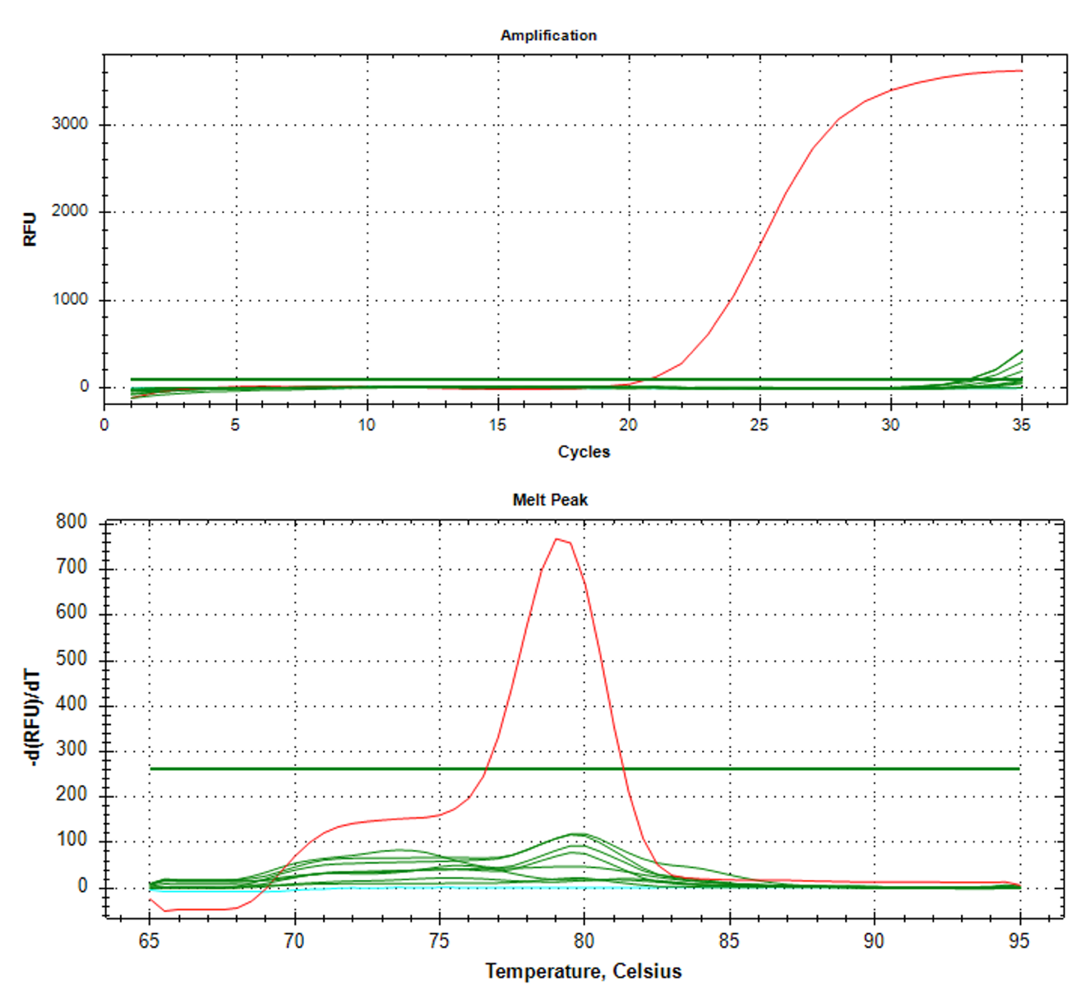
FIGURE S1. The negative results of the SDDV SYBR Green-based real-time PCR assay data.

