Supplementary Methods
Fluorescence activated cell sorting of genetically labeled cortical interneurons
Nuclei were first gated by DRAQ5+ signal, on the peak representing single nuclei. Nuclei expressing fluorescent proteins were then selected as GFP+ single nuclei. An example of the gating strategy is shown in Fig. S1.
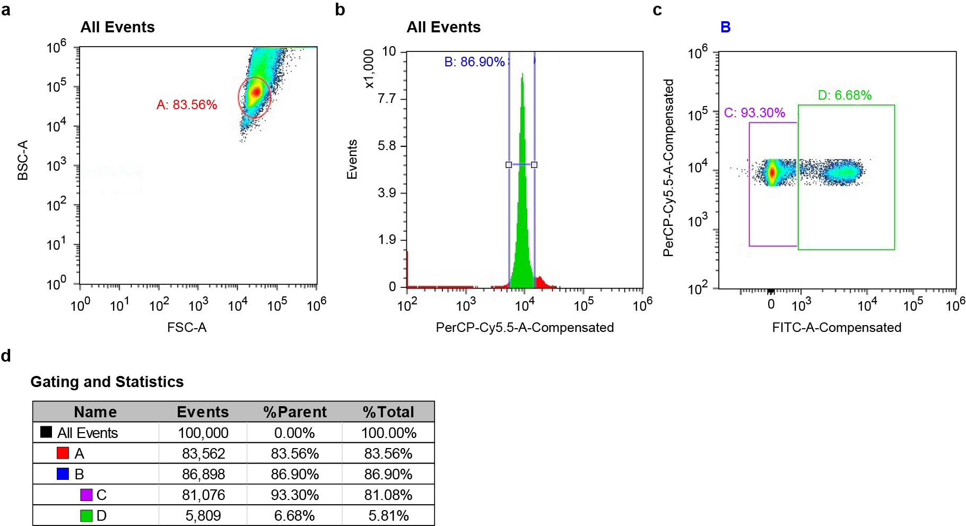
Fig. S1 Example of FACS gating strategy
This example shows FACS of genetically labeled interneurons from a P14 Nkx2.1-Cre;Bax^{fl/+};Rosa26^{LSL-h2b-GFP} mouse. a, Density plots created by Cell Sorter Software (Sony) showing backward scatter area (BSC-A) versus forward scatter area (FSC-A) distributions for the majority of nuclei, circled in A. b, Histogram of DRAQ5 signal. A gate (B) was created around the peak representing single nuclei. c, The level of GFP signal was used to gate for genetically labeled interneurons (D). d, The Gating hierarchy and sorting statistics is provided in this table.

Immunohistochemistry
Immunohistochemistry experiments were performed to amplify the fluorescent signal of genetic or viral labeled interneurons, or to label PVALB interneurons. For all histological experiments, mice were deeply anesthetized with sodium pentobarbital (Euthasol) by intraperitoneal injection and transcardially perfused with 1X PBS followed by 4% paraformaldehyde (PFA) in 1X PBS. Brains were dissected out and post-fixed overnight at 4°C. Brain slices ranging from 40-150 µm were obtained from sectioning using a vibratome (Leica VT 1200S) or using a microtome (Leica SM2010 R) after cryopreservation. Brain slices may be stored in Storage Buffer at -80 °C before further processing. Free-floating brain sections were incubated in primary antibodies diluted in antibody incubation solution (5% normal donkey serum, 0.25% Triton X-100 in 1X PBS) in coldroom overnight or up to three days. Secondary antibodies were diluted in antibody incubation solution at RT for 1-3 hrs, or in coldroom overnight. Primary antibodies used targeted: GFP (Sicgen AB0020-200), DsRed (Clontech #632496), PV (Swant PV27). Secondary antibodies used include Alexa 488 donkey anti-goat (Thermo Fisher Scientific A-11055) and Alexa 594 donkey anti-rabbit (Thermo Fisher Scientific A-21207).

Stereotaxic AAV injection
AAV-PHP.eB-hDlx-DIO-ChR2-mCherry were produced by Neurotools (University of Carolina at Chapel Hill) from user supplied plasmid preparation. To label SST-Hpse and SST-Crhr2 in control and Fezf2 KO conditions, 100 nL of this AAV (diluted to titer: E+12 vg/ml) is injected in S1 region using a Nanoject III at 6-8 weeks age. The labeling pattern was examined approximately two weeks after injection.

Tamoxifen administration
To label PVALB-Fzd6, a varying dose of tamoxifen, ranging from a single dose of 0.5 mg or two doses of 2 mg, was administrated to Pvalb^{FlpO};Tcerg1l^{CreER};Ai65 mice of 1-2 month age. Tamoxifen solution was prepared by dissolving Tamoxifen (Sigma-Aldrich, T5648) in corn oil (Sigma-Aldrich) at 10-20 mg/ml concentration with agitation or sonication. Tamoxifen solution was either stored at RT and used within one week of preparation or stored long-term at −80°C and warmed up prior to injection. Tamoxifen solution was administrated to mice through oral gavage.

