Supporting Information

Enhanced hydrothermal stability and propylene selectivity by e-beam irradiation-induced hierarchical HZSM-5 additives

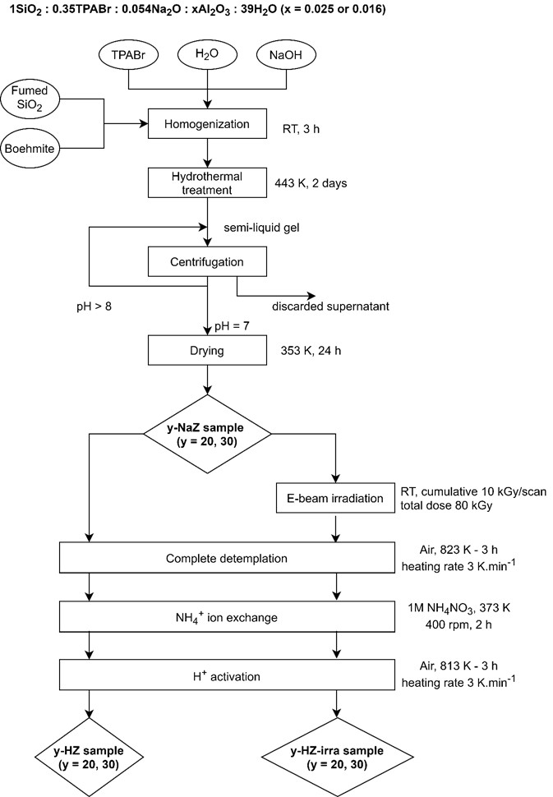
Figure S1. Experimental procedure for synthesis of fresh H-ZSM-5 samples with different Si/Al molar ratios

Table S1. Properties of equilibrium catalyst (Ecat)
Properties | Ecat
Physical analysis  Zeolitic surface area, m²/g  Matrix surface area, m²/g  Pore volume, cc/g  Average pore size, Å  Unit cell size, Å  Apparent bulk density, g/cc  Average particle size (µm)  0-20 µm (wt.%)  0-40 µm (wt.%)  0-80 µm (wt.%) | 62.5  62.4  0.2  88.2  24.3  0.8  72.2  0.6  7.2  67.8
Metals, ppm  Ni  V  Na | 3503  327  0.13
Chemical analysis, wt.%  Rare-earth oxides  Al₂O₃ | 1.1  55.3

Table S2. Properties of atmospheric residue (AR) feedstock
Properties | Atmospheric residue (AR)
Density at 288 K, gm/cc  Sulphur, wt.%  Carbon residue, wt.%  Viscosity at 373 K, cSt | 0.89  0.08  2.9  10.8
ASTM-7169 Distillation, K  Initial boiling point  5%  10%  30%  50%  60% | 579  624  646  696  734  759
Metals, ppm  Ni  V  Ca  Fe | 8.8  0.4  3.9  10.9
SARA, wt%  Saturates  Aromatics  Asphaltenes  Resin | 35.6  58.9  0.2  5.3

Table S3. Molar composition of the starting gels and the as-synthesized Na-ZSM-5 zeolites
Sample | Initial gel composition |  |  |  |  | Product composition*
Sample | Molar composition | Si/Al ratio |  | Molar composition |  |  | Si/Al ratio
20-NaZ | 1SiO₂ : 0.35TPABr : 0.054Na₂O : 0.025Al₂O₃ : 40H₂O | 20.0 |  | ((C₃H₇)₄N)_{3.56}Na_{0.99}Al_{4.55}Si_{91.45}O₁₉₂ |  |  | 20.1
30-NaZ | 1SiO₂ : 0.35TPABr : 0.054Na₂O : 0.016Al₂O₃ : 40H₂O | 31.3 |  | ((C₃H₇)₄N)_{3.11}Na_{0.14}Al_{3.05}Si_{92.95}O₁₉₂ |  |  | 30.5
*: determined by TG/DSC and ICP/MS

Table S4. Elemental compositions of the fresh H-ZSM-5 and the deactivated H-ZSM-5
Sample | Treatment | Composition* (wt.%) |  |  |  |  | Total Si, Al contents (mmol/g) |  | Bulk Si/Al
Sample | Treatment | SiO₂ | Al₂O₃ | Na₂O | H₂O |  | Q_{TSi} | Q_{TAl} | Bulk Si/Al
20-HZ | Activated (813K-3h) | 89.0 | 3.8 | 0.07 | 6.9 |  | 14.81 | 0.74 | 20.0
30-HZ | Activated (813K-3h) | 92.5 | 2.6 | 0.09 | 4.7 |  | 15.40 | 0.51 | 30.2
20-HZ-Irra | Irradiated (10kGy) + Activated (813K-3h) | 89.9 | 3.8 | 0.08 | 5.3 |  | 14.96 | 0.74 | 20.2
30-HZ-Irra | Irradiated (10kGy) + Activated (813K-3h) | 93.9 | 2.6 | 0.06 | 3.3 |  | 15.63 | 0.51 | 31.3
20-HZ-St | Activated (813K-3h) + Steamed 973K – 4h | 94.6 | 3.8 | 0.09 | 0.5 |  | 15.74 | 0.75 | 21.0
30-HZ-St | Activated (813K-3h) + Steamed 973K – 4h | 96.7 | 2.6 | 0.07 | 0.5 |  | 16.09 | 0.52 | 30.9
20-HZ-Irra-St | Irradiated (10kGy) + Activated (813K-3h) + Steamed (973K-4h) | 92.8 | 3.9 | 0.09 | 2.3 |  | 15.44 | 0.77 | 20.1
30-HZ-Irra-St | Irradiated (10kGy) + Activated (813K-3h) + Steamed (973K-4h) | 95.1 | 2.6 | 0.09 | 1.4 |  | 15.84 | 0.51 | 31.1

*: determined by ICP/MS and TG/DSC

