ANNEXURE-1

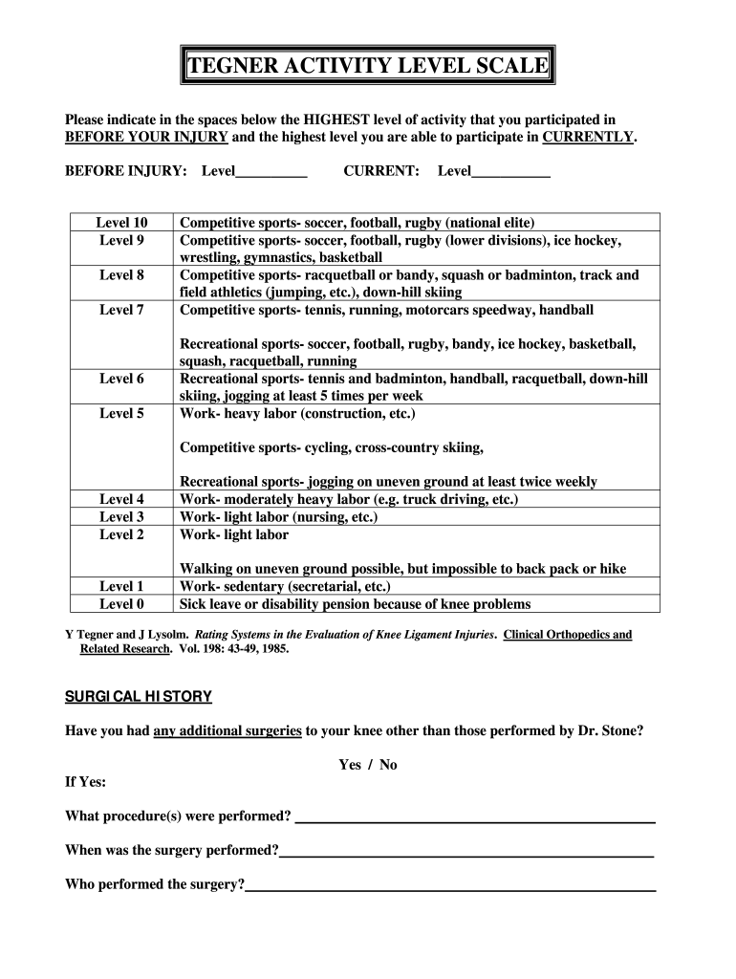

ANNEXURE 2

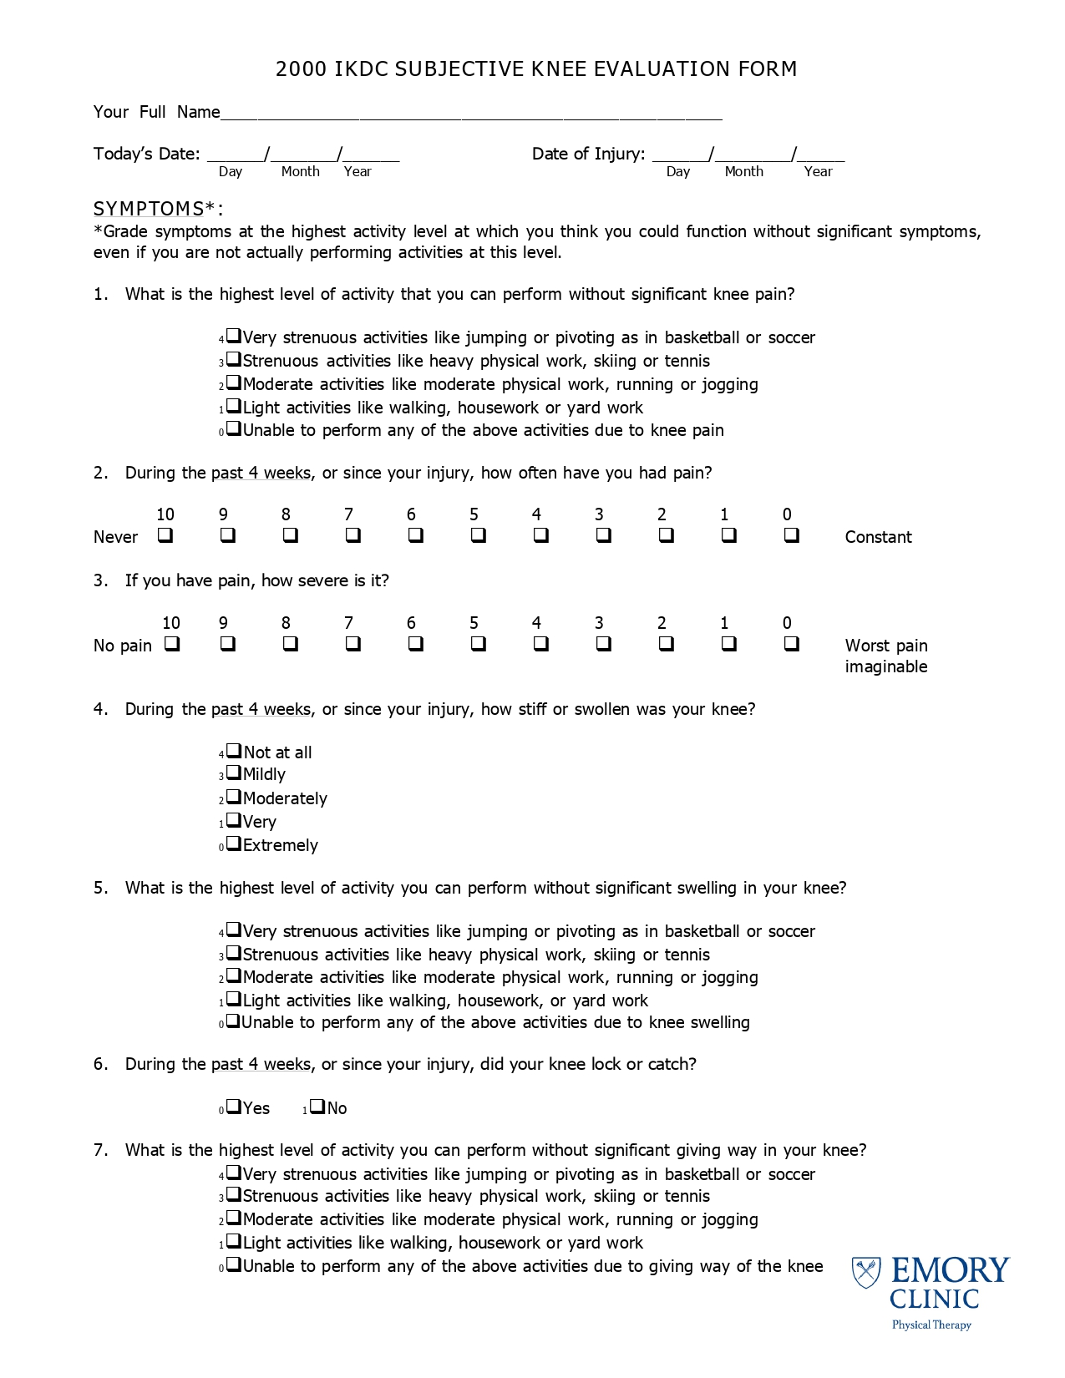

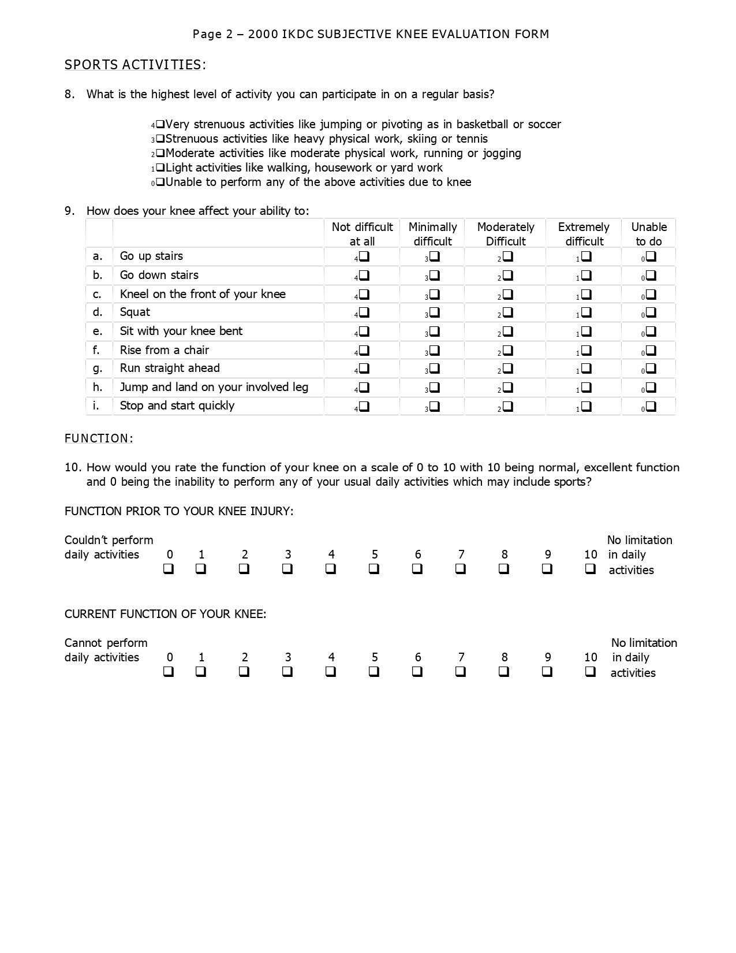ANNEXURE-3
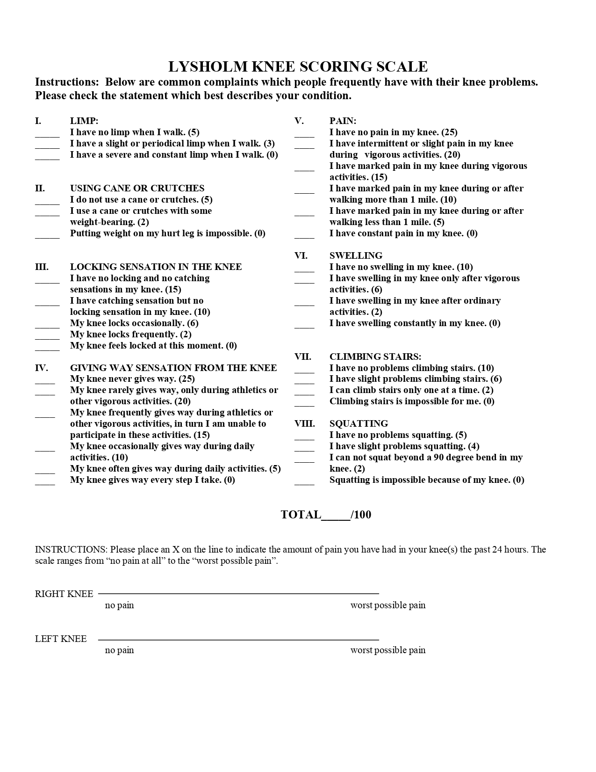

ANNEXURE-4

Numeric Pain Rating Scale

PAIN SCORE 0-10 NUMERICAL RATING

The 11-point numeric scale ranges from '0' representing one pain extreme (e.g. “no pain”) to '10' representing the other pain extreme (e.g. “pain as bad as you can imagine” or “worst pain imaginable”).
Scores range from 0-10 points, with higher scores indicating greater pain intensity.

