Frailty and long-term outcomes in patients admitted to intensive care after surgery: a retrospective multicentre cohort study

Supplementary Material

Table of Contents
sFigure 1: Patient flow chart 2
sFigure 2: Directed acyclic graph 3
sTable 1: Survival analysis using Clinical Frailty Scale as 8-level categorical variable 4
sTable 2: Survival analysis using APACHE-III score instead of SOFA score 5
sTable 3: Survival analysis using missing imputation 5
sTable 4: Survival analysis for elective vs emergency surgery subgroup 6
sTable 5: Subgroup analysis on patients with various age categories 8
sFigure 3: Survival curve for different age groups 10
sTable 6: Subgroup analysis on patients with or without any treatment limitations 11
sFigure 4: Survival curve for patients with or without treatment limitations 13
sTable 7: Subgroup analysis with patients who survived the initial hospitalization 14
sFigure 5: Survival curve for patients who survived the initial hospitalization 14
sTable 8: Diagnoses for elective and emergency surgery 15
sTable 9: Types of surgery 16
sTable 10: A list of contributing sites (in alphabetical order) 17
References 19

sFigure 1: Patient flow chart

Number of patients initially admitted to Australian intensive care units between 1st January 2018 to 31st March 2022
(n=702,675)

- non-surgical diagnoses (n= 311,679)
- cancer-related diagnoses (n= 66,005)
- Patients admitted for organ donation or palliation (n=3,847)
- Age<16 (n=2,748)

Adult ICU admission with
surgical diagnoses without oncological conditions
(n= 318,396)

- Clinical Frailty Scale not documented (n= 95,887)
Patients included
(n=222,509)

sFigure 2: Directed acyclic graph

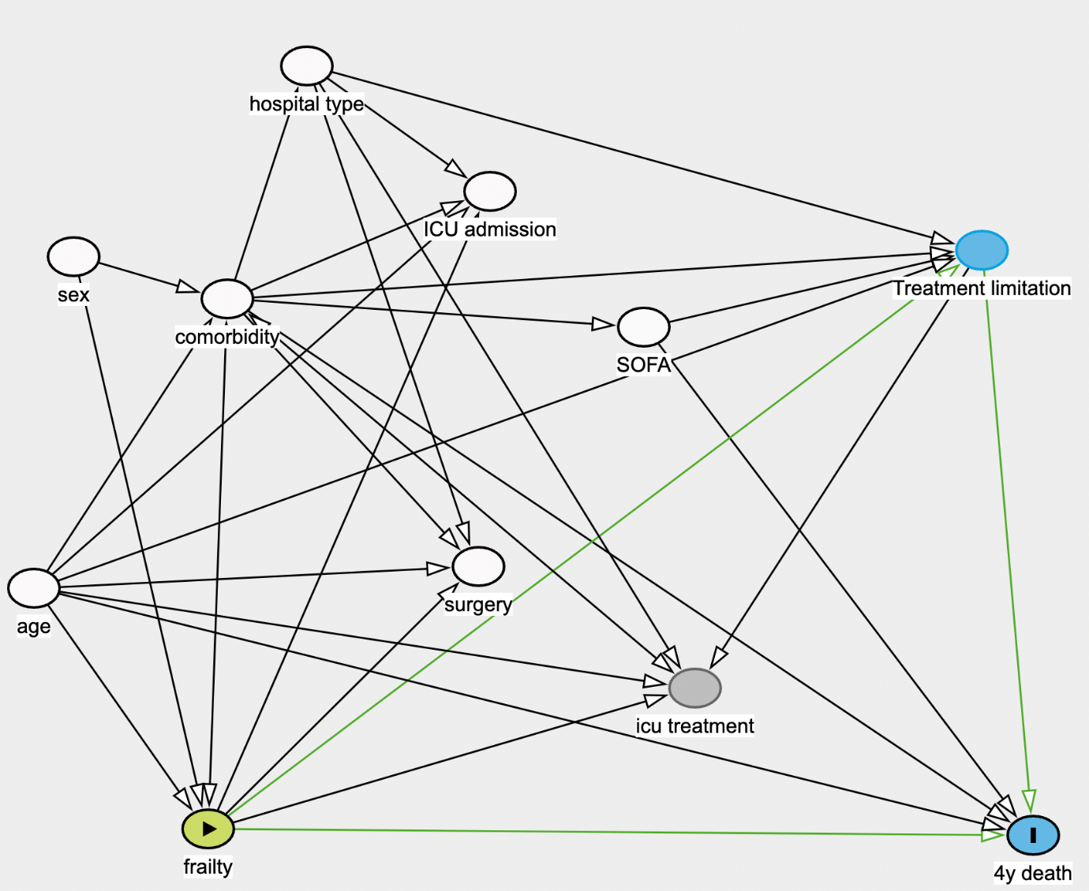

A causal DAG is a tool to model and analyze causal relationships. Each node represent variables. Arrows represent direct causal relationships between variables. An arrow from A to B means A directly causes or influences B. The absence of an arrow between two variables implies no direct causal relationship. The graph is “directed” because the arrows show the direction of causality. It is "acyclic" because it does not contain any loops or cycles.
Using this graph, we selected the white colour variables (age, sex, comorbidities, hospital type, and SOFA score) to adjust for the association between frailty and long-term outcome in ICU patients admitted after surgery. The graph was generated using Dagitty[1].

sTable 1: Survival analysis using Clinical Frailty Scale as 8-level categorical variable

 | HR [95%CI] | p-value
CFS = 1 | reference
CFS = 2 | 1.00 [0.87, 1.13] | 0.98
CFS = 3 | 1.35 [1.22, 1.47] | <0.001
CFS = 4 | 2.09 [1.96, 2.22] | <0.001
CFS = 5 | 2.90 [2.77, 3.03] | <0.001
CFS = 6 | 3.69 [3.56, 3.82] | <0.001
CFS = 7 | 5.92 [5.79, 6.05] | <0.001
CFS = 8 | 8.29 [8.16, 8.42] | <0.001
Male (compared to female) | 1.15 [1.12, 1.18] | <0.001
Age (per ten-year increment) | 1.49 [1.48, 1.51] | <0.001
SOFA score | 1.14 [1.13, 1.14] | <0.001
Hospital type (compared to public metropolitan hospital)
Private | 0.56 [0.49, 0.63] | <0.001
Public, Rural | 0.97 [0.83, 1.11] | 0.74
Public, Tertiary | 1.12 [0.94, 1.30] | 0.2
Comorbidities
Chronic Respiratory Disease | 1.27 [1.22, 1.32] | <0.001
Chronic Heart Disease | 0.96 [0.94, 0.98] | 0.02
Chronic Liver Disease | 2.35 [2.31, 2.39] | <0.001
Chronic Renal Disease | 1.46 [1.41, 1.51] | <0.001
Immunosupression | 1.03 [0.93, 1.13] | 0.58
Immunotreatment | 1.60 [1.54, 1.66] | <0.001

sTable 2: Survival analysis using APACHE-III score instead of SOFA score

 | HR [95%CI] | p-value
CFS 5-8 (compared to CFS 1-4) | 2.82 [2.74, 2.9] | <0.001
Male (compared to female) | 1.16 [1.13, 1.19] | <0.001
APACHE-III score | 1.04 [1.04, 1.04] | <0.001
Hospital type (compared to public metropolitan hospital)
Private | 0.69 [0.6, 0.79] | <0.001
Public, Rural | 1.05 [0.9, 1.24] | 0.53
Public, Tertiary | 1.11 [0.94, 1.31] | 0.22

sTable 3: Survival analysis using missing imputation

 | HR [95%CI] | p-value
CFS 5-8 (compared to CFS 1-4) | 2.14 [2.09, 2.19] | <0.001
Male (compared to female) | 1.09 [1.07, 1.11] | <0.001
Age (per one-year increment) | 1.05 [1.04, 1.05] | <0.001
SOFA score | 1.15 [1.15, 1.16] | <0.001
Hospital type (compared to public metropolitan hospital)
Private | 0.54 [0.52, 0.56] | <0.001
Public, Rural | 0.94 [0.9, 0.98] | 0.007
Public, Tertiary | 0.87 [0.84, 0.9] | <0.001
Comorbidities
Chronic Respiratory Disease | 1.33 [1.29, 1.38] | <0.001
Chronic Heart Disease | 0.92 [0.89, 0.95] | <0.001
Chronic Liver Disease | 2.31 [2.17, 2.45] | <0.001
Chronic Renal Disease | 1.57 [1.5, 1.64] | <0.001
Immunosupression | 1.24 [1.16, 1.33] | <0.001
Immunotreatment | 1.64 [1.56, 1.72] | <0.001

Imputation was performed using mice package (Multivariate Imputation by Chained Equations) in R [2]. We created 10 imputed datasets, ran 10 iterations for each imputation, and used predictive mean matching (PMM) as the imputation method.

sTable 4: Survival analysis for elective vs emergency surgery subgroup

A) Elective surgery
 | HR [95%CI] | p-value
CFS 5-8 (compared to CFS 1-4) | 2.39 [2.3, 2.48] | <0.001
Male (compared to female) | 1.2 [1.16, 1.24] | <0.001
Age (per ten-year increment) | 1.68 [1.65, 1.71] | <0.001
SOFA score | 1.08 [1.07, 1.09] | <0.001
Hospital type (compared to public metropolitan hospital)
Private | 0.66 [0.56, 0.79] | <0.001
Public, Rural | 0.92 [0.74, 1.13] | 0.42
Public, Tertiary | 1.1 [0.9, 1.35] | 0.35
Comorbidities
Chronic Respiratory Disease | 1.4 [1.32, 1.48] | <0.001
Chronic Heart Disease | 1.01 [0.96, 1.06] | 0.79
Chronic Liver Disease | 2.65 [2.3, 3.05] | <0.001
Chronic Renal Disease | 1.82 [1.7, 1.94] | <0.001
Immunosupression | 1.08 [0.95, 1.23] | 0.23
Immunotreatment | 1.92 [1.76, 2.09] | <0.001

B) Emergency surgery
 | HR [95%CI] | p-value
CFS 5-8 (compared to CFS 1-4) | 1.94 [1.9, 1.98] | <0.001
Male (compared to female) | 1.07 [1.03, 1.11] | 0.001
Age (per ten-year increment) | 1.45 [1.43, 1.46] | <0.001
SOFA score | 1.18 [1.18, 1.19] | <0.001
Hospital type (compared to public metropolitan hospital)
Private | 0.75 [0.62, 0.88] | <0.001
Public, Rural | 1.01 [0.88, 1.14] | 0.87
Public, Tertiary | 1.25 [1.12, 1.37] | <0.001
Comorbidities
Chronic Respiratory Disease | 1.24 [1.18, 1.3] | <0.001
Chronic Heart Disease | 1.02 [0.96, 1.08] | 0.52
Chronic Liver Disease | 1.97 [1.88, 2.06] | <0.001
Chronic Renal Disease | 1.31 [1.24, 1.39] | <0.001
Immunosupression | 1.08 [0.95, 1.22] | 0.25
Immunotreatment | 1.37 [1.28, 1.46] | <0.001

C) Interaction terms
 | HR [95%CI] | p-value
CFS 5-8 (compared to CFS 1-4) | 1.98 [1.90, 2.06] | <0.001
Elective surgery (compared to emergency surgery) | 0.54 [0.52, 0.56] | <0.001
Male (compared to female) | 1.15 [1.12, 1.18] | <0.001
Age (per ten-year increment) | 1.57 [1.55, 1.59] | <0.001
SOFA score | 1.12 [1.12, 1.13] | <0.001
Hospital type (compared to public metropolitan hospital)
Private | 0.73 [0.64, 0.84] | <0.001
Public, Rural | 0.97 [0.83, 1.13] | 0.68
Public, Tertiary | 1.25 [1.06, 1.46] | 0.006
Comorbidities
Chronic Respiratory Disease | 1.34 [1.29, 1.40] | <0.001
Chronic Heart Disease | 1.01 [0.97, 1.05] | 0.67
Chronic Liver Disease | 2.45 [2.27, 2.64] | <0.001
Chronic Renal Disease | 1.59 [1.51, 1.67] | <0.001
Immunosupression | 1.07 [0.98, 1.18] | 0.14
Immunotreatment | 1.65 [1.55, 1.76] | <0.001
Interaction terms
interaction between elective and CFS 5-8 | 1.26 [1.19, 1.33] | <0.001

sTable 5: Subgroup analysis on patients with various age categories

A) Age<65
 | HR [95%CI] | p-value
CFS 5-8 (compared to CFS 1-4) | 2.55 [2.37, 2.75] | <0.001
Male (compared to female) | 1.04 [0.98, 1.1] | 0.2
Age (per ten-year increment) | 1.28 [1.25, 1.32] | <0.001
SOFA score | 1.22 [1.2, 1.23] | <0.001
Hospital type (compared to public metropolitan hospital)
Private | 0.42 [0.33, 0.52] | <0.001
Public, Rural | 0.97 [0.75, 1.26] | 0.82
Public, Tertiary | 1.15 [0.9, 1.45] | 0.26
Comorbidities
Chronic Respiratory Disease | 1.18 [1.07, 1.31] | 0.002
Chronic Heart Disease | 0.94 [0.84, 1.04] | 0.2
Chronic Liver Disease | 2.42 [2.17, 2.7] | <0.001
Chronic Renal Disease | 1.47 [1.31, 1.64] | <0.001
Immunosupression | 1.05 [0.87, 1.27] | 0.62
Immunotreatment | 1.79 [1.59, 2.02] | <0.001

B) Age 65-80
 | HR [95%CI] | p-value
CFS 5-8 (compared to CFS 1-4) | 2.40 [2.29, 2.51] | <0.001
Male (compared to female) | 1.11 [1.06, 1.16] | <0.001
Age (per ten-year increment) | 1.70 [1.62, 1.78] | <0.001
SOFA score | 1.13 [1.12, 1.14] | <0.001
Hospital type (compared to public metropolitan hospital)
Private | 0.51 [0.44, 0.60] | <0.001
Public, Rural | 1.01 [0.84, 1.22] | 0.91
Public, Tertiary | 1.03 [0.86, 1.23] | 0.74
Comorbidities
Chronic Respiratory Disease | 1.46 [1.37, 1.55] | <0.001
Chronic Heart Disease | 0.92 [0.87, 0.98] | 0.009
Chronic Liver Disease | 2.24 [1.98, 2.54] | <0.001
Chronic Renal Disease | 1.68 [1.56, 1.82] | <0.001
Immunosupression | 1.05 [0.91, 1.21] | 0.48
Immunotreatment | 1.74 [1.58, 1.90] | <0.001

C) Age >80
 | HR [95%CI] | p-value
CFS 5-8 (compared to CFS 1-4) | 1.89 [1.8, 1.97] | <0.001
Male (compared to female) | 1.23 [1.18, 1.28] | <0.001
Age (per ten-year increment) | 2.13 [2.03, 2.23] | <0.001
SOFA score | 1.13 [1.12, 1.14] | <0.001
Hospital type (compared to public metropolitan hospital)
Private | 0.66 [0.58, 0.75] | <0.001
Public, Rural | 0.96 [0.83, 1.12] | 0.64
Public, Tertiary | 1.16 [1.0, 1.34] | 0.053
Comorbidities
Chronic Respiratory Disease | 1.33 [1.25, 1.43] | <0.001
Chronic Heart Disease | 1.03 [0.98, 1.09] | 0.28
Chronic Liver Disease | 2.22 [1.75, 2.82] | <0.001
Chronic Renal Disease | 1.34 [1.24, 1.45] | <0.001
Immunosupression | 1.09 [0.91, 1.3] | 0.37
Immunotreatment | 1.52 [1.34, 1.74] | <0.001

D) Interaction terms
 | HR [95%CI] | p-value
CFS 5-8 (compared to CFS 1-4) | 3.23 [3.01, 3.45] | <0.001
Age 65-80 (compared to Age < 65) | 2.11 [2.03, 2.2] | <0.001
Age >80 (compared to Age < 65) | 4.88 [4.67, 5.1] | <0.001
Male (compared to female) | 1.12 [1.09, 1.15] | <0.001
SOFA score | 1.15 [1.15, 1.16] | <0.001
Hospital type (compared to public metropolitan hospital)
Private | 0.57 [0.49, 0.66] | <0.001
Public, Rural | 0.99 [0.84, 1.17] | 0.9
Public, Tertiary | 1.11 [0.94, 1.32] | 0.23
Comorbidities
Chronic Respiratory Disease | 1.33 [1.27, 1.38] | <0.001
Chronic Heart Disease | 1.01 [0.98, 1.05] | 0.43
Chronic Liver Disease | 2.38 [2.2, 2.56] | <0.001
Chronic Renal Disease | 1.52 [1.45, 1.6] | <0.001
Immunosupression | 1.05 [0.96, 1.16] | 0.3
Immunotreatment | 1.64 [1.53, 1.74] | <0.001
Interaction terms
Age 65-80 and frailty | 0.79 [0.73, 0.85] | <0.001
Age >80 and frailty | 0.65 [0.6, 0.7] | <0.001

sFigure 3: Survival curve for different age groups

sTable 6: Subgroup analysis on patients with or without any treatment limitations

A) Patients with treatment limitations
 | HR [95%CI] | p-value
CFS 5-8 (compared to CFS 1-4) | 1.20 [1.11, 1.30] | <0.001
Male (compared to female) | 1.19 [1.10, 1.27] | <0.001
Age (per ten-year increment) | 1.06 [1.02, 1.09] | 0.002
SOFA score | 1.17 [1.15, 1.18] | <0.001
Hospital type (compared to public metropolitan hospital)
Private | 1.27 [1.06, 1.51] | 0.009
Public, Rural | 0.98 [0.84, 1.15] | 0.79
Public, Tertiary | 1.25 [1.07, 1.46] | 0.005
Comorbidities
Chronic Respiratory Disease | 1.14 [1.03, 1.26] | 0.01
Chronic Heart Disease | 1.03 [0.94, 1.13] | 0.53
Chronic Liver Disease | 1.20 [0.99, 1.44] | 0.062
Chronic Renal Disease | 1.06 [0.93, 1.21] | 0.38
Immunosupression | 0.97 [0.74, 1.27] | 0.81
Immunotreatment | 1.29 [1.08, 1.53] | 0.004

B) Patients without treatment limitations
 | HR [95%CI] | p-value
CFS 5-8 (compared to CFS 1-4) | 2.25 [2.19, 2.33] | <0.001
Male (compared to female) | 1.12 [1.09, 1.15] | <0.001
Age (per ten-year increment) | 1.55 [1.54, 1.57] | <0.001
SOFA score | 1.14 [1.13, 1.14] | <0.001
Hospital type (compared to public metropolitan hospital)
Private | 0.59 [0.5, 0.68] | <0.001
Public, Rural | 0.95 [0.8, 1.14] | 0.61
Public, Tertiary | 1.15 [0.97, 1.37] | 0.1
Comorbidities
Chronic Respiratory Disease | 1.33 [1.27, 1.39] | <0.001
Chronic Heart Disease | 0.98 [0.95, 1.03] | 0.46
Chronic Liver Disease | 2.62 [2.42, 2.85] | <0.001
Chronic Renal Disease | 1.61 [1.53, 1.7] | <0.001
Immunosupression | 1.06 [0.96, 1.17] | 0.26
Immunotreatment | 1.7 [1.59, 1.82] | <0.001

C) Interaction terms
 | HR [95%CI] | p-value
CFS 5-8 (compared to CFS 1-4) | 2.33 [2.26, 2.4] | <0.001
Treatment limitation (compared to no treatment limitation) | 3.46 [3.23, 3.71] | <0.001
Male (compared to female) | 1.13 [1.1, 1.16] | <0.001
Age (per ten-year increment) | 1.5 [1.49, 1.52] | <0.001
SOFA score | 1.14 [1.14, 1.15] | <0.001
Hospital type (compared to public metropolitan hospital)
Private | 0.64 [0.55, 0.73] | <0.001
Public, Rural | 0.96 [0.82, 1.13] | 0.62
Public, Tertiary | 1.21 [1.03, 1.42] | 0.021
Comorbidities
Chronic Respiratory Disease | 1.3 [1.25, 1.36] | <0.001
Chronic Heart Disease | 0.99 [0.95, 1.03] | 0.55
Chronic Liver Disease | 2.44 [2.27, 2.63] | <0.001
Chronic Renal Disease | 1.53 [1.46, 1.61] | <0.001
Immunosupression | 1.07 [0.97, 1.18] | 0.15
Immunotreatment | 1.64 [1.54, 1.75] | <0.001
Interaction terms
interaction between treatment limitation and CFS 5-8 | 0.5 [0.46, 0.54] | <0.001

sFigure 4: Survival curve for patients with or without treatment limitations

sTable 7: Subgroup analysis with patients who survived the initial hospitalization

 | HR [95%CI] | p-value
CFS 5-8 (compared to CFS 1-4) | 2.31 [2.24, 2.39] | <0.001
Male (compared to female) | 1.21 [1.18, 1.25] | <0.001
Age (per ten-year increment) | 1.66 [1.64, 1.69] | <0.001
SOFA score | 1.05 [1.05, 1.06] | <0.001
Hospital type (compared to public metropolitan hospital)
Private | 0.61 [0.53, 0.70] | <0.001
Public, Rural | 0.98 [0.83, 1.16] | 0.82
Public, Tertiary | 1.07 [0.90, 1.26] | 0.45
Comorbidities
Chronic Respiratory Disease | 1.34 [1.28, 1.40] | <0.001
Chronic Heart Disease | 1.00 [0.96, 1.05] | 0.82
Chronic Liver Disease | 3.08 [2.82, 3.36] | <0.001
Chronic Renal Disease | 1.77 [1.68, 1.88] | <0.001
Immunosupression | 1.07 [0.96, 1.19] | 0.22
Immunotreatment | 1.77 [1.65, 1.90] | <0.001

sFigure 5: Survival curve for patients who survived the initial hospitalization

sFigure 6: Subgroup analysis of patients with various surgical categories

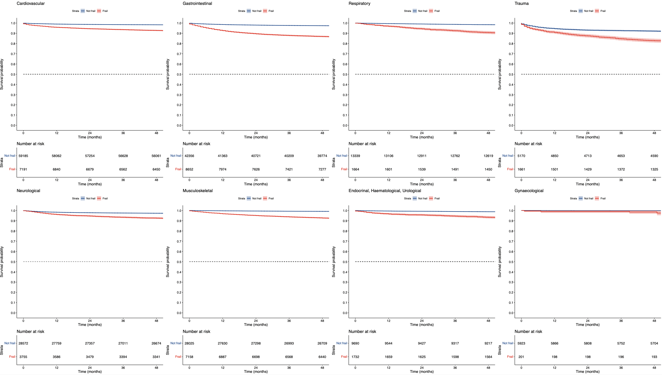
sFigure 7: survival curve comparing patients with or without documented CFS

sTable 8: Diagnoses for elective and emergency surgery
Diagnosis category for elective surgery
Cardiovascular | 57280
Gastrointestinal | 31013
Musculoskeletal | 29381
Neurology | 26939
Respiratory | 12221
Endocrine, Haematology, Renal | 8812
Gynaecology | 3011
Trauma | 1256
Others | 370
Diagnosis category for emergency surgery
Gastrointestinal | 19396
Cardiovascular | 8550
Trauma | 5500
Musculoskeletal | 5423
Neurology | 5137
Gynaecology | 3098
Respiratory | 2565
Endocrine, Haematology, Renal | 2430
Others | 127

sTable 9: Types of surgery

Surgical procedure types for elective surgery
Orthopedic | 26723
CABG | 22490
GI surgery, except for obstruction or perforation | 21050
Complication for previous spinal surgery | 18262
Cardiovascular, valve surgery | 12493
Thoracic surgery, non-cancer | 9597
Cardiothoracic, except for CABG | 8933
Neurosurgery, non-cancer | 5737
CABG with valve replacement | 4232
Endocrine surgery | 3923
Surgical procedure types for emergency surgery
GI obstruction | 4257
GI surgery, except for obstruction or perforation | 3979
Orthopedic | 3676
Trauma | 3552
GI perforation | 3359
GI bleeding | 3016
Obstetrics | 2754
CABG | 2471
Cardiothoracic, except for CABG | 2231
Neurosurgery, non-cancer | 2144

sTable 10: A list of contributing sites (in alphabetical order)
Albury Wodonga Health ICU, Alfred Hospital ICU, Alice Springs Hospital ICU, Angliss Hospital ICU, Armadale Health Service ICU, Ashford Community Hospital ICU, Austin Hospital ICU, Ballarat Health Services ICU, Bankstown-Lidcombe Hospital ICU, Bathurst Base Hospital ICU, Bendigo Health Care Group ICU, Blacktown Hospital ICU, Bowral Hospital HDU, Box Hill Hospital ICU, Buderim Private Hospital ICU, Bunbury Regional Hospital ICU, Bundaberg Base Hospital ICU, Caboolture Hospital ICU, Cabrini Hospital ICU, Cairns Hospital ICU, Calvary Adelaide Hospital ICU, Calvary Hospital (Canberra) ICU, Calvary Hospital (Lenah Valley) ICU, Calvary John James Hospital ICU, Calvary Mater Newcastle ICU, Calvary North Adelaide Hospital ICU, Campbelltown Hospital ICU, Canberra Hospital ICU, Casey Hospital ICU, Central Gippsland Health Service (Sale) ICU, Coffs Harbour Health Campus ICU, Concord Hospital (Sydney) ICU, Dandenong Hospital ICU, Dubbo Base Hospital ICU, Echuca Regional Hospital HDU, Epworth Eastern Private Hospital ICU, Epworth Freemasons Hospital ICU, Epworth Geelong ICU, Epworth Hospital (Richmond) ICU, Fairfield Hospital ICU, Fiona Stanley Hospital ICU, Flinders Medical Centre ICU, Flinders Private Hospital ICU, Footscray Hospital ICU, Frankston Hospital ICU, Gold Coast Private Hospital ICU, Gold Coast University Hospital ICU, Gosford Hospital ICU, Gosford Private Hospital ICU, Goulburn Base Hospital ICU, Goulburn Valley Health ICU, Grafton Base Hospital ICU, Greenslopes Private Hospital ICU, Griffith Base Hospital ICU, Hervey Bay Hospital ICU, Hollywood Private Hospital ICU, Holmesglen Private Hospital ICU, Hornsby Ku-ring-gai Hospital ICU, Hurstville Private Hospital ICU, Ipswich Hospital ICU, John Fawkner Hospital ICU, John Flynn Private Hospital ICU, John Hunter Hospital ICU, Joondalup Health Campus ICU, Kareena Private Hospital ICU, Knox Private Hospital ICU, Latrobe Regional Hospital ICU, Launceston General Hospital ICU, Lingard Private Hospital ICU, Lismore Base Hospital ICU, Liverpool Hospital ICU, Logan Hospital ICU, Lyell McEwin Hospital ICU, Mackay Base Hospital ICU, Macquarie University Private Hospital ICU, Maitland Hospital ICU, Maitland Private Hospital ICU, Manly Hospital & Community Health ICU, Manning Rural Referral Hospital ICU, Maroondah Hospital ICU, Mater Adults Hospital (Brisbane) ICU, Mater Health Services North Queensland ICU, Mater Private Hospital (Brisbane) ICU, Mater Private Hospital (Sydney) ICU, Melbourne Private Hospital ICU, Mildura Base Public Hospital ICU, Monash Medical Centre-Clayton Campus ICU, Mount Hospital ICU, Mount Isa Hospital ICU, Mulgrave Private Hospital ICU, National Capital Private Hospital ICU, Nepean Hospital ICU, Newcastle Private Hospital ICU, Noosa Hospital ICU, North Shore Private Hospital ICU, North West Private Hospital ICU, North West Regional Hospital (Burnie) ICU, Northeast Health Wangaratta ICU, Northern Beaches Hospital ICU, Norwest Private Hospital ICU, Orange Base Hospital ICU, Peninsula Private Hospital ICU, Pindara Private Hospital ICU, Port Macquarie Base Hospital ICU, Prince of Wales Hospital (Sydney) ICU, Prince of Wales Private Hospital (Sydney) ICU, Princess Alexandra Hospital ICU, Queen Elizabeth II Jubilee Hospital ICU, Redcliffe Hospital ICU, Robina Hospital ICU, Rockhampton Hospital ICU, Rockingham General Hospital ICU, Royal Adelaide Hospital ICU, Royal Brisbane and Women’s Hospital ICU, Royal Darwin Hospital ICU, Royal Hobart Hospital ICU, Royal Melbourne Hospital ICU, Royal North Shore Hospital ICU, Royal Perth Hospital ICU, Royal Prince Alfred Hospital ICU, Ryde Hospital and Community Health Services ICU, Shoalhaven Hospital ICU, Sir Charles Gairdner Hospital ICU, South East Regional Hospital ICU, South West Healthcare (Warrnambool) ICU, St Andrew’s Hospital (Adelaide) ICU, St Andrew’s Hospital Toowoomba ICU, St Andrew’s Private Hospital (Ipswich) ICU, St Andrew’s War Memorial Hospital ICU, St George Hospital (Sydney) ICU, St George Private Hospital (Sydney) ICU, St John Of God Health Care (Subiaco) ICU, St John Of God Hospital (Ballarat) ICU, St John of God Hospital (Bendigo) ICU, St John of God Hospital (Berwick) ICU, St John Of God Hospital (Geelong) ICU, St John Of God Hospital (Murdoch) ICU, St John of God Midland Public & Private ICU, St Vincent’s Private Hospital Northside ICU, St Vincent’s Hospital (Melbourne) ICU, St Vincent’s Hospital (Sydney) ICU, St Vincent’s Hospital (Toowoomba) ICU, St Vincent’s Private Hospital (Sydney) ICU, St Vincent’s Private Hospital Fitzroy ICU, Sunnybank Hospital ICU, Sunshine Coast University Hospital ICU, Sunshine Coast University Private Hospital ICU, Sunshine Hospital ICU, Sutherland Hospital & Community Health Services ICU, Sydney Adventist Hospital ICU, Sydney Southwest Private Hospital ICU, Tamworth Base Hospital ICU, The Bays Hospital ICU, The Chris O’Brien Lifehouse ICU, The Memorial Hospital (Adelaide) ICU, The Northern Hospital ICU, The Prince Charles Hospital ICU, The Queen Elizabeth (Adelaide) ICU, The Wesley Hospital ICU, Toowoomba Hospital ICU, Townsville University Hospital ICU, Tweed Heads District Hospital ICU, University Hospital Geelong ICU, Wagga Wagga Base Hospital & District Health ICU, Warringal Private Hospital ICU, Werribee Mercy Hospital ICU, Western District Health Service (Hamilton) ICU, Western Hospital (SA) ICU, Westmead Hospital ICU, Westmead Private Hospital ICU, Wimmera Health Care Group (Horsham) ICU, Wollongong Hospital ICU, Wollongong Private Hospital ICU, Women’s and Children’s Hospital PICU, Wyong Hospital ICU.

References
1. Textor J, Hardt J, Knüppel S (2011) DAGitty. Epidemiology 22:745
2. Van Buuren S, Groothuis-Oudshoorn K (2011) “mice: Multivariate Imputation by Chained Equations in R. Journal of Statistical Software 45:1–67

