Examining the interplay between air pollution, vegetation greenness, and stroke prevalence in East Africa: An ecological perspective
Supplemental materials
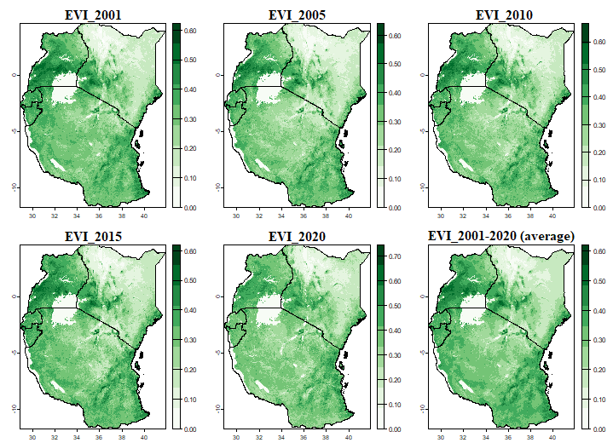
Fig. SI1 Spatial and temporal distribution of the enhanced vegetation index
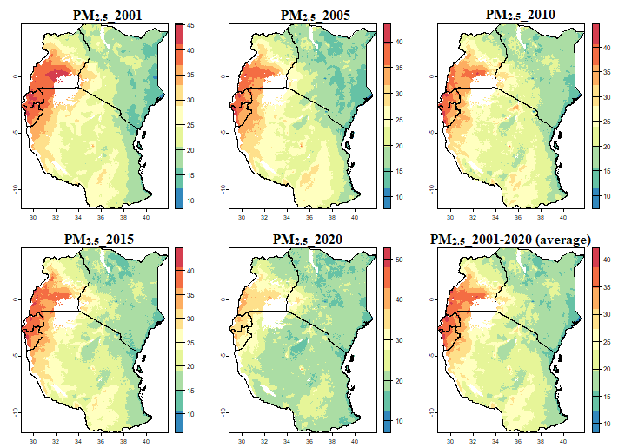
Fig. SI2 Spatial and temporal distribution of PM_{2.5}
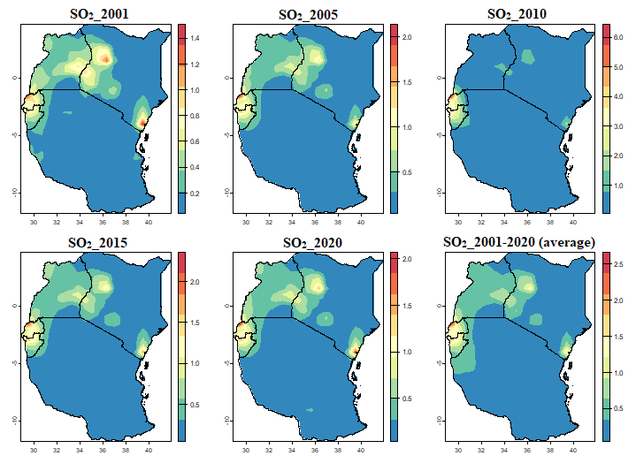
Fig. SI3 Spatial and temporal distribution of SO₂
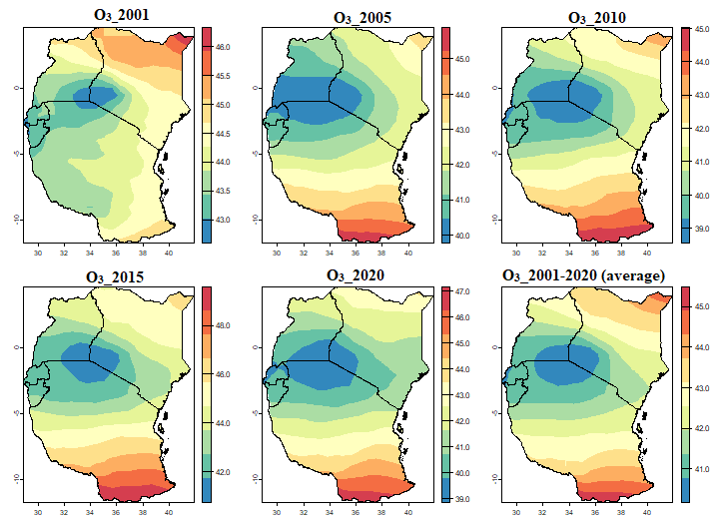
Fig. SI4 Spatial and temporal distribution of O₃
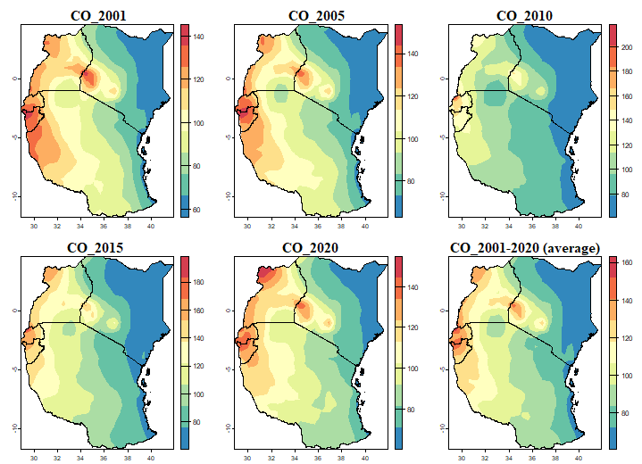
Fig. SI5 Spatial and temporal distribution of the CO

