Acc | Fruit length (cm) | Fruit breadth  (cm) | Fruit weight  (g) | Peel weight (g) | Pulp % | T.S.S  (°Brix) | Total sugar* | Reducing sugar* | Non-Redu¹  sugar* | Acidity* | Ascorbic acid*
ACC-1 | 3.45bac | 1.91bdac | 17.30cbd | 4.64ced | 63.91 | 12.00ba | 6.58b | 4.35ikj | 2.12bcd | 0.85de | 44.06ba
ACC-2 | 3.33bac | 1.88bdc | 17.09cebd | 5.76cebd | 57.58 | 13.10a | 4.84i | 4.81ifheg | 0.12ji | 0.85de | 57.80a
ACC-3 | 2.81c | 1.65dc | 22.95a | 9.03a | 54.12 | 11.60ba | 5.49fe | 4.03k | 1.38fe | 0.85de | 43.45bc
ACC-4 | 3.15bac | 1.89bdc | 13.66ef | 5.55cebd | 57.21 | 12.15ba | 6.11c | 4.39ikhj | 1.64ed | 1.15bac | 23.18d
ACC-5 | 3.11bc | 2.14bdac | 18.62b | 6.66b | 56.11 | 12.30a | 6.66b | 4.6550ifhjg | 1.90cd | 1.03bdac | 41.65bc
ACC-6 | 3.23bac | 2.24bdac | 16.80cedb | 6.51cb | 50.43 | 11.65ba | 5.32fg | 4.91feg | 0.39hgi | 0.80de | 54.37ba
ACC-7 | 3.24bac | 2.30bdac | 17.41cbd | 5.60cebd | 59.83 | 11.60ba | 5.50fe | 4.87fheg | 0.59hg | 0.78de | 45.31bac
ACC-8 | 3.06bc | 2.12bdac | 12.25f | 4.04e | 55.12 | 11.10ba | 5.56e | 4.33ikj | 1.17fe | 0.78de | 40.13bc
ACC-9 | 3.80a | 2.29bdac | 17.46cbd | 5.46cebd | 60.12 | 11.20ba | 5.29fg | 5.48cbd | 0.18hgi | 0.93dec | 47.27bac
ACC-10 | 2.99bc | 2.18bdac | 17.46cefd | 5.55cebd | 51.54 | 11.60ba | 6.20c | 4.45ikhjg | 1.66ed | 0.98dec | 37.99c
ACC-11 | 3.04bc | 1.89bdc | 17.95cb | 6.38cb | 56.00 | 12.50a | 6.64b | 5.95b | 0.65hg | 1.00bdc | 36.40dc
ACC-12 | 3.10bc | 2.10bdac | 17.59cbd | 6.65b | 53.72 | 9.00b | 5.82d | 4.74ifheg | 1.03fg | 1.25ba | 45.44bac
ACC-13 | 3.35bac | 2.22bdac | 17.45cbd | 5.39cebd | 60.58 | 11.95ba | 7.22a | 4.15k | 2.91a | 0.85de | 36.09dc
ACC-14 | 3.50ba | 2.68bac | 17.99cb | 7.02b | 53.86 | 12.00ba | 5.02hi | 6.45a | 1.37fe | 1.25ba | 37.21dc
ACC-15 | 2.99bc | 1.39d | 17.00cebd | 5.78cebd | 57.22 | 12.70a | 5.81d | 5.65bc | 0.16hgi | 0.85de | 40.31bc
ACC-16 | 3.08bc | 1.97bdac | 16.42cebd | 6.25cbd | 52.62 | 12.00ba | 5.17hg | 5.25ced | 0.08j | 0.73de | 48.44bac
ACC-17 | 3.13bc | 1.78bdc | 14.30efd | 5.78cebd | 49.82 | 12.15ba | 4.95i | 5.61bc | 0.63hg | 1.28a | 44.47bac
ACC-18 | 3.11bc | 2.61bac | 17.22cebd | 4.35ed | 65.33 | 12.75a | 6.14c | 5.08fed | 1.00fg | 1.03bdac | 41.55bc
ACC-19 | 3.12bc | 2.81ba | 17.33cbd | 6.55cb | 53.29 | 11.90ba | 6.48b | 4.19kj | 2.18bc | 0.88de | 35.34dc
ACC-20 | 3.25bac | 3.04a | 16.87cebd | 5.26cebd | 60.10 | 12.05ba | 6.62b | 3.99k | 2.50ba | 0.95dec | 38.83c
MSD | 0.65 | 1.13 | 3.64 | 1.97 | 15.86 | 3.21 | 0.21 | 0.50 | 0.51 | 0.26 | 14.34
Means in each column with the same letter are not significantly different at P ≤ 0.05
*(mg/100g pulp)
MSD= Minimum Significance Difference [Tukey’s HSD (P≤ 0.05)]
- Non reducing Sugar

Some relevant pictures:

Burmese grape plant | Phyllotaxy of leaves
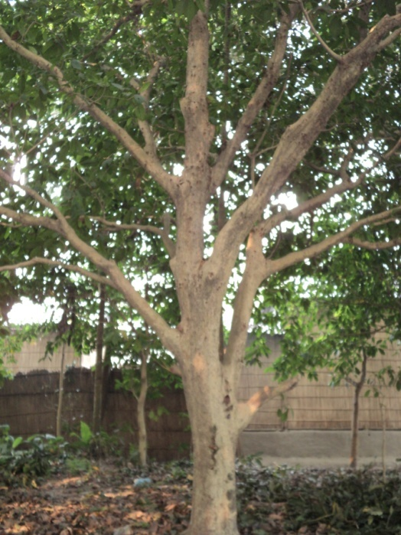 | 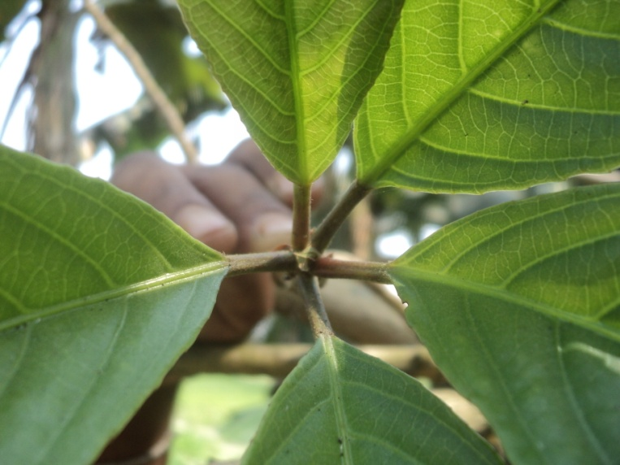
Cauliflory bearing habit (female flower) | Male Flower
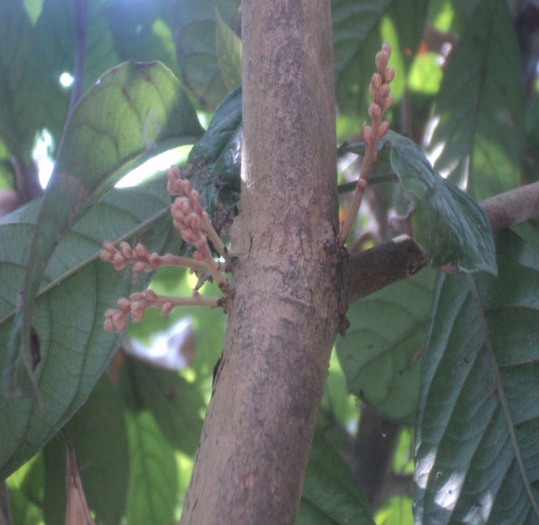 | 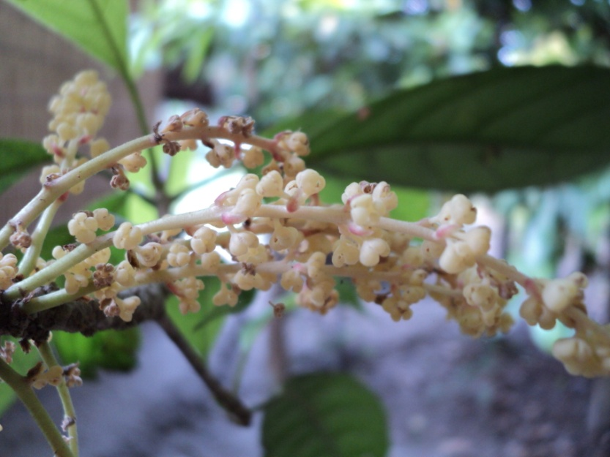

Stages of Flower bud differentiation (female)
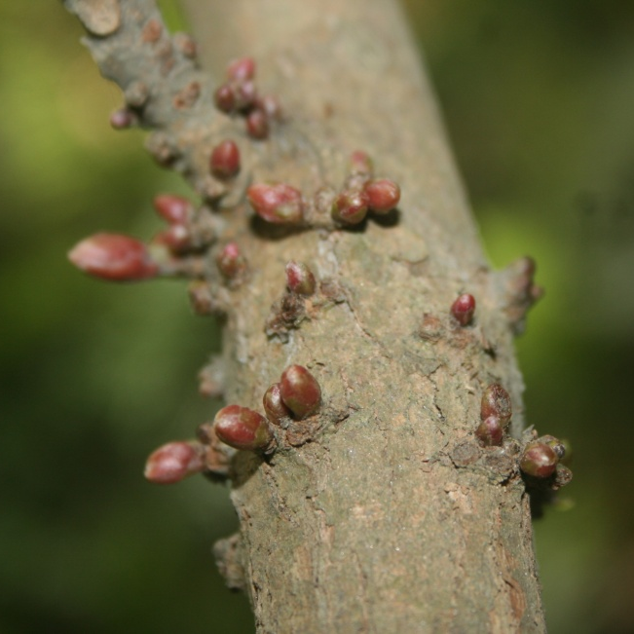 | 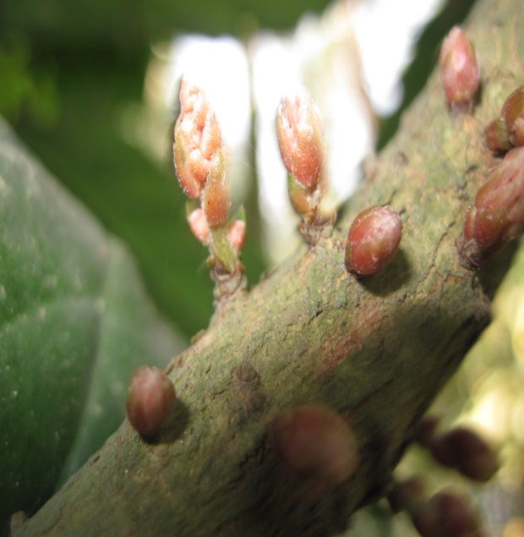
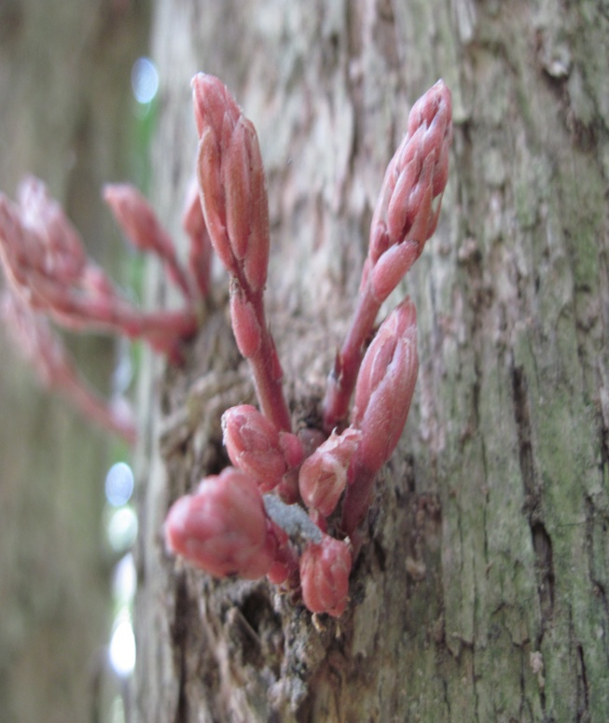 | 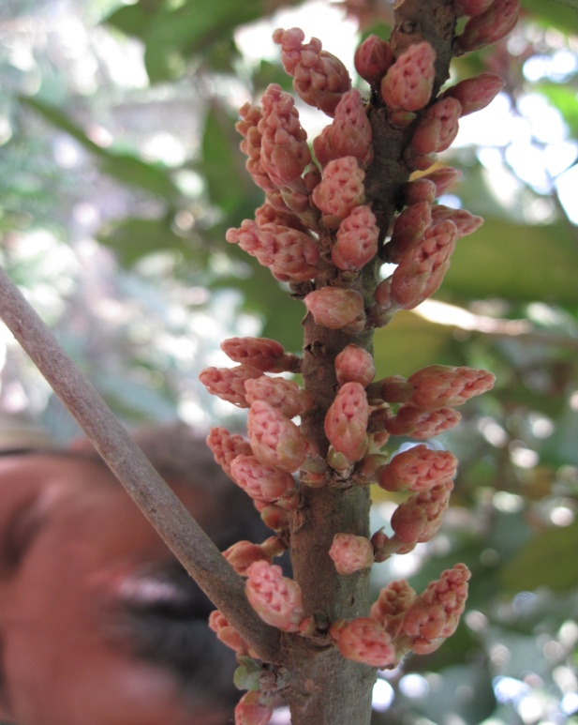

Immature fruits | Mature fruits
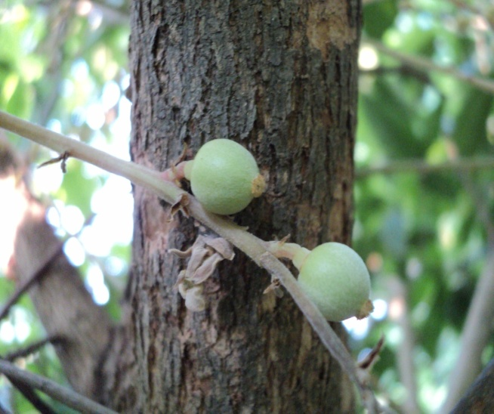 | 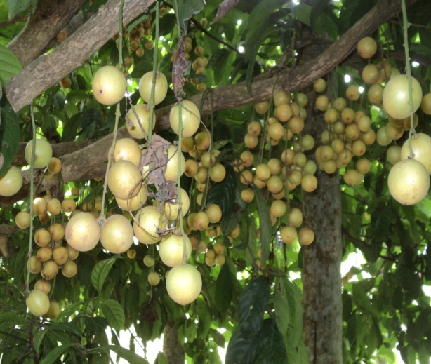
Immature pulp | Mature Pulp
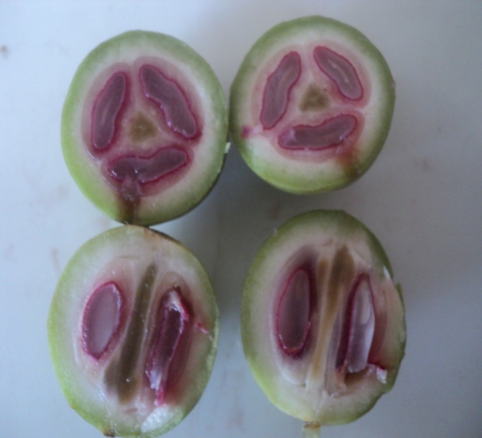 | 