sup Table 1 Rice varieties used in each phenotyping of ST assay.
Haplotype | Rice varieties | rSFW |  | DLR |  | corresponding Fig.
Haplotype | Rice varieties | average | Standard Deviation | average | Standard Deviation | corresponding Fig.
Hap4 | WAS 173-B-B-6-2-2 | 0.361 | 0.102 | none detected |  | Fig. 2C
Hap4 | E 2024 | 0.246 | 0.04 |  |  | Fig. 2C
Hap4 | Bg90-2 | 0.276 | 0.03 |  |  | Fig. 2C
Hap4 | IR36 | 0.317 | 0.084 |  |  | Fig. 2C
Hap4 | Guanghui880 | 0.345 | 0.046 |  |  | Fig. 2C
Hap4 | Yihui3551 | 0.326 | 0.098 |  |  | Fig. 2C
Hap1 | Molizhanxuan | 0.366 | 0.108 |  |  | Fig. 2C
Hap1 | Jiangnongzao1B | 0.536 | 0.12 |  |  | Fig. 2C
Hap1 | Yangdao4 | 0.323 | 0.061 |  |  | Fig. 2C
Hap1 | Wen229 | 0.363 | 0.068 |  |  | Fig. 2C
Hap1 | 88B | 0.379 | 0.071 |  |  | Fig. 2C
Hap1 | Jiangxishangraozixiangmi | 0.328 | 0.101 |  |  | Fig. 2C
Hap2 | Shanhui8281 | 0.36 | 0.101 |  |  | Fig. 2C
Hap2 | Shuhui202 | 0.49 | 0.114 |  |  | Fig. 2C
Hap2 | Jinhui18 | 0.563 | 0.087 |  |  | Fig. 2C
Hap2 | Huarun2 | 0.466 | 0.092 |  |  | Fig. 2C
Hap2 | IR 28 | 0.493 | 0.116 |  |  | Fig. 2C
Hap2 | Hongxiang2 | 0.337 | 0.079 |  |  | Fig. 2C
Hap3 | Chenghui448 | 0.625 | 0.065 |  |  | Fig. 2C
Hap3 | Minghui63 | 0.346 | 0.122 |  |  | Fig. 2C
Hap3 | EX FOILAEIN(NAPUTO) | 0.487 | 0.058 |  |  | Fig. 2C
Hap3 | Mianhui734 | 0.504 | 0.094 |  |  | Fig. 2C
Hap3 | Hua-2 | 0.366 | 0.111 |  |  | Fig. 2C
Hap3 | Chenghui178 | 0.406 | 0.174 |  |  | Fig. 2C
Hap5 | B 6144-MR-6-0-0 | 0.226 | 0.087 |  |  | Fig. 2C
Hap5 | R106 | 0.488 | 0.08 |  |  | Fig. 2C
Hap5 | C71 | 0.339 | 0.062 |  |  | Fig. 2C
Hap5 | Minghui86 | 0.478 | 0.21 |  |  | Fig. 2C
Hap5 | Menjiagao2 | 0.445 | 0.121 |  |  | Fig. 2C
Hap5 | DANGAR | 0.361 | 0.13 |  |  | Fig. 2C
Hap6 | ARC 10100 | 0.365 | 0.443 |  |  | Fig. 2C
Hap6 | Govind | 0.375 | 0.088 |  |  | Fig. 2C
Hap6 | IR66897B | 0.26 | 0.145 |  |  | Fig. 2C
Hap6 | PERUBAK LUEY | 0.322 | 0.082 |  |  | Fig. 2C
Hap6 | Xianghui91269 | 0.329 | 0.066 |  |  | Fig. 2C
Hap6 | IR68897B | 0.297 | 0.012 |  |  | Fig. 2C
Hap3 | Chenghui448 | 0.271 | 0.088 | 0.597 | 0.246 | Fig. 2E: rSFW  Fig. 2F: DLR
Hap3 | EX FOILAEIN(NAPUTO) | 0.367 | 0.157 | 0.502 | 0.259 | Fig. 2E: rSFW  Fig. 2F: DLR
Hap3 | Mianhui734 | 0.33 | 0.089 | 0.612 | 0.254 | Fig. 2E: rSFW  Fig. 2F: DLR
Hap3 | Hua-2 | 0.146 | 0.009 | 1 | 0 | Fig. 2E: rSFW  Fig. 2F: DLR
Hap3 | Shanhui287 | 0.211 | 0.119 | 0.799 | 0.266 | Fig. 2E: rSFW  Fig. 2F: DLR
Hap3 | Huhui602 | 0.206 | 0.098 | 0.868 | 0.162 | Fig. 2E: rSFW  Fig. 2F: DLR
Hap2 | Shanhui8281 | 0.22 | 0.06 | 0.859 | 0.163 | Fig. 2E: rSFW  Fig. 2F: DLR
Hap2 | Shuhui202 | 0.164 | 0.044 | 0.859 | 0.163 | Fig. 2E: rSFW  Fig. 2F: DLR
Hap2 | Jinhui18 | 0.103 | 0.009 | 1 | 0 | Fig. 2E: rSFW  Fig. 2F: DLR
Hap2 | Ehui108 | 0.179 | 0.065 | 1 | 0 | Fig. 2E: rSFW  Fig. 2F: DLR
Hap2 | IR 28 | 0.286 | 0.068 | 0.835 | 0.165 | Fig. 2E: rSFW  Fig. 2F: DLR
Hap2 | Hongxiang2 | 0.167 | 0.097 | 0.811 | 0.163 | Fig. 2E: rSFW  Fig. 2F: DLR
Hap3 | Chenghui448 | 0.691 | 0.188 | none detected |  | Fig. 3B
Hap3 | Minghui63 | 0.461 | 0.232 |  |  | Fig. 3B
Hap3 | EX FOILAEIN(NAPUTO) | 0.462 | 0.086 |  |  | Fig. 3B
Hap3 | Mianhui734 | 0.629 | 0.165 |  |  | Fig. 3B
Hap3 | Hua-2 | 0.346 | 0.158 |  |  | Fig. 3B
Hap3 | Chenghui178 | 0.465 | 0.137 |  |  | Fig. 3B
Hap9 | LALSAITA | 0.403 | 0.155 |  |  | Fig. 3B
Hap9 | LUBUK LINGGAU | 0.386 | 0.149 |  |  | Fig. 3B
Hap9 | Niboerhuangdao | 0.398 | 0.128 |  |  | Fig. 3B
Hap9 | KAMULI | 0.296 | 0.079 |  |  | Fig. 3B
Hap9 | TAIPEI 167 | 0.359 | 0.153 |  |  | Fig. 3B
Hap2 | Jinhui275 | 0.367 | 0.098 |  |  | Fig. 4B
Hap2 | Jinhui18 | 0.571 | 0.082 |  |  | Fig. 4B
Hap2 | Ehui108 | 0.501 | 0.151 |  |  | Fig. 4B
Hap2 | IR 28 | 0.675 | 0.198 |  |  | Fig. 4B
Hap15 | BA SHI ZAO | 0.387 | 0.014 |  |  | Fig. 4B
Hap15 | Nanjing11 | 0.313 | 0.032 |  |  | Fig. 4B
Hap15 | HSIEH-DAU | 0.307 | 0.116 |  |  | Fig. 4B
Hap15 | Liuyezhan | 0.117 | 0.017 |  |  | Fig. 4B
Hap1 | Chengduai3 | 0.385 | 0.008 |  |  | Fig. 4D
Hap1 | R8006(Zhonghui8006) | 0.475 | 0.095 |  |  | Fig. 4D
Hap1 | IR6 | 0.607 | 0.169 |  |  | Fig. 4D
Hap1 | 88B | 0.381 | 0.118 |  |  | Fig. 4D
Hap8 | Malaihong | 0.386 | 0.059 |  |  | Fig. 4D
Hap8 | Hongwan1 | 0.427 | 0.081 |  |  | Fig. 4D
Hap8 | NAN-ERH-AI 5 | 0.371 | 0.066 |  |  | Fig. 4D
Hap8 | Qingnongai | 0.226 | 0.05 |  |  | Fig. 4D
Hap9 | LALSAITA | 0.56 | 0.061 |  |  | Fig. 4F
Hap9 | KAMULI | 0.204 | 0.036 |  |  | Fig. 4F
Hap9 | TAIPEI 167 | 0.207 | 0.092 |  |  | Fig. 4F
Hap9 | 71011 | 0.354 | / |  |  | Fig. 4F
Hap9 | LUBUK LINGGAU | 0.444 | 0.137 |  |  | Fig. 4F
Hap10 | BEGMI 135 | 0.357 | 0.072 |  |  | Fig. 4F
Hap10 | AUS 449 | / | / |  |  | Fig. 4F
Hap10 | KURULU WEE(WHITE) | 0.135 | 0.029 |  |  | Fig. 4F
Hap10 | BATHURI | 0.223 | 0.056 |  |  | Fig. 4F
Hap12 | GLADIO | 0.288 | 0.134 | 0.834 | 0.236 | Fig. 4H: rSFW  sup Fig. 2: DLR
Hap12 | CALIFORNIA BELLE | 0.121 | 0.036 | 0.959 | 0.109 | Fig. 4H: rSFW  sup Fig. 2: DLR
Hap12 | Huhan3 | 0.191 | 0.075 | 1 | 0 | Fig. 4H: rSFW  sup Fig. 2: DLR
Hap11 | Huajingxian74 | 0.245 | 0.062 | 0.862 | 0.202 | Fig. 4H: rSFW  sup Fig. 2: DLR
Hap11 | GZ 1368-5-4 | 0.294 | 0.183 | 0.646 | 0.412 | Fig. 4H: rSFW  sup Fig. 2: DLR
Hap11 | RP 1570-44-1 | 0.301 | 0.155 | 0.666 | 0.29 | Fig. 4H: rSFW  sup Fig. 2: DLR
Hap2 | Jinhui18 | 0.682 | 0.153 | none detected |  | Fig. 5B
Hap2 | Ehui108 | 0.479 | 0.2 |  |  | Fig. 5B
Hap2 | IR28 | 0.394 | 0.257 |  |  | Fig. 5B
Hap18 | IR 80310-12-B-1-3-B | 0.37 | 0.166 |  |  | Fig. 5B
Hap18 | NSIC RC9 (APO) | 0.419 | 0.212 |  |  | Fig. 5B
Hap18 | BOUAKE 189 | 0.343 | 0.139 |  |  | Fig. 5B
Hap1 | R8006(zhonghui8006) | 0.448 | 0.085 |  |  | Fig. 5D
Hap1 | yangdao4 | 0.386 | 0.128 |  |  | Fig. 5D
Hap1 | At354 | 0.551 | 0.117 |  |  | Fig. 5D
Hap21 | DANAU LAUT TAWAR | 0.341 | 0.1 |  |  | Fig. 5D
Hap21 | C418 | 0.345 | 0.075 |  |  | Fig. 5D
Hap21 | FACAGRO 406 | 0.347 | 0.132 |  |  | Fig. 5D
Hap4 | IRGA 959-1-2-2F-4-1-4A-6-CA-6X | 0.319 | 0.075 |  |  | Fig. 5F
Hap4 | IR 56 | 0.42 | 0.112 |  |  | Fig. 5F
Hap4 | IR 21015-72-3-3-3-1 | 0.284 | 0.079 |  |  | Fig. 5F
Hap17 | Chorofa | 0.431 | 0.133 |  |  | Fig. 5F
Hap17 | IR 57514-PMI 5-B-1-2 | 0.347 | 0.115 |  |  | Fig. 5F
Hap17 | DYheidao | 0.173 | 0.054 |  |  | Fig. 5F

Sup table. 2 Primers used for qRT-PCR in the study.
Primer | Sequence (5' to 3') | Application
OsWRKY53 Forward | TCCTCAGCTCCTCCCATATCTTG | Quantitative  real time PCR
OsWRKY53 Reverse | TGCTGAGAAGCGATGAGATCGG | Quantitative  real time PCR
SKC1 Forward | TGCTCTACGTGGTGATGATGTACC | Quantitative  real time PCR
SKC1 Reverse | CTCCCGTTTGCTGGTGTTTGTC | Quantitative  real time PCR
OsACTIN-F | TGCTATGTACGTCGCCATCCAG | Quantitative  real time PCR
OsACTIN-R | AATGAGTAACCACGCTCCGTCA | Quantitative  real time PCR

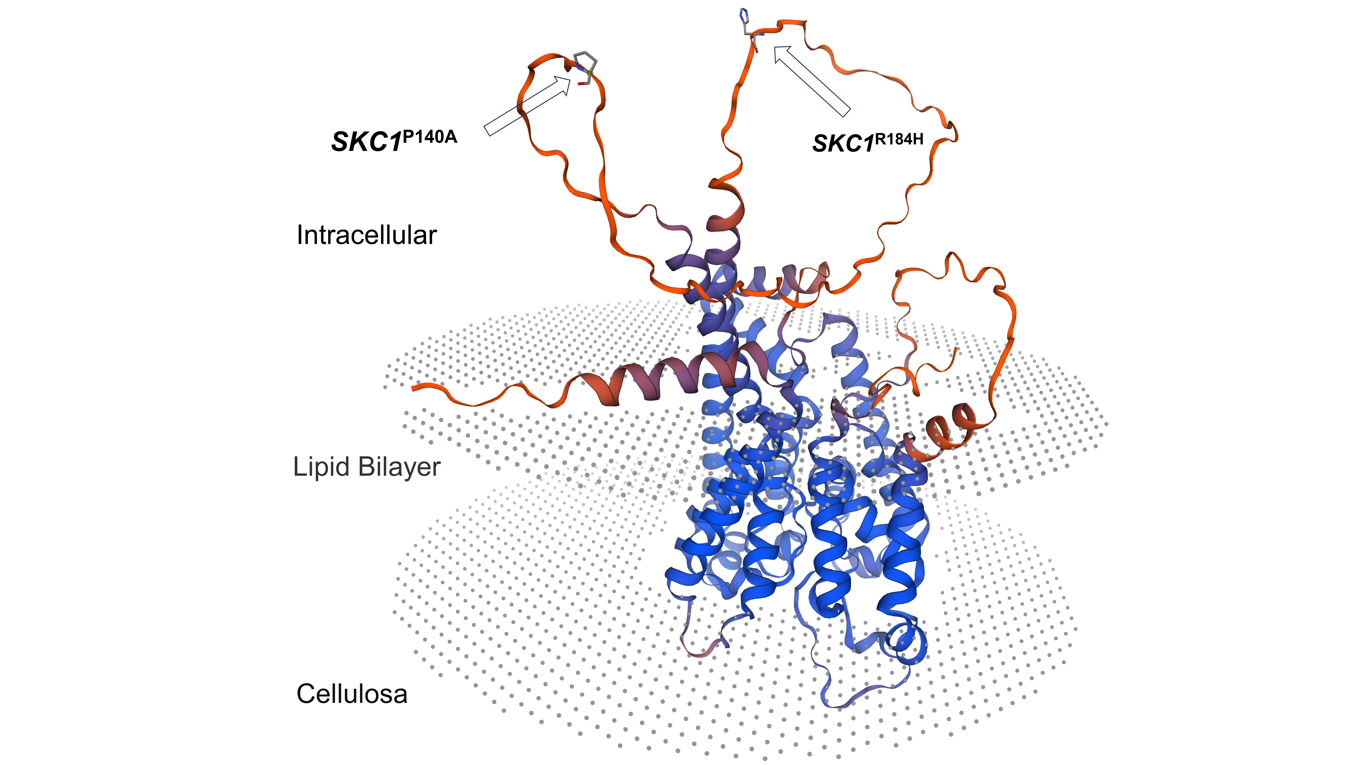
sup Fig. 1 Predicated structure of SKC1 showed on SWISS-MODEL (expasy.org). SKC1^{P140A} and SKC1R^{184H} located in a cytoplasm-exposed loop are marked in the figure.

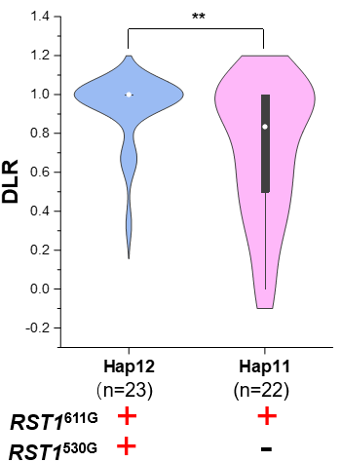
Sup Fig. 2 Comparison of DLR between Hap12 and Hap11. n represented the number of plants in an assay used for each haplotype. +/- indicates carried the specific ST-related SNPs or not. Independent samples t-test was used to analyze significant differences. ** p<0.01

