Appendix Table S1. Robustness checks.
 | (1) | (2)
 | lnr_agbc | lnr_wnpp
lnur_pop in 2006 | 0.0374*** | 0.0277***
 | (0.0095) | (0.0094)
lnur_pop in 2007 | 0.0309*** | 0.0279***
 | (0.0085) | (0.0099)
lnur_pop in 2008 | 0.0245*** | 0.0004
 | (0.0076) | (0.0084)
lnur_pop in 2009 | 0.0129 | 0.0186**
 | (0.0094) | (0.0080)
lnur_pop in 2010 | 0.0114* | 0.0047
 | (0.0059) | (0.0083)
lnur_pop in 2011 | 0.0019 | 0.0023
 | (0.0040) | (0.0090)
lnur_pop in 2012 | 0.0000 | 0.0000
 | (.) | (.)
lnur_pop in 2013 | 0.0010 | 0.0183**
 | (0.0053) | (0.0074)
lnur_pop in 2014 | -0.0055 | 0.0181*
 | (0.0067) | (0.0097)
lnur_pop in 2015 | 0.0013 | -0.0071
 | (0.0064) | (0.0084)
lnur_pop in 2016 | 0.0007 | 0.0001
 | (0.0061) | (0.0082)
lnur_pop in 2017 | -0.0022 | 0.0172*
 | (0.0060) | (0.0102)
lnur_pop in 2018 | 0.0041 | 0.0002
 | (0.0107) | (0.0085)
City-level time trend | Yes | Yes
Control variables | Yes | Yes
Individual FE | Yes | Yes
Year FE | Yes | Yes
R² | 0.0703 | 0.3083
N | 14595 | 10097
Notes: (a) ***, **, and * denote significance at the 1%, 5%, and 1% levels, respectively; (b) values in parentheses denotes clustered robust standard errors (at the city level); and (c) r_wnpp denotes rural woody vegetation’s net primary productivity.

Appendix Table S2. The impacts of urban-rural population density gap on rural aboveground biomass carbon density under different levels of urban population overflows and urban land expansion.
 | (1) | (2) | (3) | (4) | (5) | (6)
 | lnr_agbc | lnr_agbc | lnr_agbc | lnr_agbc | lnr_agbc | lnr_agbc
 | High quartile of population at the urban-rural border | Low quartile of population at the urban-rural border | High quartile of human footprint index at the urban-rural border | Low quartile of human footprint index at the urban-rural border | Built-up area expansion | Built-up area remains unchanged
lnur_pop | -0.0082 | 0.0237* | -0.0063 | 0.0072* | -0.0010 | 0.0098**
 | (0.0059) | (0.0123) | (0.0074) | (0.0040) | (0.0054) | (0.0044)
Control variables | Yes | Yes | Yes | Yes | Yes | Yes
Individual FE | Yes | Yes | Yes | Yes | Yes | Yes
Year FE | Yes | Yes | Yes | Yes | Yes | Yes
R² | 0.0464 | -0.0018 | 0.0497 | 0.0068 | 0.0218 | 0.0144
N | 6113 | 2924 | 3917 | 3183 | 8872 | 5701
Notes: (a) ***, **, and * denote significance at the 1%, 5%, and 1% levels, respectively; and (b) values in parentheses denotes clustered robust standard errors (at the city level).

Appendix Table S3. Panel threshold estimation results.
Threshold variable | Explanatory variable | Range of threshold estimator (level = 95) | Threshold  values | Coefficients | 95% confidence interval
lnrnpoparea | lnur_pop | 13.21 | γ <13.39 | 0.02*** | (+0.0085, +0.033 )
lnrnpoparea | lnur_pop | 13.40 | 13.39< γ | 0.005 | (-0.011, +0.0218)
Notes: (a) ***, **, and * denote significance at the 1%, 5%, and 1% levels, respectively; (b) values in parentheses denote robust standard errors; and (c) the threshold value is estimated based on the logarithmic rural population density.

Appendix Table S4. Discussions on the channels of the proportion of non-woody lands (lnnwood) and its further classifications in the previous period, such as Woody Savannas (lnwsav), Savannas (lnsav), Grasslands (lngrass), Permanent Wetlands (lnpw) and Cropland (lncrop) densities.
 | (1) | (2) | (3) | (4) | (5) | (6) | (7)
 | lnr_agbc | lncrop | lnr_agbc | lnr_agbc | lnr_agbc | lnr_agbc | lnr_agbc
lnur_pop×lncrop in 2006 | 0.0049*
 | (0.0027)
lnur_pop×lnnwood in 2006 |  |  | 0.0228***
lnur_pop×lnwsav in 2006 |  |  |  | 0.0010
 |  |  |  | (0.0034)
lnur_pop×lnsav in 2006 |  |  |  |  | -0.0004
 |  |  |  |  | (0.0014)
lnur_pop×lngrass in 2006 |  |  |  |  |  | -0.0045
 |  |  |  |  |  | (0.0032)
lnur_pop×lnpw in 2006 |  |  |  |  |  |  | 0.0160**
 |  |  |  |  |  |  | (0.0075)
lnur_pop in 2006 |  | -0.0036
 |  | (0.0070)
lnur_pop in 2007 |  | -0.0077**
 |  | (0.0030)
lnur_pop in 2008 |  | -0.0086
 |  | (0.0054)
lnur_pop in 2009 |  | 0.0000
 |  | (.)
lnur_pop in 2010 |  | 0.0000
 |  | (.)
lnur_pop in 2011 |  | 0.0000
 |  | (.)
lnur_pop in 2012 |  | 0.0000
 |  | (.)
lnur_pop in 2013 |  | 0.0000
 |  | (.)
lnur_pop in 2014 |  | 0.0000
 |  | (.)
lnur_pop in 2015 |  | 0.0000
 |  | (.)
lnur_pop in 2016 |  | 0.0000
 |  | (.)
lnur_pop in 2017 |  | 0.0000
 |  | (.)
lnur_pop in 2018 |  | 0.0000
 |  | (.)
Control variables | Yes | Yes | Yes | Yes | Yes | Yes | Yes
Individual FE | Yes | Yes | Yes | Yes | Yes | Yes | Yes
Year FE | Yes | Yes | Yes | Yes | Yes | Yes | Yes
R² | 0.0318 | 0.0457 | 0.0279 | 0.0158 | 0.0244 | 0.0539 | 0.0449
N | 3562 | 3690 | 14595 | 2031 | 14595 | 5874 | 7412
Notes: (a) ***, **, and * denote significance at the 1%, 5%, and 1% levels, respectively; (b) values in parentheses denotes clustered robust standard errors (at the city level); and (c) all the secondary and three interaction terms of lnur_pop, year dummy variable and lnwsav (lnsav, lngrass, lnpw or lncrop) were also controlled.

Appendix Table S5. The relationship between rural-urban migration (lnur_pop) and rural aboveground biomass carbon density (lnr_agbc) under different levels of urban-rural ecological inequality (lnuregap).
 | (1) | (2)
 | lnr_agbc | lnuregap
lnur_pop×lnuregap in 2006 | 0.0066***
 | (0.0021)
lnur_pop in 2006 |  | 0.0783*
 |  | (0.0401)
lnur_pop in 2007 |  | 0.0289
 |  | (0.0200)
lnur_pop in 2008 |  | -0.0141
 |  | (0.0190)
lnur_pop in 2009 |  | -0.0149
 |  | (0.0207)
lnur_pop in 2010 |  | -0.1281***
 |  | (0.0419)
lnur_pop in 2011 |  | -0.1652***
 |  | (0.0589)
lnur_pop in 2012 |  | -0.1428***
 |  | (0.0477)
lnur_pop in 2013 |  | -0.0936*
 |  | (0.0499)
lnur_pop in 2014 |  | -0.1916***
 |  | (0.0471)
lnur_pop in 2015 |  | -0.2091***
 |  | (0.0485)
lnur_pop in 2016 |  | -0.1991***
 |  | (0.0471)
lnur_pop in 2017 |  | -0.2005***
 |  | (0.0498)
lnur_pop in 2018 |  | -0.0946**
 |  | (0.0450)
Control variables | Yes | Yes
Individual FE | Yes | Yes
Year FE | Yes | Yes
R² | 0.0280 | 0.2934
N | 14377 | 14927
Notes: (a) ***, **, and * denote significance at the 1%, 5%, and 1% levels, respectively; (b) values in parentheses denotes clustered robust standard errors (at the city level); and (c) all the secondary and three interaction terms of lnur_pop, year dummy variable and lnuregap were also controlled.

Appendix Table S6. Discussions on the effects of lnur_pop on lnr_agbc and lnrn_peaknpp (the value of net primary productivity of growth center in rural areas) from the channels of distance between rural forest growth center and urban economic center (i.e., one-year-old trees growth center, lnD_tree1; two-to-three-year-old trees, lnD_tree2; first-order difference of lnD_tree1, FD_ lnD_tree1; second-order difference of lnD_tree1, FD_ lnD_tree2).
 | (1) | (2) | (3) | (4) | (5)
 | lnr_agbc | lnr_agbc | lnr_agbc | lnrn_peaknpp | lnrn_peaknpp
 |  |  | Low quartile of lnD_tree1 & lnD_tree2 | FD_ lnD_tree1<0& FD_ lnD_tree2<0 | FD_ lnD_tree1<0& FD_ lnD_tree2>0
lnur_pop×lnD_oshr in 2006
lnur_pop×lnD_wsav in 2006
lnur_pop×lnD_sav in 2006
lnur_pop×lnD_grass in 2006
lnur_pop×lnD_pw in 2006
lnur_pop×lnD_tree1 in 2006 | -0.0089***
 | (0.0025)
lnur_pop×lnD_tree2 in 2006 |  | -0.0225***
 |  | (0.0043)
lnur_pop |  |  | 0.0513784***
 |  |  | (0.016)
lnur_pop in 2006 |  |  |  | 0.0333** | 0.0289
 |  |  |  | (0.0149) | (0.0241)
lnur_pop in 2007 |  |  |  | 0.0000 | -0.0390
 |  |  |  | (.) | (0.0240)
lnur_pop in 2008 |  |  |  | -0.0332** | -0.0755**
 |  |  |  | (0.0131) | (0.0311)
lnur_pop in 2009 |  |  |  | -0.0199 | -0.0498*
 |  |  |  | (0.0131) | (0.0287)
lnur_pop in 2010 |  |  |  | -0.0360*** | -0.0345
 |  |  |  | (0.0134) | (0.0258)
lnur_pop in 2011 |  |  |  | 0.0000 | 0.0000
 |  |  |  | (.) | (.)
lnur_pop in 2012 |  |  |  | -0.0234 | -0.0169
 |  |  |  | (0.0151) | (0.0277)
lnur_pop in 2013 |  |  |  | -0.0375*** | -0.0669***
 |  |  |  | (0.0136) | (0.0239)
lnur_pop in 2014 |  |  |  | -0.0157 | -0.0452*
 |  |  |  | (0.0127) | (0.0249)
lnur_pop in 2015 |  |  |  | -0.0272* | -0.0449
 |  |  |  | (0.0140) | (0.0297)
lnur_pop in 2016 |  |  |  | -0.0214 | -0.0545**
 |  |  |  | (0.0132) | (0.0266)
lnur_pop in 2017 |  |  |  | -0.0257* | -0.0322
 |  |  |  | (0.0137) | (0.0232)
lnur_pop in 2018 |  |  |  | -0.0148 | -0.0330
 |  |  |  | (0.0147) | (0.0242)
lnur_pop in 2006 |  |  |  | 0.0333** | 0.0289
 |  |  |  | (0.0149) | (0.0241)
lnur_pop in 2007 |  |  |  | 0.0000 | -0.0390
 |  |  |  | (.) | (0.0240)
lnur_pop in 2008 |  |  |  | -0.0332** | -0.0755**
 |  |  |  | (0.0131) | (0.0311)
lnur_pop in 2009 |  |  |  | -0.0199 | -0.0498*
 |  |  |  | (0.0131) | (0.0287)
lnur_pop in 2010 |  |  |  | -0.0360*** | -0.0345
 |  |  |  | (0.0134) | (0.0258)
lnur_pop in 2011 |  |  |  | 0.0000 | 0.0000
 |  |  |  | (.) | (.)
Control variables | Yes | Yes | Yes
Individual FE | Yes | Yes | Yes
Year FE | Yes | Yes | Yes
R² | 0.0282 | 0.032 | 0.0935
N | 10226 | 11205 | 4637
Notes: (a) ***, **, and * denote significance at the 1%, 5%, and 1% levels, respectively; (b) values in parentheses denotes clustered robust standard errors (at the city level); and (c) all the secondary and three interaction terms of lnur_pop, year dummy variable and lnD_oshr (lnD_wsav, lnD_sav, lnD_grass, lnD_pw, lnD_tree1 or lnD_tree2) were also controlled.

Appendix Table S7. Discussions on the channels of rural terrestrial vegetation growth center and urban economic center (overall vegetation, lnD_o; Evergreen Needleleaf Forests, lnD_enf; Evergreen Broadleaf Forests, lnD_ebf; Deciduous Needleleaf Forests, lnD_dnf; Deciduous Broadleaf Forests, lnD_dbf; Mixed Forests, lnD_mf; Closed Shrublands, lnD_csh) .
 | (1) | (2) | (3) | (4) | (5) | (6) | (7)
 | lnr_agbc | lnr_agbc | lnr_agbc | lnr_agbc | lnr_agbc | lnr_agbc | lnr_agbc
lnur_pop×lnD_o in 2006 | -0.0027
 | (0.0025)
lnur_pop×lnD_enf in 2006 |  | -0.0028
 |  | (0.0050)
lnur_pop×lnD_ebf in 2006 |  |  | -0.0053
 |  |  | (0.0055)
lnur_pop×lnD_dnf in 2006 |  |  |  | -0.0431
 |  |  |  | (0.0402)
lnur_pop×lnD_dbf in 2006 |  |  |  |  | -0.0108
 |  |  |  |  | (0.0194)
lnur_pop×lnD_mf in 2006 |  |  |  |  |  | -0.0097
 |  |  |  |  |  | (0.0066)
lnur_pop×lnD_csh in 2006 |  |  |  |  |  |  | -0.0241
 |  |  |  |  |  |  | (0.0179)
Control variables | Yes | Yes | Yes | Yes | Yes | Yes | Yes
Individual FE | Yes | Yes | Yes | Yes | Yes | Yes | Yes
Year FE | Yes | Yes | Yes | Yes | Yes | Yes | Yes
R² | 0.0227 | 0.0485 | 0.0496 | 0.5475 | 0.4972 | 0.1450 | 0.1401
N | 14077 | 3107 | 3107 | 1197 | 1197 | 1445 | 1445
Notes: (a) ***, **, and * denote significance at the 1%, 5%, and 1% levels, respectively; (b) values in parentheses denotes clustered robust standard errors (at the city level); and (c) all the secondary and three interaction terms of lnur_pop, year dummy variable and lnD_o (lnD_enf, lnD_ebf, lnD_dnf, lnD_dbf, lnD_mf, or lnD_csh) were also controlled.

Appendix Table S8. Discussions on the channels of distance between rural terrestrial vegetation growth center and urban economic center (i.e., Open Shrublands, lnD_oshr; Woody Savannas, lnD_wsav; Savannas, lnD_sav; Grasslands, lnD_grass; Permanent Wetlands).
 | (1) | (2) | (3) | (4) | (5)
 | lnr_agbc | lnr_agbc | lnr_agbc | lnr_agbc | lnr_agbc
lnur_pop×lnD_oshr in 2006 | -
 | -
lnur_pop×lnD_wsav in 2006 |  | -
 |  | -
lnur_pop×lnD_sav in 2006 |  |  | -0.0128***
 |  |  | (0.0037)
lnur_pop×lnD_grass in 2006 |  |  |  | -0.0169***
 |  |  |  | (0.0048)
lnur_pop×lnD_pw in 2006 |  |  |  |  | -0.0083
 |  |  |  |  | (0.0061)
lnur_pop
Control variables | Yes | Yes | Yes | Yes | Yes
Individual FE | Yes | Yes | Yes | Yes | Yes
Year FE | Yes | Yes | Yes | Yes | Yes
R² | - | - | 0.0367 | 0.0311 | 0.0557
N | insufficient observations | insufficient observations | 9283 | 9285 | 5313
Notes: (a) ***, **, and * denote significance at the 1%, 5%, and 1% levels, respectively; (b) values in parentheses denotes clustered robust standard errors (at the city level); and (c) all the secondary and three interaction terms of lnur_pop, year dummy variable and lnD_oshr (lnD_wsav, lnD_sav, lnD_grass, lnD_pw, lnD_tree1 or lnD_tree2) were also controlled.

Appendix Table S9. Discussions on the channels of urban-rural ratio of young female (lnuryf) and male (lnurym) and ratio of female to male aged 20-70 years old in rural areas (20-30, lnr20; 30-40, lnr30; 40-50, lnr40; 50-60, lnr50; 60-70, lnr60).
 | (1) | (2) | (3) | (4) | (5) | (6) | (7)
 | lnr_agbc | lnr_agbc | lnr_agbc | lnr_agbc | lnr_agbc | lnr_agbc | lnr_agbc
lnur_pop×lnuryf in 2006 | 0.0052***
 | (0.0019)
lnur_pop×lnurym in 2006 |  | 0.0056***
 |  | (0.0019)
lnur_pop×lnr20 in 2006 |  |  | 0.0531
 |  |  | (0.0948)
lnur_pop×lnr30 in 2006 |  |  |  | -0.0226
 |  |  |  | (0.0971)
lnur_pop×lnr40 in 2006 |  |  |  |  | 0.0340
 |  |  |  |  | (0.1174)
lnur_pop×lnr50 in 2006 |  |  |  |  |  | -0.0670
 |  |  |  |  |  | (0.1068)
lnur_pop×lnr60 in 2006 |  |  |  |  |  |  | 0.1914**
 |  |  |  |  |  |  | (0.0939)
Control variables | Yes | Yes | Yes | Yes | Yes | Yes | Yes
Individual FE | Yes | Yes | Yes | Yes | Yes | Yes | Yes
Year FE | Yes | Yes | Yes | Yes | Yes | Yes | Yes
R² | 0.0227 | 0.0233 | 0.0192 | 0.0159 | 0.0197 | 0.0241 | 0.0251
N | 3384 | 3496 | 3496 | 3384 | 3496 | 3472 | 3496
Notes: (a) ***, **, and * denote significance at the 1%, 5%, and 1% levels, respectively; (b) values in parentheses denotes clustered robust standard errors (at the city level); and (c) all the secondary and three interaction terms of lnur_pop, year dummy variable and lnuryf (lnurym, lnr20, lnr30, lnr40, lnr50 or lnr60) were also controlled.

Appendix Table S10. The moderating effects of road densities (total road density, lnoroad; high way road density, lnhroad; primary road density, lnproad; secondary road density, lnsroad; tertiary road density, lntroad; local road density, lnlroad), urban nighttime light per unit area (lnntl), rural dislocation between economic center and forest center (lnrl) on the relationship between rural-urban migration (lnur_pop) and rural aboveground biomass carbon density (lnr_agbc).
 | (1) | (2) | (3) | (4) | (5) | (6) | (7) | (8)
 | lnr_agbc | lnr_agbc | lnr_agbc | lnr_agbc | lnr_agbc | lnr_agbc | lnr_agbc | lnr_agbc
lnur_pop×lnoroad in 2006 | 0.0154**
 | (0.0060)
lnur_pop×lnhroad in 2006 |  | 0.0003
 |  | (0.0075)
lnur_pop×lnproad in 2006 |  |  | 0.0165**
 |  |  | (0.0067)
lnur_pop×lnsroad in 2006 |  |  |  | 0.0113*
 |  |  |  | (0.0060)
lnur_pop×lntroad in 2006 |  |  |  |  | 0.0136**
 |  |  |  |  | (0.0057)
lnur_pop×lnlroad in 2006 |  |  |  |  |  | 0.0087*
 |  |  |  |  |  | (0.0050)
lnur_pop×lnntl in 2006 |  |  |  |  |  |  | 0.0215***
 |  |  |  |  |  |  | (0.0055)
lnur_pop×lnrl in 2006 |  |  |  |  |  |  |  | -0.0192***
 |  |  |  |  |  |  |  | (0.0051)
Control variables | Yes | Yes | Yes | Yes | Yes | Yes | Yes | Yes
Individual FE | Yes | Yes | Yes | Yes | Yes | Yes | Yes | Yes
Year FE | Yes | Yes | Yes | Yes | Yes | Yes | Yes | Yes
R² | 0.0415 | 0.0717 | 0.0479 | 0.0531 | 0.0459 | 0.0650 | 0.0452 | 0.0330
N | 7692 | 4435 | 6747 | 6016 | 6254 | 5463 | 14595 | 12887
Notes: (a) ***, **, and * denote significance at the 1%, 5%, and 1% levels, respectively; (b) values in parentheses denotes clustered robust standard errors (at the city level); and (c) all the secondary and three interaction terms of lnur_pop, year dummy variable and lnoroad (lnntl, lnrl, lnhroad, lnproad, lnsroad, lntroad or lnlroad) were also controlled.

Appendix Table S11. Scenario analysis in terms of the degrees of economic aggregation, integrated development of people and forests in rural areas, urban-rural connectivity and Croplands protection.
 | Situation | Dimension | Explanation | Relationships between multiple dimensions
Scenario1 | Baseline scenario | lnntl- | Less than low quartile of urban nighttime light per unit area | or
Scenario1 | Baseline scenario | lnrl- | More than high quartile of rural dislocation between economic center and forest center | or
Scenario1 | Baseline scenario | lnoroad- | Less than low quartile of total road density at the border between urban and rural areas | or
Scenario2 | Better ecological protection scenario | lnntl | The range of low and high quartile of urban nighttime light per unit area | and
Scenario2 | Better ecological protection scenario | lnrl+ | Less than low quartile of rural dislocation between economic center and forest center | and
Scenario2 | Better ecological protection scenario | lnoroad | The range of low and high quartile of total road density at the border between urban and rural areas | and
Scenario3 | Better urban economic aggregation | lnntl+ | More than high quartile of urban nighttime light per unit area | and
Scenario3 | Better urban economic aggregation | lnrl | The range of low and high quartile of rural dislocation between economic center and forest center | and
Scenario3 | Better urban economic aggregation | lnoroad | The range of low and high quartile of total road density at the border between urban and rural areas | and
Scenario4 | Better urban-rural connectivity scenario | lnntl | The range of low and high quartile of urban nighttime light per unit area | and
Scenario4 | Better urban-rural connectivity scenario | lnrl | The range of low and high quartile of rural dislocation between economic center and forest center | and
Scenario4 | Better urban-rural connectivity scenario | lnoroad+ | More than high quartile of total road density at the border between urban and rural areas | and
Scenario5 | Better ecological protection & Croplands protection scenario | lnntl | More than high quartile of urban nighttime light per unit area | and
Scenario5 | Better ecological protection & Croplands protection scenario | lnrl+ | Less than low quartile of rural dislocation between economic center and forest center | and
Scenario5 | Better ecological protection & Croplands protection scenario | lnoroad | More than high quartile of total road density at the border between urban and rural areas | and
Scenario5 | Better ecological protection & Croplands protection scenario | dlnCroplands | The change in the area of Croplands is not less than zero | and
Scenario6 | Better urban-rural connectivity& Croplands protection scenario | lnntl | The range of low and high quartile of urban nighttime light per unit area | and
Scenario6 |  | lnrl | The range of low and high quartile of rural dislocation between economic center and forest center | and
Scenario6 |  | lnoroad+ | More than high quartile of total road density at the border between urban and rural areas | and
Scenario6 |  | dlnCroplands | The change in the area of Croplands is not less than zero | and

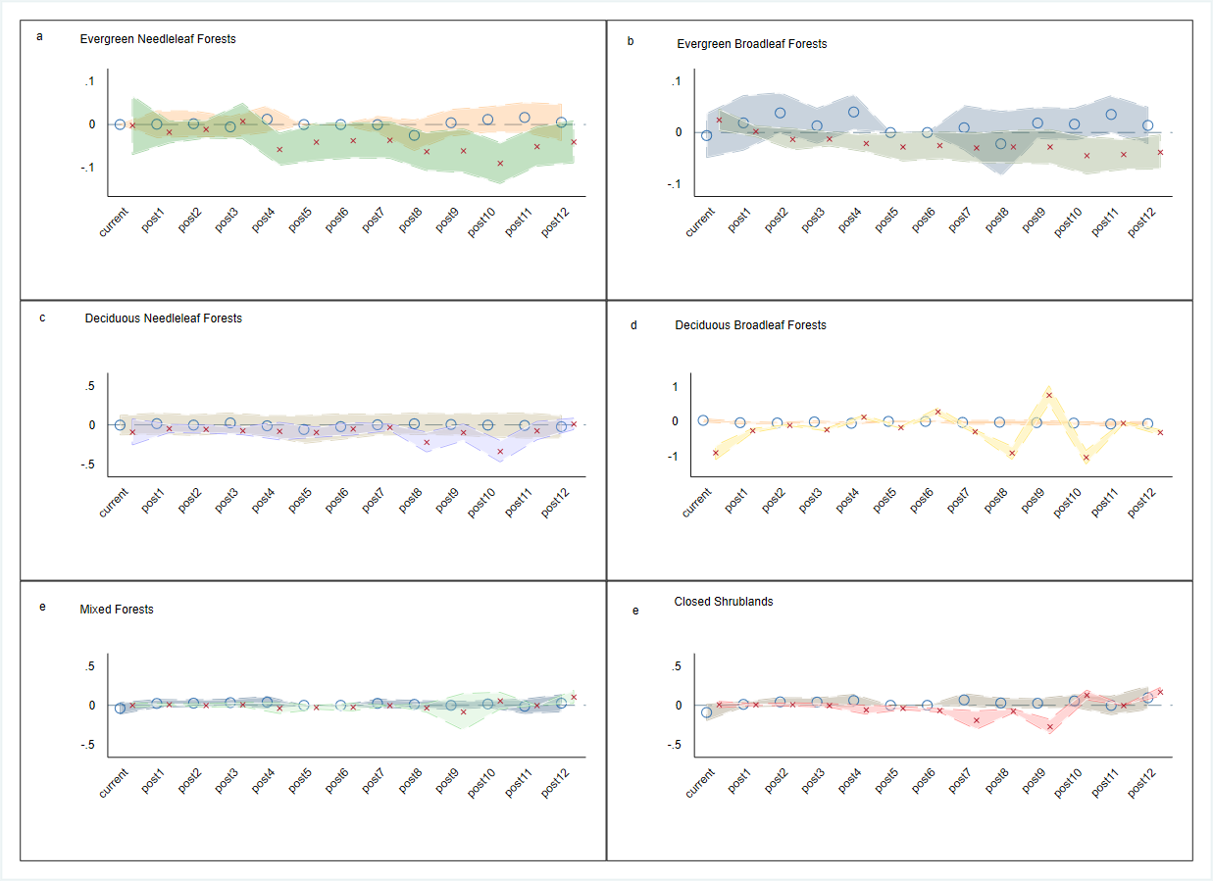

Appendix Figure S1. Yearly impacts of urban-rural population density gap on rural aboveground biomass carbon density based on the grouped subsamples of high and low quartiles of distance between rural terrestrial vegetation growth center and urban economic center. Circles and x represent high and low quartile categories, respectively. Subfigure a) shows Evergreen Needleleaf Forests; Subfigure b) shows Evergreen Broadleaf Forests; Subfigure c) shows Deciduous Needleleaf Forests; Subfigure d) shows Deciduous Broadleaf Forests; Subfigure e) shows Mixed Forests; Subfigure f) shows Closed Shrublands. Notes: the 95% confidence intervals of lnur_pop in the lagged years reflect the difference between their lnur_pop’s effects and lnur_pop in the base year.

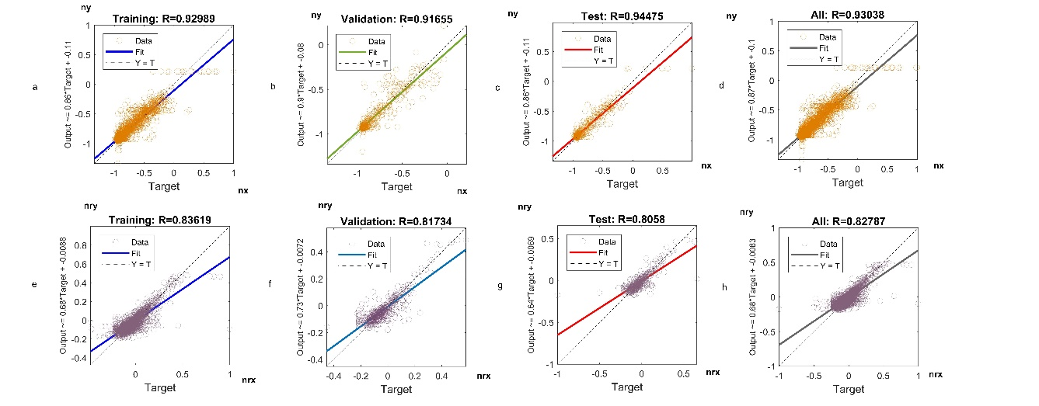

Appendix Figure S2. Fitting results for the county-level total and rural aboveground biomass. a) Training results for the relationship between county-level normalized total aboveground biomass and our estimated total aboveground biomass predicted based on the input factors; b) Validation results for the relationship between county-level normalized total aboveground biomass and our estimated total aboveground biomass predicted based on the input factors; c) Test results for the relationship between county-level normalized total aboveground biomass and our estimated total aboveground biomass predicted based on the input factors; d) All samples’ results for the relationship between county-level normalized total aboveground biomass and our estimated total aboveground biomass predicted based on the input factors; e) Training results for the relationship between county-level normalized rural aboveground biomass and our estimated rural aboveground biomass predicted based on the input factors; f) Validation results for the relationship between county-level normalized rural aboveground biomass and our estimated rural aboveground biomass predicted based on the input factors; g) Test results for the relationship between county-level normalized rural aboveground biomass and our estimated rural aboveground biomass predicted based on the input factors; h) All samples’ results for the relationship between county-level normalized rural aboveground biomass and our estimated rural aboveground biomass predicted based on the input factors.

