SUPPLEMENTARY INFORMATION

Optimized Design and Economical Analysis of Eco-Sponge water-logging Prevention System for Converter Stations
Zhengdong Wan ^{1,}*, Liangzheng WU ¹ and Yan Huang ¹
¹ energy Development Research Institute, China Southern Power Grid, Guangdong, Guangzhou 510530, China
Figure S1. Map of the molecular catchment partitioning
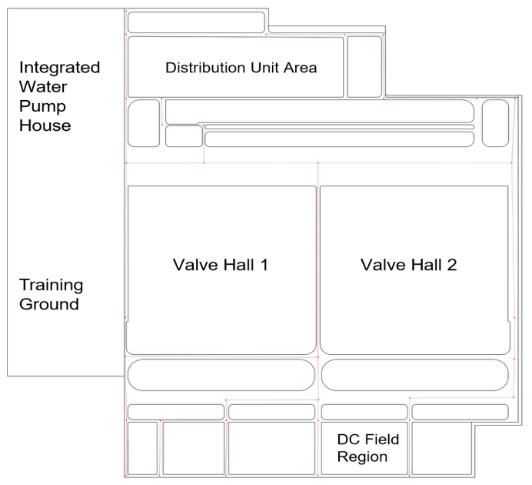
Table S1. SMMM model parameters rate-setting
Parameter names |  | Specific values | Data sources
Area of Sub-catchments |  | / | actual measurement
Width of sub-catchments |  | / | Area/Flow length
Impermeable Area Ratio of sub-catchments |  | 0-100 | actual measurement
Water storage in the low-lying land | permeability | 1.27 | Model Brochure
Water storage in the low-lying land | impermeability | 3.81 | Model Brochure
Manning N value | permeability | 0.15 | Model Brochure
Manning N value | impermeability | 0.013 | Model Brochure
Percentage of impermeable water storage without the low-lying land |  | 25% | Model Brochure
Horton equation | Maximum rate of infiltration | 75 | Reference
Horton equation | Minimum rate of infiltration | 4 | Reference
Horton equation | attenuation constant | 4 | Reference
Node parameters |  | / | Pipe network information
Pipe parameters |  | / | Pipe network information

