Supplementary Materials for

Enhancing Sub-Seasonal Soil Moisture Forecasts through Land Initialization

Authors: Yanan Duan¹, Sanjiv Kumar¹*, Montasir Maruf¹, Thomas M. Kavoo¹, Imtiaz Rangwala², Jadwiga Richter³, Anne A. Glanville ³, Teagan King ³, Musa Esit^{1,4}, Brett Raczka⁵, and Kevin Reader⁵
Affiliations:
¹College of Forestry, Wildlife and Environment, Auburn University, Auburn, AL
²Cooperative Institute for Research in Environmental Sciences & North Central Climate Adaptation Science Center, University of Colorado, Boulder, CO.
³Climate and Global Dynamics Laboratory, National Center for Atmospheric Research, Boulder, CO
⁴ Adiyaman University, Adiyaman, Turkey
⁵Computation & Information Systems Laboratory, National Center for Atmospheric Research, Boulder, CO

Submission date: 07/19/2024

Revision 1: 10/21/2024

*Corresponding author
Sanjiv Kumar, Ph.D.
College of Forestry, Wildlife and Environment
Auburn University
Email: szk0139@auburn.edu

Table S1: Sub-seasonal Soil Moisture Forecast Skill (ACC) in CESM2 Experiments for JJA and DJF Seasons. Same as Table 2 for Eco # 1-5 and 12 to 17. Eco-region numbers are shown in Fig. 2(a).

Exp No. | Experiment ID | Sub-seasonal Soil Moisture Forecast Skill (Week 3 to 4), JJA
Exp No. | Experiment ID | Eco #1 | Eco # 2 | Eco # 3 | Eco #4 | Eco # 5 | Eco # 12 | Eco # 13 | Eco # 14 | Eco # 15 | Eco # 16 | Eco # 17
1 | Control | 0.52 | 0.49 | 0.48 | 0.30 | 0.33 | 0.46 | 0.32 | 0.31 | 0.42 | 0.49 | 0.30
2 | climoATM | 0.48 | 0.44 | 0.43 | 0.31 | 0.31 | 0.43 | 0.27 | 0.24 | 0.40 | 0.46 | 0.30
3 | climoLND | 0.21 | 0.22 | 0.16 | 0.01 | 0.14 | 0.12 | 0.20 | 0.21 | 0.10 | 0.18 | -0.05
4 | climoOCN | 0.52 | 0.49 | 0.49 | 0.30 | 0.33 | 0.45 | 0.31 | 0.29 | 0.42 | 0.47 | 0.31
5 | climoOCNclimoLND | 0.22 | 0.19 | 0.21 | 0.16 | 0.12 | 0.15 | 0.29 | 0.23 | 0.13 | 0.15 | -0.01
6 | climoOCNclimoATM | 0.48 | 0.44 | 0.45 | 0.30 | 0.33 | 0.44 | 0.26 | 0.23 | 0.40 | 0.46 | 0.30
7 | climoATMclimoLND | 0.00 | 0.01 | -0.14 | -0.07 | 0.00 | 0.04 | 0.05 | 0.01 | 0.02 | 0.14 | -0.09
8 | climoALL | 0.01 | 0.01 | -0.04 | 0.08 | 0.02 | 0.00 | -0.01 | -0.02 | -0.01 | 0.11 | -0.05
Exp No. | Experiment ID | Sub-seasonal Soil Moisture Forecast Skill (Week 3 to 4), DJF
Exp No. | Experiment ID | Eco #1 | Eco # 2 | Eco # 3 | Eco #4 | Eco # 5 | Eco # 12 | Eco # 13 | Eco # 14 | Eco # 15 | Eco # 16 | Eco # 17
1 | Control | 0.23 | 0.58 | 0.59 | 0.40 | 0.21 | 0.29 | 0.51 | 0.62 | 0.44 | 0.35 | 0.64
2 | climoATM | 0.21 | 0.56 | 0.53 | 0.37 | 0.21 | 0.28 | 0.47 | 0.54 | 0.37 | 0.23 | 0.49
3 | climoLND | 0.10 | 0.21 | 0.45 | 0.41 | 0.03 | 0.16 | 0.25 | 0.45 | 0.21 | 0.26 | 0.40
4 | climoOCN | 0.22 | 0.58 | 0.56 | 0.39 | 0.21 | 0.28 | 0.50 | 0.60 | 0.40 | 0.30 | 0.58
5 | climoOCNclimoLND | 0.11 | 0.15 | 0.33 | 0.27 | 0.02 | 0.14 | 0.23 | 0.38 | 0.17 | 0.25 | 0.36
6 | climoOCNclimoATM | 0.21 | 0.57 | 0.50 | 0.36 | 0.21 | 0.27 | 0.46 | 0.54 | 0.36 | 0.19 | 0.50
7 | climoATMclimoLND | 0.09 | -0.03 | 0.17 | 0.27 | -0.02 | 0.05 | -0.01 | 0.17 | 0.12 | 0.12 | 0.15
8 | climoALL | -0.01 | -0.03 | -0.04 | 0.14 | 0.03 | 0.00 | 0.02 | 0.06 | -0.02 | 0.00 | 0.04

Table S2: Contribution of the Land-only initialization (climoOCNclimoATM) to the total sub-seasonal forecast skill (Control) for JJA and DJF seasons. This ratio is derived using the corresponding skill score shown in Table 1 and Supplementary Table S1.

Eco # | 1 | 2 | 3 | 4 | 5 | 6 | 7 | 8 | 9 | 10 | 11 | 12 | 13 | 14 | 15 | 16 | 17
JJA | 0.93 | 0.92 | 0.94 | 1.00 | 1.01 | 0.93 | 0.95 | 0.92 | 1.01 | 0.89 | 0.94 | 0.94 | 0.83 | 0.75 | 0.94 | 0.93 | 1.02
DJF | 0.95 | 0.98 | 0.85 | 0.90 | 1.00 | 0.96 | 0.98 | 0.80 | 0.98 | 0.93 | 0.85 | 0.94 | 0.91 | 0.87 | 0.81 | 0.54 | 0.78
Overall average = 0.91
2 × standard error = 0.03

Figure S1: Same as Fig. 5 but for all soil moisture conditions.
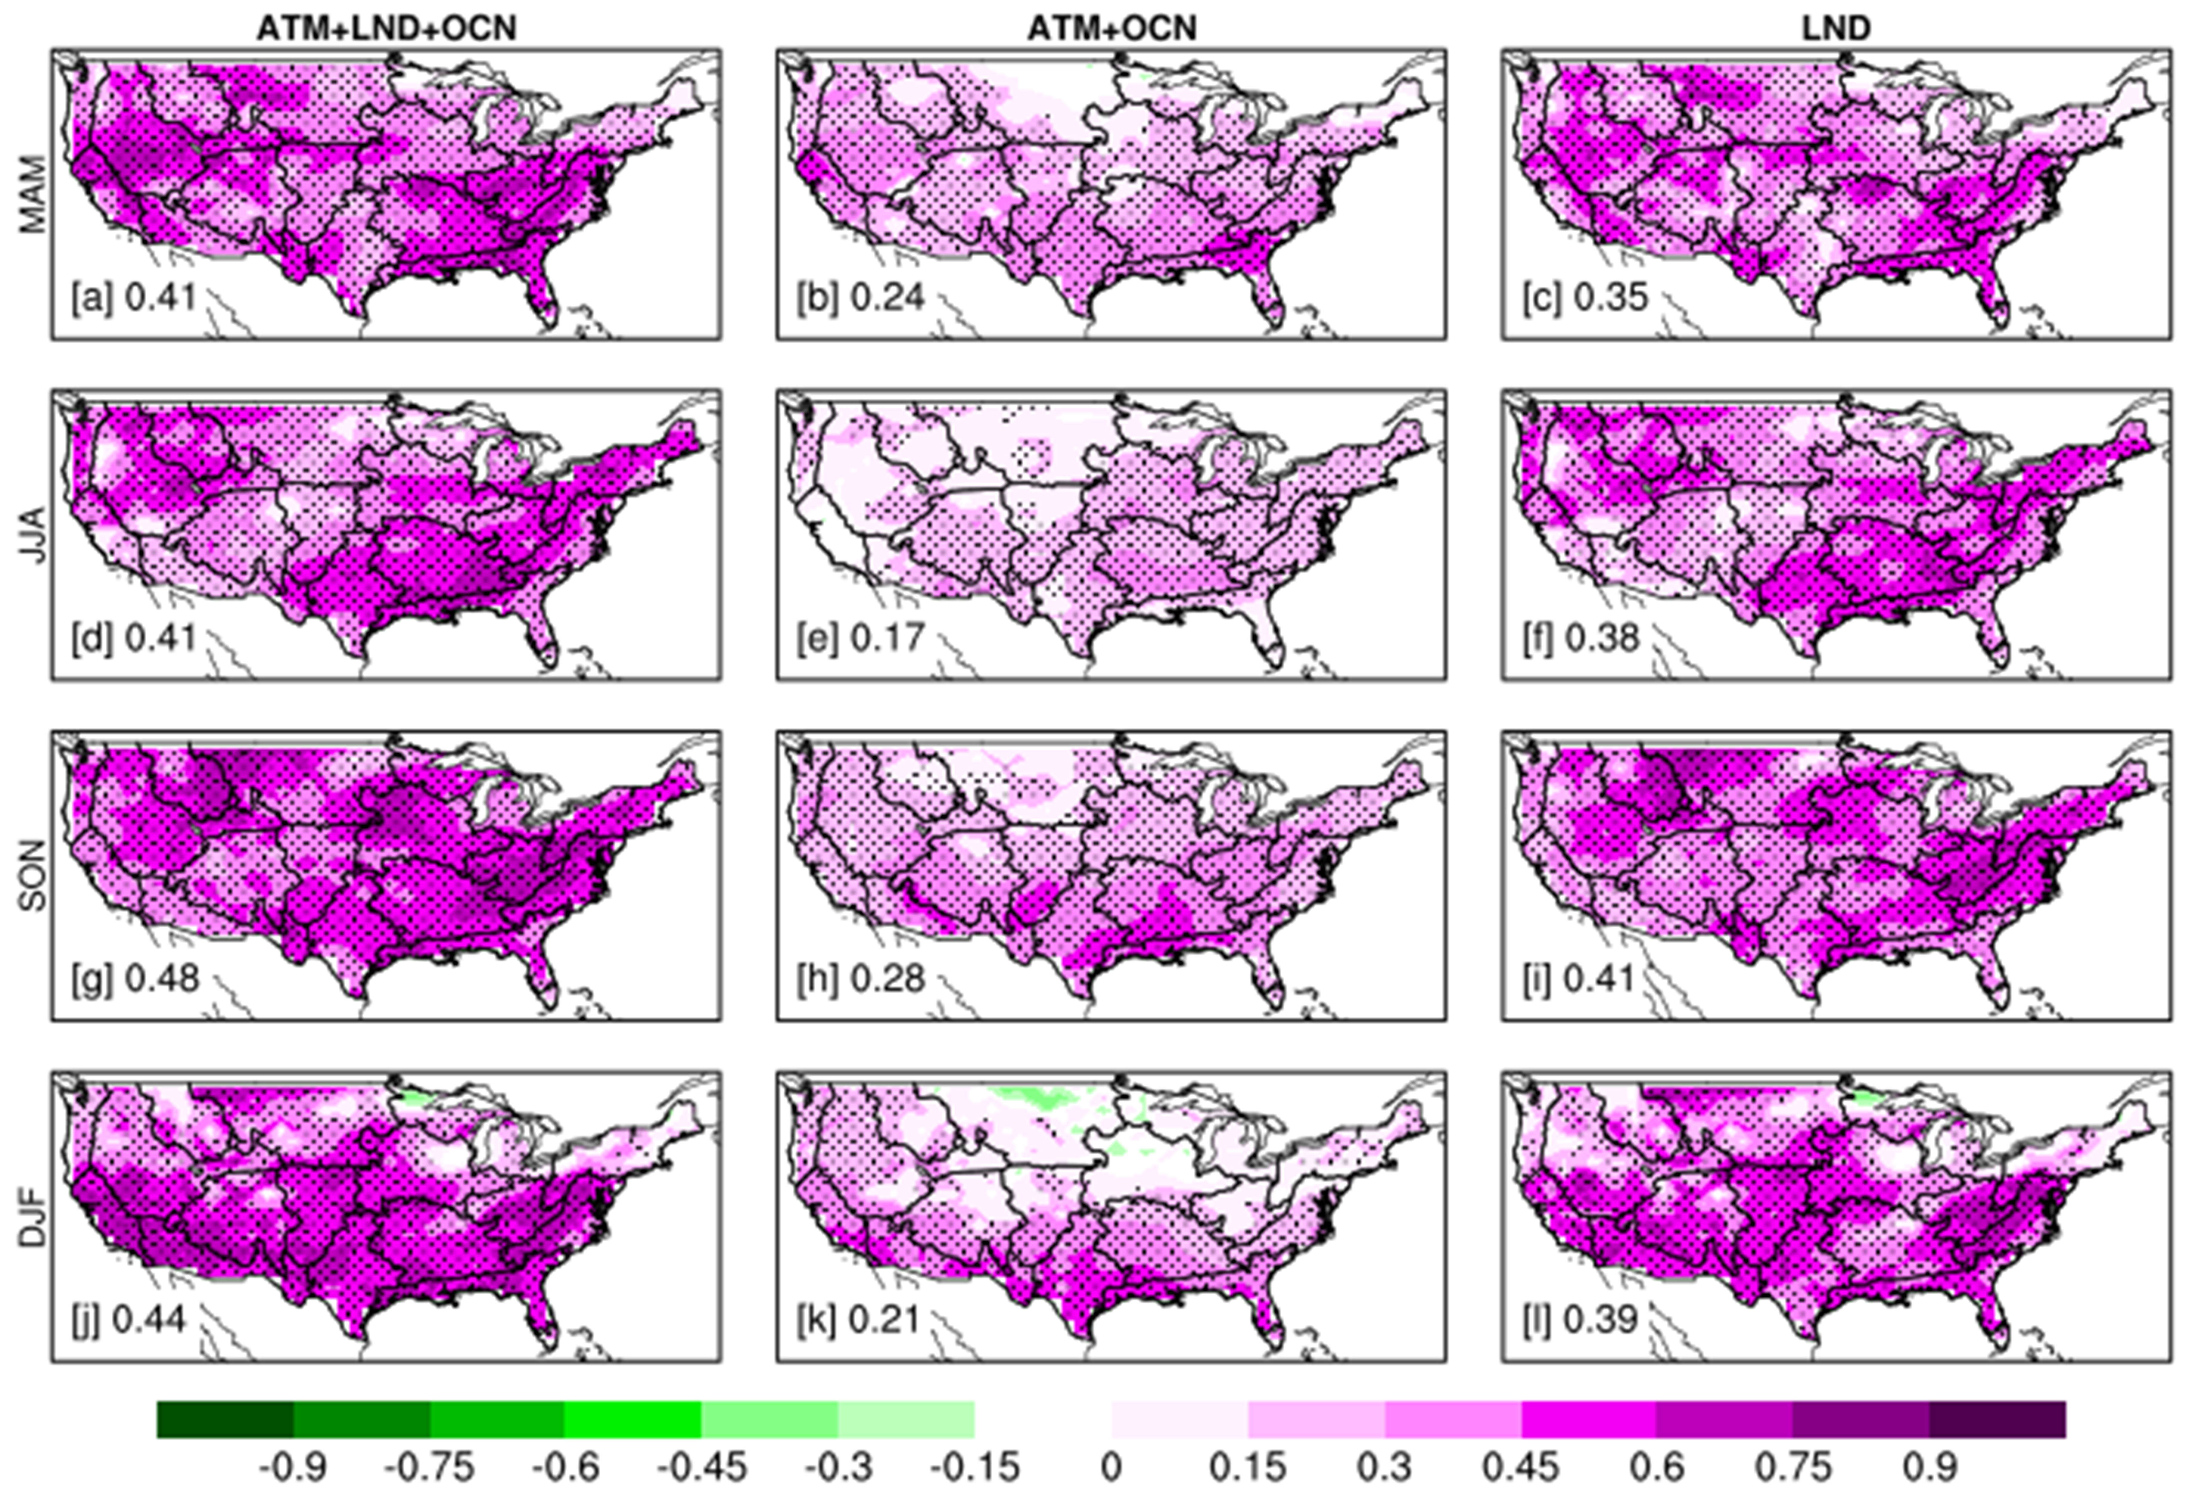

Figure S2: Impact of Soil Moisture Memory on the forecast Skill. This figure illustrates the seasonality of root zone soil moisture forecast skills for weeks 3-4 (average of forecast lead days 16-30) in the land-only initialization experiment (climoATMclimoOCN). The left column displays the anomaly correlation coefficient (ACC) between the forecast and observation calculated over 300 weeks from 1999 to 2018 (refer to Method for details). The middle column presents the lag autocorrelation at a 21-day lag from the CLM5 offline run (Memory). The right column shows the difference between the first and second columns. The four rows represent the four seasons: MAM, JJA, SON, and DJF. Striplings show statistically significant ACC at a 95% confidence level.
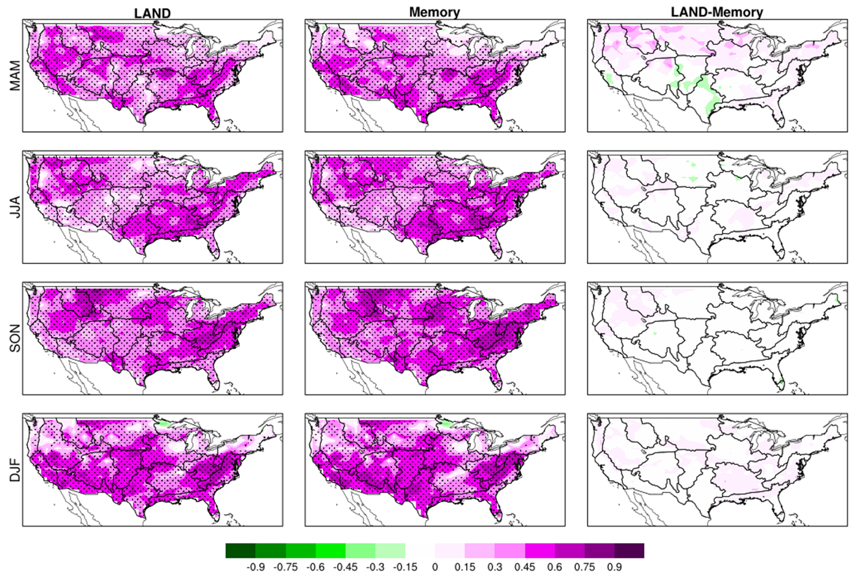

Figure S3: Same as Fig. 6(b) and (d) for root zone initial condition soil moisture anomalies correlated with week 3 to 4 precipitation forecast in CESM2. Note – Root zone soil moisture anomalies are not available for the ESRL-FIM model.
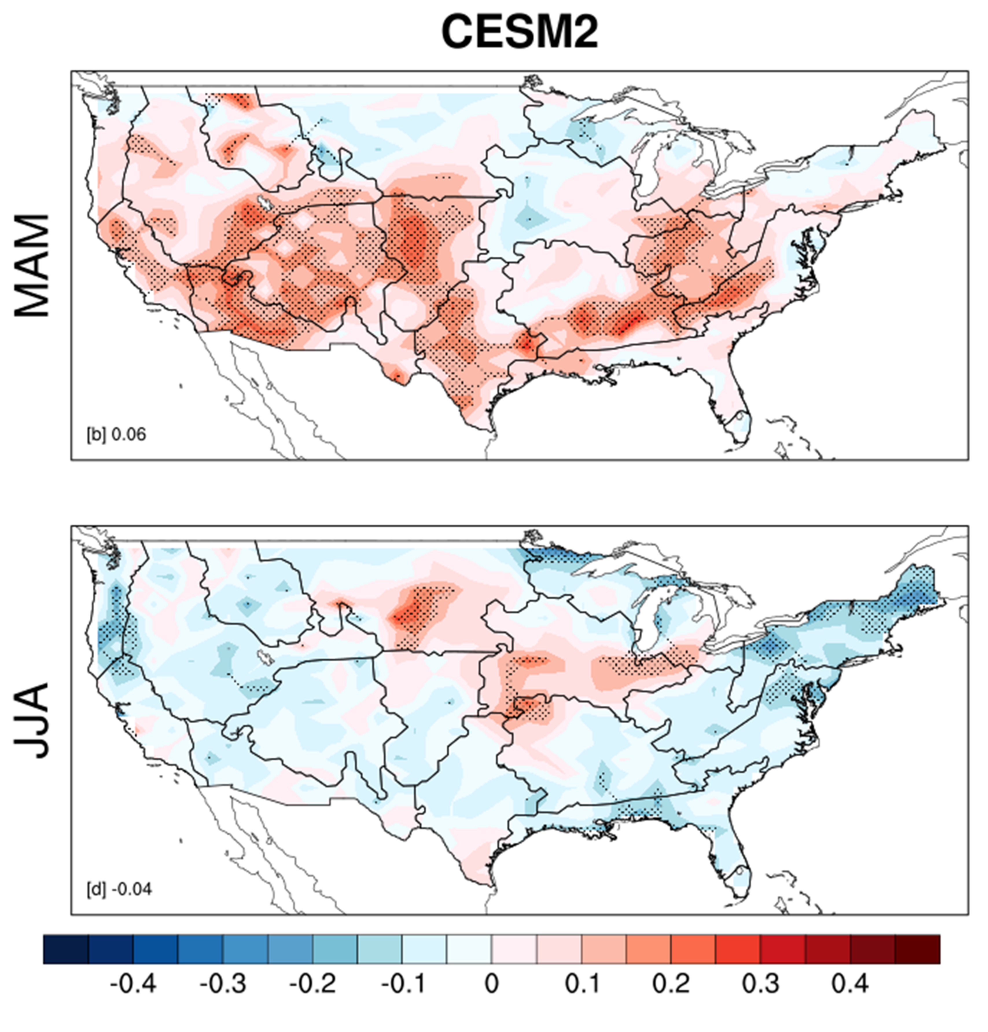
Figure S4: Same as Fig. 2 for near-surface air temperature. Observations are from Climate Research Unit version 4 temperature data¹.

Figure S5: Same as Fig. 2 for precipitation. Observations are from the Global Precipitation Climatology Project Climate Data Record version 1.3².
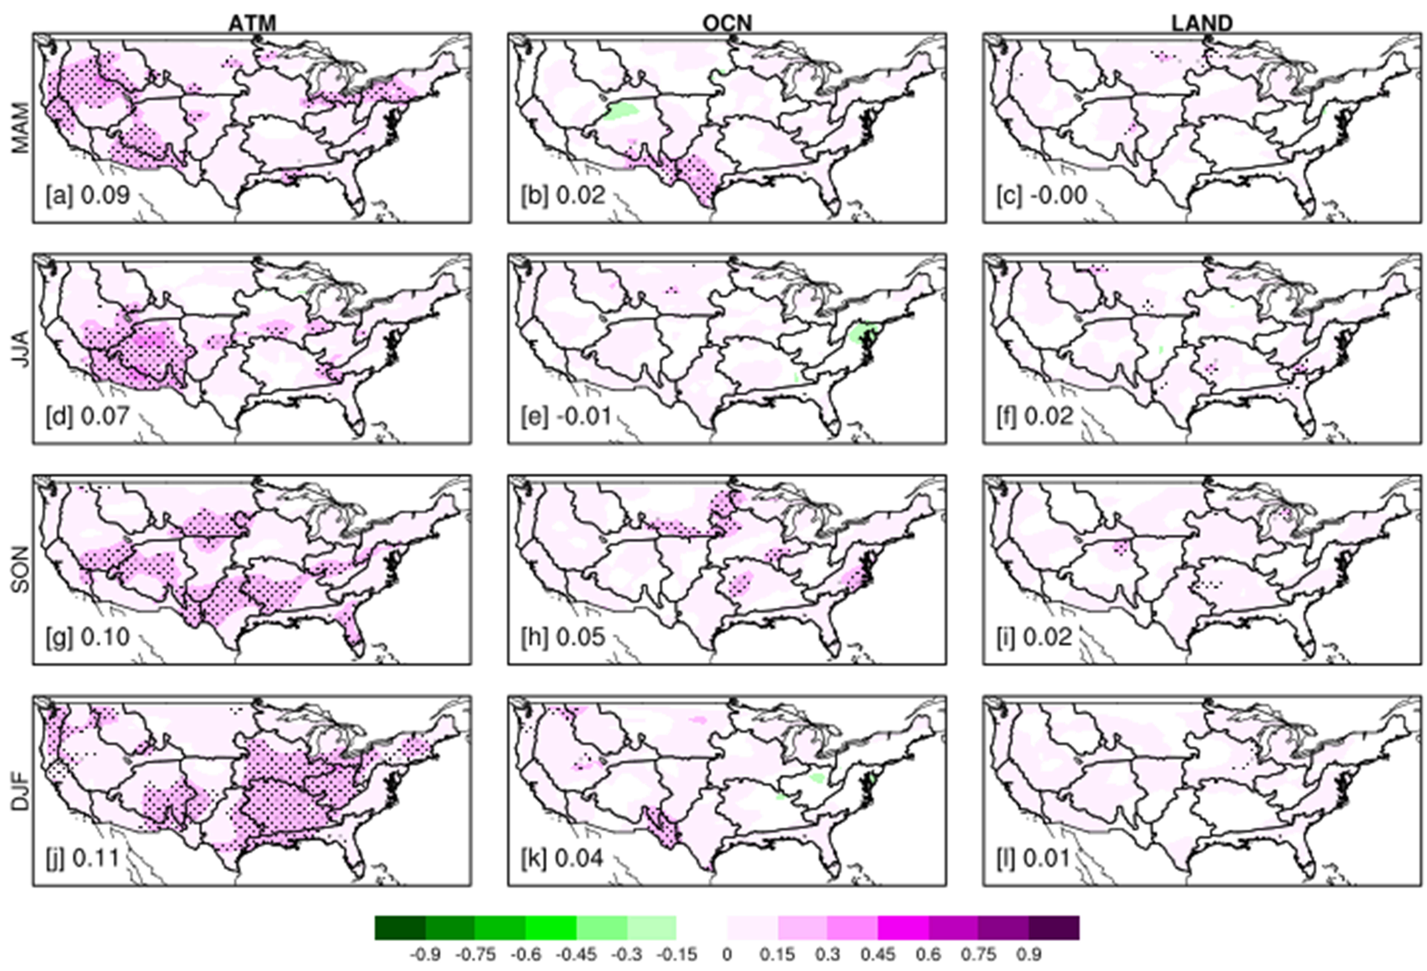

Figure S6: Same as Fig. 6(a) but for the DA experiment as discussed in the main text. The initial conditions for the DA experiment were provided by the CAM6-DART reanalysis, as described by³. The CESM2 RZ experiment was initialized through a standard approach using NCEP CFSv2, whereas CESM2-DA RZ was initialized through CAM6-DART atmospheric reanalysis. The analysis period is restricted to 2011–2018 due to data availability. The differences in CESM2 RZ forecast skill, compared with Fig. 6(a), are attributed to the shorter analysis period used in this case.
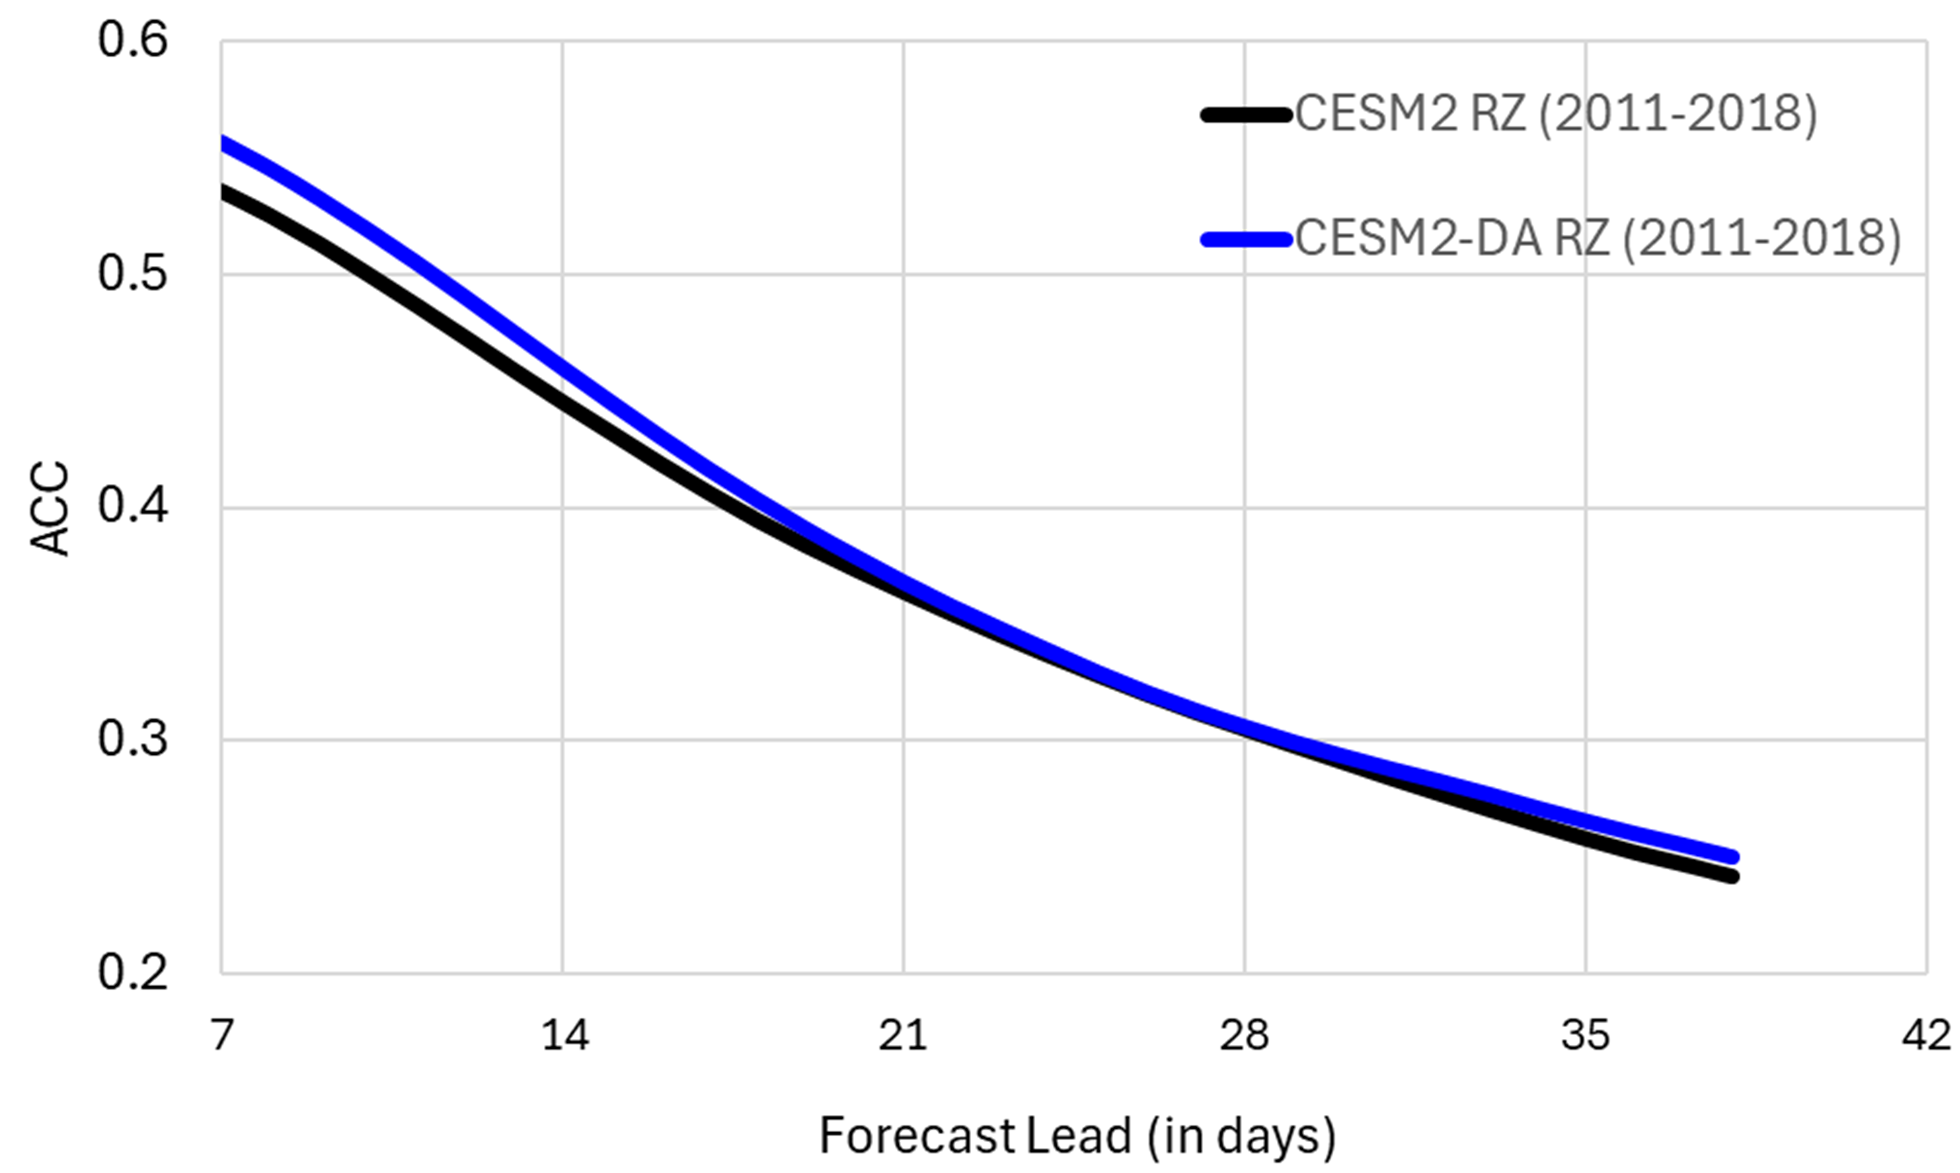

Figure S.7: The root zone soil moisture forecast skill sensitivity to observation-based data. Figure panels show ACC between the control experiment soil moisture forecast and observations for weeks 3-4 (average of forecast lead days 16-30). The control experiment incorporated all three components' initializations: Ocean, Land, and Atmosphere. The observations are ERA-5 land, SoilMerge (SMERGE), GLEAM3, and MERRA2. The four rows are four seasons: MAM, JJA, SON, and DJF. The correlation is calculated for 300 weeks from 1999 to 2018. Striplings show statistically significant ACC at a 95% confidence level.
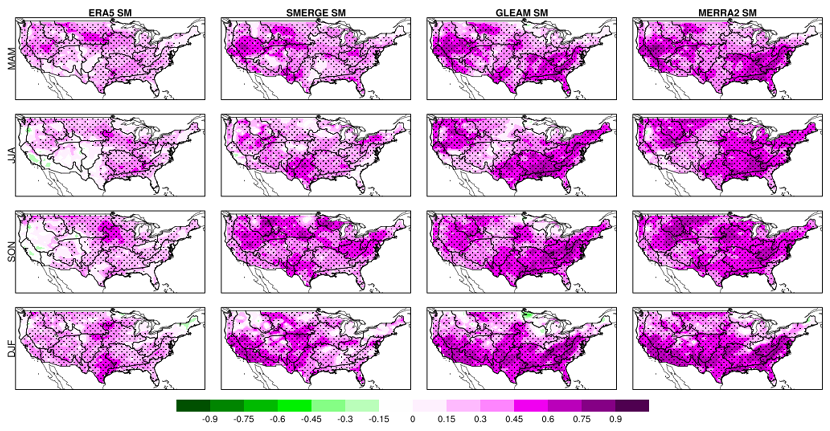

Additional References for Supplementary Materials
1 Harris, I., Osborn, T. J., Jones, P. & Lister, D. Version 4 of the CRU TS monthly high-resolution gridded multivariate climate dataset. Scientific data 7, 1-18 (2020).
2 Adler, R. et al. Global precipitation climatology project (GPCP) climate data record (CDR), version 1.3 (daily). (2020).
3 Raeder, K. et al. A new CAM6+ DART reanalysis with surface forcing from CAM6 to other CESM models. Sci Rep-Uk 11, 16384 (2021).

