Comparison of self-reported and physiological sleep quality from consumer devices to depression and neurocognitive performance

SUPPLEMENTARY MATERIALS
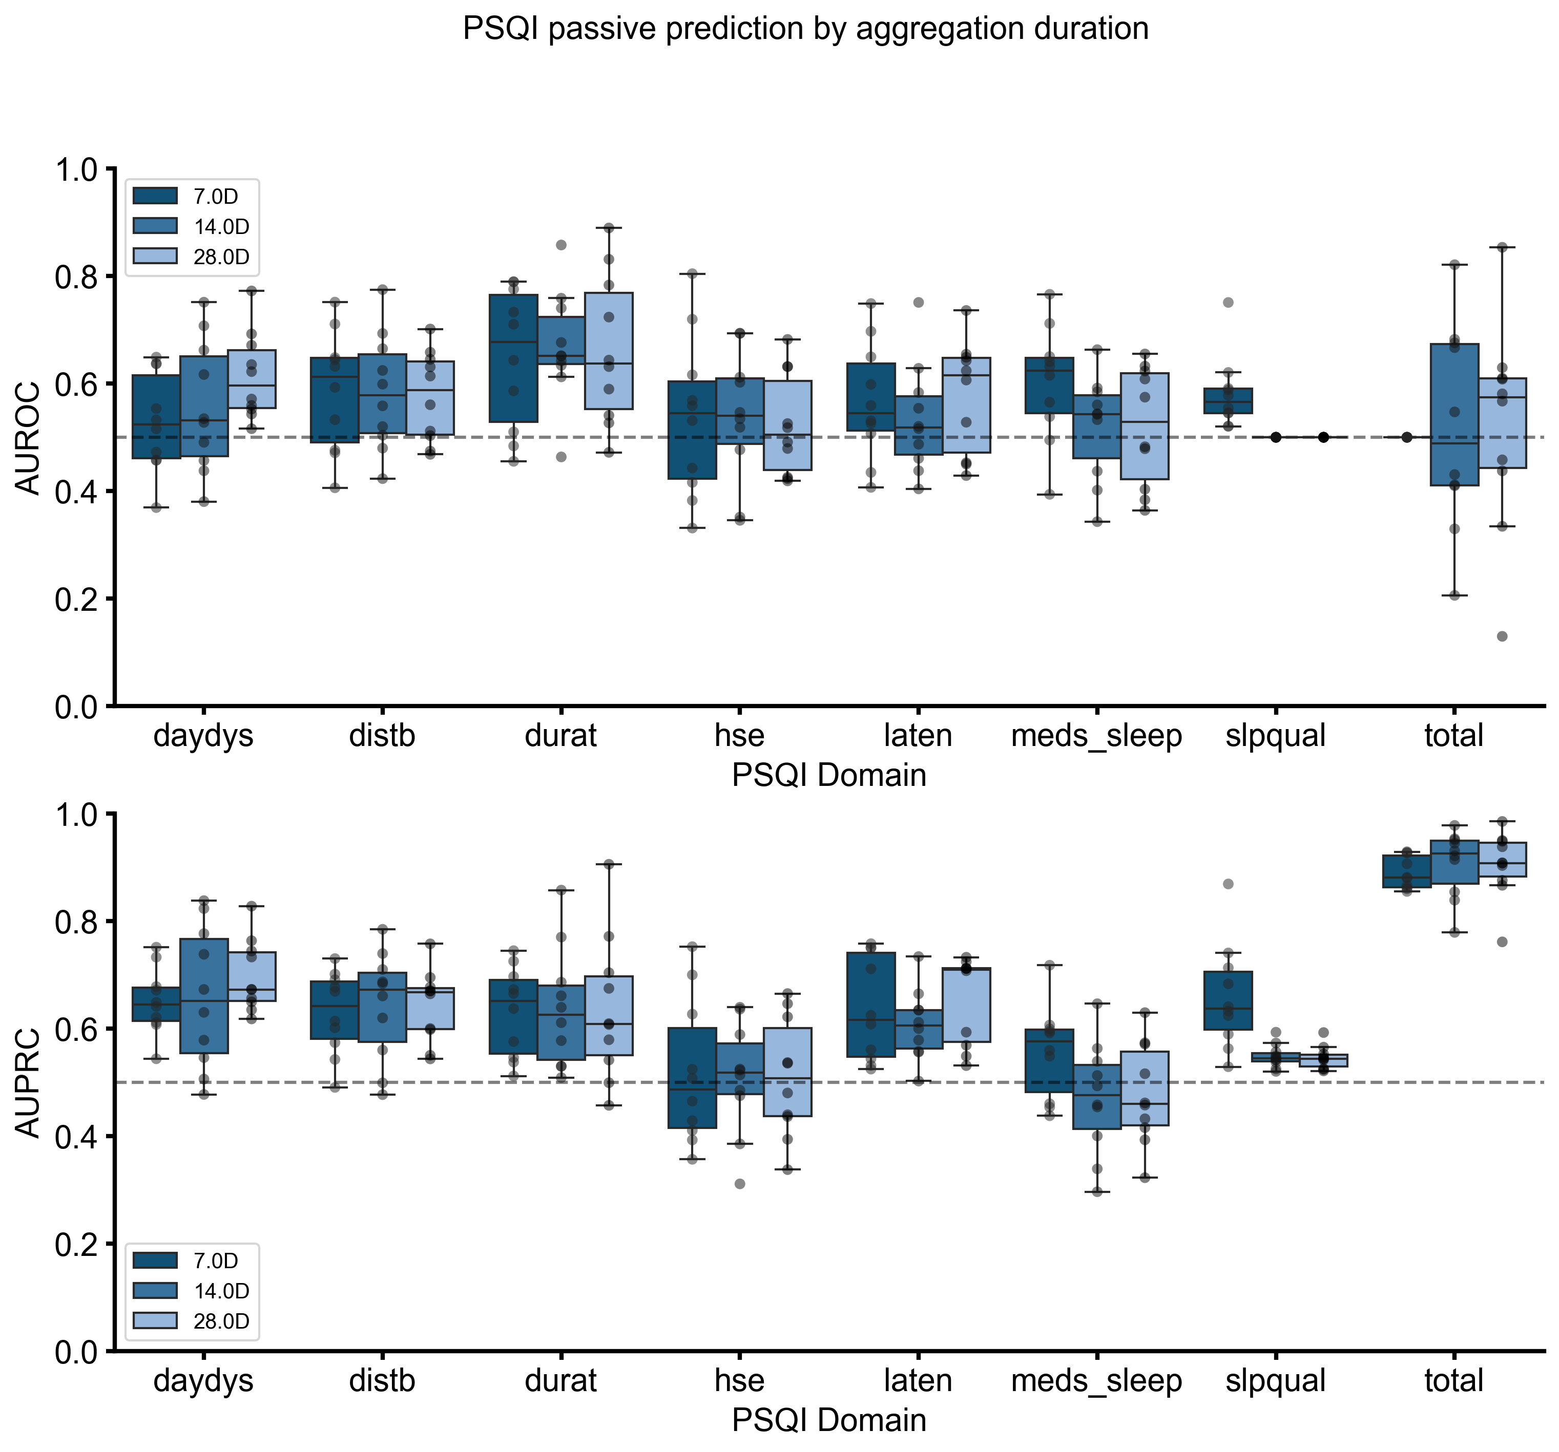
Supplemental Figure 1. Performance of predictive models at detecting domains and total scores of the Pittsburgh Sleep Quality Index (PSQI) with passive sensor data aggregated at different windows prior to self-report administration. Top plot shows AUROC score value and bottom plot shows average precision performance.

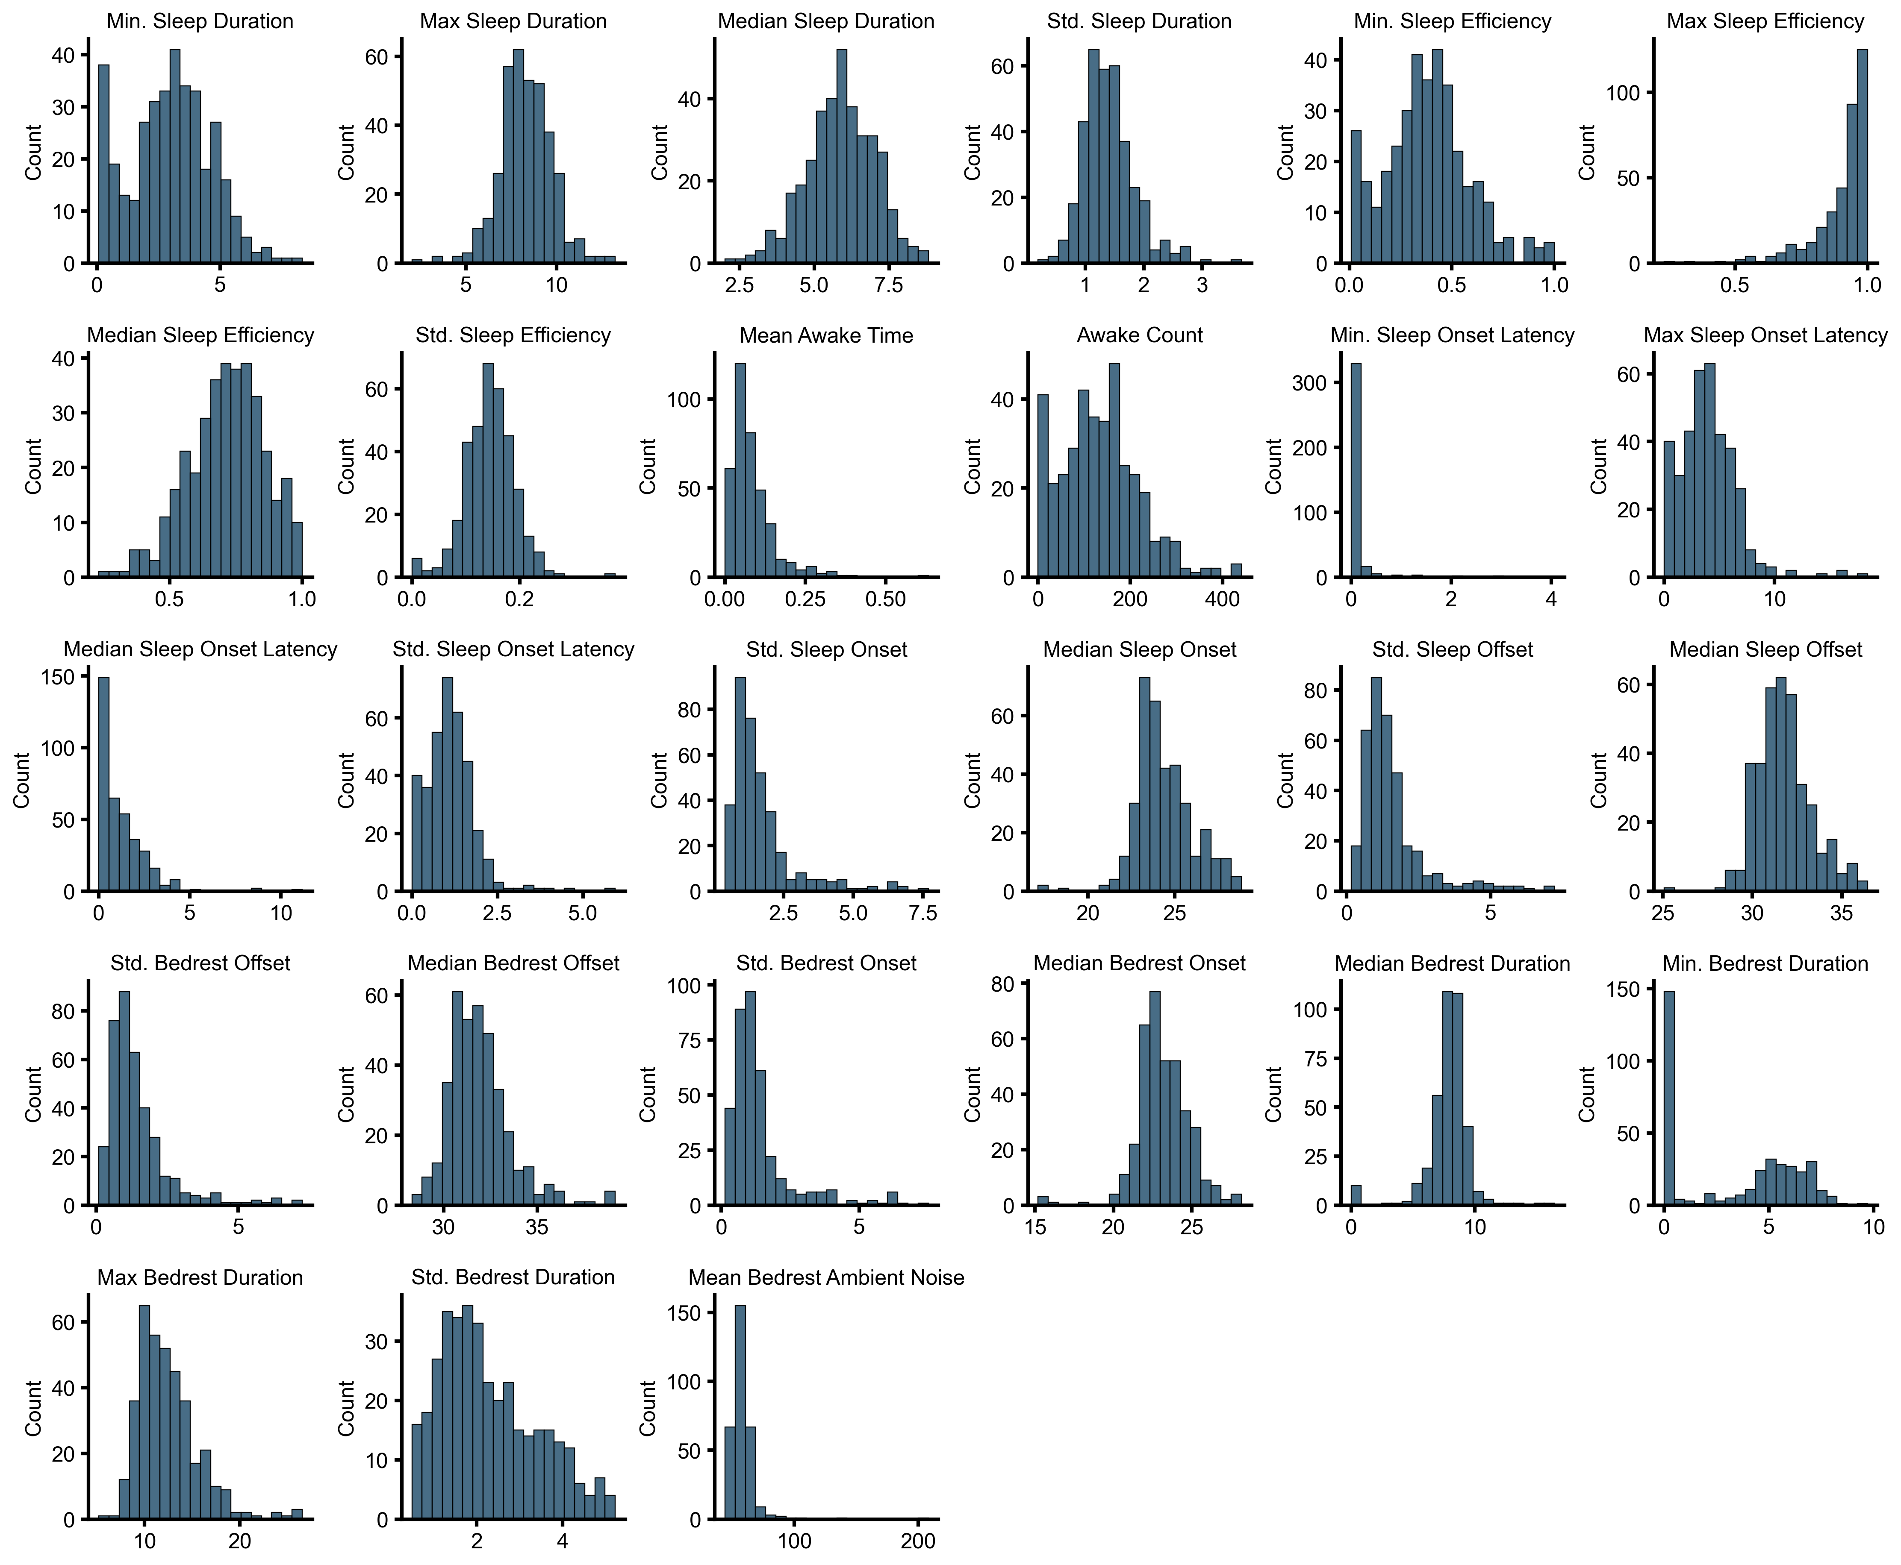
Supplemental Figure 2. Histograms of passive sleep quality features aggregated 28-days prior to Pittsburgh Sleep Quality Index (PSQI) administrations.

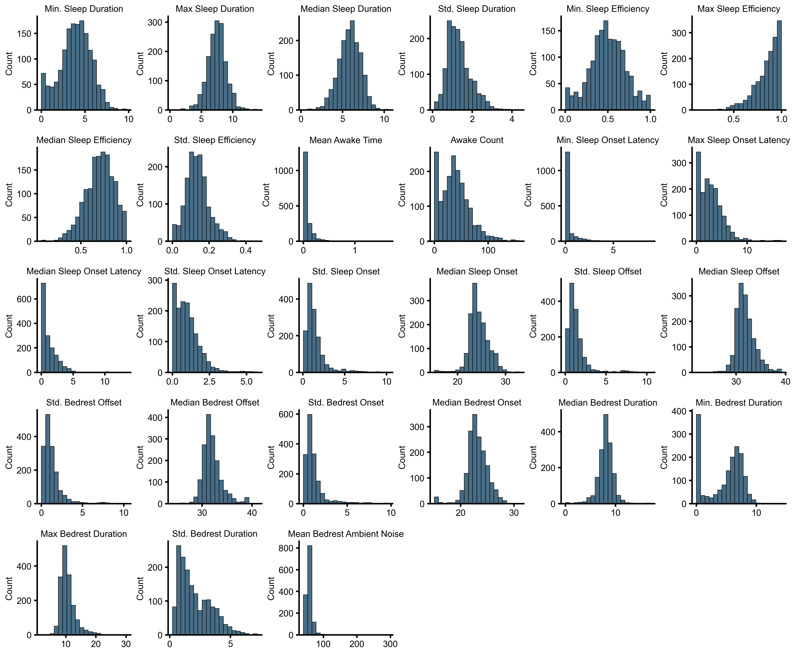
Supplemental Figure 3. Histograms of passive sleep quality features aggregated 8-days prior to Patient Health Questionnaire-14 (PHQ-14) administrations.

