Supporting Information

Crystal growth, structural phase transitions and optical gap evolution of FAPb(Br_{1-x}Cl_{x})₃ hybrid perovskites (FA: formamidinium ion, CH(NH₂)₂⁺)
Carlos A. López,^{1,2*}, Oscar Fabelo³, Carmen Abia,^{1,3} María T. Fernández-Diaz³ and José A. Alonso^{1*}

¹ Instituto de Ciencia de Materiales de Madrid, CSIC, Cantoblanco 28049 Madrid, Spain
² INTEQUI, (UNSL-CONICET) and Facultad de Química, Bioquímica y Farmacia, UNSL, Almirante Brown 1455, 5700, San Luis, Argentina.
³Institut Laue Langevin. 38042 Grenoble Cedex, France
*ja.alonso@icmm.csic.es, calopez@unsl.edu.ar, abia-sanzc@ill.fr

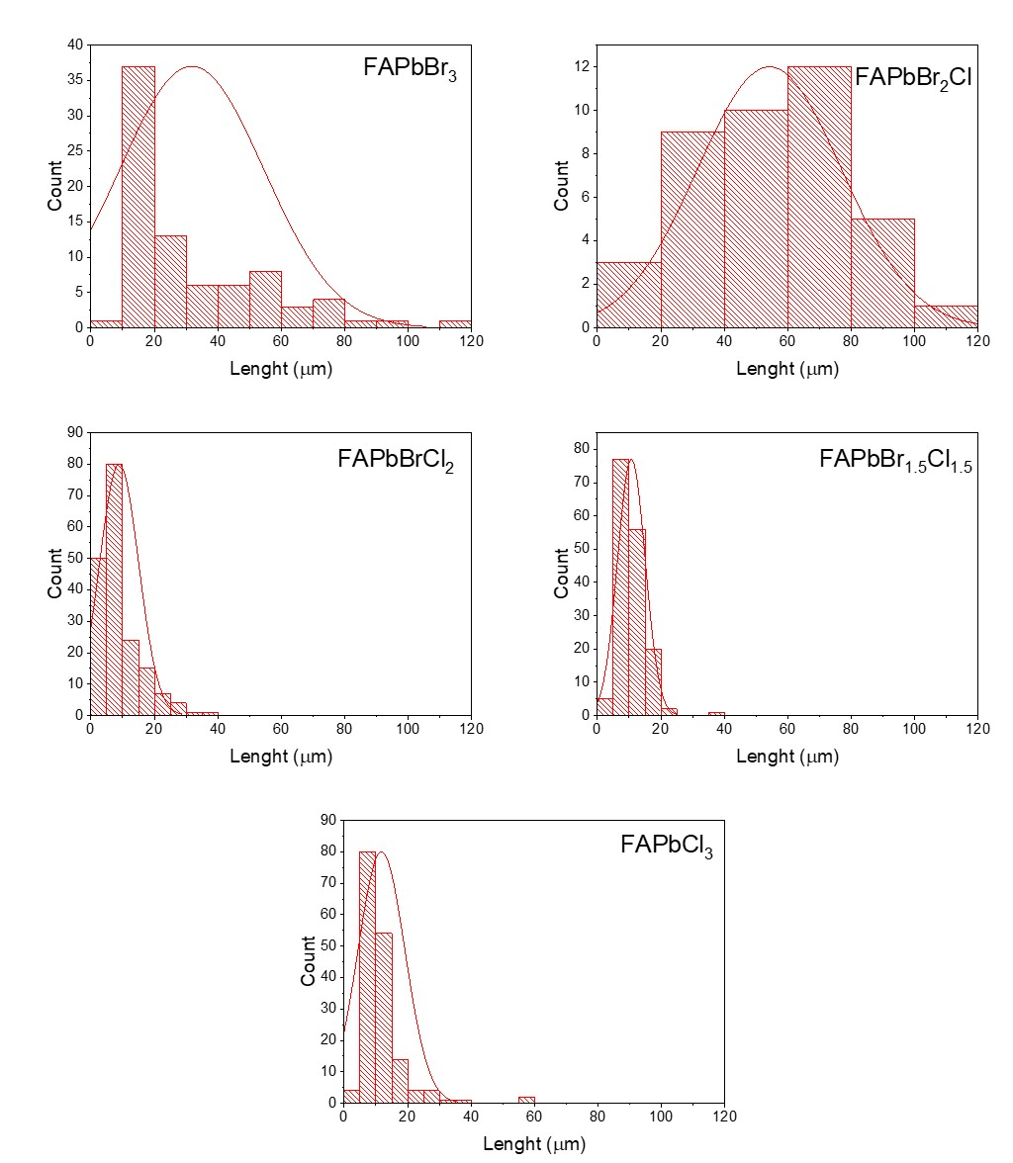
Figure S1: Histogram charts indicating the average size of the microcrystals observed from SEM (Fig. 2 of the manuscript) for the different compositions.

Figure S2: DRX pattern of FAPbBr₃, FAPbBr_{1.5}Cl_{1.5} and FAbCl₃. Asterisks indicate the diffractions lines of impurity.
Figure S3: Observed (red crosses), calculated (full black line) and difference (blue line) Rietveld profiles for FAPbBr₃ from NPD data at RT.
Table S1: Crystallographic data for FAPbBr₃ phase in the cubic system (Pm$\overline{3}$m) from NPD data at RT. a = 5.9984(9) Å and V = 215.83(7) Å³
 | x |  | y |  | z | U_{iso} |  | f_{occ}
Pb1 | 0 |  | 0 |  | 0 | 0.0406(3) |  | 1
Br1 | 0.5 |  | 0 |  | 0 | 0. 1069(2) |  | 1
C1 | 0.5 |  | 0.56408 |  | 0.5 | 0.1189(2) |  | 0.1666(7)
N1 | 0.69646 |  | 0.4724(7) |  | 0.5 | 0.1189(2) |  | 0.0832(7)
H1 | 0.5 |  | 0.7224(9) |  | 0.5 | 0.1189(2) |  | 0.1666(7)
H2 | 0.81939 |  | 0.5585(4) |  | 0.5 | 0.1189(2) |  | 0.0832(7)
H3 | 0.70954 |  | 0.3229(6) |  | 0.5 | 0.1189(2) |  | 0.0832(7)
Atomic Displacement Parameters (Å²)
 |  | U¹¹ |  | U²² |  |  | U³³
Pb1 |  | 0.0406(3) |  | 0.0406(3) |  |  | 0.0406(3)
Br1 |  | 0.0458(8) |  | 0.1374(4) |  |  | 0.1374(4)
R_{p} = 1.48%, R_{wp} = 1.88%, χ² = 1.30, R_{Bragg} = 10.8%

Table S2: Crystallographic data for FAPbBr₂Cl in the cubic system (Pm$\overline{3}$m) from NPD at RT.
a = 5.939(2) Å and V = 209.5(1) Å³
 | x |  | y |  | z | U_{iso}*/U_{eq} |  | Occ.(<1)
Pb1 | 0 |  | 0 |  | 0 | 0.094(2) |  | 1
Br1 | 0.5 |  | 0 |  | 0 | 0.156(4) |  | 0.66619
Cl1 | 0.5 |  | 0 |  | 0 | 0.156(4) |  | 0.33333
C1 | 0.5 |  | 0.614(2) |  | 0.5 | 0.071(2) |  | 0.16667
N1 | 0.6940 |  | 0.512(2) |  | 0.5 | 0.071(2) |  | 0.08327
H1 | 0.5 |  | 0.774(2) |  | 0.5 | 0.071(2) |  | 0.16667
H2 | 0.8214 |  | 0.594(2) |  | 0.5 | 0.071(2) |  | 0.08327
H3 | 0.7032 |  | 0.361(2) |  | 0.5 | 0.071(2) |  | 0.08327
Atomic Displacement Parameters (Å²)
 |  | U¹¹ |  | U²² |  |  | U³³
Pb1 |  | 0.094(2) |  | 0.094(2) |  |  | 0.094(2)
Br1/Cl1 |  | 0.125(5) |  | 0.172(4) |  |  | 0.172(4)
R_{p} = 1.32%, R_{wp} = 1.67%, R_{exp} = 1.53%, χ² = 1.19, R_{Bragg} = 5.20%

Table S3: Crystallographic data for FAPbBr_{1.5}Cl_{1.5} in the cubic system (Pm$\overline{3}$m) from NPD at RT.
a = 5.906(3) Å and V = 206.0(2) Å³
 | x |  | y |  | z | U_{iso}*/U_{eq} |  | Occ.(<1)
Pb1 | 0 |  | 0 |  | 0 | 0.115(3) |  | 1
Br1 | 0.5 |  | 0 |  | 0 | 0.172(5) |  | 0.5
Cl1 | 0.5 |  | 0 |  | 0 | 0.17(5) |  | 0.5
C1 | 0.5 |  | 0.626(2) |  | 0.5 | 0.072(2) |  | 0.16667
N1 | 0.6947 |  | 0.524(2) |  | 0.5 | 0.072(2) |  | 0.08327
H1 | 0.5 |  | 0.786(2) |  | 0.5 | 0.072(2) |  | 0.16667
H2 | 0.8226 |  | 0.606(2) |  | 0.5 | 0.072(2) |  | 0.08327
H3 | 0.7040 |  | 0.372(2) |  | 0.5 | 0.072(2) |  | 0.08327
Atomic Displacement Parameters (Å²)
 |  | U¹¹ |  | U²² |  |  | U³³
Pb1 |  | 0.115(3) |  | 0.115(3) |  |  | 0.115(3)
Br1/Cl1 |  | 0.138(5) |  | 0.138(5) |  |  | 0.138(5)
R_{p} = 1.39%, R_{wp} = 1.76%, R_{exp} = 1.60%, χ² = 1.20, R_{Bragg} = 6.44%

Table S4: Crystallographic data for FAPbBrCl₂ in the cubic system (Pm$\overline{3}$m) from NPD at RT.
a = 5.881(3) Å and V = 203.4 (2) Å³
 | x |  | y |  | z | U_{iso}*/U_{eq} |  | Occ. (<1)
Pb1 | 0 |  | 0 |  | 0 | 0.126(6) |  | 1
Br1 | 0.5 |  | 0 |  | 0 | 0.160(8) |  | 0.66619
Cl1 | 0.5 |  | 0 |  | 0 | 0.160(8) |  | 0.33333
C1 | 0.5 |  | 0.591(2) |  | 0.5 | 0.098(3) |  | 0.16667
N1 | 0.6959 |  | 0.488(2) |  | 0.5 | 0.098(3) |  | 0.08327
H1 | 0.5 |  | 0.752(2) |  | 0.5 | 0.098(3) |  | 0.16667
H2 | 0.8245 |  | 0.571(2) |  | 0.5 | 0.098(3) |  | 0.08327
H3 | 0.7052 |  | 0.335(2) |  | 0.5 | 0.098(3) |  | 0.08327
Atomic Displacement Parameters (Å²)
 |  | U¹¹ |  | U²² |  |  | U³³
Pb1 |  | 0.126(6) |  | 0.126(6) |  |  | 0.126(6)
Br1/Cl1 |  | 0.13(1) |  | 0.175(8) |  |  | 0.175(8)
R_{p} = 1.40%, R_{wp} = 1.78%, R_{exp} = 1.61%, χ² = 1.21 R_{Bragg} = 5.02%

Table S5: Crystallographic data for FAPbCl₃ in the cubic system (Pm$\overline{3}$m) from NPD at RT.
a = 5.763(2) Å and V = 191.4(1) Å³
 | x |  | y |  | z | U_{iso}*/U_{eq} |  | Occ. (<1)
Pb1 | 0 |  | 0 |  | 0 | 0.100(2) |  | 1
Cl1 | 0.5 |  | 0 |  | 0 | 0.151(3) |  | 1
C1 | 0.5 |  | 0.587(2) |  | 0.5 | 0.117(3) |  | 0.16667
N1 | 0.6999 |  | 0.483(2) |  | 0.5 | 0.117(3) |  | 0.08327
H1 | 0.5 |  | 0.752(2) |  | 0.5 | 0.117(3) |  | 0.16667
H2 | 0.8312 |  | 0.567(2) |  | 0.5 | 0.117(3) |  | 0.08327
H3 | 0.7094 |  | 0.327(2) |  | 0.5 | 0.117(3) |  | 0.08327
Atomic Displacement Parameters (Å²)
 |  | U¹¹ |  | U²² |  |  | U³³
Pb1 |  | 0.100(2) |  | 0.100(2) |  |  | 0.100(2)
Cl1 |  | 0.084(3) |  | 0.184(3) |  |  | 0.184(3)
R_{p} = 1.34%, R_{wp} = 1.70%, R_{exp} = 1.60%, χ² = 1.13, R_{Bragg} = 3.08%

Table S6: Crystallographic data for FAPbCl₃ in the cubic system (Pm$\overline{3}$m) from SCXRD at RT.
a = 5.7606(2) Å and V = 191.16(2) Å³
 | x |  | y |  | z | U_{iso}*/U_{eq} |  | Occ.(<1)
Pb1 | 0 |  | 0 |  | 0 | 0.0411(1) |  | 1
Cl1 | 0.5 |  | 0 |  | 0 | 0.0865(7) |  | 1
C1 | 0.5 |  | 0.568(5) |  | 0.5 | 0.06(1) |  | 0.1667
N1 | 0.689 |  | 0.500(5) |  | 0.5 | 0.15(3) |  | 0.3333
H1 | 0.5 |  | 0.752 |  | 0.5 | 0.07* |  | 0.1667
H2 | 0.81038 |  | 0.59275 |  | 0.5 | 0.177* |  | 0.0833
H3 | 0.71941 |  | 0.35408 |  | 0.5 | 0.177* |  | 0.0833
Atomic Displacement Parameters (Å²)
 |  | U¹¹ |  | U²² |  |  | U³³
Pb1 |  | 0.0411(1) |  | 0.0411(1) |  |  | 0.0411(1)
Cl1 |  | 0.046(1) |  | 0.107(1) |  |  | 0.107(1)
C1 |  | 0.07(2) |  | 0.04(1) |  |  | 0.07(2)
N1 |  | 0.05(1) |  | 0.19(2) |  |  | 0.19(2)
R_{all} = 1.42%, R_{wp} = 5.67%, GooF=0.532

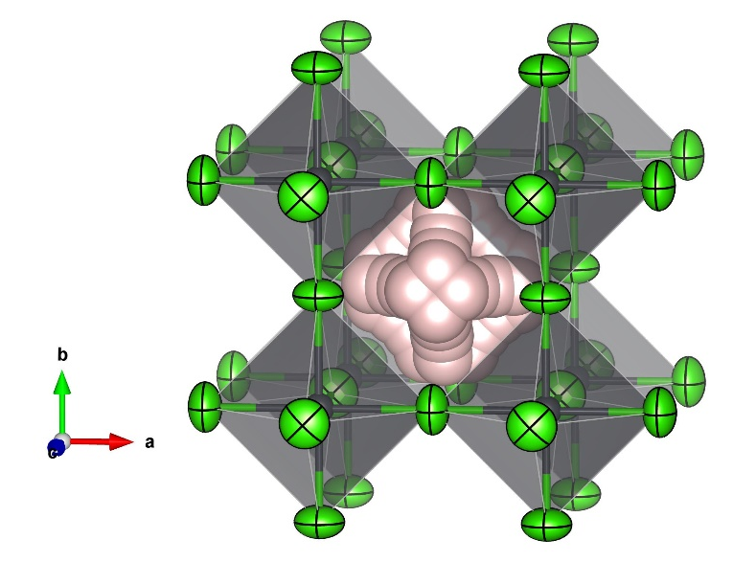
Figure S4: Crystallographic view of the FAPbCl₃ cubic phase (Pm$\overline{3}$m), refined from SCXRD data at room temperature, showing the disordered FA unit.

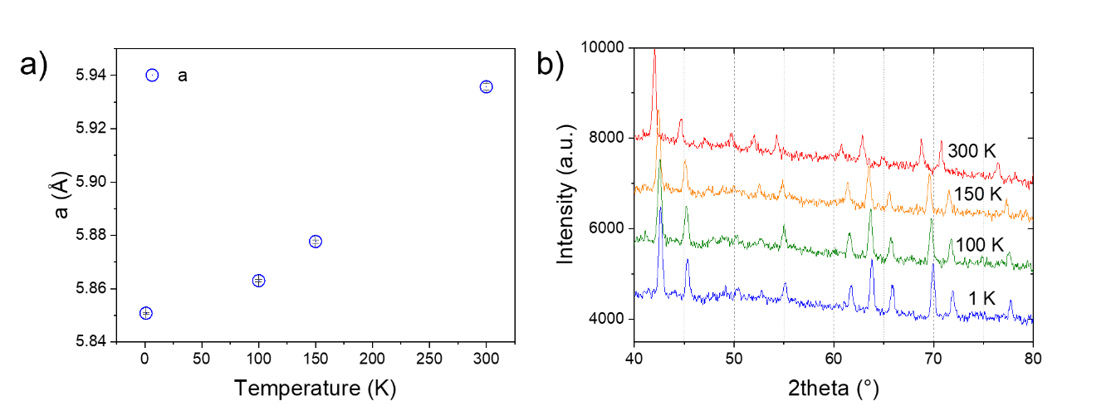
Figure S5. a) Thermal evolution of the cubic unit-cell parameter of the FAPbBr₂Cl perovskite at increasing temperatures (from 1 K to 300 K). b) Selected region of the NPD patterns of FAPbBr₂Cl in the same temperature range, illustrating the lack of phase transitions.

Table S7: Crystallographic data for FAPbBr₂Cl in the cubic system (Pm$\overline{3}$m) from NPD at 150 K
a = 5.8777(6) Å and V = 203.06(4) Å³
 | x |  | y |  | z | U_{iso}*/U_{eq} |  | Occ.(<1)
Pb1 | 0 |  | 0 |  | 0 | 0.030(2) |  | 1
Br1 | 0.5 |  | 0 |  | 0 | 0.096(5) |  | 0.66619
Cl1 | 0.5 |  | 0 |  | 0 | 0.096(5) |  | 0.33333
C1 | 0.5 |  | 0.5779(5) |  | 0.5 | 0.061(2) |  | 0.16667
N1 | 0.69852 |  | 0.4853(5) |  | 0.5 | 0.061(2) |  | 0.08327
H1 | 0.5 |  | 0.7379(5) |  | 0.5 | 0.061(2) |  | 0.16667
H2 | 0.82274 |  | 0.5723(5) |  | 0.5 | 0.061(2) |  | 0.08327
H3 | 0.71174 |  | 0.3342(5) |  | 0.5 | 0.061(2) |  | 0.08327
Atomic Displacement Parameters (Å²)
 |  | U¹¹ |  | U²² |  |  | U³³
Pb1 |  | 0.030(2) |  | 0.030(2) |  |  | 0.030(2)
Br1/Cl1 |  | 0.028(5) |  | 0.130(5) |  |  | 0.130(5)
R_{p} = 1.41%, R_{wp} = 1.78%, R_{exp} = 1.60%, χ² = 1.23, R_{Bragg} = 5.30%
Figure S6: Observed (red crosses), calculated (full black line) and difference (blue line) Rietveld profiles for FAPbBr₂Cl at 150K from NPD data.

Table S8: Crystallographic data for FAPbBr₂Cl in the cubic system (Pm$\overline{3}$m) from NPD at 100K
a = 5.8630(5) Å and V = 201.54(3) Å³
 | x |  | y |  | z | U_{iso}*/U_{eq} |  | Occ.(<1)
Pb1 | 0 |  | 0 |  | 0 | 0.0181(17) |  | 1
Br1 | 0.5 |  | 0 |  | 0 | 0.093(5) |  | 0.66619
Cl1 | 0.5 |  | 0 |  | 0 | 0.093(5) |  | 0.33333
C1 | 0.5 |  | 0.5767(4) |  | 0.5 | 0.0437(16) |  | 0.16667
N1 | 0.69852 |  | 0.4842(4) |  | 0.5 | 0.0437(16) |  | 0.08327
H1 | 0.5 |  | 0.7368(4) |  | 0.5 | 0.0437(16) |  | 0.16667
H2 | 0.82274 |  | 0.5711(4) |  | 0.5 | 0.0437(16) |  | 0.08327
H3 | 0.71174 |  | 0.3331(4) |  | 0.5 | 0.0437(16) |  | 0.08327
Atomic Displacement Parameters (Å²)
 |  | U¹¹ |  | U²² |  |  | U³³
Pb1 |  | 0.0181(17) |  | 0.0181(17) |  |  | 0.0181(17)
Br1/Cl1 |  | 0.019(4) |  | 0.130(5) |  |  | 0.130(5)
R_{p} = 1.39%, R_{wp} = 1.76%, R_{exp} = 1.59%, χ² = 1.23, R_{Bragg} = 3.70%

Figure S7: Observed (red crosses), calculated (full black line) and difference (blue line) Rietveld profiles for FAPbBr₂Cl at 100K from NPD data.

Table S9: Crystallographic data for FAPbBr₂Cl in the cubic system (Pm$\overline{3}$m) from NPD at 1K
a = 5.8508(4) Å and V = 200.29(2) Å³
 | x |  | y |  | z | U_{iso}*/U_{eq} |  | Occ.(<1)
Pb1 | 0 |  | 0 |  | 0 | 0.0119(9) |  | 1
Br1 | 0.5 |  | 0 |  | 0 | 0.089(3) |  | 0.66619
Cl1 | 0.5 |  | 0 |  | 0 | 0.089(3) |  | 0.33333
C1 | 0.5 |  | 0.5706(2) |  | 0.5 | 0.0311(10) |  | 0.16667
N1 | 0.69852 |  | 0.4780(2) |  | 0.5 | 0.0311(10) |  | 0.08327
H1 | 0.5 |  | 0.7307(2) |  | 0.5 | 0.0311(10) |  | 0.16667
H2 | 0.82274 |  | 0.5650(2) |  | 0.5 | 0.0311(10) |  | 0.08327
H3 | 0.71174 |  | 0.3270(2) |  | 0.5 | 0.0311(10) |  | 0.08327
Atomic Displacement Parameters (Å²)
 |  | U¹¹ |  | U²² |  |  | U³³
Pb1 |  | 0.0119(9) |  | 0.0119(9) |  |  | 0.0119(9)
Br1/Cl1 |  | 0.012(3) |  | 0.128(4) |  |  | 0.128(4)
R_{p} = 1.48%, R_{wp} = 1.87%, R_{exp} = 1.60%, χ² = 1.36, R_{Bragg} = 5.1%

Figure S8: Observed (red crosses), calculated (full black line) and difference (blue line) Rietveld profiles for FAPbBr₂Cl at 1K from NPD data.

