Exploring the effects of assembly strategies on differential gene expression analysis – A case study in a non-model crustacean species, the wild black tiger prawn (Penaeus monodon)
Nguyen Minh Thanh^{1†}, Tran Minh Nhut^{1†}, Tran Thi Hai Yen¹, Le Thị Hong Tham¹, Vo Thi Bao Chau¹, Nguyen Hoang Khue Tu¹, Nguyen Thanh Luan², Abigail Elizur³, Tomer Ventura³, Nguyen Viet Tuan⁴*, Vo Thi Minh Thu^{1*}
¹School of Biotechnology, International University – VNU HCM
²Research Institute for Aquaculture No.2 (RIA2), HCM city
⁴³GeneCology Research Centre, University of the Sunshine Coast, Queensland, Australia
⁵⁴Agriculture Victoria, AgriBio, Centre for AgriBiosciences, Victoria, Australia

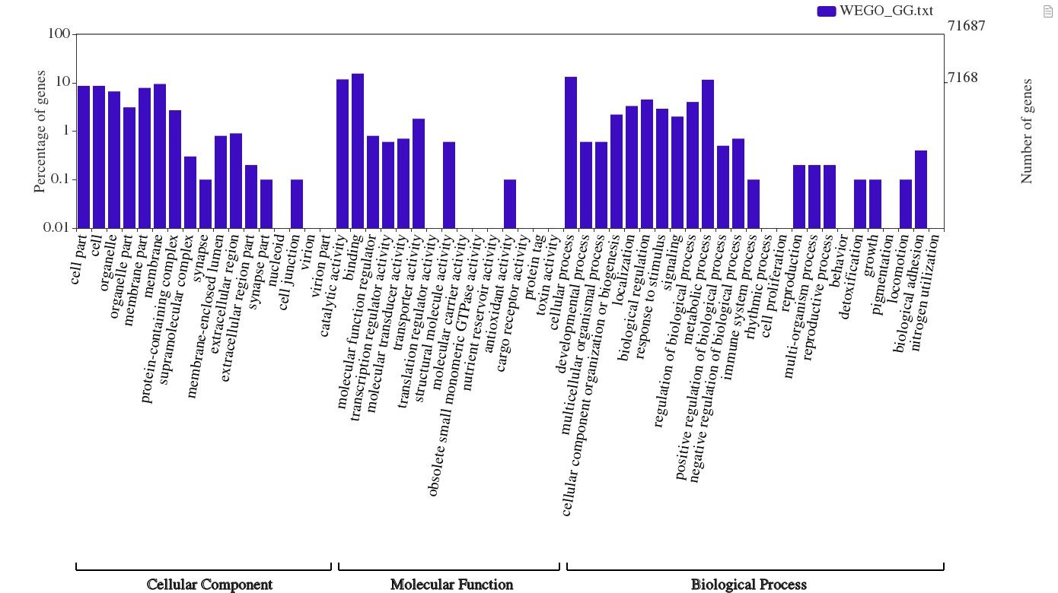
Figure S3. Gene ontology classification of genome-guided transcriptome

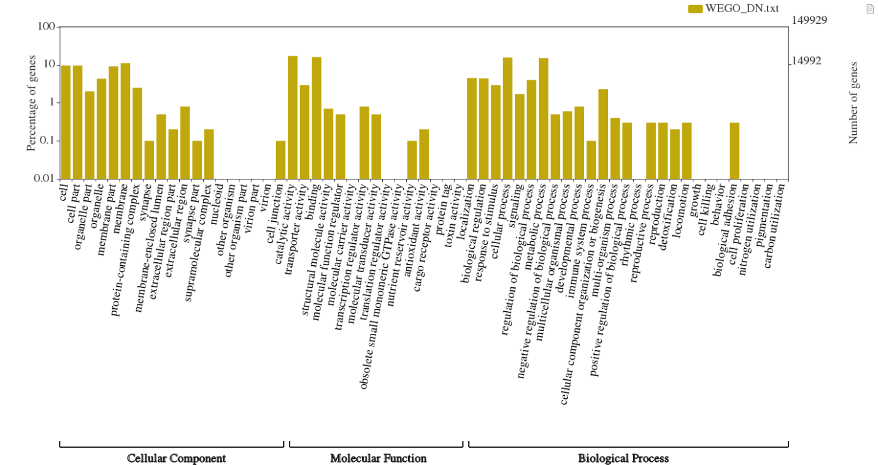

Figure S. Gene ontology classification of de novo transcriptome

