Table 4. Selected compounds from docked with putative drug targets
Molecule name | 2D structures | docking score  (kcal/mol) | Residues involved in hydrogen bonds | Residues involved in hydrophobic interaction
A0A3N4AYN0
Phloretin | 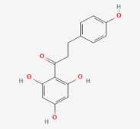 | -9.014 | Thr246, Tyr123, Lys237, Asn174, ASP202 | Gln245, Gly97, Leu242, Val98, His205, Ala234, Ser236, Ile204, Val99
Miraxanthin-I | 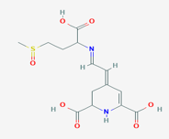 | -8.949 | Arg368, Ala39, Val99, Val98, Asn174 | Val38, Lys237, Tyr123, His205, Thr246, Ser236, Leu242, Pro100, Ile204, Gln245, Gly97
Chelidonate | 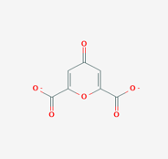 | -8.421 | Ala39, Arg368, Asn174, Tyr123 | Val38, Lys237, Leu242, Val99, His205
(S)-Mandelic Acid O-Beta-D-Glucopyranoside | 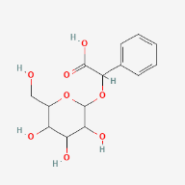 | -8.410 | Tyr123, Lys237, Asn174, Asp202 | Ser236, Gly97, Leu242, Val98, Val99, Ile204, Ala39, His205
4,4'-Dihydroxytruxillic acid | 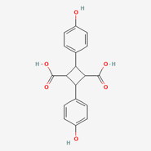 | -8.396 | Asn174, Val98, Tyr123, Gln245 | His205, Val99, Lys237, Asp202, Ile204, Ser236, Gly97, Leu242
Apigenin 7-glucuronide | 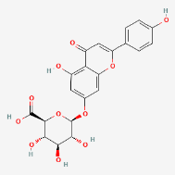 | -8.392 | Asn174, Tyr123, Lys237, Ala39, Glu17, Val98 | His205, Ile204, Asp202, Val199, Gly97, His125, Trp37, Val38
A0A0H2YHQ2
Valomaciclovir | 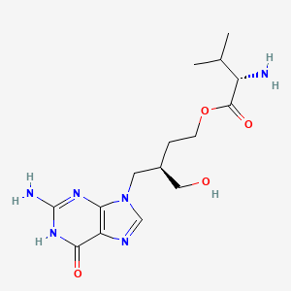 | -8.788 | Glu249, Phe208, Gly88, Lys87, Asp131 | Ile54, Lys127, Pro55, Asn40, Leu91, Thr86, Ser207
Miraxanthin-III | 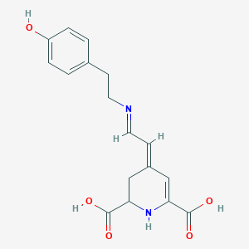 | -8.375 | Tyr57, Pro55, Lys127, Thr86, Ser207, Tyr128 | Glu56, Met205, Ile54, Glu249, Leu91, Lys87, Leu124, Ala206, Ser125
[(4-{4-[4-(Difluoro-Phosphono-Methyl)-Phenyl]-Butyl}-Phenyl)-Difluoro-Methyl]-Phosphonic Acid (DPA) | 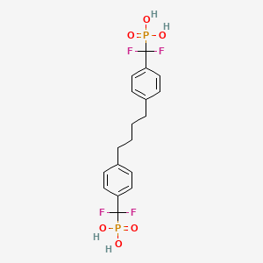 | -8.211 | Tyr57, Lys87, Lys127 | Ile59, Asn40, Leu91, Tyr128, Ser207, Gly88, Leu124, Thr86, Ala206, Met205, Glu249, Glu56
Salvianolic acid A | 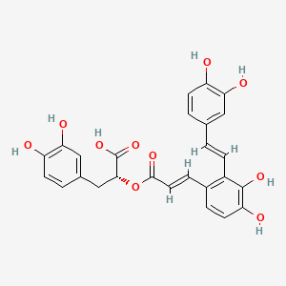 | -8.195 | Tyr57, Ile54, Lys87, Thr86, Leu124, Lys127, Phe208, Ala206 | Asn40, Leu91, Glu249, Glu56, Pro55, Gly88, Ser125, Tyr128, Ser207
Dofetilide | 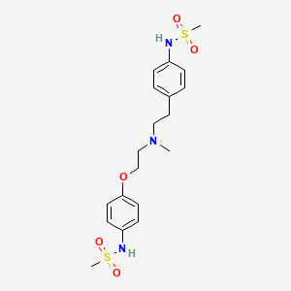 | -8.184 | Lys87, Tyr57, Glu249, Thr86, Leu124, Ser207, Tyr128 | Pro55, Glu56, Leu91, Ile54, Asn40, Met205, Ala206, Ser125, Gly88, Lys127

Table 5. ADMET analysis of docked compounds
Molecule name | Caco-2 Permeability (Log unit) |  | HIA | HOB | BBB penetration | PPB | VD | CYP2C9 inhibitor | CYP2D6 inhibitor | CYP3A4 inhibitor | half life | AMES toxicity | Carcinogenicity | Hepatotoxicity
A0A3N4AYN0
Phloretin |  | 0.33 | 68.37% | 0.45 | 0.25 | 97.52% | 0.563 | YES | YES | YES | 0.16 | 0.27 | 0.20 | 0.36
Miraxanthin-I |  | 0.08 | 47.57% | 0.5 | 0.56 | 20.62% | 0.353 | NO | NO | NO | 0.78 | 0.43 | 0.27 | 0.85
Chelidonate |  | 0.39 | 94.16% | 0.74 | 0.81 | 59.00% | 0.215 | NO | NO | NO | 0.01 | 0.16 | 0.36 | 0.53
(S)-Mandelic Acid O-Beta-D-Glucopyranoside |  | 0.08 | 21.79% | 0.18 | 0.41 | 47.52%% | 0.285 | NO | NO | NO | 0.52 | 0.11 | 0.21 | 0.09
4,4'-Dihydroxytruxillic acid |  | 0.20 | 76.59% | 0.84 | 0.47 | 89.03% | 0.348 | NO | NO | NO | 0.01 | 0.33 | 0.27 | 0.89
Apigenin 7-glucuronide |  | 0.09 | 40.83% | 0.65 | 0.50 | 14.67% | 0.553 | NO | NO | NO | 0.85 | 0.15 | 0.24 | 0.08
A0A0H2YHQ2
Valomaciclovir |  | 0.29 | 74.06% | 0.88 | 0.91 | 35.95% | 0.739 | NO | NO | NO | 0.74 | 0.27 | 0.34 | 0.99
Miraxanthin-III |  | 0.23 | 85.06% | 0.67 | 0.72 | 40.78% | 0.221 | NO | NO | NO | 0.26 | 0.30 | 0.35 | 0.67
[(4-{4-[4-(Difluoro-Phosphono-Methyl)-Phenyl]-Butyl}-Phenyl)-Difluoro-Methyl]-Phosphonic Acid (DPA) |  | 0.14 | 28.66% | 0.76 | 0.78 | 98.63% | 0.497 | NO | NO | NO | 0.99 | 0.38 | 0.28 | 0.41
Salvianolic acid A |  | 0.29 | 38.71% | 0.04 | 0.31 | 96.19% | 0.324 | YES | NO | NO | 0.09 | 0.21 | 0.43 | 0.42
Dofetilide |  | 0.30 | 95.88% | 0.91 | 0.63 | 55.30% | 0.645 | NO | YES | NO | 0.98 | 0.38 | 0.43 | 0.96

