Supplementary Information
Scientific Reports
Pom-1 anti-Candida albicans-biofilm peptides rescue efficacies of the antifungals fluconazole and amphotericin B
Supplementary Material
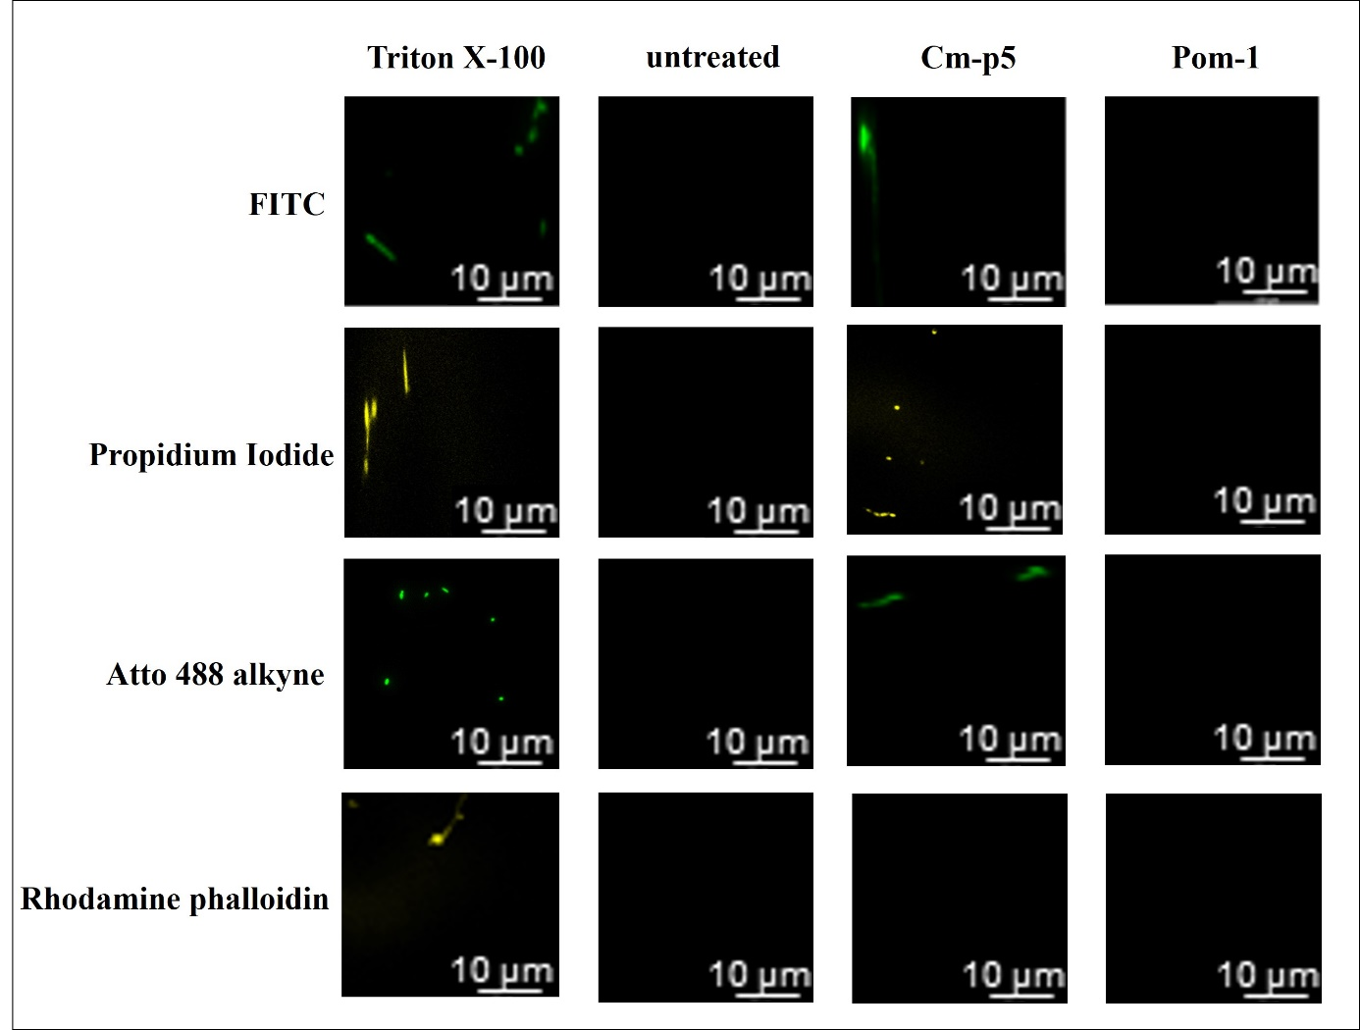
Figure S1. Pom-1 has no influence on cell permeability whereas the known Cm-p5 increases the permeability of C. albicans cells. Fluorescence microscopy images were obtained after the permeabilization assay. Shown are images of C. albicans cells after treatment with Triton X-100, Cm-p5, Pom-1 and untreated cells and consequent staining with the fluorescent dyes (increasing in size) FITC, propidium iodide, Atto 488 alkyne and rhodamine phalloidin.

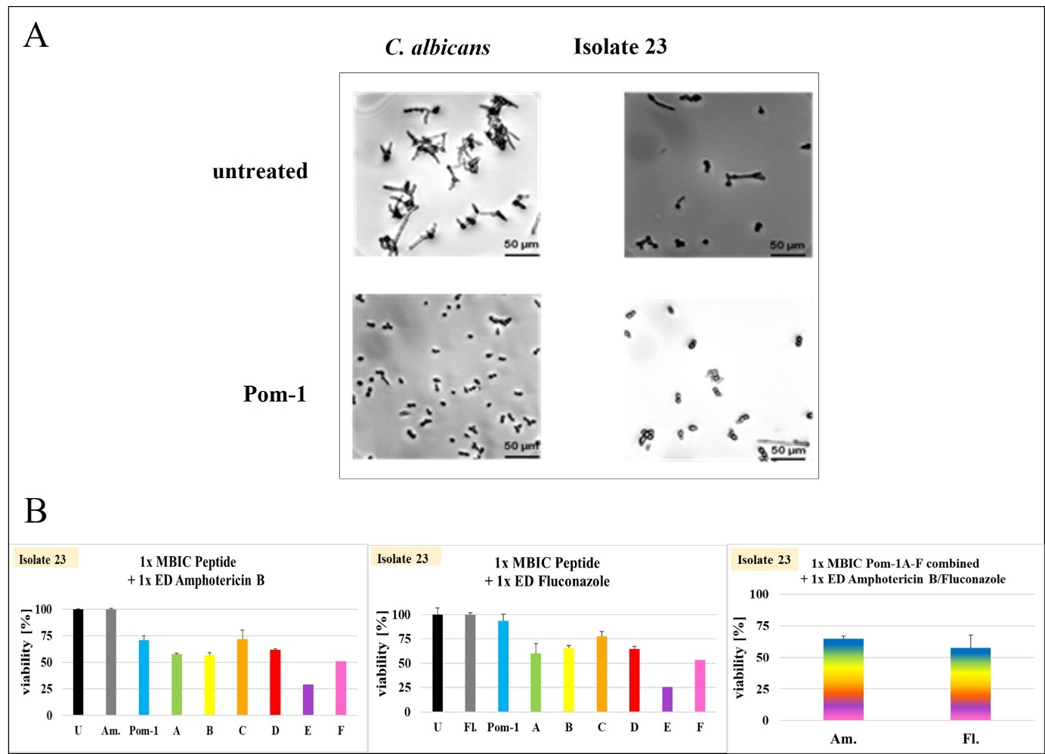
Figure S2. Inherent resilience to aggregation by isolate 23 and marginal reduction of viability by further raised concentrations of antifungal and peptide combinations. (A) Microscopic analysis using a Leica DMi8 coded (Leica Microsystems CMS GmbH, Wetzlar, Germany) microscope of C. albicans laboratory strain and clinical isolate 23 with and without treatment with Pom-1. The pictures were taken after an incubation time of 2 h. (B) Cell viability of clinical isolate 23 after treatment with 1x MBIC of the individual Pom-1 derivatives as well as 1x ED of amphotericin B/fluconazole and cell viability of isolate 23 after treatment with 1x MBIC of all Pom-1 derivatives in mixtures combined with 1x ED amphotericin B/fluconazole. “U” indicates the untreated control whereas “Am.” And “Fl.” represent amphotericin B and fluconazole. The individual Pom-1 derivatives are named according to their letter (A-F).

