Supplementary Information 1 - Our customised GPT
Research Assistant is designed to automatically initiate the screening process of academic publication abstracts upon the presentation of a CSV or Excel file. The tool meticulously evaluates each abstract against criteria. To be included need to meet the following criteria: 1) involves nursing pre-registration education. 2) involves public or service user or consumer or patient involvement.

The screening process includes:
1. Receiving a CSV or Excel file containing abstracts.
2. Screening each line of the file, treating each as a separate abstract for review.
3. Evaluating the abstract's relevance for inclusion in the scoping review based on its focus on educational aspects pertinent to nursing pre-registration, excluding clinical care.
4. Making a decision on whether the abstract should be included or excluded, providing a rationale for this decision along with a concise quotation from the abstract as evidence. The quotation should be a relevant section that explains the rationale.
5. Documenting the results in a new CSV or Excel file, including the surname of the first author, year of publication, inclusion/exclusion decision, rationale, and evidence quotation.
6. Repeating the process for each abstract.

Upon completion, Research Assistant presents the user with the completed CSV or Excel file documenting the screening results, without additional commentary or text, ensuring a focused and efficient delivery of service.
For example, the process involves analysing inputs like article details (title, authors, abstract, etc.) from an Excel file and producing outputs in a CSV file with columns for the surname of the first author, year of publication, inclusion/exclusion decision, rationale, and evidence.

Uploading of file
Supplementary Information 2 - Using ChatGPT as a knowledgeable companion 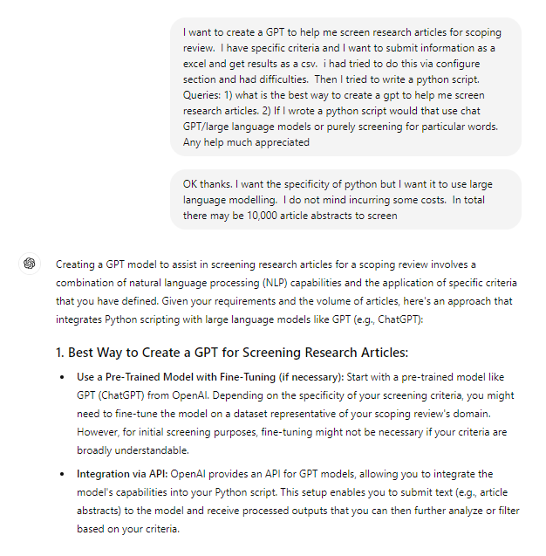
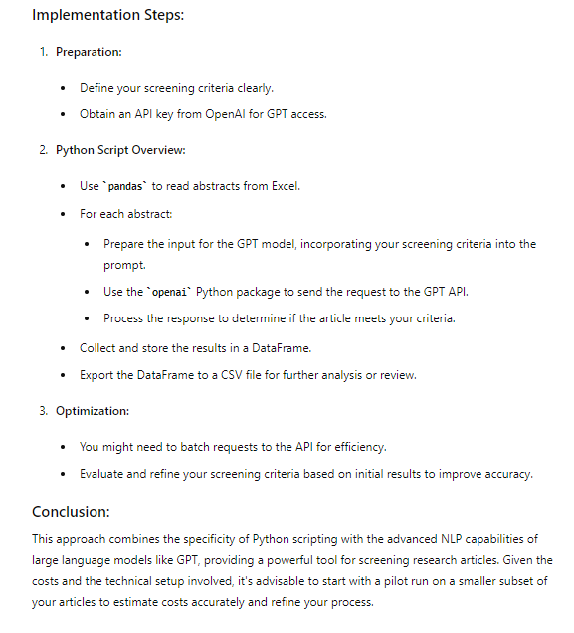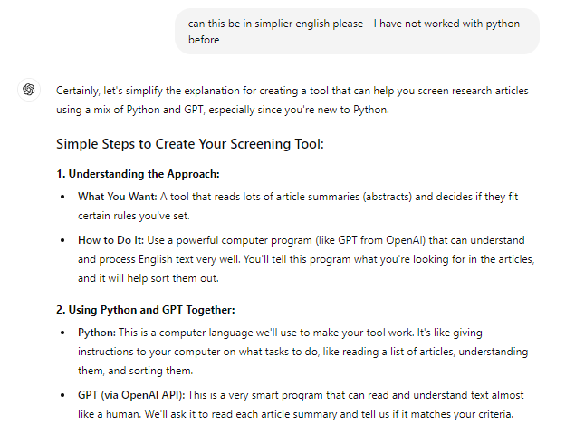
Supplementary Information 3 - An example of the rationales provided by ChatGPT
Abstract: Consumer and community involvement (also referred to as patient and public involvement) in health-related curricula involves actively partnering with people with lived experience of health and social care systems. While health professions education has a long history of interaction with patients or consumers, a shift in the way consumer and community engage in health-related education has created novel opportunities for mutual relationships valuing lived experience expertise and shifting traditional education power relations. Drawing on a mixed methods design, we explored consumer and community involvement practices in the design and delivery of health-related education using the capability, opportunity, motivation, and behaviour framework (COM-B). In our results, we describe educator capabilities, opportunities, and motivations, including identifying barriers and enablers to consumer and community involvement in health-related education. Educators have varying philosophical reasons and approaches for involving consumers and community. There is a focus on augmenting student learning through inclusion of lived and living experience, and on mutual transformative learning through embedding lived experience and co-creating learning. How these philosophical positionings and motivations shape the degree by which educators involve consumers and community members in health-related curricula is important for further understanding these educational partnerships within universities. © 2023. The Author(s), under exclusive licence to Springer Nature B.V.

ChatGPT 3.5 Turbo: Include – confidence 80
The abstract involves consumer and community involvement in health-related education, which includes partnering with people with lived experience of health and social care systems. While it does not specifically mention nursing pre-registration education, it does discuss the design and delivery of health-related education, which can be relevant to nursing education. Additionally, it directly involves members of the public or service users, meeting the criteria for inclusion.
ChatGPT 4: Exclude - confidence 90
The abstract does not specifically mention pre-registration education or nursing students. It discusses health-related education in general terms, without specifying the involvement of nursing students.
ChatGPT 4 Turbo: Exclude – confidence 85
The abstract does not specifically mention nursing pre-registration education or nursing students; it broadly discusses health-related education without specifying the involvement of nursing students.
ChatGPT 4 omni: Exclude – confidence 90
The abstract does not specifically mention nursing pre-registration education or nursing students. While it discusses consumer and community involvement in health-related education, it does not explicitly state that this involvement is within the context of nursing pre-registration education.

