Supplementary methods
Circularization of linear DNA
Phosphorylated linear DNA (92 bases) and primer DNA (22 bases) at a final concentration of 10 μM were mixed in nuclease-free water (Table S1). For denaturation and annealing, the mixture was heated to 95 °C for 2 min and cooled slowly to 25 °C for 1 h using a thermal cycler (Bio-Rad). To ligate the nick in the circularized DNA, the solution was incubated overnight with 0.06 U·μl⁻¹ of T4 DNA ligase and ligase buffer (30 mM Tris-HCl (pH 7.8), 10 mM MgCl₂, 10 mM dithiothreitol (DTT), and 1 mM adenosine triphosphate (ATP)).

Rolling Circle Amplification (RCA) of biotin-modified DNAMS via RCA and Streptavidin Quantum Dot (STA-QD) conjugation
For rolling circle DNA replication, the circularized template (at a final concentration of 1 μM) was incubated with Phi29 DNA polymerase (10 U·μl⁻¹), dNTP mix (0.8 mM), biotin-14-dCTP (0.04 mM), and reaction buffer (50 mM Tris-HCl, 10 mM MgCl2, 10 mM (NH4)2SO4, and 4 mM DTT) for 20 h at 30 °C. Following incubation, the solution was centrifuged at 3000 RCF for 5 min to remove the supernatant. The particles were then washed with nuclease-free water; washing was repeated twice to thoroughly remove RCA reagents. Hoechst 33342 dye was added to the washed biotin-modified DNAMS, and the mixture was incubated overnight in a 1000D solution. The dyed DNAMS was then washed using the aforementioned method.
To conjugate quantum dots to the biotin-modified DNAMS, 500 ng of biotin-modified DNAMS was mixed with 0.4 μM of Qdot 565 Streptavidin Conjugate (Invitrogen) solution and incubated for at least 48 h at room temperature. The STA-QD DNAMS was then washed as previously described to remove any unbound reagents. Imaging of the STA-QD DNAMS was performed using an Eclipse Ti (Nikon) inverted fluorescence microscope.

Dot Blot Analysis with aptamer 1 and STA-QD DNAMS
Polyvinylidene fluoride (PVDF) membrane was activated via soaking in methanol (100%) for 1 min. After activation, the membrane was washed with NFW. The protein (BSA or USE1) was loaded onto the PVDF membrane and incubated at 37 ℃ for 1 h. The membrane was washed with PBST (0.1% v/v) for 5 min. For denaturation and annealing of aptamer 1, 5 μM of diluted aptamer solution was heated to 95 °C for 2 min and cooled slowly to 25 °C for 1 h using a thermal cycler (Bio-Rad). Thereafter, the USE1 aptamer was loaded on the protein with different concentrations and incubated at 37 ℃ for 1 h. The membrane was washed with PBST as mentioned earlier. STA-QD (40 fmole) or STA-QD DNAMS (2 pmole) was loaded on the dot and incubated at 37 ℃ for 1 h. Finally, the membrane was washed with PBST overnight. A Dot Blot image was captured using the Gel Doc imaging system. Heatmaps were generated by analyzing the relative intensity of each spot relative to the control blot.

Fluorescence biosensing kit for USE1 protein detection
The kit scaffold was designed using TinkerCad and fabricated with a multijet 3D printer (3D Systems, ProJet 3510 HD) using a biocompatible UV-curable resin (3D Systems, Visijet M3 Crystal). The dimensions of the kit body were 1.0 cm x 1.2 cm x 2.5 cm, with two wells for loading the solutions. An activated PVDF membrane was attached to the backside of the scaffold. For the experimental setup, 500 nM of streptavidin was loaded onto the control line, while 500 nM of BSA or USE1 protein was loaded onto the test line. Thereafter, incubation was performed at 37 °C for 1 h. After incubation, the lines were washed with PBST. Denaturation and annealing of aptamer 1 were performed as described earlier. Subsequently, 20 pmoles of USE1 aptamer was loaded onto each line and incubated at 37 °C for 1 h. After washing with PBST, 2 pmole of STA-QD DNAMS was loaded into the wells, which were then incubated at 37 °C for 1 h. Finally, the wells were washed with PBST, and images were captured using a Canon EOS M50 Mark II (Canon, Inc., Tokyo, Japan).
The RGB digital images were processed into HSB images using ImageJ software. The hue image was depicted in pseudocolor. For colorimetric analysis, the saturation intensity of the control (C) and test (T) lines based on the color image was analyzed using ImageJ software.
.

Table S1. DNA sequences for circular DNA synthesis and fabrication of DNAMS.
Name | Sequence (5’ to 3’) | Modification
Linear DNA (92 bp) | ACG TAC GGG TGA CGA AAC GAC GTT CCA TCG CTG TTA GAC TCA GAT TGG TTG CAC TTT CAG CAC GGG TTA TTC CGA GTG AAC CGT CCA CCA TC | 5’-Phosphate
Primer (20 bp) | CCC GTA CGT GAT GGT GGA CG

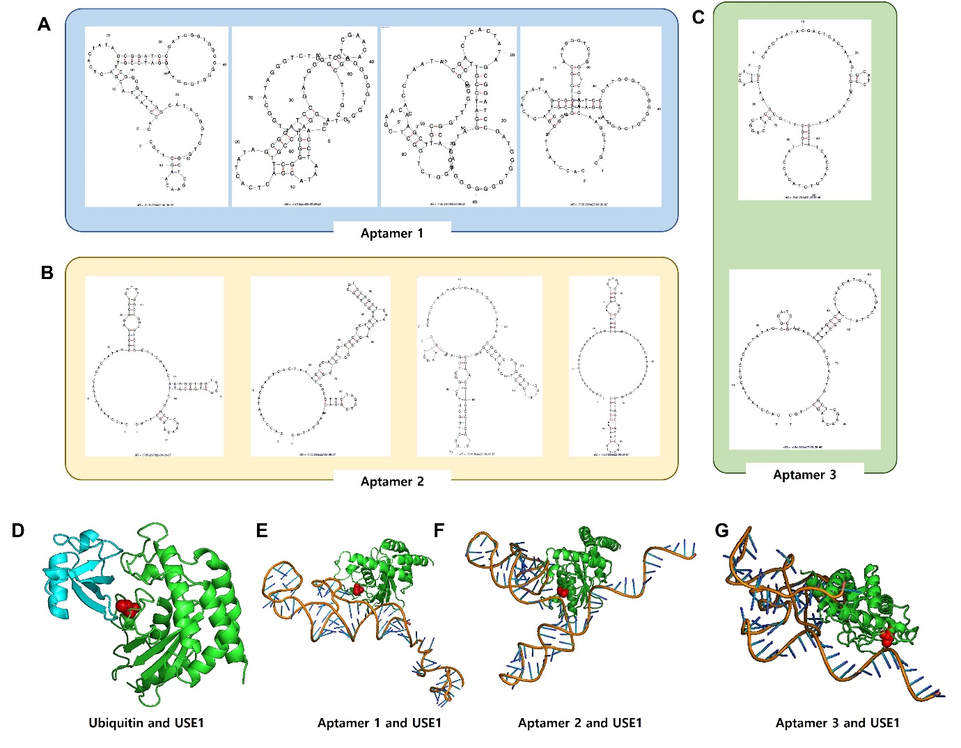Supplementary figure. 1. Predicted structures and docking simulation of aptamers.
(A-C) Secondary structure of aptamers 1, 2, and 3 were predicted using M-fold
(D-G) 3D binding model of aptamers 1, 2, and 3 with USE1 protein based on HDOCK

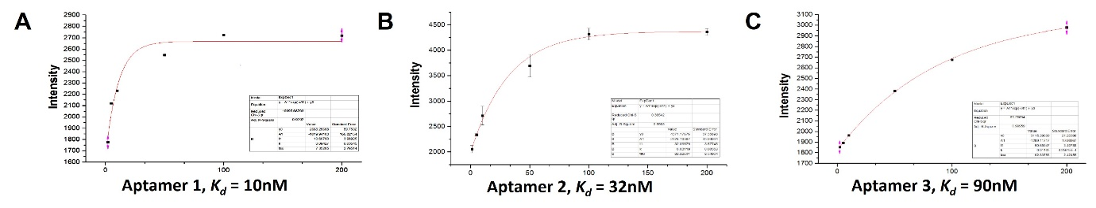
Supplementary figure. 2. Estimated equilibrium dissociation curve of Aptamers 1, 2, and 3.
The estimated dissociation constant (K_{d}) were 10 nM, 32 nM, and 90 nM for Aptamer 1 (A), 2 (B), and 3 (C), retrospectively.
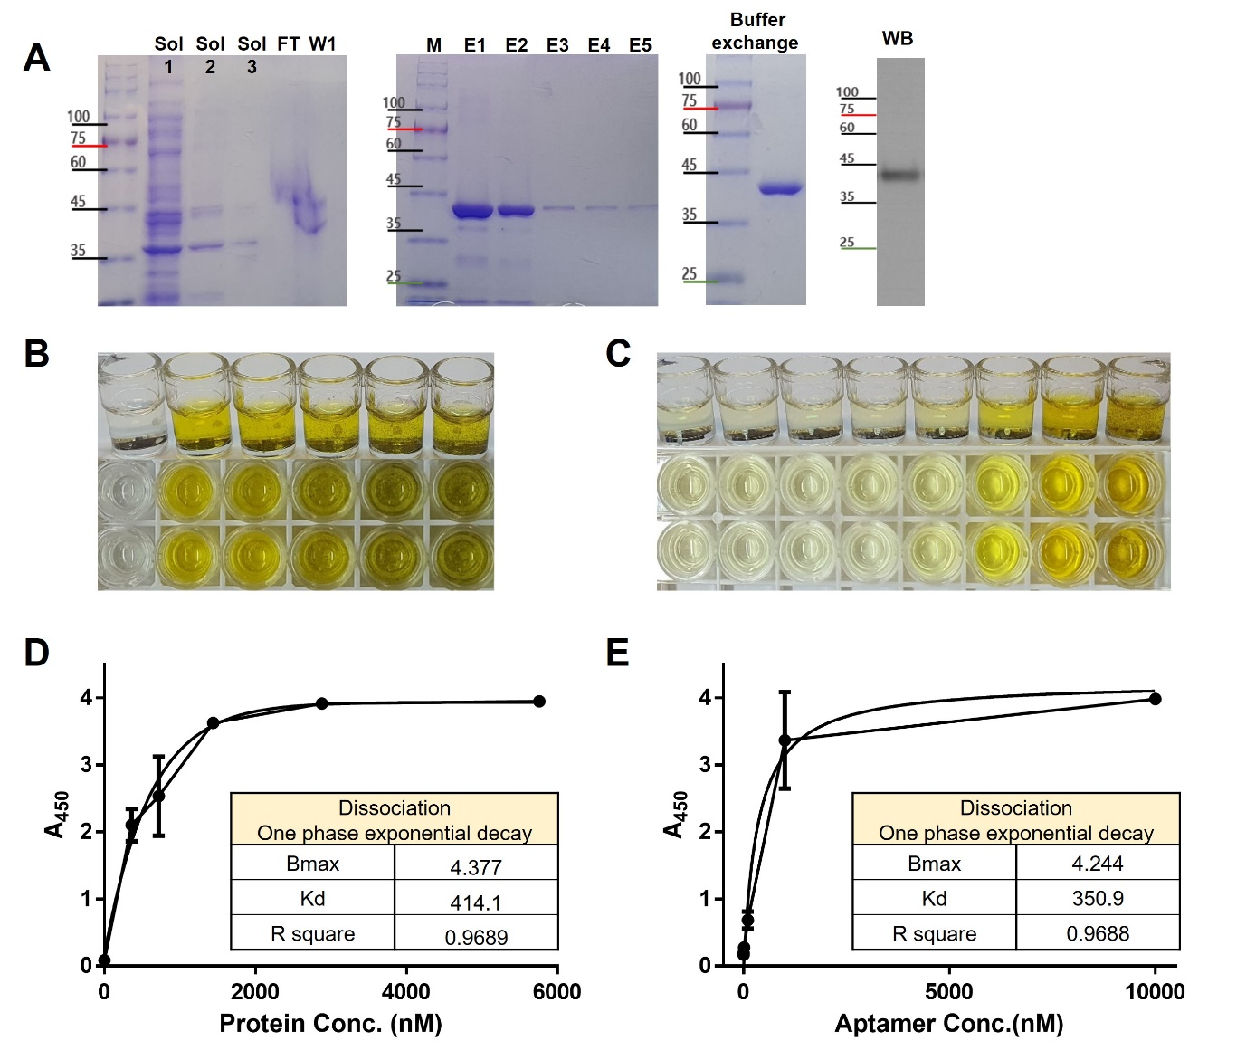
Supplementary figure. 3. Purification of the target protein, USE1, and dissociation constant of Aptamer 1 for the USE1 protein using ELONA.
- Solubility test, elution, buffer exchange, and immunoblotting for USE1 protein purification and validation.
(B, D) Microtiter plates were coated with 0-5,800 nM of the USE1 protein; 10 μM of 5′ biotinylated aptamer 1 was applied for binding. Each data point represents the average of four independent experiments, each with two replicates.
(C, E) Microtiter plates were coated with 723 nM of the USE1 protein; 0-10,000 nM of 5′ biotinylated aptamer 1 was applied for binding. Each data point represents the average of four independent experiments, each with two replicates.

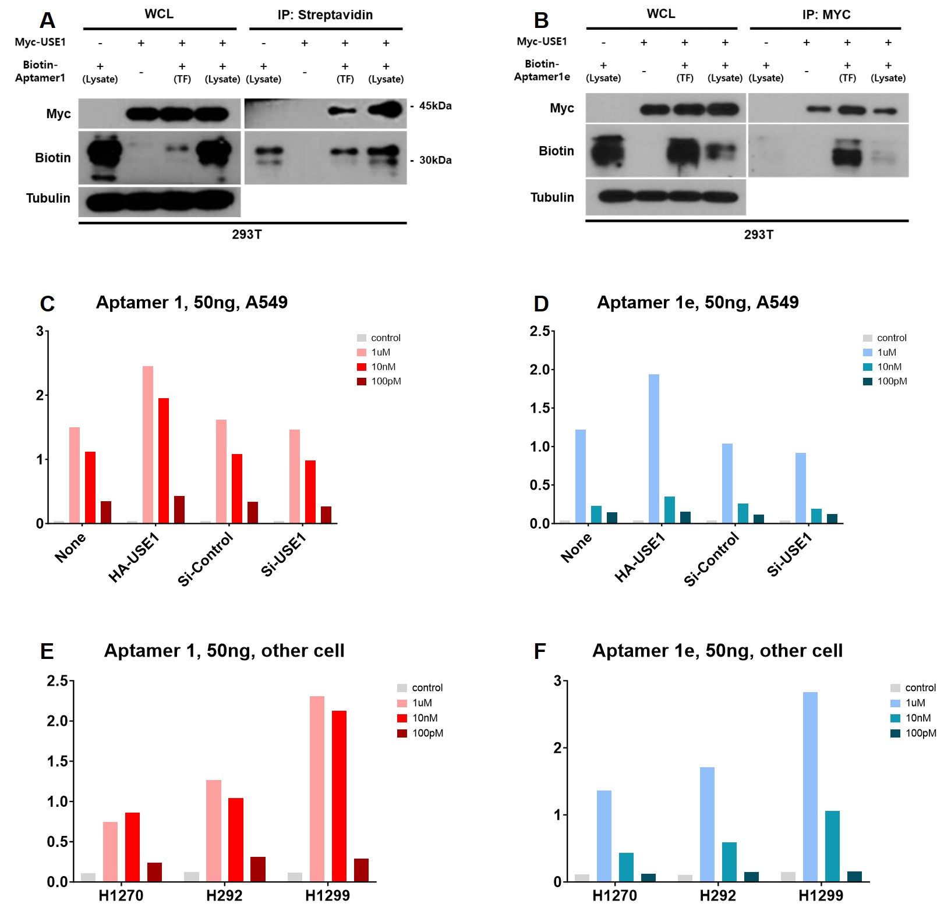
Supplementary figure 4. Evaluation of the binding ability of aptamer 1 and truncated aptamer 1e with the USE1 protein using in vitro and in vivo immunoblotting and ELONA.
- HEK293T cells were transfected with Myc-USE1 and Biotin-Aptamer 1, and cell lysates were analyzed via immunoprecipitation with streptavidin beads followed by immunoblotting with antibody against Myc and Biotin.
- HEK293T cells were transfected with Myc-USE1 and Biotin-Aptamer 1e, and cell lysates were analyzed via immunoprecipitation with Myc beads followed by immunoblotting with antibody against Myc and Biotin.
- USE1 was overexpressed or knocked down (siUSE1) in A549 cells using; 50 ng of the cell lysate with Aptamer 1 was analyzed using ELONA.
- USE1 was overexpressed or knocked down (siUSE1) in H1270, H292, and H1299; 50 ng of the cell lysate with Aptamer 1 was analyzed using ELONA.
- USE1 was overexpressed or knocked down (siUSE1) in A549 cells; 50 ng of the cell lysate with Aptamer 1e was analyzed using ELONA.
- USE1 was overexpressed or knocked down (siUSE1) in H1270, H292, and H1299; 50 ng of the cell lysate with Aptamer 1e was analyzed using ELONA.

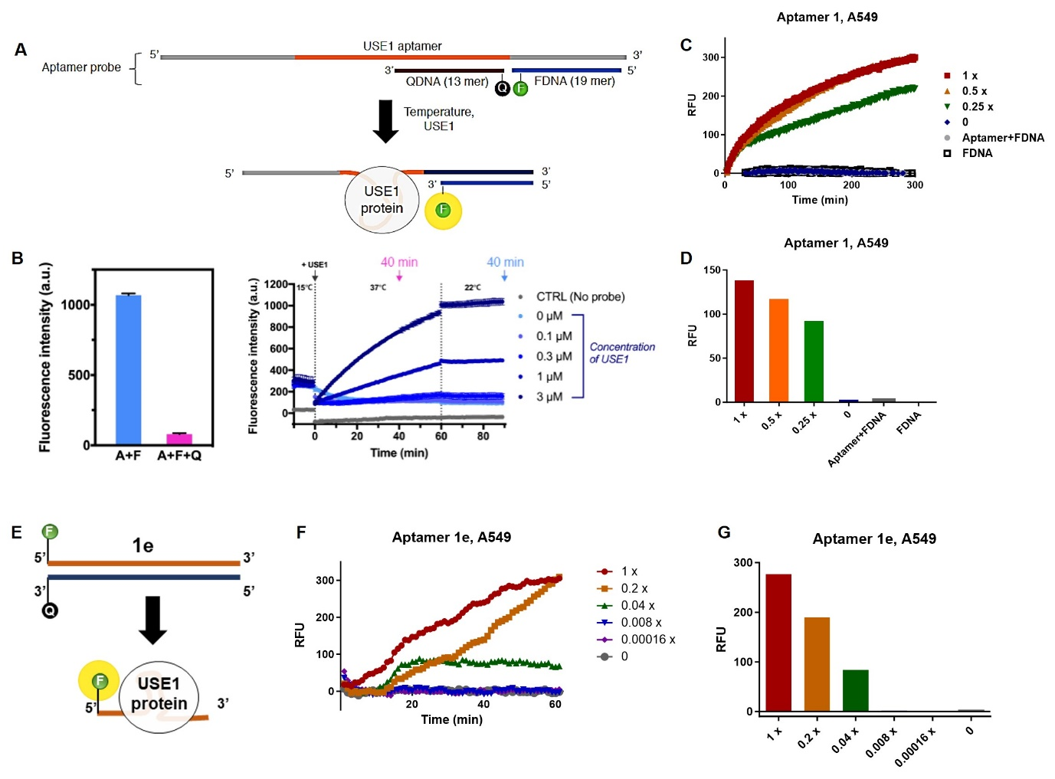
Supplementary figure 5. Fluorescence/quencher aptamer probe for USE1 protein detection.
- Construction scheme of Fluorescence/quencher aptamer 1 probe.
- Fluorescence intensity according to the concentration of USE1 protein.
- Time dependent aptamer probe binding assay with aptamer 1 and the USE1 protein in A549 cell lysate.
- Dose of USE1 protein dependent aptamer probe binding assay with with aptamer 1 and the USE1 protein in A549 cell lysate.
- Construction scheme of Fluorescence/quencher aptamer 1e probe
- Time dependent aptamer probe binding assay with aptamer 1e and the USE1 protein in A549 cell lysate.
- Dose of USE1 protein dependent aptamer probe binding assay with aptamer 1e and the USE1 protein in A549 cell lysate.

