Supplementary materials for the article “Imaging volcanoes during unrest: Ambient Noise Tomography of a transient plumbing system, Vulcano, Italy.”

Douglas Stumpp^{(1,*)}, Iván Cabrera-Pérez ⁽¹⁾, Geneviève Savard ⁽¹⁾, Tullio Ricci ⁽²⁾, Salvatore Alparone ⁽³⁾, Andrea Ursino ⁽³⁾, Mimmo Palano ⁽³⁾, Federica Sparacino ⁽³⁾, Francisco Muñoz Burbano ⁽¹⁾, Célia Barat ⁽¹⁾, Joël Ruch ⁽¹⁾, Costanza Bonadonna ⁽¹⁾, María-Paz Reyes Hardy ⁽¹⁾, and Matteo Lupi ⁽¹⁾.

(1) Department of Earth Sciences, University of Geneva, Geneva, Switerland.
(2) Istituto Nazionale di Geofisica e Vulcanologia, Roma, Italy.
(3) Istituto Nazionale di Geofisica e Vulcanologia – Osservatorio Etneo – Sezione di Catania, Italy.
*douglas@stumpp.fr

List of Figures
Figure S1 shows the ray path density (and anisotropy map).
Figure S2 shows the cross-correlations of all station pairs and the Rayleigh wave dispersion curves used in this study.
Figure S3 shows the checkerboard tests and the corresponding recovered group velocity maps.
Figure S4 shows the Rayleigh wave 2-D group velocity maps for different scales.
Figure S5 shows the Rayleigh wave 2-D group velocity maps for different periods.
Figure S6 shows an example of 1D transdimensional inversion.
Figure S7 shows the sensivity kernels for different periods.

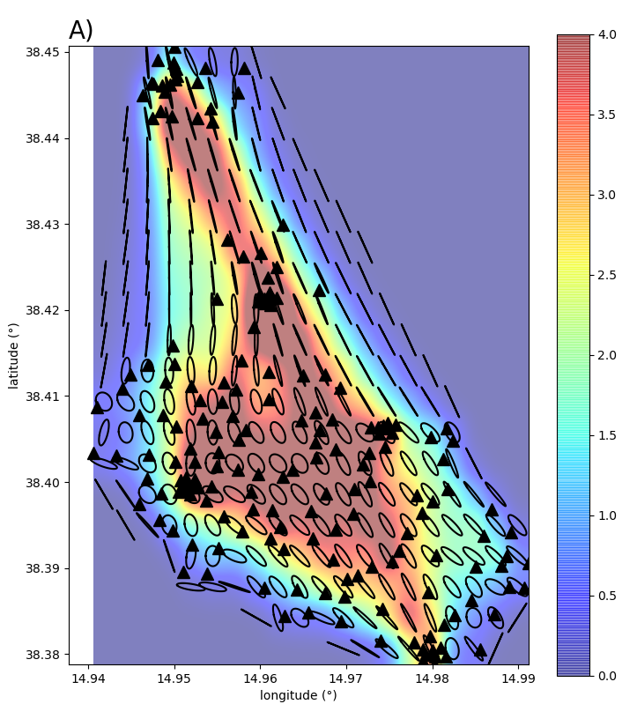
Ray Density (km⁻¹)
Figure S1. The map shows the distribution of seismic stations (black triangles), while the density of ray paths is indicated by the color bar. The ellipses on the figure illustrate the anisotropy of the ray paths.
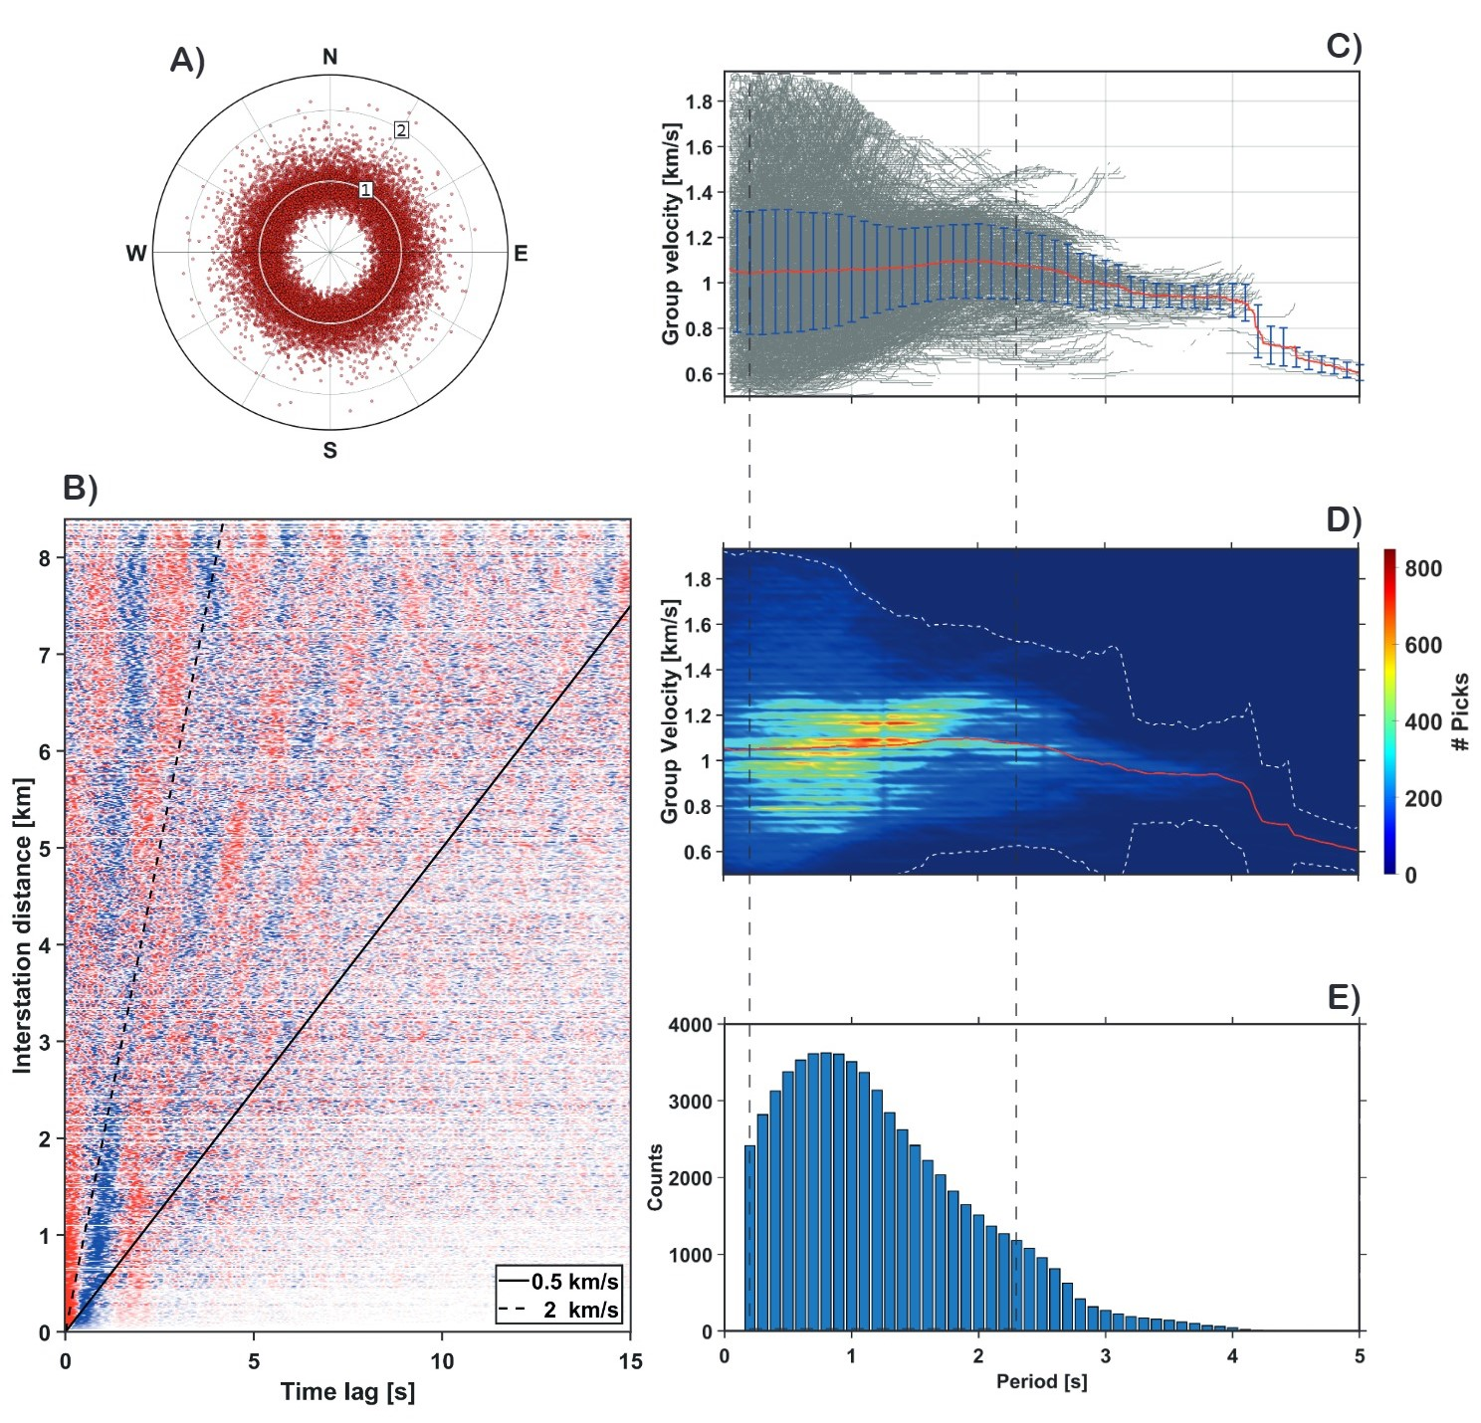

Figure S2. A) Amplitude ratio of causal and acausal parts of cross-correlations as a function of the azimuthal distribution. The white circle represents the unitary value of the amplitude ratio. B) Symmetric cross-correlations of all station pairs are sorted according to the interstation distance. Velocities of 0.5 and 2.0 km/s are marked. C) Rayleigh wave dispersion curves (grey lines) were used in this study. The average dispersion curve with the corresponding standard deviation (blue line) is in red. D) Histogram distribution of all the dispersion curve picks used in this study. The red line shows the mean dispersion curve, while the white dotted lines shows the interval defined by three standard deviations from this mean. E) Number of measurements as a period function. The grey dotted square represents the period's range used in the inversion (0.2-2.6s).

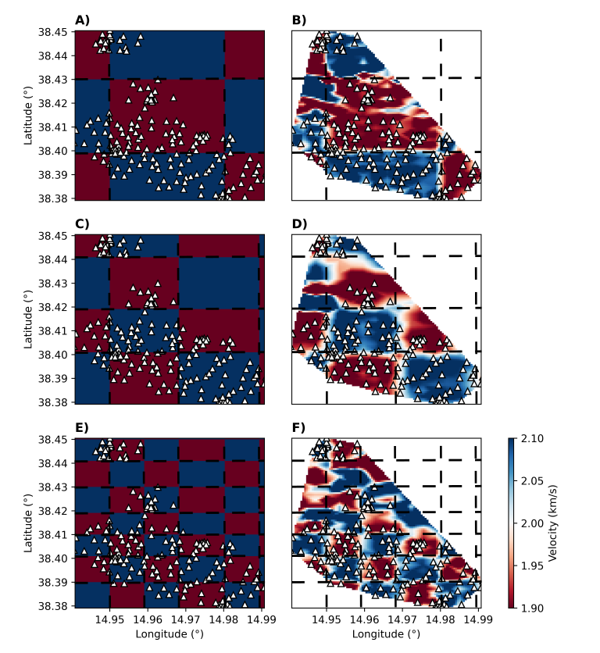
Figure S3. Checkerboard tests with (A) 0.03º x 0.03º, (C) 0.02º x 0.02º and (E) 0.01º x 0.01º. The corresponding recovered group velocity maps are shown in panels (B), (D) and (F), respectively.
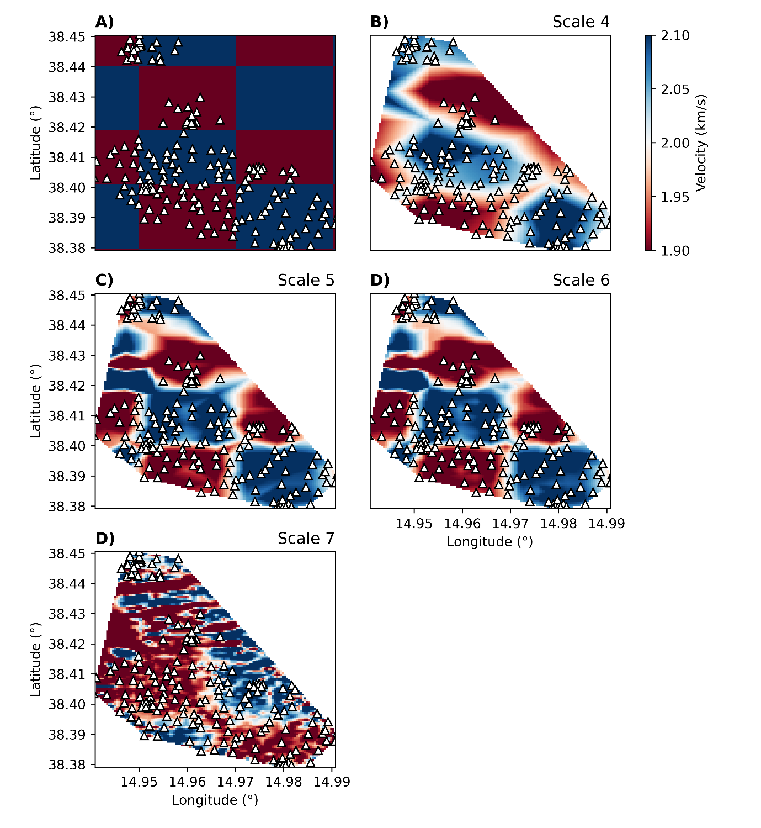
E)
Figure S4. Rayleigh wave 2-D group velocity maps for different scales, B) scale 4, C) scale 5, D) scale 6 and E) scale 7 for a period of T=1.00 s, which checkerboard is represented in Figure A). White triangles represent the location of seismic stations and the nodes used in the inversion process.

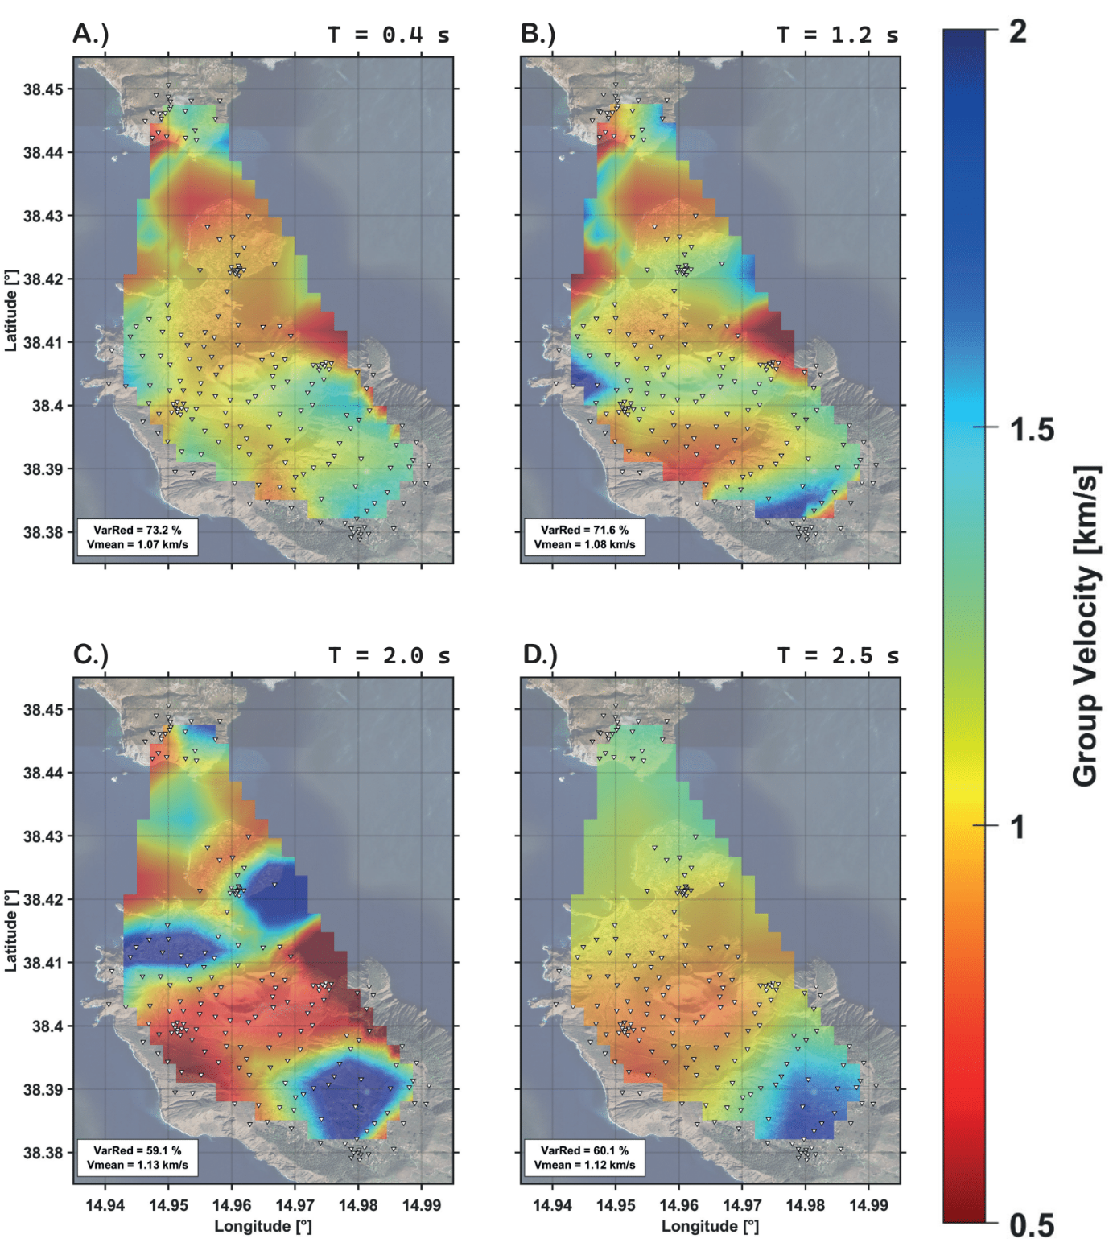

Figure S5. Rayleigh wave 2-D group velocity maps for different periods (indicated at the top-right of each panel) between T = 0.40 and T = 2.50 s. White triangles represent the seismic stations. Variance reduction and mean velocity are indicated at the bottom-left corner of each panel.
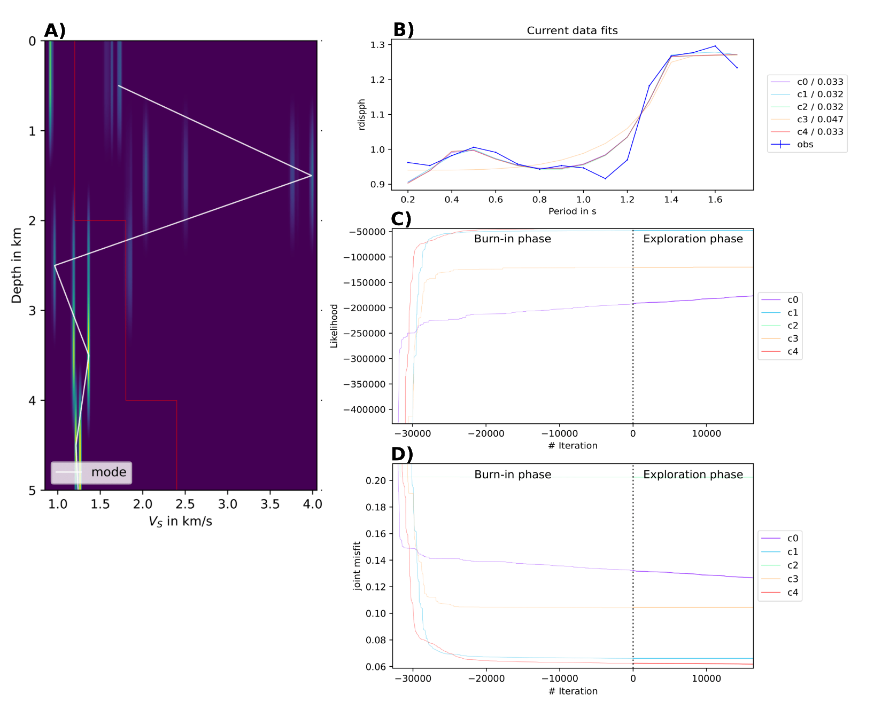
Figure S6. Example of 1-D transdimensional inversion. The colour represents the probability distribution for Vs at each depth. The red and white lines represent the initial model and the mode, respectively.
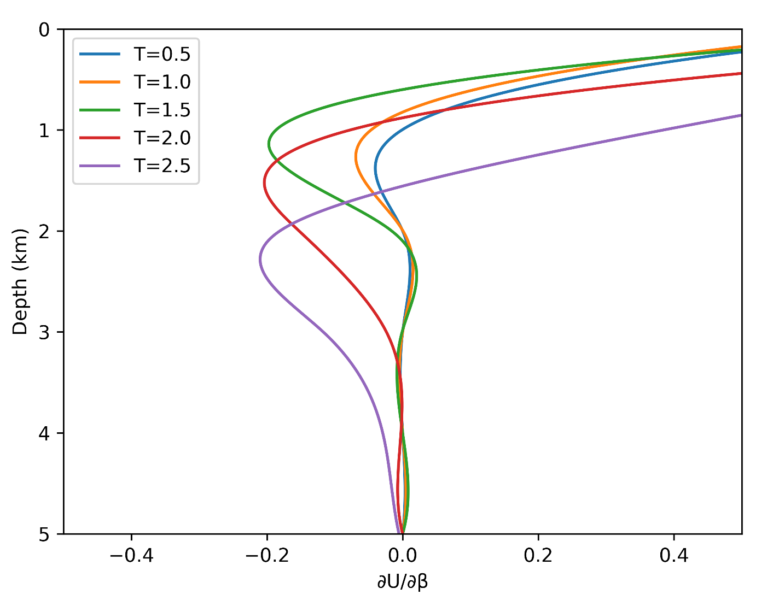
Figure S7. Fundamental mode of the Rayleigh wave group velocity sensitivity kernels for T = 0.5 s (blue line), T = 1 s (orange line), T = 1.5 s (green line), T = 2 s (red line) and T = 2.5 s (purple line) periods. Kernel is based on the 1-D mean S-wave velocity model. The horizontal black dashed line denotes the maximum resolution in the depth of our model.

