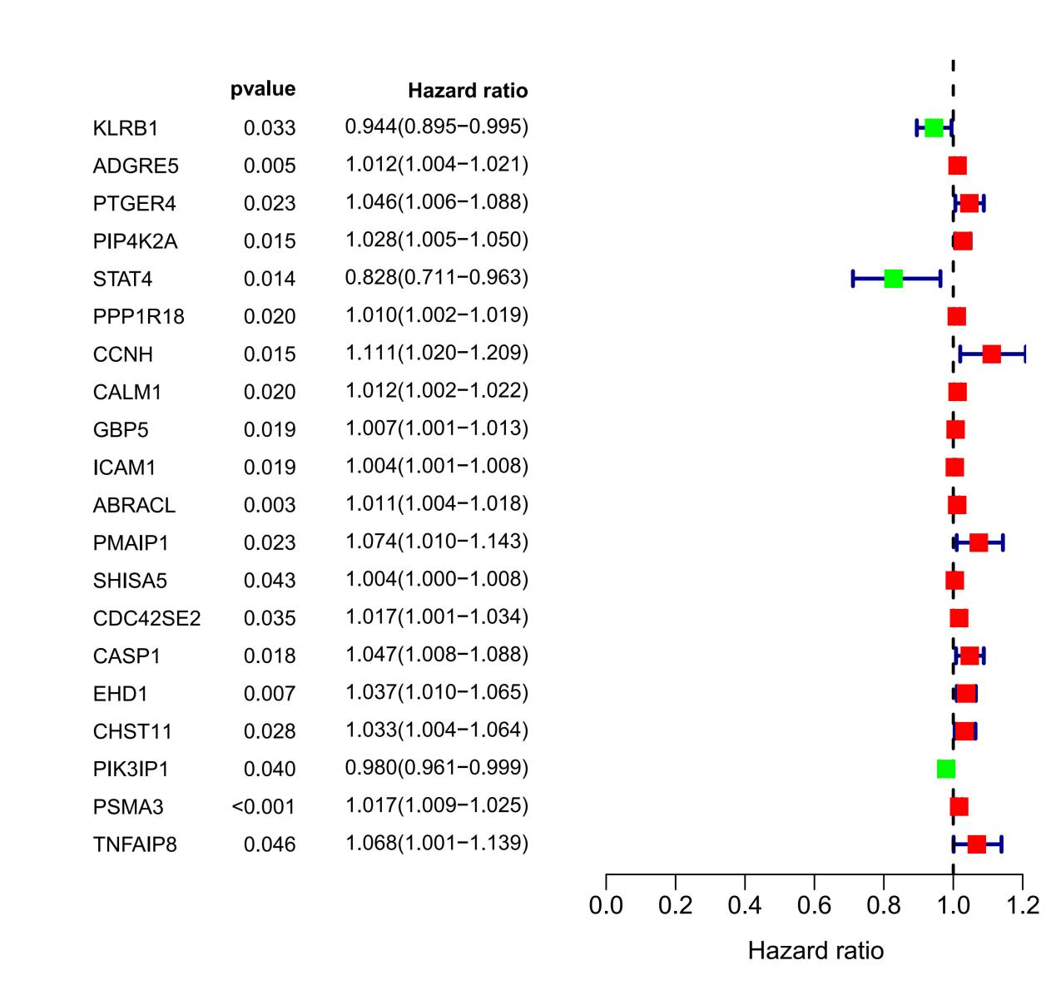
Figure S1 Show the result of Unicox analysis

