An Inclusive agri-food systems transformation pathway for India
Supplementary Material

Validation plots and historical trends
Fig SM1: Comparison of key indicators (population, per capita income, calorie supply and crop and livestock demand) across model and historical data for the baseline (BASE_SSP2) and FST_SDP scenario
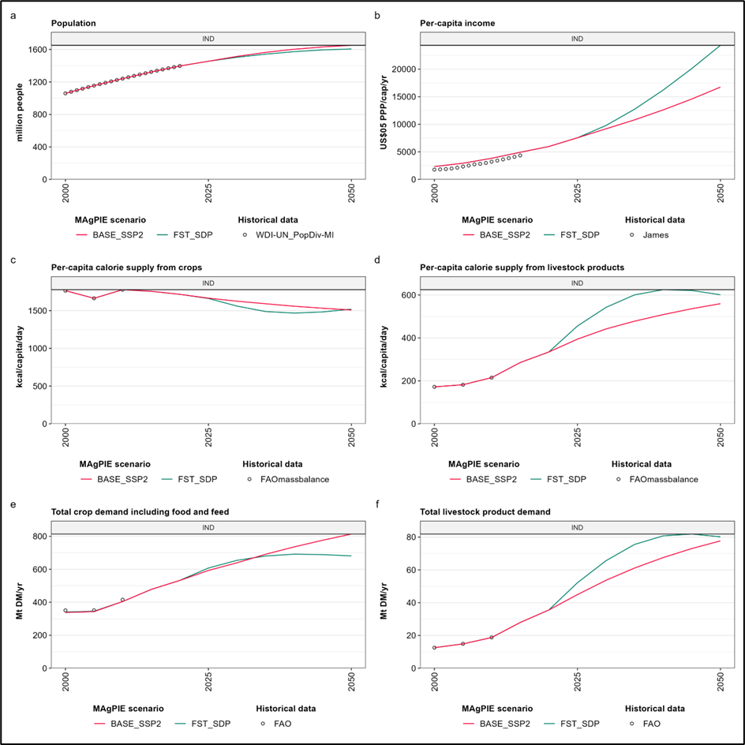

Fig SM2: Comparison of key indicators (land types) across model and historical data for the baseline (BASE_SSP2) and FST_SDP scenario
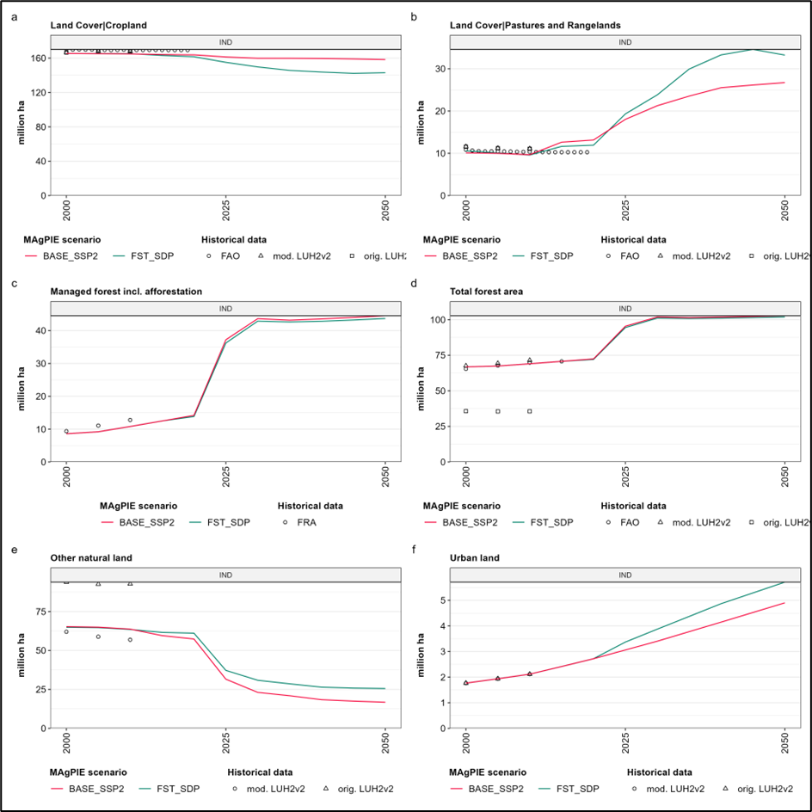

Fig SM3: Comparison of key indicators (technological intensification, nitrogen use and agricultural water withdrawals) across model and historical data for the baseline (BASE_SSP2) and FST_SDP scenario
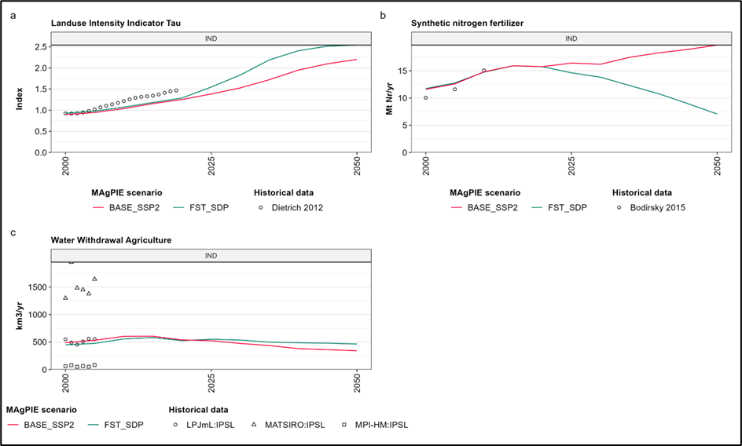

Figure SM4: Food expenditure out of total expenditure over the years up to 2050 for all scenarios 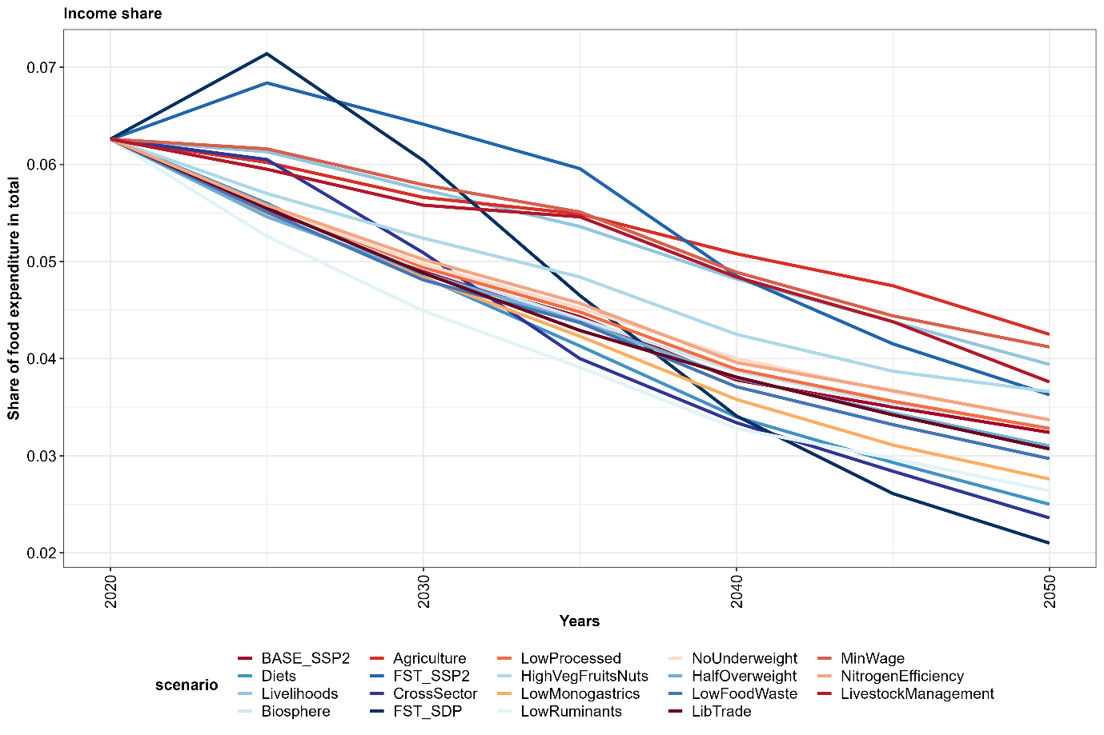

Figure SM5: Irrigated cropland for food based dietary scenarios over the years up to 2050
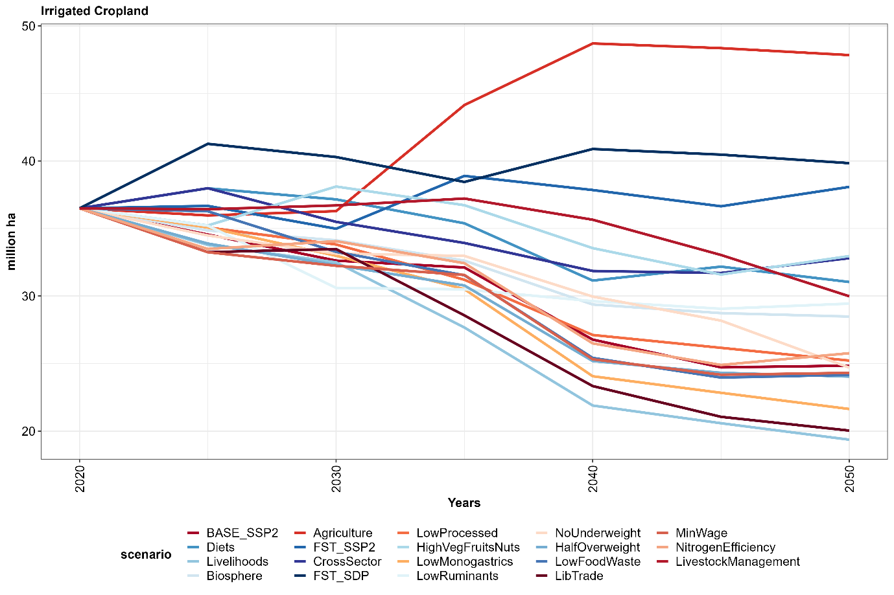
Figure SM6: Net trade under food based dietary and livelihood scenarios over the years up to 2050 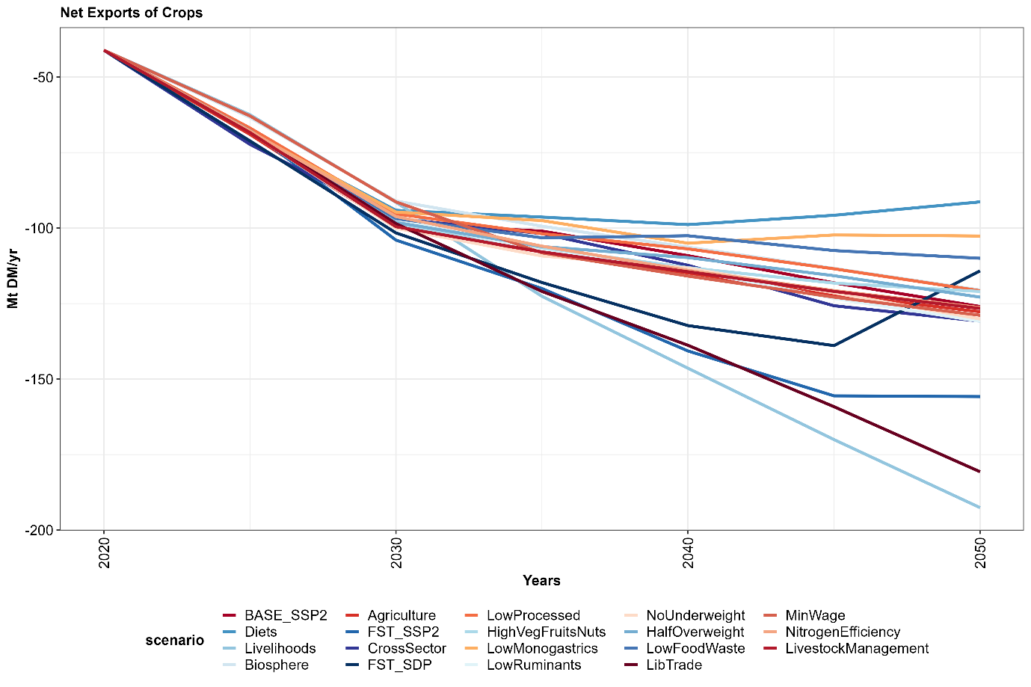
Figure SM7: Agricultural commodity price indices across scenarios until 2050
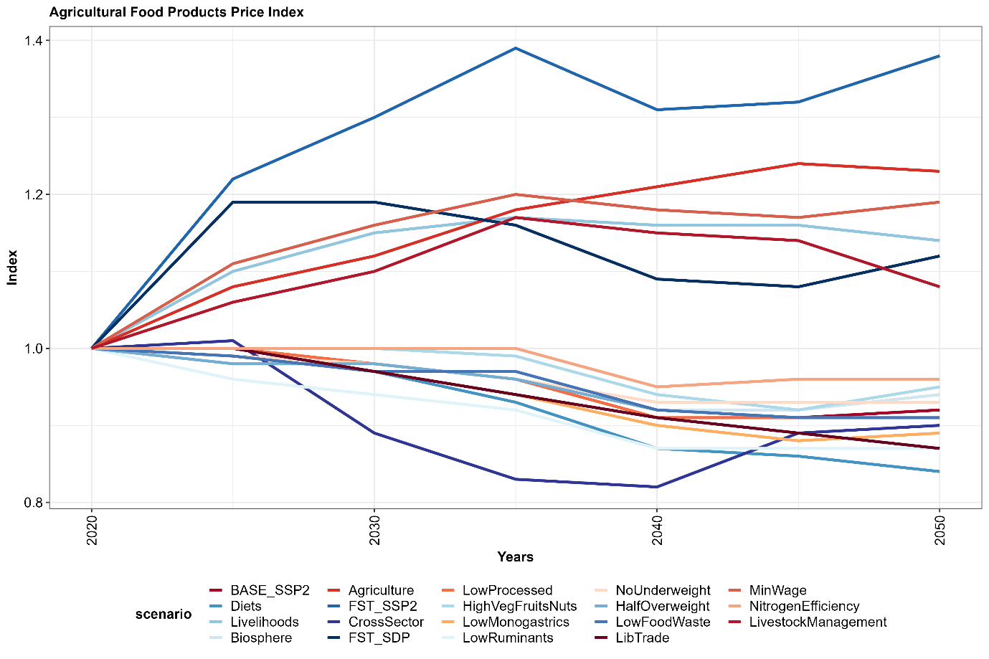
Figure SM8: Change in hourly costs of labor across key measures until 2050