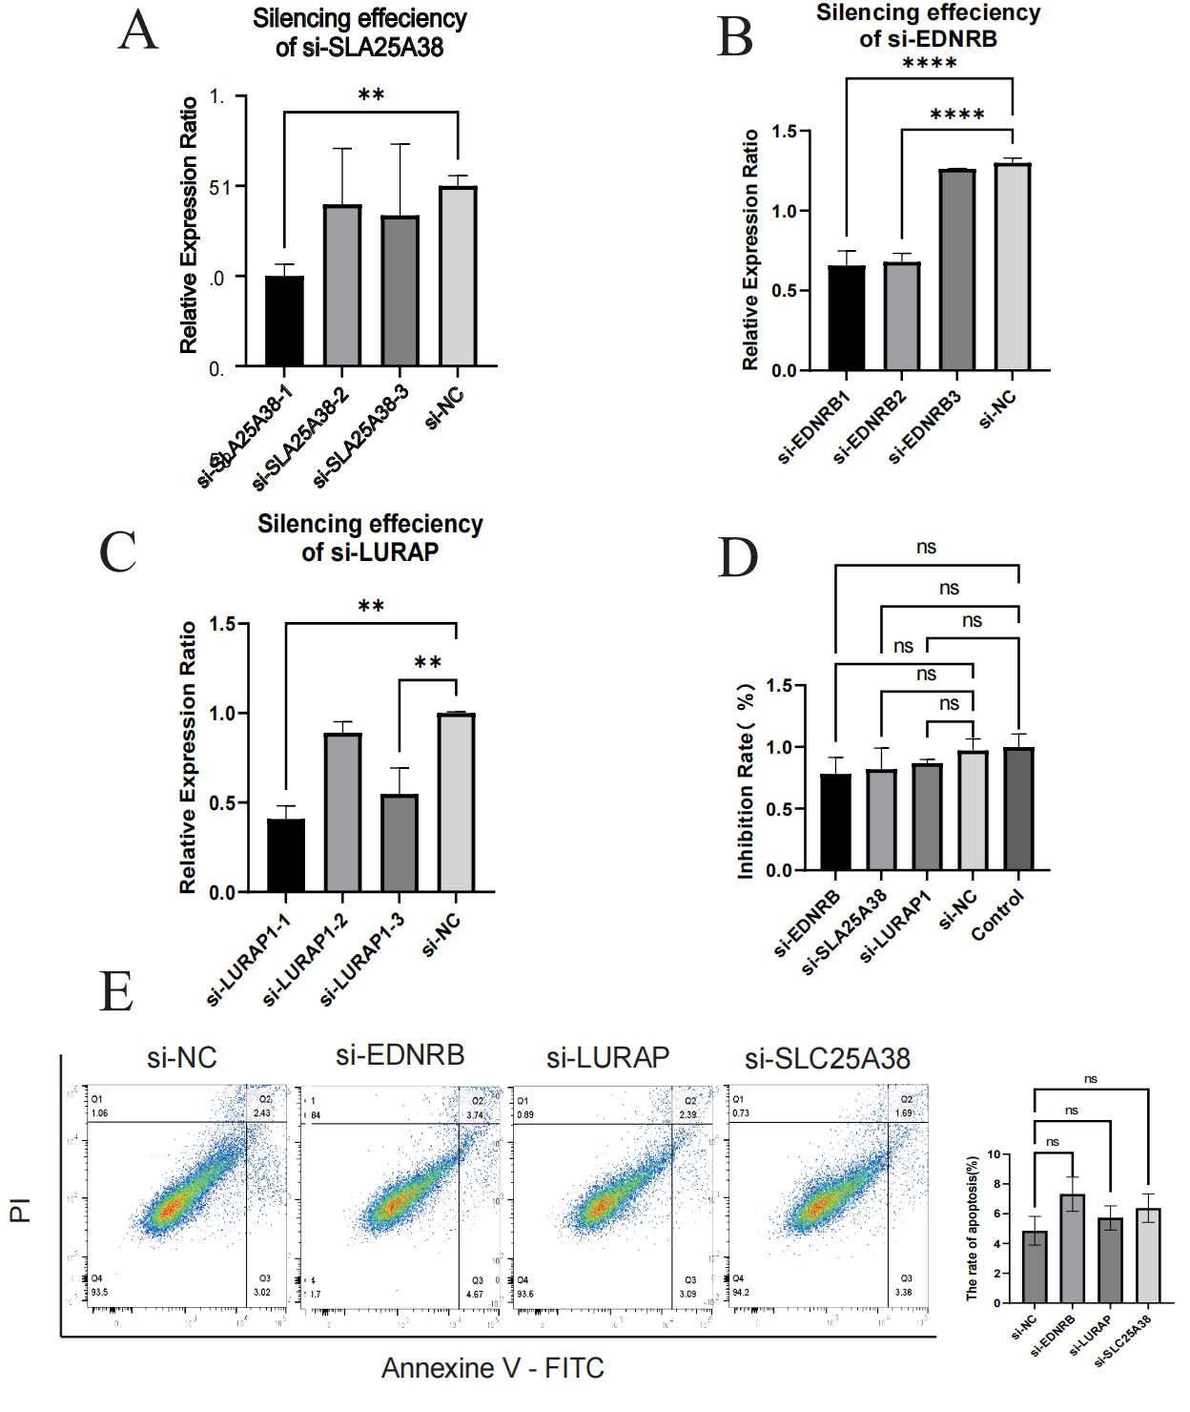
Supplementary Fig 1:Cell viability assay, Quantitative real-time PCR and apoptosis flow assays A)CCK8 OD value showing cell toxicity and proliferation of si-EDNRB, si-LURAP, si-SLC25A38, si-NC and control, ns = no significant difference, Kruskal-Wallis test. B~D）Relative mRNA levels of si-EDNRB, si-LURAP, si-SLA25A38 and si-NC were measured by qRT-PCR, **p< 0.01, ****p< 0.0001, one-way ANOVA. E）MUM2B cells were treated with transfection reagents for 24-48h. Cell apoptosis was analyzed by flow cytometry with annexin V and propidium iodide (PI) double staining (left), and the percentage of apoptotic cells was quantified (right, n = 4) was performed. ns = no significant difference, Kruskal-Wallis test.

