Supplementary Information
Sustainable development of anticancer and antidiabetic derivatives by solvent-free heterocyclization
Kajal Patil¹ • Sachin Mane^{1*} • Suhas Mohite² • Dhanaji Kanase^{1*}
¹Department of Chemistry, Bharati Vidyapeeth’s Dr. Patangrao Kadam Mahavidyalaya, Sangli, Maharashtra, India.
²Department of Chemistry, Bharati Vidyapeeth (Deemed To Be University) Yashwantrao Mohite College, Pune, Maharashtra, India.
*Corresponding Author E-mail: Dhanaji Kanase: dgkanase@gmail.com
Sachin Mane: stm2011.mane@gmail.com

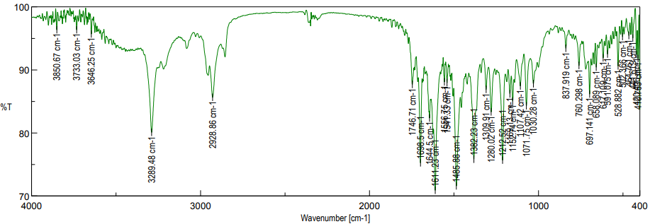

Fig. S1. FTIR spectrum of ethyl 2,7,7-trimethyl-5-oxo-4-phenyl-1,4,5,6,7,8-hexahydroquinolone-3-carboxylate (R=H).

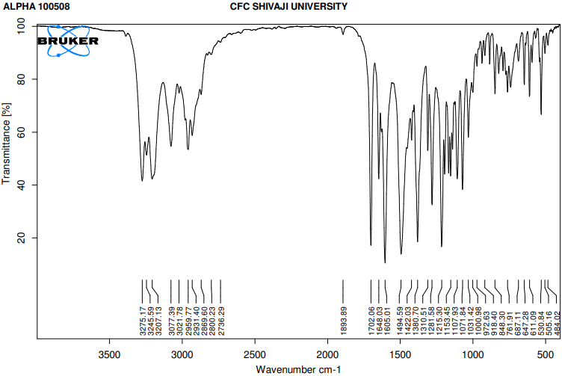
Fig. S2. FTIR spectrum of ethyl 4-(4-methylphenyl)-2,7,7-trimethyl-5-oxo-1,4,5,6,7,8-hexahydroquinoline-3-carboxylate (R=CH₃).

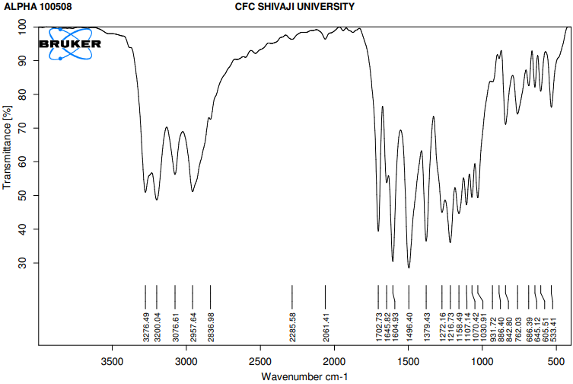
Fig. S3. FTIR spectrum of ethyl 4-(4-methoxyphenyl)-2,7,7-trimethyl-5-oxo-1,4,5,6,7,8-hexahydroquinolone-3-carboxylate (R=OCH₃).

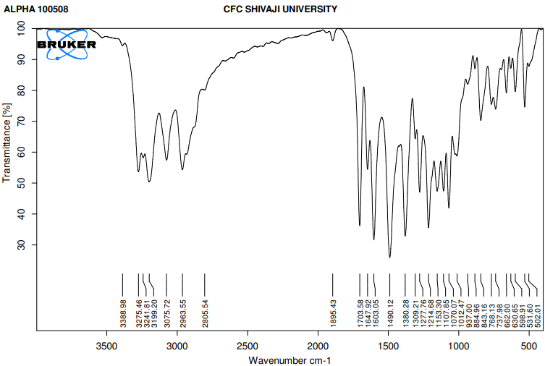
Fig. S4. FTIR spectrum of ethyl 4-(4-bromophenyl)-2,7,7-trimethyl-5-oxo-1,4,5,6,7,8-hexahydroquinolone-3-carboxylate (R=Br).

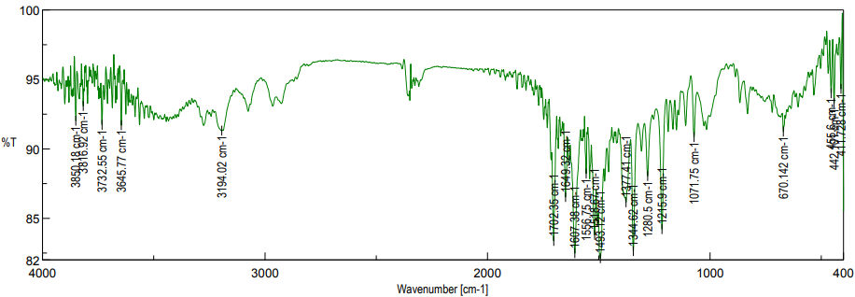

Fig. S5. FTIR spectrum of ethyl 2,7,7-trimethyl-4-(4-nitrophenyl)-5-oxo-1,4,5,6,7,8-hexahydroquinolone-3-carboxylate (R=NO₂).

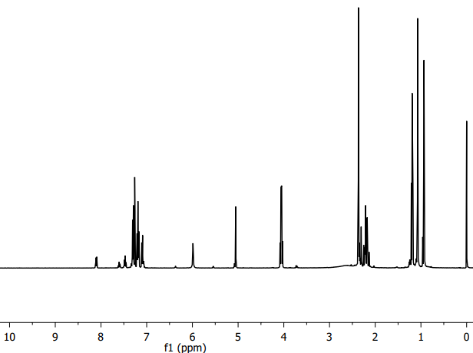
Fig. S6. ¹H-NMR spectrum of ethyl 2,7,7-trimethyl-5-oxo-4-phenyl-1,4,5,6,7,8-hexahydroquinolone-3-carboxylate (R=H).

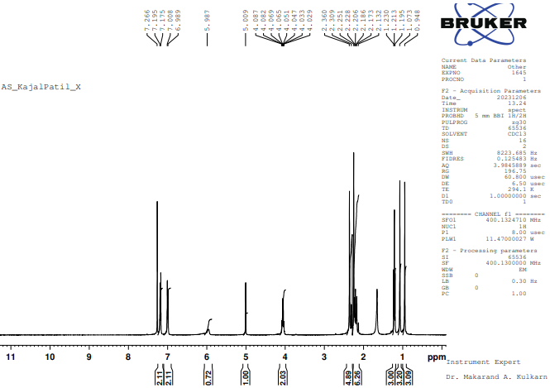
Fig. S7. ¹H-NMR spectrum of ethyl 4-(4-methylphenyl)-2,7,7-trimethyl-5-oxo-1,4,5,6,7,8-hexahydroquinoline-3-carboxylate (R=CH₃).

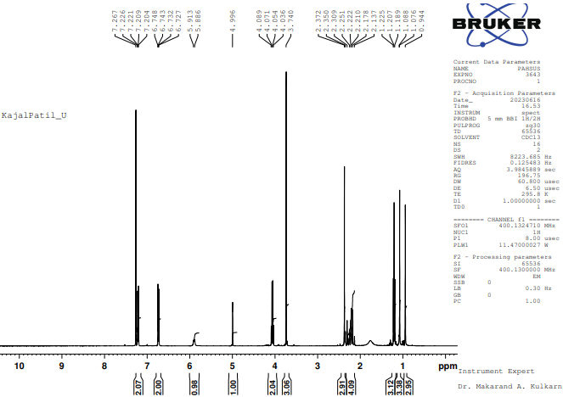
Fig. S8. ¹H-NMR spectrum of ethyl 4-(4-methoxyphenyl)-2,7,7-trimethyl-5-oxo-1,4,5,6,7,8-hexahydroquinolone-3-carboxylate (R=OCH₃).

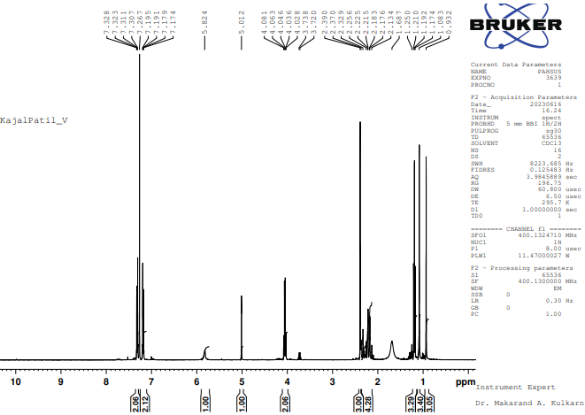

Fig. S9. ¹H-NMR spectrum of ethyl 4-(4-bromophenyl)-2,7,7-trimethyl-5-oxo-1,4,5,6,7,8-hexahydroquinolone-3-carboxylate (R=Br).

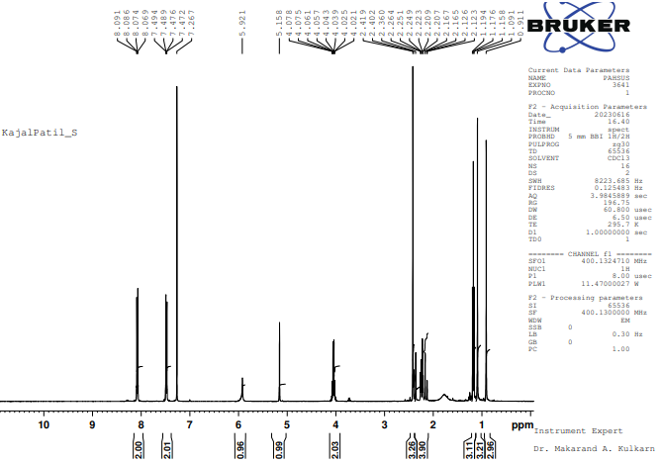

Fig. S10. ¹H-NMR spectrum of ethyl 2,7,7-trimethyl-4-(4-nitrophenyl)-5-oxo-1,4,5,6,7,8-hexahydroquinolone-3-carboxylate (R=NO₂).

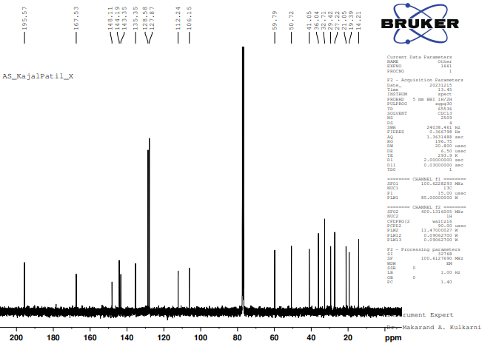

Fig. S11. ¹³C-NMR spectrum of ethyl 4-(4-methylphenyl)-2,7,7-trimethyl-5-oxo-1,4,5,6,7,8-hexahydroquinoline-3-carboxylate (R=CH₃).

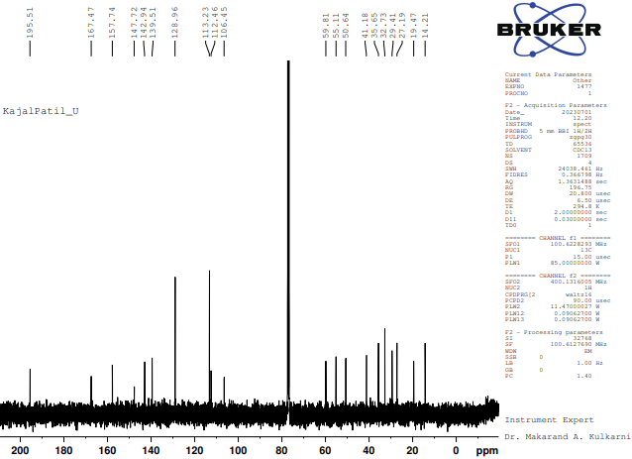

Fig. S12. ¹³C-NMR spectrum of ethyl 4-(4-methoxyphenyl)-2,7,7-trimethyl-5-oxo-1,4,5,6,7,8-hexahydroquinolone-3-carboxylate (R=OCH₃).

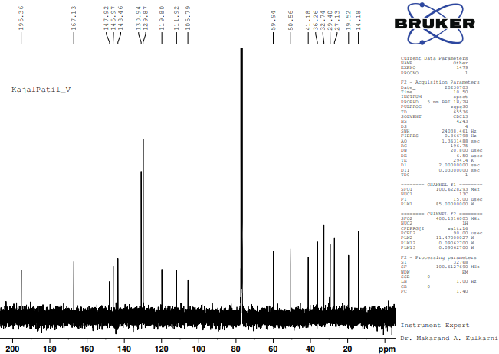
Fig. S13. ¹³C-NMR spectrum of ethyl 4-(4-bromophenyl)-2,7,7-trimethyl-5-oxo-1,4,5,6,7,8-hexahydroquinolone-3-carboxylate (R=Br).

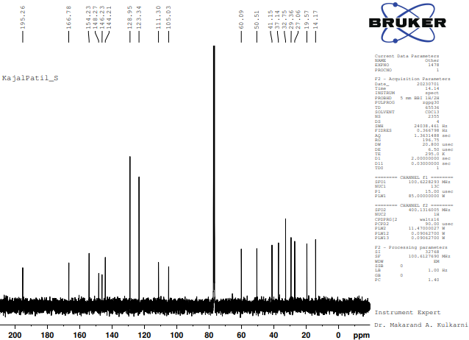
Fig. S14. ¹³C-NMR spectrum of ethyl 2,7,7-trimethyl-4-(4-nitrophenyl)-5-oxo-1,4,5,6,7,8-hexahydroquinolone-3-carboxylate (R=NO₂).

