Supplementary materials to:
Reliability of in vitro data for the mechanistic prediction of brain extracellular fluid pharmacokinetics of P-glycoprotein substrates in vivo; are we scaling correctly?
Authors: Daan W. van Valkengoed¹, Makoto Hirasawa¹, Vivi Rottschäfer^{2,3}, Elizabeth C.M. de Lange^{1*}
Affiliations:
1: Division of Systems Pharmacology and Pharmacy, Leiden University, The Netherlands
2: Mathematical Institute, Leiden University, The Netherlands
3: Korteweg-de Vries Institute for Mathematics, University of Amsterdam, The Netherlands
*Corresponding author (email: ecmdelange@lacdr.leidenuniv.nl)
Gorlaeus Laboratories, Einsteinweg 55, 2333 CC Leiden, The Netherlands
Tel : +31 71 527 6330

Supplementary table 1: Drug physicochemical properties used for all model predictions. All values were taken from Drugbank version 5.1.12, except for verapamil which were taken from PubChem. All f_{up} values were derived from Yamamoto et al. (2017)¹, except for verapamil which was reported by Holt et al. (2019)²
Drug | Molecular weight | logP | pKa | pKb | f_{up}
Acetaminophen | 151.2 | 0.51 | 9.46 | -4.4 | 0.81
Morphine | 285.3 | 0.99 | 10.26 | 9.12 | 0.83
Paliperidone | 426.5 | 2.3 | 13.74 | 8.76 | 0.08
Quinidine | 324.2 | 2.82 | 13.89 | 9.05 | 0.14
Raclopride | 347.2 | 3.19 | 6.26 | 8.47 | 0.07
Risperidone | 410.5 | 3.27 | NA | 8.76 | 0.07
Verapamil | 454.6 | 3.8 | NA | 9.07 | 0.09

Parameter category (units) | Name (abbreviation) | Value
Volumes (mL) | Total brain (V_{brain}) | 1.88
Volumes (mL) | Brain ECF (V_{ECF}) | 0.36
Volumes (mL) | Brain cell lysosome (V_{LYS}) | 0.018
Volumes (mL) | Lateral ventricles (V_{LV}) | 0.0075
Volumes (mL) | Third/fourth ventricles (V_{TFV}) | 0.0075
Volumes (mL) | Cisterna magna (V_{CM}) | 0.017
Volumes (mL) | Subarachnoid space (V_{SAS}) | 0.135
Volumes (mL) | Microvasculature (V_{MV}) | 0.054
Flows (mL/min) | ECF bulk flow (Q_{ECF}) | 0.0002
Flows (mL/min) | CSF (Q_{CSF}) | 0.0022
Flows (mL/min) | Cerebral blood flow (Q_{CBF}) | 2.87
Surface areas (cm²) | Surface area of BBB (SA_{BBB}) | 155
Surface areas (cm²) | Surface area of BCSFB (SA_{BCSFB}) | 25
Surface areas (cm²) | Surface area of brain cell membrane (SA_{BCM}) | 4250
Surface areas (cm²) | Surface area of lysosomes (SA_{LYS}) | 2700
pH | pH microvasculature (pH_{MV}) | 7.4
pH | pH brain ECF (pH_{ECF}) | 7.3
pH | pH brain ICF (pH_{ICF)} | 7
pH | pH lysosomes (pH_{LYS}) | 5
pH | pH CSF (pH_{CSF}) | 7.3
Effective surface area (%) | Transcellular BBB transport (SA_{fraction.BBB.trans}) | 99.8
Effective surface area (%) | Paracellular BBB transport (SA_{fraction.BBB.para}) | 0.006
Effective surface area (%) | Transcellular BCSFB transport (SA_{fraction.BCSFB.trans}) | 99.8
Effective surface area (%) | Paracellular BCSFB transport (SA_{fraction.BCSFB.para}) | 0.05
Weight (kg) | Weight (WT) | 0.25
Brain phospholipid fraction (unitless) | Brain phospholipids volume fraction (V_{phb}) | 0.0533
Supplementary table 2: Rat physiological parameters used for all model predictions. Taken from Saleh et al. (2021)³.
System | P-gp expression  (fmol/µg protein) | Reference
Rat | 19.65 | Al Feteisi (2018)⁴
Rat | 19.1 | Hoshi (2013)⁵
Caco-2 | 7.89 | Miliotis (2011)⁶
Caco-2 | 6.92 | Harwood (2016)⁷
Caco-2 | 2.0 | Harwood (2016)⁷
LLC-PK1-MDR1 | 13.1 | Nicolaï (2020)⁸
LLC-PK1-mdr1a | 61.0 | Nicolaï (2020)⁸
LLC-PK1-mdr1a | 15.2 | Uchida (2011)⁹
MDCKII-MDR1 | 10.3 | Bao (2019)¹⁰
MDCKII-MDR1 | 2.08 | Feng (2019)¹¹
MDCKII-MDR1 | 1.9 | Di (2011)¹²
MDCKII-MDR1 | 2.847 | Jacqueroux (2020)¹³
MDCKII-MDR1 | 2.394 | Jacqueroux (2020)¹³
Supplementary table 3: P-gp protein expression in fmol/µg protein for in vitro and in vivo systems as reported in literature
Supplementary table 4: Overview of median prediction errors (PE) for all possible short infusion predictions. PE_{REF} corresponds to the PE based on the entire bandwidth of predictions, while PE_{high}, PE_{average}, and PE_{low} are the PE observed for the predictions using the highest, average and lowest in vitro P-gp expression, respectively. PE_{NOREF} is the PE of the prediction made without a REF. PE values shaded in green, orange and red fall within 2-fold error, 3-fold error and >3-fold error, respectively.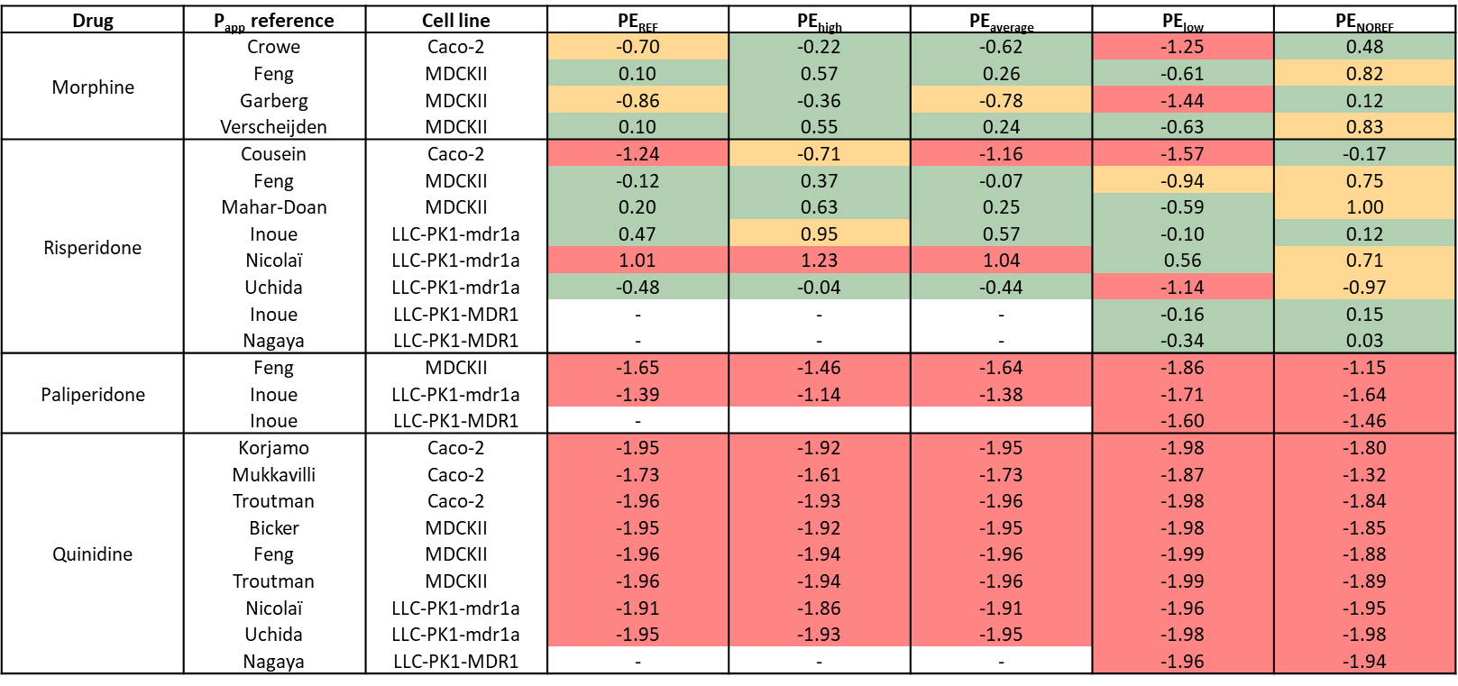
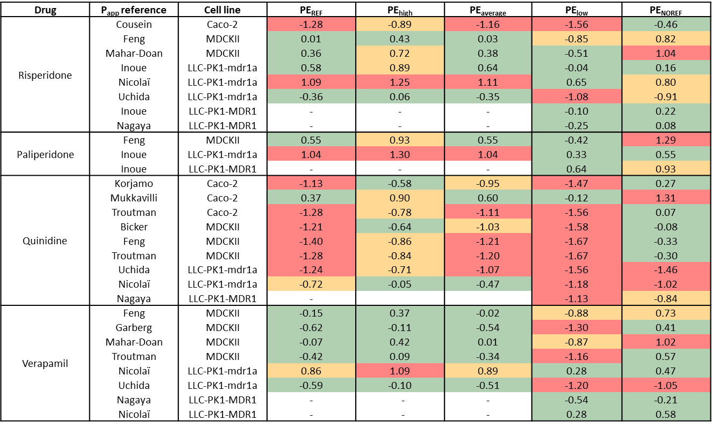
Supplementary table 5: Overview of median prediction errors (PE) for all possible continuous infusion predictions. PE_{REF} corresponds to the PE based on the entire bandwidth of predictions, while PE_{high}, PE_{average}, and PE_{low} are the PE observed for the predictions using the highest, average and lowest in vitro P-gp expression, respectively. PE_{NOREF} is the PE of the prediction made without a REF. PE values shaded in green, orange and red fall within 2-fold error, 3-fold error and >3-fold error, respectively.

Supplementary figure 1: Plasma PK predictions of the short infusion (A) and continuous infusion (B) dosing regimens. All plasma data concerned unbound measurements, except for morphine which are total concentrations.

Supplementary figure 2: Rat brainECF PK predictions after (A) short infusion (or subcutaneous dose administration) and (B) continuous infusion of the P-gp substrates paliperidone, quinidine, risperidone, morphine and verapamil without scaling for differences in P-gp protein expression. Predictions are shown as coloured lines. Reference of the P_{app} values corresponds to the colour of the predicted line. Each column shows which cell line was used to determine P_{app} and ER_{c} values used as input for the prediction. Each row indicates a different drug. Plots without predictions indicate a lack of transport data in a cell line for a given drug. Observed unbound brainECF concentrations are shown as black points.
Supplementary figure 3: Rat brainECF PK predictions after (A) short infusion (or subcutaneous dose administration) and (B) continuous infusion of the P-gp substrates paliperidone, quinidine, risperidone, morphine and verapamil. The colour of the prediction band indicates which cell line the input data was derived from. Top of the prediction bands indicate the predictions made using the highest in vitro P-gp expression value for the given cell line, while the bottom of the band corresponds to the lowest expression value. Black lines indicate the prediction made using the average in vitro P-gp expression. Each row indicates a different drug. Observed unbound brainECF concentrations are shown as black points.

References
1 Yamamoto, Y. et al. Predicting Drug Concentration-Time Profiles in Multiple CNS Compartments Using a Comprehensive Physiologically-Based Pharmacokinetic Model. CPT Pharmacometrics Syst Pharmacol 6, 765-777, doi:10.1002/psp4.12250 (2017).
2 Holt, K., Ye, M., Nagar, S. & Korzekwa, K. Prediction of Tissue-Plasma Partition Coefficients Using Microsomal Partitioning: Incorporation into Physiologically based Pharmacokinetic Models and Steady-State Volume of Distribution Predictions. Drug Metab Dispos 47, 1050-1060, doi:10.1124/dmd.119.087973 (2019).
3 Saleh, M. A. A., Loo, C. F., Elassaiss-Schaap, J. & De Lange, E. C. M. Lumbar cerebrospinal fluid-to-brain extracellular fluid surrogacy is context-specific: insights from LeiCNS-PK3.0 simulations. J Pharmacokinet Pharmacodyn 48, 725-741, doi:10.1007/s10928-021-09768-7 (2021).
4 Al Feteisi, H. et al. Identification and quantification of blood-brain barrier transporters in isolated rat brain microvessels. J Neurochem 146, 670-685, doi:10.1111/jnc.14446 (2018).
5 Hoshi, Y. et al. Quantitative atlas of blood-brain barrier transporters, receptors, and tight junction proteins in rats and common marmoset. J Pharm Sci 102, 3343-3355, doi:10.1002/jps.23575 (2013).
6 Miliotis, T. et al. Development of a highly sensitive method using liquid chromatography-multiple reaction monitoring to quantify membrane P-glycoprotein in biological matrices and relationship to transport function. Drug Metab Dispos 39, 2440-2449, doi:10.1124/dmd.111.040774 (2011).
7 Harwood, M. D. et al. In Vitro-In Vivo Extrapolation Scaling Factors for Intestinal P-Glycoprotein and Breast Cancer Resistance Protein: Part I: A Cross-Laboratory Comparison of Transporter-Protein Abundances and Relative Expression Factors in Human Intestine and Caco-2 Cells. Drug Metab Dispos 44, 297-307, doi:10.1124/dmd.115.067371 (2016).
8 Nicolaï, J. et al. Impact of In Vitro Passive Permeability in a P-gp-transfected LLC-PK1 Model on the Prediction of the Rat and Human Unbound Brain-to-Plasma Concentration Ratio. Pharm Res 37, 175, doi:10.1007/s11095-020-02867-z (2020).
9 Uchida, Y., Ohtsuki, S., Kamiie, J. & Terasaki, T. Blood-brain barrier (BBB) pharmacoproteomics: reconstruction of in vivo brain distribution of 11 P-glycoprotein substrates based on the BBB transporter protein concentration, in vitro intrinsic transport activity, and unbound fraction in plasma and brain in mice. J Pharmacol Exp Ther 339, 579-588, doi:10.1124/jpet.111.184200 (2011).
10 Bao, X. et al. Protein Expression and Functional Relevance of Efflux and Uptake Drug Transporters at the Blood-Brain Barrier of Human Brain and Glioblastoma. Clin Pharmacol Ther 107, 1116-1127, doi:10.1002/cpt.1710 (2020).
11 Feng, B. et al. Validation of Human MDR1-MDCK and BCRP-MDCK Cell Lines to Improve the Prediction of Brain Penetration. J Pharm Sci 108, 2476-2483, doi:10.1016/j.xphs.2019.02.005 (2019).
12 Di, L. et al. Development of a new permeability assay using low-efflux MDCKII cells. J Pharm Sci 100, 4974-4985, doi:10.1002/jps.22674 (2011).
13 Jacqueroux, E. et al. Value of quantifying ABC transporters by mass spectrometry and impact on in vitro-to-in vivo prediction of transporter-mediated drug-drug interactions of rivaroxaban. Eur J Pharm Biopharm 148, 27-37, doi:10.1016/j.ejpb.2020.01.002 (2020).

