Chart 1. The prescription distributions of different age groups

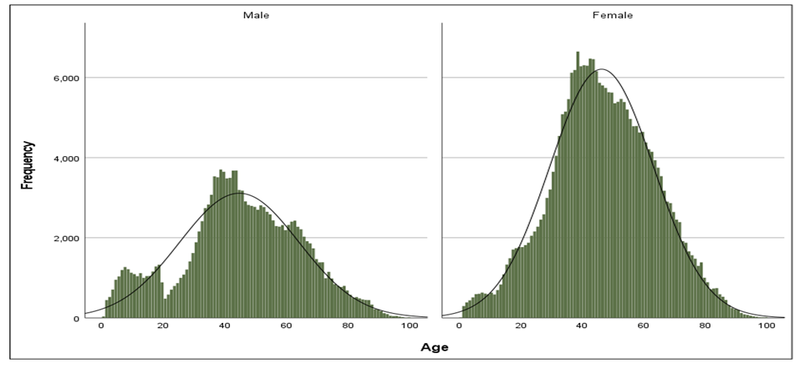
Chart 2. Bar chart displaying the age and sex distributions of the prescriptions

Chart 3. The number of psychotropic medications prescribed by different specialties

