Supplementary Information for

Synergetic strength-ductility enhancement of ultra-thin W wire by La oxide nanoprecipitates induced pinning effect

Yu Zhang¹, Miao Li¹, Fang Xie², Jianhong Dai², Xiaobo Gong², Xiping Cui¹, Xiaoxiao Huang¹, Junsong Zhang⁶*, Tao Zhang^{2,3,4}*, Yujing Liu⁵*

¹School of Materials Science and Engineering, Harbin Institute of Technology, Harbin 150001, China.
²School of Materials Science and Engineering, Harbin Institute of Technology at Weihai, Weihai 264209, China.
³Shandong Provincial Key Laboratory of Marine Electronic Information and Intelligent Unmanned Systems, Weihai 264209, China.
⁴Key Laboratory of Cross-Domain Synergy and Comprehensive Support for Unmanned Marine Systems, Ministry of Industry and Information Technology.
⁵Yuhua Institute of Advanced Materials, Baoji Xigong Titanium Alloy Products Co., Ltd, Baoji 721300, China.
⁶Center for Advanced Structural Materials, State Key Laboratory of Metastable Materials Science and Technology, Yanshan University, Qinhuangdao, Hebei 066004, China.

*Correspondence to:
junsong.zhang@ysu.edu.cn;
taoozhang@126.com;
yjliu@csust.edu.cn

This file includes:
Experimental Section
Supplementary Figures (1-7)
Supplementary Tables (1-4)
Supplementary Movies (1-2)
Supplementary References (1-20)

Experimental Section
Fabrication of the 38.0 μm La-doped W wire
We used the Ammonium paratungstate (APT) powders and lanthanum nitrate hexahydrate powders as raw materials, the detailed information is listed in Supplementary Table 3. As the schematic demonstrated in Supplementary Figure 6, the production procedure was: roasting - hydrogen reduction – doping - powder reduction – pressing – sintering - rotary forging - drawing. Firstly, 700 g APT powders were roasted in a reduction furnace, with feeding port temperature of 310 ℃, 350 ℃, 400 ℃, and 430 ℃, sequentially, pushing speed of 15 min/boat, and hydrogen flow rate of 0.4 m³/h. Afterwards, we obtained the blue tungsten oxide with average particle sizes of 3-8 μm and WO₃ composition of 80-90 %. Secondly, the obtained blue tungsten oxide was reduced at 800 °C in hydrogen flow rate of 20 m³/h to obtain tungsten powder with an average particle size of 1-2 μm. Thirdly, the tungsten powders and lanthanum nitrate solution were mixed together and the mass fraction of tungsten to lanthanum was 99.75 % to 0.25 %, the mixed solution was then stirred and heated at 80℃ to obtain mixed dry powders. After two hydrogen reductions of 500 ℃ for 60 min and 800 ℃ for 60 min in sequence, the mixed powders were sifted for use. After thoroughly stirred evenly, 500 g mixed powders were weighed and filled into the mold. We used a cold isostatic pressing machine with a maximum pressing pressure of 160 MPa to form a 30 mm side length billet. The billet was then put into the tungsten crucible of the medium frequency induction furnace and sintered under hydrogen protection with a flow rate of 8 m³/h, the sintering temperature and holding time were demonstrated in Supplementary Figure 7. Afterwards, through multiple rotary forging by rolling machine, the La-doped W billet was rolled into 2 mm diameter wire. Subsequently, after coating the wire surface with lubricant, we used the non-slip drawing equipment to draw the La-doped W wire from 2.0 mm to 38.0 μm diameter. The process was conducted in an ice bath at a speed of 35 m/min, and with a compression rate decreasing from 20 % to 10 % every pass. Eventually, the obtained 38 µm ultrafine wire was wrapped onto the wire reels and subjected to mechanical property testing.
Mechanical properties
Tensile tests were performed by Instron-5569 universal testing machine with a tensile speed of 0.5 mm/min and a tensile load of 10-20 N. The microhardness was measured with a digital microhardness tester (HXD-1000TM; Shang Guang Corporation, China) using a Vickers diamond with an indentation depth of 300 nm applied for 5s. As shown in Figure 4f, microhardness tests were performed with an array of 7 points at 4.7 μm intervals along with the diameter.
Microstructure Characterization
The morphology of the La-doped W wire was investigated by SEM (Zeiss, Merlin Compact). The FIB-TEM samples were prepared by Thermo Scientific Scios 2 DualBeam. The platinum film was deposited on the La-doped W and pure W samples before lifting out of prepared TEM samples. High resolution STEM imaging and the EDS mapping were performed using the TEM (FEI Tecnai F30) and ACTEM (FEI Themis Z) operated at 300 kV with convergence semi-angle of 24 mrad. The lattice strain in HRTEM was calculated by GPA custom plugins in the Gatan Digital Micrograph (DM) software. In-situ tensile tests were conducted using a Nanofactory scanning tunneling microscopy holder inside a FEI Tecnai F30 TEM and a FEI Titian 80-300 kV TEM.
DFT calculation
The SFE calculation implemented in this study was carried out using the Vienna ab initio Simulation Package (VASP) software package¹. The spin-polarized DFT^{2, 3} was formulated within the generalized-gradient approximation for the exchange-correlation functional as parameterized by Perdew, Burke, and Ernzerhof⁴. The SFE was calculated based on the following formula (1):
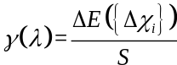 (1)
where γ(λ) is the generalized SFE associated with laterally extended n-layer planar faults on bcc planes⁵, where ΔE = E ({${Δχ}_{i}$}) − E_{bulk} is the total energy difference of the faulted structure relative to the fault-free bcc structure, and S represents the cross-sectional fault area. The index i refers to consecutive {110} planes and ${Δχ}_{i}$ denotes the relative shear displacement vector between layer i and layer i-1⁶.
MD simulation
MD simulation was performed to investigate the effect of La clusters on the deformation of W polycrystalline materials according to the formula (2). Polycrystals of W were constructed using the Voronoi tessellation method in the atomsk software package. Due to the absence of the W-La atomic interaction potential, a neuro evolution machine learning potential (NEP) was developed (Supplementary Table 4). The dataset mainly considers 3010 configurations consisting mainly of bulk, surface, perturbation, and deformation structures, showing an accurate fit to the W-La system, as shown in Supplementary Fig. 4. The mechanical testing in uniaxial tension was simulated via the GPU molecular dynamics (GPUMD) package with a strain rate of 10⁸ s⁻¹. Post-processing and visualization of the simulated data was carried by Ovito Pro. Besides, the deformation inhomogeneity parameter $h$ was introduced to quantify the contribution of La to plasticity.
$h=\frac{1}{2N}\sum_{k=1}^{r}{\left({8.89}^{1-k}\sum_{i=1}^{2^{3k}}{\left|m_{i}-\overline{m}\left(2^{3k}\right)\right|}\right)}$ (2)

Supplementary Figures
Supplementary Fig. 1 | HRTEM image of nanoprecipitates at the grain boundary.

Supplementary Fig. 2 | The STEM and bright field TEM images after in-situ tensile test revealing the pinning effect of La oxide precipitates on the crack extension during the drawing process.

Supplementary Fig. 3 | Schematic illustration showing the pinning effect of La-doped W versus pure W under force.
Supplementary Fig. 4 | The MD simulation results of pure W and W-La clusters. a) Simulation models. b) The simulated mechanical property curve. c) The simulated deformation uniform mity curve. d) The strain distribution of two types of 3D models during the deformation process.

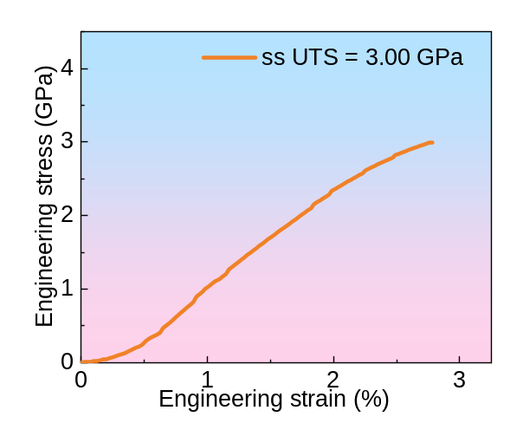
Supplementary Fig. 5 | The mechanical property of stainless steel produced using the same fabrication method with the La-doped W wire, showing the ultimate tensile strength of 3.00 GPa.

Supplementary Fig. 6 | Fabrication method schematic of the 38.0 μm La-doped W wire

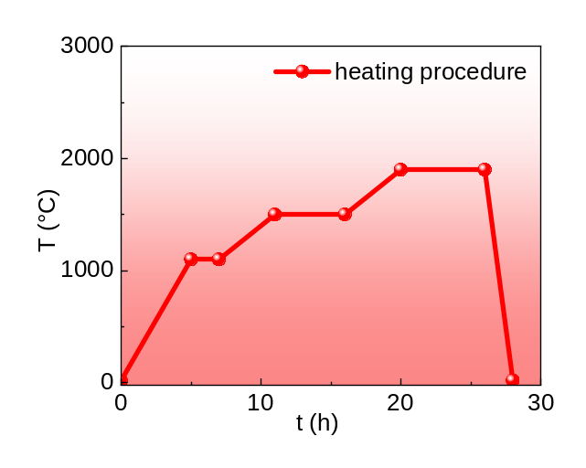
Supplementary Fig. 7 | Heating procedure of the medium frequency induction furnace in sintering the La-doped W billet

Supplementary Tables

Supplementary Table 1 | Crystallographic orientation relationships for the six variants of the hcp to bcc transformation in the Burgers mechanism.
hcp → bcc | Planes | Directions
V1 | (0001) _{hcp} // (1$\overline{\text{1}}$0) _{bcc} | [2$\overline{\text{1}}\overline{\text{1}}$0] _{hcp} // [111] _{bcc}
V2 | (0001) _{hcp} // (110) _{bcc} | [2$\overline{\text{1}}\overline{\text{1}}$0] _{hcp} // [1$\overline{\text{1}}$1] _{bcc}
V3 | (0001) _{hcp} // (1$\overline{\text{1}}$0) _{bcc} | [11$\overline{\text{2}}$0] _{hcp} // [111] _{bcc}
V4 | (0001) _{hcp} // (110) _{bcc} | [11$\overline{\text{2}}$0] _{hcp} // [1$\overline{\text{1}}$1] _{bcc}
V5 | (0001) _{hcp} // (1$\overline{\text{1}}$0) _{bcc} | [$\overline{\text{1}}$2$\overline{\text{1}}$0] _{hcp} // [111] _{bcc}
V6 | (0001) _{hcp} // (110) _{bcc} | [$\overline{\text{1}}$2$\overline{\text{1}}$0] _{hcp} // [1$\overline{\text{1}}$1] _{bcc}

Supplementary Table 2 | Statistical table of ultimate tensile strength and wire diameter in this work compared to other reported saw alloy wires in reference.
Material | No. | Wire diameter (µm) | Ultimate tensile strength (GPa) | Reference
This work: W-La | 1 | 38 | 6.924
This work: pure W | 2 | 38 | 5.312
This work: Steel | 3 | 25 | 2.997
W | 4 | 200 | 2.294 | ⁷ (2013)
W | 5 | 150 | 2.926 | ⁸ (2017)
W | 6 | 100 | 4.800 | ⁹ (2020)
W+K | 7 | 12 | 4.226 | ¹⁰ (2021)
W+K | 8 | 12 | 3.800 | ¹⁰ (2021)
W+K | 9 | 12 | 4.000 | ¹⁰ (2021)
W+K | 10 | 148 | 2.900 | ¹¹ (2016)
W+K | 11 | 22 | 4.100 | ¹⁰ (2021)
W+K | 12 | 60 | 4.500 | ¹² (2019)
W+K | 13 | 16 | 4.550 | ¹³ (2017)
W+K | 14 | 148.7 | 2.5 | ¹⁴ (2020)
W+Re | 15 | 80 | 4.400 | ¹⁵ (2018)
Ti | 16 | 20 | 2.518 | ¹⁶ (2014)
Ti | 17 | 170 | 0.393 | ¹⁷ (2023)
Ti | 18 | 200 | 1.100 | ¹⁸ (2013)
Steel | 20 | 300 | 2.264 | ¹⁹ (2017)
Steel | 21 | 50 | 2.300 | ²⁰ (2021)

Supplementary Table 3 | Detailed information of the raw materials.
Raw materials | Detailed information
APT | Purity: 99.95%, CAS: 11120-25-5, Aladdin Biochemical  Technology Co., Ltd., Shanghai, China
Lanthanum nitrate hexahydrate | Purity: 99.9%, CAS: 10277-43-7, Aladdin Biochemical  Technology Co., Ltd., Shanghai, China

Supplementary Table 4 | NEP of W-La alloy
W | Exp | DFT | WLa-NEP | Mason-eam.fs | UNEP | Zhou-eam.alloy | Hiremath-meam
a | 3.165c | 3.185b | 3.185 | 3.165 | 3.185 | 3.165 | 3.165
B | 310 | 304 | 300.52 | 312.8 | 340.66 | 310.4 | 304.7
C11 | 522 | 522 | 530.713 | 529.58 | 530.48 | 522.62 | 528.01
C12 | 204 | 195 | 217.569 | 204.42 | 245.76 | 204.29 | 193.04
C44 | 161 | 148 | 134.913 | 160.61 | 104.53 | 160.78 | 177.70
(001) Surface energy | — | 3898.039 | 3775.23 | 3841.12 | 3824.23 | 2983.45 | 3855.57
(110) Surface energy | — | 3225.185 | 3044.28 | 3496.72 | 2987.55 | 2567.80 | 3313.13
(111) Surface energy | — | 3835.136 | 3680.84 | 4155.44 | 3627.53 | 3329.95 | 4045.86
(112) Surface energy | — | 3656.8 | 3476.56 | 3865.79 | 3410.69 | 3021.93 | 3772.75
Vacancy formation energy | 3.67 | 3.36 | 3.27 | 3.73 | 3.31 | 3.58 | 4.14
Sia formation energy | — | 10.29 | 11.86 | 8.91 | 10.35 | 12.05 | 10.74

Supplementary References
1. Wang XY, Wu RY, Xu T, Gao Y. Mechanical and electrical properties of borophene and its band structure modulation via strain and electric fields: a first-principles study. Mater Res Express 8, 10 (2021).

2. Kohn W, Sham LJJPr. Self-consistent equations including exchange and correlation effects. 140, A1133 (1965).

3. Hohenberg P, Kohn WJPr. Inhomogeneous electron gas. 136, B864 (1964).

4. Perdew JP, Burke K, Ernzerhof MJPrl. Generalized gradient approximation made simple. 77, 3865 (1996).

5. Cheng Z, Bu LF, Zhang Y, Wu HA, Zhu T, Lu L. Characterization of gradient plastic deformation in gradient nanotwinned Cu. Acta Mater 246, 11 (2023).

6. Wang C, Schonecker S, Li W, Yang YC, Hu QM, Vitos L. Twinning pathways in Fe and Fe-Cr alloys from first-principles theory. Acta Mater 215, 14 (2021).

7. Bochniak W, Piela K, Vinarski S, Lagoda M. Mechanical properties of tungsten wires after cycling deformation treatment. The International Journal of Advanced Manufacturing Technology 69, 1955-1959 (2013).

8. Zhao P, et al. Microstructure, mechanical behaviour and fracture of pure tungsten wire after different heat treatments. International Journal of Refractory Metals and Hard Materials 68, 29-40 (2017).

9. Kanazawa T, Iguchi Y, Kohyama N, Shimada A, Tsuji K, Nakai Y. Tungsten line having high tensile strength, and saw wire Patent WO2020137255 (2020).

10. Watanabe S, Itoh Y. Wire including tungsten Patent WO2021153451 (2021).

11. Riesch J, et al. Development of tungsten fibre-reinforced tungsten composites towards their use in DEMO—potassium doped tungsten wire. Physica Scripta 2016, 014006 (2016).

12. Kanazawa T, Koyama N, Iguchi Y, Sasagawa Y, Shibata T, Tani T. Metal wire, saw wire, cutting apparatus, and method of manufacturing metal wire Patent US20190232404 (2019).

13. Riesch J, et al. Tensile behaviour of drawn tungsten wire used in tungsten fibre-reinforced tungsten composites. Physica scripta 2017, 014032 (2017).

14. Terentyev D, Dubinko A, Riesch J, Lebediev S, Volkov I, Zhurkin E. Performance of tungsten fibers for Wf/W composites under cyclic tensile load. International Journal of Refractory Metals and Hard Materials 86, 105094 (2020).

15. Qiu N-n, Zhang Y, Zhang C, Tong H, Song X-p. Tensile properties of tungsten-rhenium wires with nanofibrous structure. International Journal of Minerals, Metallurgy, and Materials 25, 1055-1059 (2018).

16. Kimura H, Takabayashi H. Steel used for high-strength high-fatigue-strength saw wires for cutting of single-crystal silicon ingot, contains specified amount of carbon, nitrogen, cobalt, molybdenum, chromium, aluminum, titanium, nitrogen, oxygen and iron Patent JP2014005493-A.

17. Sakamoto J, Tada N, Uemori T. Tensile properties and slip deformation behavior of pure titanium thin wire with a small diameter-to-grain-size ratio. Materials Science and Engineering: A 863, 144532 (2023).

18. Semboshi S, Takasugi T. Fabrication of high-strength and high-conductivity Cu–Ti alloy wire by aging in a hydrogen atmosphere. Journal of alloys and compounds 580, S397-S400 (2013).

19. He Z, Huang H, Yin F, Xu X. Development of a brazed diamond wire for slicing single-crystal SiC ingots. The International Journal of Advanced Manufacturing Technology 91, 189-199 (2017).

20. Chen CY, Sun M, Wang B, Zhou JA, Jiang ZH. Recent Advances on Drawing Technology of Ultra-Fine Steel Tire Cord and Steel Saw Wire. Metals 11, 33 (2021).

