SUPPLEMENTARY DOCUMENTS

Figure 1: CONSORT diagram for schools and participants recruitment in the study
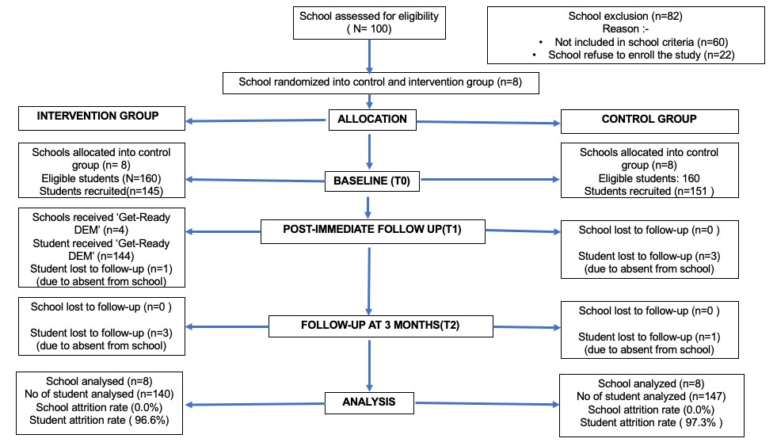

A questionnaire using flood disaster preparedness index score.

Flood Disaster preparedness Index (14 items)
In this section, the flood disaster preparedness index refers to the level of preparedness of you and your family members in facing a flood disaster.

Have you or your family adopted the flood disaster preparedness activities below? You can select (√) your response either Yes, No, or Not sure in the space given.

Item No | Activities | Responses
 |  | Yes | Not sure | No
A1 | Identified the evacuation route nearby your house.
A2 | Identified a safe elevated area to rescue from floods.
A3 | Identified emergency services contact numbers (such as 999, Ambulance, Fire, and Police)
A4 | Prepare a family emergency plan.
A5 | Shared information on disaster preparedness with other family and friends
A6 | Recognized the locally available emergency warning system ( such as sirens, cameras, and flood gauges)
A7 | Keep the important document in a safe place (such as a copy of your birth certificate or passport in a waterproof sealed file or online storage)
A8 | Bought insurance policy related to disaster
A9 | Prepared an emergency bag
A10 | Stored hazardous material safely (e.g., gas cylinder )
A11 | Placed all the movable objects at home at a higher place ( TV, Computer)
A12 | Learn how to turn off the main switch of the electrical power
A13 | Stored at least three days of clean water supply for every household. A 3-day water supply is at least 7.5 Litres of water per person per day.
A14 | Own applications that relay information about flood disasters (PublicInfobanjir, My DIMS, etc.)

Table 1 : Socio-demographic details of the background’s participant.

ITEM TOTAL CONTROL, INTERVENTION,
=287 (n, %) n = 147 n=140
Gender  - Male  - Female | 130 (45.3 %) 73 (49.7%) 57(40.7 %) 157 (54.7 %) 74(50.3%) 83 (59.3%)
Background Family’s  Education  - Primary school  - Secondary school  - Tertiary school | 12 (4.2%) 198 (69%)  77 (26.8%) | 7(4.8%) 5(3.6%) 102(69.4%) 96(68.6%)  38(25.9%) 39(27.9%)
Family’s monthly Income  - B40  - M40  - T20 | 186 (64.8%)  88 (30.7%)  13 (4.5%) | 94(63.9%)  46(31.3%)  7(4.8%) | 93(66.4%)  41(29.3%)  6(4.3%)
Disaster experience | n=285 | n=145 | n=140
- Individuals (Yes)  (No)  - Family/friends  (Yes)  (No) | 91(31.9%) 194 (68.1%)  n=279 168(60.2%) | 70(47.6%) 75 (51%)  n=144 98(66.7%) | 21(15%)  119(85%)  n=135 69(51.1%)
 | 111(39.8%) | 46(31.3%) | 66(48.9%)
Severity of the disaster  Individual  - Very Severe  - Severe  - Moderately Severe  - Not severe at all  - Does not want to answer | n=91 6(6.6%)  12(13.2 %)  30(33%)  23(25.2%)  20(22%) | n=70 5(7.1%)  10(14.1%)  20(28.2%)  16(22.5%)  19 (27.1% | n=21 1(4.8%)  2(9.8%)  10(47.6%)  7(33.3%)  1(4.8%)
Family/Friends  - Very Severe  - Severe  - Moderately Severe  - Not severe at all  - Does not want to answer | n=168 17(10.2%)  17(10.2%)  69(41.2%)  27(16.2%)  37(22.2%) | n=98 3(3.1%)  3(3.1%)  36(36.7 %)  19 (19.4%)  37 (37.8%) | n=69 14(20.3%  14(20.3%  33(47.8%)  8(11.6%)  -

Table 2- Model of parameter the effect of flood disaster education module on flood disaster preparedness after controlling the significance covariates comparing between trial group and across three different timelines.

β

SE

Wald

% CI
95

p
-
value
b

Lower Upper
Intercept | -647.04 | 203.259 10.131 |  | -1045.475 -248.599 |  | 0.001
Trial group |  | Between group
Control ª | Ref
Intervention | 0.892 | 0.351 6.467 |  | 0.205 1.58 |  | 0.011
 |  | Timeline
Baselineª
Post-immediate | -0.76 | 0.163 0.219 |  | 0.205 1.58 |  | 0.011
3-month follow up | 0.293 | 0.177 2.736 |  | -0.54 0.641 |  | 0.098
Interaction Timeline*trial group
Intervention*baseline | Ref
Intervention*postimmediate | 2.146 | 0.257 69.849 |  | 1.643 | 2.65 | <0.001
Intervention*3-month follow up | 1.53 | 0.294 27.158 |  | 0.955 | 2.105 | <0.001
 |  | Covariates
Age | 0.952 | 0.210 | 20.505 | 0.540 | 1.364 | <0.001
Perceived Efficacy | 0.428 | 0.107 | 16.046 | 0.219 | 0.637 | <0.001
Perceived Threat | 0.095 | 0.123 | 0.598 | -0.146 | 0.337 | 0.439
Disaster Severity of Individual | 0.641 | 0.203 | 9.93 | 0.242 | 1.04 | 0.002
Individual Disaster Experience (No) | Ref
Individual Disaster Experience (Yes) | 638.6 | 202.59 | 9.936 | 241.529 | 1035.67 | 0.002
Family/friend’s Disaster Experience (No) | Ref
Family/friend’s  Disaster Experience (Yes) | 0.558 | 0.286 | 3.804 | -0.003 | 1.12 | 0.051

Note (*)-significant p-value <0.05,SE-standard error, CI -confidence interval, Ref= reference category, QIC = 5712.855, QICC= 5700.387

Figure 2: Graph showed the total mean of Flood Disaster Preparedness Index Score (FDPI) on flood disaster preparedness between trial group at different timeline.

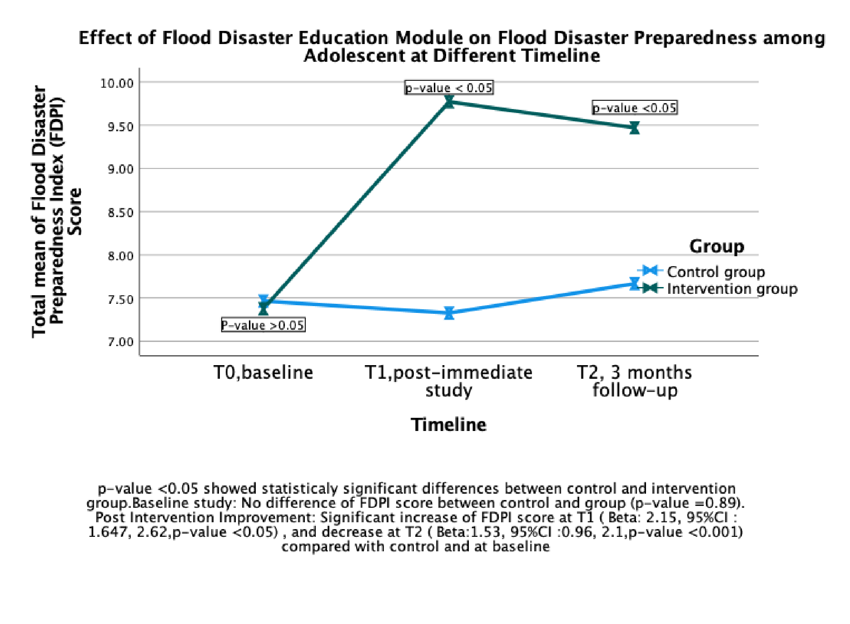

A questionnaire using flood disaster preparedness index score.

Flood Disaster preparedness Index (14 items)
In this section, the flood disaster preparedness index refers to the level of preparedness of you and your family members in facing a flood disaster.

Have you or your family adopted the flood disaster preparedness activities below? You can select (√) your response either Yes, No, or Not sure in the space given.

Item No | Activities | Responses
 |  | Yes | Not sure | No
A1 | Identified the evacuation route nearby your house.
A2 | Identified a safe elevated area to rescue from floods.
A3 | Identified emergency services contact numbers (such as 999, Ambulance, Fire, and Police)
A4 | Prepare a family emergency plan.
A5 | Shared information on disaster preparedness with other family and friends
A6 | Recognized the locally available emergency warning system ( such as sirens, cameras, and flood gauges)
A7 | Keep the important document in a safe place (such as a copy of your birth certificate or passport in a waterproof sealed file or online storage)
A8 | Bought insurance policy related to disaster
A9 | Prepared an emergency bag
A10 | Stored hazardous material safely (e.g., gas cylinder )
A11 | Placed all the movable objects at home at a higher place ( TV, Computer)
A12 | Learn how to turn off the main switch of the electrical power
A13 | Stored at least three days of clean water supply for every household. A 3-day water supply is at least 7.5 Litres of water per person per day.
A14 | Own applications that relay information about flood disasters (PublicInfobanjir, My DIMS, etc.)

