Supplementary

Supplemental Table S1. Variable Dictionary
Variable Name | Type of Variable | Description
Postoperative Laboratory Tests
maxAALT | Continuous | Postoperative liver function: ALT
maxATBil | Continuous | Postoperative liver function: TBIL
Demographic Characteristics
patient_id | Numerical | Patient's hospital ID
age | Continuous | Age
BMI | Continuous | Body Mass Index
gender | Categorical, Binary | Gender, 0—Female; 1—Male
ethnicity | Categorical, Ternary | Ethnicity, 1—Han; 2—Tibetan; 3—Other
smoking | Categorical, Binary | Current Smoking
alcohol_abuse | Categorical, Binary | Current Alcohol
NYHA | Ordinal, Quaternary | New York Heart Association classification, Grades 1-4
ASA_class | Ordinal, Ternary | American Society of Anesthesiologists classification, Grades 2-4
wound_class | Ordinal, Ternary | Surgical incision classification, 1-3
post_death | Categorical, Binary | Postoperative in-hospital death
admission_date | Time variable: Date | Admission date
discharge_date | Time variable: Date | Discharge date
operation_date | Time variable: Date | Operation date
Preoperative Diagnosis
oper_indication_simple_valve | Categorical, Binary | Preoperative diagnosis/indication: Simple valve disease
oper_indication_complex_valve | Categorical, Binary | Preoperative diagnosis/indication: Complex valve disease
oper_indication_CHD | Categorical, Binary | Preoperative diagnosis/indication: Coronary artery disease
oper_indication_myxoma | Categorical, Binary | Preoperative diagnosis/indication: Atrial myxoma
oper_indication_valve_chd | Categorical, Binary | Preoperative diagnosis/indication: Valve disease with CAD
oper_indication_endocarditis | Categorical, Binary | Preoperative diagnosis/indication: Infective endocarditis
Preoperative Disease History
pre_cardiac_history | Categorical, Binary | Previous cardiovascular disease history
pre_hypertension | Categorical, Binary | History of hypertension
pre_CHD | Ordinal, Quinary | Preoperative coronary artery disease history, 0—None; 1—Single vessel; 2—Double vessel; 3—Triple vessel; 4—Other
pre_endocarditis | Categorical, Binary | History of infective endocarditis
pre_AF | Categorical, Binary | History of atrial fibrillation
pre_HF | Categorical, Binary | History of heart failure
pre_PVD | Categorical, Binary | History of peripheral vascular disease
pre_cardiosurgery_history | Categorical, Binary | History of cardiovascular surgery
pre_atelectasis | Categorical, Binary | Preoperative atelectasis
pre_COPD | Categorical, Binary | History of Chronic Obstructive Pulmonary Disease
pre_asthma | Categorical, Binary | History of asthma
pre_lung_infection | Categorical, Binary | Preoperative lung infection
pre_pleural_effusion | Categorical, Binary | Preoperative pleural effusion
pre_pulmonary_hypertension | Ordinal, Quaternary | Preoperative pulmonary hypertension, 0—Normal; 1—Mild; 2—Moderate; 3—Severe
pre_stroke | Categorical, Binary | History of stroke
pre_cerebral_hemorrhage | Categorical, Binary | History of cerebral hemorrhage
pre_diabetes | Categorical, Binary | History of diabetes
pre_hyperthyroidism | Categorical, Binary | History of hyperthyroidism
pre_hypothyroidism | Categorical, Binary | History of hypothyroidism
pre_hyperlipemia | Categorical, Binary | Preoperative hyperlipidemia
pre_GI_bleeding | Categorical, Binary | Preoperative gastrointestinal bleeding
pre_renal_dysfunction | Categorical, Binary | Preoperative renal dysfunction
pre_CR_level | Ordinal, Ternary | Preoperative serum creatinine levels, 1—≤110; 2—>110 and <176; 3—≥176
Preoperative Medication History
beta_blockers | Categorical, Binary | Preoperative medication: β-blockers
antiplatelet_drug | Categorical, Binary | Preoperative medication: Antiplatelet drugs
aspirin | Categorical, Binary | Preoperative medication: Aspirin
cardiotonic_drug | Categorical, Binary | Preoperative medication: Cardiotonics
anticoagulant_drug | Categorical, Binary | Preoperative medication: Anticoagulants
diuretics | Categorical, Binary | Preoperative medication: Diuretics
Surgery type
surgery_method_simple_replacement | Categorical, Binary | Surgical method: Simple valve replacement
surgery_method_complex_replacement | Categorical, Binary | Surgical method: Complex valve replacement
surgery_method_CABG | Categorical, Binary | Surgical method: CABG
surgery_method_myxoma | Categorical, Binary | Surgical method: Cardiac tumor excision
surgery_method_replacement_CABG | Categorical, Binary | Surgical method: Valve replacement combined with CABG
surgery_method_radiofrequency_ablation | Categorical, Binary | Surgical method: Intraoperative radiofrequency ablation
surgery_method_thrombus_removal | Categorical, Binary | Surgical method: Intraoperative left atrial appendage thrombus removal
Preoperative Laboratory Tests
P_RBC | Continuous | Preoperative routine: Red Blood Cell count
P_Hb | Continuous | Preoperative routine: Hemoglobin
P_Plt | Continuous | Preoperative routine: Platelet count
P_WBC | Continuous | Preoperative routine: White Blood Cell count
P_PT | Continuous | Preoperative coagulation: Prothrombin Time
P_INR | Continuous | Preoperative coagulation: International Normalized Ratio
P_APTT | Continuous | Preoperative coagulation: Activated Partial Thromboplastin Time
P_FIB | Continuous | Preoperative coagulation: Fibrinogen
P_TBil | Continuous | Preoperative biochemical: Total bilirubin
P_ALT | Continuous | Preoperative biochemical: Alanine aminotransferase
P_ALB | Continuous | Preoperative biochemical: Albumin
P_Glu | Continuous | Preoperative biochemical: Glucose
P_BUN | Continuous | Preoperative biochemical: Blood urea nitrogen
P_CR | Continuous | Preoperative biochemical: Serum Creatinine
P_CysC | Continuous | Preoperative biochemical: Cystatin C
P_CRP | Continuous | Preoperative C-reactive protein
pre_EF | Continuous | Preoperative echocardiogram ejection fraction value
Intraoperative data
Cryo_time | Continuous | Cryo time
CPB_time | Continuous | CPB (Cardiopulmonary Bypass) total duration
Operation_time | Continuous | Total operation duration
cross_clamp_time | Continuous | Aortic cross-clamp time
total_RBC | Discrete | Total intraoperative red blood cell transfusion
oper_RBC | Discrete | Intraoperative red blood cell transfusion
post_RBC | Discrete | Postoperative red blood cell transfusion
CPB_blood_volume | Continuous | CPB machine blood volume
intraoperative_thrombin | Discrete | Intraoperative thrombin (Prothrombin complex) dose

Supplemental Table S2. Additional baseline characteristics of patients in the internal and external data sets, related to Table 1.
 | Internal |  |  | External | P value
 | Overall | Training | Internal validation | External validation | P value
Preoperative Laboratory Tests
Preoperative PT (seconds) | 11.80  [11.20, 12.60] | 11.80  [11.20, 12.60] | 11.80  [11.30, 12.60] | 13.40  [12.90, 14.30] | <0.001
Preoperative INR | 1.04  [0.99, 1.11] | 1.04  [0.99, 1.11] | 1.04  [0.98, 1.10] | 1.04  [0.98, 1.12] | 0.273
Preoperative APTT (seconds) | 28.70  [26.00, 31.60] | 28.70  [26.00, 31.60] | 28.60  [26.00, 31.80] | 38.10  [35.20, 42.00] | <0.001
Preoperative FIB (g/L) | 2.75  [2.35, 3.25] | 2.74  [2.34, 3.24] | 2.75  [2.37, 3.26] | 3.16  [2.70, 3.78] | <0.001
Preoperative TBil (mg/dL) | 14.50  [10.90, 19.20] | 14.50  [10.80, 19.12] | 14.30  [10.90, 19.20] | 13.40  [10.50, 18.00] | <0.001
Preoperative ALT (U/L) | 21.00  [15.00, 28.00] | 21.00  [15.00, 28.00] | 21.00  [15.00, 29.00] | 19.00  [14.00, 26.00] | <0.001
Preoperative ALB (g/dL) | 42.70  [40.10, 45.10] | 42.70  [40.10, 45.10] | 42.50  [40.00, 45.20] | 39.60  [37.10, 42.20] | <0.001
Preoperative Glu (mg/dL) | 4.95  [4.60, 5.43] | 4.96  [4.61, 5.44] | 4.93  [4.57, 5.39] | 4.97  [4.60, 5.52] | 0.195
Preoperative BUN (mg/dL) | 5.63  [4.60, 6.90] | 5.64  [4.60, 6.87] | 5.60  [4.54, 6.96] | 5.81  [4.76, 7.15] | 0.001
Preoperative CR (mg/dL) | 71.65  [62.00, 83.00] | 71.50  [62.00, 83.00] | 72.00  [62.00, 83.00] | 66.00  [55.00, 78.00] | <0.001
Preoperative cystatin-C (mg/L) | 1.03  [0.92, 1.16] | 1.03  [0.92, 1.15] | 1.02  [0.92, 1.17] | 1.13  [0.97, 1.34] | <0.001
Preoperative CRP (mg/L) | 2.14  [1.38, 3.98] | 2.15  [1.37, 3.96] | 2.10  [1.40, 4.11] | 1.80  [0.90, 4.40] | <0.001
Preoperative EF (%) | 63.00  [57.00, 68.00] | 63.00  [57.00, 68.00] | 63.00  [57.00, 67.00] | 61.00  [55.00, 67.00] | 0.001
Comorbidities and medical history
Cardiovascular disease | 4311 (80.4) | 3471 (80.9) | 840 (78.4) | 986 (81.7) | 0.102
Hypertension | 722 (13.5) | 568 (13.2) | 154 (14.4) | 412 (34.1) | <0.001
Prior endocarditis | 103 ( 1.9) | 80 ( 1.9) | 23 ( 2.1) | 45 ( 3.7) | 0.001
Atrial fibrillation | 2428 (45.3) | 1957 (45.6) | 471 (43.9) | 414 (34.3) | <0.001
Congestive heart failure | 1163 (21.7) | 939 (21.9) | 224 (20.9) | 43 ( 3.6) | <0.001
Peripheral vascular disease | 53 ( 1.0) | 39 ( 0.9) | 14 ( 1.3) | 35 ( 2.9) | <0.001
Prior cardiovascular surgery | 1187 (22.1) | 939 (21.9) | 248 (23.1) | 335 (27.8) | <0.001
Asthma | 9 ( 0.2) | 7 ( 0.2) | 2 ( 0.2) | 5 ( 0.4) | 0.242
COPD | 36 ( 0.7) | 29 ( 0.7) | 7 ( 0.7) | 20 ( 1.7) | 0.003
Cerebral hemorrhage | 13 ( 0.2) | 9 ( 0.2) | 4 ( 0.4) | 3 ( 0.2) | 0.623
Diabetes | 322 ( 6.0) | 255 ( 5.9) | 67 ( 6.2) | 126 (10.4) | <0.001
Hyperthyroidism | 87 ( 1.6) | 73 ( 1.7) | 14 ( 1.3) | 21 ( 1.7) | 0.634
Hypothyroidism | 1020 (19.0) | 813 (18.9) | 207 (19.3) | 37 ( 3.1) | <0.001
Atelectasis | 16 ( 0.3) | 12 ( 0.3) | 4 ( 0.4) | 3 ( 0.2) | 0.842
Lung Infection | 52 ( 1.0) | 38 ( 0.9) | 14 ( 1.3) | 60 ( 5.0) | <0.001
Pleural Effusion | 64 ( 1.2) | 52 ( 1.2) | 12 ( 1.1) | 27 ( 2.2) | 0.019
Hyperlipidemia | 1389 (25.9) | 1105 (25.7) | 284 (26.5) | 372 (30.8) | 0.002
Gastrointestinal Bleeding | 20 ( 0.4) | 17 ( 0.4) | 3 ( 0.3) | 3 ( 0.2) | 0.681
CHD |  |  |  |  | <0.001
None | 4842 (90.3) | 3884 (90.5) | 958 (89.4) | 845 (70.0)
Single vessel | 138 ( 2.6) | 111 ( 2.6) | 27 ( 2.5) | 58 ( 4.8)
Double vessel | 117 ( 2.2) | 89 ( 2.1) | 28 ( 2.6) | 43 ( 3.6)
Triple vessel | 265 ( 4.9) | 206 ( 4.8) | 59 ( 5.5) | 156 (12.9)
Other | 2 ( 0.0) | 2 ( 0.0) | 0 ( 0.0) | 105 ( 8.7)
Pulmonary hypertension |  |  |  |  | <0.001
None | 4548 (84.8) | 3647 (85.0) | 901 (84.0) | 867 (71.8)
Mild | 201 ( 3.7) | 154 ( 3.6) | 47 ( 4.4) | 150 (12.4)
Moderate | 414 ( 7.7) | 331 ( 7.7) | 83 ( 7.7) | 141 (11.7)
Severe | 201 ( 3.7) | 160 ( 3.7) | 41 ( 3.8) | 49 ( 4.1)
NYHA classification
Ⅰ | 77 ( 1.4) | 56 ( 1.3) | 21 ( 2.0) | 71 ( 5.9) | <0.001
Ⅱ | 1326 (24.7) | 1063 (24.8) | 263 (24.5) | 498 (41.3)
Ⅲ | 3853 (71.8) | 3091 (72.0) | 762 (71.1) | 536 (44.4)
Ⅳ | 108 ( 2.0) | 82 ( 1.9) | 26 ( 2.4) | 102 ( 8.5)
ASA physical status
Ⅱ | 96 ( 1.8) | 73 ( 1.7) | 23 ( 2.1) | 166 (13.8) | <0.001
Ⅲ | 4991 (93.0) | 3999 (93.2) | 992 (92.5) | 954 (79.0)
Ⅳ | 277 ( 5.2) | 220 ( 5.1) | 57 ( 5.3) | 87 ( 7.2)

Supplemental Table S3. Feature selection step 1: Single feature AUC and AUC under IFS strategy
 | Features | AUROC | IFS AUROC
1 | P_TBil | 0.696 | 0.696
2 | CPB_time | 0.597 | 0.718
3 | P_PT | 0.588 | 0.719
4 | Operation_time | 0.581 | 0.722
5 | cross_clamp_time | 0.577 | 0.722
6 | P_APTT | 0.574 | 0.727
7 | P_INR | 0.573 | 0.729
8 | pre_AF | 0.570 | 0.728
9 | P_CysC | 0.555 | 0.728
10 | P_ALT | 0.552 | 0.730
11 | surgery_method_complex_replacement | 0.545 | 0.730
12 | surgery_method_simple_replacement | 0.543 | 0.731
13 | pre_EF | 0.543 | 0.731
14 | oper_indication_complex_valve | 0.538 | 0.731
15 | pre_pulmonary_hypertension | 0.537 | 0.730
16 | P_CR | 0.536 | 0.730
17 | P_BUN | 0.535 | 0.731
18 | CPB_blood_volume | 0.535 | 0.731
19 | oper_indication_simple_valve | 0.534 | 0.731
20 | pre_hypothyroidism | 0.531 | 0.731
21 | NYHA | 0.530 | 0.730
22 | Cryo_time | 0.530 | 0.733
23 | pre_cardiac_history | 0.529 | 0.733
24 | P_FIB | 0.525 | 0.733
25 | cardiotonic_drug | 0.525 | 0.733
26 | pre_HF | 0.524 | 0.733
27 | pre_hyperlipemia | 0.523 | 0.732
28 | gender | 0.522 | 0.732
29 | P_Glu | 0.521 | 0.732
30 | P_ALB | 0.521 | 0.732
31 | BMI | 0.515 | 0.732
32 | ASA_class | 0.515 | 0.732
33 | pre_hypertension | 0.515 | 0.731
34 | P_CRP | 0.514 | 0.731
35 | surgery_method_thrombus_removal | 0.513 | 0.732
36 | diuretics | 0.513 | 0.732
37 | intraoperative_thrombin | 0.510 | 0.731
38 | surgery_method_radiofrequency_ablation | 0.509 | 0.733
39 | beta_blockers | 0.508 | 0.732
40 | oper_RBC | 0.508 | 0.733
41 | age | 0.507 | 0.733
42 | surgery_method_CABG | 0.507 | 0.733
43 | ethnicity | 0.506 | 0.733
44 | pre_diabetes | 0.506 | 0.733
45 | oper_indication_CHD | 0.505 | 0.733
46 | anticoagulant_drug | 0.504 | 0.733
47 | surgery_method_replacement_CABG | 0.504 | 0.732
48 | pre_endocarditis | 0.504 | 0.732
49 | pre_hyperthyroidism | 0.504 | 0.732
50 | pre_pleural_effusion | 0.503 | 0.732
51 | pre_GI_bleeding | 0.503 | 0.732
52 | aspirin | 0.502 | 0.732
53 | oper_indication_valve_chd | 0.502 | 0.731
54 | antiplatelet_drug | 0.502 | 0.731
55 | pre_PVD | 0.502 | 0.731
56 | pre_COPD | 0.501 | 0.731
57 | oper_indication_endocarditis | 0.501 | 0.731
58 | pre_cerebral_hemorrhage | 0.500 | 0.729
59 | pre_atelectasis | 0.499 | 0.729
60 | pre_asthma | 0.498 | 0.727
61 | pre_stroke | 0.498 | 0.727
62 | alcohol_abuse | 0.497 | 0.727
63 | pre_lung_infection | 0.496 | 0.727
64 | surgery_method_myxoma | 0.496 | 0.727
65 | oper_indication_myxoma | 0.496 | 0.727
66 | pre_CHD | 0.495 | 0.726
67 | pre_cardiosurgery_history | 0.494 | 0.726
68 | smoking | 0.486 | 0.725

R code for GAM to perform feature selection

m = gam(post_liver_injury_2 ~ s(P_TBil, bs = "cr", k = -1) + s(CPB_time,
bs = "cr", k = -1) + s(P_PT, bs = "cr", k = -1) + pre_AF +
s(P_CysC, bs = "cr", k = -1) + s(P_ALT, bs = "cr", k = -1) +
surgery_method_simple_replacement + s(pre_EF, bs = "cr",
k = -1) + pre_pulmonary_hypertension + s(P_BUN, bs = "cr",
k = -1) + s(CPB_blood_volume, bs = "cr", k = -1) + pre_hypothyroidism +
NYHA + s(Cryo_time, bs = "cr", k = -1) + s(P_FIB, bs = "cr",
k = -1) + cardiotonic_drug + pre_HF + pre_hyperlipemia +
gender + s(P_Glu, bs = "cr", k = -1) + s(P_ALB, bs = "cr",
k = -1) + s(BMI, bs = "cr", k = -1) + ASA_class + pre_hypertension +
s(P_CRP, bs = "cr", k = -1) + surgery_method_thrombus_removal +
diuretics + intraoperative_thrombin + beta_blockers + s(oper_RBC,
bs = "cr", k = -1) + s(age, bs = "cr", k = -1) + ethnicity, data=trainSet, family = ‘binomial’)

Supplemental Table S4. Feature Selection Step 3: Results of the Wald Chi-square Test for Each Feature in the GAM
 | Features | Df / Edf | Chi.sq | P value
1 | pre_AF | 1.000 | 0.179 | 0.673
2 | surgery_method_simple_replacement | 1.000 | 0.114 | 0.736
3 | pre_pulmonary_hypertension | 3.000 | 3.687 | 0.297
4 | pre_hypothyroidism | 1.000 | 13.337 | 0.000
5 | NYHA | 3.000 | 0.709 | 0.871
6 | cardiotonic_drug | 1.000 | 1.541 | 0.215
7 | pre_HF | 1.000 | 0.063 | 0.802
8 | pre_hyperlipemia | 1.000 | 1.272 | 0.259
9 | gender | 1.000 | 3.527 | 0.060
10 | ASA_class | 2.000 | 5.426 | 0.066
11 | pre_hypertension | 1.000 | 2.730 | 0.099
12 | surgery_method_thrombus_removal | 1.000 | 2.747 | 0.097
13 | diuretics | 1.000 | 0.515 | 0.473
14 | intraoperative_thrombin | 1.000 | 1.640 | 0.200
15 | beta_blockers | 1.000 | 0.146 | 0.703
16 | ethnicity | 2.000 | 3.712 | 0.156
17 | s(P_TBil) | 3.202 | 337.952 | < 2e-16
18 | s(CPB_time) | 1.000 | 45.160 | < 2e-16
19 | s(P_PT) | 6.410 | 18.264 | 0.013
20 | s(P_CysC) | 1.000 | 0.431 | 0.512
21 | s(P_ALT) | 1.260 | 14.987 | 0.001
22 | s(pre_EF) | 1.000 | 0.100 | 0.752
23 | s(P_BUN) | 7.305 | 9.512 | 0.315
24 | s(CPB_blood_volume) | 2.324 | 5.402 | 0.144
25 | s(Cryo_time) | 1.222 | 30.022 | 0.000
26 | s(P_FIB) | 1.000 | 1.209 | 0.272
27 | s(P_Glu) | 1.000 | 0.321 | 0.571
28 | s(P_ALB) | 7.616 | 13.903 | 0.141
29 | s(BMI) | 1.000 | 0.314 | 0.575
30 | s(P_CRP) | 5.995 | 7.116 | 0.329
31 | s(oper_RBC) | 1.000 | 14.080 | 0.000
32 | s(age) | 8.611 | 18.894 | 0.022
Df: Degree of freedom; Edf: Effective degrees of freedom; Chi.sq: Wald Chi-square Test

Supplemental Figure S1. Missing Data Patterns in Internal and External Datasets: a. Missing data pattern in the internal dataset; b. Missing data pattern in the external dataset.
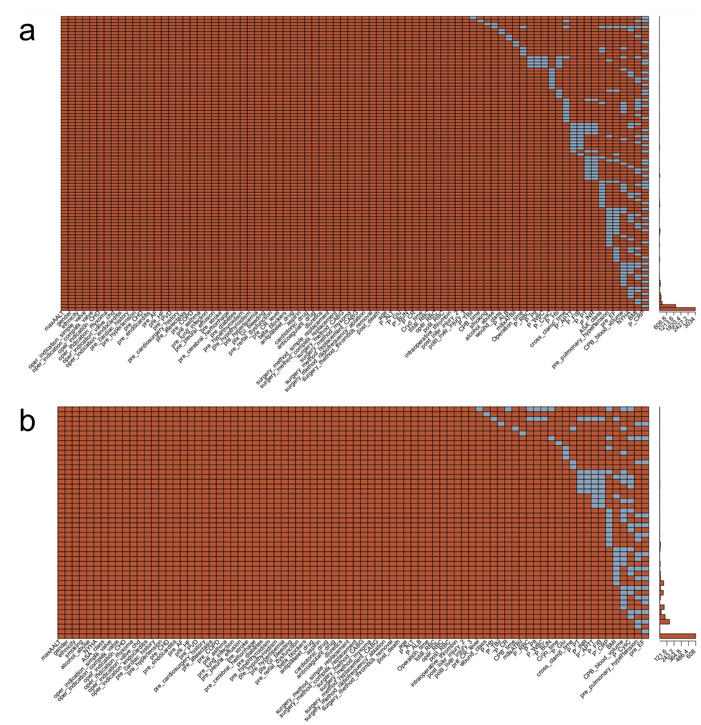
Elements in the heatmap on the left indicate whether a variable is missing (blue) or present (red), with each row representing a specific pattern of missingness. The histogram on the right shows the frequency of each missing pattern.

Supplemental Figure S2. Decision curve analysis of the prediction model for the internal and external validation data sets. a. Decision curve analysis in the internal dataset; b. Decision curve analysis in the external dataset.
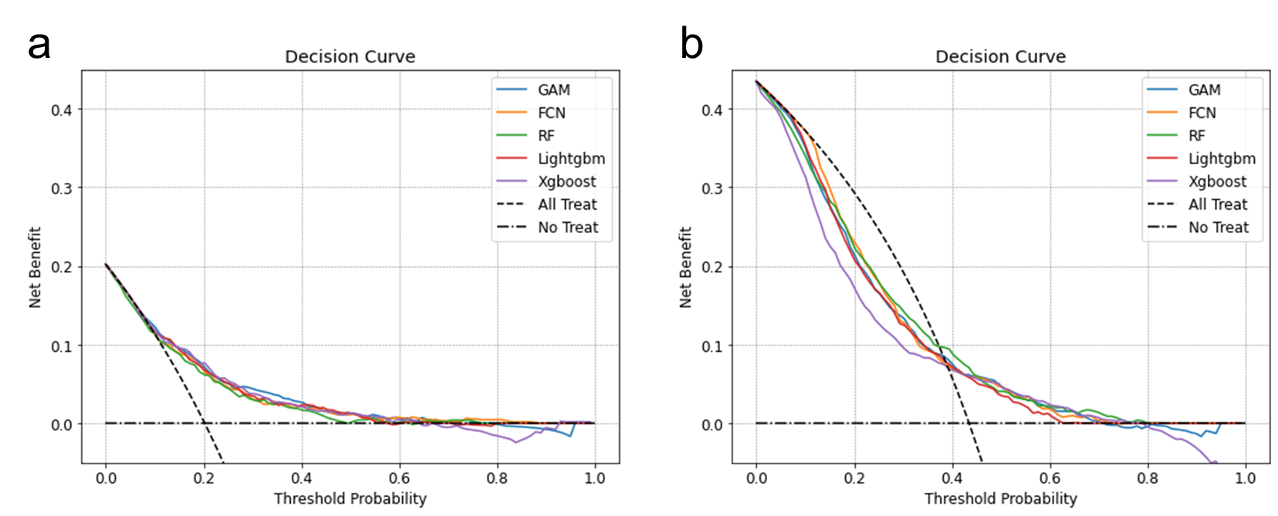
Net benefit of using a model to predict the risk of postoperative new-onset liver injury in patients as compared with the strategies of ‘treat all patients’ or ‘treat no patient’ for different thresholds. Net benefits of various machine learning models are shown as a function of sequential probability thresholds.

