Supplementary Information

Ultra-low power-consumption OLEDs via phosphor-assisted thermally-activated-delayed-fluorescence-sensitized narrowband emission

Chen Yin,^{#1} Yangyang Xin,^{#1} Tianyu Huang,¹ Qisheng Zhang,³ Lian Duan,^{1,2} Dongdong Zhang*¹

¹Key Laboratory of Organic Optoelectronics and Molecular Engineering of Ministry of Education, Department of Chemistry, Department of Chemistry, Tsinghua University, Beijing 100084, China
²Laboratory of Flexible Electronics Technology, Tsinghua University, Beijing, 100084, China
³MOE Key Laboratory of Macromolecular Synthesis and Functionalization, Department of Polymer Science and Engineering, Zhejiang University, Hangzhou, 310027, China
E-mail: ddzhang@mail.tsinghua.edu.cn
#Those authors contribute equally to this work.

Table of Contents

1. Supplementary Figures......................................................................3
2. Supplementary Tables.......................................................................14
3. Supplemental Methods.....................................................................14
3.1 General Information………………………………..……….14
3.2 Analysis of Single-Crystal Structure………………….……15
3.3 Computational methods…………………………….………15
3.4 Photophysical Property Measurements……………………15
3.5 Electrochemical and thermal stability measurements……16
3.6 OLED fabrication and characterization…………………..17
3.7 The synthesis and characterization of DPT-IC……………17
4. Supplementary References..............................................................20

1. Supplementary Figures

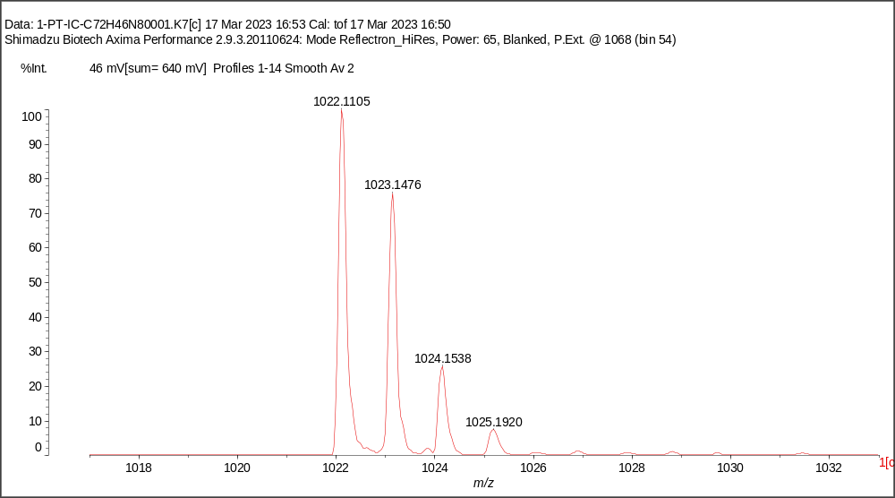
Figure S1. MALDI-TOF mass spectrum of DPT-IC.

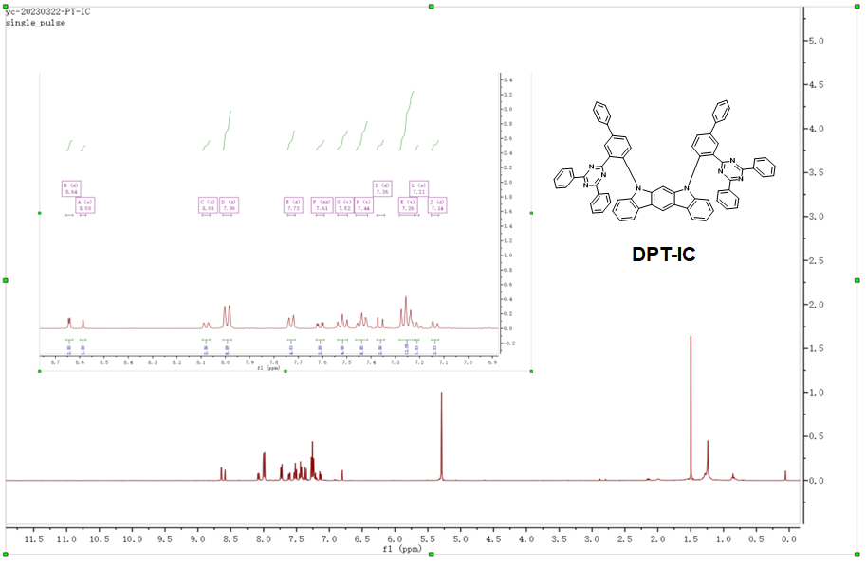
Figure S2. ¹H NMR spectrum of DPT-IC.

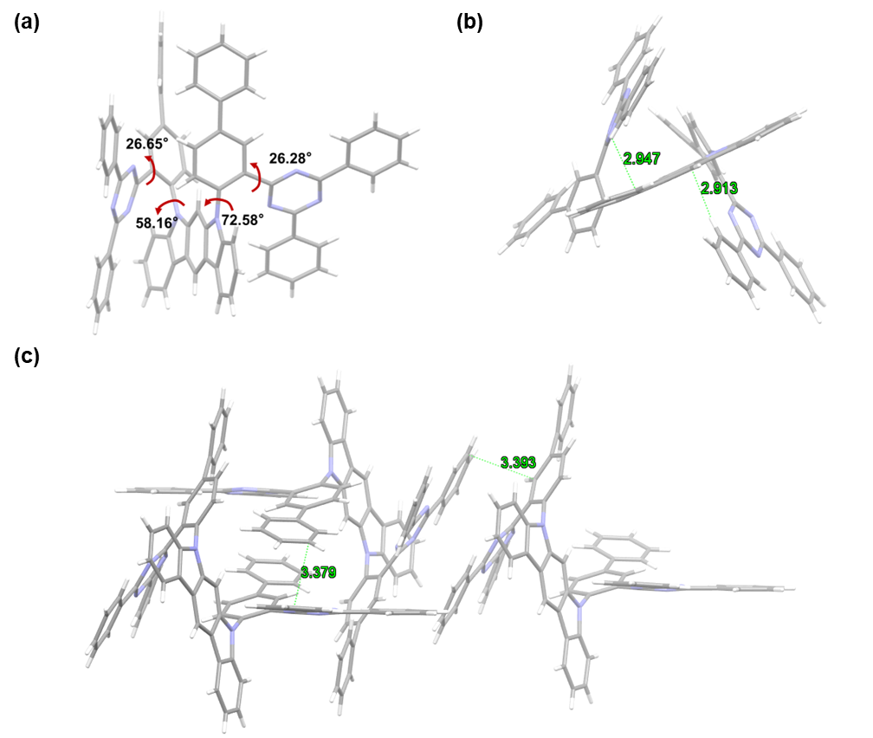
Figure S3. Single-crystal structure of DPT-IC, (a) front view, (b) top view, (c) stack view.

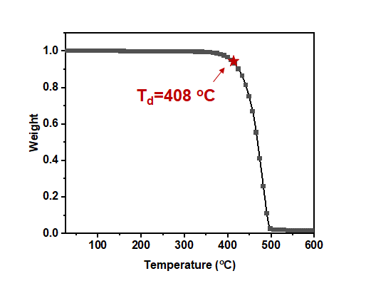
Figure S4. Thermogravimetry analysis (TGA) of DPT-IC.

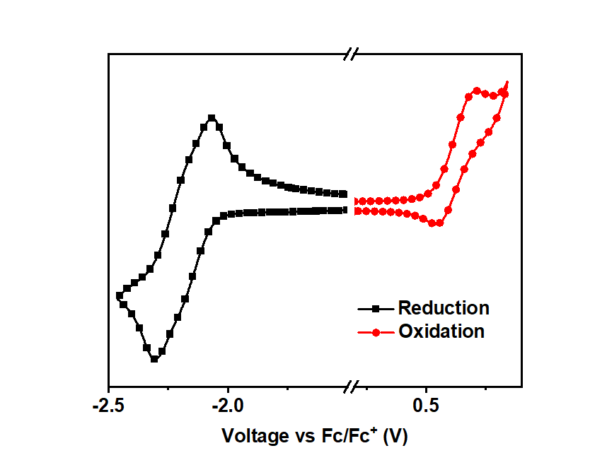
Figure S5. Cyclic Voltammograms of DPT-IC.

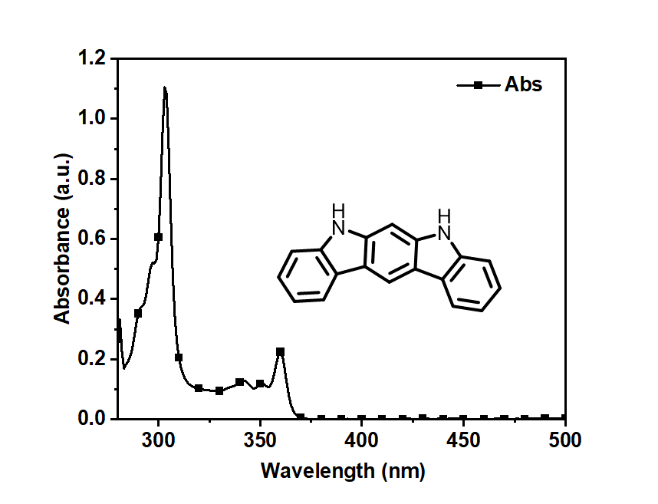
Figure S6. The absorption of 5,7-dihydroindolo[2,3-b]carbazole (23bICz).

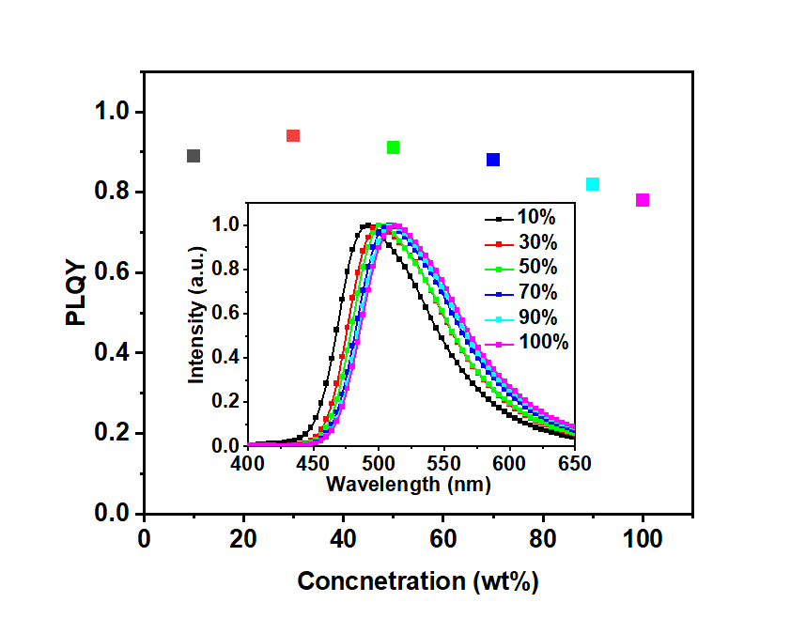
Figure S7. The PLQY and emission spectra of mCPBC: DPT-IC doped films with concentrations of DPT-IC ranging from 10% to 100% (prinstine film).

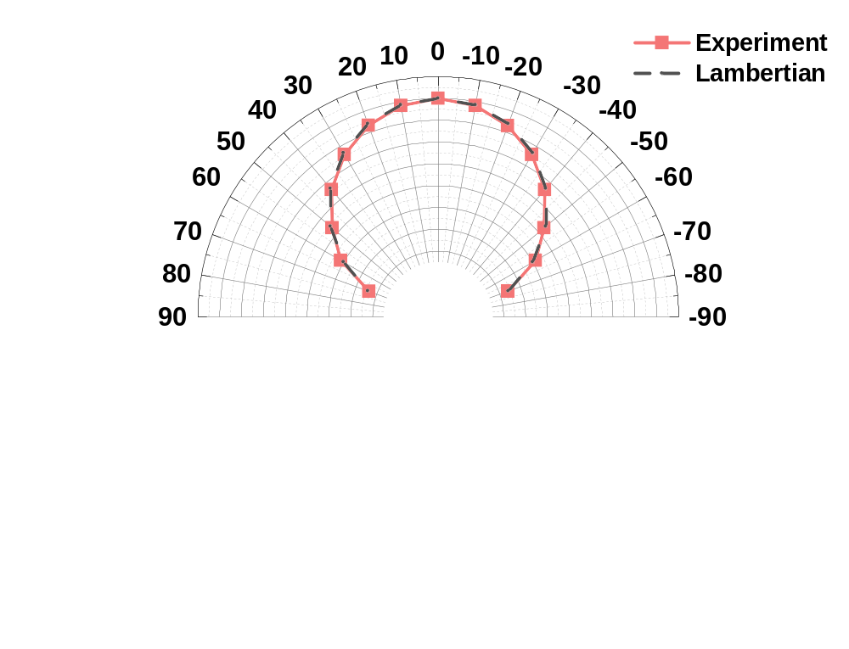
Figure S8. The angle-dependent EL intensity of pTSF device compared to the Lambertian distribution.

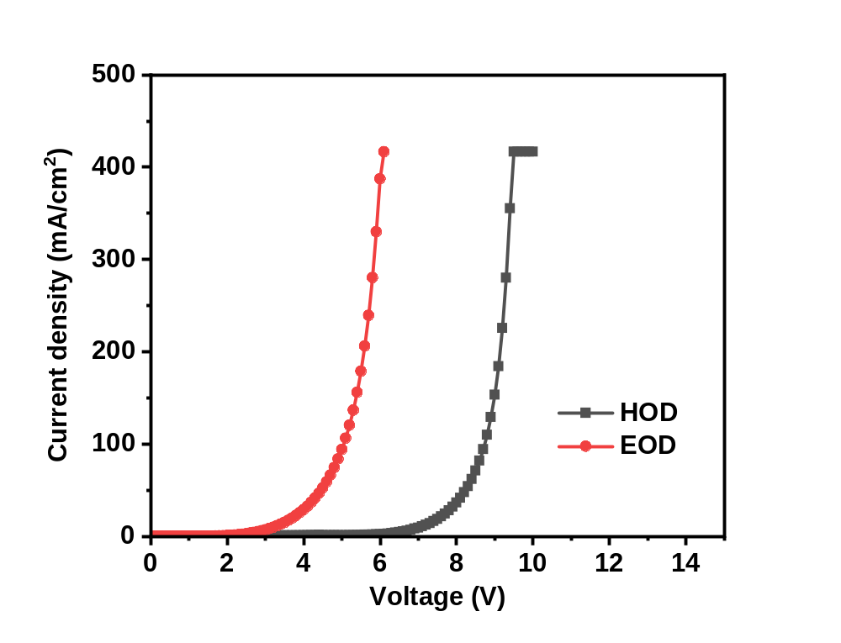
Figure S9. Single carrier devices of DPT-IC. The device structure of Hole-only device: ITO/NPB (30 nm)/DPT-IC (100 nm)/NPB (30 nm)/Al (150 nm), and the device structure of electron-only device: ITO/Bphen (30 nm)/ DPT-IC (100 nm)/Bphen (30 nm)/LiF (0.7 nm)/Al (150 nm).

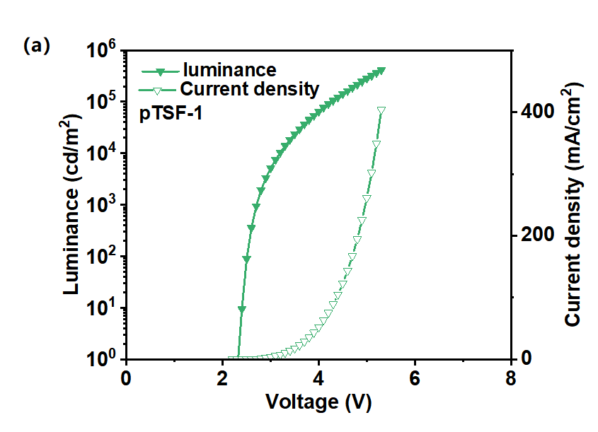
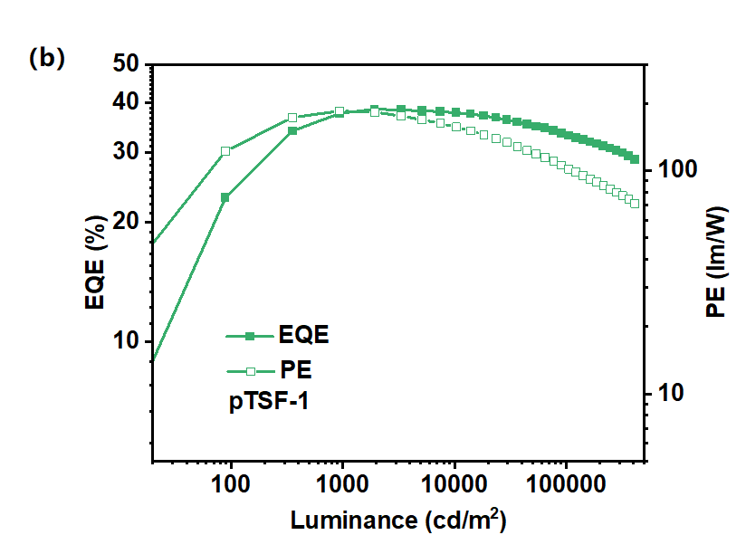
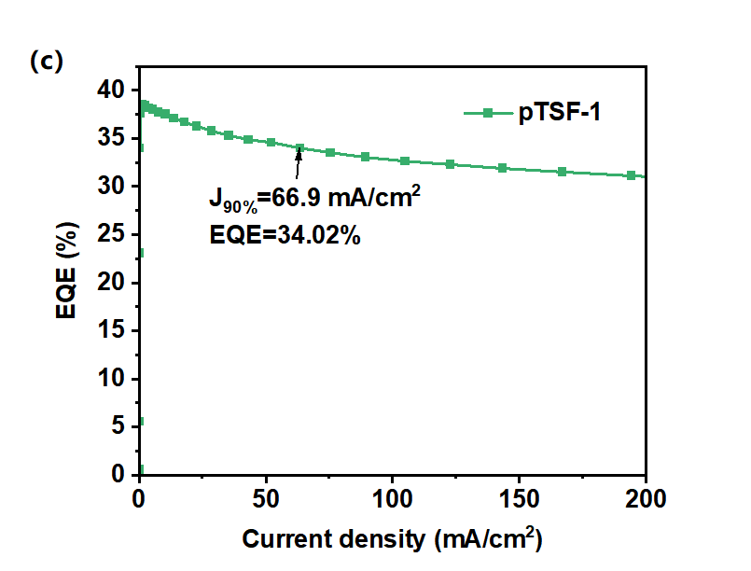
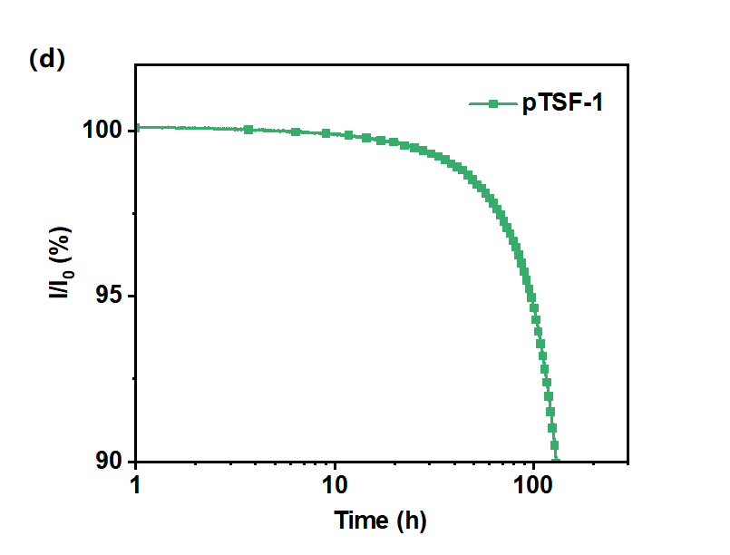
Figure S10. (a) The luminance-voltage-current density curves. (b) The EQE-luminance-PE curves. (c) The current density-EQE character. (d) Normalized luminance of the pTSF-1 device as a function of operating time at a constant current density with the initial luminance of 10,000 cd/m².

2. Supplementary Table

Table S1. PE_{max} and L_{PE=100 lm/W} (the maximum luminance at a PE of 100 lm/W) of the reported devices with different kinds of emitters.
Emission type | Emitter | PE_{max} (lm W⁻¹) | L_{PE=100 lm/W} | Ref.
pTSF | tCzphB-FI | 185.4 | 114,330 | This Work
TSF | HF DtCzB-DPTRZ | 181.3 | ～1700 | 21
TSF | HF BN₃ | 205.8 | ～1500 | 21
TADF | CzDBA | 121.6 | ～1900 | 9
TADF | CzCF7oB | 123.9 | ～450 | 14
TADF | 4CzIPN | 106.9 | ～1000 | 17
TADF | 4CzIPN | 116.5 | ～800 | 18
TADF | B4PyMPM | 145.4 | ～2000 | 19
TADF | 2PXZBN | 123.4 | ～150 | 21
TADF | 2PTZBN | 157.7 | ～1200 | 21
TADF | BNSSe | 156.2 | ～800 | 21
TADF | BNSeSe | 146.3 | ～1200 | 21
TADF | BN₃ | 170.7 | ～200 | 21
TADF | DQBC | 112 | ～500 | 27
Phosphorescence | Ir(ppy)₂(acac) | 127.3 | ～2000 | 10
Phosphorescence | Ir(ppy)₂(acac) | 143.4 | ～3900 | 11
Phosphorescence | PO-01 | 108.3 | ～150 | 12
Phosphorescence | FIrpic | 105 | ～400 | 13
Phosphorescence | Ir(ppy)3 | 133 | ～1500 | 15
Phosphorescence | Ir(ppy)₂tmd | 142.5 | ～4000 | 16
Phosphorescence | Ir(ppy)₂tmd | 122.8 | ～500 | 16
Phosphorescence | Ir(mppy)₃ | 118 | ～18000 | 20
Phosphorescence | DCzBN-Au | 106.8 | ～100 | 22
Phosphorescence | FIrpic | 124 | ～6500 | 23
Phosphorescence | Ir(MDQ)₂(acac) | 111 | ～3200 | 23
Phosphorescence | Ir(ppy)₂(acac) | 124 | ～3000 | 24
Phosphorescence | PO-01 | 115.5 | ～4100 | 25
Phosphorescence | Ir(ppy)₃ | 115 | ～200 | 26

3. Supplemental Methods
3.1 General Information. All the commercially available reagents were used as received and all the measurements were carried out at room temperature unless otherwise stated. The reagents for the synthesis of DTP-IC were mainly purchased from Shanghai Bide Medical Technology Co. Ltd. The compounds used in the device were purchased from Jilin Optical and Electronic Materials Co. Ltd. The final emitter, tCzphB-FI, was synthesized according to the literature.^{[1]} The reactions of the synthetic procedure were carried out under a nitrogen atmosphere using Schlenk techniques. For the ¹H NMR spectrum measurement of DPT-IC, a JEOL JNM-ECS600 spectrometer (600 Hz) was adopted, with the compound dissolved in in deuterated dichloromethane with tetramethyl silane as the internal standard. The molecular mass was measured using Matrix-Assisted Laser Desorption / Ionization Time of Flight Mass Spectrometry (MALDI-TOF-MS) with a Shimadzu AXIMA Performance MALDI-TOF instrument in positive detection modes.
3.2 Analysis of Single-Crystal Structure. The diffraction data of single crystal of DPT-IC was collected using a Rigaku R-AXIS-RAPID diffractometer at the ω-scan mode with graphite-monochromator Mo•Kα radiation. And the SHELXTL programs was used to directly determine the molecular structure, which was further refined using full-matrix least squares on F2. The data could be obtained freely from the Cambridge Crystallographic Data Centre via www.ccdc.cam.ac.uk/data_request/cif with a CCDC reference number of 2355309.
3.3 Computational methods. The electronic properties of the molecular in the ground state were studied performed with the Gaussian 16 package using the density functional theory (DFT) and excited-state electronic analysis by time-dependent DFT (TD-DFT) method with the same basis of B3LYP/6-31(G)*.^{[2]} The Multiwfn program was adopted to calculate the reduced density gradient (RDG), which was then plotted by VMD.^{[3,4]} The hole-particle analysis of the degenerate singlet and triplet states was conducted using the Multiwfn 3.8 program and the spin-orbital coupling matrix element (SOCME) values between those states were calculated with ORCA package.^{[5]}
3.4 Photophysical Property Measurements. The solutions with concentration of 1×10⁻⁵ M were prepared for the solution measurements. All the organic films used for the photoluminescence measurements were deposited onto clean quartz substrates by thermal evaporation at 1-1.5 Å s⁻¹ under high vacuum with a base pressure of <10⁻⁶ torr. An Agilent 8453 spectrophotometer was used for the UV-vis absorption spectra measurement while a Hitachi F-7000 Fluorescence Spectrometer for the steady fluorescence and phosphorescence spectra. Edinburgh fluorescence spectrometer (FLS1000) using picosecond pulsed diode laser was adopted to measure the photoluminescence decay curve under an excitation wavelength at 375 nm. And a Hamamatsu absolute PL quantum yield spectrometer (C9920-02G) with an integrating sphere was used for the photoluminescence quantum yields measurement.
The rate constants of TADF process were calculated using the equations below:^{[6]}
$$k_{r}=\frac{Φ_{PF}}{τ_{PF}}$$
$$k_{ISC}=\frac{1-Φ_{PF}}{τ_{PF}}$$
$$k_{RISC}=\frac{Φ_{DF}}{τ_{DF}k_{ISC}τ_{PF}Φ_{PF}}$$
The FET radii was calculated by equation:^{[7]}
$$R_{0}^{6}=\frac{9000ln10}{128π^{5}n^{4}N_{A}}η_{PL}κ^{2}\int_{0}^{∞}{f_{D}(λ)ε_{A}(λ)λ^{4}dλ}$$
R₀ is the distance between D and A. $κ^{2 }$is the azimuth factor, usually 2/3. N_{A} is AvogadLuo constant. n is the material refractive index, for organic materials generally 1.7. $\int_{0}^{∞}{f_{D}(λ)ε_{A}(λ)λ^{4}dλ}$ is the overlap integral between the emission spectrum of D and the absorption spectrum of A.
A RSQX-01 instrument (Changchun Ruoshui Co.) was adopted to measure the horizontal emitting dipole ratio (Θ) of the final emitter doped in a 30-nm-thick film fabricated by thermal vacuum evaporation onto a D-shape quartz column substrate. A continuous-wave laser was used as the excitation source with an excitation wavelength of 360 nm and a fixed excitation angle of 45º. The photoluminescence intensity with varied angles were recorded at the peak wavelength of the film as the sample stage was rotated automatically at intervals of 3° from -3° to 90°. The wavelength range is between 380 nm and 800 nm.
3.5 Electrochemical and thermal stability measurements. A Potentiostat/Galvanostat Model 283 (Princeton Applied Research) electrochemical workstation was used for the electrochemical measurements with Pt as the working electrode, platinum wire as the auxiliary electrode, and an Ag wire as the reference electrode standardized against ferrocene/ferrocenium. A concentration of 10 mg/mL for DPT-IC and a scan rate of 100 mV s⁻¹ were adopted during the measurement. The dichloromethane (CH₂Cl₂) solution using 0.1 M n-Bu₄NPF₆ as the supporting electrolyte was used for the oxidation potential measurement while N, N-Dimethylformamide (DMF) solution containing 0.1 M n-Bu₄NClO₄ for the reduction potentials. The thermogravimetry analysis (TGA) of DPT-IC was measured using TGA55 (TA Instrument) with a temperature range from 30 to 600 ºC and a heating rate of 10 ºC/min. The LUMO and LUOMO energy levels were determined from the cathodic reduction and oxidation potentials, respectively.
3.6 OLED fabrication and characterization. All the compounds for the device fabrication were firstly subjected to temperature-gradient sublimation under high vacuum. The ITO-coated transparent glass was adopted as the substrates for OLEDs with multiple organic functional layers sandwiched between the bottom ITO anode and the top metal cathode. The substrates were pre-cleaned carefully before device fabrication and the functional films were then deposited by evaporation in a vacuum chamber with a base pressure of 10⁻⁶ torr. The complete device was fabricated in a single vacuum pump-down without breaking vacuum to guarantee device performances. For the organic films, a deposition rate of 1.0 Å s⁻¹ was maintained. The doping ratio in emitting layer was conducted by co-evaporation from the corresponding separated evaporation sources with different evaporation rates. The device was finally encapsulated before characterization. An EQE measurement system (Hamamatsu C9920-12, equipped with Hamamatsu PMA-12 Photonic multichannel analyzer C10027-02 whose longest detection wavelength is 1100 nm) integrating with a Keithley 2400 source meter was used to characterize the electroluminescence performances of the devices, including the current density, voltage, luminance, EQE, electroluminescent spectra and other EL properties at the same time. The angle-dependent EL intensity of pTSF device was measured using Hamamatsu C9920-11 system under a constant voltage of 4 V with the anlge range was set from 0º to ±90º with a step of 5º. The EL decay behaviors were detected sing an Edinburgh FLS1000 transient spectrometer with the device being excited by a short-pulse generated by an Agilent 8114A. The short-pulse possesses a pulse width of 15 μs, an amplitude of 7 V and a baseline of -3 V, respectively. The whole period was 50 μs with a delayed time 25 μs and a duty cycle 30%. The device operation lifetimes were measured using an OLED aging lifetime tester (ZJZCL-1, Shanghai University).

3.7 The synthesis and characterization of DPT-IC
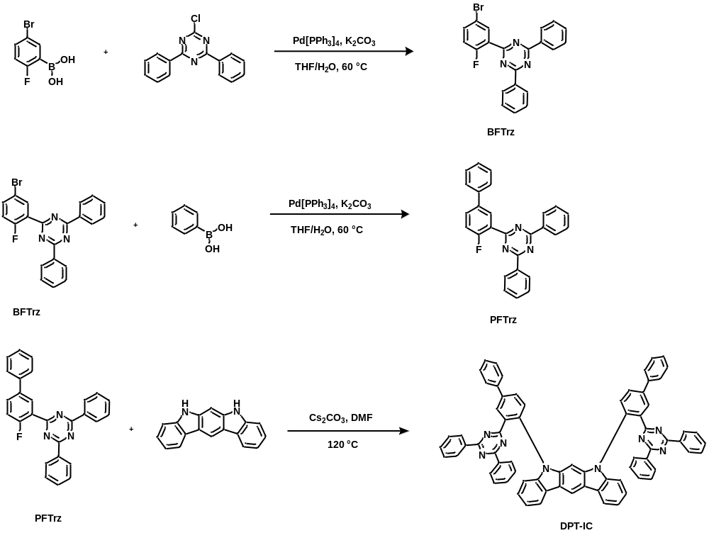
Scheme S1. Synthetic procedure of BFTrz, PFTrz and DPT-IC.

Synthesis of 2-(5-bromo-2-fluorophenyl)-4,6-diphenyl-1,3,5-triazine (BFTrz)
A mixture of (2-fluoro-5-bromophenyl)boronic acid (2.08g, 10 mmol), 2-chloro-4,6- diphenyl-1,3,5-triazine (2.68 g, 10 mmol), Tetrakis(triphenylphosphine)palladium (0.15 g, 0.1 mmol) and potassium carbonate (4.15 g, 30 mmol) in 60 ml THF/H2O (volume ratio 2:1) was added into a three-necked bottle and stirred at 60 °C overnight under nitrogen atmosphere. Then the reaction was cooled to room temperature and poured into water, followed with extraction by dichloromethane. Next, the combined organic layer was dried with anhydrous Na₂SO₄, and the solvent was removed under reduced pressure. The residue was purified by column chromatograph using CH₂Cl₂/petroleum ether (1:3) as the solvent to get BFTrz as a white solid (2.96 g, 75%). The compound was directly used as the reagent for the following reaction without further treatment.

Synthesis of 2-(4-fluoride-[1,1’-biphenyl]-3-yl)-4,6-diphenyl-1,3,5-triazine (PFTrz)
A mixture of phenylboric acid (0.84g, 7 mmol), BFTrz (2.76 g, 7 mmol), Tetrakis(triphenylphosphine)palladium (0.15 g, 0.1 mmol) and potassium carbonate (2.80 g, 20 mmol) in 60 ml THF/H₂O (volume ratio 2:1) was added into a three-necked bottle and stirred at 60 °C overnight under nitrogen atmosphere. Then the reaction was cooled to room temperature and poured into water, followed with extraction by dichloromethane. Next, the combined organic layer was dried with anhydrous Na₂SO₄, and the solvent was removed under reduced pressure. The residue was purified by column chromatograph using CH₂Cl₂/petroleum ether (1:3) as the solvent to get PFTrz as a white solid (2.36 g, 82%). The compound was directly used as the reagent for the following reaction without further treatment.

Synthesis of 5,7-bis(3-(4,6-diphenyl-1,3,5-triazin-2-yl)-[1,1'-biphenyl]-4-yl)-5,7-dihydroindolo [2,3-b] carbazole (DPT-IC)
PFTrz (2.0 g, 5 mmol), 5,7-dihydroindolo[2,3-b] carbazole (0.64 g, 2.5 mmol), Cesium carbonate (6.5 g, 20 mmol) and 40 ml Dimethylformamide (DMF) was added to a two necked round bottom flask equipped with a reflux condenser. After the mixture was bubbled with nitrogen for 10 minutes, the reaction was stirred at 120°C overnight under nitrogen atmosphere. Then the mixture was cooled to room temperature and then poured into water. The solid substance is obtained after vacuum filtration, rinsed with deionized water for 3 times, and then put into a vacuum oven dry for 24 hours. The residue was purified by column chromatograph using CH₂Cl₂/petroleum ether (1:1) as the solvent to get DPT-IC as a yellow solid (2.37 g, 86%).
MALDI-TOF MS：Calculated: C₇₂H₄₆N₈ [m/z]=1022.3845，Found: [m/z] =1022.1105.
¹H NMR（600 MHz, CD₂Cl₂）δ: 8.64 (d, 2H), 8.59 (s, 1H), 8.08 (d, 2H), 7.99 (d, 8H), 7.73 (d, 4H), 7.61 (dd, 2H), 7.52 (t, 4H), 7.44 (t, 6H), 7.36 (d, 2H), 7.26 (t, 12H), 7.21 (s, 1H), 7.14 (d, 2H).
Anal. Calcd (%) for C₇₂H₄₆N₈: C, 84.52; H, 4.53; N, 10.95; Found: C, 84.50; H, 4.51; N, 10.99;

4. Supplementary References.
[1] Liu, J., Zhu, Y., Tsuboi, T. et al. Toward a BT.2020 green emitter through a combined multiple resonance effect and multi-lock strategy. Nat Commun 13, 4876 (2022).
[2] M. J. Frisch, G. W. Trucks, H. B. Schlegel, G. E. Scuseria, M. A. Robb, J. R. Cheeseman, G. Scalmani, V. Barone, G. A. Petersson, H. Nakatsuji, X. Li, M. Caricato, A. V. Marenich, J. Bloino, B. G. Janesko, R. Gomperts, B. Mennucci, H. P. Hratchian, J. V. Ortiz, A. F. Izmaylov, J. L. Sonnenberg, Williams, F. Ding, F. Lipparini, F. Egidi, J. Goings, B. Peng, A. Petrone, T. Henderson, D. Ranasinghe, V. G. Zakrzewski, J. Gao, N. Rega, G. Zheng, W. Liang, M. Hada, M. Ehara, K. Toyota, R. Fukuda, J. Hasegawa, M. Ishida, T. Nakajima, Y. Honda, O. Kitao, H. Nakai, T. Vreven, K. Throssell, J. A. Montgomery Jr., J. E. Peralta, F. Ogliaro, M. J. Bearpark, J. J. Heyd, E. N. Brothers, K. N. Kudin, V. N. Staroverov, T. A. Keith, R. Kobayashi, J. Normand, K. Raghavachari, A. P. Rendell, J. C. Burant, S. S. Iyengar, J. Tomasi, M. Cossi, J. M. Millam, M. Klene, C. Adamo, R. Cammi, J. W. Ochterski, R. L. Martin, K. Morokuma, O. Farkas, J. B. Foresman, D. J. Fox, Wallingford, CT, 2016.
[3] T. Lu, F. Chen, J. Comput. Chem. 2012, 33, 580-592.
[4] W. Humphrey, A. Dalke, K. Schulten, J. Mol. Graph. 1996, 14, 33-38.
[5] F. Neese, The ORCA program system. WIREs Comput. Nol. Sci. 2, 73-78 (2012).
[6] Masui. K., Nakanotani, H. & Adachi, C. Analysis of exciton annihilation in high-efficiency sky-blue organic light-emitting diodes with thermally activated delayed fluorescence. Organ. Electron. 14, 2721-2726 (2013).
[7] Stavrou, K., Franca, L.G., Danos, A. et al. Key requirements for ultraefficient sensitization in hyperfluorescence organic light-emitting diodes. Nat. Photon. (2024). https://doi.org/10.1038/s41566-024-01395-1.

