Supplements

Control group (more than 287 lobules)
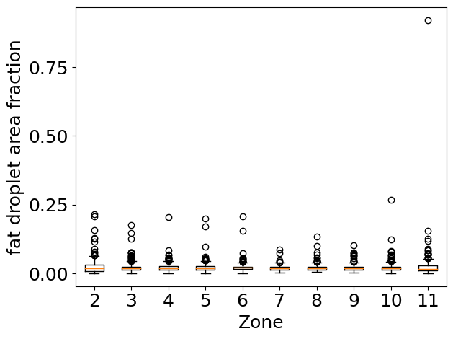 | 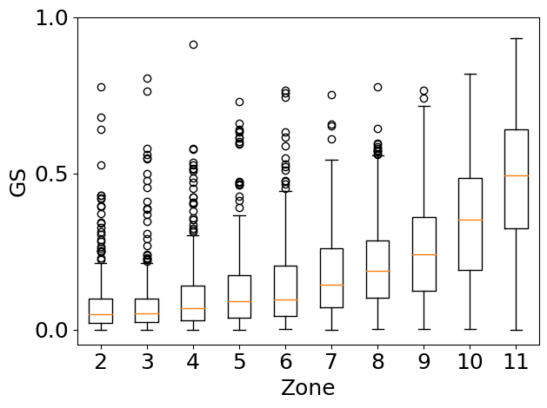
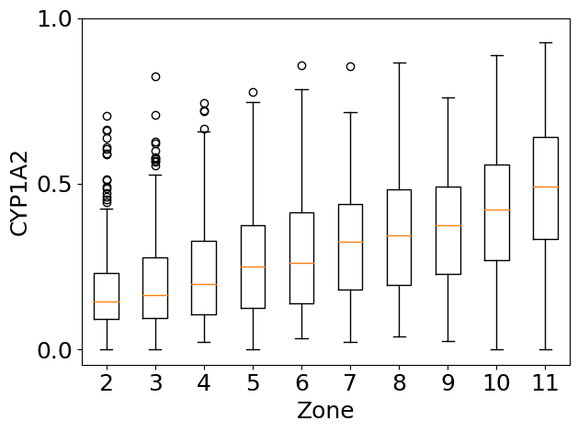 | 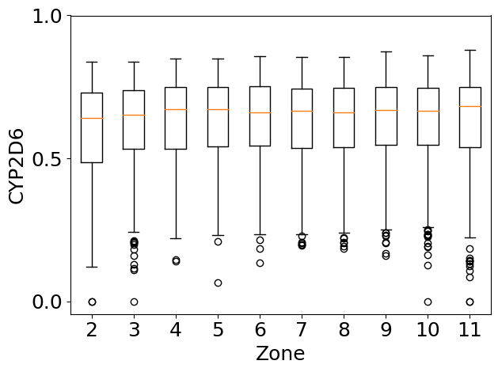
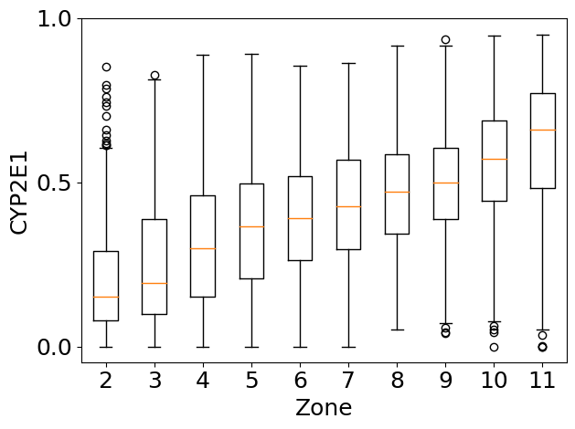 | 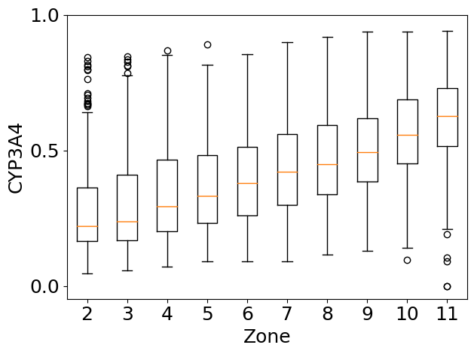

Figure 5c: Box-whisker-plot quantifying the spatial distribution of parameters within the hepatic lobules of a steatotic mouse liver along the sinusoidal porto-central axis.
(A) Graphical representation of the quantitative intralobular spatial distribution of steatosis showing the gentle decline of the slope from portal to central vein. (B) Graphical representation of the quantitative intralobular zonal distribution of GS showing the absence of expression in zone 1-8 and the steep gradient representing the expression in zone 9-11. (C) demonstrating CYP enzyme expression showing the steep incline of the slope representing CYP1A2 (upper left) and (D) for CYP2E1 (upper right) from 0 to 0.8, (E) the gentle incline for CYP3A4 from 0.5 to 0.8 and (F) no incline but rather uniform throughout the lobule for CYP2D6. The X-axis represents the portality index arbitrarily divided into 12 zones. The y-axis represents fat droplet area fraction and the ratio of positively stained over all tissue in each zone, respectively. The orange line indicates the median, the box in the 1st and 3rd quartiles, and the median whiskers extend up to 1.5 times the interquartile range. Data outside the whiskers range are displayed as circles indicating outliers. Notably, two Steatosis outliers in the control group are caused by isolated foreground pixels in a vessel that is mainly classified as background.

2 weeks feeding (more than 175 lobules)
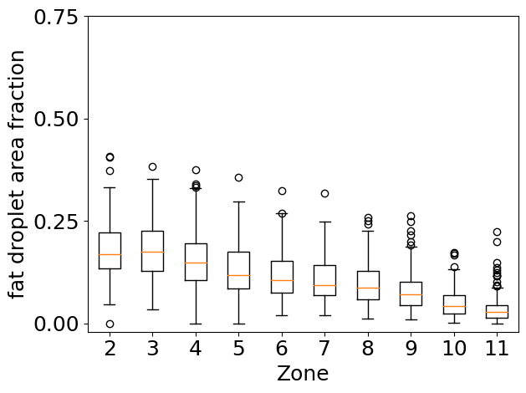 | 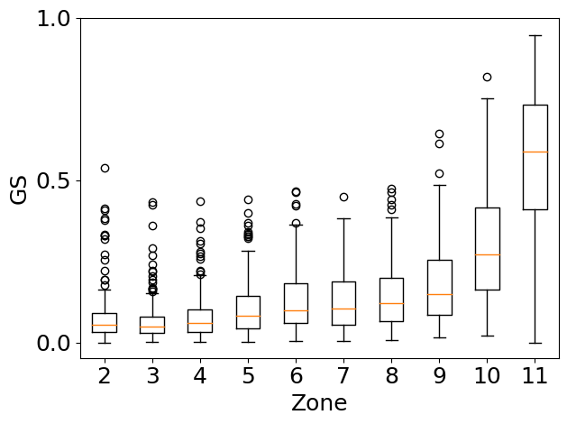
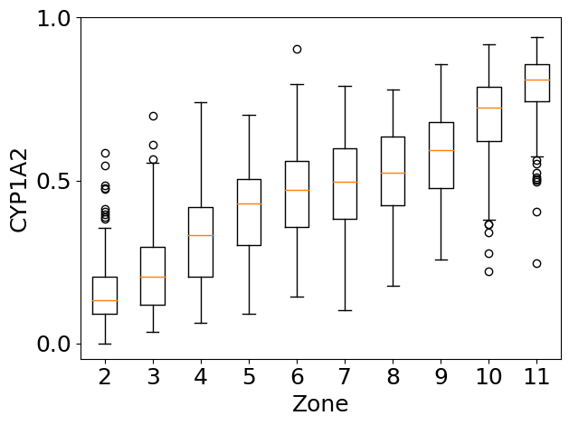 | 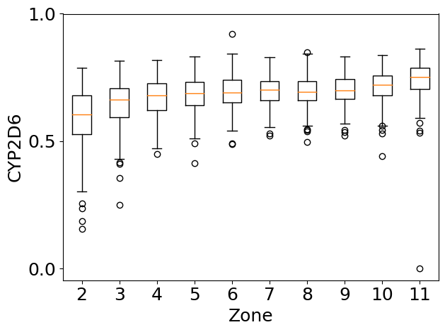
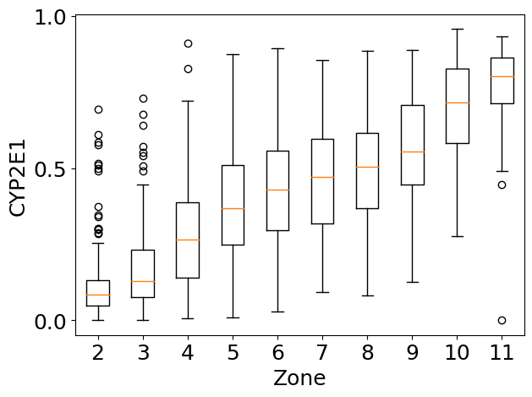 | 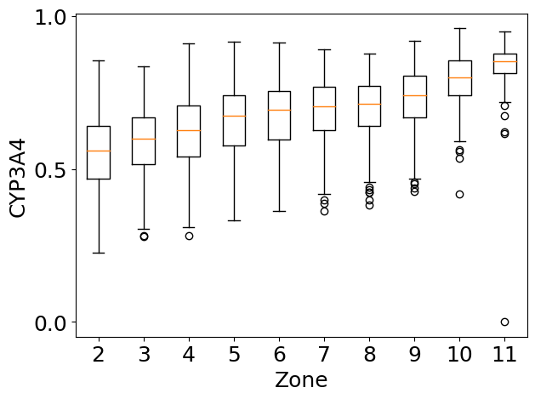

Figure 5b: Box-whisker-plot quantifying the spatial distribution of parameters within the hepatic lobules of a steatotic mouse liver along the sinusoidal porto-central axis.
(A) Graphical representation of the quantitative intralobular spatial distribution of steatosis showing the gentle decline of the slope from portal to central vein. (B) Graphical representation of the quantitative intralobular zonal distribution of GS showing the absence of expression in zone 1-8 and the steep gradient representing the expression in zone 9-11. (C) demonstrating CYP enzyme expression showing the steep incline of the slope representing CYP1A2 (upper left) and (D) for CYP2E1 (upper right) from 0 to 0.8, (E) the gentle incline for CYP3A4 from 0.5 to 0.8 and (F) no incline but rather uniform throughout the lobule for CYP2D6. The X-axis represents the portality index arbitrarily divided into 12 zones. The y-axis represents fat droplet area fraction and the ratio of positively stained over all tissue in each zone, respectively. The orange line indicates the median, the box in the 1st and 3rd quartiles, and the median whiskers extend up to 1.5 times the interquartile range. Data outside the whiskers range are displayed as circles indicating outliers. Notably, two Steatosis outliers in the control group are caused by isolated foreground pixels in a vessel that is mainly classified as background.

