Supporting Information for
Heteroatom engineering enhancing thermoelectric power factor of molecular junctions

Wuxian Peng,¹ Ningyue Chen,¹ Yu Xie,¹ Liang Ma,^{2*} Jing-tao Lü,^{3*} and Yuan Li^{1*}

¹ Key Laboratory of Organic Optoelectronics and Molecular Engineering and Laboratory of Flexible Electronics Technology, Department of Chemistry, Tsinghua University, Beijing 100084, China
² State Key Laboratory of Metastable Materials Science & Technology and Key Laboratory for Microstructural Material Physics of Hebei Province, School of Science, Yanshan University, Qinhuangdao 066004, China
³ School of Physics and Wuhan National High Magnetic Field Center, Huazhong University of Science and Technology, Wuhan 430074, China

S1. Synthesis.
General Methods. All reagents and solvents were purchased from commercial sources and used. Manipulations were performed under a normal laboratory atmosphere unless otherwise noted. Nuclear magnetic resonance (NMR) spectra were recorded at ambient temperature using Bruker AVANCE III 400 spectrometers, with working frequencies of 400 MHz for ¹H and 100 MHz for ¹³C, respectively. Chemical shifts are reported in ppm relative to the residual internal non-deuterated solvent signals (CDCl₃). The samples were performed with a Waters Synapt G2-Si ESI-Q-TOF High resolution MS system, equipped with a Waters Acquity H class Ultra High Performance Liquid Chromatograph (UHPLC). ¹
Synthesis and Characterization of Compounds
5-iodo-1-pentylthioacetate (I-C₅-SAc) as prepared according to a literature method. 1, 5-diiodopentane (10.00 g, 30.80 mmol) and potassium thioacetate (0.87 g, 7.70 mmol) were added into 300 mL tetrahydrofuran, stirred for 12h at room temperature, followed by removal of the acetone under reduced pressure. The residue was dissolved in diethyl ether, filtered, and washed with DI water. The organic layer was dried over Na₂SO₄, filtered and concentrated after which the raw product was purified with column chromatography with ethyl acetate and hexane (1: 10). Yield: 1.57 g (6.90 mmol) 5-iodo-1-pentylthioacetate (89.0 % yield). ¹H NMR (400 MHz, CDCl₃) δ 3.18 (t, J = 6.9 Hz, 2H), 2.87 (t, J = 7.2 Hz, 2H), 2.33 (s, 3H), 1.84 (p, J = 7.1 Hz, 2H), 1.64 – 1.56 (m, 2H), 1.52 – 1.44 (m, 2H).
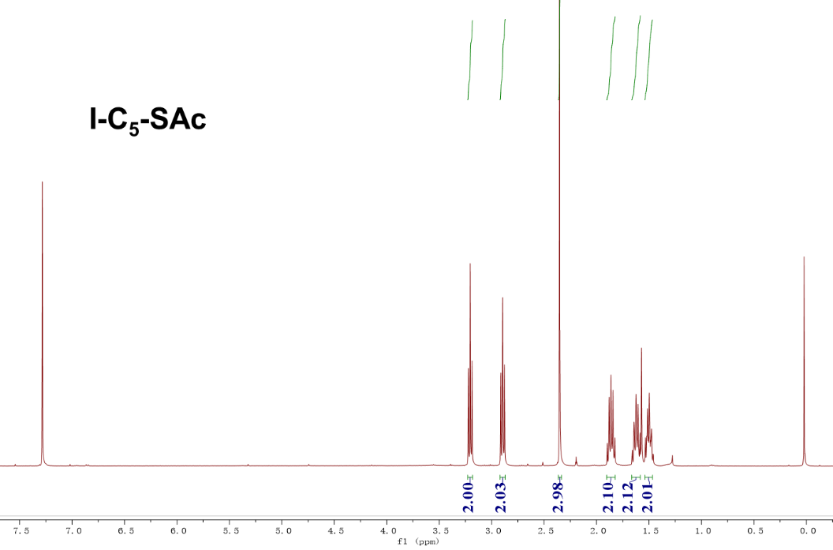
Fig. S1 | The ¹H-NMR spectrum of compound I-C₅-SAc.
5-iodopentane-1-thiol (I-C₅-SH) was synthesized as follows. 5-iodo-1-pentylthioacetate was dissolved (1.37 g, 6.02 mmol) in 40 mL methanol and degassed for 20 min. Subsequently, 1.5 mL trifluoroacetic acid was added. The solution was refluxed for 5h then cooled down to room temperature. The solvent was removed by rotary evaporator; DCM was used to extract the product. The organic layer was washed with DI water 3 times before dried over anhydrous Na2SO4. After filtration and concentration, the raw product was purified by column chromatography with hexane as eluent. Yield: 18 % (0.25 g, 1.08 mmol). ¹H NMR (400 MHz, Chloroform-d) δ 3.19 (t, J = 7.0 Hz, 2H), 2.57 – 2.51 (m, 2H), 1.84 (p, J = 7.0 Hz, 2H), 1.68 – 1.60 (m, 2H), 1.54 – 1.47 (m, 2H). ¹³C NMR (100 MHz, CDCl₃) δ 38.70, 33.07, 29.35, 28.11, 6.57. HRMS (ESI+ ): m/z calc for C₅H₁₁IS [M+H] ⁺ 228.9548, found 228.9569.
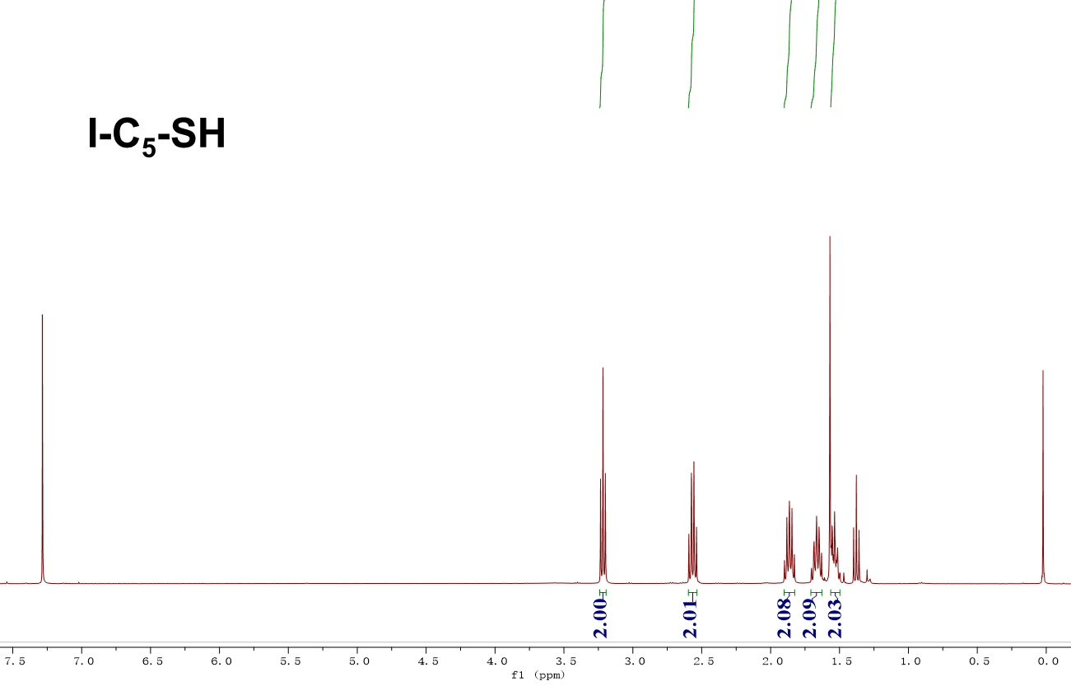
Fig. S2 | The ¹H-NMR spectrum of compound I-C₅-SH.
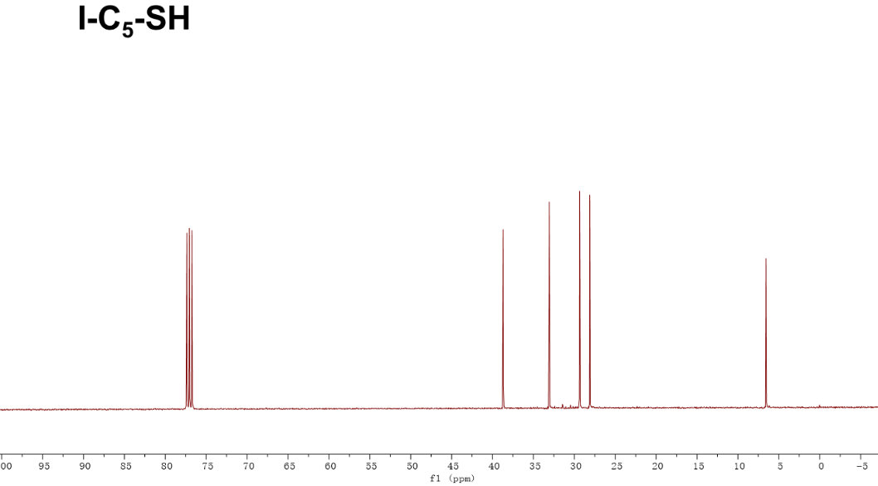
Fig. S3 | The ¹³C-NMR spectrum of compound I-C₅-SH.
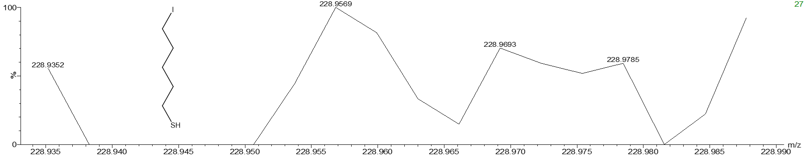
Fig. S4 | The HRMS spectrum of compound I-C₅-SH.

S-(8-iodooctyl) ethanethioate (I-C₈-SAc) as prepared as follows. 1,8-diiodooctane (5.00 g, 13.66 mmol) and potassium thioacetate (0.39 g, 3.42 mmol) were added into 200 mL tetrahydrofuran, stirred for 12h at room temperature, followed by removal of the tetrahydrofuran under reduced pressure. The residue was dissolved in diethyl ether, filtered, and washed with DI water. The organic layer was dried over Na₂SO₄, filtered and concentrated after which the raw product was purified with column chromatography with ethyl acetate and hexane (1: 10). Yield: 0.95 g (3.04 mmol) S-(8-iodooctyl) ethanethioate (89.0 % yield). ¹H NMR (400 MHz, Chloroform-d) δ 3.19 (t, J = 7.0 Hz, 2H), 2.87 (t, J = 7.3 Hz, 2H), 2.33 (s, 3H), 1.82 (p, J = 7.1 Hz, 2H), 1.60 – 1.56 (m, 2H), 1.32 (q, J = 6.1, 4.8 Hz, 8H).
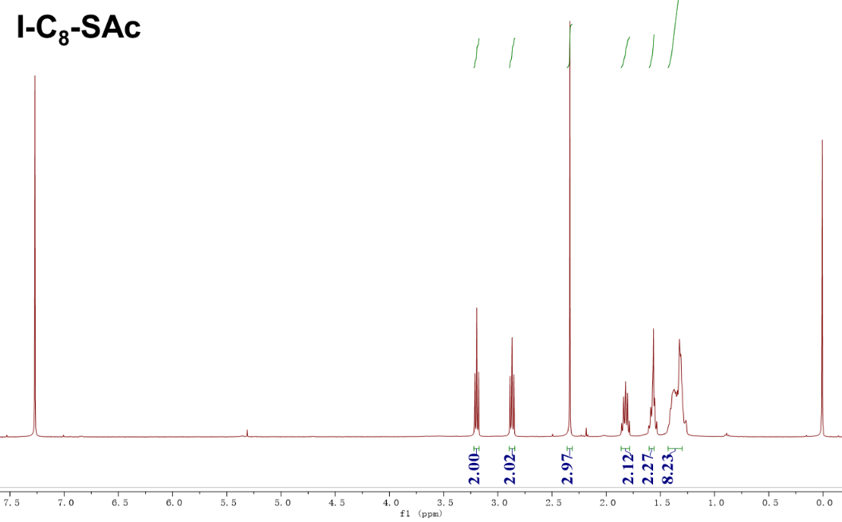
Fig. S5 | The ¹H-NMR spectrum of compound I-C₈-SAc.

8-iodooctane-1-thiol (I-C₈-SH) was synthesized as follows. S-(8-iodooctyl) ethanethioate was dissolved (0.71 g, 2.27 mmol) in 30 mL methanol and degassed for 20 min. Subsequently, 1.0 mL trifluoroacetic acid was added. The solution was refluxed for 5h then cooled down to room temperature. The solvent was removed by rotary evaporator; DCM was used to extract the product. The organic layer was washed with DI water 3 times before dried over anhydrous Na₂SO₄. After filtration and concentration, the raw product was purified by column chromatography with hexane as eluent. Yield: 18 % (0.11 g, 0.41 mmol). ¹H NMR (400 MHz, Chloroform-d) δ 3.21 (t, J = 7.0 Hz, 2H), 2.55 (q, J = 7.4 Hz, 2H), 1.84 (p, J = 7.1 Hz, 2H), 1.63 (t, J = 7.4 Hz, 2H), 1.45 – 1.33 (m, 8H). ¹³C NMR (100 MHz, Chloroform-d) δ 33.96, 33.49, 30.42, 29.66, 28.86, 28.42, 28.25, 24.63, 7.27. HRMS (ESI+ ): m/z calc for C₈H₁₆IS [M+H] ⁺ 271.0017, found 270.999.
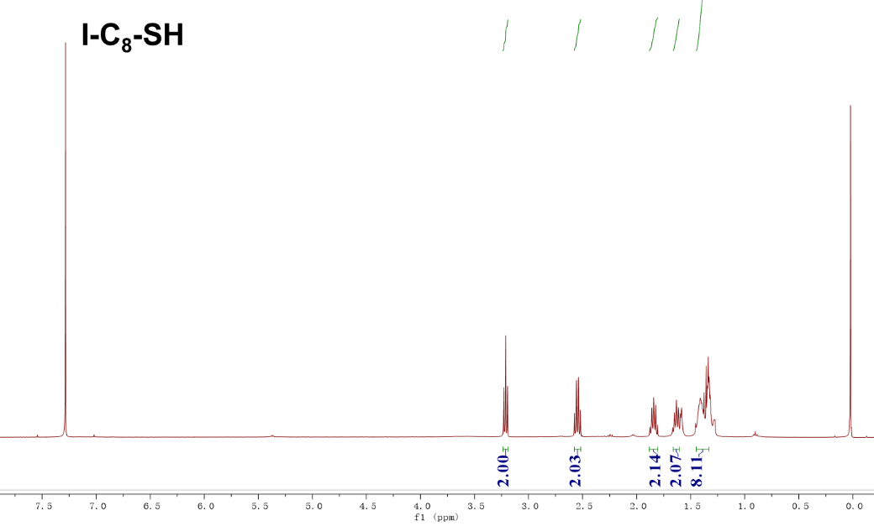
Fig. S6 | The ¹H-NMR spectrum of compound I-C₈-SH.

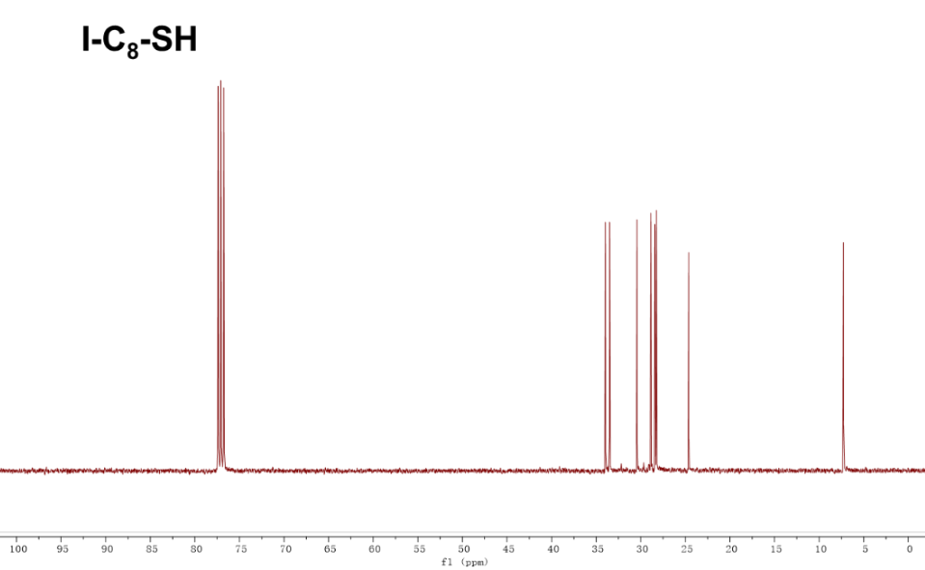
Fig. S7 | The ¹³C spectrum of compound I-C₈-SH.
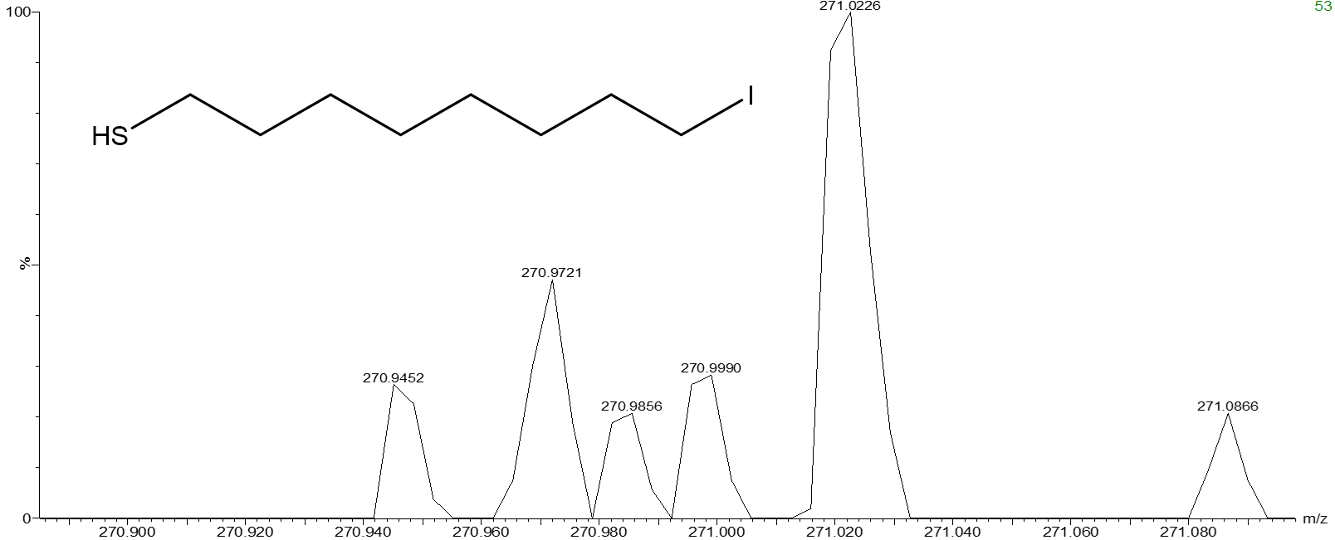
Fig. S8 | The HRMS spectrum of compound I-C₈-SH.

1,11-diiodoundecane (I-C₁₁-I) was prepare as follows. 1,11-dibromoundecane (11.80 g, 34.60 mmol) and sodium iodide (15.00 g, 138.00 mmol) were added into 300 mL acetone, refluxed for 5h, cooled down, followed by removal of the acetone under reduced pressure. The residue was dissolved in diethyl ether, filtered, and washed with DI water. The organic layer was dried over Na₂SO₄, filtered and concentrated after which the raw product was purified with column chromatography with hexane. Yield: 12.7 g (31.14 mmol) 1,11-diiodoundecane (90.0 % yield). ¹H NMR (400 MHz, Chloroform-d) δ 3.20 (td, J = 7.1, 1.6 Hz, 4H), 1.88 – 1.79 (m, 4H), 1.39 (q, J = 6.8 Hz, 4H), 1.29 (s, 10H).
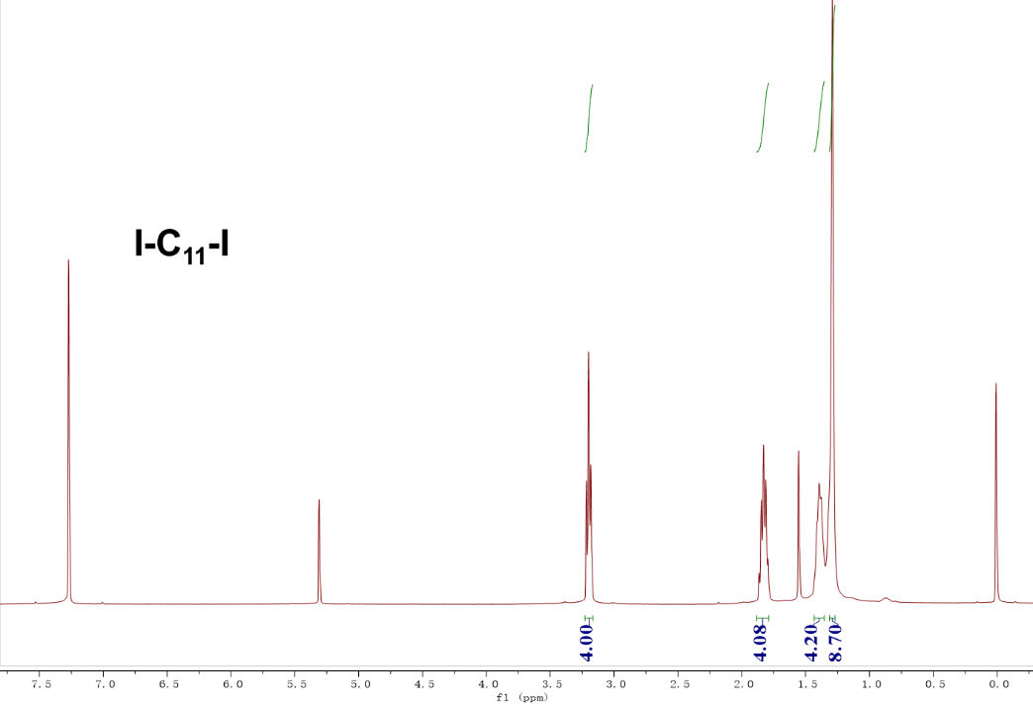
Fig. S9 | The ¹H-NMR spectrum of compound I-C₁₁-I.
S-(11-iodoundecyl) ethanethioate (I-C₁₁-SAc) was prepared as follows. 1,11-diiodoundecane (17.00 g, 41.7 mmol) and potassium thioacetate (1.20 g, 10.50 mmol) were added into 300 mL tetrahydrofuran, stirred for 12h at room temperature, followed by removal of the tetrahydrofuran under reduced pressure. The residue was dissolved in diethyl ether, filtered, and washed with DI water. The organic layer was dried over Na₂SO₄, filtered and concentrated after which the raw product was purified with column chromatography with dichloromethane and hexane (1: 2). Yield: 3.32 g (9.35 mmol) S-(11-iodoundecyl) ethanethioate (89.0 % yield). ¹H NMR (400 MHz, Chloroform-d) δ 3.21 (t, J = 7.0 Hz, 2H), 2.88 (t, J = 7.3 Hz, 2H), 2.34 (s, 3H), 1.84 (p, J = 7.1 Hz, 2H), 1.61 – 1.55 (m, 3H), 1.43 – 1.27 (m, 14H).
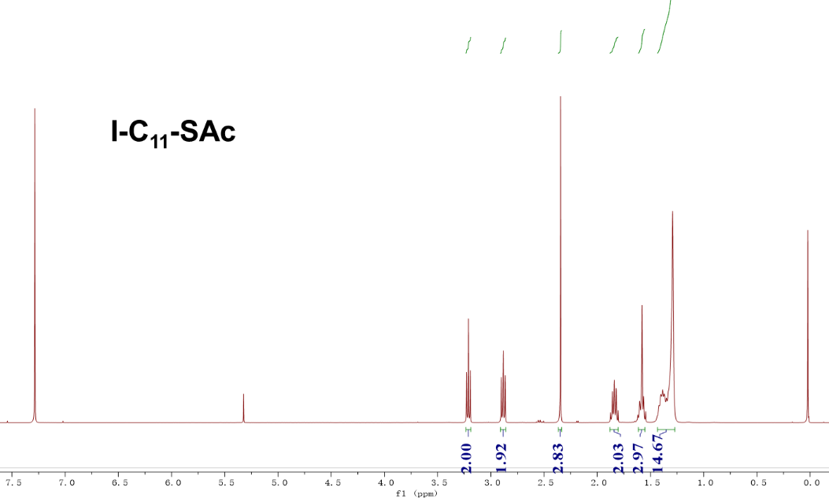
Fig. S10 | The ¹H-NMR spectrum of compound I-C₁₁-SAc.

11-iodoundecane-1-thiol (I-C₁₁-SH) was prepared as follows. S-(11-iodoundecyl) ethanethioate (2.17 g, 6.11 mmol) was dissolved in 50 mL methanol and degassed for 20 min. Subsequently, 4.0 mL trifluoroacetic acid was added. The solution was refluxed for 5h then cooled down to room temperature. The solvent was removed by rotary evaporator; DCM was used to extract the product. The organic layer was washed with DI water 3 times before dried over anhydrous Na₂SO₄. After filtration and concentration, the raw product was purified by column chromatography with dichloromethane and hexane (1: 2) as eluent. Yield: 18 % (0.36 g, 1.10 mmol). ¹H NMR (400 MHz, Chloroform-d) δ 3.18 (t, J = 7.0 Hz, 2H), 2.51 (q, J = 7.4 Hz, 2H), 1.81 (p, J = 7.1 Hz, 2H), 1.59 (p, J = 7.2 Hz, 2H), 1.37 – 1.24 (m, 14H). ¹³C NMR (100 MHz, Chloroform-d) δ 34.05, 33.57, 30.51, 29.47, 29.40, 29.07, 28.54, 28.38, 24.68, 7.36. HRMS (ESI+ ): m/z calc for C₁₁H₂₂IS [M+H] ⁺ 313.0487, found 313.0439.
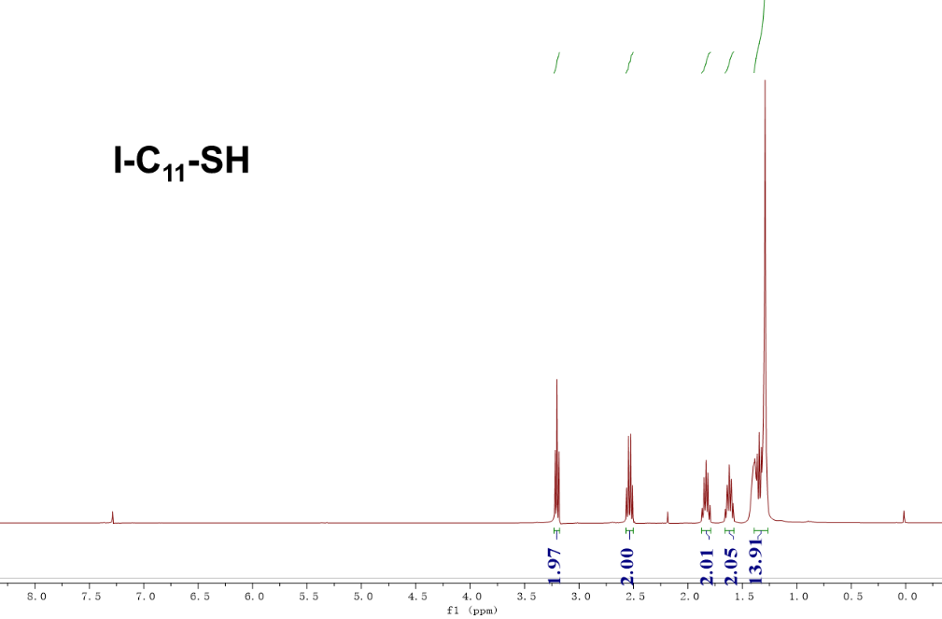
Fig. S11 | The ¹H-NMR spectrum of compound I-C₁₁-SH.
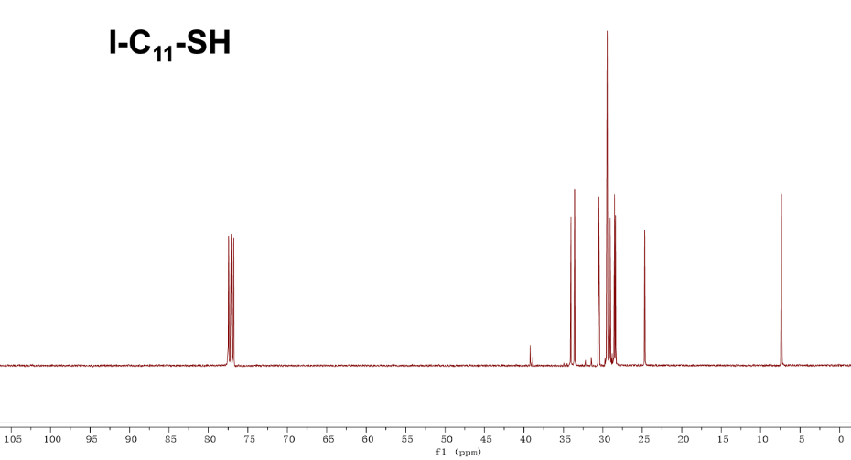
Fig. S12 | The ¹³C-NMR spectrum of compound I-C₁₁-SH.
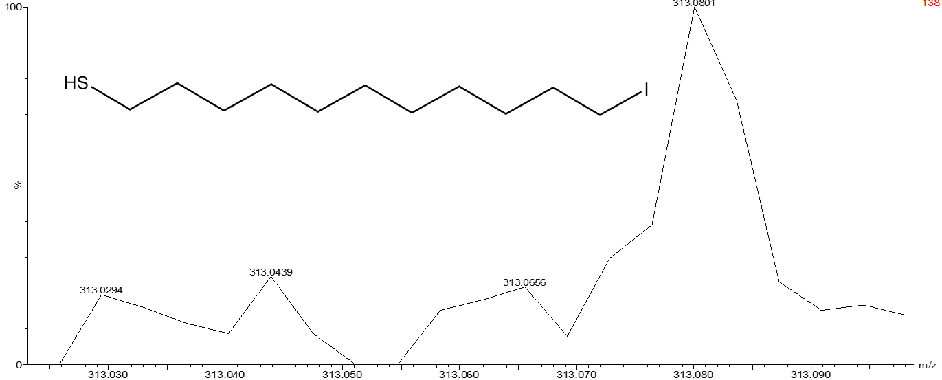
Fig. S13 | The HRMS spectrum of compound I-C₁₁-SH.
1,14-dibromotetradecane (Br-C14-Br) was synthesized according to previous reported method.² A 50 mL solution of triphenylphosphine (3.93 g, 15 mmol) in anhydrous THF was added to a stirred solution of N-bromosuccinamide (NBS, 2.67 g, 15 mmol) in 50 mL THF at 0 ˚C. With vigorous stirring, a solution of 1,14-tetradecanediol (1.00 g, 4.34 mmol) in 25 mL THF was slowly added to the mixture of NBS and Ph₃P. The resulting solution was warmed to rt and then heated at 50 ˚C for 3.5 h. The THF was then removed under reduced pressure and the residue crystallized from ethanol to obtain 1.1 g of the product as a white powder (70% yield). ¹H NMR (400 MHz, Chloroform-d) δ 3.43 (t, J = 6.9 Hz, 4H), 1.88 (p, J = 6.9 Hz, 4H), 1.44 (q, J = 7.0 Hz, 4H), 1.30 (d, J = 6.4 Hz, 16H).
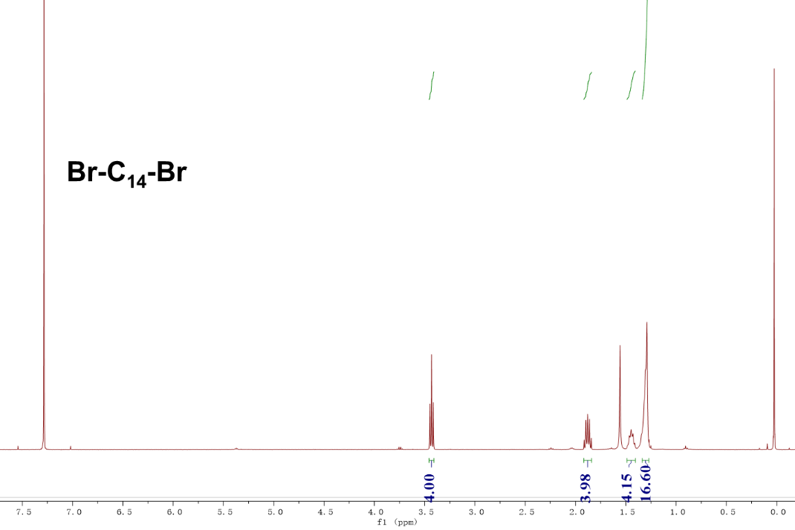
Fig. S14 | The ¹H-NMR spectrum of compound Br-C₁₄-Br.

1,14-diiodotetradecane (I-C₁₄-I) was prepare as follows. 1,14-dibromotetradecane (2.52 g, 7.00 mmol) and sodium iodide (4.00 g, 28.00 mmol) were added into 200 mL acetone, refluxed for 5h, cooled down, followed by removal of the acetone under reduced pressure. The residue was dissolved in diethyl ether, filtered, and washed with DI water. The organic layer was dried over Na₂SO₄, filtered and concentrated after which the raw product was purified with column chromatography with hexane. Yield: 2.84 g (6.30 mmol) 1,14-diiodotetradecane (90.0 % yield). 1H NMR (400 MHz, Chloroform-d) δ 3.20 (t, J = 7.0 Hz, 4H), 1.83 (p, J = 7.1 Hz, 4H), 1.43 – 1.36 (m, 4H), 1.32 – 1.26 (m, 16H).
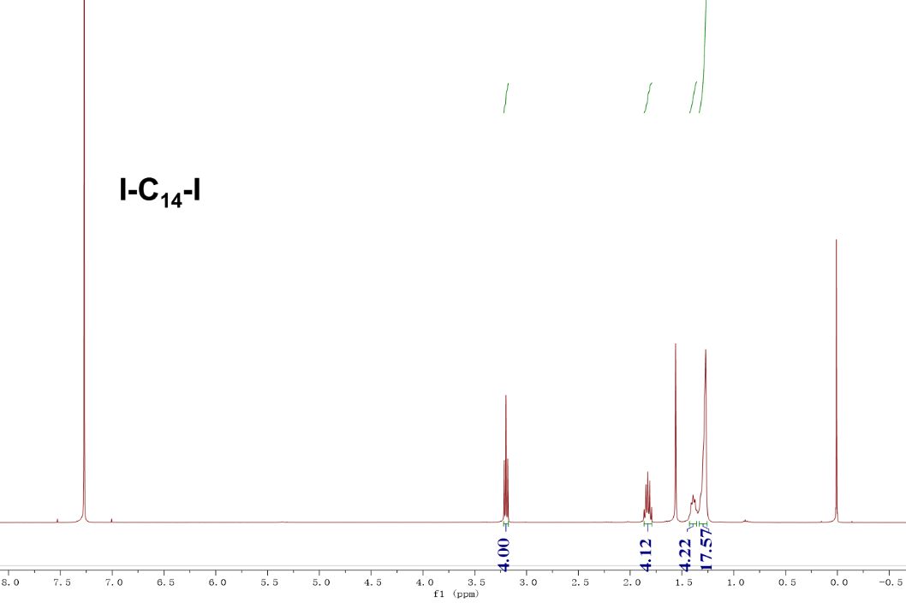
Fig. S15 | The ¹H-NMR spectrum of compound I-C₁₄-I.

S-(14-iodotetradecyl) ethanethioate (I-C₁₄-SAc) was prepared as follows. 1,14-diiodotetradecane (13.56 g, 30.00 mmol) and potassium thioacetate (1.05 g, 7.50 mmol) were added into 300 mL tetrahydrofuran, stirred for 12h at room temperature, followed by removal of the tetrahydrofuran under reduced pressure. The residue was dissolved in diethyl ether, filtered, and washed with DI water. The organic layer was dried over Na₂SO₄, filtered and concentrated after which the raw product was purified with column chromatography with dichloromethane and hexane (1: 2). Yield: 2.60 g (6.68 mmol) S-(14-iodotetradecyl) ethanethioate (89.0 % yield). ¹H NMR (400 MHz, Chloroform-d) δ 3.21 (t, J = 7.0 Hz, 2H), 2.89 (t, J = 7.4 Hz, 2H), 2.35 (s, 3H), 1.84 (p, J = 7.1 Hz, 2H), 1.61 (d, J = 7.0 Hz, 2H), 1.28 (s, 20H).
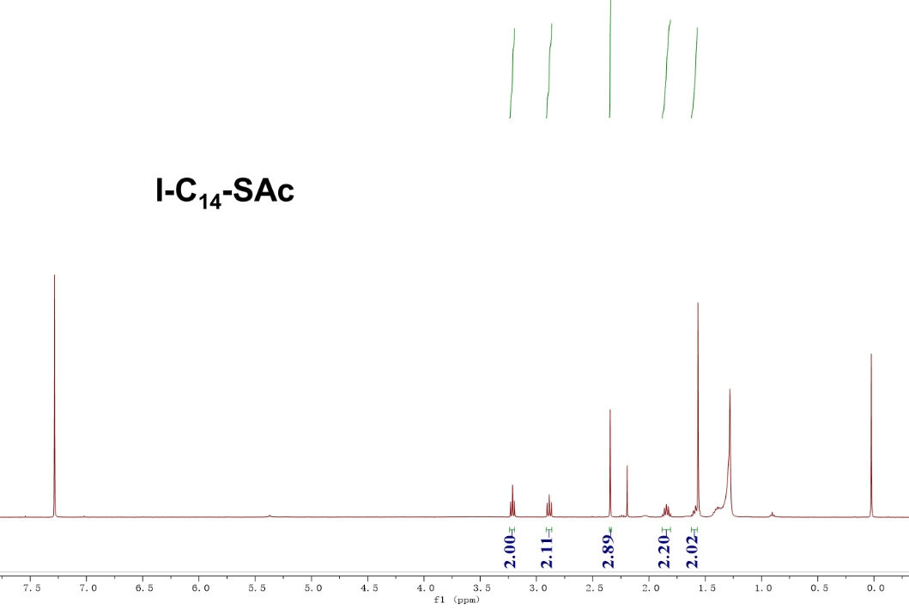
Fig. S16 | The ¹H-NMR spectrum of compound I-C₁₄-SAc.

14-iodotetradecane-1-thiol (I-C₁₄-SH) was prepared as follows. S-(14-iodotetradecyl) ethanethioate (2.08 g, 5.22 mmol) was dissolved in 50 mL methanol and degassed for 20 min. Subsequently, 4.0 mL trifluoroacetic acid was added. The solution was refluxed for 5h then cooled down to room temperature. The solvent was removed by rotary evaporator; DCM was used to extract the product. The organic layer was washed with DI water 3 times before dried over anhydrous Na₂SO₄. After filtration and concentration, the raw product was purified by column chromatography with dichloromethane and hexane (1: 2) as eluent. Yield: 18 % (0.33 g, 0.94 mmol). ¹H NMR (400 MHz, Chloroform-d) δ 3.21 (t, J = 7.1 Hz, 2H), 2.55 (q, J = 7.4 Hz, 2H), 1.84 (p, J = 7.1 Hz, 2H), 1.63 (t, J = 7.4 Hz, 2H), 1.39 – 1.27 (m, 20H). ¹³C NMR (100 MHz, Chloroform-d) δ 34.10, 33.61, 30.55, 29.65, 29.63, 29.62, 29.58, 29.56, 29.46, 29.12, 28.59, 28.42, 24.70, 7.29. HRMS (ESI+ ): m/z calc for C₁₄H₂₈IS [M+H] ⁺ 355.0956, found 355.0986.
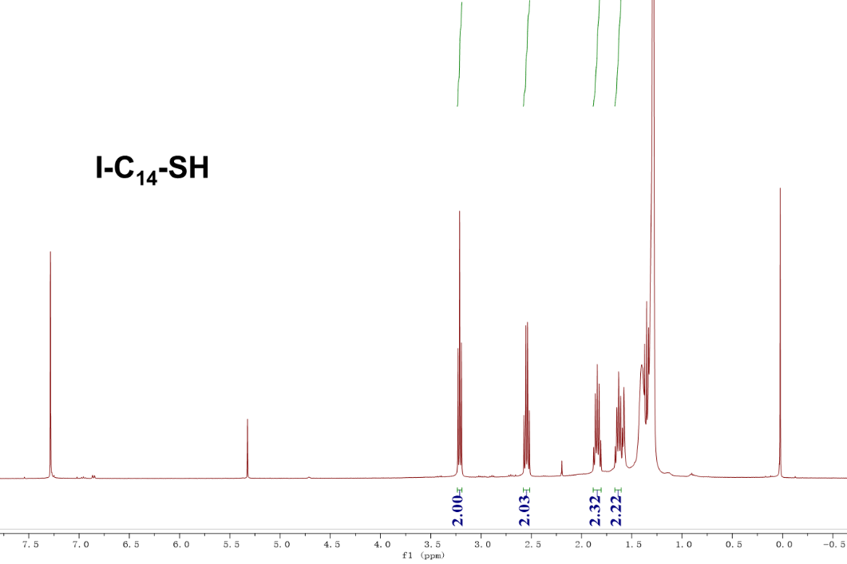
Fig. S17 | The ¹H-NMR spectrum of compound I-C₁₄-SH.
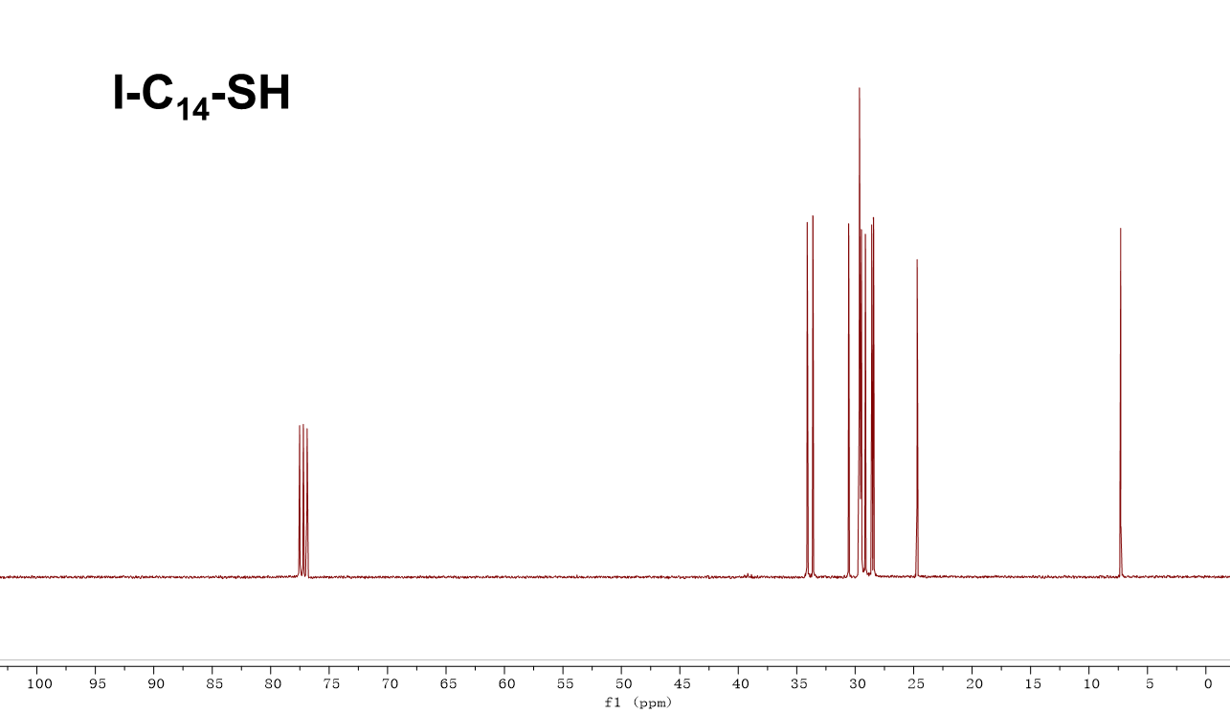
Fig. S18| The ¹³C-NMR spectrum of compound I-C₁₄-SH.
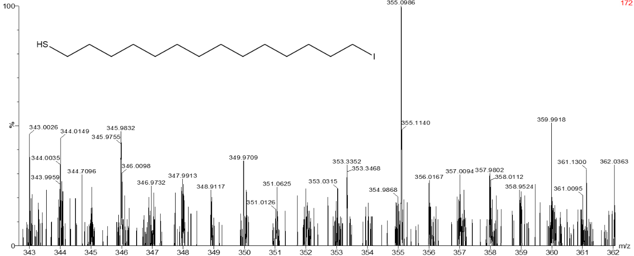
Fig. S19 | The HRMS spectrum of compound I-C₁₄-SH.
S-(2-(2-ethoxyethoxy)ethyl) ethanethioate ((C₂O)₂-C₂-SAc) was prepared as follows.
1-bromo-2-(2-ethoxyethoxy)ethane (1.97 g, 10.00 mmol) and potassium thioacetate (4.56 g, 40.00 mmol) were added into 300 mL tetrahydrofuran, refluxed for 12h, followed by removal of the tetrahydrofuran under reduced pressure. The residue was dissolved in diethyl ether, filtered, and washed with DI water. The organic layer was dried over Na₂SO₄, filtered and concentrated after which the raw product was purified with column chromatography with dichloromethane and hexane (1:2). Yield: 1.71 g (8.90 mmol) S-(2-(2-ethoxyethoxy)ethyl) ethanethioate (89.0 % yield). ¹H NMR (400 MHz, Chloroform-d) δ 3.66 – 3.59 (m, 6H), 3.54 (t, J = 7.0 Hz, 2H), 3.12 (t, J = 6.5 Hz, 2H), 2.36 (s, 3H), 1.24 (t, J = 7.0 Hz, 3H).
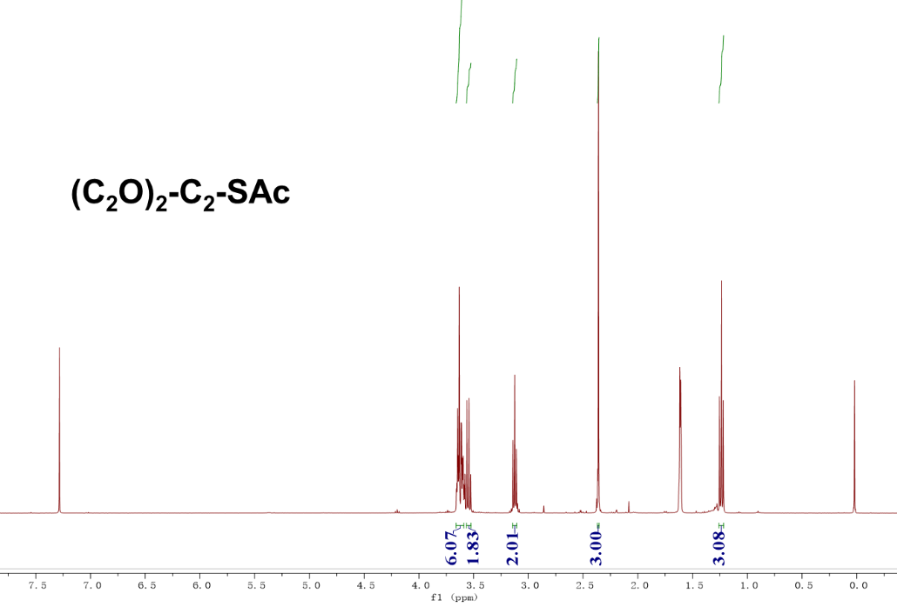
Fig. S20 | The ¹H-NMR spectrum of compound (C₂O)₂-C₂-SAc.

2-(2-ethoxyethoxy)ethane-1-thiol ((C₂O)₂-C₂-SH) was prepared as follows. S-(2-(2-ethoxyethoxy)ethyl) ethanethioate (1.05 g, 7.00 mmol) was dissolved in 50 mL methanol and degassed for 20 min. Subsequently, 4.0 mL trifluoroacetic acid was added. The solution was refluxed for 5h then cooled down to room temperature. The solvent was removed by rotary evaporator; DCM was used to extract the product. The organic layer was washed with DI water 3 times before dried over anhydrous Na₂SO₄. After filtration and concentration, the raw product was purified by column chromatography with dichloromethane and hexane (1: 2) as eluent. Yield: 18 % (0.19 g, 1.26 mmol). ¹H NMR (400 MHz, Chloroform-d) δ 3.67 – 3.61 (m, 6H), 3.56 (q, J = 7.0 Hz, 2H), 2.73 (q, J = 8.2, 6.5 Hz, 2H), 1.24 (t, J = 7.0 Hz, 3H). HRMS (ESI+ ): m/z calc for C₆H₃S [M+H] ⁺ 149.0636, found 149.0643.

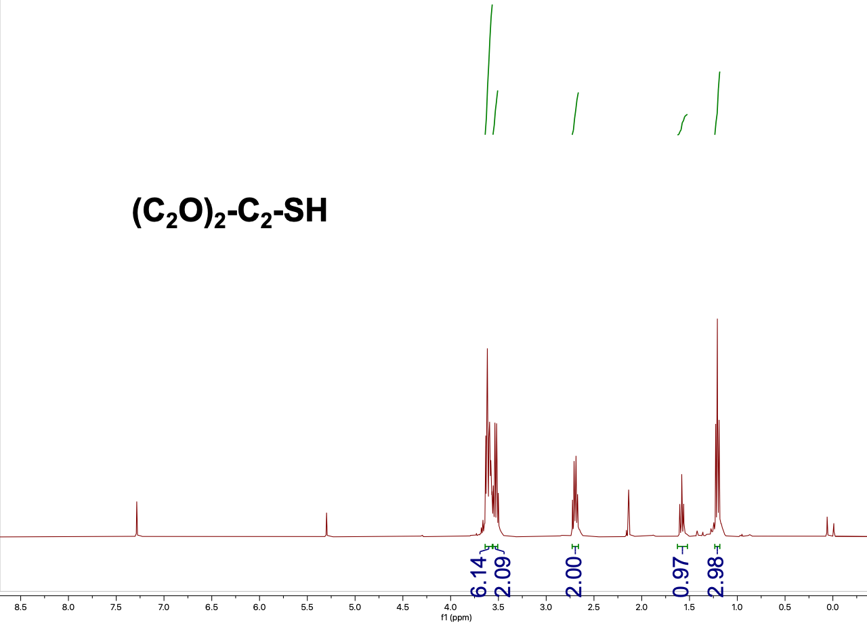
Fig. S21 | The ¹H-NMR spectrum of compound (C₂O)₂-C₂-SH.
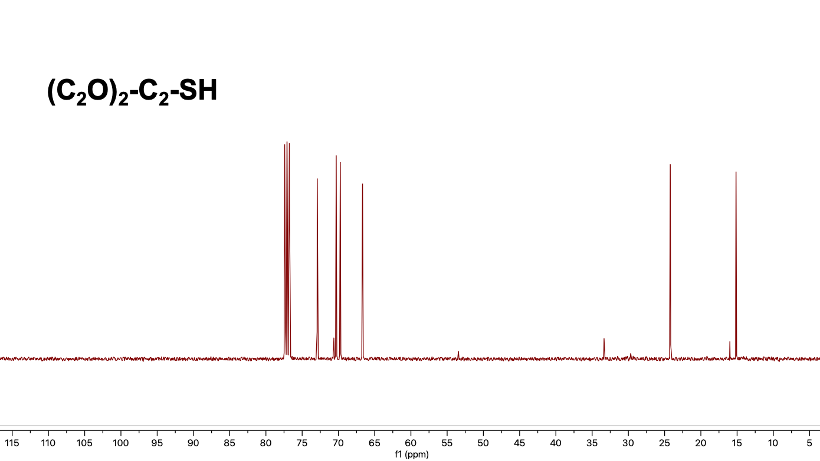
Fig. S22 | The ¹³C-NMR spectrum of compound (C₂O)₂-C₂-SH.

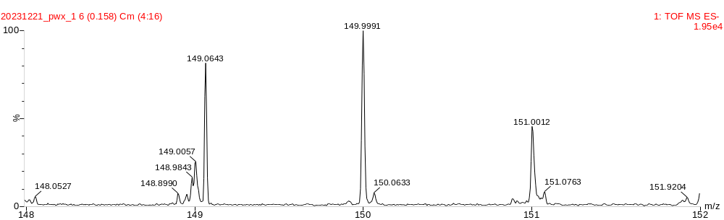
Fig. S23 | The HRMS spectrum of compound (C₂O)₂-C₂-SH.

2-(2-(2-ethoxyethoxy)ethoxy)ethyl 4-methylbenzenesulfonate ((C₂O)₃-C₂-OTs) was prepared as follows.³ In a 250 mL round-bottomed flask, triethylene glycol monoethyl ether (5.00 mL, 28.60 mmol) was dissolved in triethylamine (20 mL, 144.00 mmol), and the mixture was cooled to 0 °C. After addition of para-toluenesulfonyl chloride (6.00 g, 31.40 mmol), the mixture was allowed to warm slowly to room temperature and stirred for further 5 h. Subsequently, the reaction mixture was carefully added to a stirred mixture of concentrated hydrochloric acid (30 mL) and crushed ice (40 g). The mixture was extracted three times with diethyl ether (100 mL), and the combined organic phases were washed successively with brine (100 mL) and a saturated solution of sodium hydrogen carbonate. The organic phases were dried with MgSO₄ and filtered, and the solvents were removed under reduced pressure. Clear, colorless oil. Yield: 8.54 g (90 %). ¹H NMR (400 MHz, Chloroform-d) δ 7.84 – 7.81 (m, 2H), 7.36 (d, J = 8.1 Hz, 2H), 4.21 – 4.17 (m, 2H), 3.71 (dd, J = 5.6, 4.2 Hz, 2H), 3.65 – 3.57 (m, 8H), 3.54 (q, J = 7.0 Hz, 2H), 2.47 (s, 3H), 1.23 (t, J = 7.0 Hz, 3H).
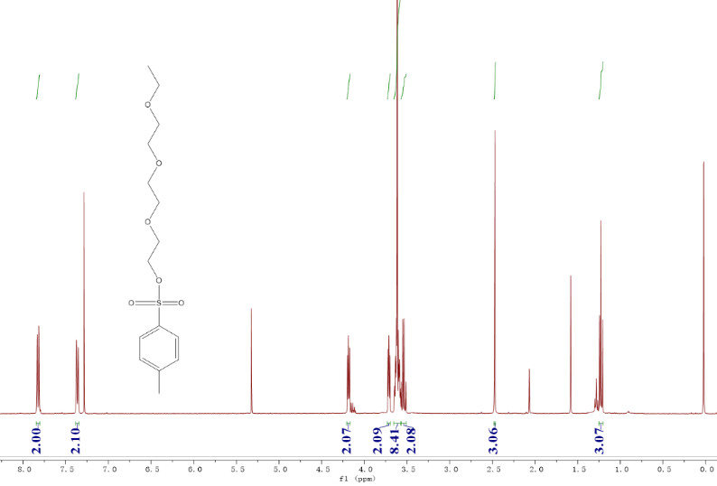
Fig. S24 | The ¹H-NMR spectrum of compound (C₂O)₃-C₂-OTs.
S-(2-(2-(2-ethoxyethoxy)ethoxy)ethyl) ethanethioate ((C₂O)₃-C₂-SAc) was prepared as follows. 2-(2-(2-ethoxyethoxy)ethoxy)ethyl 4-methylbenzenesulfonate (3.32 g, 10.00 mmol) and potassium thioacetate (4.56 g, 40.00 mmol) were added into 300 mL tetrahydrofuran, refluxed for 12h, followed by removal of the tetrahydrofuran under reduced pressure. The residue was dissolved in diethyl ether, filtered, and washed with DI water. The organic layer was dried over Na₂SO₄, filtered and concentrated after which the raw product was purified with column chromatography with dichloromethane and hexane (1:2). Yield: 2.10 g (8.90 mmol) S-(2-(2-(2-ethoxyethoxy)ethoxy)ethyl) ethanethioate (89.0 % yield). ¹H NMR (400 MHz, Chloroform-d) δ 3.69 – 3.60 (m, 10H), 3.55 (q, J = 7.0 Hz, 2H), 3.12 (t, J = 6.5 Hz, 2H), 2.36 (s, 3H), 1.23 (t, J = 7.0 Hz, 3H).
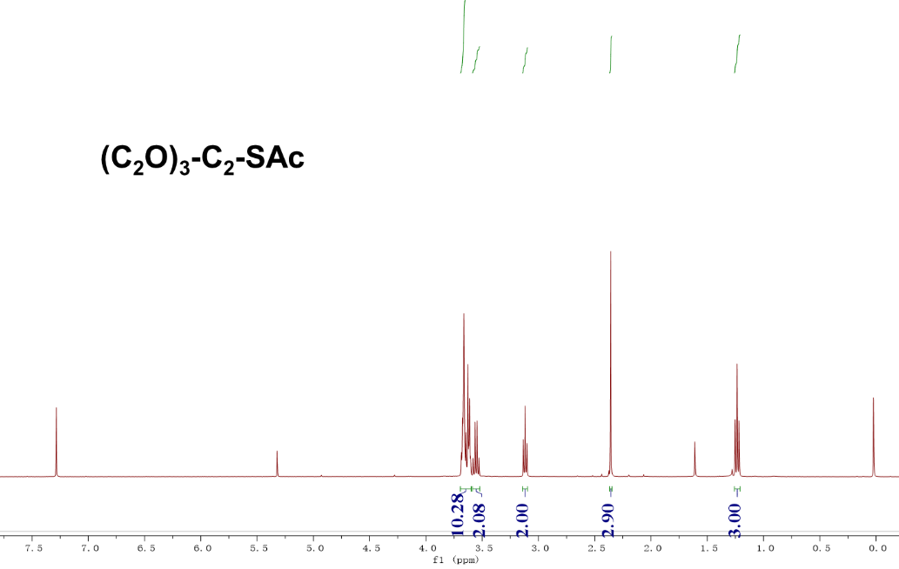
Fig. S25 | The ¹H-NMR spectrum of compound (C₂O)₃-C₂-SAc.

2-(2-(2-ethoxyethoxy)ethoxy)ethane-1-thiol ((C₂O)₃-C₂-SH) was prepared as follows.⁴ S-(2-(2-(2-ethoxyethoxy)ethoxy)ethyl) ethanethioate (1.00 g, 4.24 mmol) was dissolved in dry THF (50 mL) and added dropwise to a stirring slurry of LiAlH₄ (0.64 g; 16.96 mmol) in THF (16.96 mL) at 0 °C. The reaction was stirred at room temperature for 6 h under nitrogen. The reaction was then quenched at 0 °C with water (25 mL, previously degassed), and was acidified with 1 M HCl solution (previously degassed). The mixture was then extracted with Et₂O (3 × 100 mL). The combined organic phases were washed with water (1 × 100 mL) and brine (1 × 100 mL), dried over MgSO₄, filtered, and evaporated to dryness. The crude thiol product was purified by column chromatography on silica gel (hexanes). Yield: 0.76 g (3.90 mmol) 2-(2-(2-ethoxyethoxy)ethoxy)ethane-1-thiol (92.0 % yield). ¹H NMR (400 MHz, Chloroform-d) δ 3.69 – 3.60 (m, 10H), 3.54 (q, J = 7.0 Hz, 2H), 2.71 (dt, J = 8.2, 6.4 Hz, 2H), 1.60 (t, J = 8.2 Hz, 1H), 1.22 (t, J = 7.0 Hz, 3H). ¹³C NMR (100 MHz, Chloroform-d) δ 72.74, 70.58, 70.42, 70.10, 69.72, 66.44, 24.14, 15.08. HRMS (ESI+ ): m/z calc for C₈H₁₉O₃S [M+H] ⁺ 195.1055, found 195.1054.
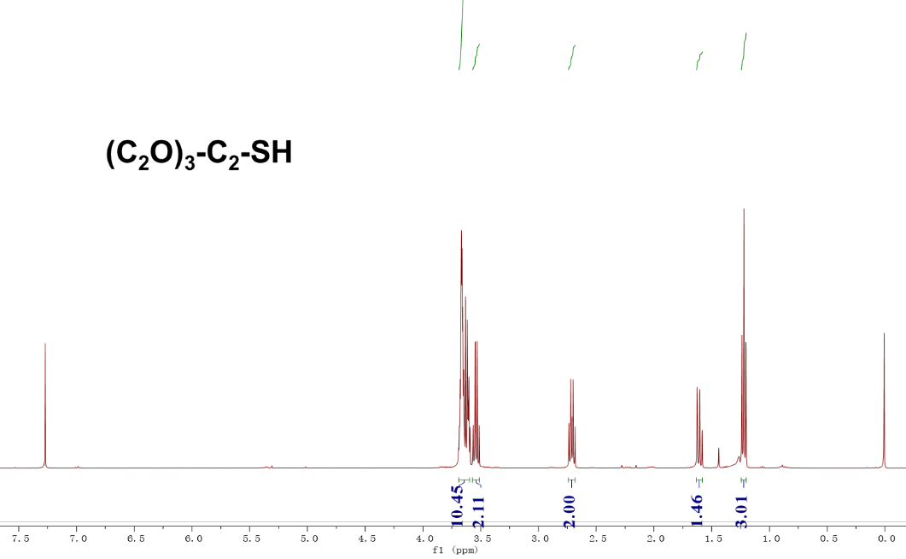
Fig. S26 | The ¹H-NMR spectrum of compound (C₂O)₃-C₂-SH.

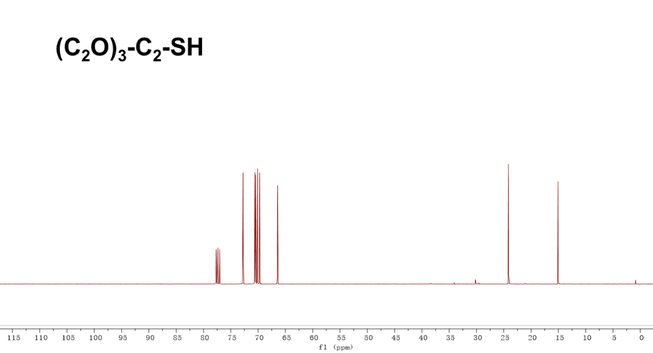
Fig. S27 | The ¹³C-NMR spectrum of compound (C₂O)₃-C₂-SH.
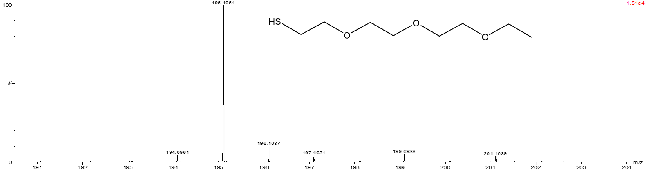
Fig. S28 | The HRMS spectrum of compound (C₂O)₃-C₂-SH.

3,6,9,12-tetraoxatetradecan-1-ol ((C₂O)₄-C₂-OH) was prepared as follows.⁵ A suspension of 60% NaH in mineral oil (1 g, 25.23 mmol) was washed with anhydrous hexane (10 mL) and suspended in freshly distilled THF (30 mL). Then, tetraethylene glycol (4 mL, 22.94 mmol) was added to the above suspension and the reaction mixture was refluxed for 1 h. After the mixture was cooled to 0 °C using an ice bath, bromoethane (0.88 mL, 11.47 mmol) was added slowly, and the reaction mixture was kept at 0 °C for 1 h. The solvent was evaporated under a vacuum, ice water was added, and then, the aqueous solution was extracted twice with CHCl₃. The combined extract was washed with brine, dried over anhydrous Na₂SO₄, and concentrated to yield the crude compound. After silica gel chromatography (4% CH₃OH in CHCl₃ as eluting solvent), 3,6,9,12-tetraoxatetradecan-1-ol was obtained (650 mg, as a colorless oil, 25.5% yield). ¹H NMR (400 MHz, Chloroform-d) δ 3.74 – 3.57 (m, 16H), 3.52 (q, J = 7.0 Hz, 2H), 1.21 (t, J = 7.0 Hz, 3H).
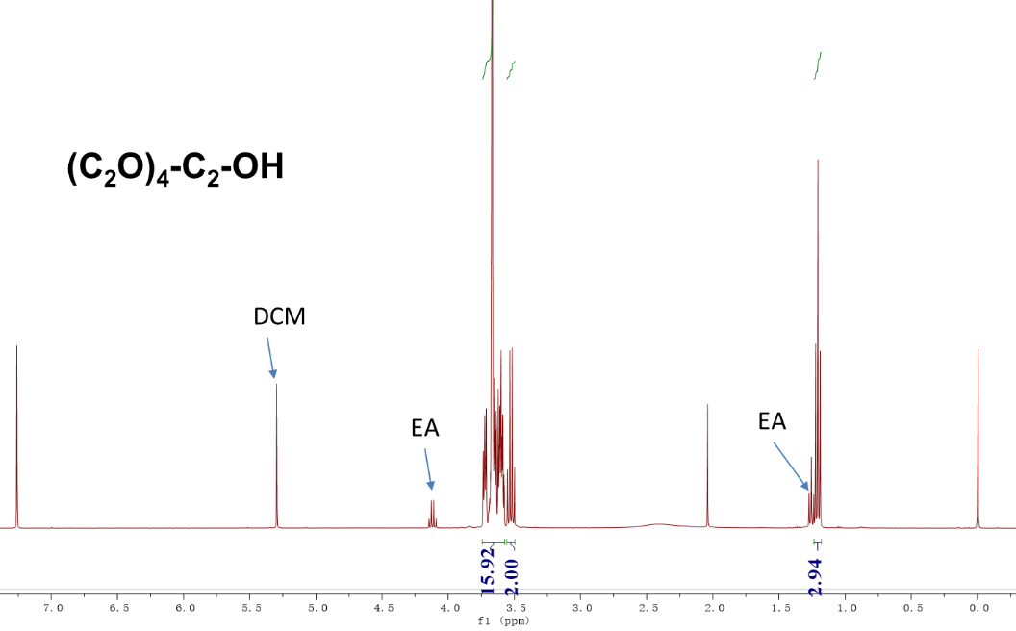
Fig. S29 | The ¹H-NMR spectrum of compound (C₂O)₄-C₂-OH.
3,6,9,12-tetraoxatetradecyl 4-methylbenzenesulfonate ((C₂O)₄-C₂-OTs) was prepared as follows.³ In a 250 mL round-bottomed flask, 3,6,9,12-tetraoxatetradecan-1-ol (18.00 g, 81.01 mmol) was dissolved in triethylamine (56.64 mL, 407.52 mmol), and the mixture was cooled to 0 °C. After addition of para-toluenesulfonyl chloride (16.98 g, 88.86 mmol), the mixture was allowed to warm slowly to room temperature and stirred for further 5 h. Subsequently, the reaction mixture was carefully added to a stirred mixture of concentrated hydrochloric acid (50 mL) and crushed ice (80 g). The mixture was extracted three times with diethyl ether (200 mL), and the combined organic phases were washed successively with brine (200 mL) and a saturated solution of sodium hydrogen carbonate. The organic phases were dried with MgSO₄ and filtered, and the solvents were removed under reduced pressure. Clear, colorless oil. Yield: 27.4 g (90 %). ¹H NMR (400 MHz, Chloroform-d) δ 7.83 – 7.77 (m, 2H), 7.37 – 7.31 (m, 2H), 4.18 – 4.14 (m, 2H), 3.70 – 3.67 (m, 2H), 3.65 – 3.57 (m, 12H), 3.55 – 3.49 (m, 2H), 2.45 (s, 3H), 1.20 (t, J = 7.0 Hz, 3H).
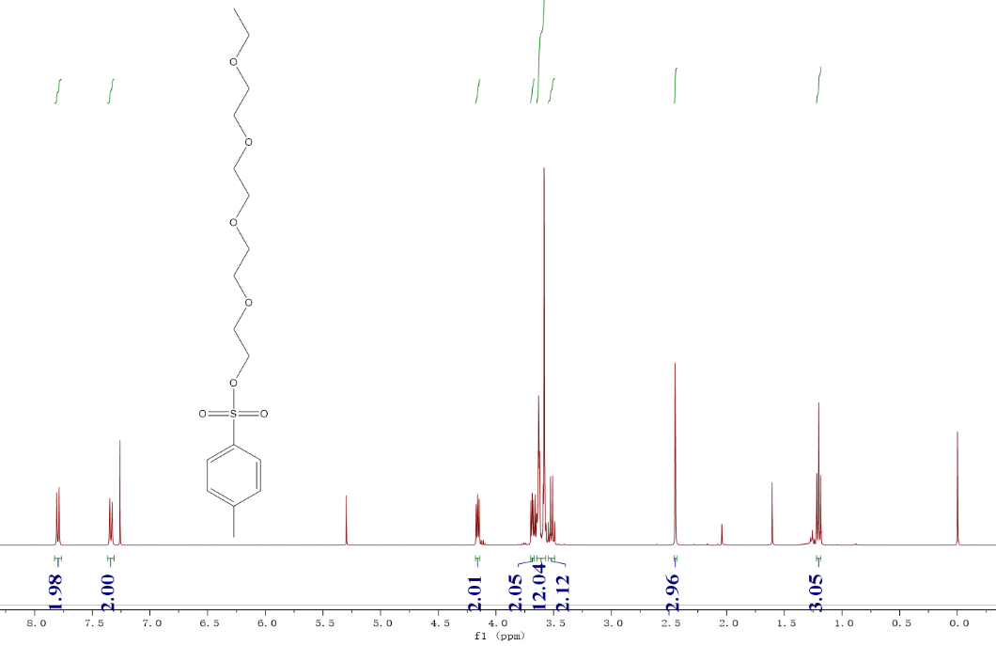
Fig. S30 | The ¹H-NMR spectrum of compound (C₂O)₄-C₂-OTs.

S-(3,6,9,12-tetraoxatetradecyl) ethanethioate ((C₂O)₄-C₂-SAc) was prepared as follows. 3,6,9,12-tetraoxatetradecyl 4-methylbenzenesulfonate (10.00 g, 26.60 mmol) and potassium thioacetate (12.13 g, 106.40 mmol) were added into 400 mL tetrahydrofuran, refluxed for 12h, followed by removal of the tetrahydrofuran under reduced pressure. The residue was dissolved in diethyl ether, filtered, and washed with DI water. The organic layer was dried over Na₂SO₄, filtered and concentrated after which the raw product was purified with column chromatography with dichloromethane and hexane (1:2). Yield: 6.63 g (23.67 mmol) S-(3,6,9,12-tetraoxatetradecyl) ethanethioate (89.0 % yield). ¹H NMR (400 MHz, Chloroform-d) δ 3.66 – 3.57 (m, 14H), 3.53 (q, J = 7.0 Hz, 2H), 3.09 (t, J = 6.5 Hz, 2H), 2.33 (s, 3H), 1.21 (t, J = 7.0 Hz, 3H).
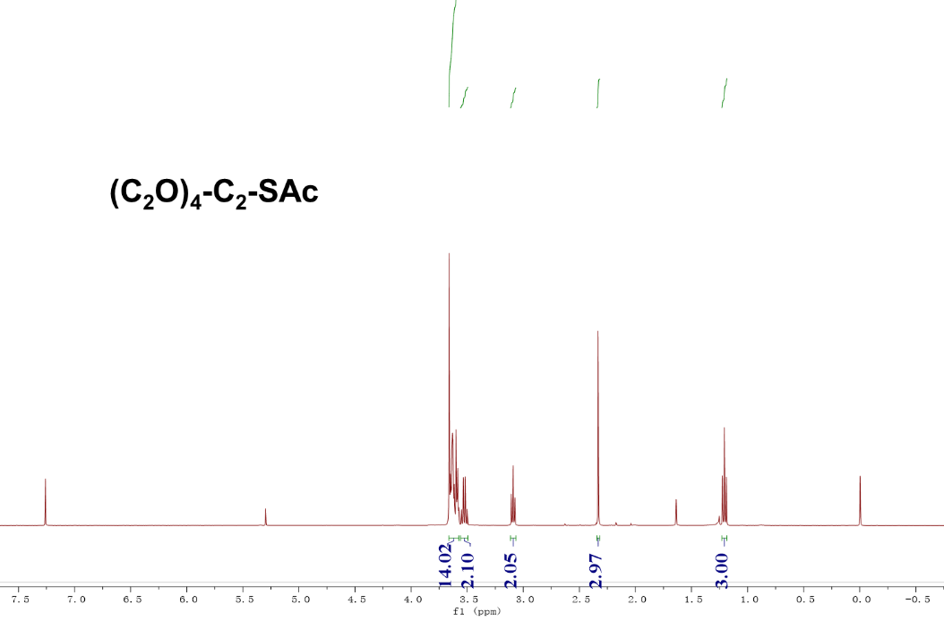
Fig. S31 | The ¹H-NMR spectrum of compound (C₂O)₄-C₂-SAc.

3,6,9,12-tetraoxatetradecane-1-thiol ((C₂O)₄-C₂-SH) was prepared as follows.⁴ S-(3,6,9,12-tetraoxatetradecyl) ethanethioate (1.00 g, 3.57 mmol) was dissolved in dry THF (40 mL) and added dropwise to a stirring slurry of LiAlH₄ (0.54 g; 14.28 mmol) in THF (14.3 mL) at 0 °C. The reaction was stirred at room temperature for 6 h under nitrogen. The reaction was then quenched at 0 °C with water (25 mL, previously degassed), and was acidified with 1 M HCl solution (previously degassed). The mixture was then extracted with Et₂O (3 × 100 mL). The combined organic phases were washed with water (1 × 100 mL) and brine (1 × 100 mL), dried over MgSO₄, filtered, and evaporated to dryness. The crude thiol product was purified by column chromatography on silica gel (hexanes). Yield: 0.78 g (3.28 mmol) 3,6,9,12-tetraoxatetradecane-1-thiol (92.0 % yield). ¹H NMR (400 MHz, Chloroform-d) δ 3.71 – 3.60 (m, 14H), 3.58 – 3.52 (m, 2H), 2.72 (dt, J = 8.3, 6.5 Hz, 2H), 1.23 (t, J = 7.0 Hz, 3H). ¹³C NMR (100 MHz, Chloroform-d) δ 72.76, 70.57, 70.53, 70.51, 70.43, 70.12, 69.73, 66.46, 24.16, 15.10. HRMS (ESI+ ): m/z calc for C₁₀H₂₃O₄S [M+H] ⁺ 239.1317, found 239.1325.

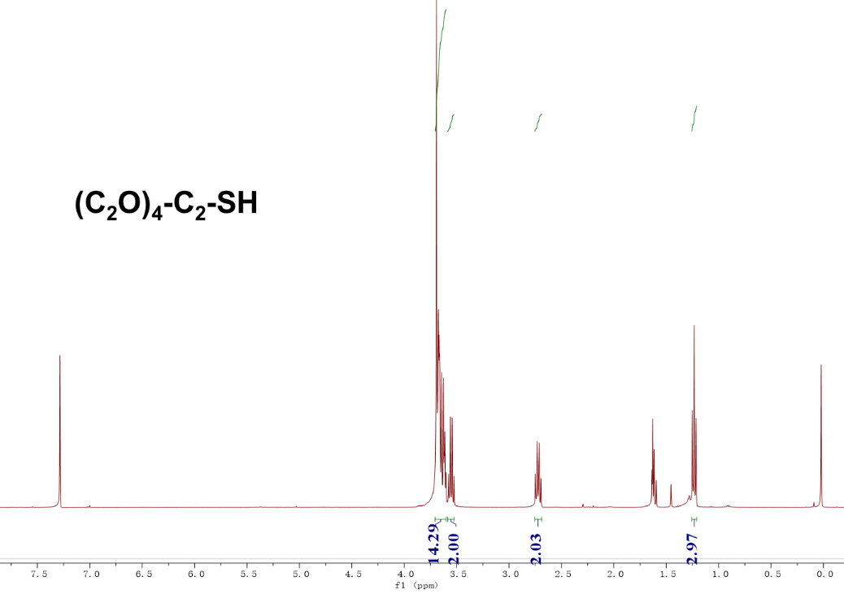
Fig. S32 | The ¹H-NMR spectrum of compound (C₂O)₄-C₂-SH.
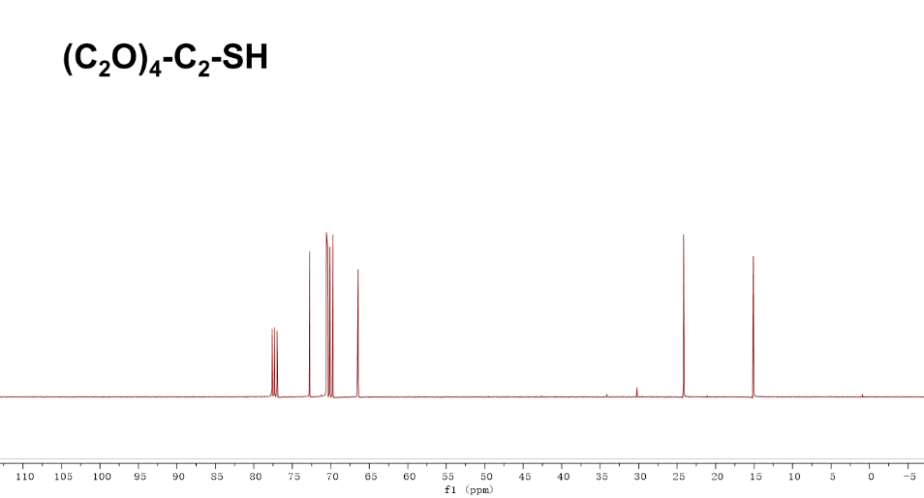
Fig. S33 | The ¹³C-NMR spectrum of compound (C₂O)₄-C₂-SH.
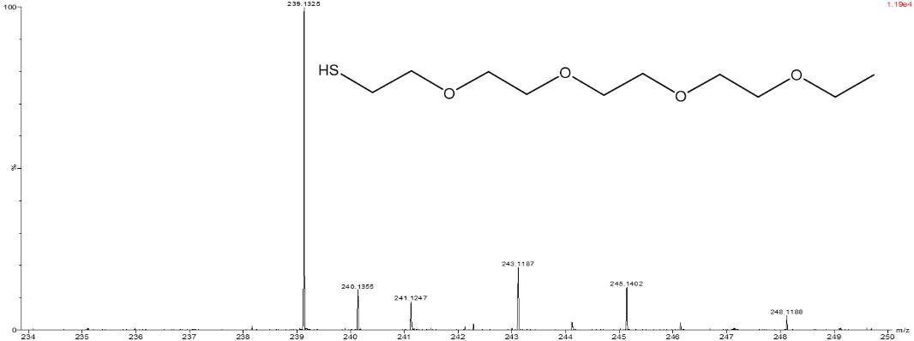
Fig. S34 | The HRMS spectrum of compound (C₂O)₄-C₂-SH.
1-iodo-2-(2-iodoethoxy)ethane (I-C₂O-C₂-I) was prepared as follows.⁶ To a stirred solution of 2-chloroethyl ether (14.30 g, 100.00 mmol) in acetone (200.00 mL) was added powder NaI (65.00 g, 433.6 mmol). The resulting clear yellow solution was heated as reflux for 48h. Then, cooled, filtered through a plug of celite and concentrated to give yellow liquid. This was taken up in ether (200 mL) washed with water (50 mL) and 10% aq. NaHSO₃ (20 mL), dried (NaHSO₄), filtered. The crude thiol product was purified by column chromatography on silica gel (hexanes). Yield: 26.65 g (82.00 mmol) 1-iodo-2-(2-iodoethoxy)ethane (82.0 % yield). ¹H NMR (400 MHz, Chloroform-d) δ 3.79 (dd, J = 7.4, 6.2 Hz, 4H), 3.29 (t, J = 6.8 Hz, 4H).
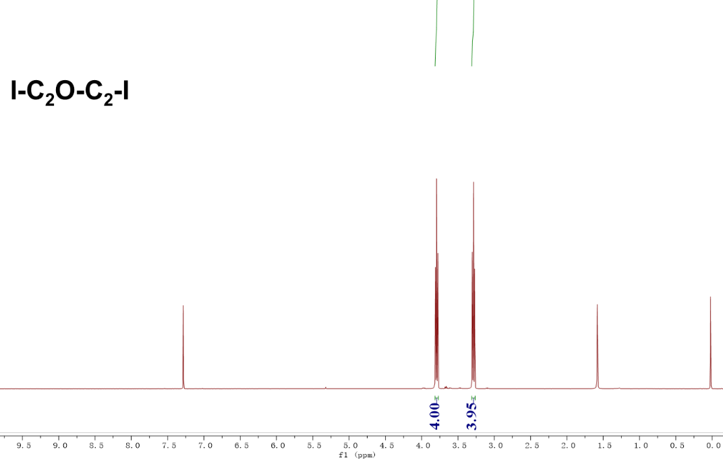
Fig. S35 | The ¹H-NMR spectrum of compound I-C₂O-C₂-I.

S-(2-(2-iodoethoxy)ethyl) ethanethioate (I-C₂O-C₂-SAc) was prepared as follows. 1-iodo-2-(2-iodoethoxy)ethane (14.80 g, 45.40 mmol) and potassium thioacetate (1.30 g, 11.34 mmol) were added into 200 mL tetrahydrofuran, stirred for 12h at room temperature, followed by removal of the tetrahydrofuran under reduced pressure. The residue was dissolved in diethyl ether, filtered, and washed with DI water. The organic layer was dried over Na₂SO₄, filtered and concentrated after which the raw product was purified with column chromatography with ethyl acetate and hexane (1: 10). Yield: 2.77 g (10.09 mmol) S-(2-(2-iodoethoxy)ethyl) ethanethioate (89.0 % yield). 1H NMR (400 MHz, Chloroform-d) δ 3.78 – 3.72 (m, 2H), 3.64 (td, J = 6.4, 1.7 Hz, 2H), 3.29 – 3.24 (m, 2H), 3.12 (td, J = 6.4, 1.7 Hz, 2H), 2.37 (d, J = 1.8 Hz, 3H).
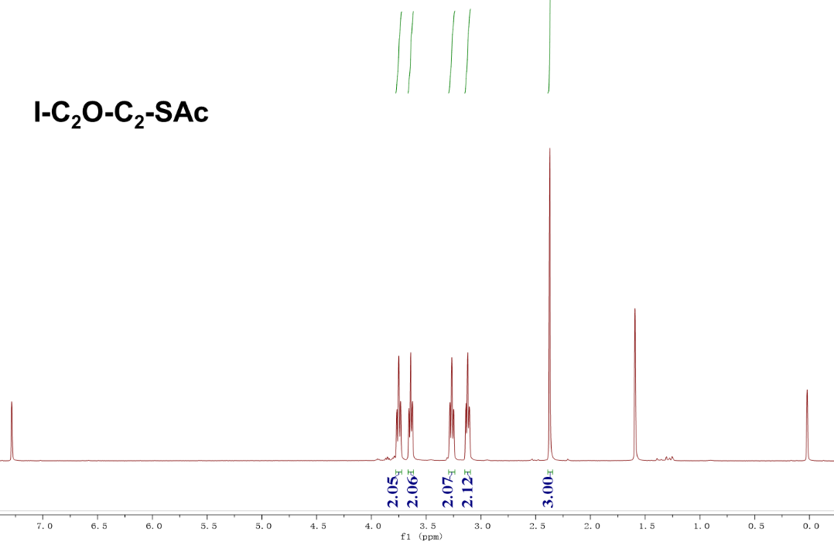
Fig. S36 | The ¹H-NMR spectrum of compound I-C₂O-C₂-SAc.

2-(2-iodoethoxy)ethane-1-thiol (I-C₂O-C₂-SH) was prepared as follows. S-(2-(2-iodoethoxy)ethyl) ethanethioate (1.17 g, 4.27 mmol) was dissolved in 50 mL methanol and degassed for 20 min. Subsequently, 3.0 mL trifluoroacetic acid was added. The solution was refluxed for 5h then cooled down to room temperature. The solvent was removed by rotary evaporator; DCM was used to extract the product. The organic layer was washed with DI water 3 times before dried over anhydrous Na₂SO₄. After filtration and concentration, the raw product was purified by column chromatography with hexane as eluent. Yield: 18 % (0.18 g, 0.77 mmol). ¹H NMR (400 MHz, Chloroform-d) δ 3.75 (t, J = 6.7 Hz, 2H), 3.65 (t, J = 6.3 Hz, 2H), 3.28 (t, J = 6.7 Hz, 2H), 2.72 (q, J = 8.2, 6.3 Hz, 2H), 1.66 (t, J = 8.2 Hz, 1H). ¹³C NMR (100 MHz, Chloroform-d) δ 72.32, 71.34, 24.46, 3.21. HRMS (ESI+ ): m/z calc for C₄H₈OSI [M+H] ⁺ 230.9341, found 230.9356.

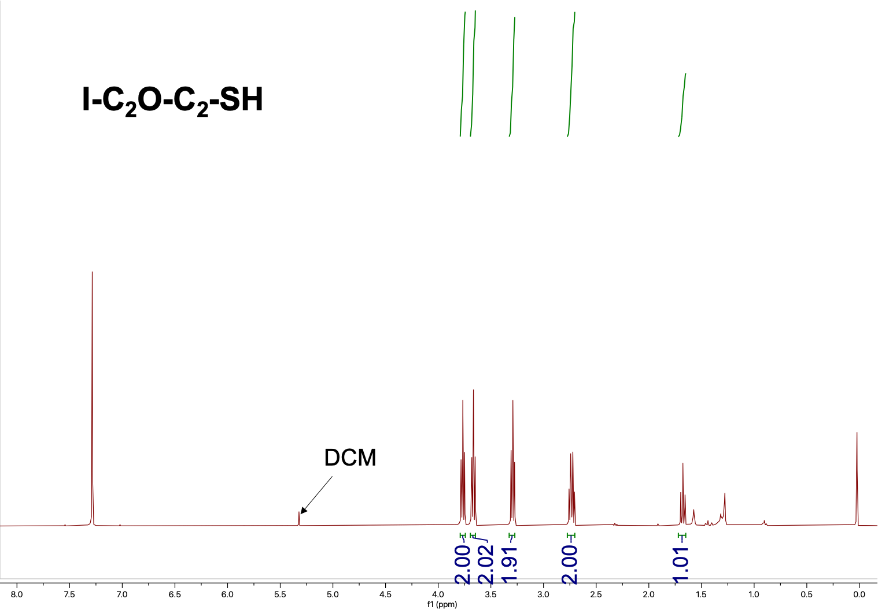
Fig. S37 | The ¹H-NMR spectrum of compound I-C₂O-C₂-SH.

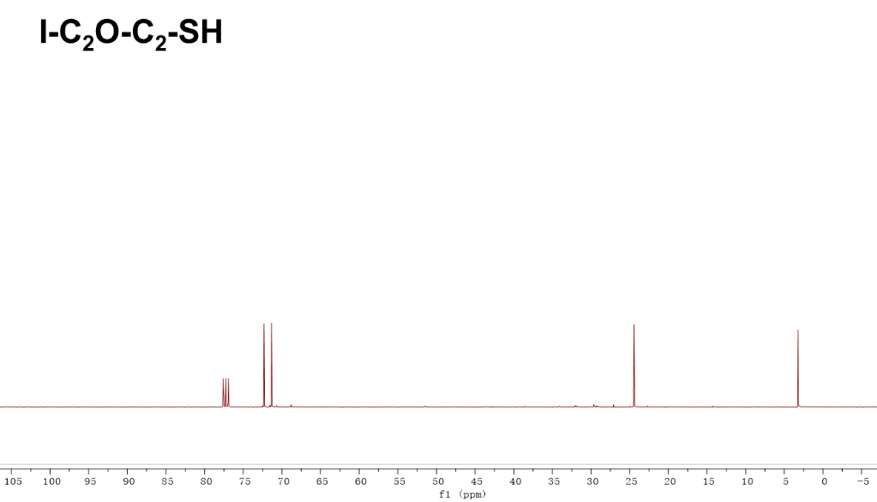
Fig. S38 | The ¹³C-NMR spectrum of compound I-C₂O-C₂-SH.

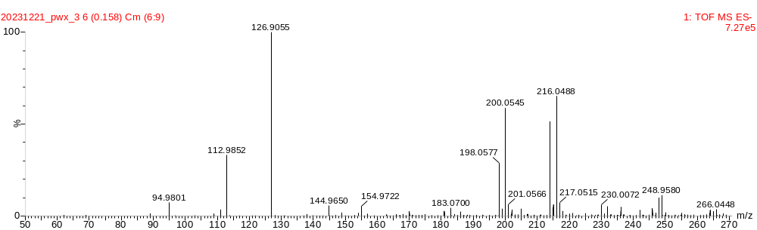
Fig. S39 | The HRMS spectrum of compound I-C₂O-C₂-SH.
1,2-bis(2-iodoethoxy)ethane (I-(C₂O)₂-C₂-I) was prepared as follows. To a stirred solution of 1,2-bis(2-chloroethoxy)ethane (18.70 g, 100.00 mmol) in acetone (200.00 mL) was added powder NaI (65.00 g, 433.6 mmol). The resulting clear yellow solution was heated as reflux for 48h. Then, cooled, filtered through a plug of celite and concentrated to give yellow liquid. This was taken up in ether (200 mL) washed with water (50 mL) and 10% aq. NaHSO₃ (20 mL), dried (NaHSO₄), filtered. The crude thiol product was purified by column chromatography on silica gel (hexanes). Yield: 30.26 g (82.00 mmol) 1,2-bis(2-iodoethoxy) ethane (82.0 % yield). 1H NMR (400 MHz, Chloroform-d) δ 3.78 (t, J = 6.8 Hz, 4H), 3.69 (s, 4H), 3.28 (t, J = 6.8 Hz, 4H).
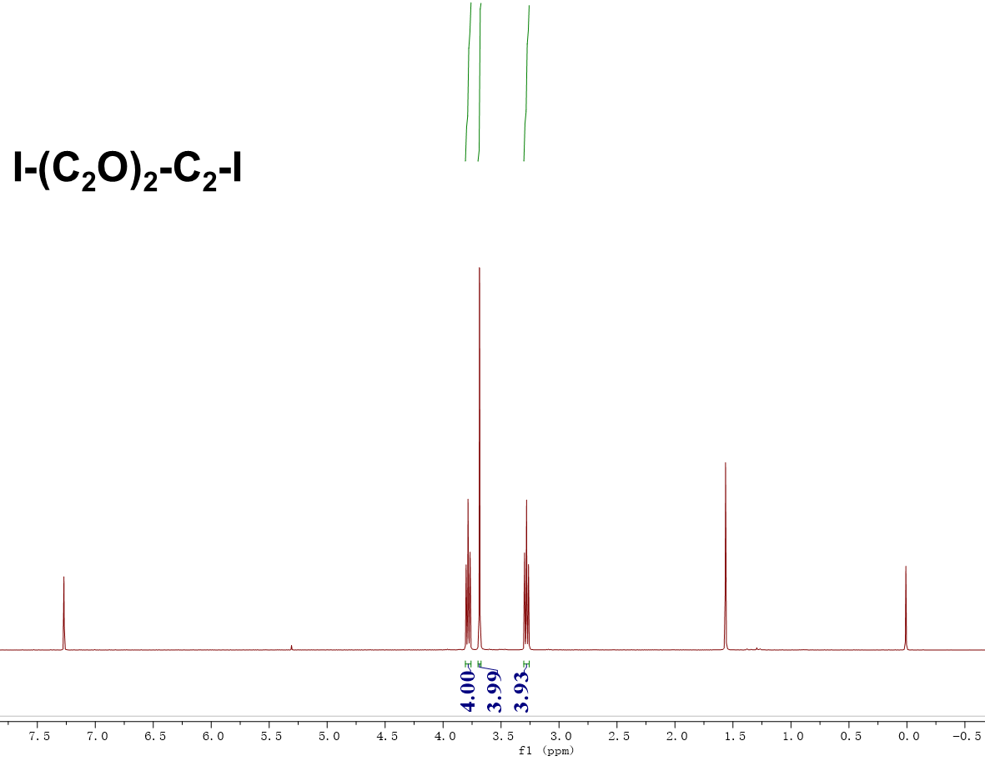
Fig. S40 | The ¹H-NMR spectrum of compound I-(C₂O)₂-C₂-I.

S-(2-(2-(2-iodoethoxy)ethoxy)ethyl) ethanethioate (I-(C₂O)₂-C₂-SAc) was prepared as follows. 1,2-bis(2-iodoethoxy)ethane (24.62 g, 66.72 mmol) and potassium thioacetate (1.90 g, 16.68 mmol) were added into 200 mL tetrahydrofuran, stirred for 12h at room temperature, followed by removal of the tetrahydrofuran under reduced pressure. The residue was dissolved in diethyl ether, filtered, and washed with DI water. The organic layer was dried over Na₂SO₄, filtered and concentrated after which the raw product was purified with column chromatography with dichloromethane and hexane (1: 10). Yield: 4.72 g (14.85 mmol) S-(2-(2-(2-iodoethoxy)ethoxy)ethyl) ethanethioate (89.0 % yield). ¹H NMR (400 MHz, Chloroform-d) δ 3.78 (t, J = 6.9 Hz, 2H), 3.67 (m, J = 4.6, 2.8, 1.4 Hz, 4H), 3.65 – 3.62 (m, 2H), 3.29 (t, J = 7.3, 6.5 Hz, 2H), 3.12 (t, J = 6.4 Hz, 2H), 2.36 (s, 3H).
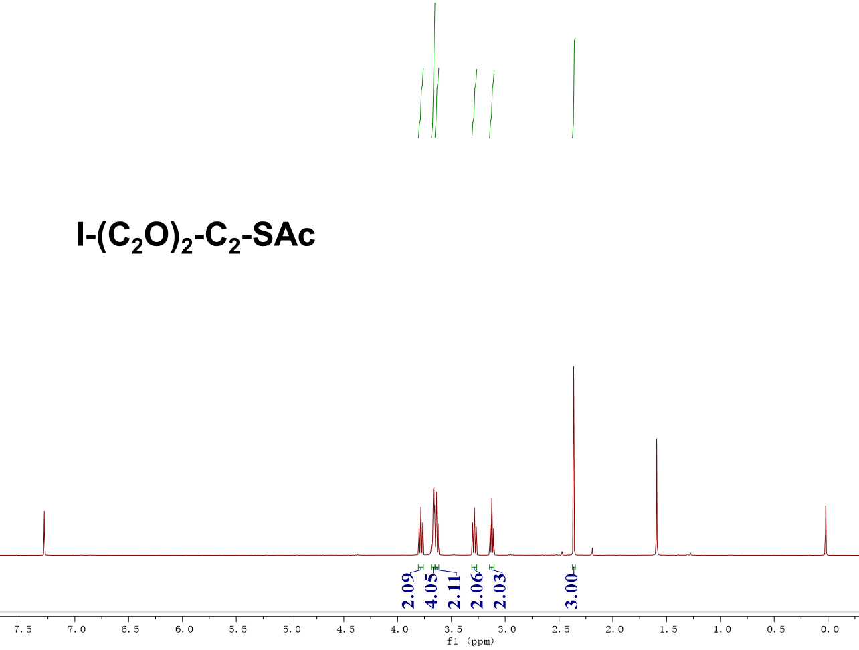
Fig. S41 | The ¹H-NMR spectrum of compound I-(C₂O)₂-C₂-SAc.

2-(2-(2-iodoethoxy)ethoxy)ethane-1-thiol (I-(C₂O)₂-C₂-SH) was prepared as follows. S-(2-(2-(2-iodoethoxy)ethoxy)ethyl) ethanethioate (0.83 g, 2.61 mmol) was dissolved in 30 mL methanol and degassed for 20 min. Subsequently, 3.0 mL trifluoroacetic acid was added. The solution was refluxed for 5h then cooled down to room temperature. The solvent was removed by rotary evaporator; DCM was used to extract the product. The organic layer was washed with DI water 3 times before dried over anhydrous Na₂SO₄. After filtration and concentration, the raw product was purified by column chromatography with hexane as eluent. Yield: 18 % (0.13 g, 0.47 mmol). ¹H NMR (400 MHz, Chloroform-d) δ 3.78 (t, J = 6.9 Hz, 2H), 3.67 (m, J = 5.7, 3.2, 1.5 Hz, 4H), 3.64 (d, J = 6.5 Hz, 2H), 3.28 (t, J = 6.9 Hz, 2H), 2.72 (q, J = 8.2, 6.4 Hz, 2H). ¹³C NMR (100 MHz, Chloroform-d) δ 72.96, 71.99, 70.23, 70.17, 24.31, 2.92. HRMS (ESI+ ): m/z calc for C₆H₁₄O₂SI [M+H] ⁺ 276.9759, found 276.9762.

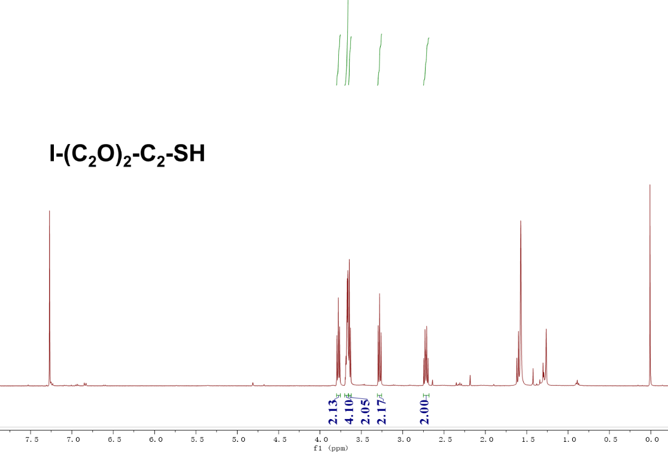
Fig. S42 | The ¹H-NMR spectrum of compound I-(C₂O)₂-C₂-SH.
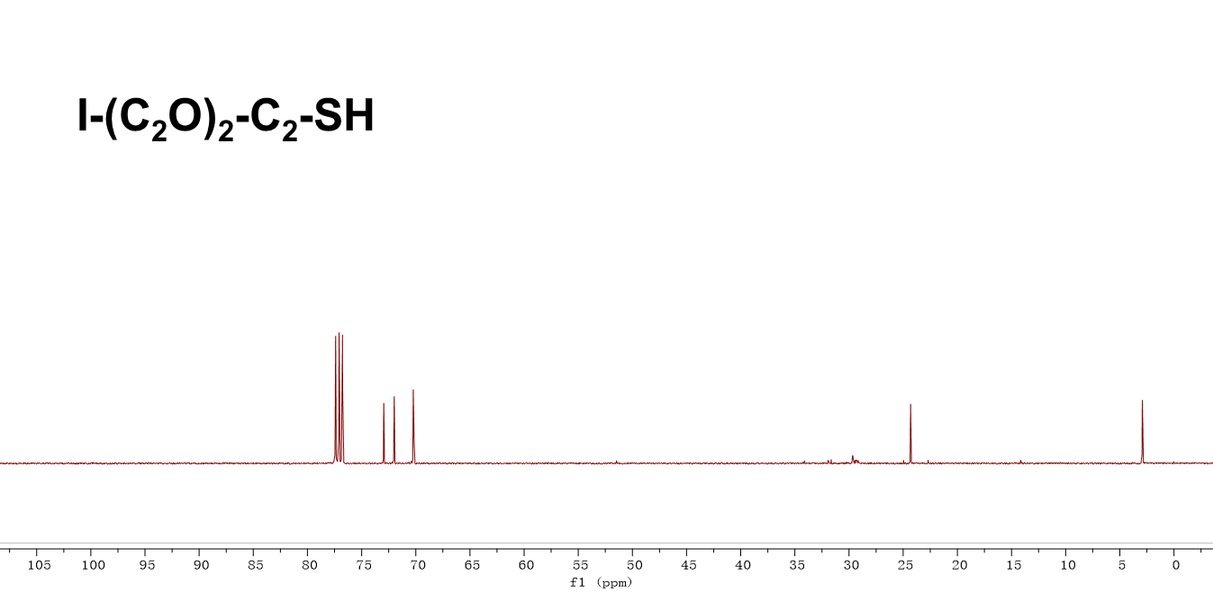
Fig. S43 | The ¹³C-NMR spectrum of compound I-(C₂O)₂-C₂-SH.
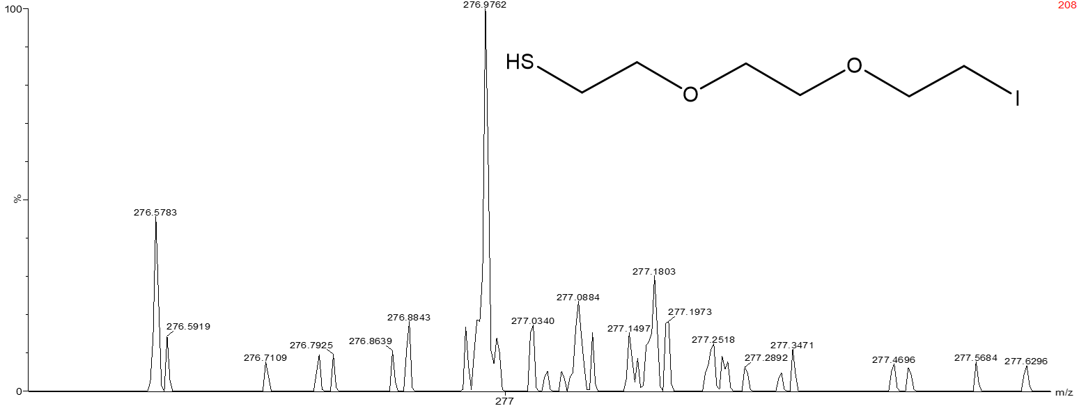
Fig. S44 | The HRMS spectrum of compound I-(C₂O)₂-C₂-SH.

1-iodo-2-(2-(2-(2-iodoethoxy)ethoxy)ethoxy)ethane (I-(C₂O)₃-C₂-I) was prepared as follows. To a stirred solution of 1-chloro-2-(2-(2-(2-chloroethoxy)ethoxy)ethoxy)ethane (10.00 g, 43.29 mmol) in acetone (200.00 mL) was added powder NaI (25.97 g, 173.16 mmol). The resulting clear yellow solution was heated as reflux for 48h. Then, cooled, filtered through a plug of celite and concentrated to give yellow liquid. This was taken up in ether (200 mL) washed with water (50 mL) and 10% aq. NaHSO₃ (20 mL), dried (NaHSO₄), filtered. The crude thiol product was purified by column chromatography on silica gel (hexanes). Yield: 14.70 g, 35.49 mmol, 82.0 %. ¹H NMR (400 MHz, Chloroform-d) δ 3.77 (t, J = 6.9 Hz, 4H), 3.68 (s, 8H), 3.28 (t, J = 6.9 Hz, 4H).
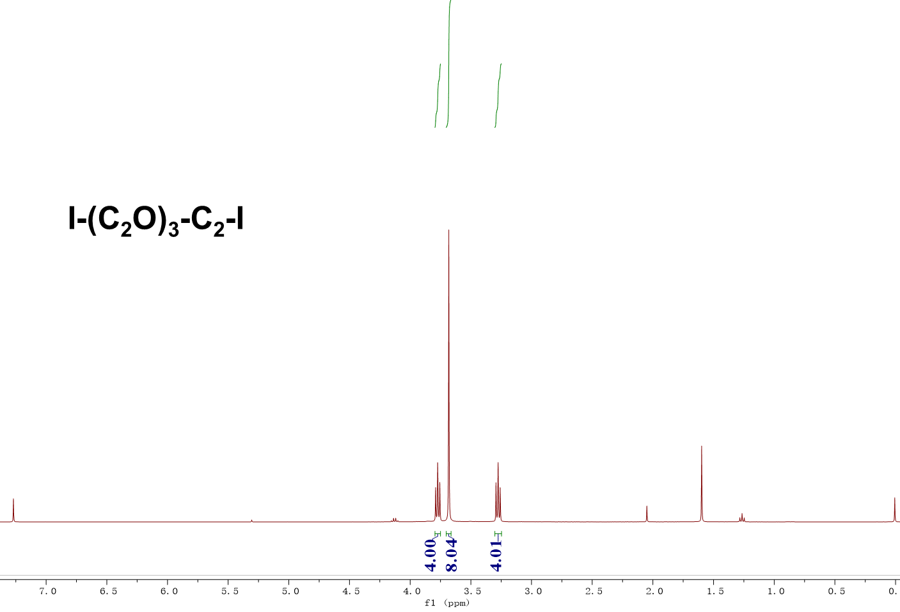
Fig. S45 | The ¹H-NMR spectrum of compound I-(C₂O)₃-C₂-I.

S-(2-(2-(2-(2-chloroethoxy)ethoxy)ethoxy)ethyl) ethanethioate (I-(C₂O)₃-C₂-SAc) was prepared as follows. 1-iodo-2-(2-(2-(2-iodoethoxy)ethoxy)ethoxy)ethane (17.94 g, 43.33 mmol) and potassium thioacetate (1.24 g, 10.83 mmol) were added into 200 mL tetrahydrofuran, stirred for 12h at room temperature, followed by removal of the tetrahydrofuran under reduced pressure. The residue was dissolved in diethyl ether, filtered, and washed with DI water. The organic layer was dried over Na₂SO₄, filtered and concentrated after which the raw product was purified with column chromatography with dichloromethane and hexane (1: 10). Yield: 3.49 g (9.64 mmol, 89.0 % yield). ¹H NMR (400 MHz, Chloroform-d) δ 3.78 (t, J = 7.4, 6.5 Hz, 2H), 3.70 – 3.65 (m, 8H), 3.64 – 3.61 (m, 2H), 3.29 (t, J = 7.3, 6.5 Hz, 2H), 3.12 (t, J = 6.5 Hz, 2H), 2.36 (s, 3H).
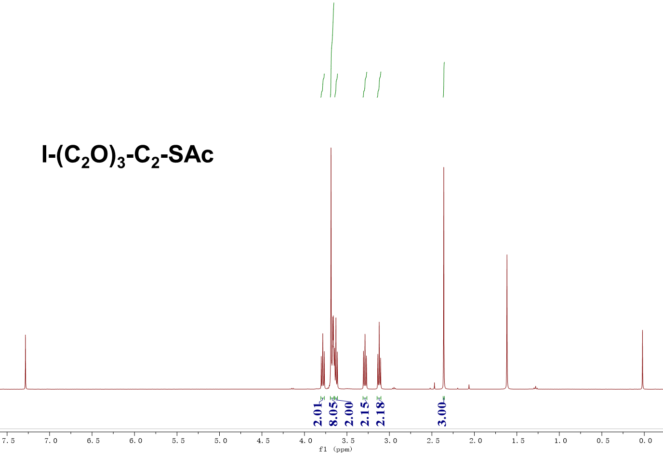
Fig. S46 | The ¹H-NMR spectrum of compound I-(C₂O)₃-C₂-SAc.

2-(2-(2-(2-iodoethoxy)ethoxy)ethoxy)ethane-1-thiol (I-(C₂O)₃-C₂-SH) was prepared as follows. S-(2-(2-(2-(2-chloroethoxy)ethoxy)ethoxy)ethyl) ethanethioate (1.08 g, 2.98 mmol) was dissolved in 30 mL methanol and degassed for 20 min. Subsequently, 4.0 mL trifluoroacetic acid was added. The solution was refluxed for 5h then cooled down to room temperature. The solvent was removed by rotary evaporator; DCM was used to extract the product. The organic layer was washed with DI water 3 times before dried over anhydrous Na₂SO₄. After filtration and concentration, the raw product was purified by column chromatography with hexane as eluent. Yield: 18 % (0.17 g, 0.54 mmol). ¹H NMR (400 MHz, Chloroform-d) δ 3.81 – 3.77 (t, 2H), 3.71 – 3.67 (m, 8H), 3.66 – 3.63 (t, 2H), 3.29 (t, J = 7.4, 6.4 Hz, 2H), 2.73 (q, J = 8.2, 6.4 Hz, 2H). ¹³C NMR (100 MHz, Chloroform-d) δ 72.91, 72.00, 70.71, 70.67, 70.65, 70.27, 24.32, 2.95. HRMS (ESI+ ): m/z calc for C₈H₁₈O₃SI [M+H] ⁺ 321.0021, found 321.0023.
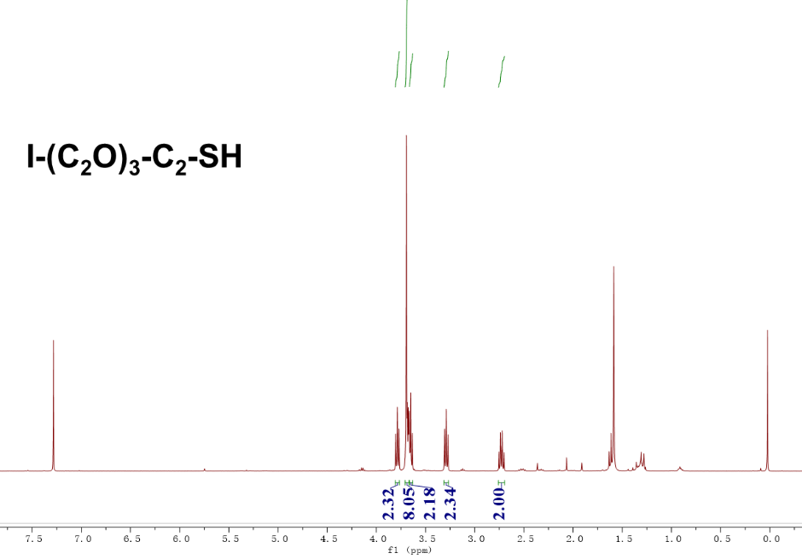
Fig. S47 | The ¹H-NMR spectrum of compound I-(C₂O)₃-C₂-SH.
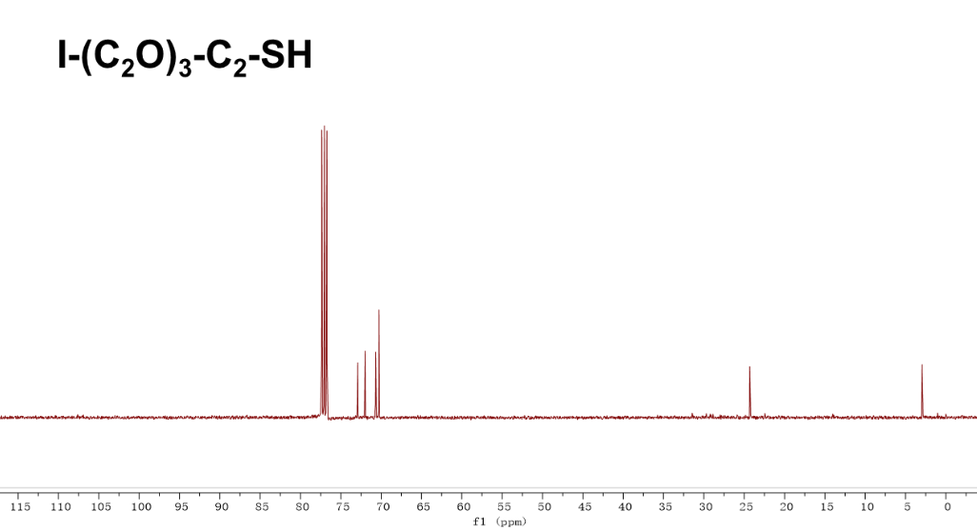
Fig. S48 | The ¹³C-NMR spectrum of compound I-(C₂O)₃-C₂-SH.

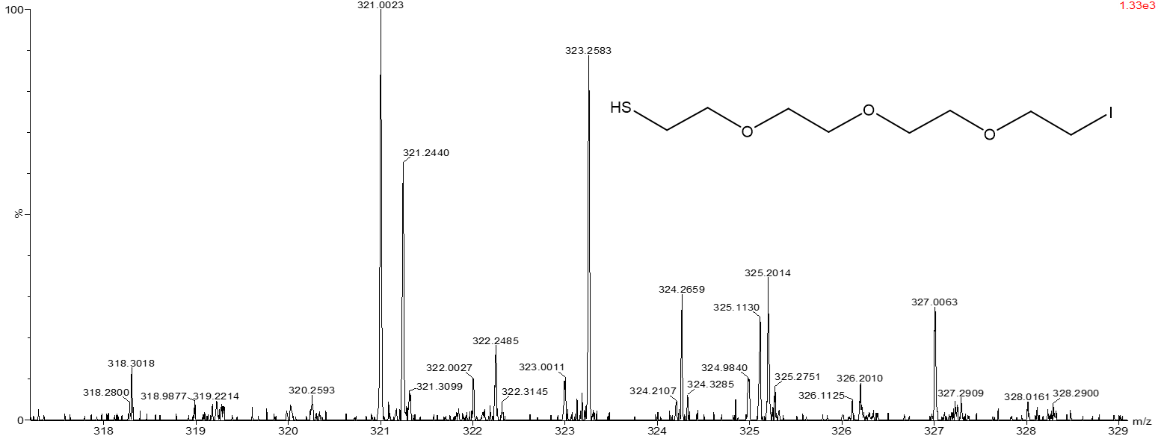
Fig. S49 | The HRMS spectrum of compound I-(C₂O)₃-C₂-SH.
1,14-diiodo-3,6,9,12-tetraoxatetradecane (I-(C₂O)₄-C₂-I) was prepared as follows. To a stirred solution of 3,6,9,12-tetraoxatetradecane-1,14-diyl bis(4-methylbenzenesulfonate) (10.00 g, 18.32 mmol) in acetone (200.00 mL) was added powder NaI (10.98 g, 73.26 mmol). The resulting clear yellow solution was heated as reflux for 48h. Then, cooled, filtered through a plug of celite and concentrated to give yellow liquid. This was taken up in ether (200 mL) washed with water (50 mL) and 10% aq. NaHSO₃ (20 mL), dried (NaHSO₄), filtered. The crude thiol product was purified by column chromatography on silica gel (hexanes). Yield: 6.68 g, 15.02 mmol, 82.0 %. ¹H NMR (400 MHz, Chloroform-d) δ 3.78 (t, J = 7.3, 6.6 Hz, 4H), 3.69 (s, J = 1.9 Hz, 12H), 3.29 (t, J = 6.9 Hz, 4H).
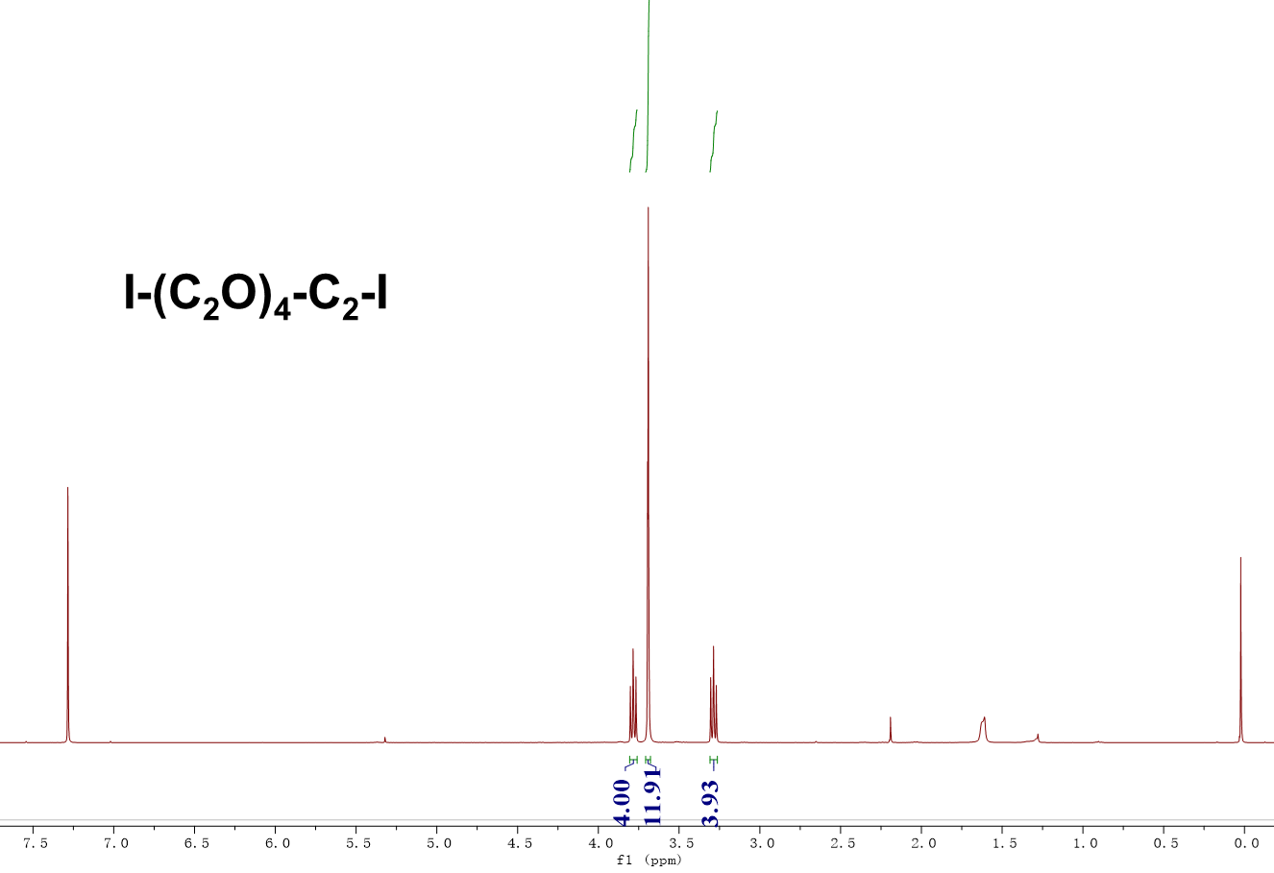
Fig. S50 | The ¹H-NMR spectrum of compound I-(C₂O)₄-C₂-I.

S-(14-iodo-3,6,9,12-tetraoxatetradecyl) ethanethioate (I-(C₂O)₄-C₂-SAc) was prepared as follows. 1,14-diiodo-3,6,9,12-tetraoxatetradecane (6.68 g, 15.02 mmol) and potassium thioacetate (0.43 g, 3.76 mmol) were added into 100 mL tetrahydrofuran, stirred for 12h at room temperature, followed by removal of the tetrahydrofuran under reduced pressure. The residue was dissolved in diethyl ether, filtered, and washed with DI water. The organic layer was dried over Na₂SO₄, filtered and concentrated after which the raw product was purified with column chromatography with dichloromethane and hexane (1: 10). Yield: 1.26 g (3.35 mmol, 89.0 % yield). ¹H NMR (400 MHz, Chloroform-d) δ 3.78 (t, J = 6.9 Hz, 2H), 3.70 – 3.65 (m, 12H), 3.62 (t, J = 6.4 Hz, 2H), 3.29 (t, J = 6.9 Hz, 2H), 3.12 (t, J = 6.5 Hz, 2H), 2.36 (s, 3H).
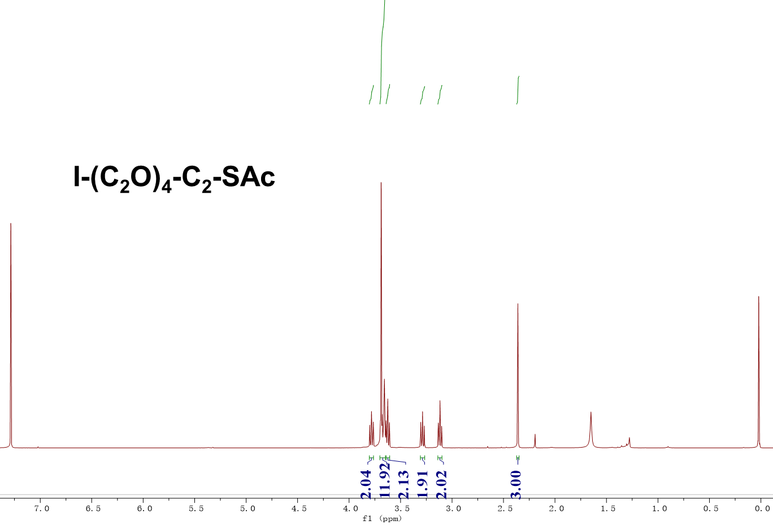
Fig. S51 | The ¹H-NMR spectrum of compound I-(C₂O)₄-C₂-SAc.

14-iodo-3,6,9,12-tetraoxatetradecane-1-thiol (I-(C₂O)₄-C₂-SH) was prepared as follows. S- S-(14-iodo-3,6,9,12-tetraoxatetradecyl) ethanethioate (1.26 g, 3.35 mmol) was dissolved in 30 mL methanol and degassed for 20 min. Subsequently, 4.0 mL trifluoroacetic acid was added. The solution was refluxed for 5h then cooled down to room temperature. The solvent was removed by rotary evaporator; DCM was used to extract the product. The organic layer was washed with DI water 3 times before dried over anhydrous Na₂SO₄. After filtration and concentration, the raw product was purified by column chromatography with hexane as eluent. Yield: 18 % (0.22 g, 0.60 mmol). ¹H NMR (400 MHz, Chloroform-d) δ 3.78 – 3.75 (t, 2H), 3.67 (m, J = 7.0, 2.1 Hz, 12H), 3.62 (t, J = 6.4 Hz, 2H), 3.28 (t, J = 6.9 Hz, 2H), 2.71 (q, J = 8.2, 6.4 Hz, 2H). ¹³C NMR (100 MHz, Chloroform-d) δ 72.87, 71.97, 70.70, 70.66, 70.62, 70.56, 70.25, 70.23, 24.30, 3.01. HRMS (ESI+ ): m/z calc for C₁₀H₂₂O₄SI [M+H] ⁺ 365.0283, found 365.0259.

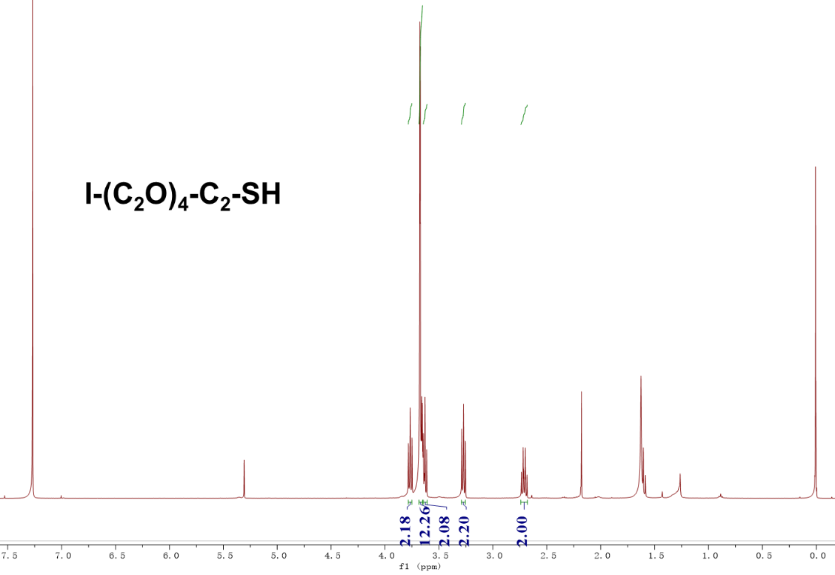
Fig. S52 | The ¹H-NMR spectrum of compound I-(C₂O)₄-C₂-SH.
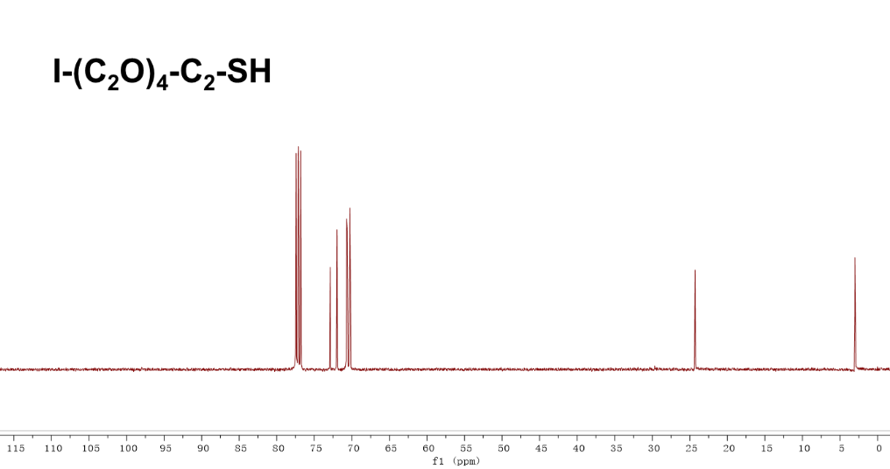
Fig. S53 | The ¹³C-NMR spectrum of compound I-(C₂O)₄-C₂-SH.
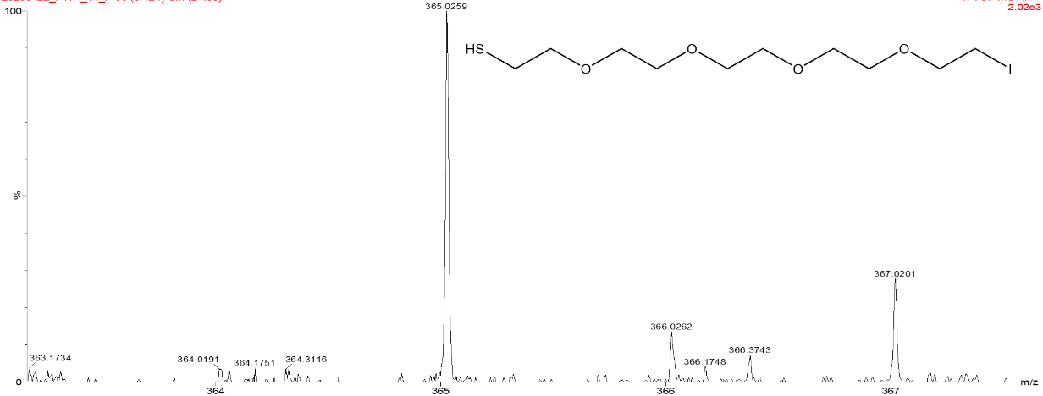
Fig. S54 | The HRMS spectrum of compound I-(C₂O)₄-C₂-SH.

S2. SAMs preparations
Template-stripped Au surfaces (Au^{TS}). Au^{TS} substrates were prepared as our previous works reported. ⁷⁻⁹ Firstly, Au (a purity of 99.999% from Dimu Materials, Inc (China)) film with thickness of ~200 nm was thermally deposited on the surface of clean Si (100) wafers (KYKY-400, Zhongke Ke Yi, China), which natively possesses a SiO₂ layer under the base pressure of 2×10⁻⁵ Pa. In this process, the evaporation rate was primarily set as 0.2 Å/s at the first 50nm and then ~1 Å/s for the rest 150 nm. Secondly, the ultrasonically cleaned glass slides (1.5 × 1.5 cm²) were dried in a stream of N₂ gas, followed by cleaned by a plasma of air for 5 mins at a pressure of 100 Pa. The slides were stuck on the Au substrate through photo-curable optical adhesive (Norland, No. 61). Thirdly, to cure the optical adhesive, the substrates were placed in a 100 Watt UV lamp at a distance of approximately 60 cm from the light source for about 1 hour. Before preparation of SAMs, the slides with a layer of Au were lift-off by a razor blade.

SAMs preparation. To assembled SAMs, the Au^{TS} substrates were placed in degassed 1 mM ethanolic solutions of the targeted molecules overnight under the protection of inert nitrogen environment. After that, ethanol (AR grade) was utilized to remove the undensely packed molecules, like the physisorbed one, a stream of dry N₂ was used to gently dried the surface of SAMs, and conducted electrical measurements with minutes to avoid the degradation of Au-S covalent interactions as well as surface contaminations.

S3. Sample Characterizations.
X-ray Photoelectron Spectroscopy (XPS) Measurements. XPS was utilized to detect the quality and supermolecular molecular structures of the SAMs composed of the saturated molecules with instruments located in National Center of Electron Spectroscopy in Beijing. The Thermo Scientific K-Alpha XPS system was used as the incident X-ray beam with energy of 1486.6 eV. We collected the high-resolution XPS spectra of S 2p, C 1s, I 4f, O 1s. It is worth noted that the peaks of high-resolution XPS spectra of C 1s and O 1s may originated from the impurities absorbed on the surface of the SAMs in atmosphere. Therefore, detailed analysis of the compositional ratio of C and O for all SAMs seems to have little significance.
To further analyze the chemical environments of each element, the least-square peak fit with a pseudo-Voigt function (a linear combination of Lorentzian (30%) and Gaussian (70%) functions)¹⁰ was utilized to fit the XPS spectra with Avantage software, and the sloping background was modelled using a smart background correction.

Ultraviolet Photoelectron Spectroscopy (UPS) Measurements. UPS was carried out to characterize the work function (WF) and the location of HOMO with instrument installed in the Thermo Scientific K-Alpha XPS system. The photon energy at 21.22 eV and -10 V bias was utilized to the samples to probe the valence band. The fermi edge of Au was regarded as the reference for all the UPS spectra.
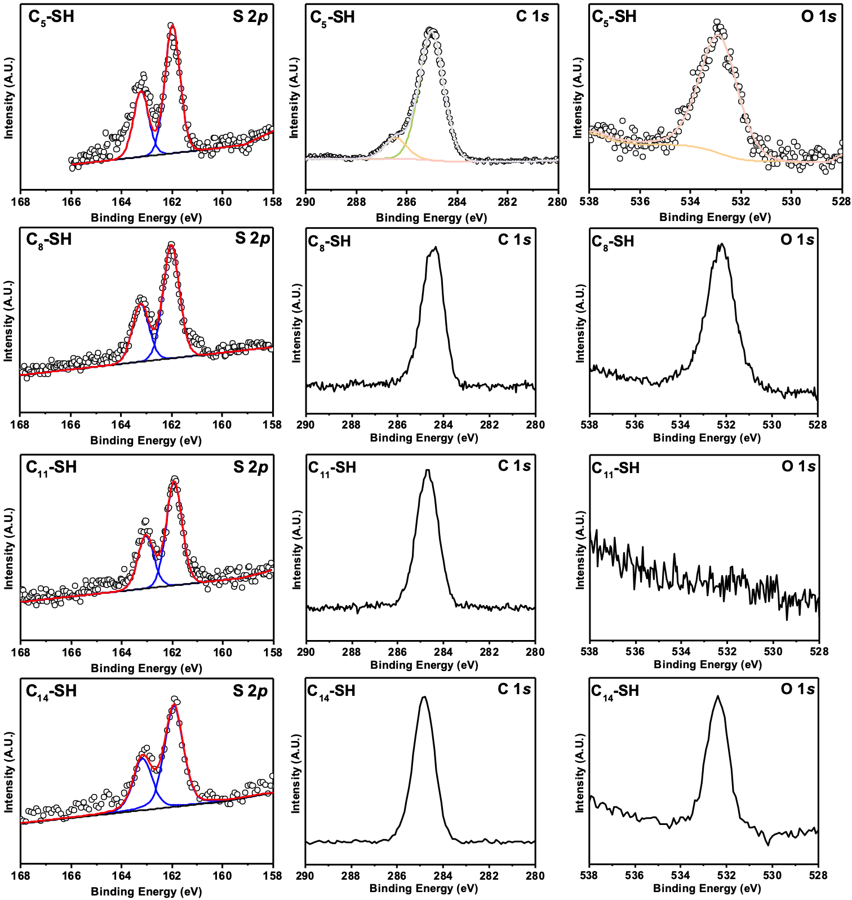
Fig. S55 | The high resolution XPS S 2p, C 1s and O1s spectra for Au-SC₅, Au-SC₈, Au-SC₁₁ and Au-SC₁₄.

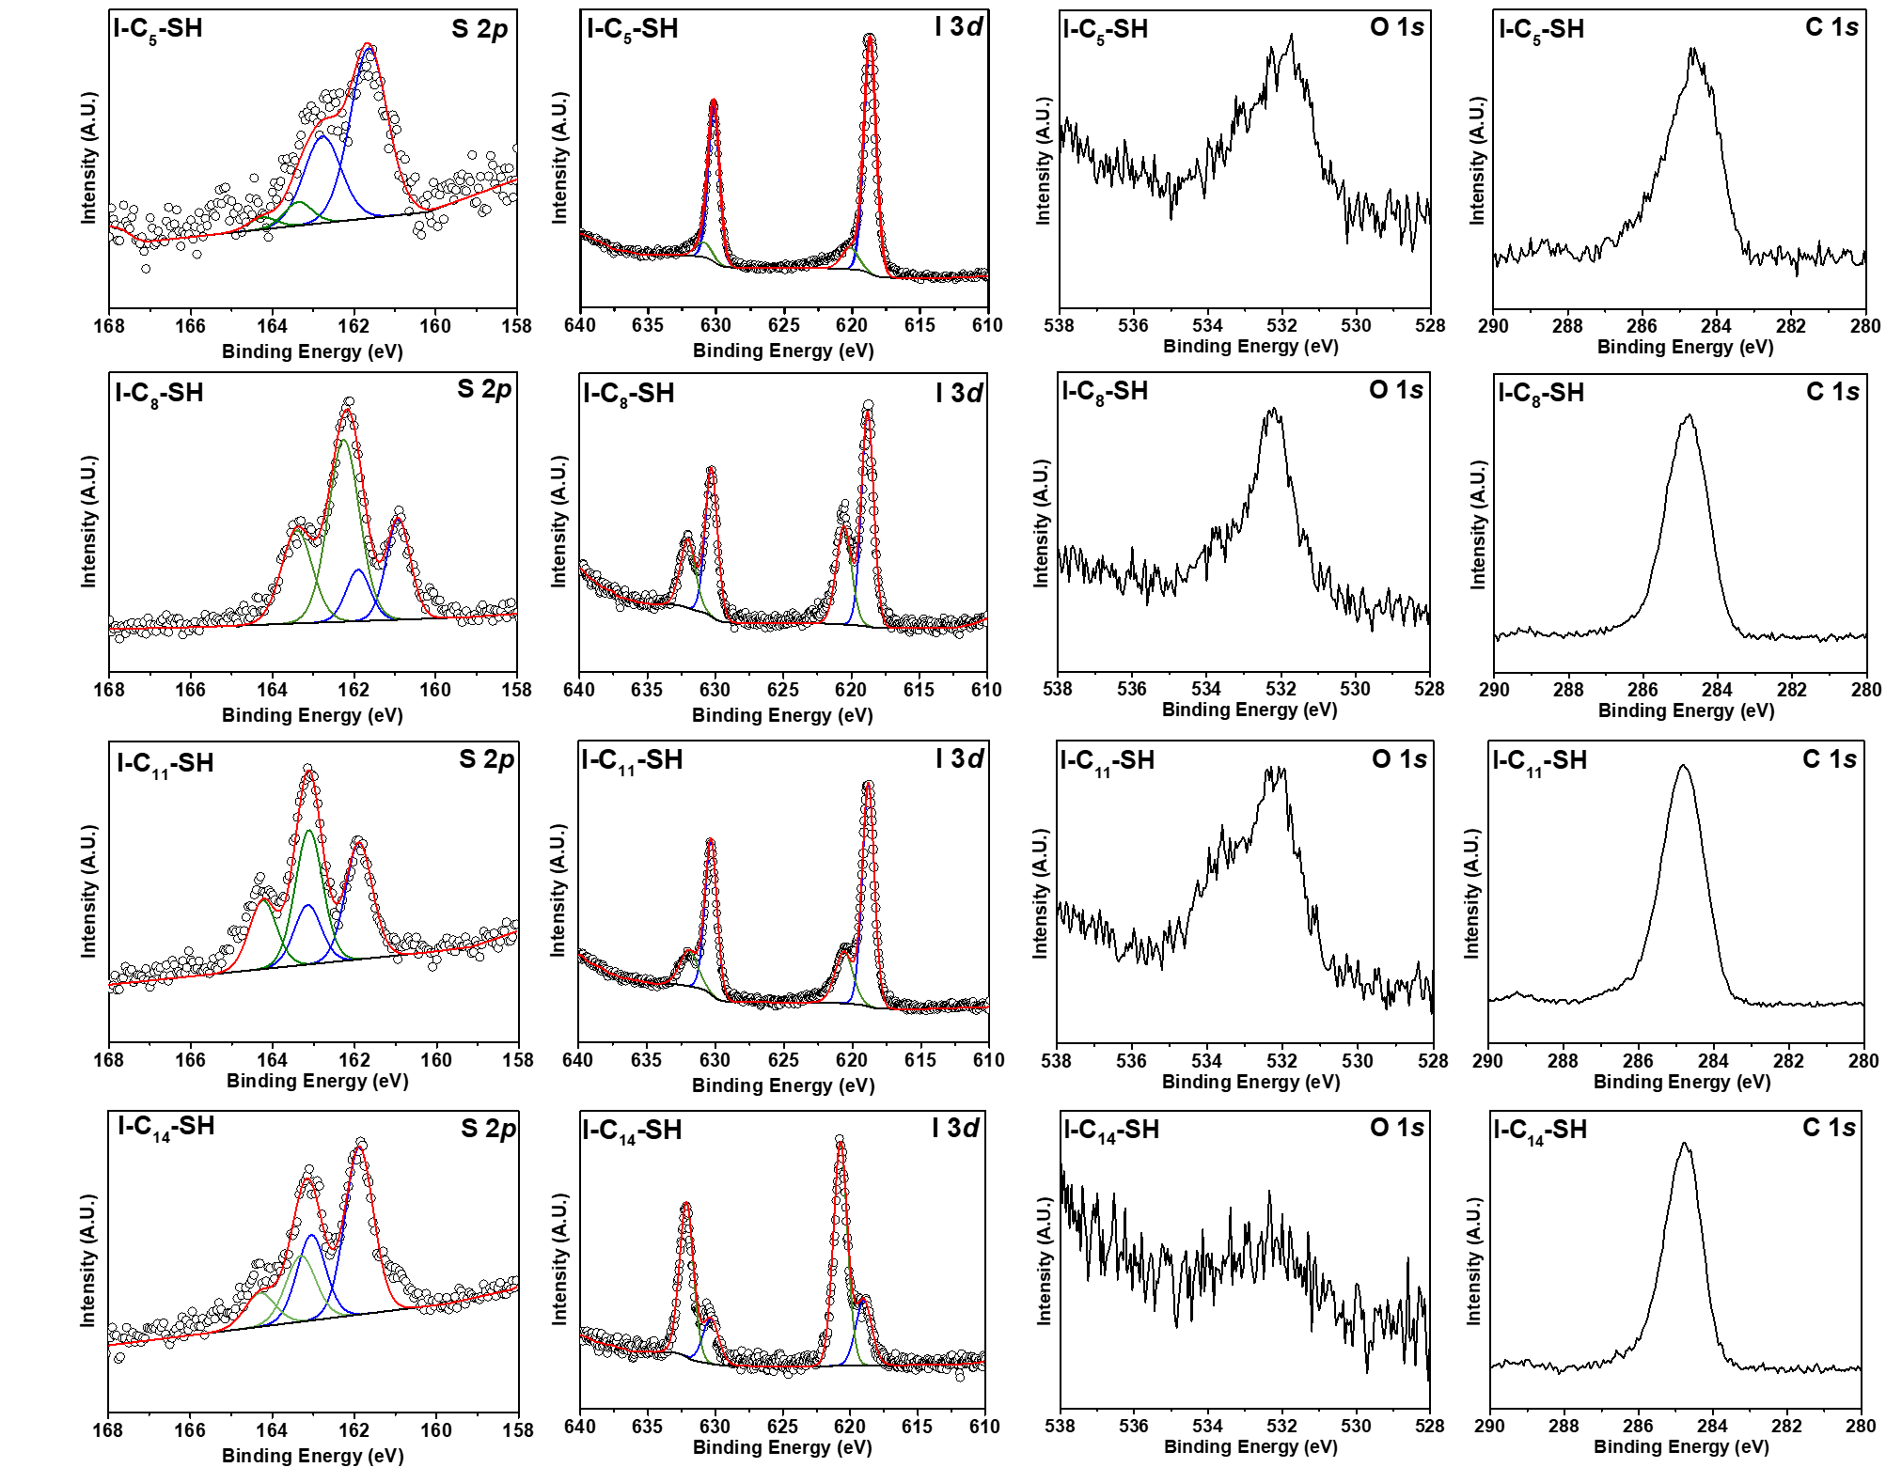
Fig. S56 | The high resolution XPS S 2p, C 1s and O1s spectra for Au-SC₅-I, Au-SC₈-I, Au-SC₁₁-I and Au-SC₁₄-I.

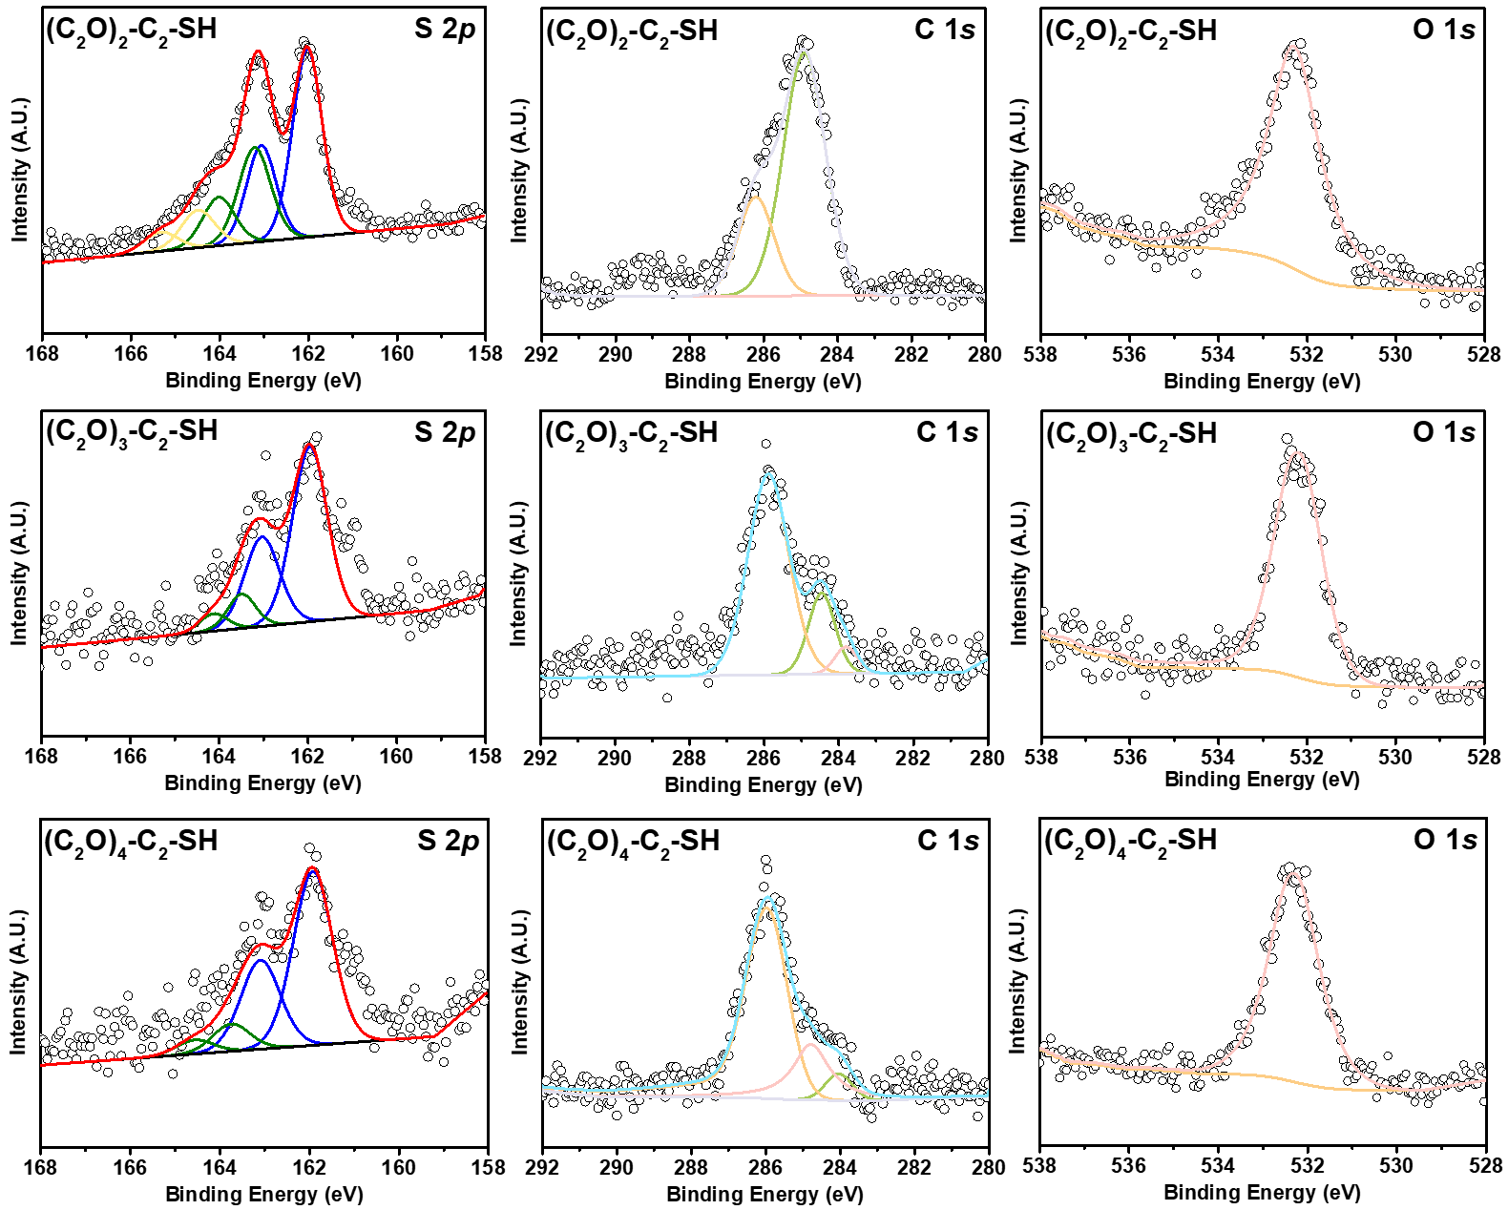
Fig. S57 | The high resolution XPS S 2p, C 1s and O1s spectra for Au-SC₂-(OC₂)₂, Au-SC₂-(OC₂)₃ and Au-SC₂-(OC₂)₄.

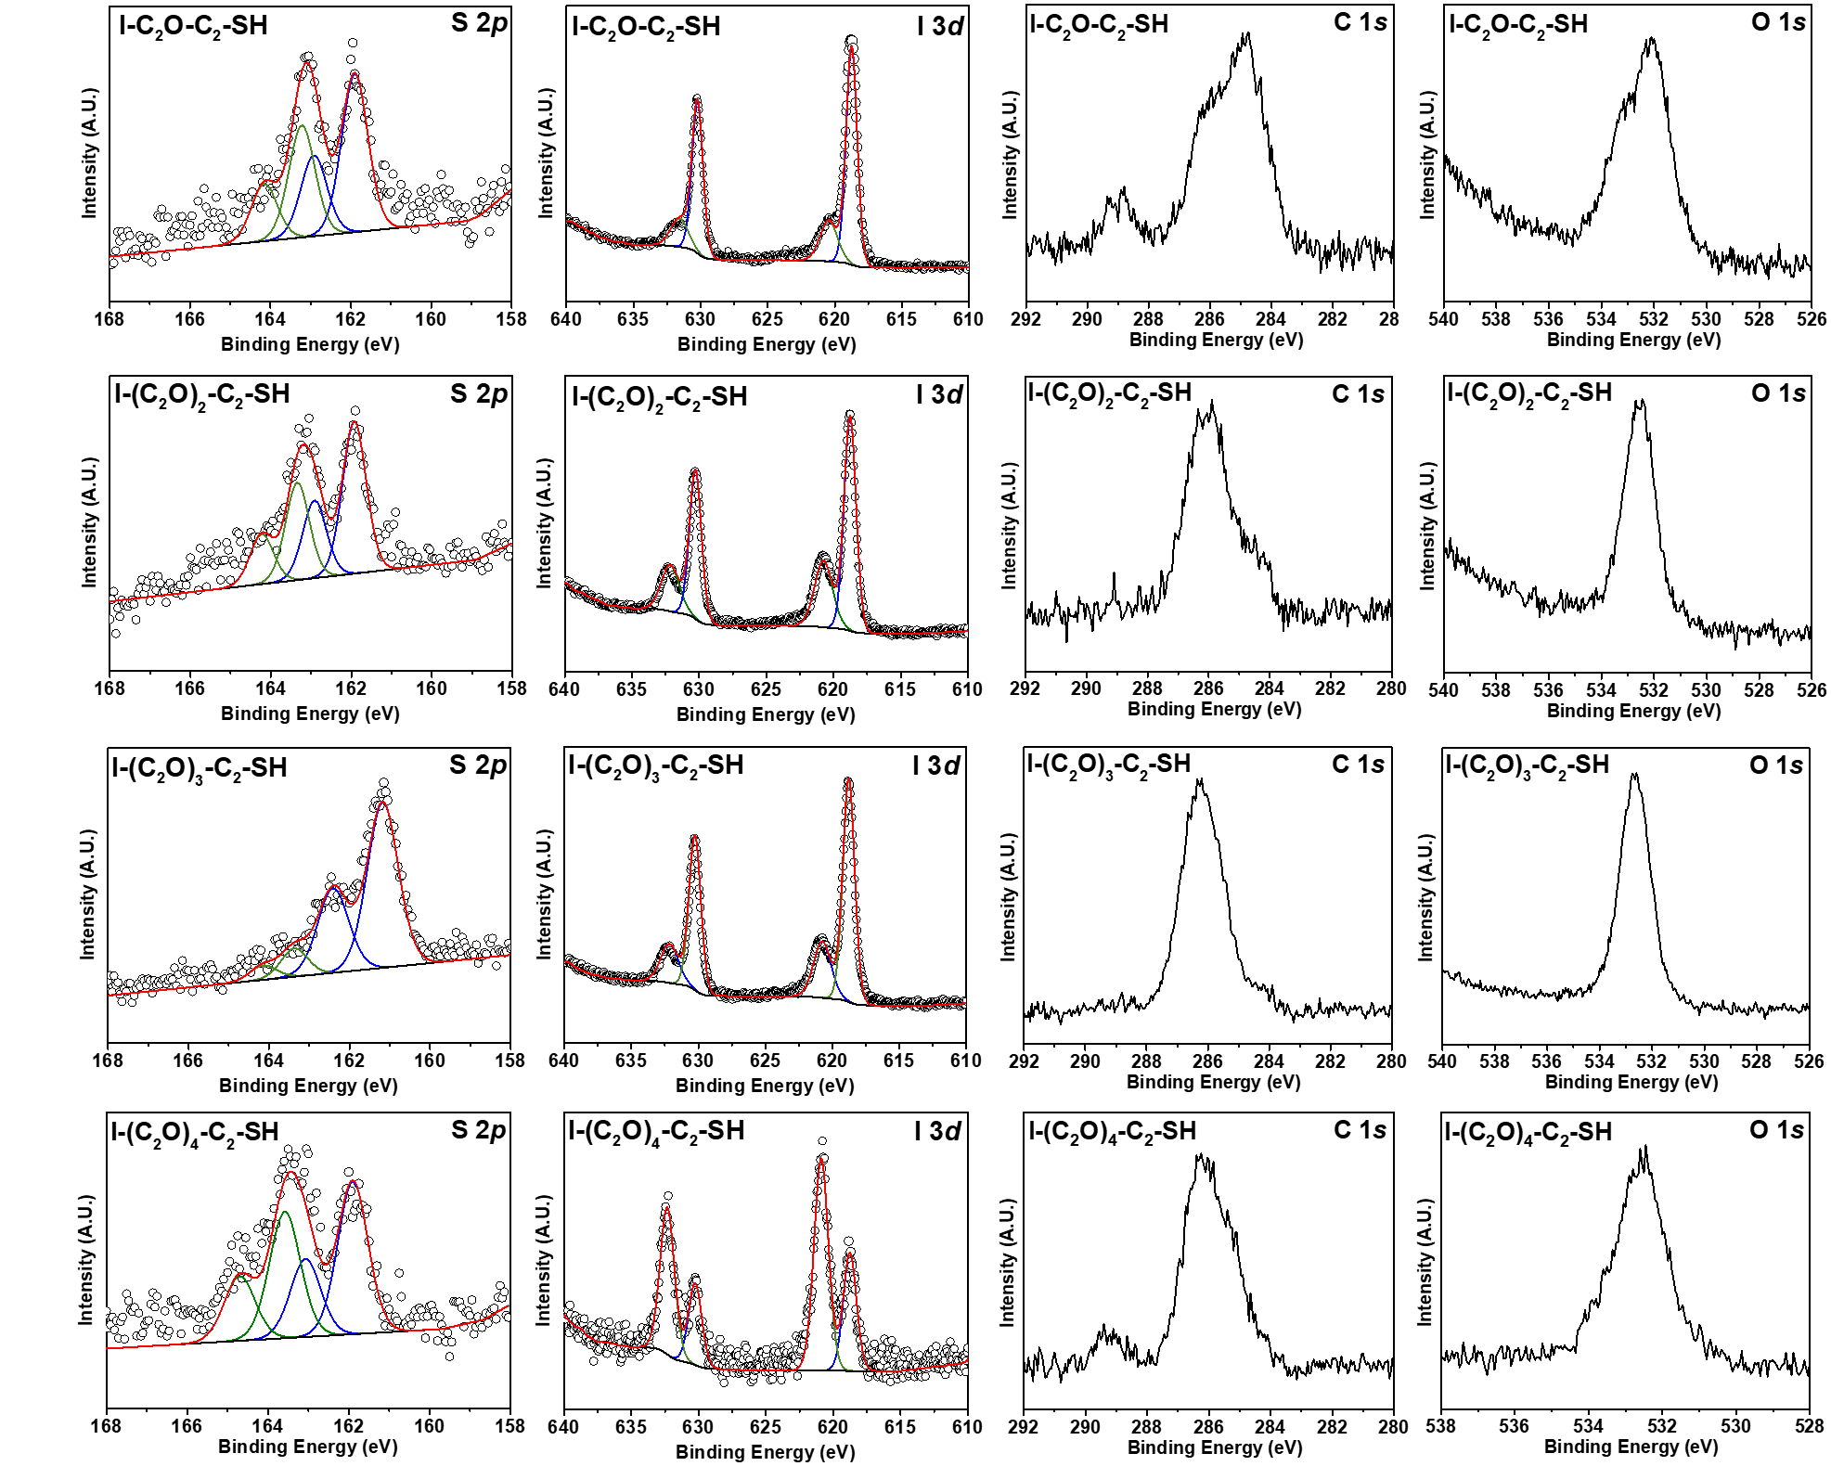
Fig. S58 | The high resolution XPS S 2p, C 1s and O1s spectra for Au-SC₂-OC₂-I, Au-SC₂-(OC₂)₂-I, Au-SC₂-(OC₂)₃-I and Au-SC₂-(OC₂)₄-I.

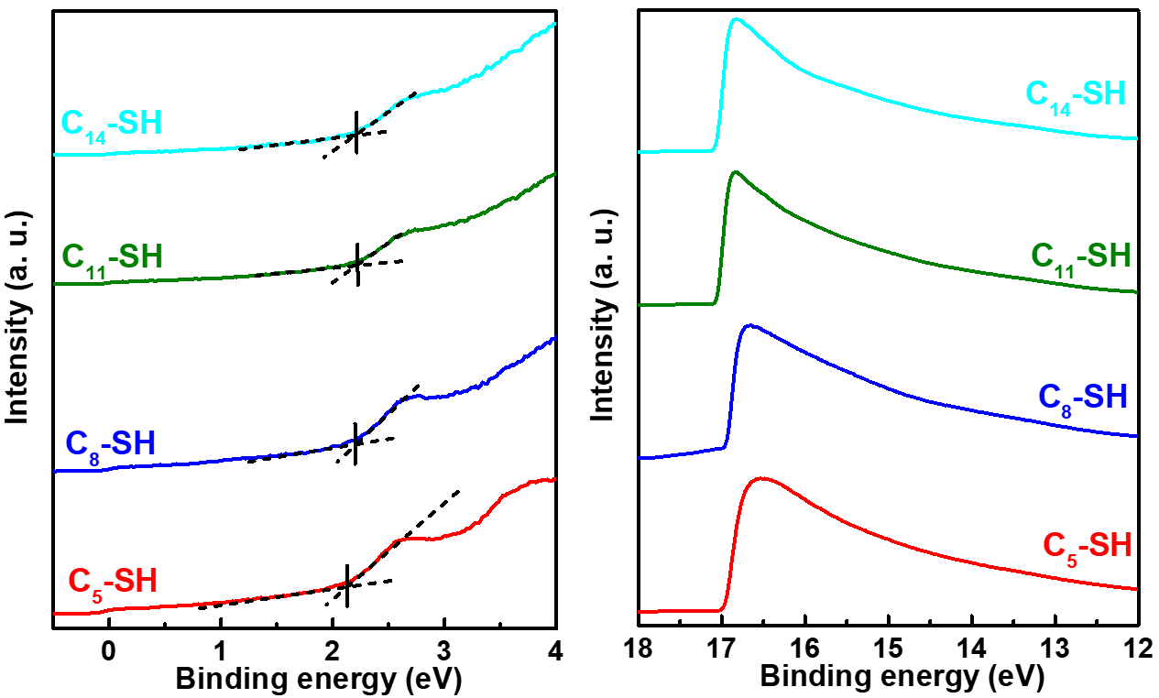
Fig. S59 | Secondary cutoff and valence band spectra of the HOMO peak for Au-SC₅, Au-SC₈, Au-SC₁₁ and Au-SC₁₄. determined by UPS.
Table S1. Properties of the studied SAMs obtained by UPS
Molecules | δE_{ME} (eV) | E_{cut off} (eV) | WF (eV) | E_{HOMO} (eV)
C₅-SH | 2.10 | 17.00 | 4.22 | -6.32
C₈-SH | 2.17 | 16.96 | 4.26 | -6.43
C₁₁-SH | 2.13 | 17.06 | 4.16 | -6.29
C₁₄-SH | 2.13 | 17.09 | 4.13 | -6.26

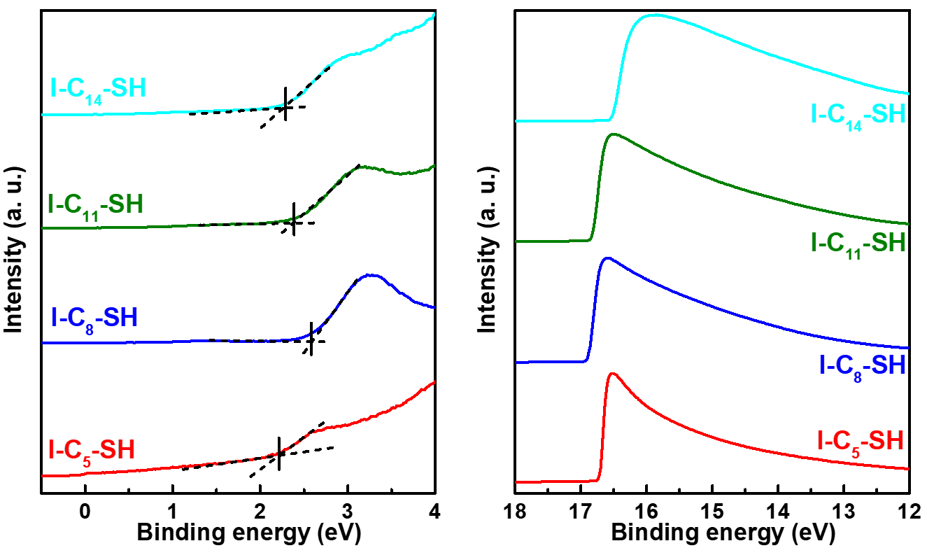
Fig. S60 | Secondary cutoff and valence band spectra of the HOMO peak for Au-SC₅-I, Au-SC₈-I, Au-SC₁₁-I and Au-SC₁₄-I. determined by UPS.

Table S2. Properties of the studied SAMs obtained by UPS
Molecules | δE_{ME} (eV) | E_{cut off} (eV) | WF (eV) | E_{HOMO} (eV)
I-C₅-SH | 2.11 | 16.75 | 4.47 | -6.58
I-C₈-SH | 2.57 | 16.87 | 4.35 | -6.92
I-C₁₁-SH | 2.38 | 16.82 | 4.40 | -6.78
I-C₁₄-SH | 2.28 | 16.53 | 4.69 | -6.97

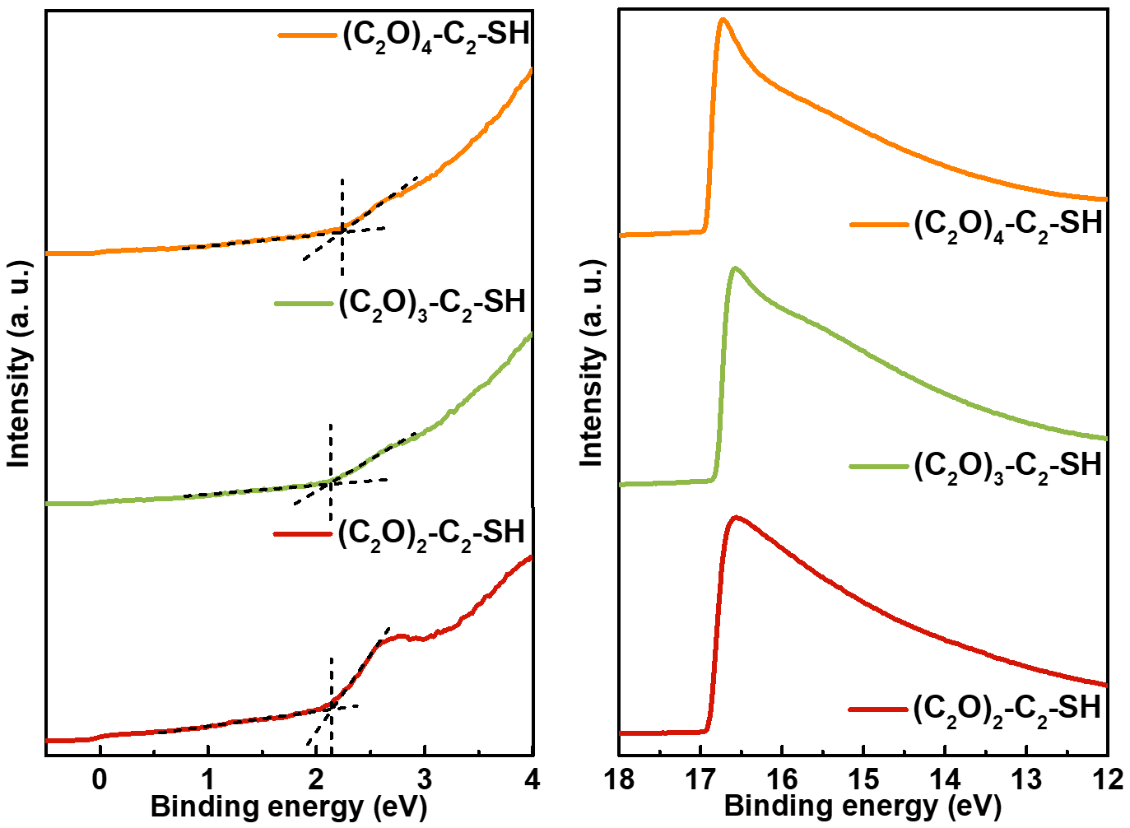
Fig. S61 | Secondary cutoff and valence band spectra of the HOMO peak for Au-SC₂-(OC₂)₂, Au-SC₂-(OC₂)₃ and Au-SC₂-(OC₂)₄ determined by UPS.

Table S3. Properties of the studied SAMs obtained by UPS
Molecules | δE_{ME} (eV) | E_{cut off} (eV) | WF (eV) | E_{HOMO} (eV)
(C₂O)₂-C₂-SH | 2.13 | 16.92 | 4.30 | -6.43
(C₂O)₃-C₂-SH | 2.09 | 16.82 | 4.40 | -6.49
(C₂O)₄-C₂-SH | 2.22 | 16.94 | 4.28 | -6.50

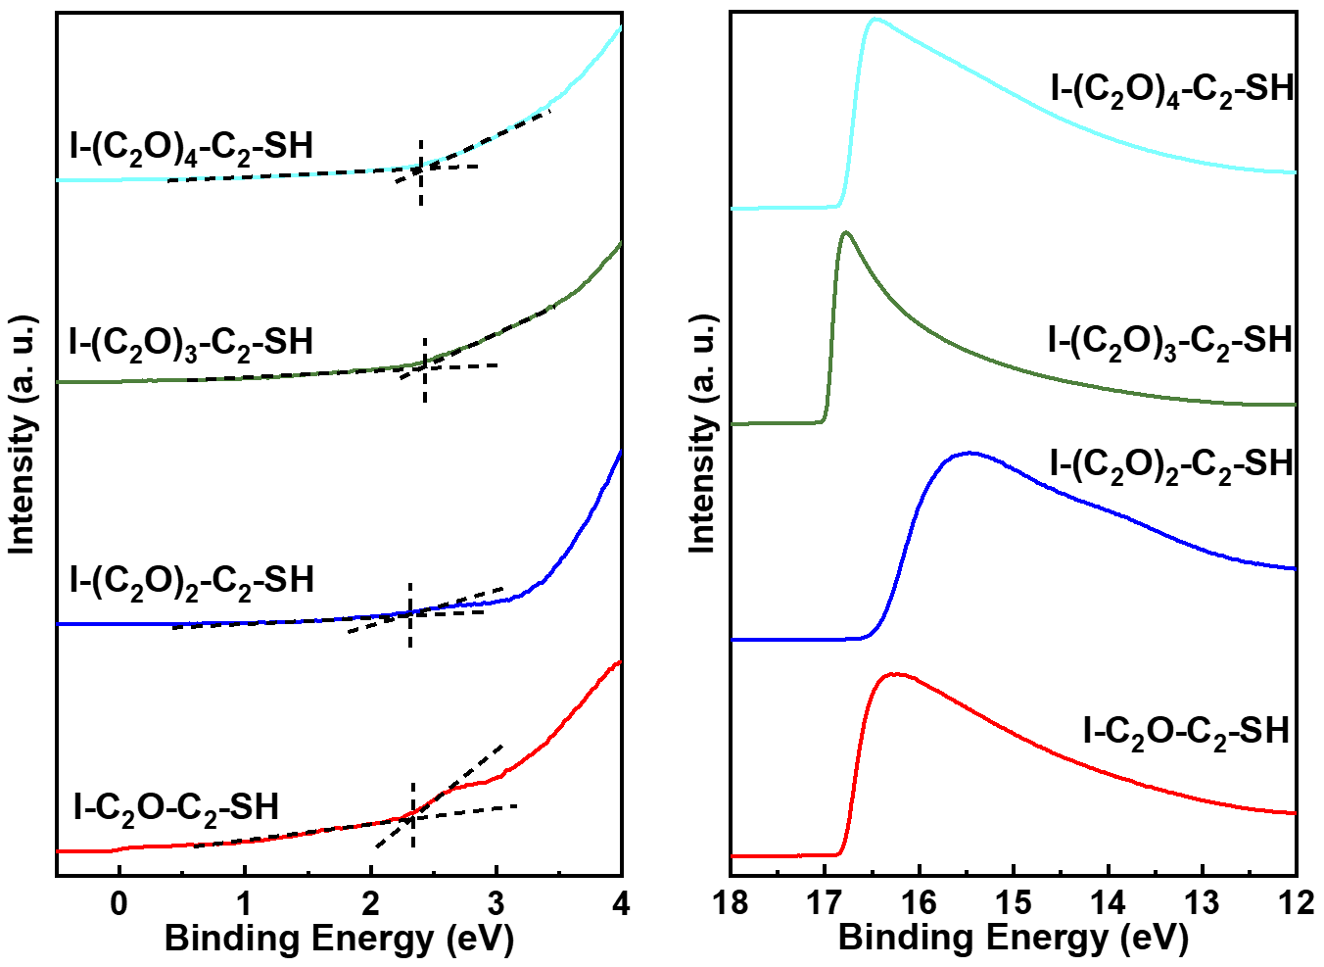
Fig. S62 | Secondary cutoff and valence band spectra of the HOMO peak for Au-SC₂-OC₂-I, Au-SC₂-(OC₂)₂-I, Au-SC₂-(OC₂)₃-I and Au-SC₂-(OC₂)₄-I determined by UPS.

Table S4. Properties of the studied SAMs obtained by UPS
Molecules | δE_{ME} (eV) | E_{cut off} (eV) | WF (eV) | E_{HOMO} (eV)
I-C₂O-C₂-SH | 2.22 | 16.84 | 4.38 | -6.60
I-(C₂O)₂-C₂-SH | 2.31 | 16.52 | 4.70 | -7.01
I-(C₂O)₃-C₂-SH | 2.42 | 17.00 | 4.22 | -6.64
I-(C₂O)₄-C₂-SH | 2.40 | 16.80 | 4.42 | -6.82

S4. Electrical conductance measurements and analysis. According to our previous work, ^{7,8} the cone-shaped tips of Ga₂O₃/EGaIn was contacted with SAMs to form molecular junctions. The Au^{TS} bottom electrode was grounded and the EGaIn electrode was biased from 0V +0.5 V 0V -0.5 V 0V, with a step size of 50 mV and a delay of 0.1 s. We collected at least three samples to obtain ≥20 junctions, each with 20-24 J(V) traces, which contains a total of ~480 J(V) traces for each type of SAM. Then, the histograms of log₁₀$\left|\text{J}\right|$ were plotted for each bias and fitted Gaussians to the histograms to obtain the log-mean (µ_{log}) of the values of J and their log standard-deviations (σ_{log}).
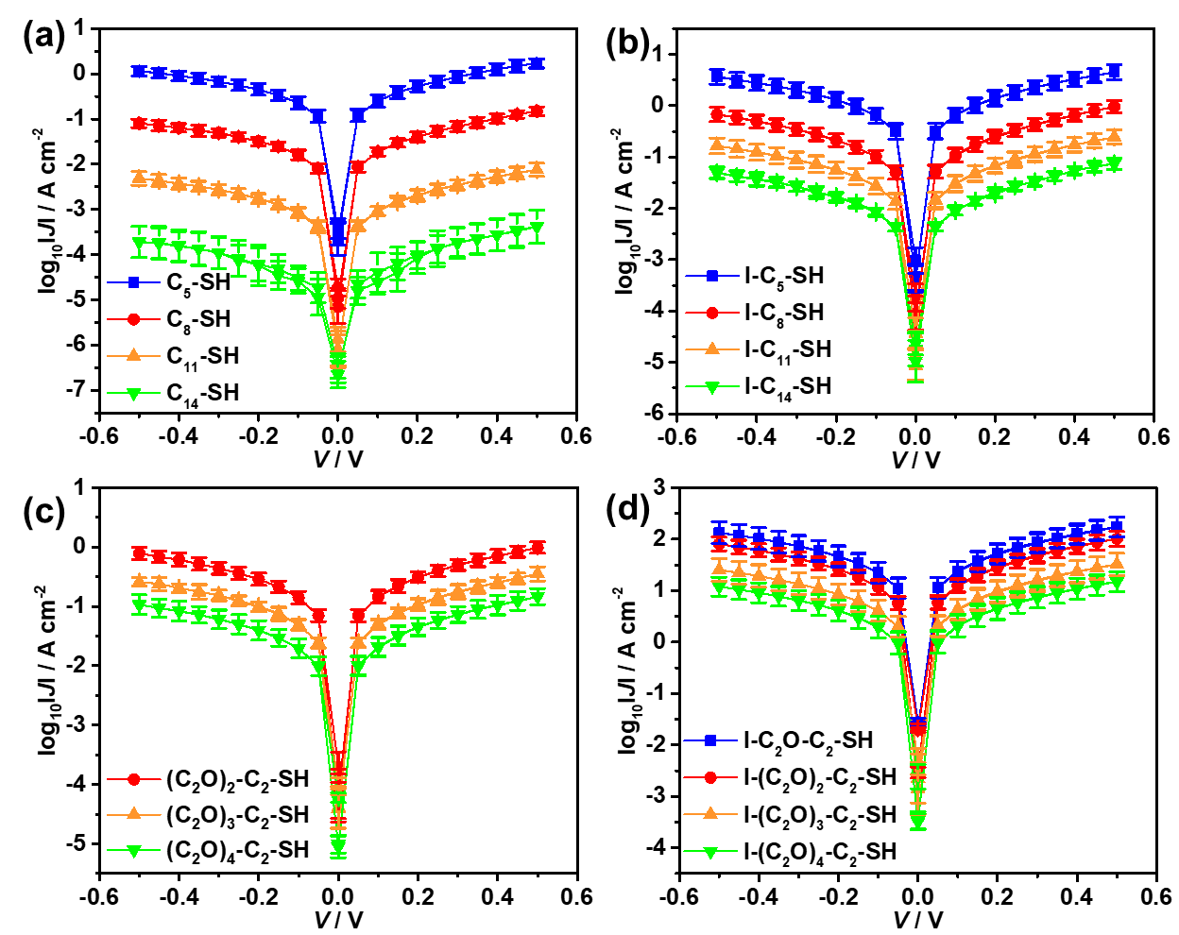
Fig. S63 | Average plots of the log₁₀$\left|\text{J}\right|$ −V of (a) C_{n}-SH (n = 5, 8, 10, 11), (b) I-C_{n}-SH (n = 5, 8, 10, 11), (c) (C₂O)_{m}-C₂-SH (m = 2, 3, 4), (d) I-(C₂O)_{m}-C₂-SH (m = 1, 2, 3, 4).

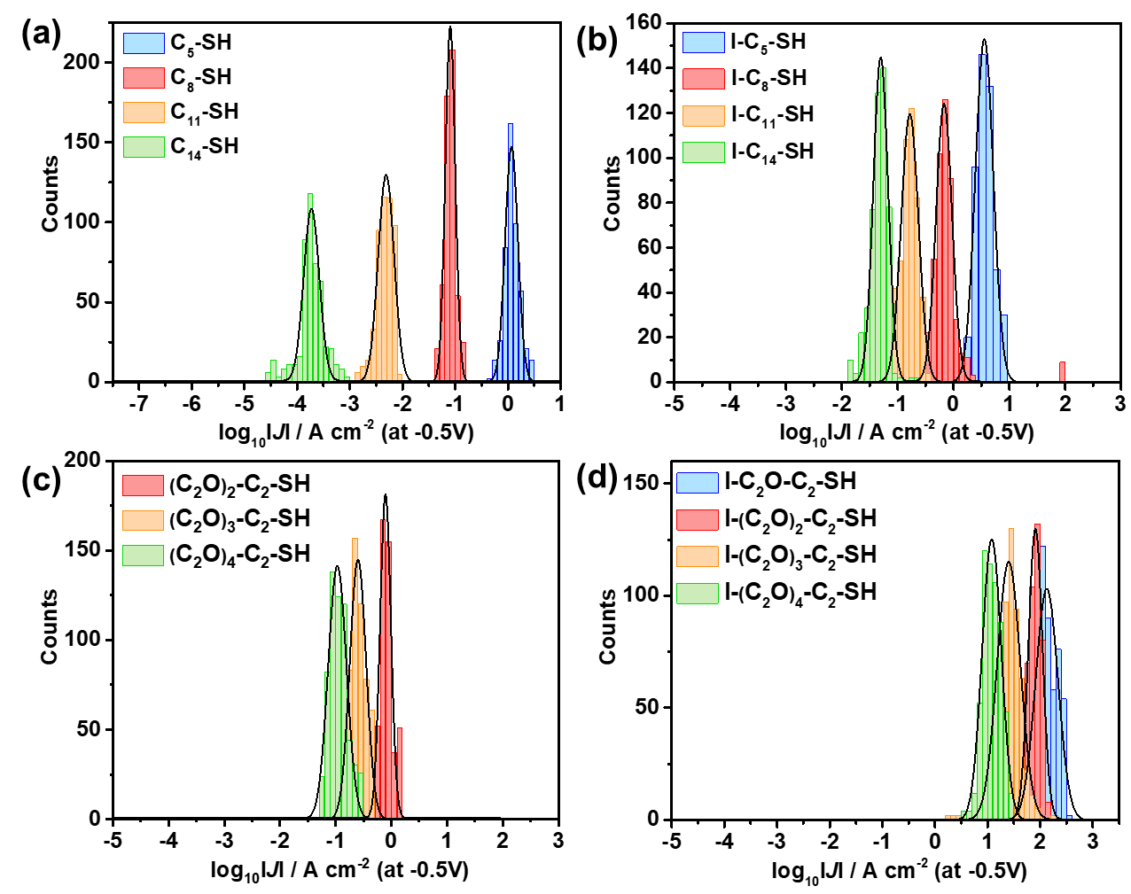
Fig. S64 | The histograms of log₁₀IJI at -0.5V with Gaussian fits for (a) C_{n}-SH (n = 5, 8, 10,
11), (b) I-C_{n}-SH (n = 5, 8, 10, 11), (c) (C₂O)_{m}-C₂-SH (m = 2, 3, 4), (d) I-(C₂O)_{m}-C₂-SH (m
= 1, 2, 3, 4).
S5. Thermoelectrical measurements and determination of PF for the molecular junctions.
The processes of obtaining the S of molecular junctions were followed by our previous work. ⁹ Briefly, a polyimide (PI) film with heating resistors is applied to generate temperature difference ($∆T=$ 2.0 K, 3.5 K and 5.0 K) across the molecular junctions. As shown in Fig. S65, after the SAMs assembled on Au^{TS} electrode, T₁, V₁ and T₄, V₄ were defined as the temperature (room temperature) and potential of Syringe and tungsten (W) tip away from SAMs, respectively (T₁ = T₄). T₂ and V₂ were the temperature measured by thermocouple potential of Syringe close to SAMs. V₃ and T₃ are the potential and temperature of Au surface. The measured T₂ was higher than room temperature and approximately half as $T_{3}$ probably due to heat radiation ($∆T=∆T_{1}≈∆T_{2}$= ${\frac{1}{2}∆T_{3}=(T}_{1}-T_{3})$). Therefore, the relationship between S and measured $∆V$ for Au/SAM//Ga₂O₃/EGaIn junctions can be generally depicted as Equation. (S1-S5).
$S_{EGaIn}=-\frac{V_{1}-V_{2}}{T_{1}-T_{2}}=-\frac{∆V_{1}}{∆T_{1}}=-\frac{V_{1}-V_{2}}{∆T}$ (S1)
$S_{SAM}=-\frac{V_{2}-V_{3}}{T_{2}-T_{3}}=-\frac{∆V_{2}}{∆T_{2}}=-\frac{V_{2}-V_{3}}{∆T}$ (S2)
$S_{W}=-\frac{V_{4}-V_{3}}{T_{4}-T_{3}}=-\frac{∆V_{3}}{∆T_{3}}=-\frac{V_{4}-V_{3}}{2∆T}$ (S3)
$S_{EGaIn}+S_{SAM}-2S_{W}=-\frac{V_{1}-V_{2}}{∆T}-\frac{V_{2}-V_{3}}{∆T}-(2×\frac{V_{4}-V_{3}}{2∆T})=-\frac{{V_{1}-V}_{4}}{∆T}$ (S4)
Wherein the (${V_{1}-V}_{4}$) represented the measured $∆V$ in this work. According to the previous works,^{9,11} the values of thermopower of W tip (S_{W}) and thermopower of EGaIn (S_{EGaIn}) are ~1.0 μV/K and 3.0μV/K, respectively, hence the S_{SAM} can be extracted as follows.
$S_{SAM}=-\frac{{V_{1}-V}_{4}}{∆T}-S_{EGaIn}+2S_{W}=-\frac{{V_{1}-V}_{4}}{∆T}-1$ (S5)
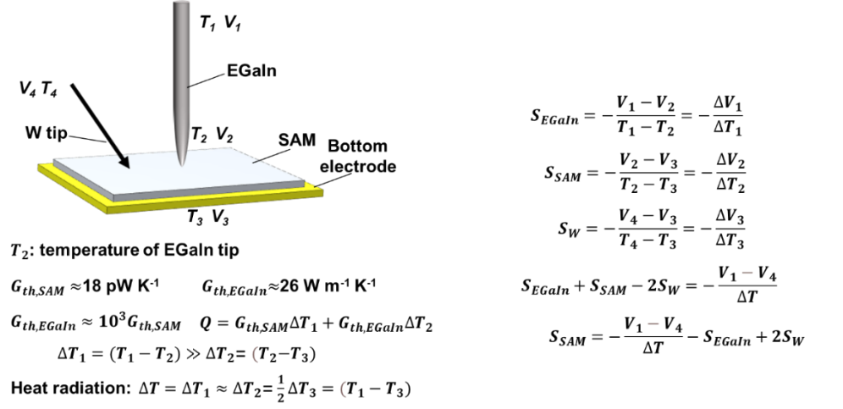
Fig. S65 | Schematic diagram of the voltages and temperatures across Au/SAM//Ga₂O₃/EGaIn junction. ⁹

Determination of power factor (PF). The values of PF of Au-SAMs//Ga₂O₃/EGaIn junctions with C_{n}-SH (n = 5, 8, 11, 14), I-C_{n}-SH (n = 5, 8, 11, 14), (C₂O)_{m}-C₂-SH (m = 2, 3, 4), I-(C₂O)_{m}-C₂-SH (m = 1, 2, 3, 4) were determined by the previously reported procedure. ^{9,12} The magnitude of electric field intensity (ε) can be given by:
$ε=\frac{V}{l} (GV{ m}^{-1} )$ (S6)
where V is the applied voltage and l is the molecular length considering the tilt angle (30°) of SAMs. The conductivity ($σ$) is the inverse of resistivity, and can be obtained as follows:
$σ=\frac{J}{ε} (μS {cm}^{-1})$ (S7)
J (A cm⁻²) is the current density. Using the calculated $σ$ value and the measured S, the power factor (PF) value was obtained according to the following relationship:
$PF=S^{2}σ (μW K^{-2} m^{-1})$ (S8)
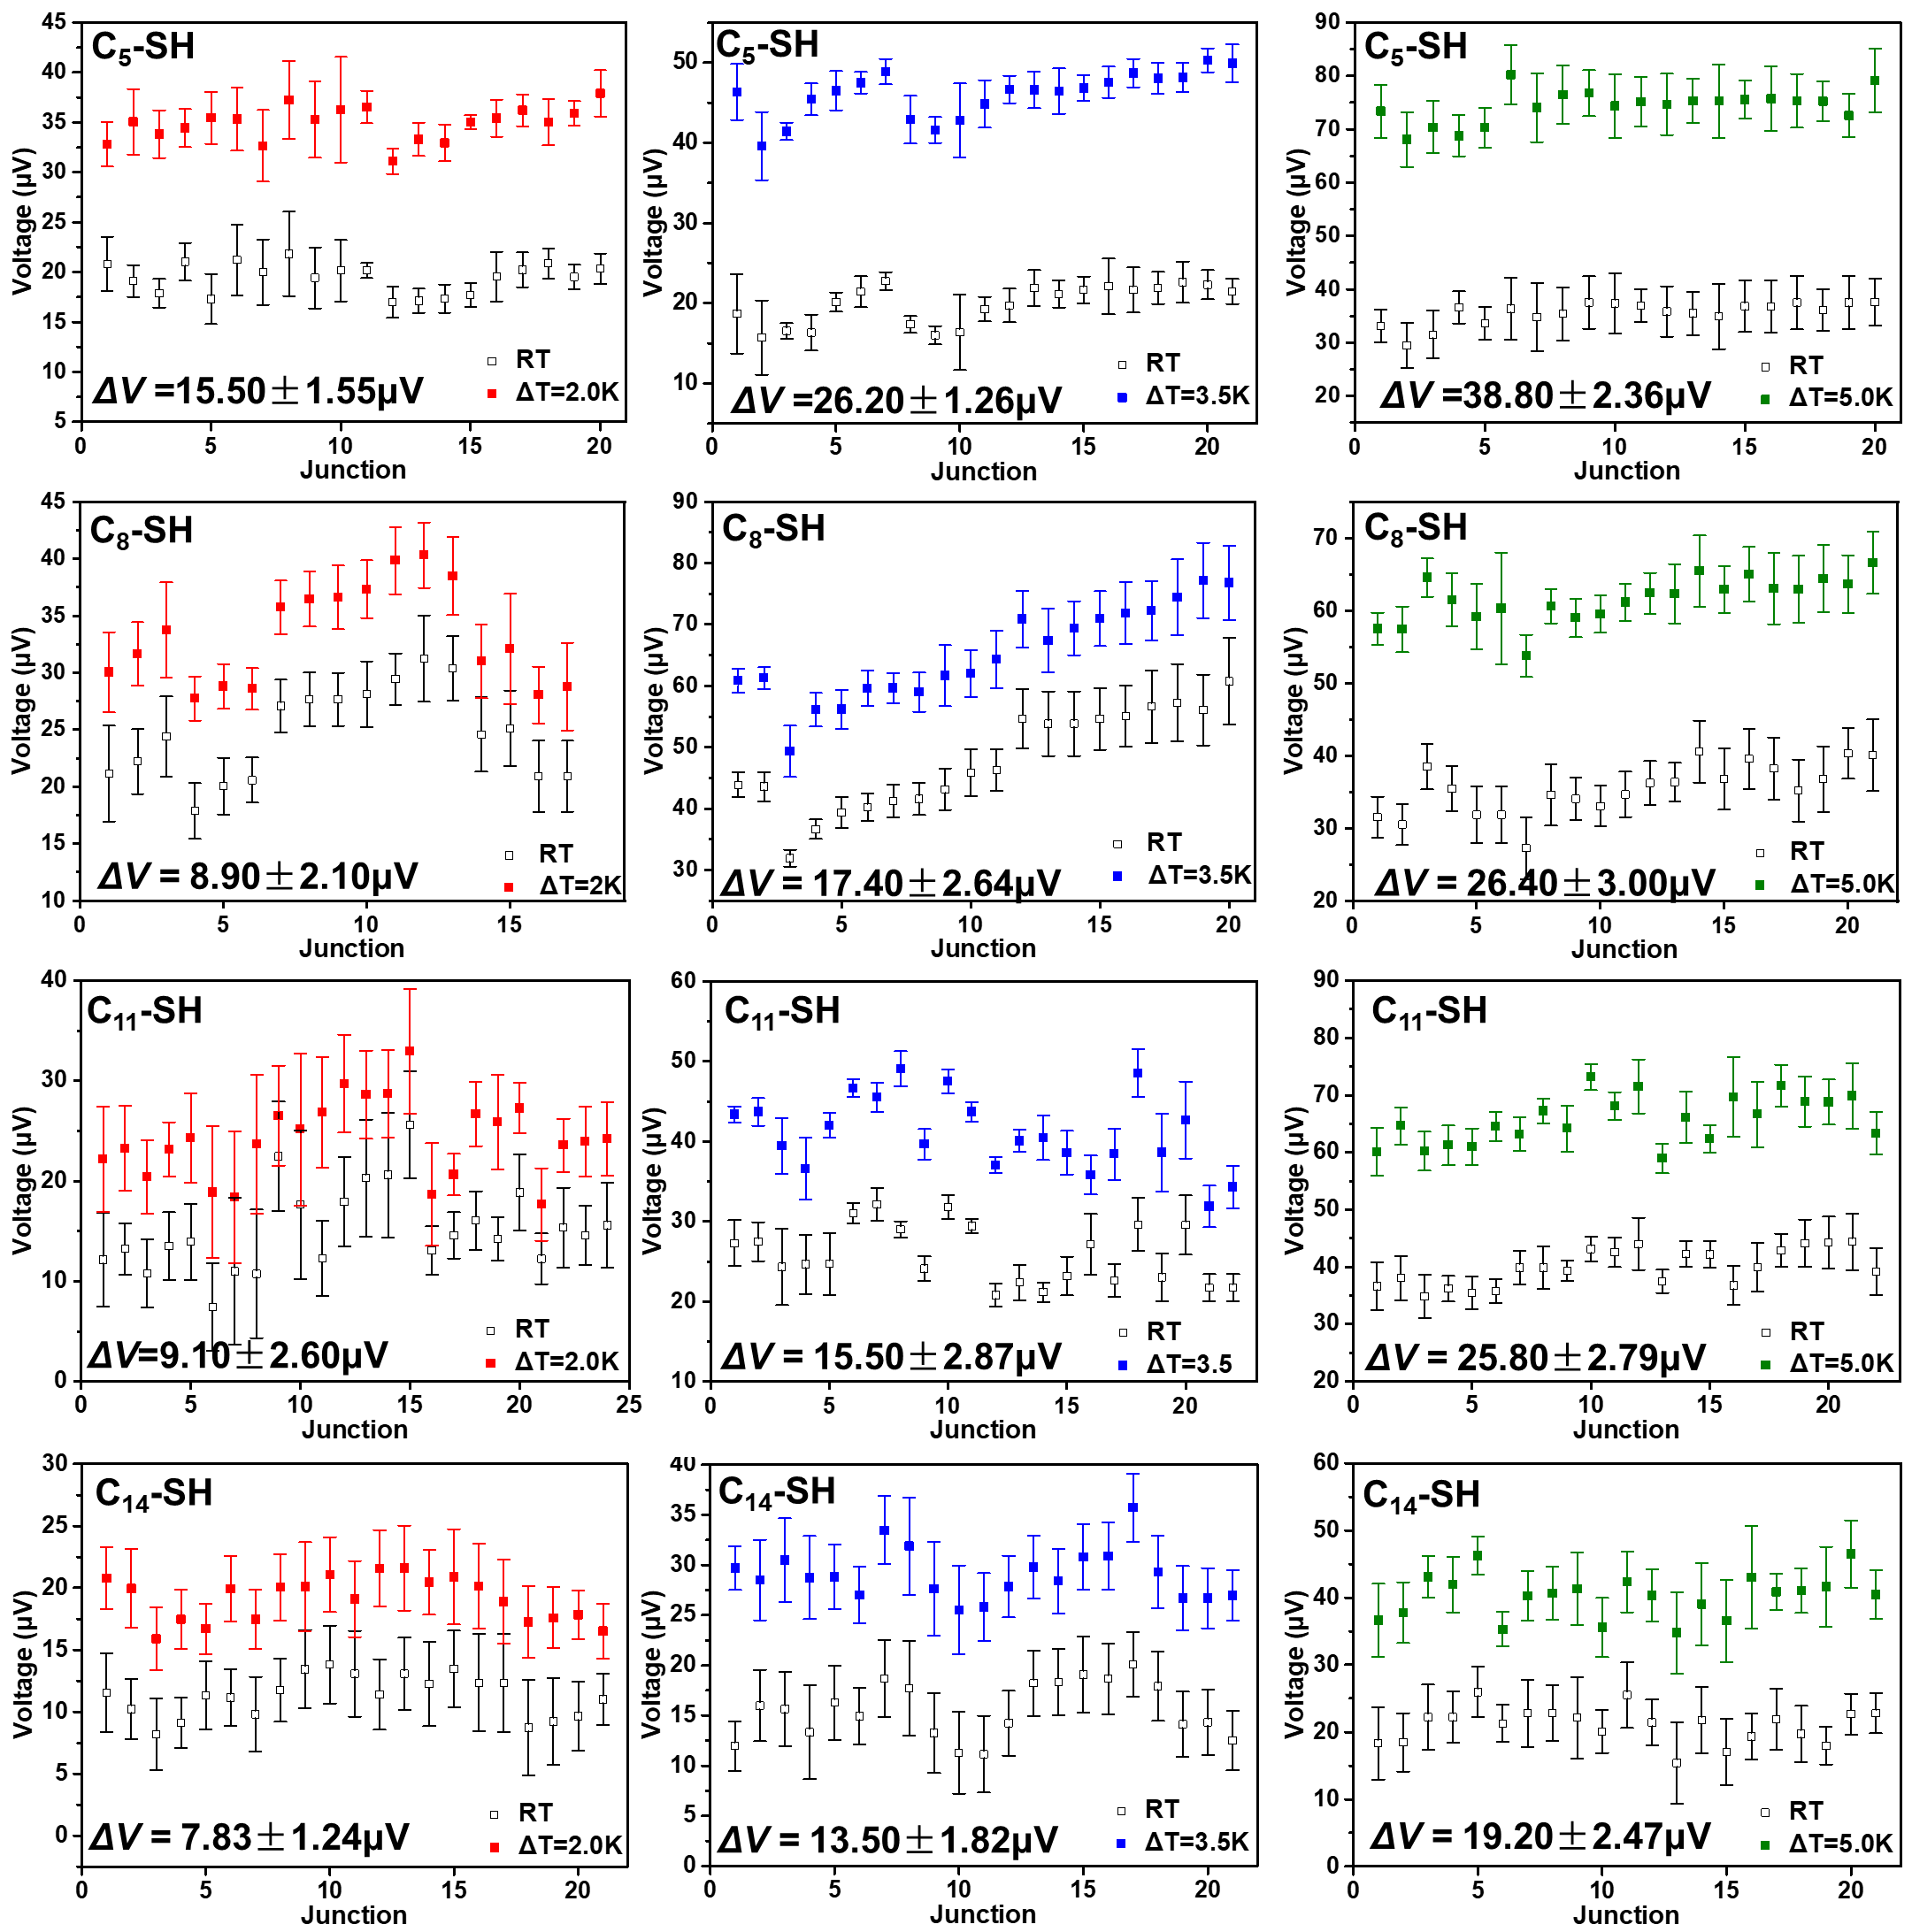
Fig. S66 | The potential change of Au-S-C_{n}//Ga₂O₃/EGaIn junctions for each junction (n =
5, 8, 11, 14).

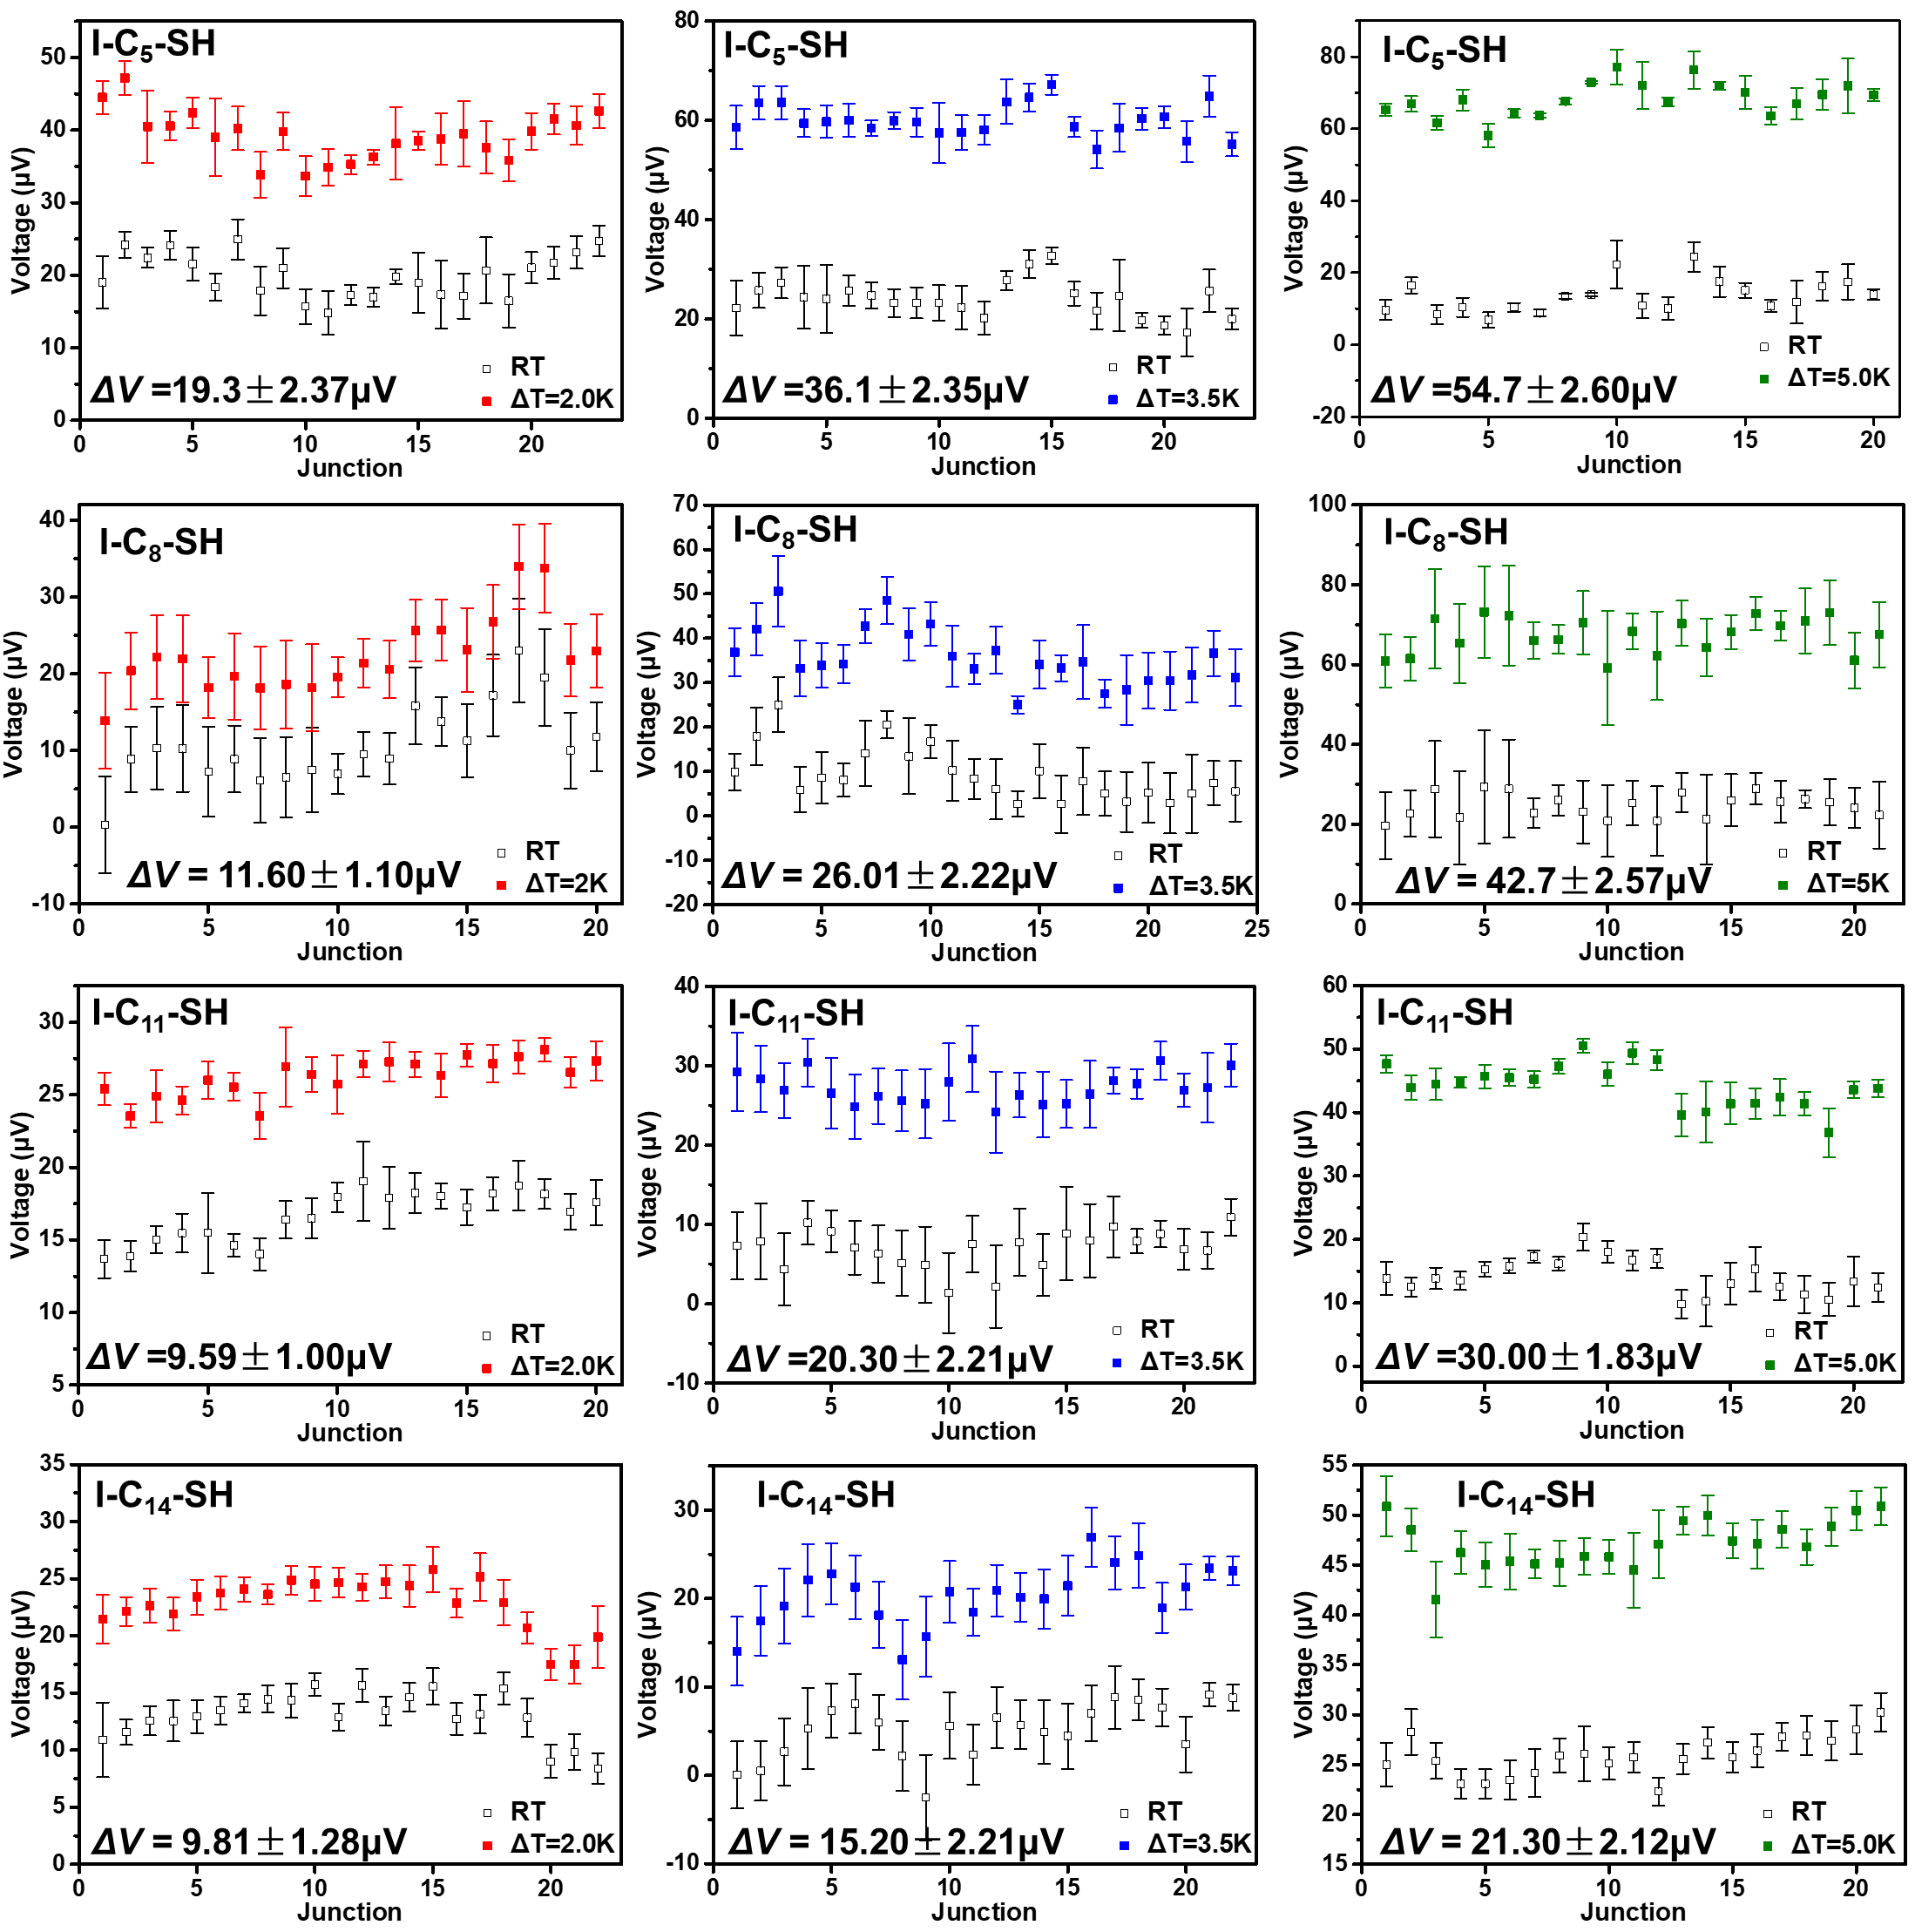
Fig. S67 | The potential change of Au-S-C_{n}-I//Ga₂O₃/EGaIn junctions for each junction
(n =5, 8, 11, 14).

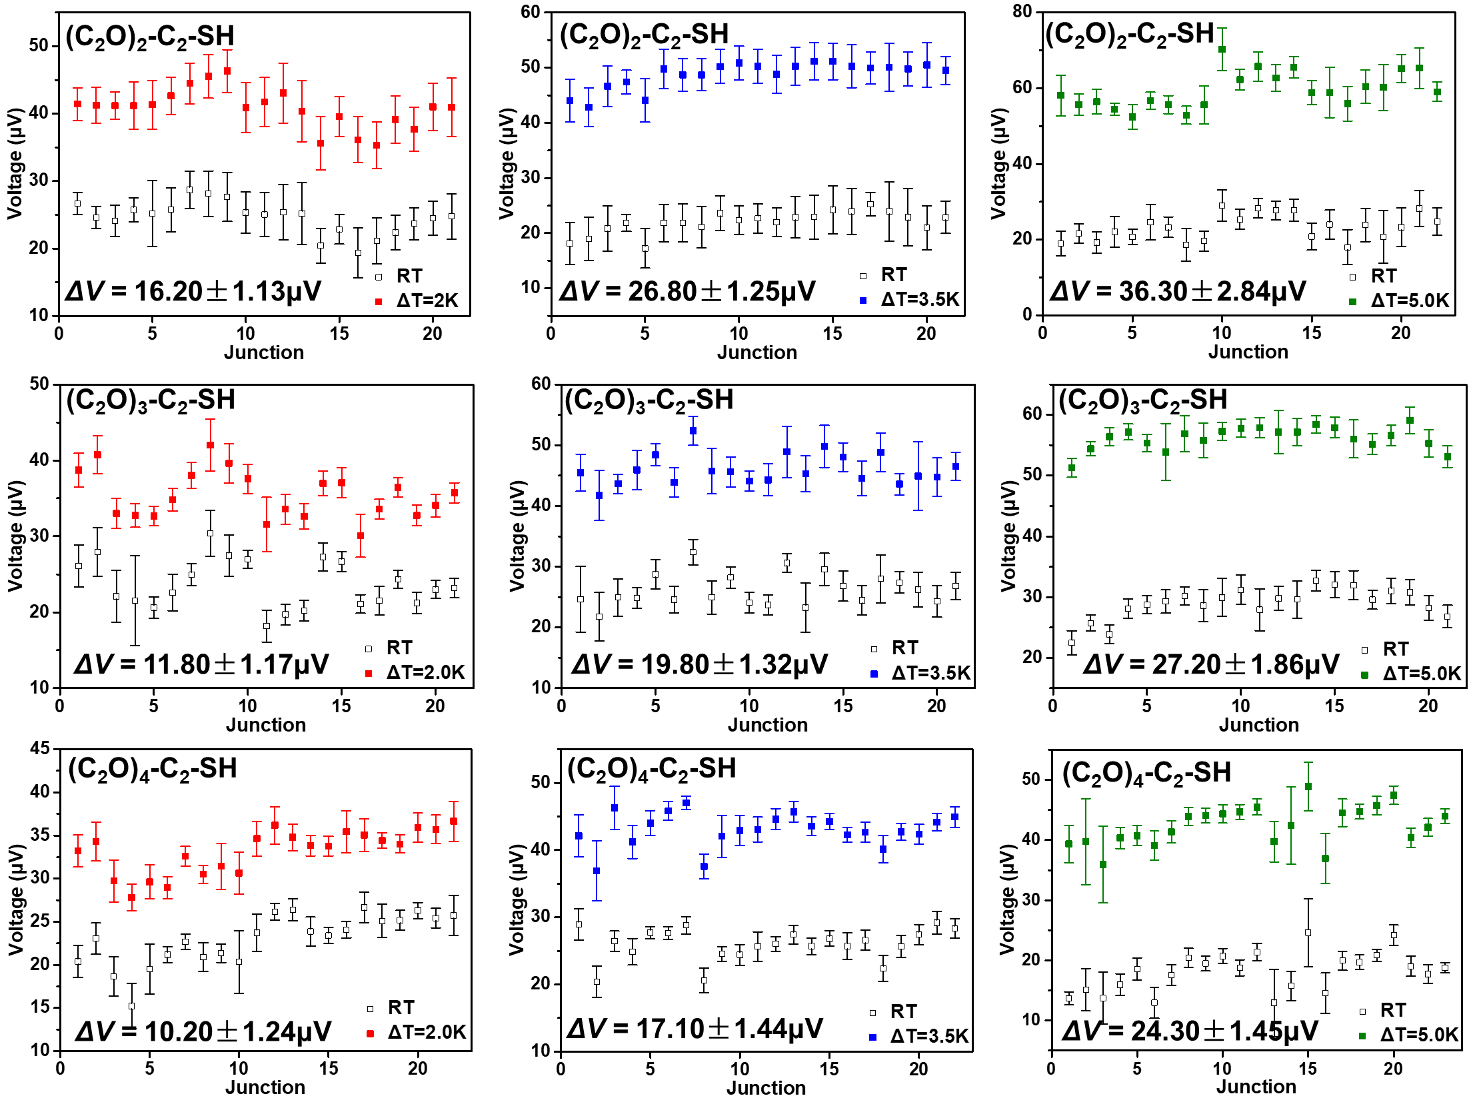
Fig. S68 | The potential change of Au-S-C₂-(OC₂)_{m}//Ga₂O₃/EGaIn junctions for each
junction (m = 2, 3, 4).
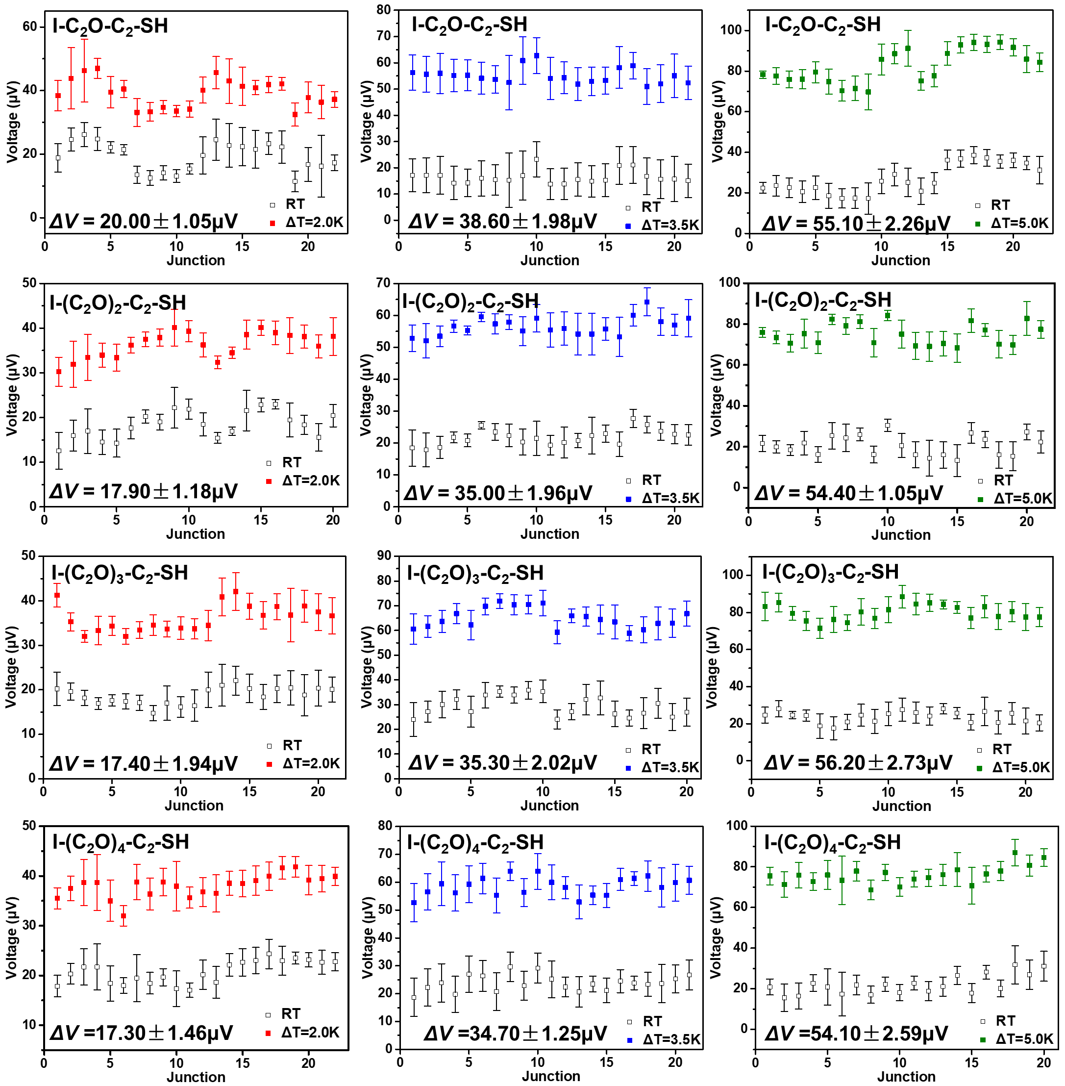
Fig. S69 | The potential change of Au-S-C₂-(OC₂)_{m}-I//Ga₂O₃/EGaIn junctions for each
junction (m = 1, 2, 3, 4).
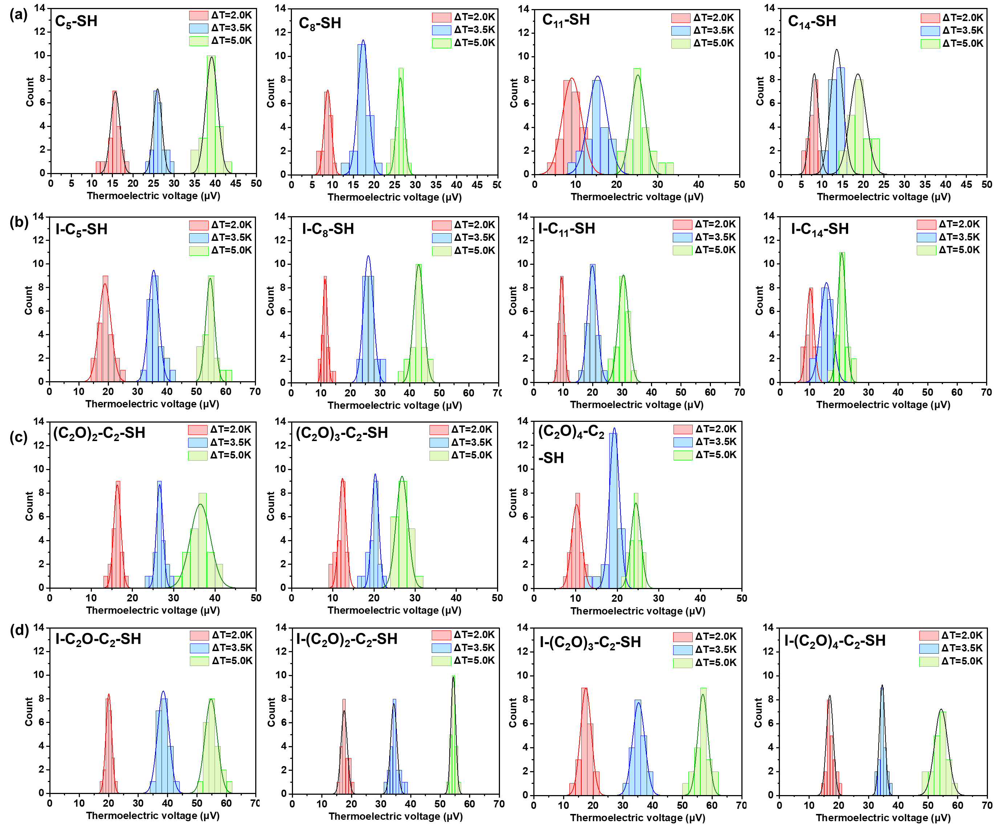
Fig.. S70 | The $∆V$ at each applied $∆T$ and the corresponding histograms of $∆V$ with a
Gaussian fit to these histograms of Au-SAMs//Ga₂O₃/EGaIn junctions with (a) C_{n}-SH (n = 5,
8, 10, 11), (b) I-C_{n}-SH (n = 5, 8, 10, 11), (c) (C₂O)_{m}-C₂-SH (m = 2, 3, 4), (d) I-(C₂O)_{m} C₂-SH
(m = 1, 2, 3, 4).

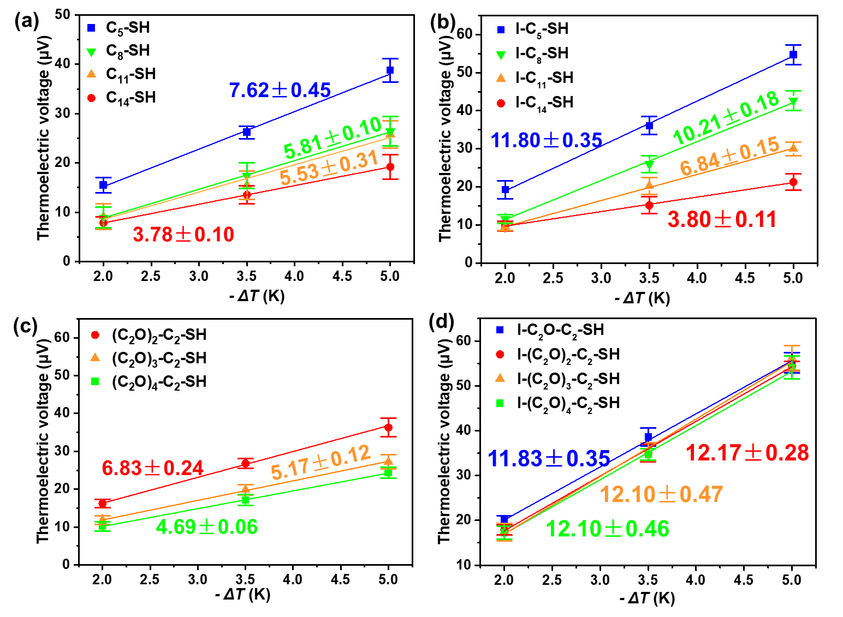
Fig. S71 | Plots of thermoelectric voltage verses ΔT of Au-SAMs//Ga₂O₃/EGaIn junctions
with (a) C_{n}-SH (n = 5, 8,10, 11), (b) I-C_{n}-SH (n = 5, 8, 10, 11), (c) (C₂O)_{m}-SH (m = 2, 3, 4),
(d) I-(C₂O)_{m}-SH (m = 1, 2, 3, 4).

S6. DFT calculation.
Electronic structure. The electronic structures of the considered junctions were calculated using the SIESTA package at DFT level. The standard norm-conserving pseudopotentials and a numerical linear combination of an atomic orbital basis set were employed in this package. We used the double-ζ polarized (DZP) basis sets for H, C, O, S and I atoms and single-ζ polarized (SZP) for Au. A real-space grid was defined with an energy cutoff of 200 Ry. All atoms, expect for the Au electrode, were relaxed until the forces acting on them were less than 0.02 eV/Å. The optimized structures of molecular junctions are shown in Fig. S72 and S73.
Transmission coefficients. Upon the electronic structures were obtained from the converged DFT calculation, we can calculate the transmission coefficients by means of the non-equilibrium Green’s function method implemented in TRANSIESTA and the “post-processing” code TBtrans. To eliminate the influence of surface states on top electrode, the wide-band approximation was employed based on the convergent hamiltonian and overlap matrix (Fig. S74). We also calculated the projected density of states (PDOS). The results shows that the transmission peaks near fermi level are mainly induced by O atoms (Fig. S78). Different packages are used to calculate the PDOS for I-C₂O-C₂-SH. Comparing the results, we found that the location of the peak below fermi level was different (Fig. S79).
Thermoelectric coefficients. Based on the calculated transmission coefficients, the electrical conductance (G), Seebeck coefficient (S) and power factor (PF) can be calculated in the framework of a linear response regime. The G, S and PF can be written as follows:
$$G\left(μ, T\right)={\left.\frac{I}{ΔV}\right|}_{∆T=0}=e^{2}L_{0}$$
$$S\left(μ,T\right)={\left.-\frac{ΔV}{ΔT}\right|}_{I=0}=-\frac{1}{eT}\frac{L_{1}}{L_{0}}$$
$$PF=GS^{2}$$
Here the coefficient L_{n} dependent on the transmission coefficient.
$$L_{n}\left(μ,T\right)=\frac{1}{h}\int_{-∞}^{∞}{{(E-μ)}^{n}T(E)(-\frac{∂f(E,μ,T)}{∂E})}dE$$

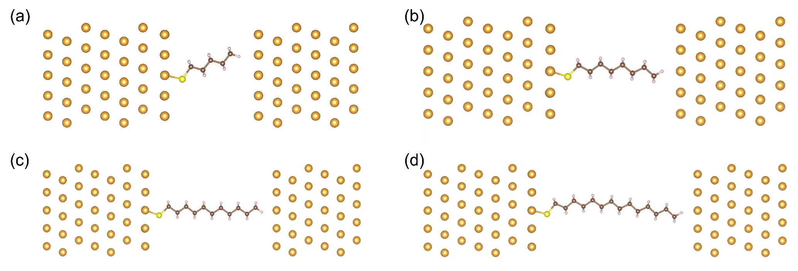
Fig. S72 | The optimized structure of molecular junctions for (a) C₅-SH, (b) C₈-SH, (c) C₁₁-SH, (d) C₁₄-SH.

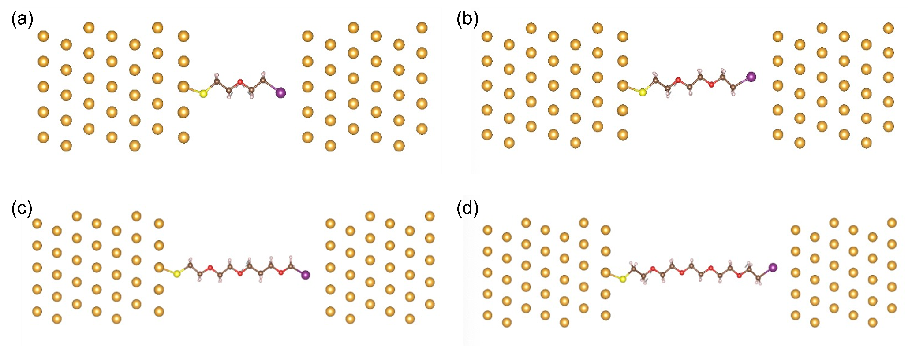
Fig. S73 | The optimized structure of molecular junctions for (a) I-C₂O-C₂-SH, (b) I-(C₂O)₂-C₂-SH, (c) I-(C₂O)₃-C₂-SH, (d) I-(C₂O)₄-C₂-SH.

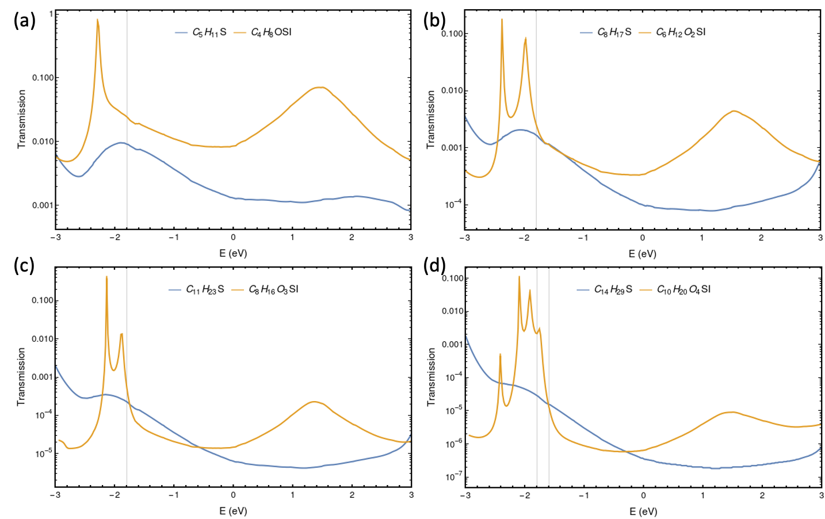
Fig. S74 | The calculated transmission coefficient for (a) C₅-SH, I-C₂O-C₂-SH, (b) C₈-SH, I-(C₂O)₂-C₂-SH, (c) C₁₁-SH, I-(C₂O)₃-C₂-SH, (d) C₁₄-SH, I-(C₂O)₄-C₂-SH.

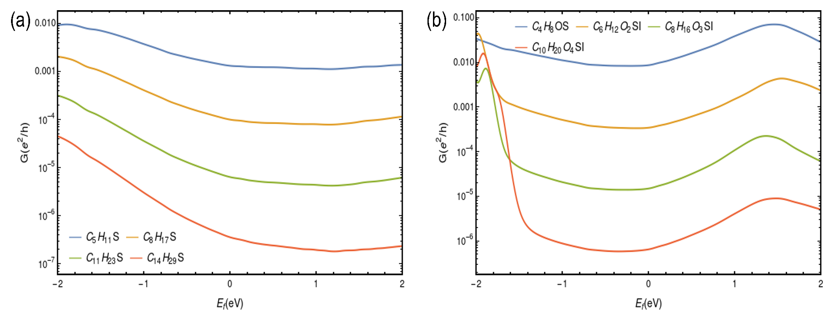
Fig. S75 | The calculated electrical conductance (G) with different Fermi energy for (a) C_{n}-SH, (b) I-(C₂O)_{m}-C₂-SH.

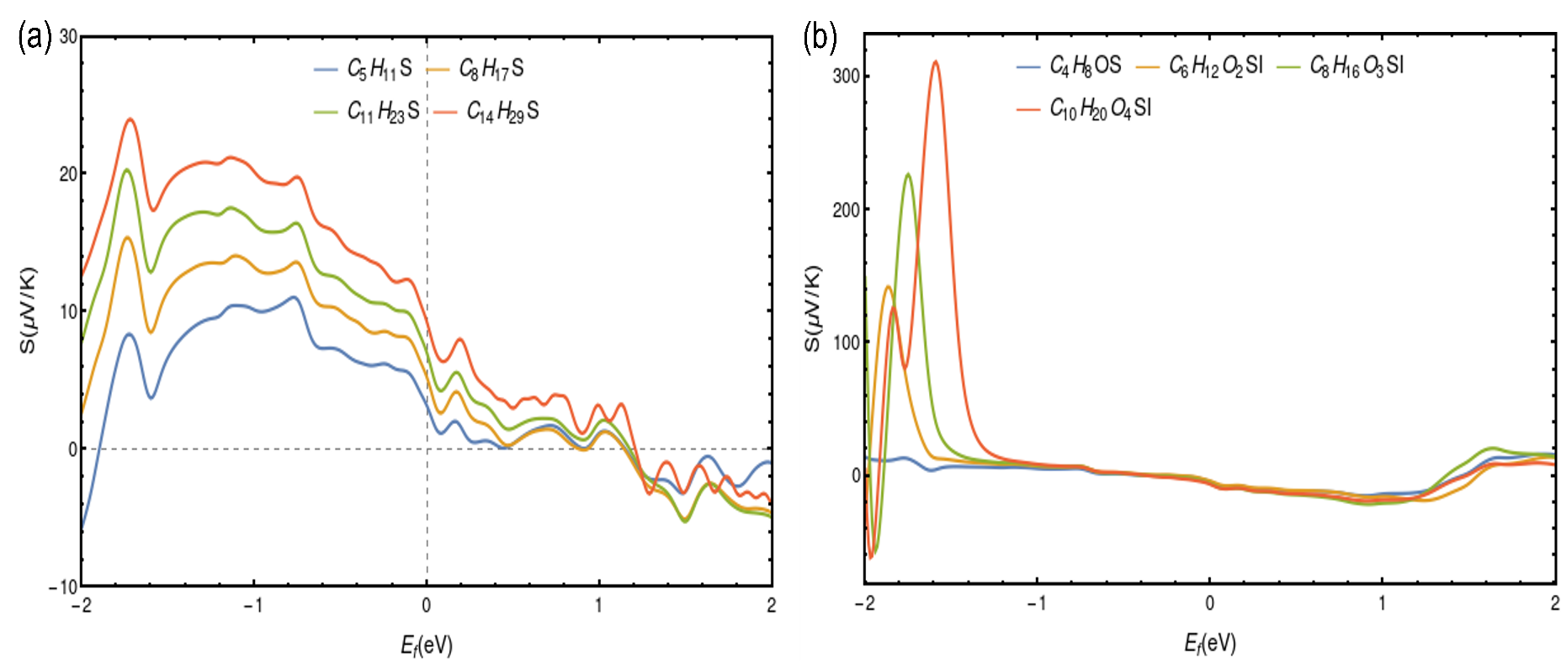
Fig. S76 | The calculated Seebeck coefficients (S) with different Fermi energy for (a) C_{n}-SH, (b) I-(C₂O)_{m}-C₂-SH.

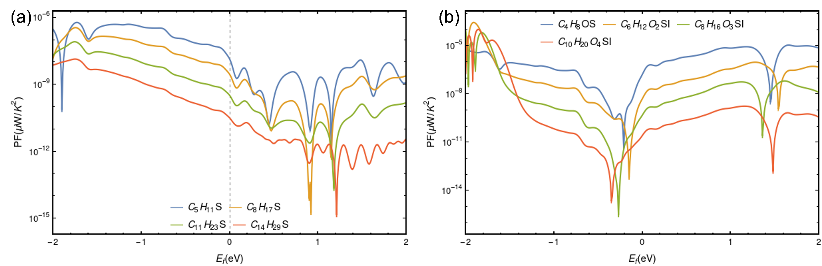
Fig. S77 | The calculated power factor (PF) with different Fermi energy for (a) C_{n}-SH, (b) I-(C₂O)_{m}-C₂-SH.
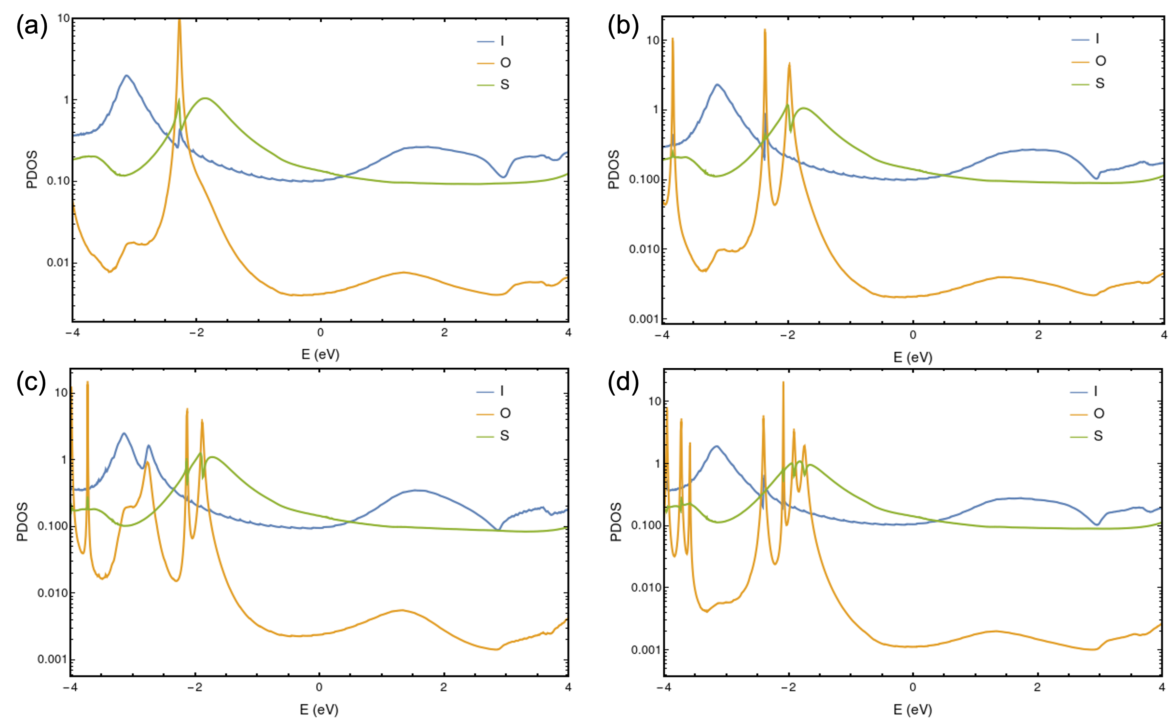
Fig. S78 | The calculated projected density of states (PDOS) for (a) I-C₂O-C₂-SH, (b) I-(C₂O)₂-C₂-SH, (c) I-(C₂O)₃-C₂-SH, (d) I-(C₂O)₄-C₂-SH.

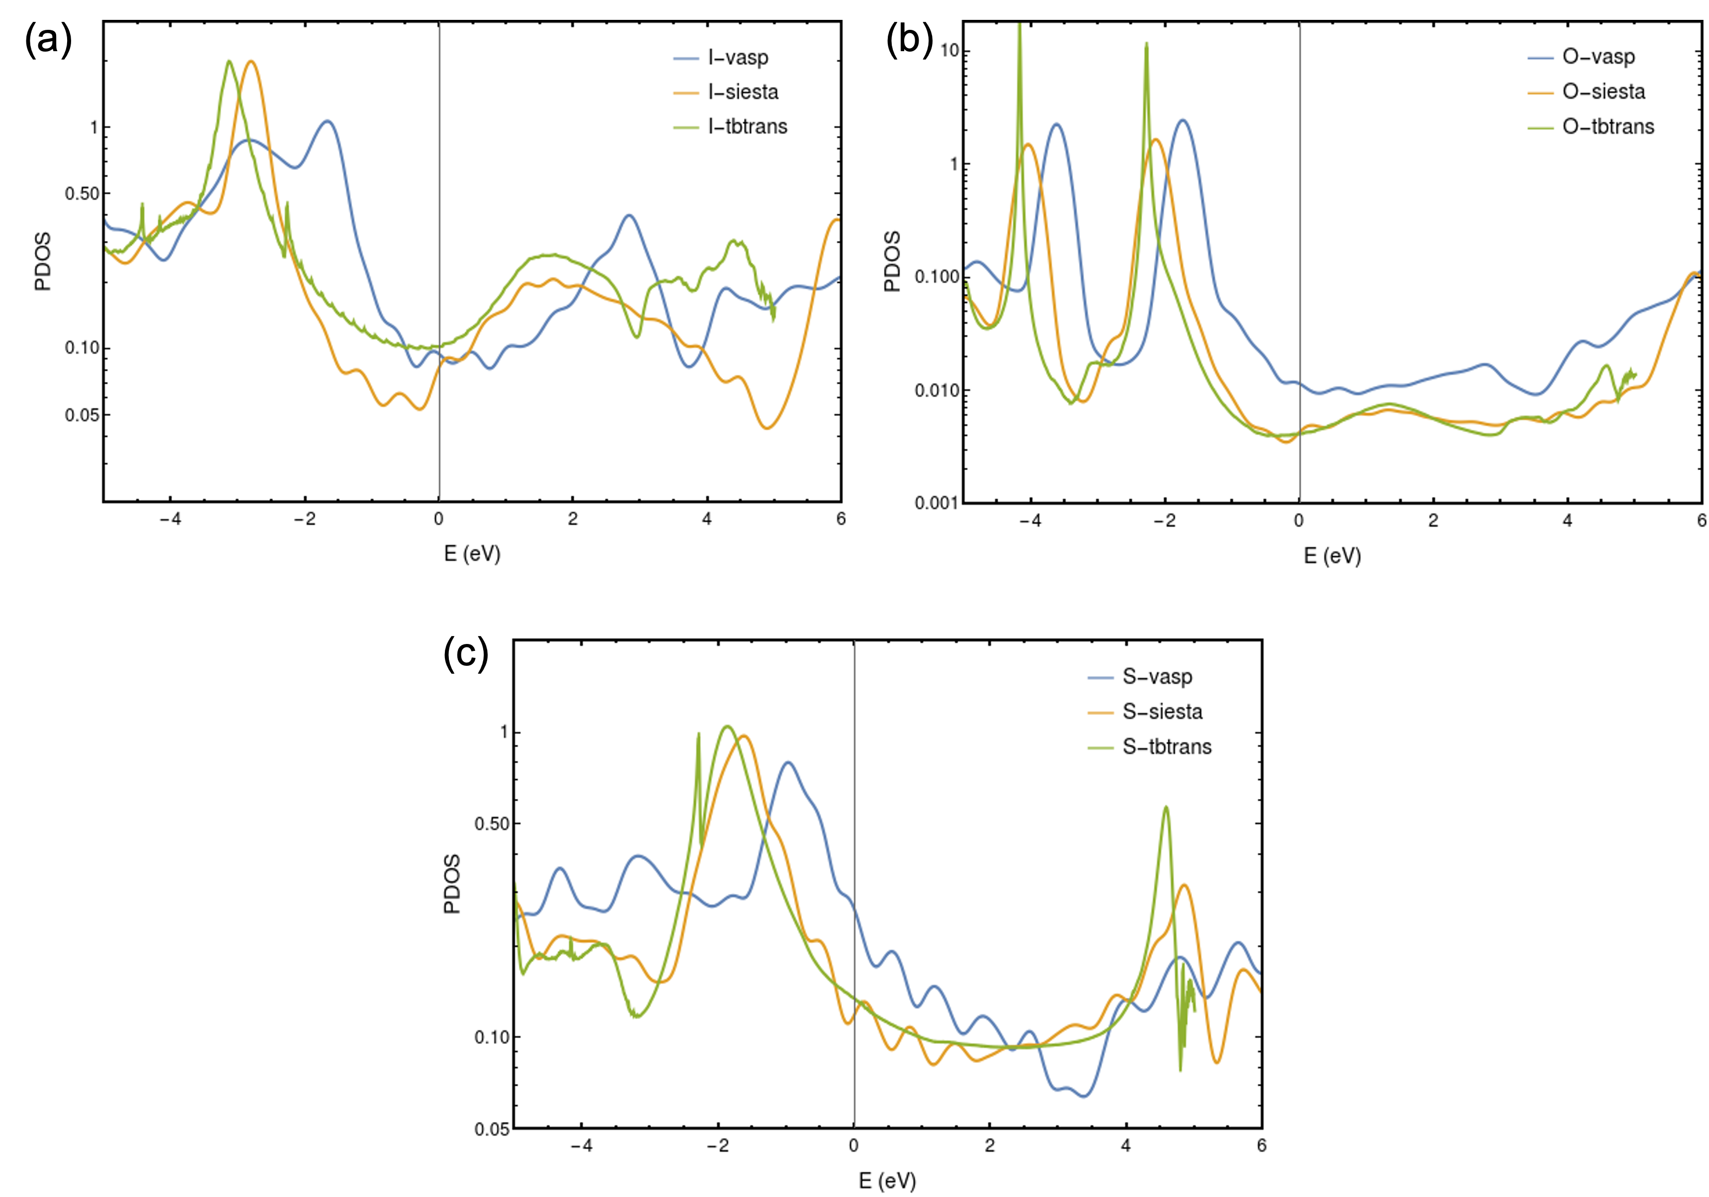
Fig. S79 | The calculated PDOS using different package for (a) I atom (b) O atom, (c) S atom. The results obtained from VASP, SIESTA, and TBtrans are represented by blue, yellow, and green, respectively.

References
1 Ai, Y. et al. In-place modulation of rectification in tunneling junctions comprising self-assembled monolayers. Nano Lett. 18, 7552 (2018). https://doi.org:10.1021/acs.nanolett.8b03042
2 Wang, K. et al. Electrostatic Control of Macrocyclization Reactions within Nanospaces. J. Am. Chem. Soc. 141, 6740 (2019). https://doi.org:10.1021/jacs.9b02287
3 von Delius, M., Hauke, F. & Hirsch, A. Evaluation of an Intramolecular Approach for the Synthesis of the Elusive C58N2Heterofullerene Family. Eur. J. Org. Chem., 4109 (2008). https://doi.org:10.1002/ejoc.200800423
4 Zenasni, O., Jamison, A. C., Marquez, M. D. & Lee, T. R. Self-assembled monolayers on gold generated from terminally perfluorinated alkanethiols bearing propyl vs. ethyl hydrocarbon spacers. J. Fluorine Chem. 168, 128 (2014). https://doi.org:10.1016/j.jfluchem.2014.09.003
5 Yang Cao, M. Z., Cindy Wu, Selina Lee, Mary Elizabeth Wroblewski, Trisha Whipple, Peter I. Nagy, Krisztina Takács-Novák, Attila Balázs, Szilárd Torös, and William S. Messer, Jr. Synthesis and Biological Characterization of 1-Methyl-1,2,5,6-tetrahydropyridyl-1,2,5-thiadiazole Derivatives as Muscarinic Agonists for the Treatment of Neurological Disorders. J. Med. Chem. 46, 4273 (2003).
6 Provencher-Mandeville, J. et al. Synthesis of 17beta-estradiol-platinum(II) hybrid molecules showing cytotoxic activity on breast cancer cell lines. Bioorg. Med. Chem. Lett. 18, 2282 (2008). https://doi.org:10.1016/j.bmcl.2008.03.005
7 Li, Y., Jiang, L., Zhang, B. & Nijhuis, C. A. Dependency of the tunneling decay coefficient in molecular tunneling junctions on the topography of the bottom electrodes. Angew. Chem. Int. Edit. 53, 3377 (2014). https://doi.org:10.1002/anie.201309506
8 Lin, J.-L. et al. Molecular diodes with tunable threshold voltage based on π‐extended tetrathiafulvalene. Adv. Mater. Interfaces 9, 2201238 (2022). https://doi.org:10.1002/admi.202201238
9 Peng, W., Cao, Z., Chen, N., Xie, Y. & Li, Y. Dependence of thermoelectric effects in molecular junctions on the topography of the bottom electrodes. J. Mater. Chem. A 10, 23304 (2022). https://doi.org:10.1039/d2ta05642a
10 Doniach, S. & Sunjic, M. Many-electron singularity in X-ray photoemission and X-ray line spectra from metals. J. Phys. C Solid State Phys. 3, 285 (1970).
11 Park, S. & Yoon, H. J. New approach for large-area thermoelectric junctions with a liquid eutectic Gallium-Indium electrode. Nano Lett. 18, 7715 (2018). https://doi.org:10.1021/acs.nanolett.8b03404
12 Park, S., Kang, S. & Yoon, H. J. Power factor of one molecule thick films and length dependence. ACS Cent. Sci. 5, 1975 (2019). https://doi.org:10.1021/acscentsci.9b01042

