Clickable Nifuroxazide analogs synthesis

EXPERIMENTAL SECTION
1-General information
All solvents and chemicals were purchased from commercially available sources and used without further purification, or purified according to Purification of Laboratory Chemicals (Armarego, W.L.F.; Chai, C.L.L. 5th Ed.). Solvents were dried under standard conditions. Reactions were monitored by thin layer chromatography (TLC) using pre-coated silica on aluminum plates from Merck (60F₂₅₄). TLC plates were visualized with UV-light and/or by treatment with ceric ammonium molybdate solution (CAM) or ninhydrin solution and heating. Products were purified on column chromatography with Silica gel 60 from Macherey Nagel (0.036-0.071 mm; 215-400 mesh), a CombiFlash Rf+ Teledyne Isco system fitted with pre-packed silica gel columns (Interchim) or/and preparative HPLC Quaternary Gradient 2545 equipped with a Photodiode Array detector (Waters) fitted with a reverse phase column (XBridge Prep C18 5μm OBD, 30×150 mm).
NMR spectroscopy was performed on Bruker spectrometers. Spectra were run in DMSO-d₆ or CD₂Cl₂ or CD₃CN, at 298 K. ¹H NMR were recorded at 400 or 500 MHz, and chemical shifts δ are expressed in ppm using the residual non-deuterated solvent signal as internal standard and the coupling constants J are specified in Hz. The following abbreviations are used: s, singlet; brs, broad singlet; d, doublet; dd, doublet of doublets; dt, doublet of triplets; dq, doublet of quartets; ddd, doublet of doublet of doublets; dqd, doublet of quartet of doublets; t, triplet; td, triplet of doublets; tdd, triplet of doublet of doublets; q, quartet; m, multiplet. We only reported labile protons that could be clearly identified in the spectra. ¹³C NMR were recorded at 101 or 126 MHz, and chemical shifts δ are expressed in ppm using deuterated solvent signal as internal standard.
The purity of final compounds, determined to be >95% by UPLC MS, was recorded on a Waters Acquity H-class equipped with a Photodiode array detector and SQ Detector 2 with a reverse phase column (Aquity UPLC® BEH C18 1.7 μm, 2.1×50 mm).
“Classic System”: ACN (+0.1% FA) and MilliQ Water (+0.1% FA): isocratic at 5% of ACN (0.2 min), then linear gradient from 5% to 100% of ACN in 2.3 min, then isocratic at 100% of ACN (0.5 min).
High-resolution mass spectra (HRMS) were recorded on a Thermo Fisher Scientific Q-Exactive Plus equipped with a Robotic TriVersa NanoMate Advion.

2-Abbreviations

ACN, acetonitrile; AcOH, glacial acetic acid; aq., aqueous; Boc₂O, di-tert-butyl dicarbonate; Cs₂CO₃, cesium carbonate; DCM, dichloromethane; DMF, dimethylformamide ; equiv., equivalent(s); ESI, electrospray ionization; EtOAc, ethyl acetate; EtOH, ethanol; Et₂O, diethyl ether; Et₃N, triethylamine; FA, formic acid; HPLC, high pressure liquid chromatography; HRMS, high resolution mass spectroscopy; K₂CO₃, potassium carbonate; MeOH, methanol; MgSO₄, sulfate magnesium; MS, mass spectrometry; NaH, sodium hydride; NMR, nuclear magnetic resonance; RT, room temperature; THF, TLC, thin-layer chromatography; UPLC, ultra-high performance liquid chromatography; UV, ultraviolet.

3-Chemical synthesis
3.1-Clickable HBH analog HBH-C
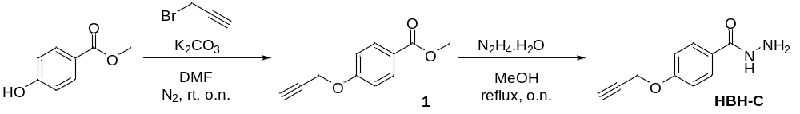

Compound 1 was prepared according to a previously published procedures [1, 2]. To a stirred solution of 4-hydroxy methyl benzoate (304 mg, 2 mmol) and anhydrous K₂CO₃ (345 mg, 1.25 eq.) in dry DMF (3.5 mL) at room temperature was added propargylbromide (256 µL, 1.15 eq.). The reaction mixture was stirred at room temperature for 16 h. The mixture solution was extracted with water (20.0 mL) and EtOAc (4 x 15.0 mL). The combined organic phase was dried over MgSO₄. The solvent was removed under reduced pressure to afford compound 1 (370 mg, 97%) as a pale brownish solid.
Yield: 370 mg, 97%. Isolated as a pale brownish solid, >95% pure by NMR and a single spot by TLC; R_{f}: 0.63 in n-Hex/EtOAc, 80/20.
¹H NMR (500 MHz, CD₂Cl₂) δ ppm = 7.99 (d, J = 8.1 Hz, 2H), 7.00 (d, J = 8.1 Hz, 2H), 4.76 (d, J = 2.4 Hz, 2H), 3.86 (s, 3H), 2.61 (t, J = 2.4 Hz, 1H).
¹³C NMR (126 MHz, CD₂Cl₂) δ ppm = 166.8; 161.6; 131.8 (2C); 124.0; 114.9 (2C); 78.3; 76.2; 56.3; 52.2.
UPLC: R_{T}: 1.33 (classic system)
MS (ESI⁺) m/z [M+H]⁺ Calcd for C₁₁H₁₁O₃⁺ 191.06; Found 191.25.

HBH-C was prepared according to a previously published procedure [1, 2]. Compound 1 (200 mg, 1.05 mmol) and hydrazine hydrate (0.8 mL) were dissolved in MeOH (6 mL) at room temperature. The reaction mixture was refluxed overnight. Upon cooling down to room temperature, the resulting mixture was poured into deionized water at 0 ℃. The solid was collected and recrystallized from ethanol to afford HBH-C (148 mg, 74 %).
Yield: 148 mg, 74%. Isolated as a white powder, >95% pure by NMR;
¹H NMR (400 MHz, CD₂Cl₂) δ ppm = 7.71 (d, J = 8.5 Hz, 2H), 7.40 (brs, 1H), 7.01 (d, J = 8.9 Hz, 2H), 4.75 (d, J = 2.5 Hz, 2H), 3.55 (brs, 2H), 2.60 (t, J = 2.5 Hz, 1H).
¹³C NMR (101 MHz, CD₂Cl₂) δ ppm = 168.1; 160.6; 128.9 (2C); 126.5; 115.1 (2C); 78.4; 76.1; 56.3.
UPLC: R_{T}: 1.36 (classic system)
HRMS (ESI⁺) m/z [M+H]⁺ Calcd for C_{1O}H₁₁N₂O₂⁺ 191.0742; Found 191.0817

3.2-Clickable Nifuroxazide analog NIF-C
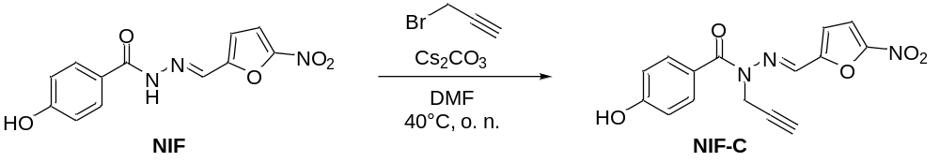

The clickable nifuroxazide analog NIF-C was prepared by reacting nifuroxazide NIF (138 mg, 0.5 mmol) with Cs₂CO₃ (179 mg, 1.1 eq.) and propargyl bromide (46 µL, 1.05 eq.) in dry DMF (5 mL) at room temperature overnight. The mixture solution was extracted with water (20.0 mL) and EtOAc (4 x 25.0 mL). The combined organic phases were dried over MgSO₄ and concentrated. The crude product was purified by flash column chromatography on silica gel (n-Hex/EtOAC gradient: 0 to 100) to afford the product NIF-C as a yellow powder.

Yield: 15 mg, 9.6%. Isolated as a yellow powder, >95% pure by NMR and a single spot by TLC; R_{f}: 0.72 in n-Hex/EtOAc, 20/80.
¹H NMR (500 MHz, CD₃CN) δ ppm = 7.89 (s, 1H), 7.70 (d, J = 8.8 Hz, 2H), 7.45 (d, J = 3.9 Hz, 1H), 6.87 (m, 3H), 4.90 (d, J = 2.7 Hz, 2H), 2.63 (t, J = 2.6 Hz, 1H).
¹³C NMR (126 MHz, CD₃CN) δ ppm = 169.9; 160.8; 153.2 (2C) ; 133.8 (2C) ; 129.2 ; 125.8 ; 115.3 (2C) ; 114.8; 114.3 ; 77.2; 74.6; 32.5.
UPLC: R_{T}: 2.08 (classic system)
HRMS (ESI⁺) m/z [M+H]⁺ Calcd for C₁₅H₁₂N₃O₅⁺ 314.0699; Found 314.0771.

3.3-Clickable Nitrofuranamide analog M2-C
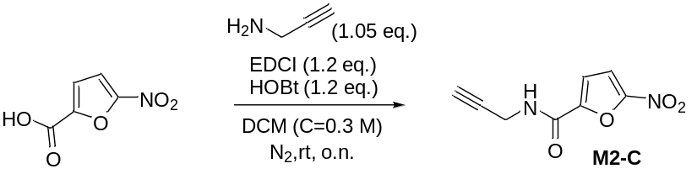
M2-C was prepared according to a previously published procedure [3, 4]. To 5-nitro-2-furoic acid (314 mg, 2 mmol) in CH₂Cl₂, HOBt (1.2 eq.), EDC (1.2 eq.) and propargyl amine (1.05 eq.) were added and the reaction mixture was stirred for 12 h. After completion of the reaction, water was added. Subsequently the reaction mixture was washed with saturated NaHCO₃ solution followed by addition of 2N HCl solution. The combined organic layer was separated, dried over anhydrous Na₂SO₄ and evaporated on a rotavapor to afford M2-C in good yields.
Yield: 331 mg, 85%. Isolated as a yellowish solid, >95% pure by NMR and a single spot by TLC; R_{f}: 0.6 in n-Hex/EtOAc, 50/50.
¹H NMR (400 MHz, DMSO-d6) δ ppm = 9.34 (t, J = 5.5 Hz, 1H), 7.75 (d, J = 3.9 Hz, 1H), 7.44 (d, J = 3.9 Hz, 1H), 4.05 (dd, J = 2.6 Hz, J = 5.7 Hz, 2H), 3.18 (t, J = 2.5 Hz, 1H).
¹³C NMR (101 MHz, DMSO-d6) δ ppm = 155.9; 151.6; 147.7 ; 115.9 ; 113.4 ; 80.4 ; 73.4 ; 28.2.
UPLC: R_{T}: 1.59 (classic system)
HRMS (ESI⁺) m/z [M+H]⁺ Calcd for C₈H₇N₂O₄⁺ 195,0328; Found 195.0403.

4-References
[1] Hui Liu, Ziqing Hu, Hanwei Zhang, Qingyun Li, Kai Lou, and Xiaofan Ji, A Strategy Based on Aggregation-Induced Ratiometric Emission to Differentiate Molecular Weight of Supramolecular Polymers, Angew. Chem. Int. Ed. 2022, 61, e202203505 doi.org/10.1002/anie.202203505

[2] Sohrab Rahmani and Amin Shafiei zadeh Mahani, Synthesis and Characterization of Novel Poly(arylene ether)s Containing1,3,4-Oxadiazole and Triazole Units Through Click Chemistry, Macromol. Res. 2015, doi.org/10.1007/s13233-015-3133-y

[3] Ahmed Kamal, S. M. Ali Hussaini, M. Lakshmi Sucharitha, Y. Poornachandra, Faria Sultanaa and C. Ganesh Kumara, Synthesis and antimicrobial potential of nitrofuran–triazole congeners, Org. Biomol. Chem. 2015, 13, 9388, doi.org/10.1039/c5ob01353d
[4] Ahmed Kamal, Syed Mohammed Ali Hussaini, Shaikh Faazil, Y. Poornachandra, G. Narender Reddy, C. Ganesh Kumar, Vikrant Singh Rajput, Chitra Rani, Rashmi Sharma, Inshad Ali Khan, N. Jagadeesh Babu, Anti-tubercular agents. Part 8: Synthesis, antibacterial and antitubercular activity of 5-nitrofuran based 1,2,3-triazoles, Bioorg. Med. Chem. Lett. 2013, 23, 6842–6846, doi.org/10.1016/j.bmcl.2013.10.010

5-Spectroscopic and spectrometric analysis of synthesized compounds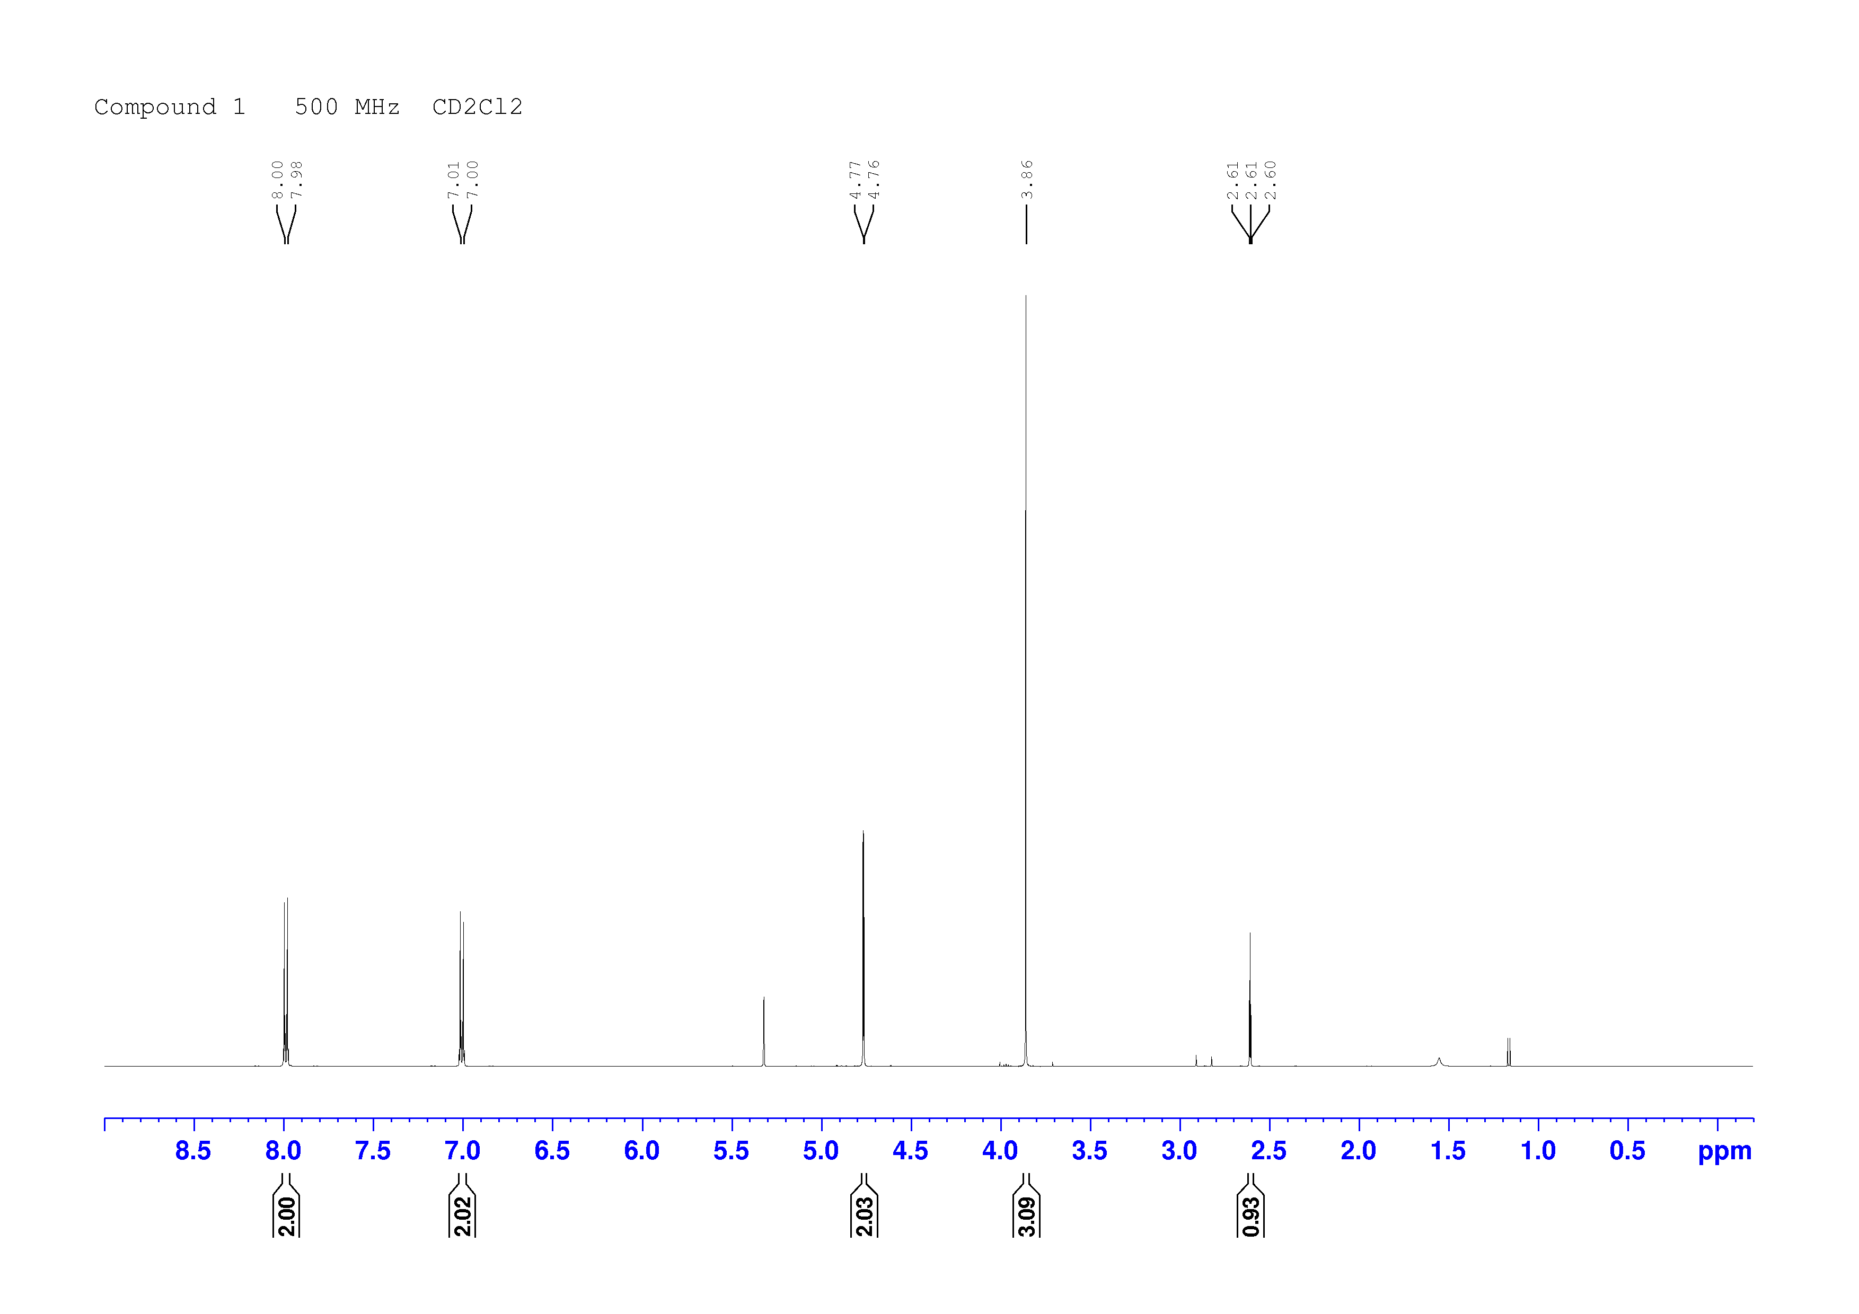¹H NMR spectrum of 1 in dichloromethane-d2.
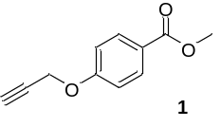
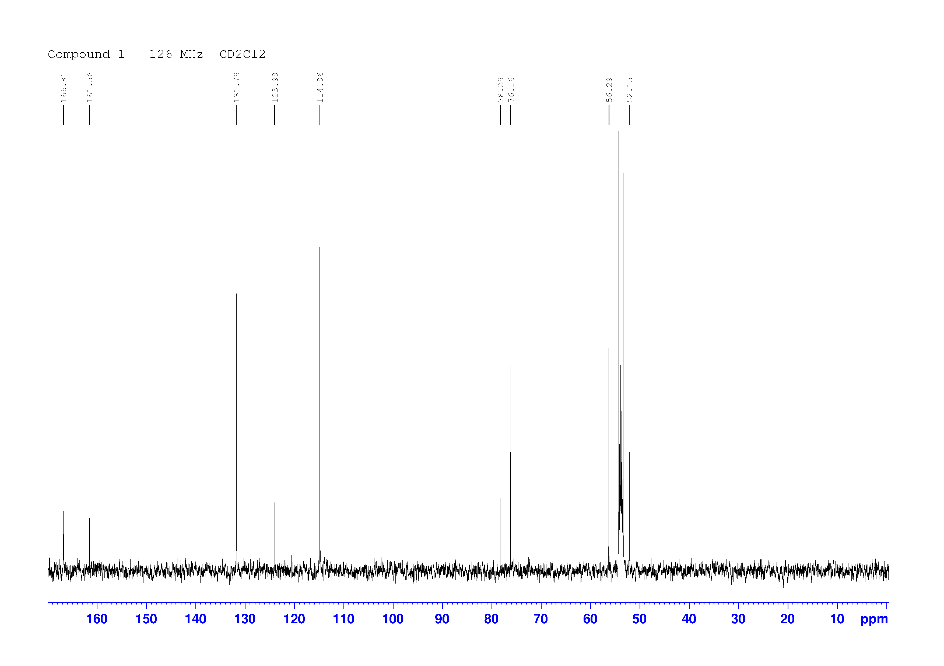¹³C NMR spectrum of 1 in dichloromethane-d2.
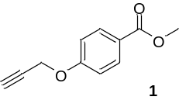

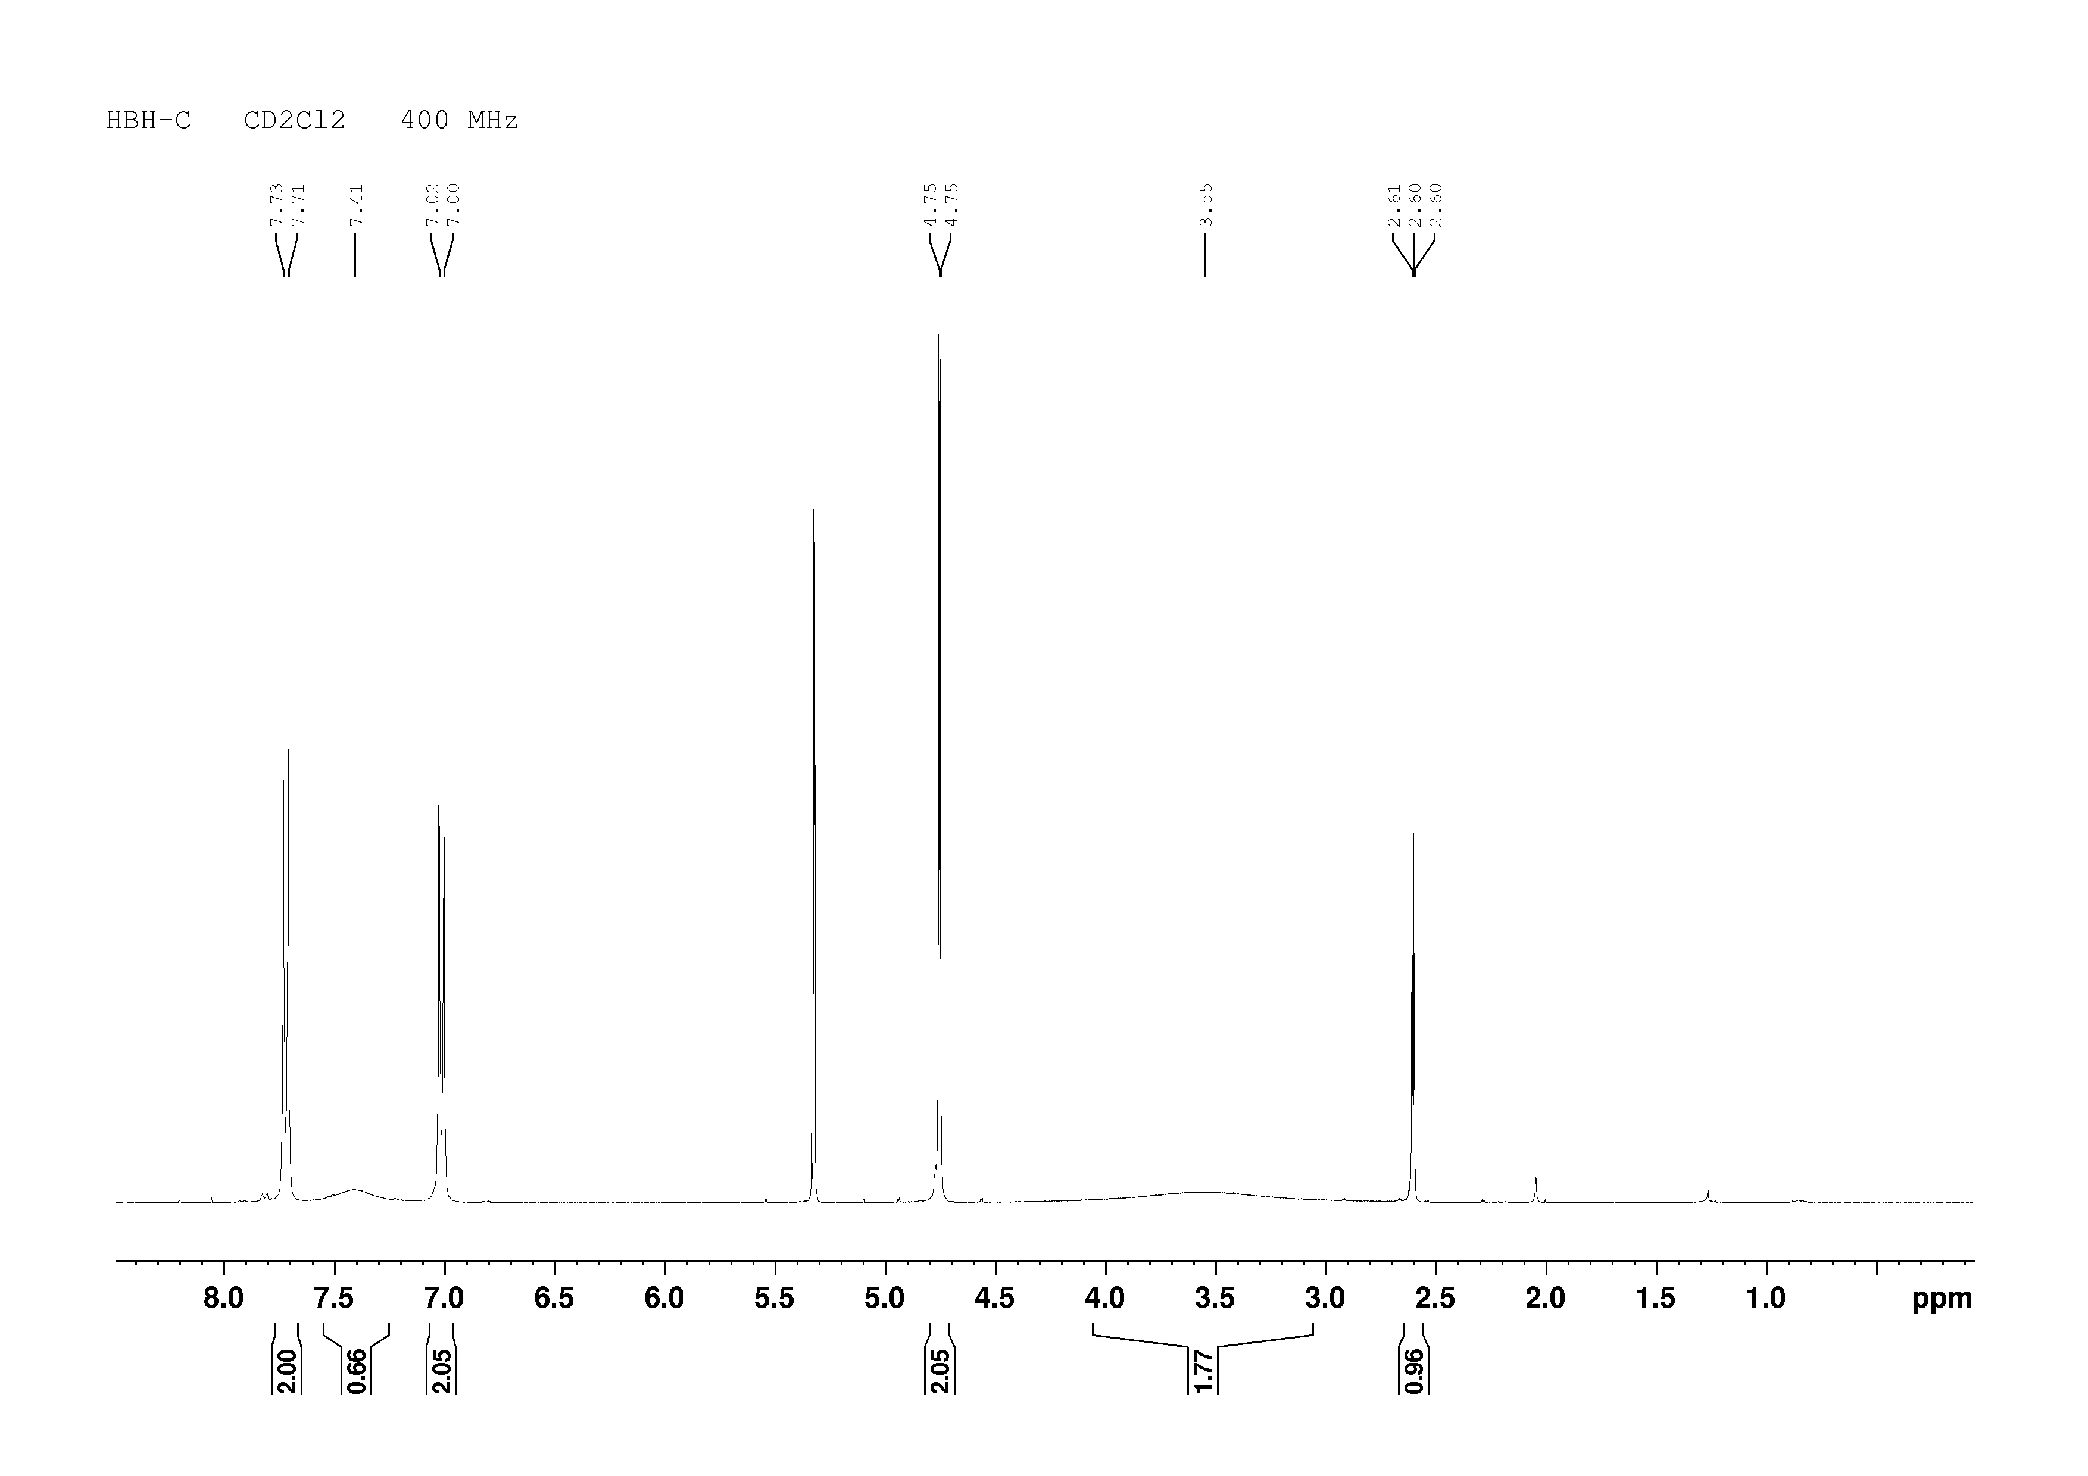¹H NMR spectrum of HBH-C in dichloromethane-d2.
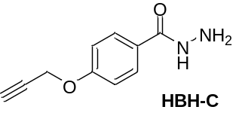

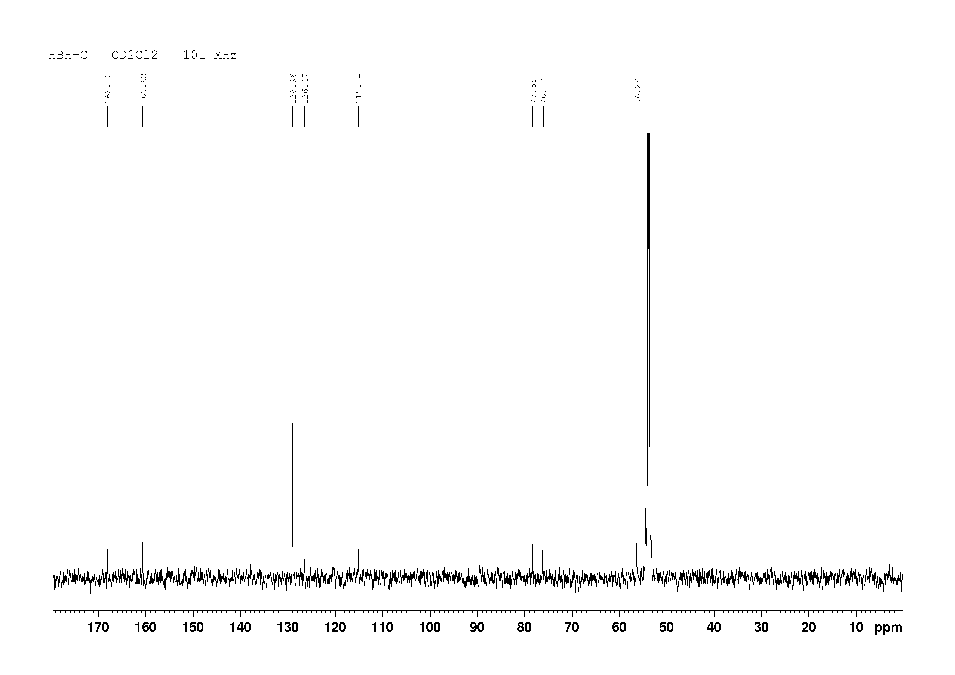¹³C NMR spectrum of HBH-C in dichloromethane-d2.
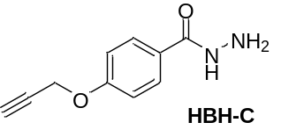

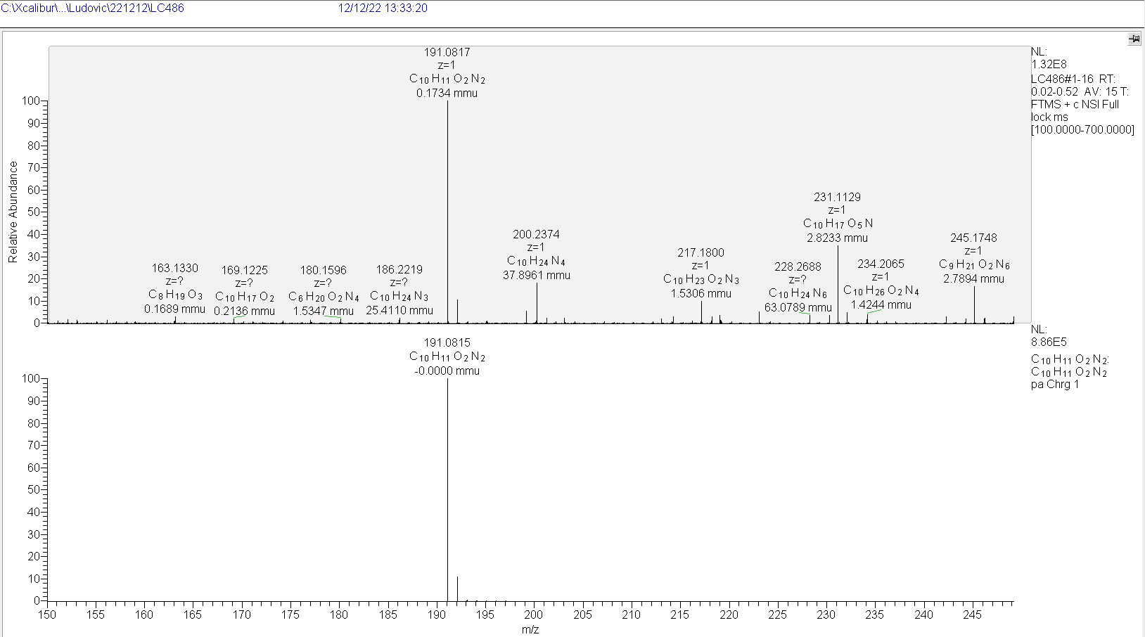HRMS spectrum of HBH-C.
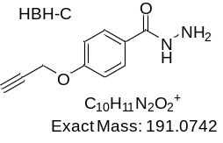

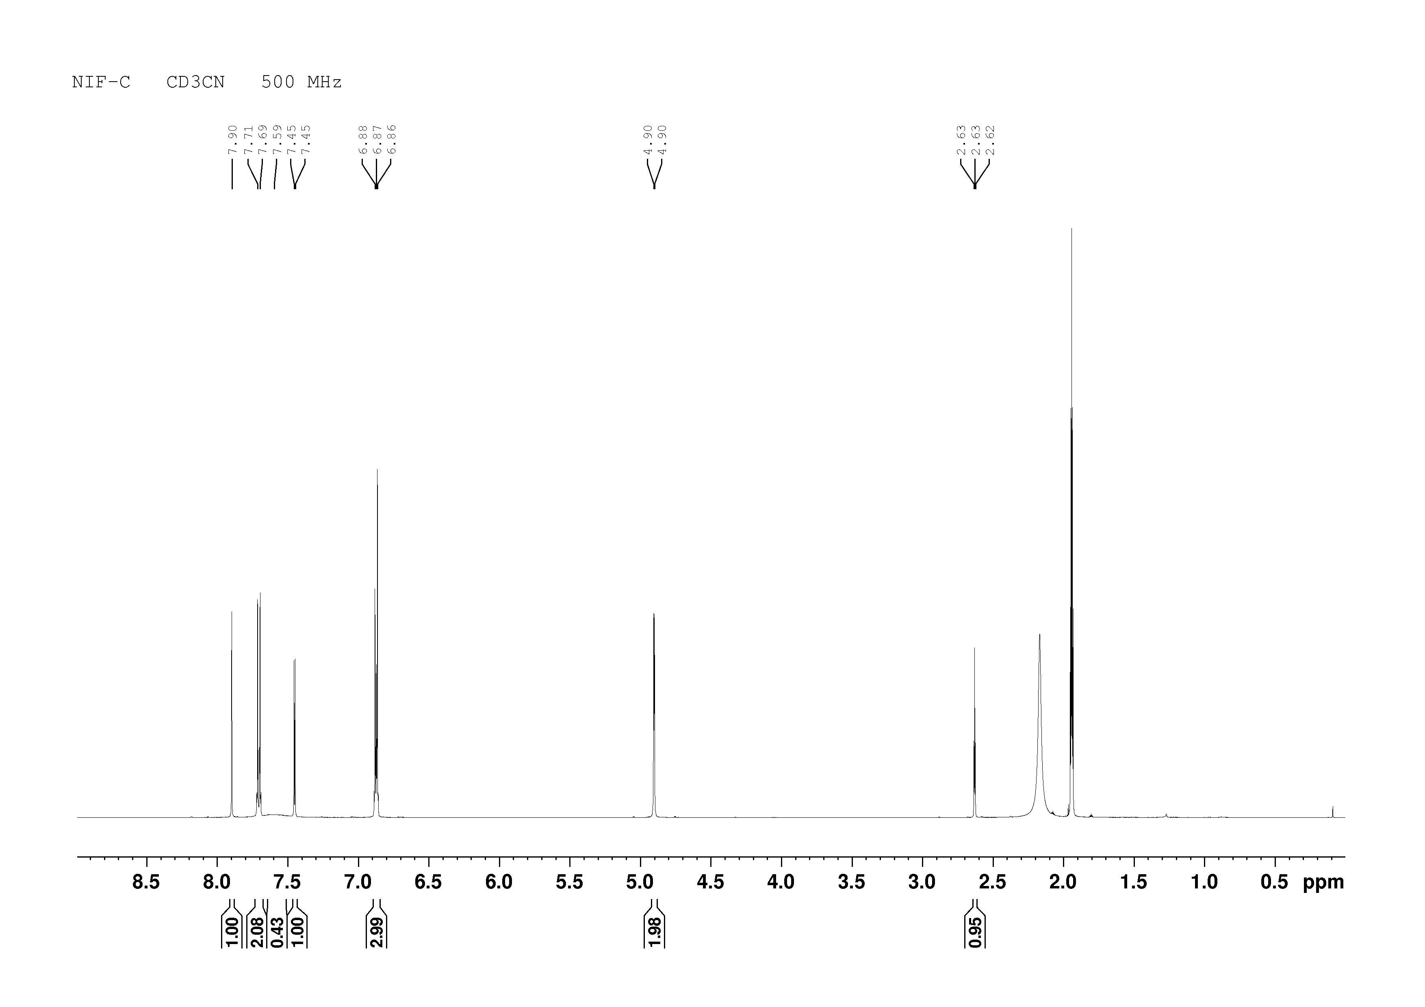
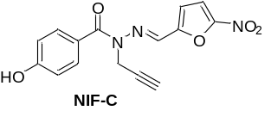
¹H NMR spectrum of 3 in acetonitrile-d3.

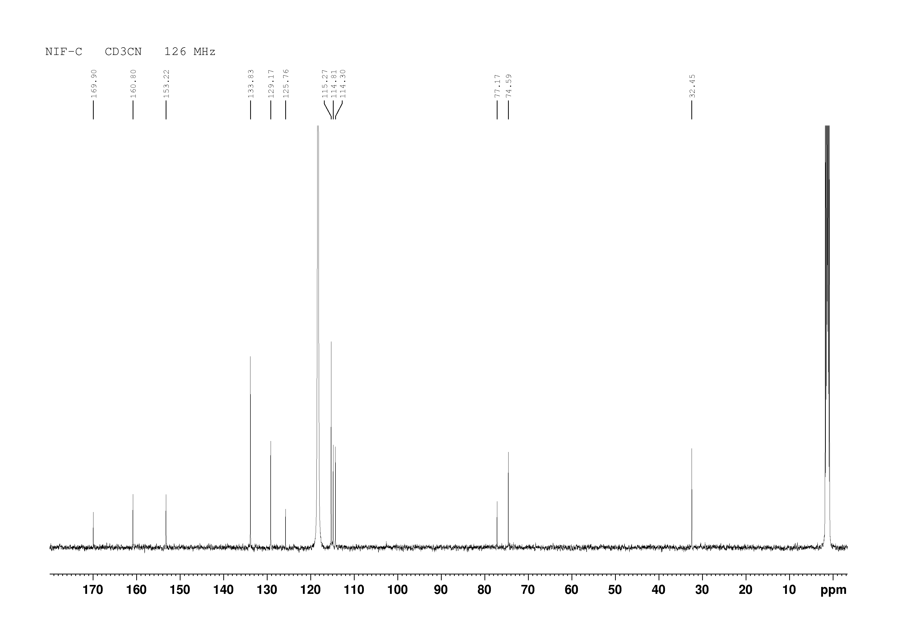 ¹³C NMR spectrum of NIF-C in acetonitrile-d3.
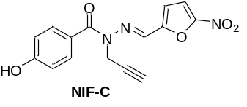
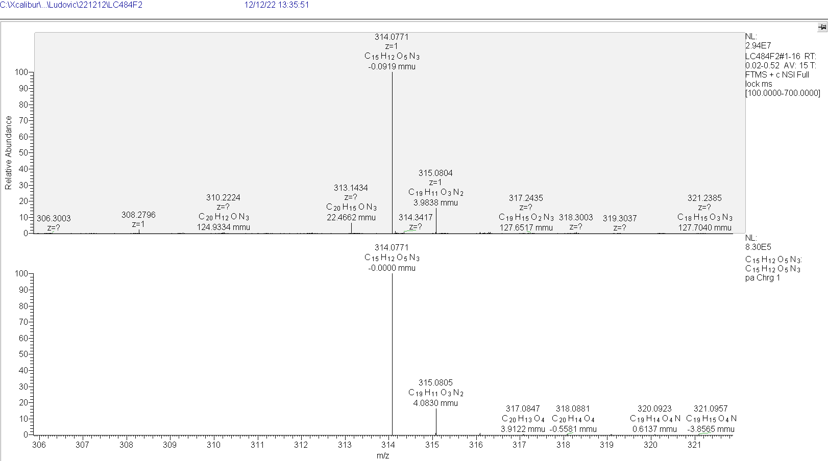
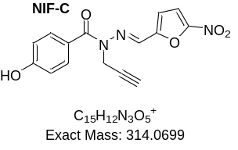
HRMS spectrum of NIF-C.

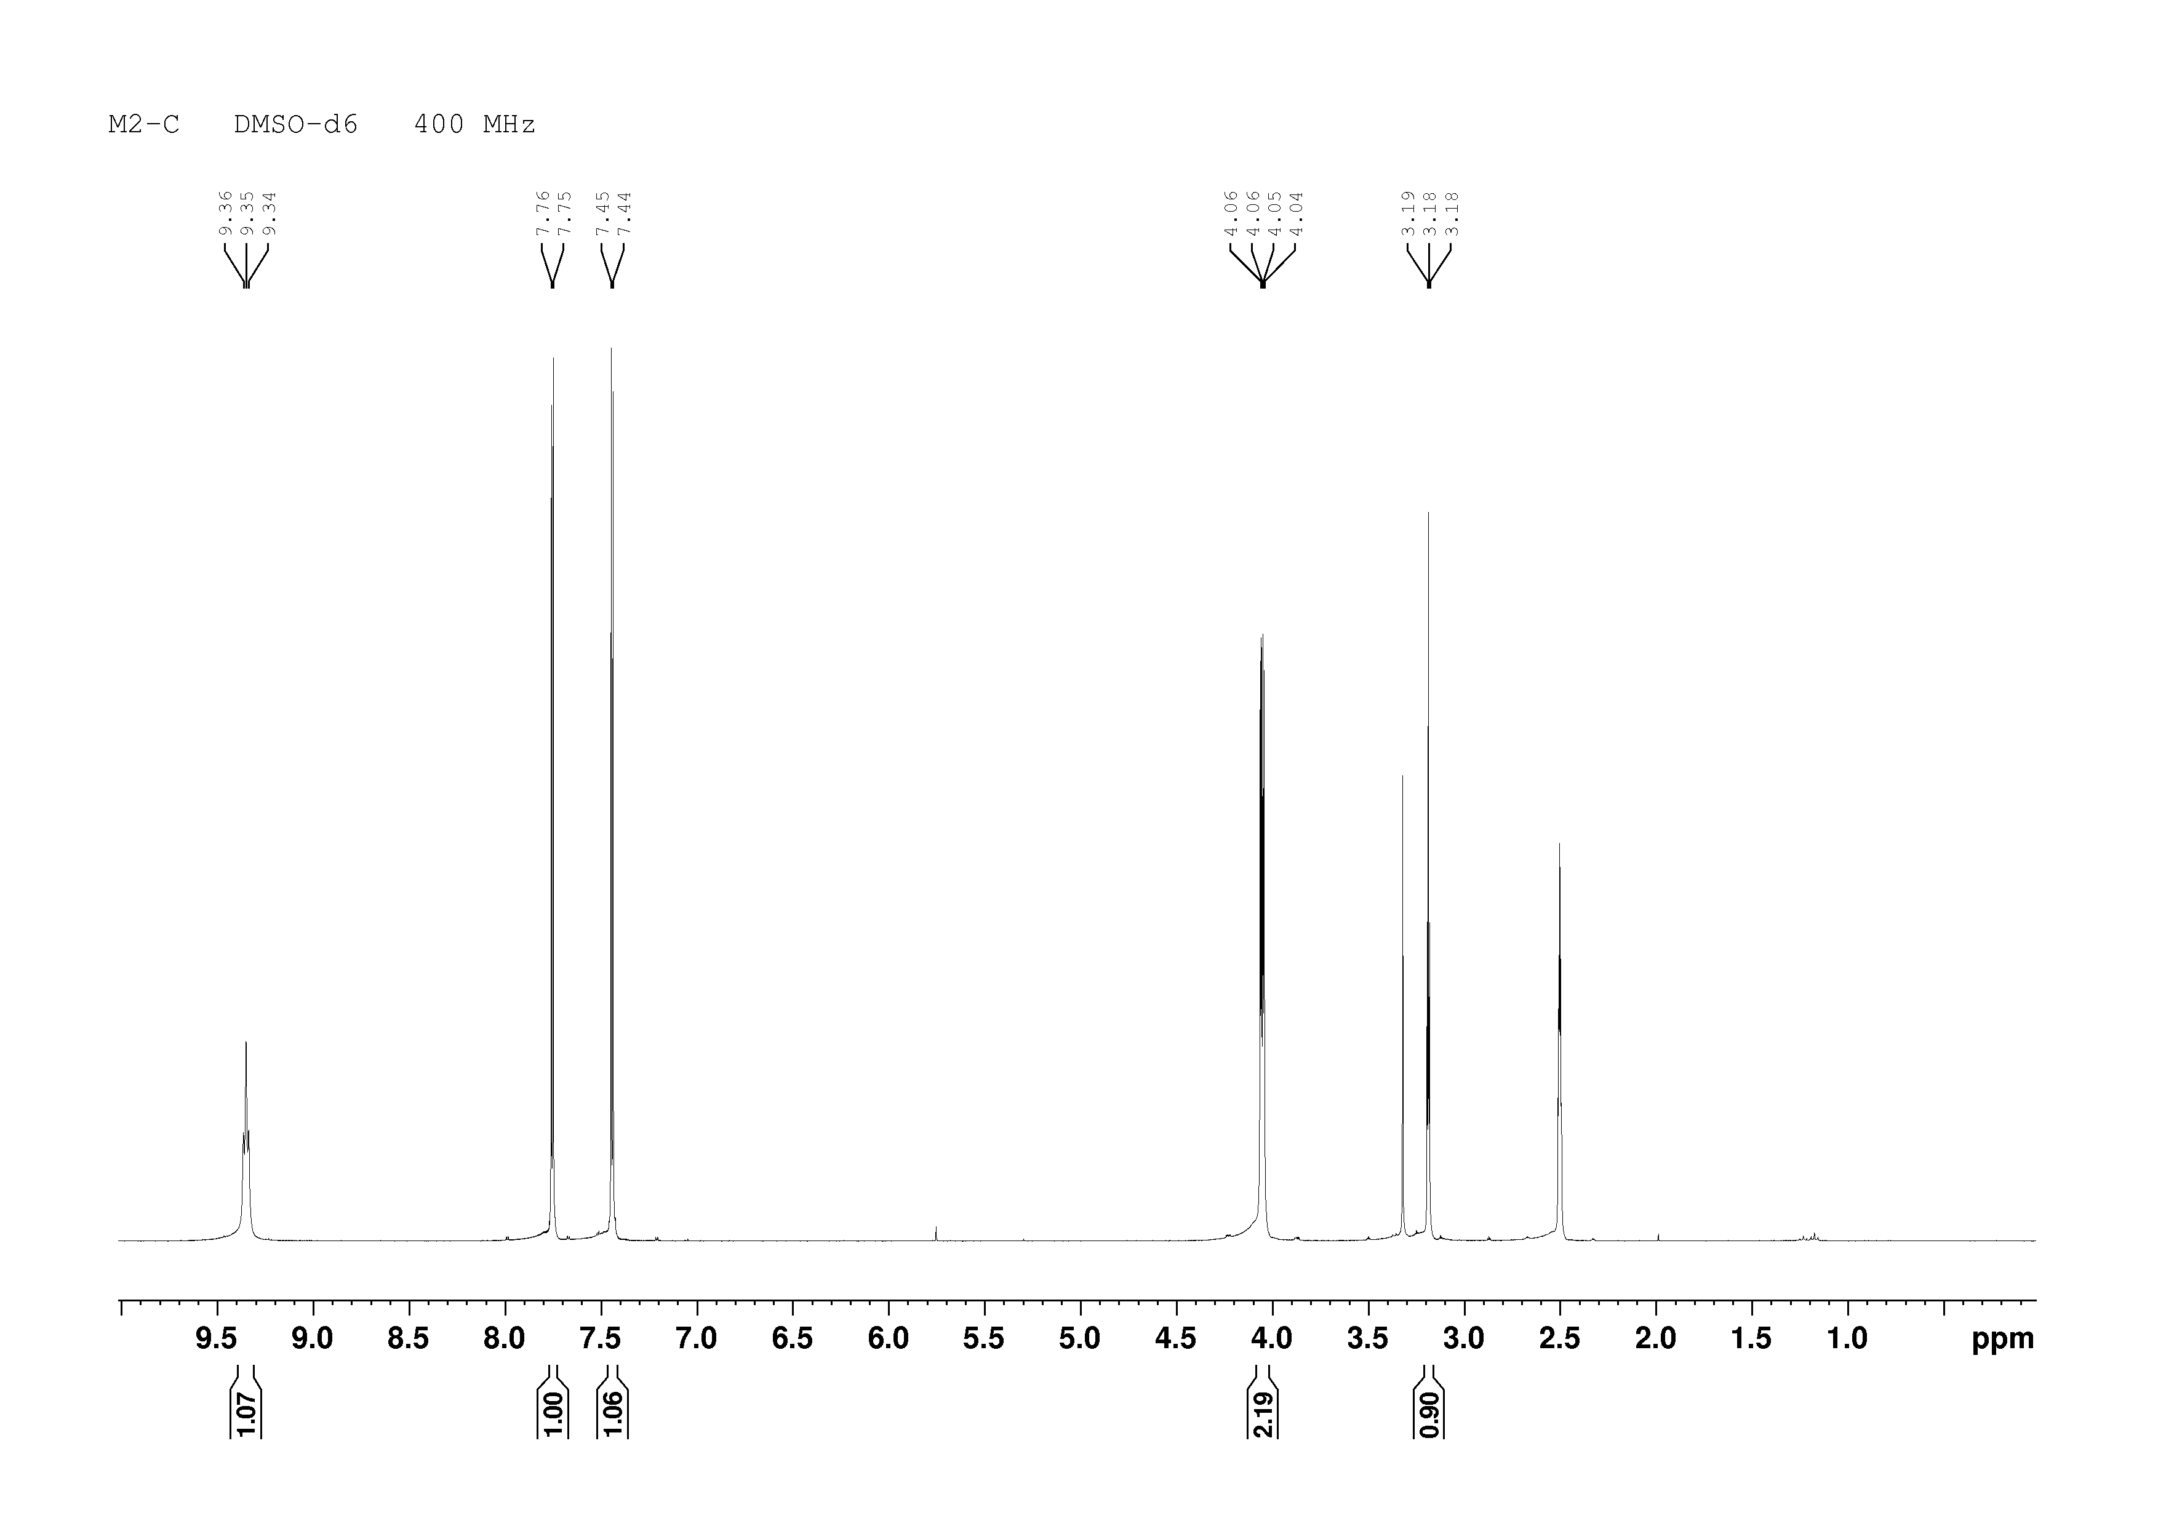¹H NMR spectrum of M2-C in dimethylsulfoxide-d6.
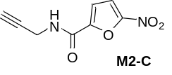

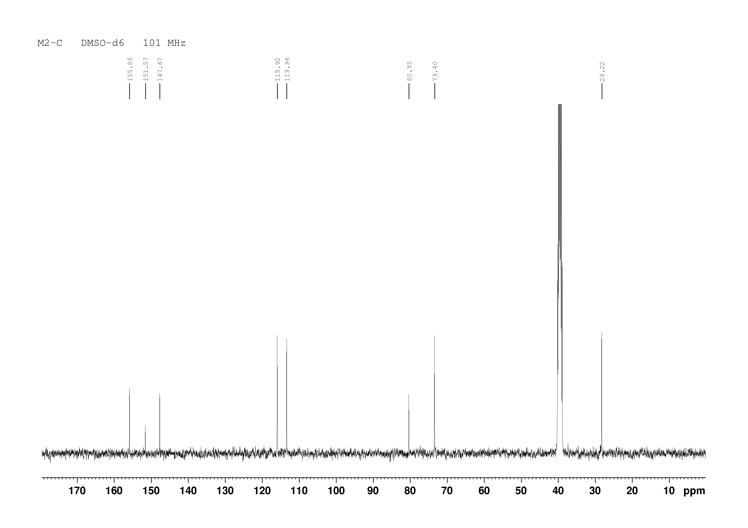¹³C NMR spectrum of M2-C in dimethylsulfoxide-d6.
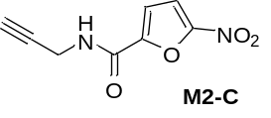
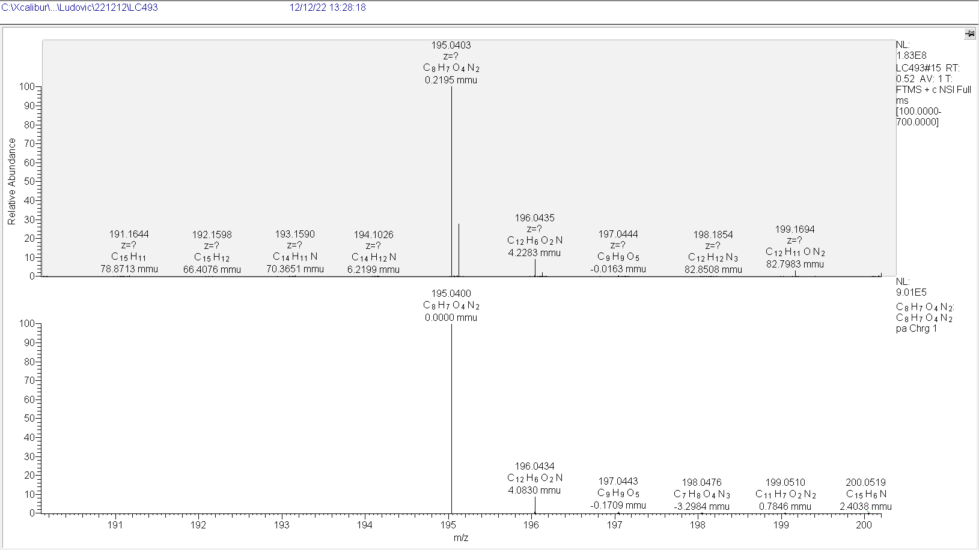HRMS spectrum of M2-C.
