Supplementary Material
Self-assembly of S,N-codoped Ce/Cu bimetallic nanoparticles for fluorescence and visual detection of hexavalent chromium
Hanyu Yang, Kaijing Yang, Rong Tang, Hui Chen, Wei Liu* and Xiupei Yang*
College of Chemistry and Chemical Engineering, Chemical Synthesis and Pollution Control Key Laboratory of Sichuan Province, China West Normal University, Nanchong 637000, PR China
*Corresponding authors. E-mail address: weiliu2022@cwnu.edu.cn (W. Liu), xiupeiyang@cwnu.edu.cn (X. Yang).

Contents
S1. Reagents and materials.
S2. Characterization and measurements.
Figure S1. Effect of the synthesis conditions on the S,N-codoped Cu/Ce NPs: (a) mole ratio of ligand to metal, (b) mole ratio of Cu to Ce, (c) reaction temperature, and (d) reaction time.
Figure S2. The effect of the presence or absence of SO₄²⁻ on the fluorescence intensity under different synthesis conditions: (a) mole ratio of ligand to metal, (b) mole ratio of Cu to Ce, and (c) reaction temperature.
Figure S3. The effect of the presence or absence of NO₃⁻ on the fluorescence intensity under different synthesis conditions: (a) mole ratio of ligand to metal, (b) mole ratio of Cu to Ce, and (c) reaction temperature.
Figure S4. The fluorescence intensity after the addition of (a) SO₄²⁻ to N-doped Cu/Ce NCs and (c) NO₃⁻ to S-doped Cu/Ce NPs (the inset shows the corresponding images), and the change in fluorescence intensity after the addition of (b) SO₄²⁻ to N-doped NCs and (d) NO₃⁻ to S-doped Cu/Ce NPs.
Figure S5. The change in fluorescence intensity after the addition of NaNO₃ or Na₂SO₄ to (a) the S,N-codoped Cu/Ce NPs and (b) the centrifuged S,N-codoped Cu/Ce NPs.
Figure S6. (a) Fluorescence intensity of Cu NCs doped with different metal ions. (b) Fluorescence intensity of N-doped Cu/Ce NCs, S-doped Cu/Ce NPs and S,N-codoped Cu/Ce NPs.
Figure S7. Changes in the fluorescence intensity of the S,N-codoped Cu/Ce NPs under different conditions: (a) irradiation with a xenon lamp, (b) heating for 2 hours, and (c) refrigeration at 4 ℃.
Figure S8. XPS spectra of S,N-codoped Cu/Ce NPs: (a) S_{2p}, (b) N_{1s}, (c) Cu_{2p}, and (d) total spectrum. XPS spectra of N-doped Cu/Ce NCs: (a) S_{2p}, (b) N_{1s}, (c) Cu_{2p}, and (d) total spectrum.
Figure S9. FT-IR spectra of S-doped Cu/Ce NPs, N-doped Cu/Ce NCs and S,N-doped Cu/Ce NPs.
Figure S10. Photos of N-doped Cu/Ce NCs, S,N-codoped Cu/Ce NPs, and S-doped Cu/Ce NPs (from left to right) under (a) daylight and (b) a UV lamp.
Fig S11. Fluorescence lifetimes of (a) S,N-codoped Cu/Ce NPs, (b) S-doped Cu/Ce NPs and (c) N-doped Cu/Ce NCs.
Figure S12. Mapping of S,N-codoped Cu/Ce NPs.
Figure S13. The fluorescence intensity before (solid line) and after (dashed line) the addition of Cr(Ⅵ) S-doped Cu/Ce NPs, N-doped Cu/Ce NCs, and S,N-codoped Cu/Ce NPs (the inserts show the changes in the fluorescence intensity of the three composites).
Fig S14. Changes in fluorescence intensity after S,N-codoped Cu/Ce NPs reacted with Cr₂O₇² in different buffer solutions (a) (①, citric acid-sodium citrate; ②, phosphoric acid-disodium hydrogen phosphate; ③, sodium acetate-acetic acid; ④, glycine-hydrochloric acid; and ⑤, no buffer); (b) at different pH values; (c) at different concentrations; (d) at different incubation times.
Fig S15. Changes in the relative intensity of fluorescence with the addition of different concentrations of CrO₄²⁻ and Cr₂O₇²⁻.
Fig S16. (a) Changes in fluorescence intensity and (b) quenching constants of S,N-doped Cu/Ce DAMP NPs reacting with Cr(VI) at different temperatures.
Fig S17. (a) Fluorescence lifetime of Cu/Ce-DAMP before and after reaction with Cr(Ⅵ) and (b) UV absorption spectra of Cu/Ce-DAMP and Cr(Ⅵ).
Table S1: Comparison of some fluorescent materials for detecting Cr(Ⅵ) and this work.
Table S2: Results of the determination of Cr(Ⅵ) in real and spiked samples by fluorescence analysis.
Table S3: Results of the determination of Cr(Ⅵ) in real and spiked Jialing River water samples by smartphone photo detection.
References.
S1. Reagents and materials
Copper nitrate (CuNO₃∙3H₂O, AR), cerium sulfate (Ce₂(SO₄)₃∙8H₂O), AR), copper sulfate (CuSO₄∙5H₂O, 99%), cerium nitrate (Ce(NO₃)₃∙6H₂O), AR), sodium sulfate (Na₂SO₄, 99%), sodium meta-aluminate (NaAlO₂, 98%), sodium chloride (NaCl, 99.5%), sodium hydrogen phosphate (NaHPO₄, AR), iron nitrate (Fe(NO₃)₃∙9H₂O, AR), chromium nitrate (Cr(NO₃)₃∙9H₂O, AR), cobalt nitrate (Co(NO₃)₂∙6H₂O, AR), cadmium nitrate (Cd(NO₃)₂∙4H₂O, AR) and 4,6-diamino-2-mercaptopyrimidine (95%) were purchased from Aladdin (Shanghai, China). Hydrochloric acid (HCl, AR), sodium oxalate (Na₂C₂O₄, AR), sodium sulfide (Na₂S, AR), potassium permanganate (KMnO₄, AR), potassium nitrate (KNO₃, AR), aluminum nitrate (Al(NO₃)₃∙9H₂O, 98%), and sodium fluoride (Na₂CO₃, AR) were obtained from Kelong (Chengdu, China). Zinc nitrate (Zn(NO₃)₂∙6H₂O, AR), magnesium nitrate (Mg(NO₃)₂, 99%), sodium nitrate (NaNO₃, AR), Lushi (Shanghai, China), glycine (AR), and nickel nitrate (Ni(NO₃)₂∙6H₂O, AR) were purchased from Jinshan (Chengdu, China). Sodium fluoride (NaF, AR), potassium dichromate (K₂Cr₂O₇, AR) and sodium silicate (Na₂SiO₃, AR) were obtained from Maoye (Chongqing, China). All reagents were used without further purification.
S2. Characterization and measurements
Fluorescence spectra were measured with a Cary Eclipse Fluorescence Spectrophotometer (Varian, USA). FT-IR spectra were obtained using a Nicolet 6700 Fourier in situ infrared spectrometer (Thermo Electron Corporation, USA). UV–vis absorption spectra were obtained with a UV-2550 ultraviolet visible spectrophotometer (Kyoto, Japan). Powder X-ray diffraction (PXRD) patterns were measured on a DX-2700 diffractometer. The scanning electron-mapping images were taken by a JSM-6530LV scanning electron microscope (Netzsch, Germany). The zeta potential was obtained with a ZSA-3200 Zetasizer Pro (Malvern Panalytical). The fluorescence decay and quantum yield were recorded by an Edinburgh-FLS1000 fluorescence and phosphorescence spectrometer (Ediburgh Instruments, Britain). TEM images were obtained with a Talos F200S G2 field emission transmission electron microscope. XPS data were acquired on a K-ALPHA X-ray photoelectron spectrometer. The atomic absorption spectrum was measured by a Beijing Puxi general atomic absorption spectrophotometer (A3F).
Fig S1. Effect of the synthesis conditions on the S,N-codoped Cu/Ce NPs: (a) mole ratio of ligand to metal, (b) mole ratio of Cu to Ce, (c) reaction temperature, and (d) reaction time.
Fig S2. The effect of the presence or absence of SO₄²⁻ on the fluorescence intensity under different synthesis conditions: (a) mole ratio of ligand to metal, (b) mole ratio of Cu to Ce, and (c) reaction temperature.
Fig S3. The effect of the presence or absence of NO₃⁻ on the fluorescence intensity under different synthesis conditions: (a) mole ratio of ligand to metal, (b) mole ratio of Cu to Ce, and (c) reaction temperature.

Fig S4. The fluorescence intensity after the addition of (a) SO₄²⁻ to N-doped Cu/Ce NCs and (c) NO₃⁻ to S-doped Cu/Ce NPs (the inset shows the corresponding images), and the change in fluorescence intensity after the addition of (b) SO₄²⁻ to N-doped NCs and (d) NO₃⁻ to S-doped Cu/Ce NPs.
Fig S5. The change in fluorescence intensity after the addition of NaNO₃ or Na₂SO₄ to (a) the S,N-codoped Cu/Ce NPs and (b) the centrifuged S,N-codoped Cu/Ce NPs.

Fig S6. (a) Fluorescence intensity of doping different metal ions in Cu NCs. (b) Fluorescence intensity of N-doped Cu/Ce NCs, S-doped Cu/Ce NPs and S,N-codoped Cu/Ce NPs.

Fig S7. Changes in the fluorescence intensity of the S,N-codoped Cu/Ce NPs under different conditions: (a) irradiation with a xenon lamp, (b) heating for 2 hours, and (c) refrigeration at 4 ℃.

Fig S8. XPS spectra of S,N-codoped Cu/Ce NPs: (a) S_{2p}, (b) N_{1s}, (c) Cu_{2p}, and (d) total spectrum. XPS spectra of N-doped Cu/Ce NCs: (e) S_{2p}, (f) N_{1s}, (g) Cu_{2p}, and (h) total spectrum.

Fig S9. The FT-IR spectra of S-doped Cu/Ce NPs, N-doped Cu/Ce NCs and S, N-doped Cu/Ce NPs.

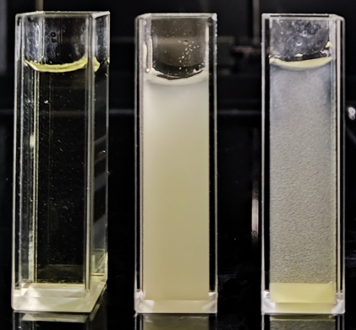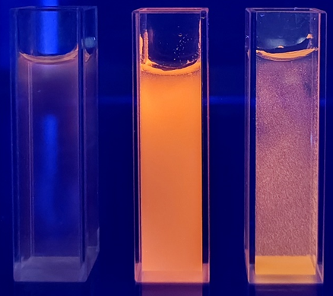
Fig S10. The photos of N-doped Cu/Ce NCs, S,N-codoped Cu/Ce NPs, and S-doped Cu/Ce NPs (from left to right) under (a)daylight, and (b)UV lamp.
Fig S11. Fluorescence lifetime of (a) S,N-codoped Cu/Ce NPs, (b) S -doped Cu/Ce NPs and (c) N-doped Cu/Ce NCs.

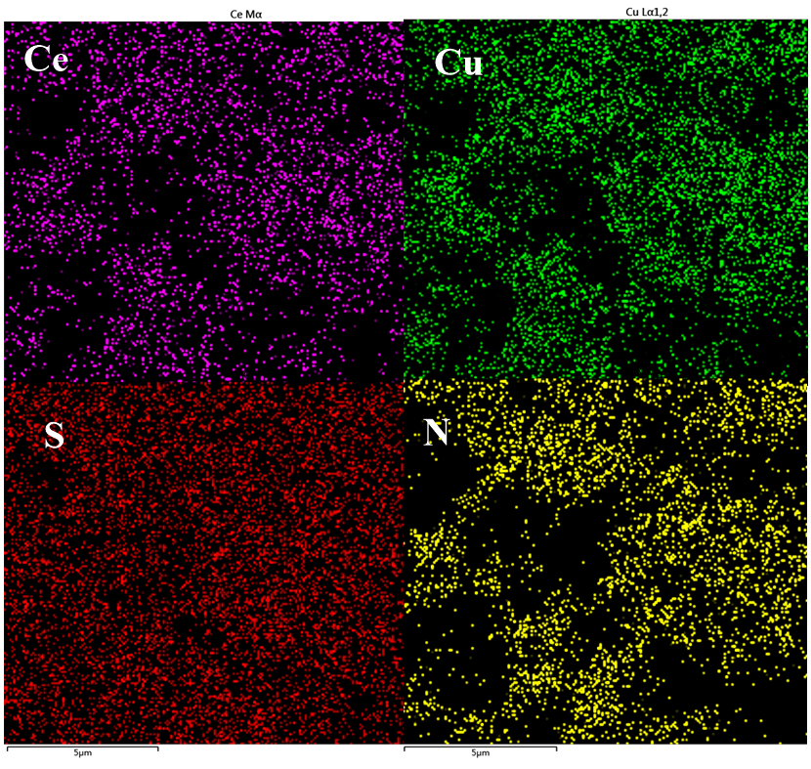
Fig S12. The mapping of S,N-codoped Cu/Ce NPs.

Fig S13. The fluorescence intensity before (solid line) and after (dashed line) the addition of Cr(Ⅵ) to S-doped Cu/Ce NPs, N-doped Cu/Ce NCs, and S,N-codoped Cu/Ce NPs (the inserts show the changes in the fluorescence intensity of the three composites).

Fig S14. Changes in fluorescence intensity after S,N-codoped Cu/Ce NPs reacted with Cr₂O₇² in different buffer solutions (a) (①, citric acid-sodium citrate; ②, phosphoric acid-disodium hydrogen phosphate; ③, sodium acetate-acetic acid; ④, glycine-hydrochloric acid; and ⑤, no buffer); (b) at different pH values; (c) at different concentrations; (d) at different incubation times.
Fig S15. Changes in the relative intensity of fluorescence with the addition of different concentrations of CrO₄²⁻ and Cr₂O₇²⁻.

Fig S16. (a) Changes in fluorescence intensity and (b) quenching constants of S,N-doped Cu/Ce DAMP NPs reacting with Cr(VI) at different temperatures.

Fig S17. (a) Fluorescence lifetime of S,N-codoped Cu/Ce NPs before and after reaction with Cr(Ⅵ) and (b) UV absorption spectra of S,N-codoped Cu/Ce NPs and Cr(Ⅵ).

Table S1. Comparison of some fluorescent materials for detecting Cr(Ⅵ) and this work
Materials | Linear Rang | LOD | Ref.
g-C₃N₄ nanosheets | 0.63 - 300 μM | 0.11 μM | [1]
Carbon dots | 0.8 - 189 μM | 0.16 μM | [2]
perovskite quantum dots | 0.8 - 400 µM | 0.27 µM | [3]
coumarin and diphenylcarbazide | 0.048 - 268 μM | 0.048 μM | [4]
MXene quantum dots | 0.1 - 500.0 μM | 0.012 μM | [5]
Carbon dots | 0 - 160 μM | 0.25 μM | [6]
S,N-codoped Cu/Ce-DAMP | 0.5 - 120 µM | 0.134 μM | This work

Table S2. Comparison of fluorescence analysis results of Cr(VI) in actual samples and spiked samples with the results of the Chinese national standard method
Sample | Fluorescent method |  |  |  |  | GB/T 2394-2009
Sample | Found  (µM) | Add  (µM) | Total  Found  (µM) | RSD  (%) | Recovery  (%) | Found  (µM) | Add  (µM) | Total  Found  (µM) | RSD  (%) | Recovery  (%)
River water | 0 | 2.00 | 2.06 | 4.18 | 103.0 | 0 | 2.00 | 2.18 | 0.69 | 109.0
River water | 0 | 20.00 | 20.72 | 5.33 | 103.6 | 0 | 20.00 | 21.18 | 4.54 | 105.9
River water | 0 | 40.00 | 38.22 | 4.82 | 95.6 | 0 | 40.00 | 41.34 | 1.61 | 103.4
Outlet of water | 0 | 2.00 | 2.22 | 5.48 | 111.0 | 0 | 2.00 | 2.04 | 2.85 | 102.0
Outlet of water | 0 | 20.00 | 21.66 | 3.83 | 108.3 | 0 | 20.00 | 19.54 | 5.18 | 97.7
Outlet of water | 0 | 40.00 | 41.56 | 4.08 | 103.9 | 0 | 40.00 | 38.64 | 4.21 | 96.6
Inlet of tannery waste water | 2.02 | 2.00 | 4.18 | 1.46 | 104.0 | 1.86 | 2.00 | 4.14 | 0.64 | 107.3
Inlet of tannery waste water | 2.02 | 20.00 | 23.72 | 5.07 | 107.7 | 1.86 | 20.00 | 23.98 | 2.91 | 109.7
Inlet of tannery waste water | 2.02 | 40.00 | 42.30 | 3.53 | 100.6 | 1.86 | 40.00 | 42.86 | 2.94 | 102.4

Table S3. Results of the determination of Cr(Ⅵ) in real and spiked Jialing River water samples by smartphone photo detection
Sample | Found | Add (µM) | Total Found (µM) | Recovery (%) | RSD  (%)
River water | 0 | 10.00 | 10.04 | 100.4 | 5.11
River water | 0 | 20.00 | 19.76 | 98.8 | 4.57
River water | 0 | 80.00 | 81.02 | 101.3 | 4.93

References
[1] Jia, Y., Wu, S., Duan, Z., Song, S., Shuang, S., Gong, X., Dong, C., (2022) A facile fluorescence platform for chromium and ascorbic acid detection based on “on-off-on” strategy, Spectrochimica Acta Part A: Molecular and Biomolecular Spectroscopy 278 121343.http://https://doi.org/10.1016/j.saa.2022.121343
[2] Xu, J., Gao, Q., Wang, Z., (2023) Porous g-C3N4 Nanosheets for On–Off–On Fluorescence Detection and Elimination of Chromium(VI) and Sulfite, ACS Applied Nano Materials 6(1) 750-758.http://10.1021/acsanm.2c05105
[3] Gao, D., Zhang, A., Lyu, B., Ma, J., (2024) Visual and rapid fluorescence sensing for hexavalent chromium by hydroxypropyl chitosan passivated bismuth-based perovskite quantum dots, Microchimica Acta 191(4) 219.http://10.1007/s00604-024-06251-1
[4] Khairy, G.M., Ragab, S.M., Moawed, E.A., El sadda, R.R., Aboelnga, M.M., (2024) Uncovering an effecient binary system as a chemosensor for visual and fluorescence detection of chromium (VI) in water samples, Spectrochimica Acta Part A: Molecular and Biomolecular Spectroscopy 321 124729.http://https://doi.org/10.1016/j.saa.2024.124729
[5] Huang, D., Wu, Y., Ai, F., Zhou, X., Zhu, G., (2021) Fluorescent nitrogen-doped Ti3C2 MXene quantum dots as a unique “on-off-on” nanoprobe for chrominum (VI) and ascorbic acid based on inner filter effect, Sensors and Actuators B: Chemical 342 130074.http://https://doi.org/10.1016/j.snb.2021.130074
[6] Huang, Q., Bao, Q., Wu, C., Hu, M., Chen, Y., Wang, L., Chen, W., (2022) Carbon dots derived from Poria cocos polysaccharide as an effective “on-off” fluorescence sensor for chromium (VI) detection, Journal of Pharmaceutical Analysis 12(1) 104-112.http://https://doi.org/10.1016/j.jpha.2021.04.004

