Supplementary materials

Synthesis of the dibenzylbutane lignan LCA derivatives and evaluation of their anti-inflammatory activities
Juan Zhang ^{a, b,1}, Conghao Gai ^{a,1}, Jing Wang ª, Xiaobin Zhuo ª, Yan Zou ª, Jishun Yang ^{b}, Yan Song ^{b, ***}, Qingjie Zhao ^{a, **}, Xiaoyun Chai ^{a, *}

ª Department of Organic Chemistry, School of Pharmacy, Naval Medical University, Shanghai 200433, China
^{b} Naval Medical Center, Naval Medical University, Shanghai, 200433, China

Experimental characterization data for products:
Figure S1: ¹H NMR spectrum of 8.
Figure S2: ¹³C NMR spectrum of 8.
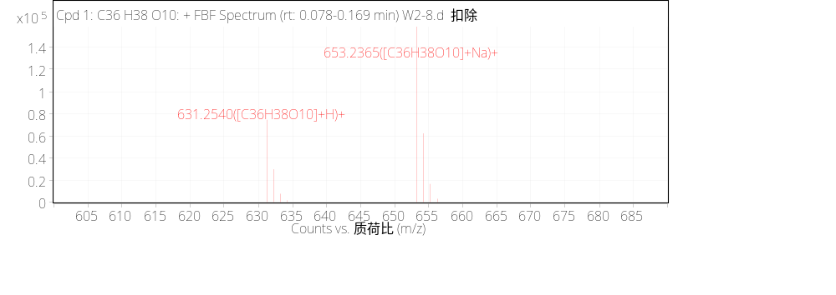
Figure S3: HR MS spectrum of 8.
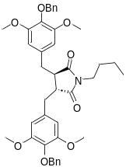
Figure S4: ¹H NMR spectrum of 10a.

Figure S5: ¹³C NMR spectrum of 10a.
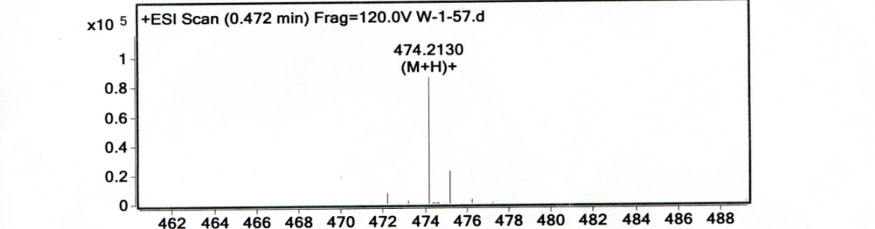
Figure S6: HR MS spectrum of 10a.

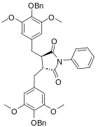
Figure S7: ¹H NMR spectrum of 10b.
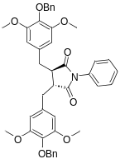
Figure S8: ¹³C NMR spectrum of 10b.

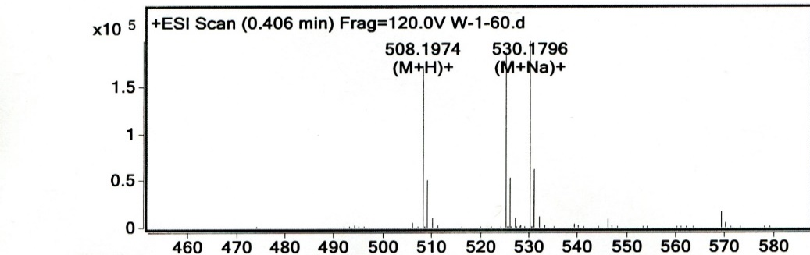
Figure S9: HR MS spectrum of 10b.
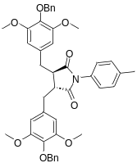
Figure S10: ¹H NMR spectrum of 10c.
Figure S11: ¹³C NMR spectrum of 10c.
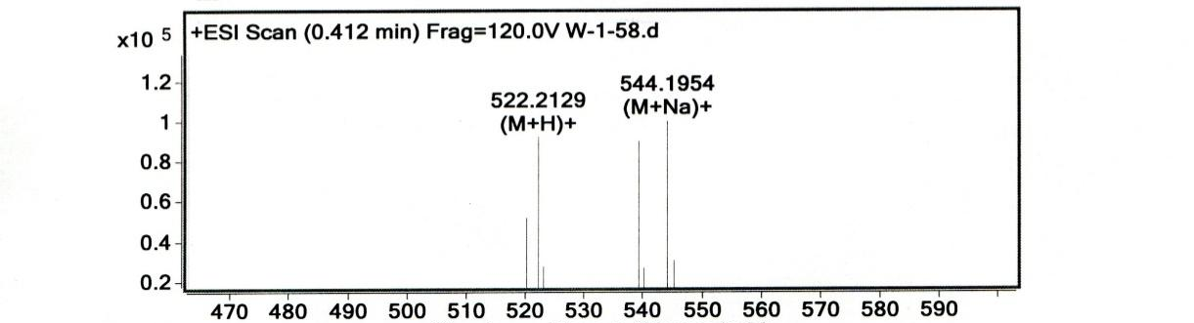
Figure S12: HR MS spectrum of 10c.

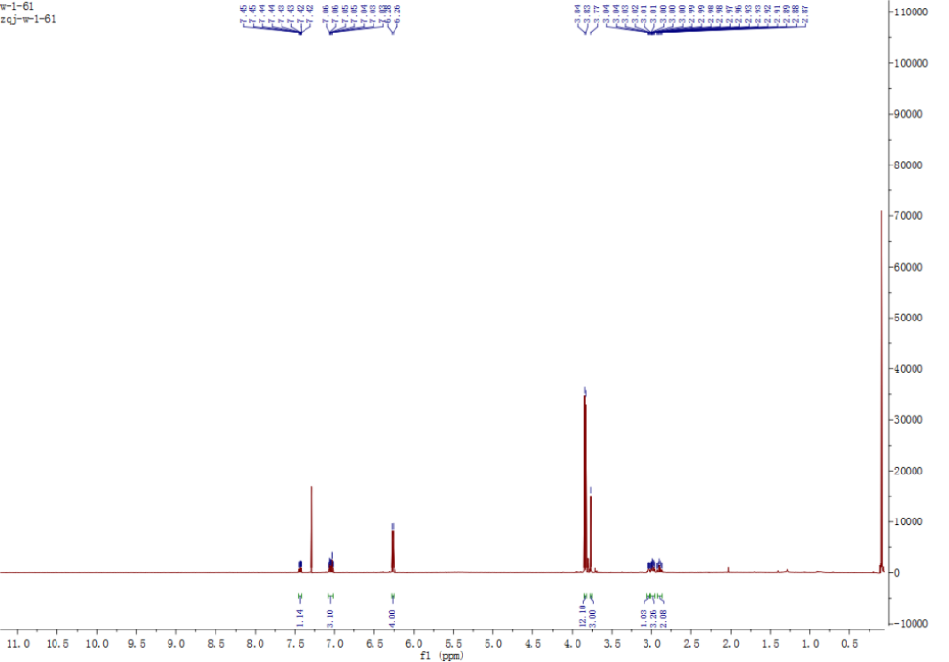
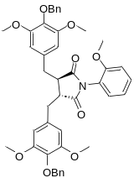
Figure S13: ¹H NMR spectrum of 10d.
Figure S14: ¹³C NMR spectrum of 10d.

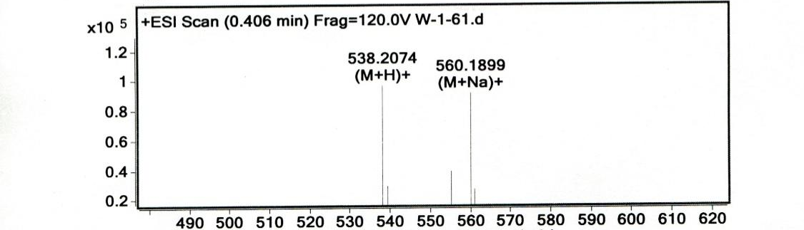
Figure S15: HR MS spectrum of 10d.
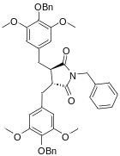
Figure S16: ¹H NMR spectrum of 10e.
Figure S17: ¹³C NMR spectrum of 10e.
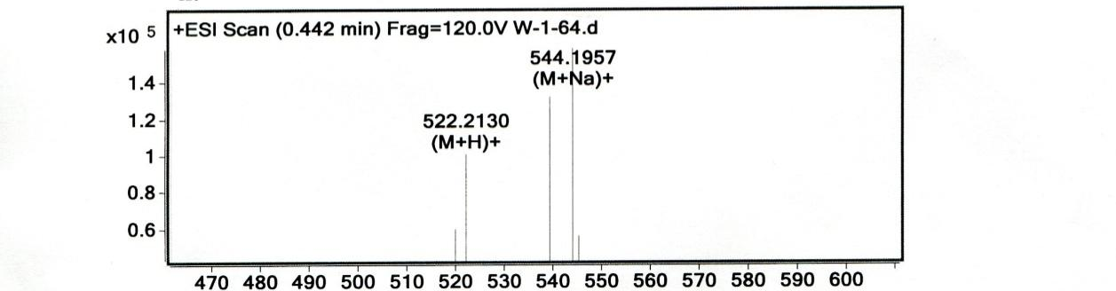
Figure S18: HR MS spectrum of 10e.

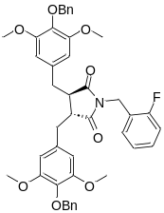
Figure S19: ¹H NMR spectrum of 10f.
Figure S20: ¹³C NMR spectrum of 10f.

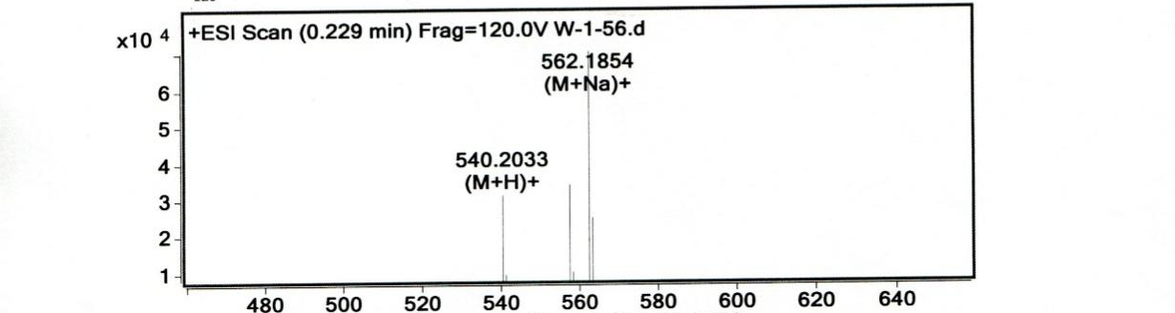
Figure S21: HR MS spectrum of 10f.
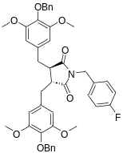
Figure S22: ¹H NMR spectrum of 10g.
Figure S23: ¹³C NMR spectrum of 10g.
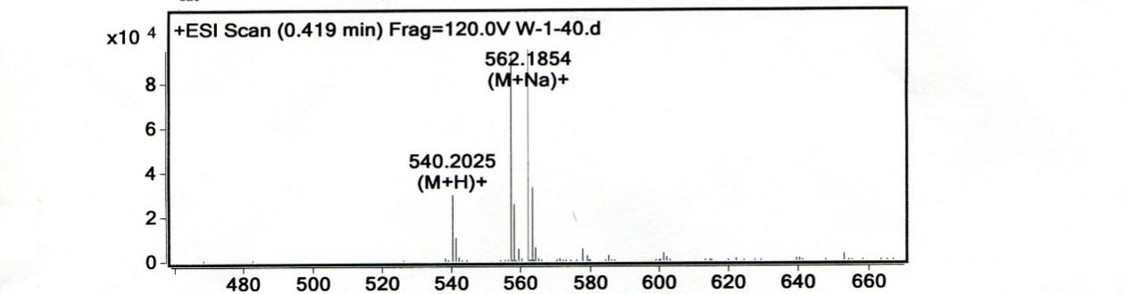
Figure S24: HR MS spectrum of 10g.

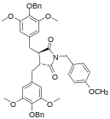
Figure S25: ¹H NMR spectrum of 10h.
Figure S26: ¹³C NMR spectrum of 10h.

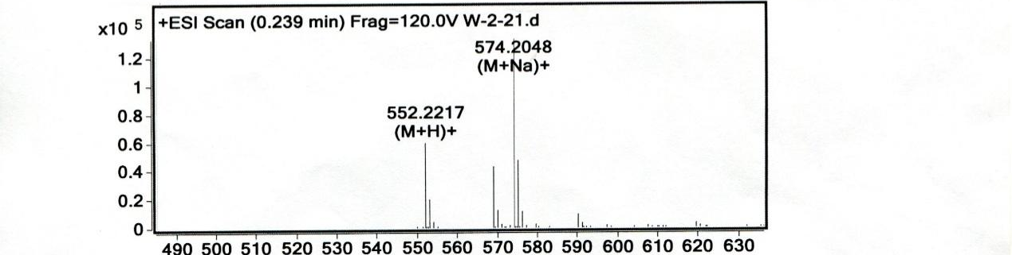
Figure S27: HR MS spectrum of 10h.
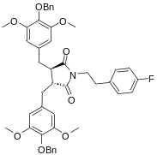
Figure S28: ¹H NMR spectrum of 10i.
Figure S29: ¹³C NMR spectrum of 10i.
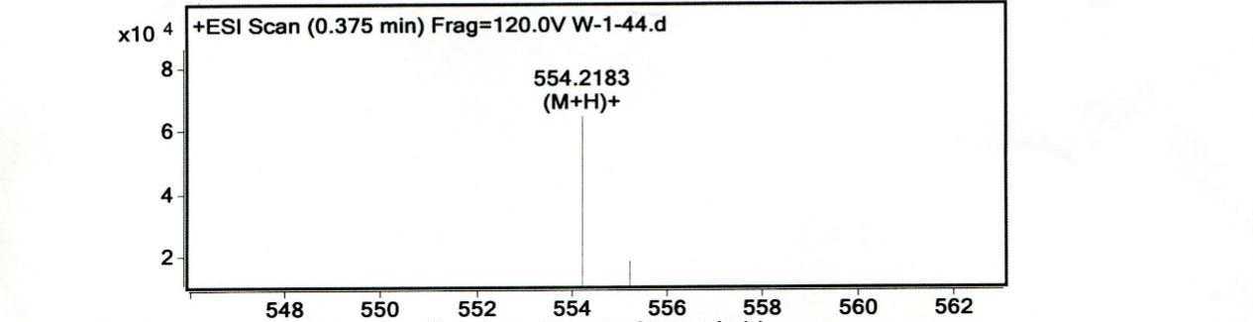
Figure S30: HR MS spectrum of 10i.
Figure S31: ¹H NMR spectrum of 13.
Figure S32: ¹³C NMR spectrum of 13.
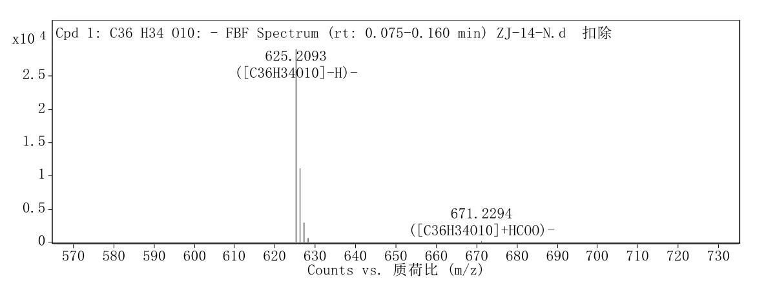

Figure S33: HR MS spectrum of 14.

Figure S34: ¹H NMR spectrum of 16a.
Figure S35: ¹³C NMR spectrum of 16a.
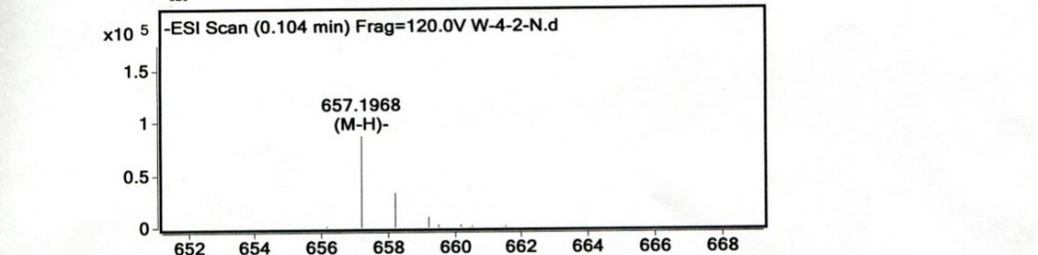
Figure S36: HR MS spectrum of 16a.
Figure S37: ¹H NMR spectrum of 16b.
Figure S38: ¹³C NMR spectrum of 16b.
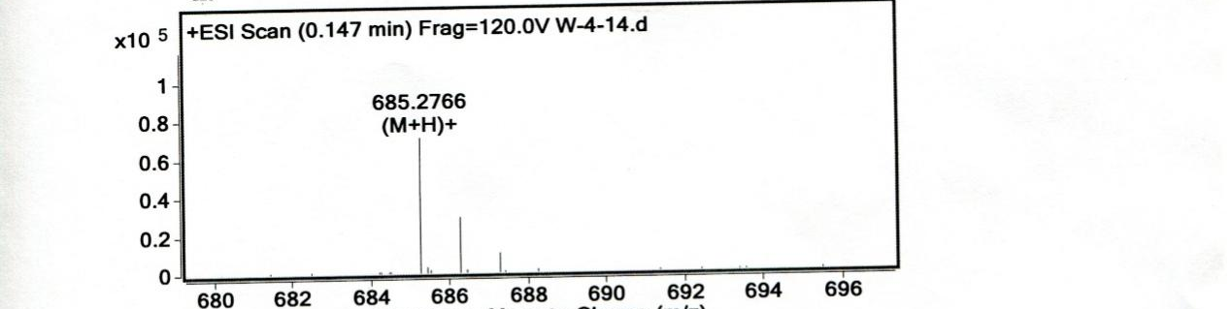
Figure S39: HR MS spectrum of 16b.

Figure S40: ¹H NMR spectrum of 16c.
Figure S41: ¹³C NMR spectrum of 16c.

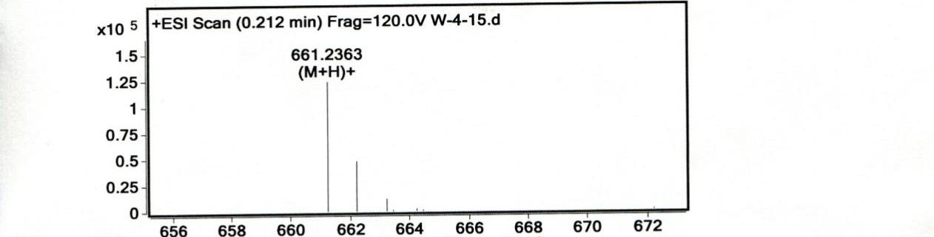
Figure S42: HR MS spectrum of 16c.
Figure S43: ¹H NMR spectrum of 16d.
Figure S44: ¹³C NMR spectrum of 16d.
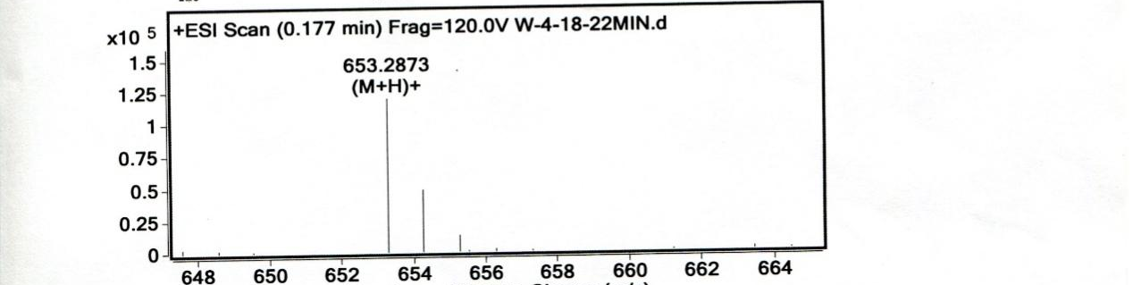
Figure S45: HR MS spectrum of 16d.

* Corresponding author. Department of Organic Chemistry, School of Pharmacy, Naval Medical University, Shanghai 200433, China. ** Corresponding author. Department of Organic Chemistry, School of Pharmacy, Naval Medical University, Shanghai 200433, China. *** Corresponding author. Naval Medical Center, Naval Medical University, Shanghai, 200433, China. E-mail addresses: chaixy1207@163.com (X. Chai), qjzhao_325@126.com (Q. Zhao), songyan455@126.com (Y. Song). ¹ These authors contribute equally to this work.

