Supplementary files
Supplementary Table 1. Summary statistics of the weekly number of clinical malaria cases in zones of Ethiopia aggregated annually and across the whole study period. The exposed population for each year is calculated as the cumulative population size of zones with non-missing data on clinical malaria cases.
Year | Mean | Standard deviation | Min | 1st quartile | Median | 3rd quartile | Max | Exposed Population
2013 | 823.7 | 1090.9 | 0 | 127 | 366 | 1167.75 | 12622 | 80,940,353
2014 | 537.0 | 807.3 | 0 | 110 | 257 | 694 | 11505 | 83,125,742
2015 | 428.5 | 753.4 | 0 | 83 | 185 | 409 | 10815 | 85,370,137
2016 | 430.1 | 693.9 | 0 | 83 | 190 | 439.75 | 8206 | 89,556,108
2017 | 308.7 | 529.3 | 0 | 60 | 129 | 309 | 6841 | 92,648,115
2018 | 238.5 | 404.4 | 0 | 42 | 92 | 263 | 5571 | 95,503,848
2019 | 342.3 | 539.4 | 0 | 50.5 | 138 | 373.5 | 4974 | 98,082,452
2020 | 333.9 | 561.9 | 0 | 52 | 155 | 356.75 | 6607 | 101,845,634
2021 | 300.3 | 548.2 | 0 | 42 | 128 | 311 | 8122 | 105,068,112
2022 | 613.6 | 1127.4 | 0 | 71 | 215 | 683.75 | 15913 | 102,011,002
2023 | 656.1 | 891.2 | 0 | 85 | 317 | 765 | 5212 | 104,765,299
Overall | 432.8 | 758.1 | 0 | 65 | 170 | 456 | 15913 | 105,068,112

Supplementary Table 2. Population in 2022, the number of zones, and summary statistics of the weekly counts of clinical malaria cases for each region in Ethiopia.
Region | Population in 2022 | Number of zones | Mean | Standard deviation | Min | 1st quartile | Median | 3rd quartile | Max
Addis Ababa | 3,859,999 | 1 | 71.8 | 34.7 | 0 | 47 | 67 | 91 | 210
Afar | 2,033,002 | 5 | 278.2 | 192.2 | 0 | 149 | 251 | 367 | 1594
Amhara | 22,876,991 | 12 | 936.9 | 1415.7 | 0 | 149 | 362 | 1155 | 15913
Benishangul-Gumuz | 1,218,000 | 4 | 961.6 | 920.9 | 0 | 170 | 707.75 | 1490.25 | 5571
Dire Dawa | 535,000 | 1 | 42.3 | 95.3 | 1 | 11 | 19 | 37 | 1128
Gambela | 508,004 | 4 | 440.1 | 492.7 | 0 | 136 | 243 | 581 | 4333
Harari | 276,000 | 1 | 91.7 | 107.1 | 1 | 17.75 | 48 | 117.25 | 579
Oromia | 39,926,505 | 20 | 249.9 | 387.7 | 0 | 48 | 121 | 278 | 5431
SNNP | 13,763,888 | 17 | 437.8 | 549.5 | 0 | 65 | 207 | 634 | 4645
Sidama | 4,141,905 | 1 | 929.7 | 1113.1 | 0 | 283.75 | 469 | 981 | 7396
Somali | 6,602,612 | 11 | 102.0 | 76.7 | 0 | 41 | 82 | 151 | 719
South West | 3,587,210 | 6 | 303.9 | 429.9 | 0 | 67 | 172 | 350.5 | 4219
Tigray | 5,738,996 | 7 | 573.8 | 749.0 | 0 | 52 | 215 | 879 | 5829

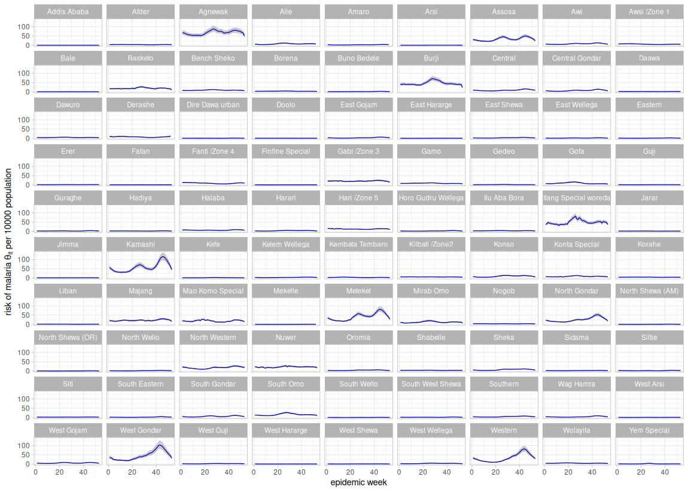
Supplementary figure 1. Mean (solid line) and 95% credible interval (grey shading) of the estimated risk of malarial per 10,000 population for each week in different zones of Ethiopia.

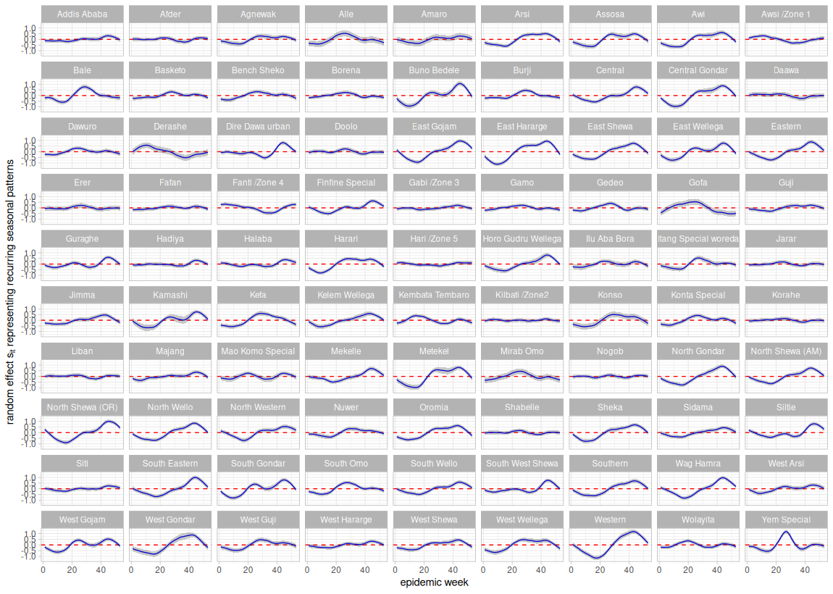

Supplementary figure 2. Mean (solid line) and 95% credible interval (grey shading) of the temporal random effect representing weekly recurring seasonal patterns in different zones of Ethiopia.

