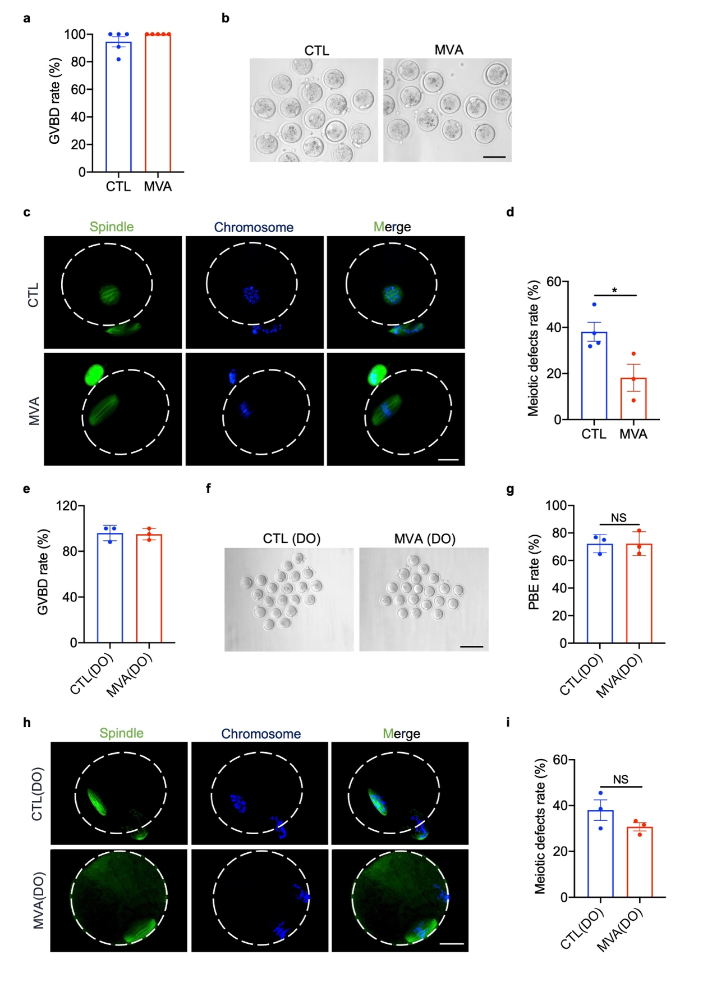
Extended Data Fig. 1| MVA supplementation has no effect on the meiotic process in DOs. a, Rate of germinal vesicle breakdown (GVBD) in the control (CTL) and MVA groups. CTL group: aged COCs cultured in MEMα maturation medium. MVA group: aged COCs cultured in MEMα maturation medium supplemented with 50 µM MVA. The data are presented as the mean ± SEM of five independent experiments. b, Images of oocytes isolated from COCs after maturation for 14 h in the CTL and MVA groups. Scale bar, 100 µm. c, Representative images of spindle morphology and chromosome alignment in the CTL and MVA groups. Scale bar, 25 µm. d, Rate of meiotic defects was analyzed in the CTL and MVA groups. The data are shown as the mean ± SEM of at least three independent experiments. e, Rate of GVBD in the CTL (control) and MVA groups. CTL group: DOs cultured in MEMα maturation medium; MVA group: DOs cultured in MEMα maturation medium with 50 µM MVA. The data are shown as the mean ± SEM of three independent experiments. f, Images of oocytes after maturation for 14 h in the CTL and MVA groups. Scale bar, 200 µm. g, PBE rate was measured in the CTL and MVA groups. The data are shown as the mean ± SEM of three independent experiments. NS, not significant. h, Representative images of spindle morphology and chromosome alignment in the CTL and MVA groups. Scale bar, 25 µm. i, Rate of the meiotic defects was analyzed in the CTL and MVA groups. The data are shown as the mean ± SEM of three independent experiments. NS, not significant. An unpaired two-tailed Student’s t test was used for statistical analysis. *P < 0.05.

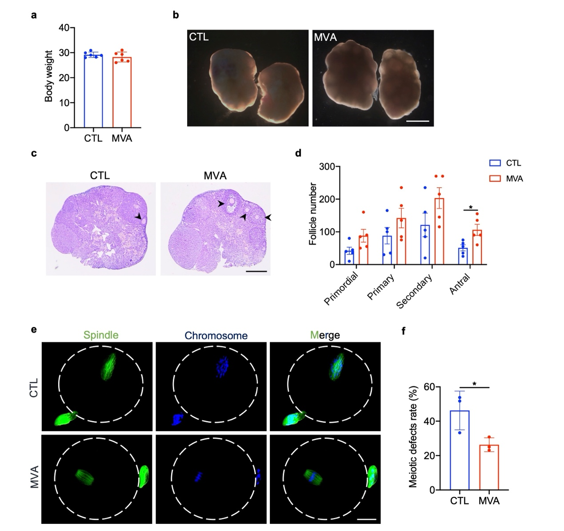
Extended Data Fig. 2| MVA injection ameliorates aging-related ovarian reserve depletion in vivo. a, Body weights of mice in the CTL and MVA groups. CTL group: Nine-month-old female mice intraperitoneally injected with normal saline. MVA injected group, 9-month-old female mice intraperitoneally injected with 5 mg kg⁻¹ MVA every day. The data are shown as the mean ± SEM of five independent experiments. b, Micrographs of ovaries from mice in the CTL and MVA injected groups. Scale bar, 1 mm. c, HE-stained micrographs of ovaries from the CTL and MVA group mice. The arrowheads denote antral follicles. Scale bar, 500 µm. d, The number of follicles in the CTL and MVA injected groups. The data are shown as the mean ± SEM of five independent experiments. e, Representative images of spindle morphology and chromosome alignment in the CTL and MVA injected groups. Scale bar, 25 µm. f, Rate of the meiotic defects was analyzed in the CTL and MVA injected groups. The data are shown as the mean ± SEM of three independent experiments. An unpaired two-tailed Student’s t test was used for statistical analysis. *P < 0.05.
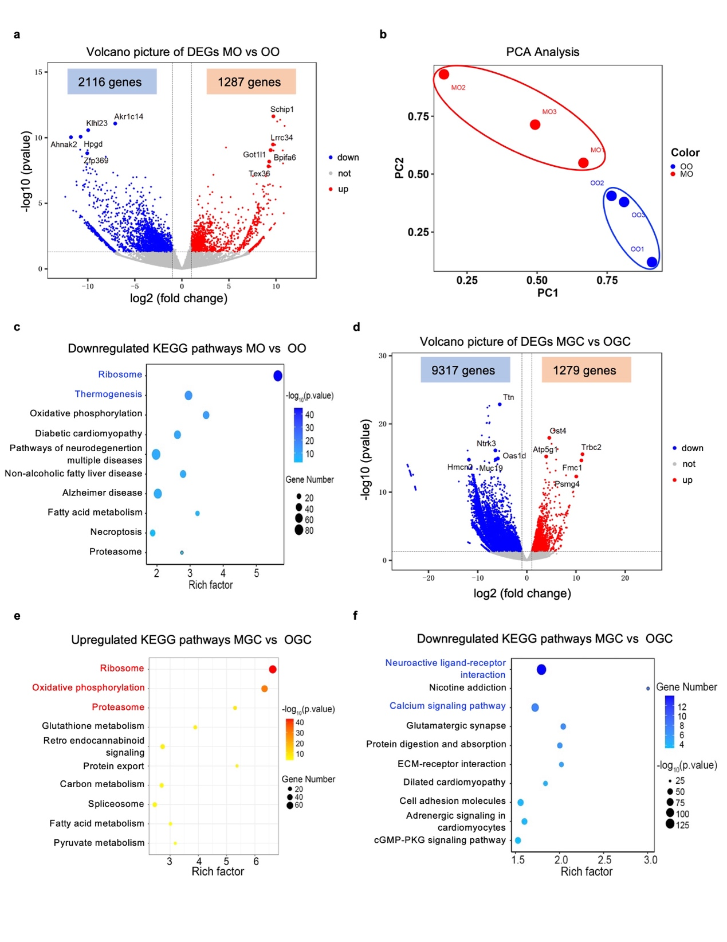
Extended Data Fig. 3| RNA-seq analysis of oocytes and GCs from aged COCs in the CTL and MVA groups. a, Volcano plot showing DEGs (downregulated, blue; upregulated, red) in oocytes from the MVA group compared with those from the CTL group. The highly expressed DEGs are listed. b, PCA plot of oocyte gene expression patterns in the CTL and MVA groups separated by PC1 and PC2. c, KEGG analysis of the downregulated DEGs in CTL and MVA- treated aged oocytes from COCs. d, Volcano plot showing DEGs (downregulated, blue; upregulated, red) in GCs from aged COCs in the MVA- treated group compared with those in GCs from the CTL group. The highly expressed DEGs are listed. e, KEGG analysis of the upregulated DEGs in CTL and MVA- treated GCs from COCs. f, KEGG analysis of the downregulated DEGs in CTL and MVA- treated GCs from COCs.

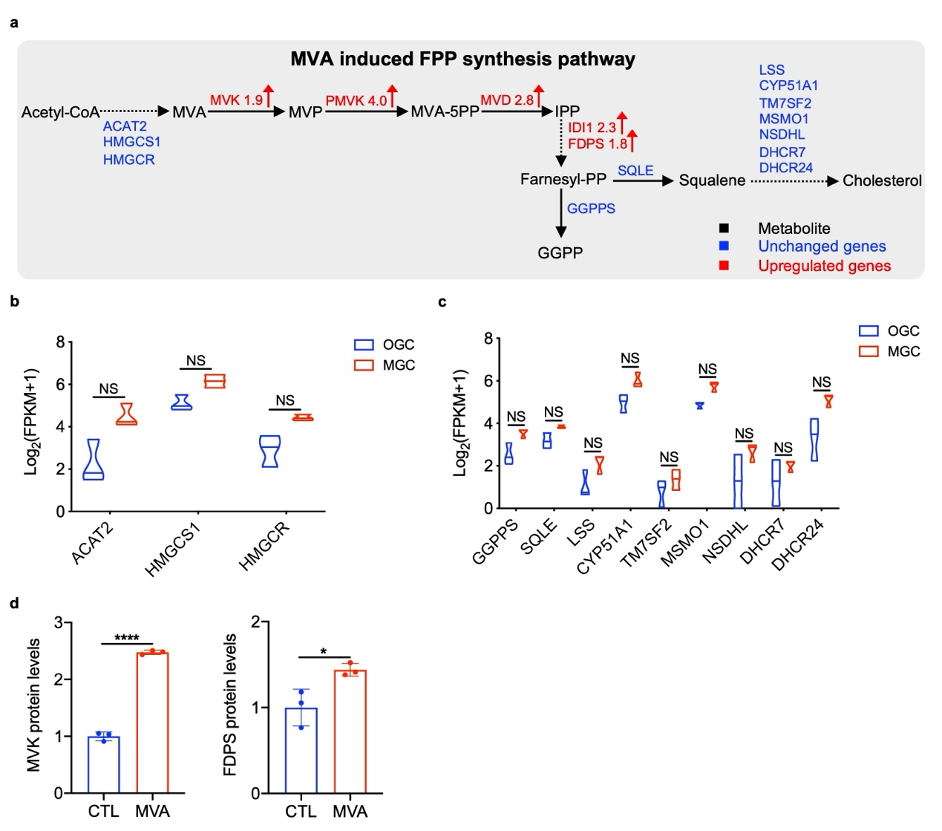
Extended Data Fig. 4| MVA activates FPP synthesis pathway-associated genes in GCs of aged COCs. a, Overview of the MVA pathway status after MVA supplementation in GCs from aged COCs. The red font denotes upregulated genes. b, Violin plot showing the expression levels of ACAT2, HMGCS1, and HMGCR in CTL- and MVA-treated GCs based on the RNA-seq results. NS, not significant. c, Violin plot showing the expression levels of GGPPS, SQLE, LSS, CYP51A1, TM7SF2, MSMO1, NSDHL, DHCR7, and DHCR24 in CTL and MVA-treated GCs based on the RNA-seq results. NS, not significant. d, The protein levels of MVK and FDPS in MVA-treated KGN cells. The data are shown as the mean ± SEM of three independent experiments. An unpaired two-tailed Student’s t test was used for statistical analysis. *P < 0.05 or ****P < 0.0001.

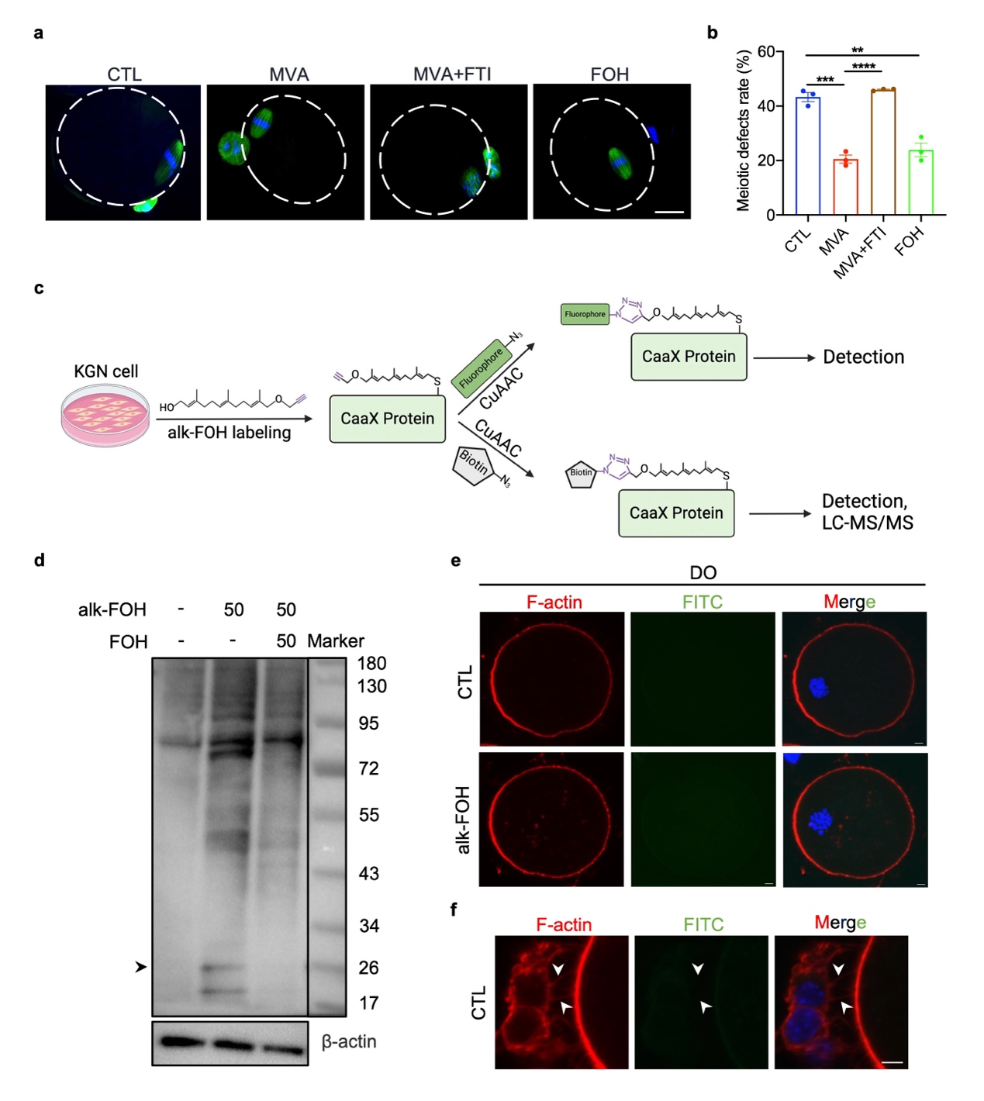
Extended Data Fig. 5| The addition of alkyne groups does not affect the activity of FOH. a, Representative images of spindle morphology and chromosome alignment in the CTL, MVA, MVA+FTI, and FOH groups. CTL group: Old COCs cultured in MEMα maturation medium; MVA group: Old COCs cultured in MEMα maturation medium supplemented with 50 µM MVA; MVA+FTI group: Old COCs cultured in MEMα maturation medium supplemented with 50 µM MVA and 10 µM FTI-277; FOH group: Old COCs cultured in MEMα maturation medium supplemented with 10 µM FOH. Scale bar, 25 µm. b, Rate of the meiotic defects were analyzed in the CTL, MVA, MVA+FTI, and FOH groups. The data are shown as the mean ± SEM of three independent experiments. c, Schematic of the metabolic labelling of KGN cells with alk-FOH and subsequent CuAAC ligation with biorthogonal detection tags for imaging or proteomics. d, Western blotting analysis showing prenylated proteins in KGN cells treated with alk-FOH (50 µM) with or without FOH (50 µM). e, Fluorescence imaging of DOs after incubation with 50 µM alk-FOH for 14 h. Scale bar, 5 µm. f, Fluorescence imaging showing the alk-FOH signals in the gap junction from COCs in the CTL group. Scale bar, 5 µm. An unpaired two-tailed Student’s t test was used for statistical analysis. **P < 0.01, ***P < 0.001, or ****P < 0.0001.

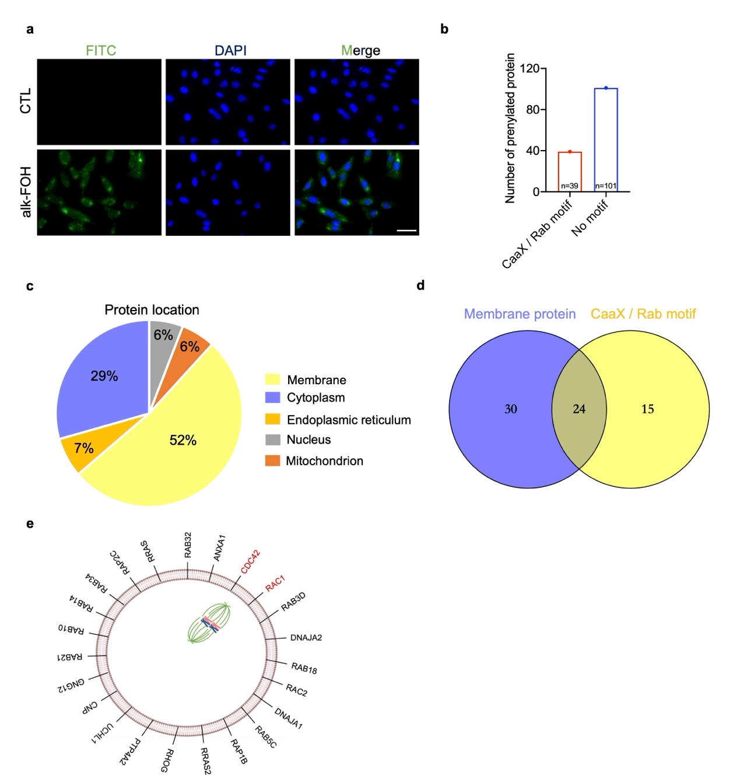
Extended Data Fig. 6| Identification of putative prenylated proteins. a, Fluorescence imaging of KGN cells after incubation with 50 µM alk-FOH for 24 h. Scale bar, 50 µm. b, The number of proteins labelled by alk-FOH with a carboxyl-terminal CaaX/Rab motif or without the motif. c, Protein localization of identified proteins predicted by UniProt analysis. d, Overlap of identified proteins with a carboxyl-terminal CaaX or Rab motif and proteins located on the cell membrane. e, Proteins labelled with alk-FOH with a carboxyl-terminal CaaX/Rab motif and located on the cell membrane.
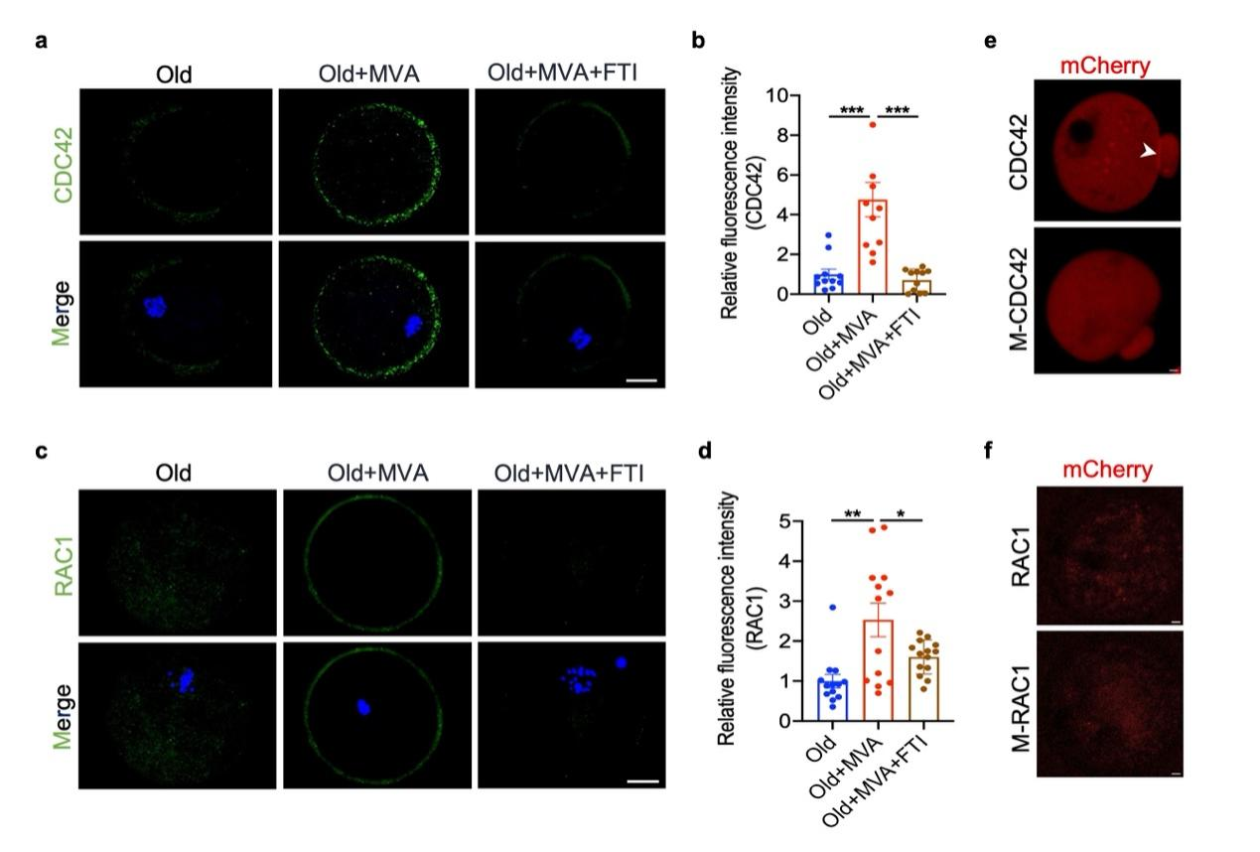
Extended Data Fig. 7| MVA induces cortical localization of CDC42 and RAC1 via prenylation. a, Fluorescence imaging showing CDC42 expression in oocytes from the Old, Old+MVA, and Old+MVA+FTI groups. Scale bar, 25 µm. b, CDC42 fluorescence intensity in the Old (n=11), Old+MVA (n=11), and Old+MVA+FTI (n=11) groups. c, Fluorescence imaging showing RAC1 expression in oocytes from the Old, Old+MVA, and Old+MVA+FTI groups. Scale bar, 25 µm. d, RAC1 fluorescence intensity in the Old (n=13), Old+MVA (n=13), and Old+MVA+FTI (n=14) groups. e, Representative images of CDC42 distribution in oocytes injected with CDC42 mRNA or CDC42^{C188Y}(M-CDC42) mRNA. f, Representative images of RAC1 distribution in oocytes injected with RAC1 mRNA or RAC1^{C188Y}(M-RAC1) mRNA. An unpaired two-tailed Student’s t test was used for statistical analysis. *P < 0.05, **P < 0.01, and ***P < 0.001.
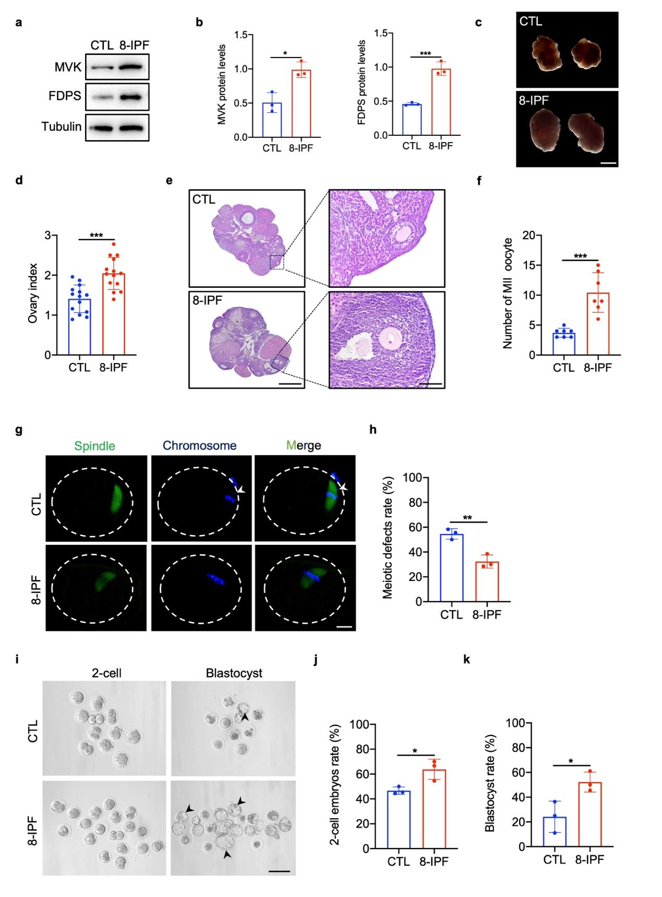
Extended Data Fig. 8| 8-IPF ameliorates ovarian reserve and embryo development in aged mice. a, Western blotting analysis of MVK and FDPS expression in aged mouse GCs treated with 8-IPF. b, MVK and FDPS protein levels in 8-IPF-treated aged mouse GCs. The data are shown as the mean ± SEM of three independent experiments. c, Micrographs of ovaries from the CTL and 8-IPF groups. Scale bar, 1 mm. CTL group: aged mice treated with normal saline. 8-IPF group: aged mice treated with 5 mg/kg/d 8-IPF. d, Ovary index of the CTL (n=14) and 8-IPF (n=14) groups. The data are shown as the mean ± SEM. e, HE-stained micrographs of mouse ovaries from the CTL and 8-IPF groups. Scale bar, 50 µm or 500 µm. f, The number of MII oocytes in the CTL (n=7) and 8-IPF (n=7) groups. The data are shown as the mean ± SEM. g, Morphologies of spindles and chromosomes in MII oocytes derived from CTL and 8-IPF mice. Scale bar, 25 µm. h, The meiotic defect rates of MII oocytes derived from CTL and 8-IPF mice. The data are shown as the mean ± SEM of three independent experiments. i, Micrographs of in vitro fertilization (IVF) outcomes in the CTL and 8-IPF groups. The arrowheads indicate blastocysts. Scale bar, 200 µm. j-k, Rates of 2-cell embryos and blastocysts in the CTL and 8-IPF groups. The data are shown as the mean ± SEM of three independent experiments. An unpaired two-tailed Student’s t test was used for statistical analysis. *P < 0.05, **P < 0.01, or ***P < 0.001.

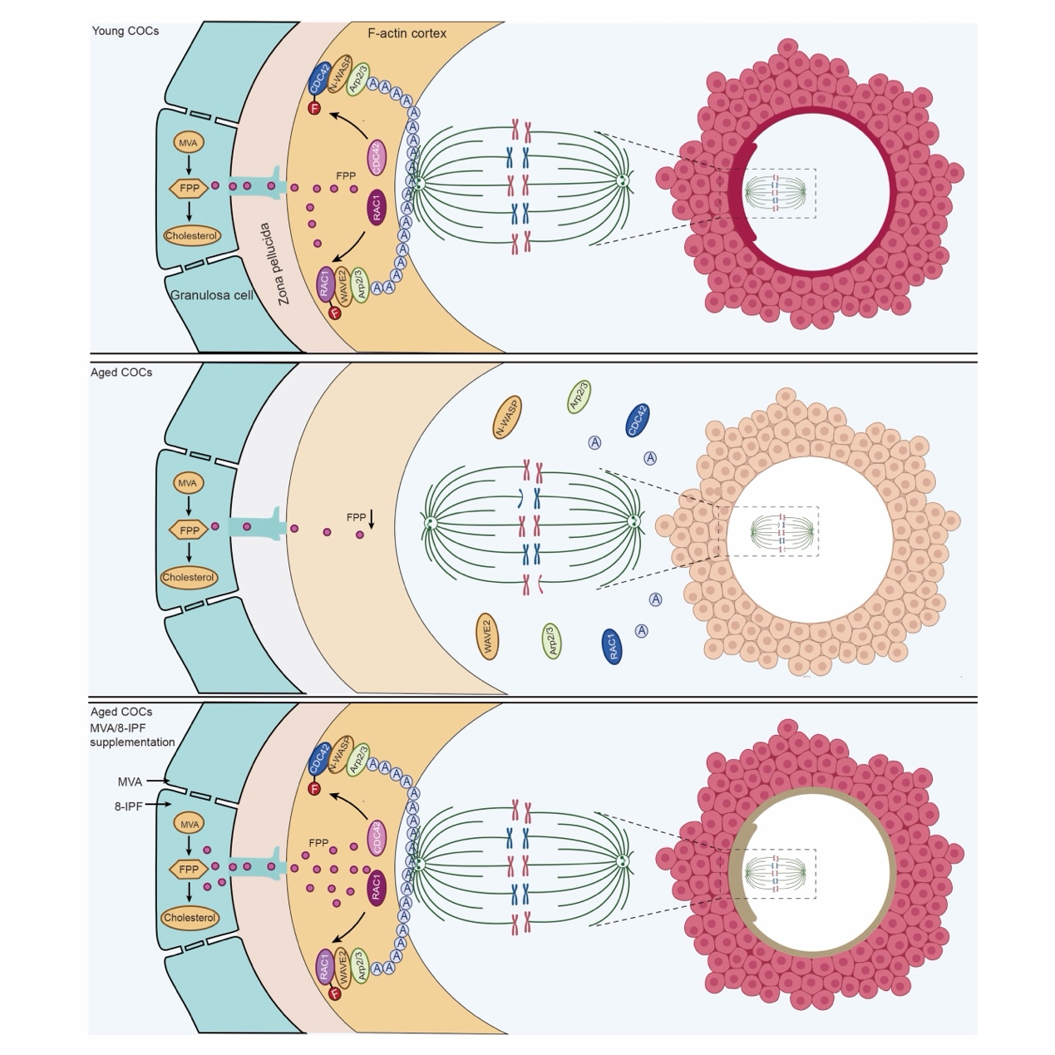
Extended Data Fig. 9| Schematic showing the mechanism by which MVA ameliorates aged oocyte cortical F-actin assembly and quality. Decreased FPP synthesis in GCs is one of the main causes of declined quality in oocytes during ovarian aging. MVA/8-IPF supplementation activate the FPP synthesis pathway in GCs, and GCs subsequently transfer FPP to oocytes to prenylate CDC42 and RAC1 and promote cortical F-actin assembly in aged oocytes. F, prenylation.

