Supplementary Information
Characterizing Hormone Secretion Patterns in PitNETs with Metabolomics: Implications for Understanding Tumor Biology
2D NMR Spectral Process:
For the purpose of validation, two-dimensional (2D) heteronuclear 1H-13C Heteronuclear Single Quantum Coherence Spectra (HSQC) and homonuclear proton Total Correlation Spectroscopy (TOCSY) NMR spectroscopy experiments were acquired on Qc samples obtained by extracting 100 µL from each respective sample groups. The HSQC and TOCSY NMR spectra were obtained for each QC sample using the "hsqcetgpsisp2.2" and "dipsi2gpphzs" pulse sequences from Bruker's standard pulse catalog on a 700 MHz NMR system (Bruker Neo) with a cryogenically cooled probe head (QCI CryoProbe) at a temperature of 22 ºC within the TUBITAK Marmara Research Center. The spectral width for the 1H (F2) and 13C (F1) dimensions in HSQC was 11.7 and 185 ppm, respectively, and for TOCSY it was 11.7 and 12.0 ppm, respectively, with 256 increments recorded for every spectrum. The HSQC experiments were conducted with 64 scans and a relaxation delay of 1.5 s for each scan, while the TOCSY experiments were conducted with 48 scans and a relaxation delay of 2 s. For all the TOCSY experiments the mixing time for spin systems was set to 80 ms. During the spectral processing, a QSINC window function was applied to all free induction decays (FID), and the LPfc linear prediction procedure was used with a coefficient of 60 and 48 for the HSQC and TOCSY experiments, respectively.

Table 1. The median and mean values of all the metabolites measured with NMR.

METABOLITE | F |  |  | NF
 | Median | Mean | MAD | Mean | Median | MAD
Acetate | 251,85 | 289,6 | 118,18 | 343,5417 | 283,6000 | 155,9722
Acetoacetate | 94,9 | 134,3 | 71,16 | 127,9250 | 133,5000 | 53,525
Alanine | 1183,3 | 1403,44 | 658,956 | 1327,3167 | 1163,1500 | 602,8223
Arginine | 502,25 | 729,42 | 367,464 | 898,8583 | 629,7500 | 543,3013
Ascorbate | 414,75 | 612,15 | 408,86 | 1004,5000 | 1145,2500 | 587,5833
Aspartate | 722,65 | 836,22 | 447,004 | 697,9833 | 687,4000 | 345,2167
Choline | 210 | 272,01 | 152,772 | 451,6083 | 391,6500 | 187,9263
Creatine | 117,6 | 195,06 | 154,444 | 147,2500 | 150,3000 | 42,19167
Creatine phosphate | 194,95 | 244,68 | 134,812 | 240,6000 | 213,7000 | 119,1833
Ethanolamine | 256,75 | 425,49 | 309,708 | 364,3182 | 245,6000 | 177,4744
Fumarate | 44 | 48,25 | 16,22 | 38,0333 | 37,0000 | 10,92217
Glucose | 264,6 | 516,25 | 449,61 | 169,5750 | 141,0000 | 61,63333
Glutamate | 2172,15 | 2855,28 | 1605,736 | 1486,7667 | 1319,0500 | 670,8767
Glutamine | 208,05 | 358,2375 | 272,82 | 235,9417 | 127,6500 | 187,8387
Glycine | 1233,5 | 1593,18 | 766,096 | 1958,7333 | 1640,8500 | 978,9943
Histidine | 254,95 | 281,48 | 112,18 | 192,4750 | 167,7000 | 82,0875
Hypoxanthine | 411,85 | 391,89 | 116,21 | 383,7833 | 364,2000 | 73,62767
Isocitrate | 678,9 | 952,8667 | 576,4664 | 676,2750 | 557,2000 | 399,5417
Isoleucine | 239 | 252,64 | 80,396 | 134,0750 | 135,1000 | 48,74167
Lactate | 5350 | 6879,35 | 3890,55 | 4855,2250 | 4810,5500 | 2307,108
Leucine | 785,85 | 858,03 | 295,976 | 686,9000 | 690,6000 | 242,7667
Lysine | 561,8 | 576,68 | 270,12 | 420,6375 | 415,0000 | 228,0719
Methionine | 177,3 | 208,85 | 93,29 | 132,6000 | 111,0000 | 70,74545
N-Acetylaspartate | 259,65 | 402,575 | 354,7063 | 404,5250 | 325,1500 | 200,6958
N-Acetylglutamine | 154,85 | 221,66 | 146,572 | 181,0286 | 161,5000 | 107,2611
O-Phosphocholine | 417,25 | 505,19 | 291,966 | 642,5333 | 533,2500 | 355,7217
O-Phosphoethanolamine | 1165,35 | 1766,6 | 1124,08 | 4027,4583 | 3924,1000 | 1974,458
Phenylalanine | 282,6 | 394,79 | 193,728 | 192,1583 | 169,7500 | 75,968
Proline | 879,2 | 955,52 | 458,264 | 1000,6167 | 828,8500 | 527,1517
S-Adenosylhomocysteine | 212,9 | 260,7 | 129,96 | 184,8500 | 177,4500 | 94,26667
Taurine | 1709,95 | 3249,75 | 2460,41 | 3690,6667 | 2855,8500 | 1924,903
Threonine | 411,6 | 532,69 | 293,008 | 305,5250 | 278,2000 | 125,8792
Tyrosine | 326,9 | 336,01 | 112,39 | 199,8833 | 197,1500 | 86,53333
Uracil | 218,1 | 250,01 | 87,972 | 227,1583 | 219,5000 | 78,075
Valine | 452,25 | 455,93 | 151,85 | 302,7417 | 341,0500 | 110,1348
myo-Inositol | 479,85 | 631,39 | 336,506 | 2622,7000 | 2622,8000 | 1237,917
sn-Glycero-3-phosphocholine | 315,4 | 417,65 | 220,18 | 575,4083 | 420,9000 | 364,4083
VoT | 3,885 | 5,572 | 3,5464 | 8,9975 | 5,6150 | 6,109167
F: Functioning, NF: Nonfunctioning, MAD:Mean Absolute Deviation. (The units of measurement are expressed as micromolars per 100 milligrams of tissue)
VoT: Volume of Tumor (mm³)

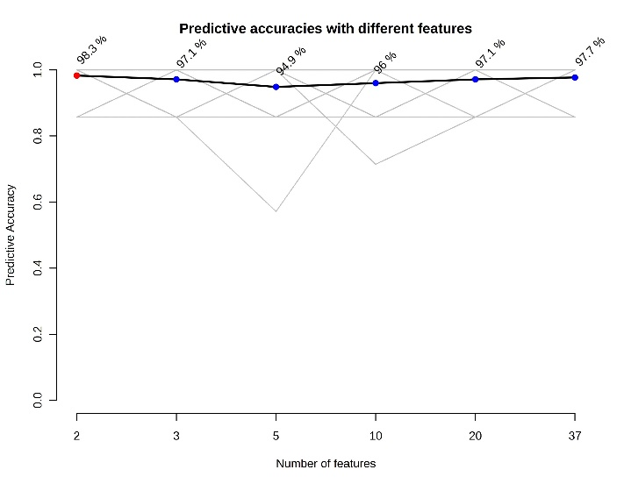
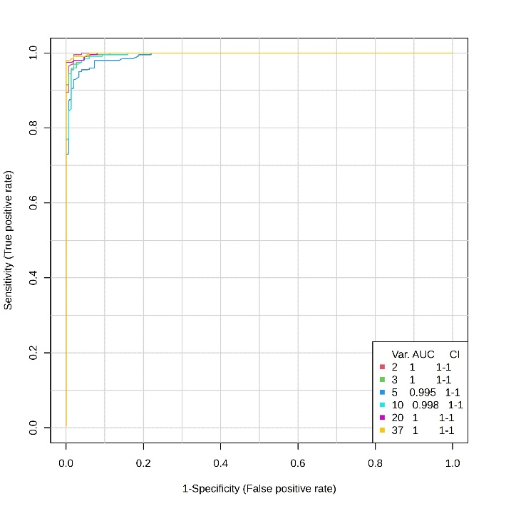
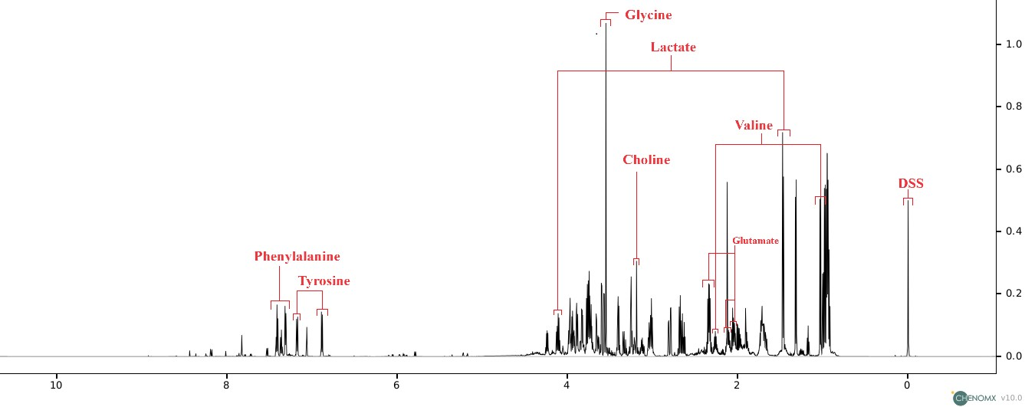
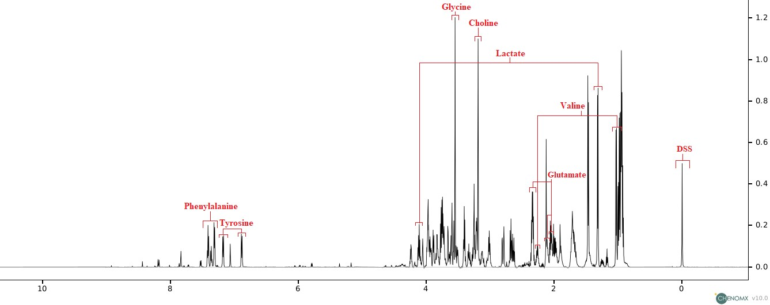
2
1
Fig 2 and 3: ROC analysis viusalizations of the study. AUC values have more than 99 % in (1) and the values of the predictive accuracies for different numbers of feature groups in (2) on the right
Fig 1 The NMR spectroscopic profiles of the samples (Qc) were obtained from separately pooled groups. The spectrum of the functioning group's Qc is displayed in the upper section, while the NMR spectrum of the nonfunctioning group's Qc is situated in the lower section. It is important to note that the fingerprint spectra of significant metabolites such as myo-inositol, isoleucine, and o-phosphoethanolamine are not distinctly represented in this visualization. This omission is due to the concealment of these metabolites' spectral signatures within the spectra of other metabolites present in the samples. DSS: Sodium 2-(trimethylsilyl)-1-propanesulfonate-d6

Table 2. Influenced pathways, number of hits, hit metabolites and p values according to function of PitNETs
PATHWAY | Total Compound |  | Hits |  | Hit metabolites | Raw p | Impact
Glycine, serine and threonine metabolism | 33 | 4 |  | Choline; Glycine; L-Threonine; Creatine |  | 9.87E-05 | 0.25981
Glycerophospholipid metabolism | 36 | 5 |  | Choline phosphate; Choline; Ethanolamine phosphate; Ethanolamine; sn-Glycero-3-phosphocholine |  | 0.000101 | 0.1208
Inositol phosphate metabolism | 30 | 1 |  | myo-Inositol |  | 0.00026 | 0.12939
Phenylalanine, tyrosine and tryptophan biosynthesis | 4 | 2 |  | L-Phenylalanine; L-Tyrosine |  | 0.000994 | 1
Phenylalanine metabolism | 8 | 2 |  | L-Phenylalanine; L-Tyrosine |  | 0.000994 | 0.35714
Tyrosine metabolism | 42 | 2 |  | L-Tyrosine; Acetoacetate |  | 0.006675 | 0.13972
Histidine metabolism | 16 | 2 |  | L-Histidine; L-Aspartate |  | 0.008956 | 0.22131
Cysteine and methionine metabolism | 33 | 2 |  | L-Methionine; S-Adenosyl-L-homocysteine |  | 0.042683 | 0.13105

