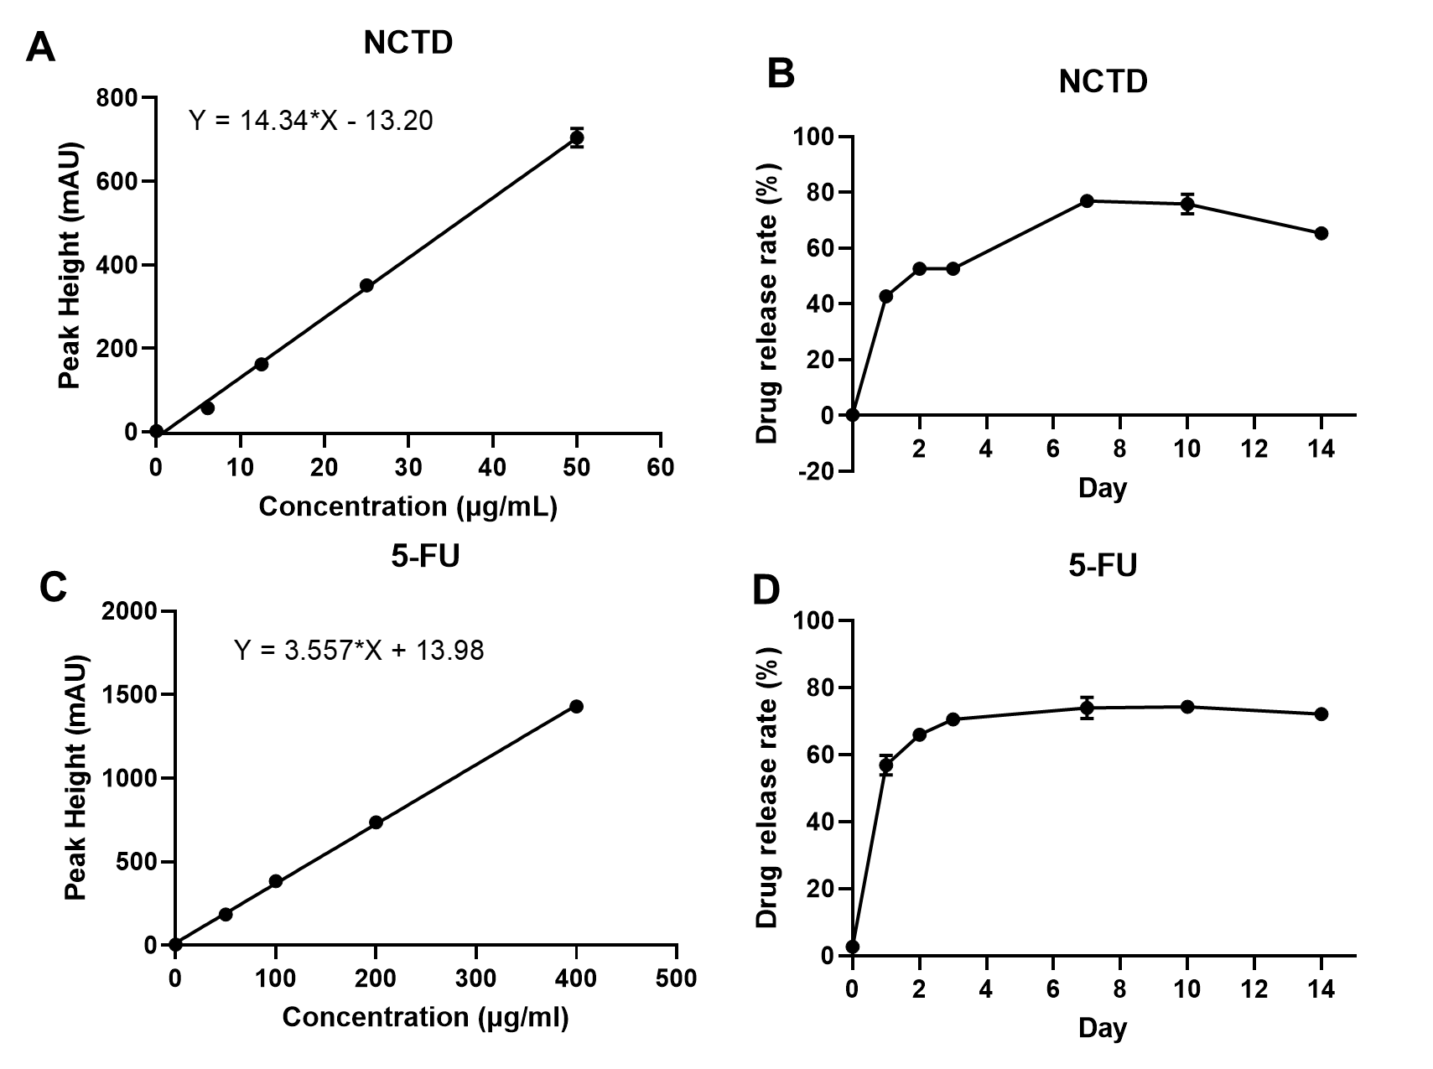
Figure S1 In vitro drug release experiment. Standard curves of NCTD (A) and 5-FU (C) drug concentrations and absorption peaks in the liquid phase. Payload release profiles of nanoparticle: NCTD@F127 (B) and 5-FU@F127 (D) in PBS at 37° over 14 days.
Figure S2 Images for the tumor bearing mice administered with NCTD@F127, 5-FU@F127 and Osimertinib@F127 treatment alone or combinational therapy (Combi). F127 treated group serves as vehicle control.

