Supplementary Figures
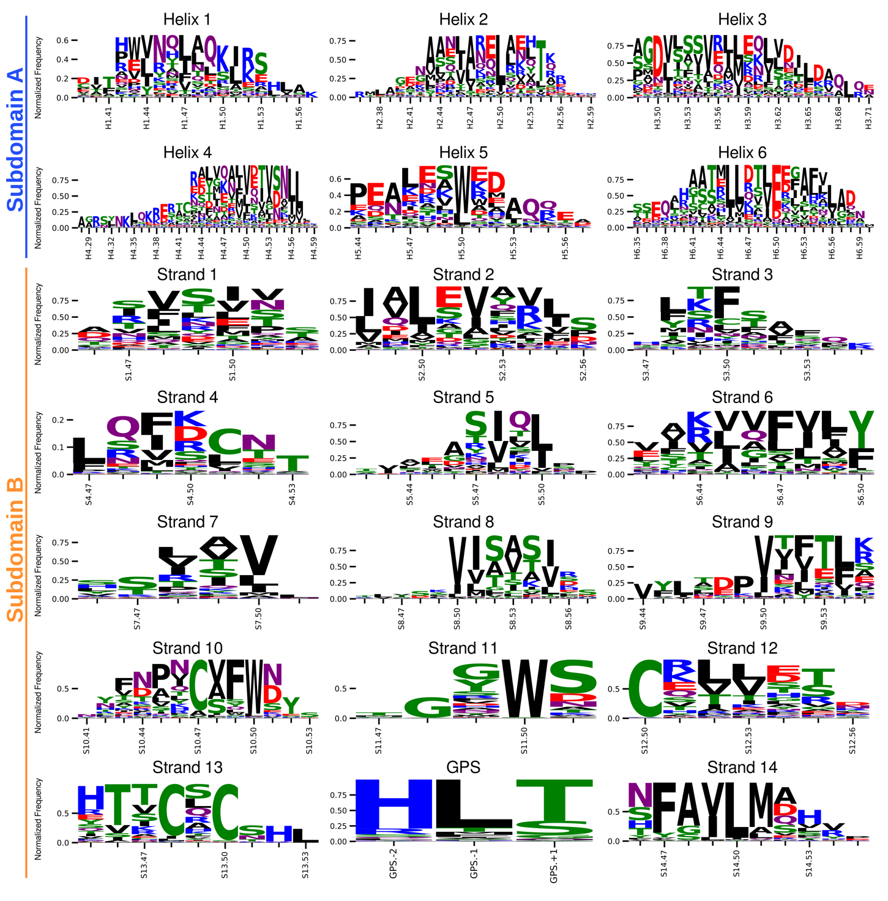

Supplementary Fig. 1 | Consensus Logo for all GAIN-GRN indexed segments. Residues are colored by chemical property. Total column height represents the total number of structures. The labeled position and letter height represents the relative fraction of residue present at the respective position, with a value of 1.0 indicating the GRN present in all 14,435 studied adhesion GPCR GAIN domains.

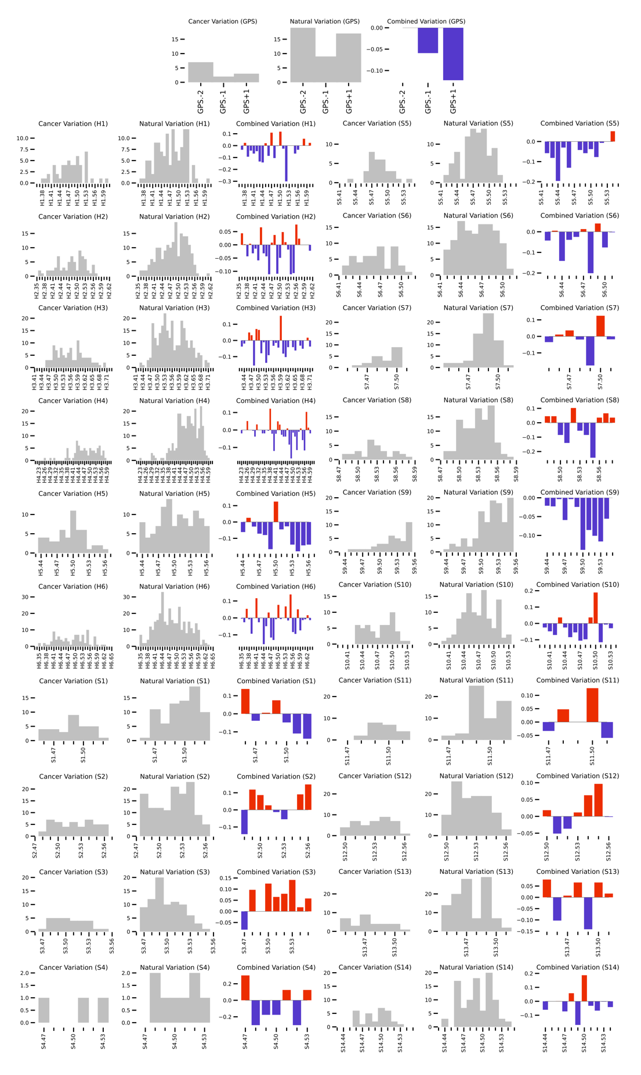
Supplementary Fig. 2 | Cancer Enrichment Score for GAIN-GRN indexed Elements. Grey plots show number of cancer-associated variants from The Cancer Genome Atlas (TCGA) Genomic Data Commons (GDC)¹ and naturally occurring polymorphisms from the dbSNP. Right plots show cancer enrichment score according to Wright et al., 2019 ².

Supplementary Fig. 3 | The topology of polycystin GAIN domains. a, the adhesion GPCR GAIN domain shows up to six helices in subdomain A (blue) and up to 14 β-strands in a β-sandwich subdomain B (orange), with the tethered agonist (TA, yellow), forming the most C-terminal β-strand. The GPCR proteolysis site is denoted by the catalytic triad HL|T (labeled spheres) for autoproteolysis. b, the polycystin GAIN domain shows more helices in subdomain A (light blue for additional helices, blue), with identical topology of subdomain B and an additional subdomain C (green) forming a β-sandwich of nine strands with an extension of the TA embedded as its most C-terminal strand (c). d, the topology of the polycystin GAIN domain shows the additional helices and subdomain C as an extended fold between S9 and S10, where S10 may extend in β-strand conformation uninterrupted as part of both β-sandwich subdomains. Topology is based on human polycystin-1 (PKD1) protein (UniProt identifier: P98161).

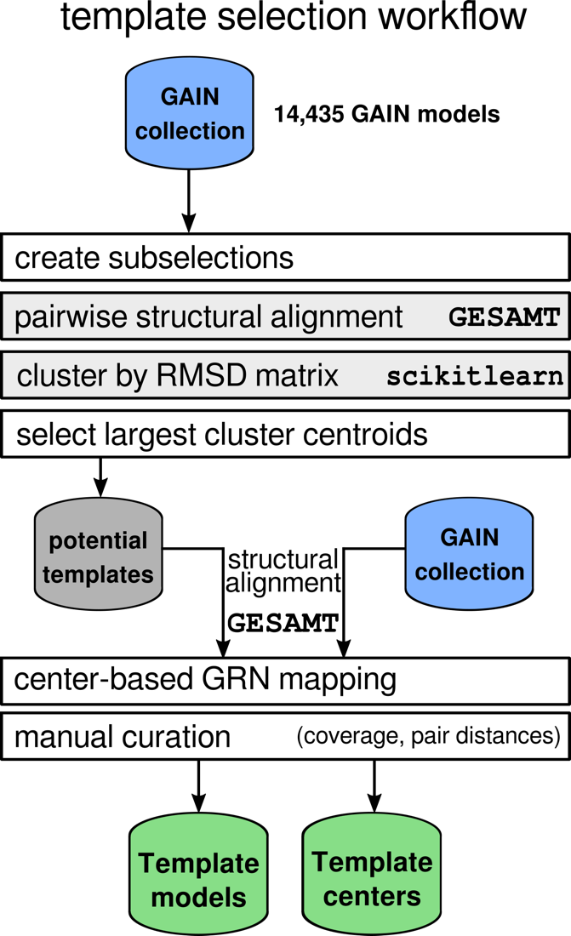

Supplementary Fig. 4 | Methodological workflow for template selection. The workflow proceeds top to bottom. Based on the dataset of 14,435 adhesion GPCR GAIN domain models (blue), sub-selections were created based on receptor orthologues, which were put through GESAMT pairwise alignment¹⁰, to find cluster within the sub-selections with the scikitlearn¹¹ package. Of these clusters, the lowest-RMSD structure was added to the potential templates. Each of the potential template was pairwise aligned via GESAMT¹⁰ and via manual curation, a set of template models covering all receptor orthologues was created and center positions (represented by the “.50” GRN) defined as the basis for the GAIN GRN calculation (green).

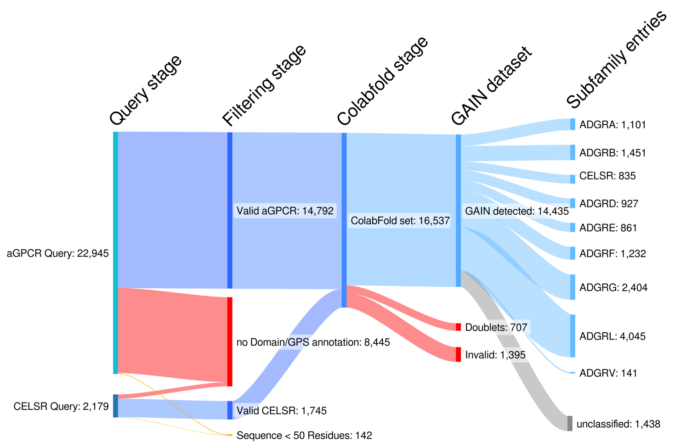

Supplementary Fig. 5 | Filtering and Composition of the aGPCR GAIN domain dataset for the GAIN GRN. From left to right: At the query stage, the sequences were retrieved in two queries from the UniProtKB database¹². Entries were filtered for the “GPS” domain entry and a minimum sequence length of 50 residues. The remaining sequences were folded via ColabFold/AlphaFold2^{13,14} and checked for valid GAIN domain architecture. The dataset decomposed by aGPCR subfamily is shown in the right.
Created with SankeyMATIC (https://sankeymatic.com).

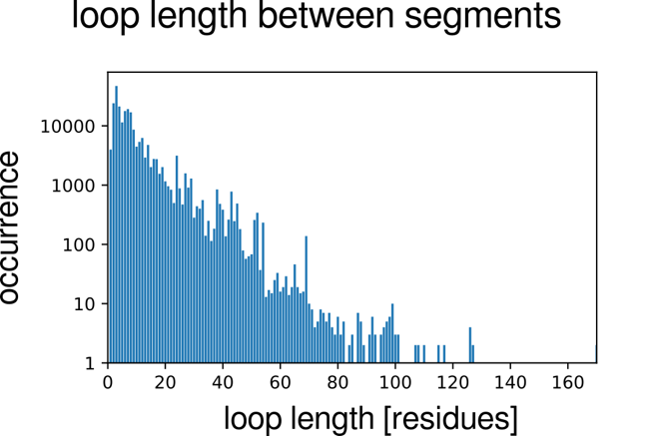

Supplementary Fig. 6 | Distribution of inter-segment loop lengths in the GAIN domain model dataset. Number of occurring loop with defined length is shown with logarithmic scale.

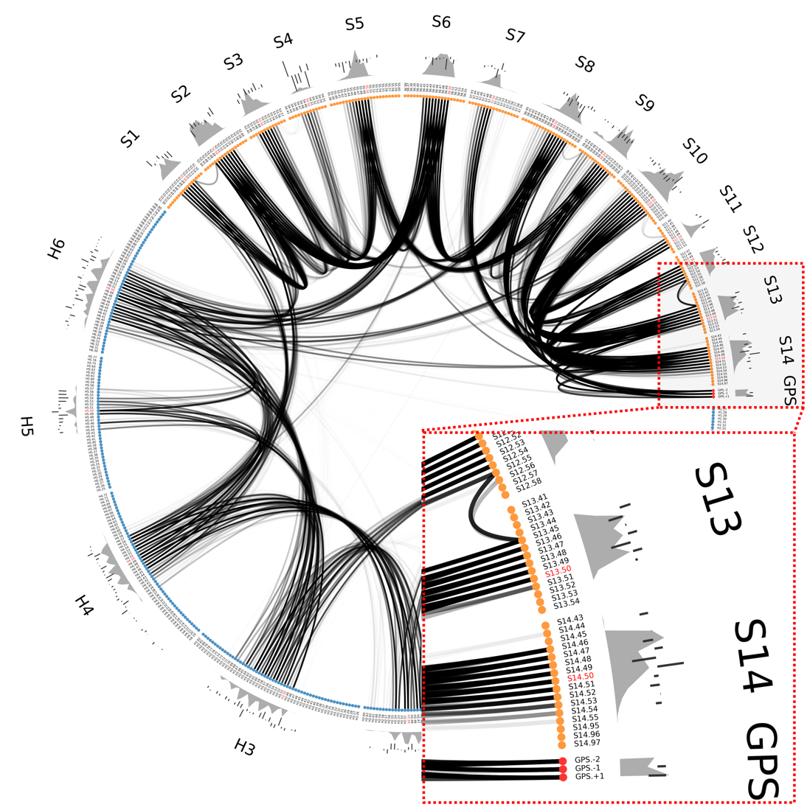
Supplementary Fig. 7 | aGPCR contactome visualized as a flareplot. Residues are represented as color-coded dots in a circle (blue and orange for subdomains A and B, respectively and red for GPS) grouped by their SSE. Pairs of dots are connected with black curves, with opacities proportional to each pair’s residue-residue contact frequencies (4 Å distance cutoff) over the whole dataset of geometries (N= 14435, see Supplementary Fig. 5). Aggregated by residue, these frequencies yield a measure of residue participation in the overall GAIN-contactome. This measure is represented in gray on the outer ring of the plot (gray, ragged backdrop or aura). Also on that outer ring is the cancer enrichment score (Supplementary Fig. 2), which is represented as straight lines pointing either inwards (negative score) or outwards (positive score). Taking the shown inset as example, the following information can be extracted: of S14, residue S14.47 is the highest participating residue (highest gray aura) while not particularly cancer enriched (short straight line going inwards). The segment center, S14.50 (GRN label in red) is cancer enriched (longer straight line pointing outwards) and also one of the highest participating residues. For clarity, intra-segment contacts are not shown.

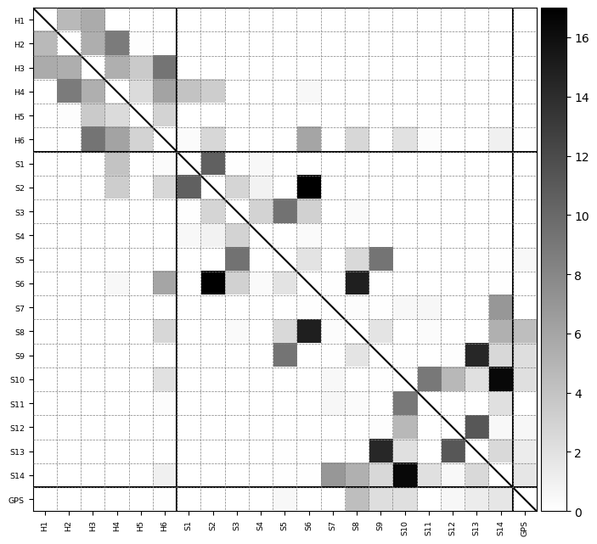
Supplementary Fig. 8 | Per-segment contact-map for intra- and inter-domain contacts. Average number of residue-residue contacts (4 Å distance cutoff) aggregated to each residue’s GAIN segment. For clarity of the colormap, the diagonal has been left blank. The solid vertical and horizontal lines visually separate subdomains A, B and the GPS triad. Of note, H4 and H6 of subdomain A account for all inter-domain contacts (off-diagonal blocks in the upper right, or in the bottom left), contacting mostly S6 of subdomain B. This is in line with the observation about conserved SSEs of Figure 2 b. For individual contacts between residues, see Supplementary Fig. 7.
1. Araç, D. et al. A novel evolutionarily conserved domain of cell-adhesion GPCRs mexadiates autoproteolysis. The EMBO Journal 31, 1364–1378 (2012).
2. Munk, C., Harpsøe, K., Hauser, A. S., Isberg, V. & Gloriam, D. E. Integrating structural and mutagenesis data to elucidate GPCR ligand binding. Curr. Opin. Pharmacol. 30, 51–58 (2016).
3. Isberg, V. et al. Generic GPCR residue numbers - Aligning topology maps while minding the gaps. Trends in Pharmacological Sciences 36, 22–31 (2015).
4. Isberg, V. et al. GPCRDB: an information system for G protein-coupled receptors. Nucleic Acids Res. 42, D422–D425 (2014).
5. Kooistra, A. J. et al. GPCRdb in 2021: Integrating GPCR sequence, structure and function. Nucleic Acids Research 49, D335–D343 (2021).
6. Linden, O. P. J. van, Kooistra, A. J., Leurs, R., Esch, I. J. P. de & Graaf, C. de. KLIFS: A Knowledge-Based Structural Database To Navigate Kinase–Ligand Interaction Space. J. Med. Chem. 57, 249–277 (2014).
7. Collins, R. L. et al. A structural variation reference for medical and population genetics. Nature 581, 444–451 (2020).
8. Vincent, F. et al. Toward a Shared Vision for Cancer Genomic Data. N. Engl. J. Med. 375, 1109–1112 (2016).
9. Wright, S. C. et al. A conserved molecular switch in Class F receptors regulates receptor activation and pathway selection. Nature Communications 10, (2019).
10. Krissinel, E. Enhanced fold recognition using efficient short fragment clustering. Journal of molecular biochemistry 1, 76 (2012).
11. Pedregosa, F. et al. Scikit-Learn: Machine Learning in Python. J. Mach. Learn. Res. 12, 2825–2830 (2011).
12. Consortium, T. U. et al. UniProt: the Universal Protein Knowledgebase in 2023. Nucleic Acids Res. 51, D523–D531 (2023).
13. Jumper, J. et al. Highly accurate protein structure prediction with AlphaFold. Nature 596, 583–589 (2021).
14. Mirdita, M. et al. ColabFold: making protein folding accessible to all. Nature Methods 19, 679–682 (2022).

