Quantifying the Transformational Requirements of the Electricity Sector Under Uncertain Expectations of Carbon Removal

Sandylove Afrane ^{1,2}, Jeffrey Dankwa Ampah ^{3*}, Humphrey Adun ⁴, Jianlin Chen ⁵, Hongyang Zou⁶, Guozhu Mao ^{2*}, Pingjian Yang ^{1*}
¹ Chinese Research Academy of Environmental Sciences, Beijing, 100012, PR China
² School of Environmental Science and Engineering, Tianjin University, 300072 Tianjin, China
³ School of Mechanical Engineering, Tianjin University, 300072 Tianjin, China
⁴ Energy Systems Engineering Department, Cyprus International University, Nicosia 99258, Turkey
⁵ State Key Laboratory of Marine Pollution, City University of Hong Kong, Tat Chee Avenue, Kowloon, Hong Kong SAR, China
⁶ College of Management & Economics, Tianjin University, Tianjin 300072, China
* Corresponding authors: yang.pingjian@craes.org.cn, maoguozhu@tju.edu.cn and jeffampah@live.com

Contents
Supplementary Figures 2
CDR description 16
Model parameterization and underlying equations for demand and supply 18
References 37

Supplementary Figures
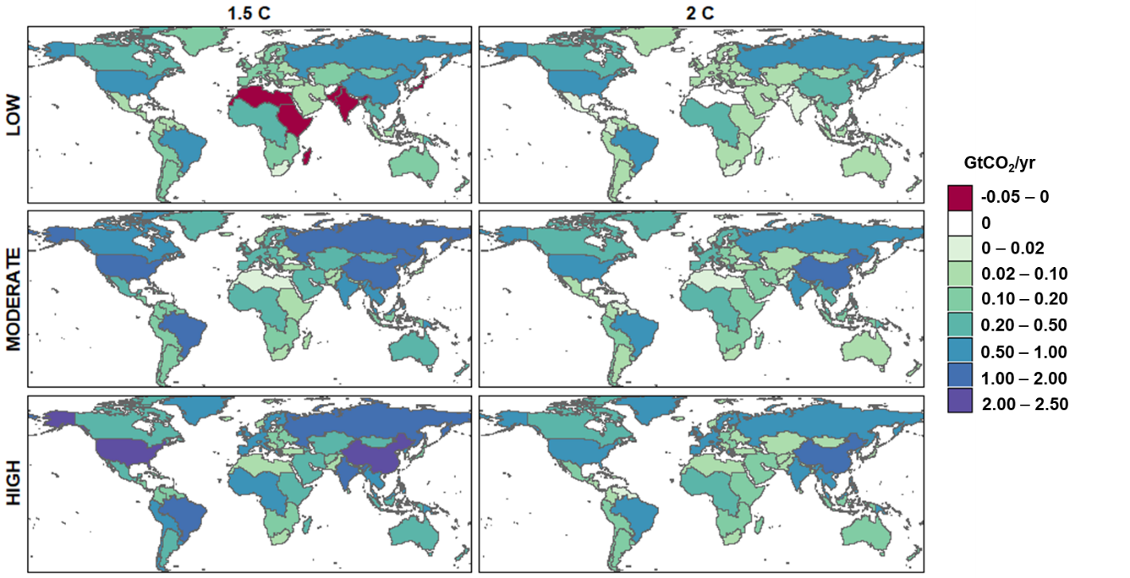
Fig. S1 Regional negative emissions in 2050 across various scenarios. Negative values represent net positive emissions, reflecting the balance between carbon sinks (photosynthetic processes in forests and savannas, and non-photosynthetic sequestration in soils and water bodies) and carbon sources (emissions from deforestation, fires, and forest degradation). In LOW scenarios, where direct air carbon capture and storage (DACCS) is the sole novel carbon dioxide removal (CDR) technology available, certain countries or regions such as India, North, and East Africa, with minimal potential for DACCS deployment, may exhibit no net negative emissions if their deforestation rates exceed afforestation/reforestation efforts. In contrast, under HIGH CDR scenarios incorporating a diverse portfolio of CDR technologies, India is projected to join major contributors like China and the United States in achieving substantial negative emissions by 2050, with estimates ranging from 1 to 2.5 GtCO2/yr.

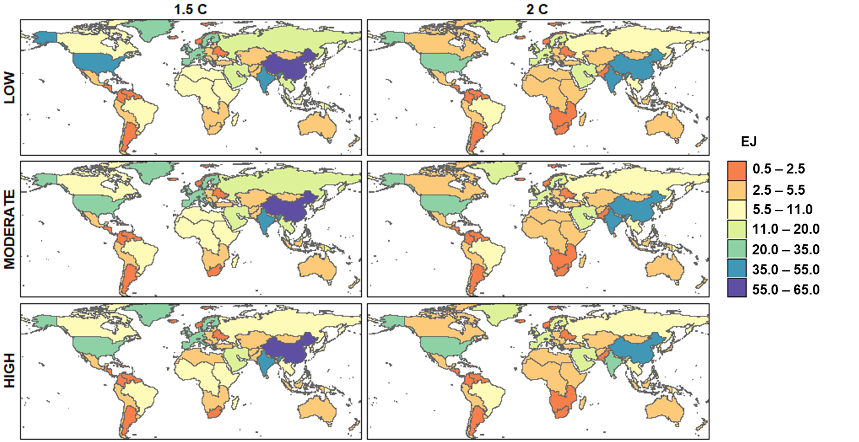
Fig. S2 Regional variations in electricity generation by 2050 across different scenarios. China will continue to lead in total electricity generation by 2050 across all scenarios, followed by India and the USA, reflective of their large economies and populations. The energy technology pathways and policy priorities adopted by these major economies will be vital in steering global deployment and innovation trajectories for clean electricity sources over the coming decades.

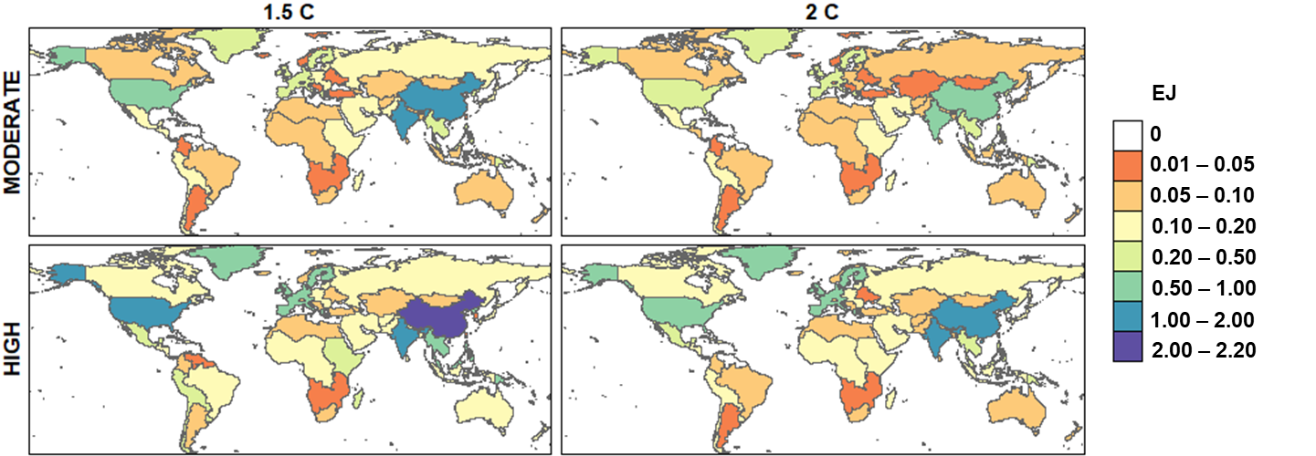
Fig. S3 Regional variations in electricity generation from bioenergy with carbon capture and storage (BECCS) by 2050 across the MODERATE and HIGH scenarios. Under the LOW CDR scenario, BECCS is not available for negative emissions, thus the electricity sector has no generation from BECCS. China, the US, and India see the highest electricity generation from BECCS by 2050 across all scenarios.

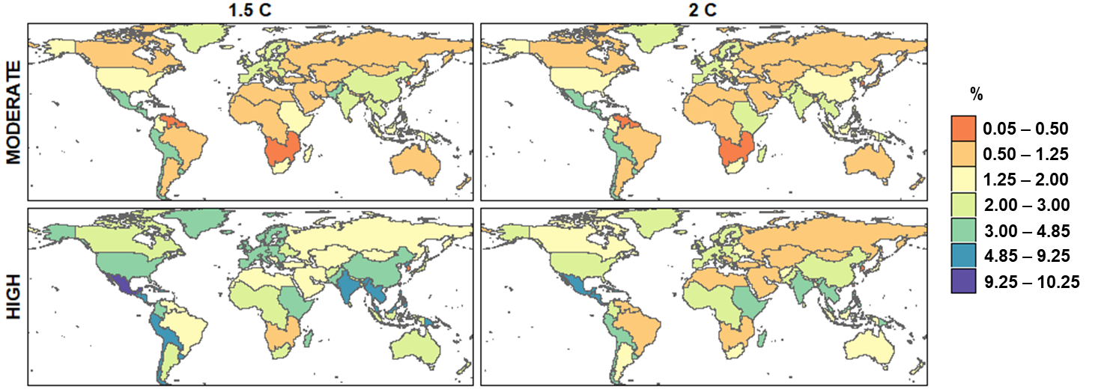
Fig. S4 Share of BECCS in each region’s total electricity generation by 2050. Higher shares of BECCS in total electricity generation are recorded under HIGH CDR, and Central America, India, Indonesia, and some parts of South America are expected to see the largest shares of BECCS in their electricity generation.
Fig. S5 Electricity generation costs by fuel. Costs for electricity generation technologies are expected to increase significantly under 1.5℃ due to its higher carbon prices compared to 2℃. In scenarios with HIGH CDR, the cost of biomass for electricity generation is relatively lower due to lower carbon prices. In all scenarios, generation costs for biomass, refined liquids, and geothermal sources are projected to be the highest.
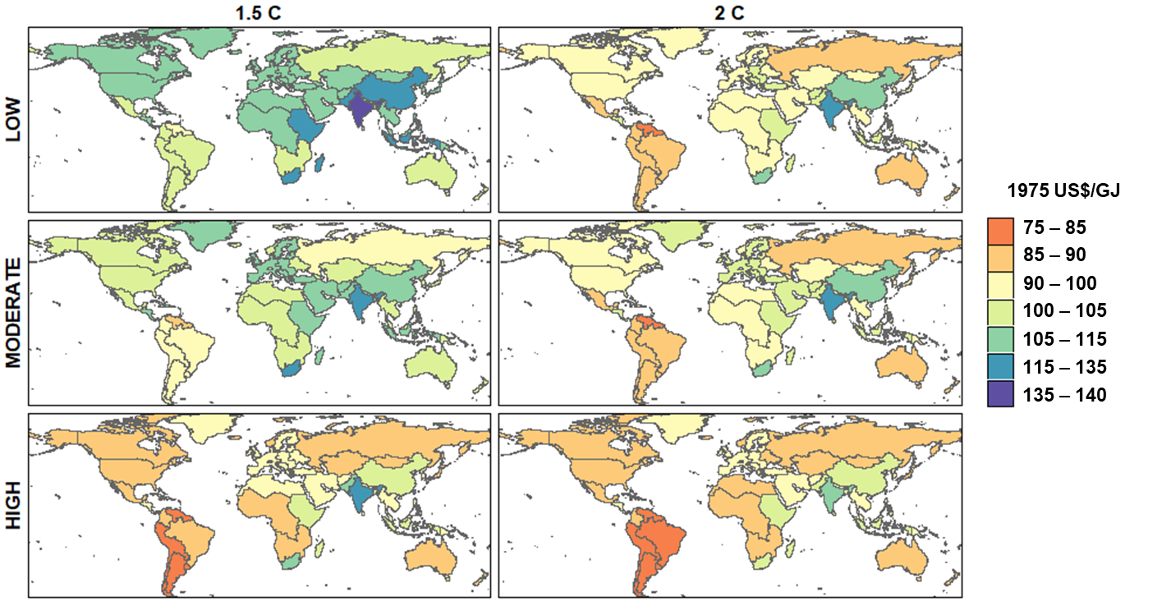
Fig. S6 Distribution of electricity generation costs by 2050 across various countries and regions. India is expected to record the highest generation cost across all scenarios especially under the LOW CDR scenario due to the need to rapidly phase out/down coal electricity. Other coal-dependent countries like China and South Africa will also have significantly high electricity generation costs by 2050.

Fig. S7 Electricity consumption under different building sub-sectors (cooling, heating, and others) across modeled scenarios. Here, “Other” could refer to services such as lighting and ventilation. The residential sector slightly dominates total electricity consumption in buildings, with most of the electricity used to meet demands other than cooling and heating. The need for rapid emission cuts will lead to higher electrification in buildings especially under 1.5℃_LOW.

Fig. S8 Electricity consumption in industrial sub-sectors across modeled scenarios. Most of the electricity consumption in the industrial sector will be in various sub-sectors other than cement. Due to cement being one of the main hard-to-abate sectors, its decarbonization with electricity would be technically and economically challenging. Strategies such as hydrogen deployment or CCS would be required to reduce emissions from cement. Also, emissions from cement could be counterbalanced with CDR. Electricity for CO₂ removal depends on the availability of energy-intensive technologies like DACCS, and as DACCS increases, the amount of electricity for removing CO₂ increases as seen in the 1.5℃_HIGH compared to other scenarios.
Fig. S9 Electricity consumption in the transport sector by technology and mode across modeled scenarios. LOW CDR pathways require rapid decarbonization across all sectors, as such electrification in transport rapidly increases as CDR availability decreases. BEV cars will highly dominate the BEV market followed by BEV-large cars and trucks across all scenarios. For modes of transportation that use electricity but without onboard batteries, freight rails will dominate, followed by passenger rails, and their dominance decrease with CDR availability and lower carbon prices under 2℃. 2W and 3W: Two and three wheel; HSR: High speed rail; BEV: battery electric vehicle

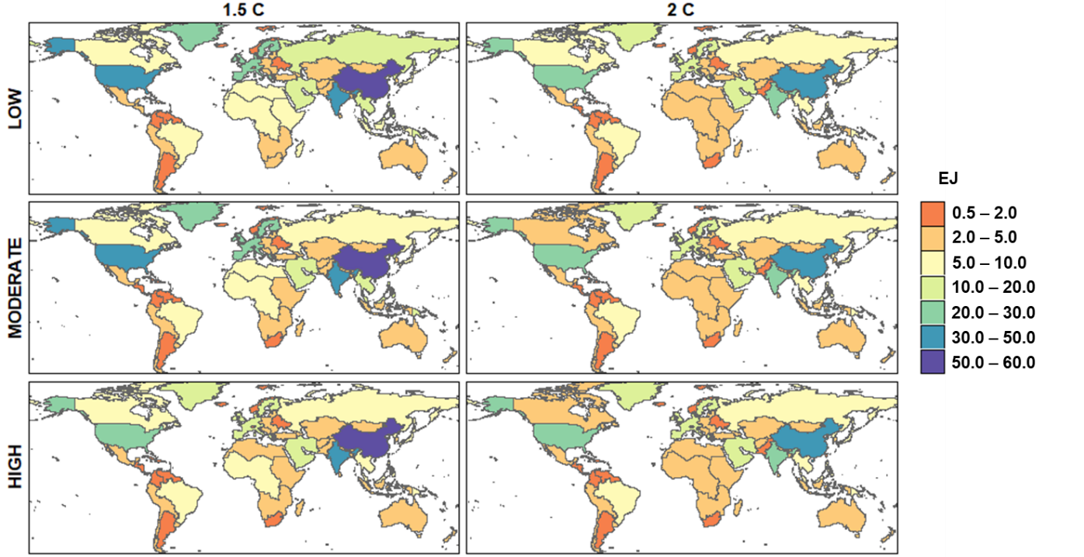
Fig. S10 Regional distribution of electricity consumption in end-use sectors by 2050 across modeled scenarios. The 1.5℃ scenarios show higher electrification across all regions compared to their respective electrification rates under 2℃ pathways. Higher electrification rates are also expected under LOW CDR as a result of the need for rapid emission cuts.

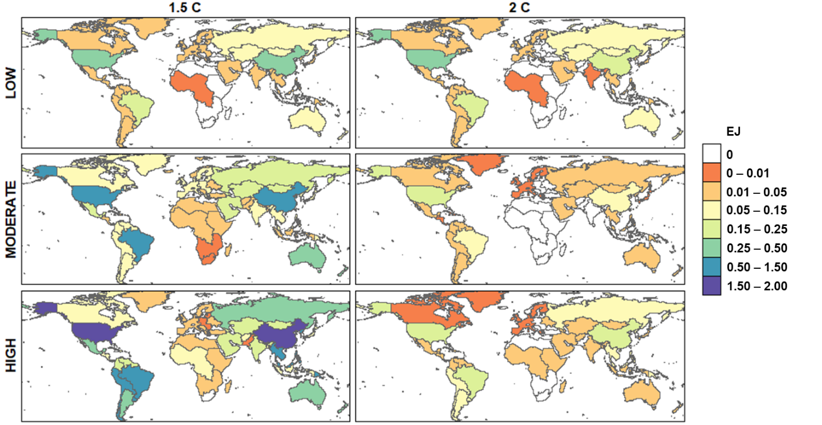
Fig. S11 Regional variations in electricity consumption for CDR by 2050 across modeled scenarios. The CDR scenarios aligned with the 1.5°C pathway, particularly the MODERATE and HIGH scenarios, show increased electricity consumption for CDR across multiple countries and regions compared to their consumption patterns under the 2°C pathway. This can be attributed to the 2°C pathway's minimization of energy-intensive CDR technologies, like DACCS, when alternative CDR options are viable. The 1.5°C_HIGH scenario, which demonstrates the most substantial electricity demand for CDR, projects that by 2050, countries/regions like China, the United States, and several areas within South America will allocate approximately 0.5-2 EJ/yr of their electricity consumption to CDR processes. Meanwhile, the 2°C_MODERATE pathway, which assumes the least overall CDR electricity consumption, sees nearly zero electricity consumption for CDR in several countries across Africa, Europe, and Southern Asia.

Fig. S12 Total water withdrawal by electricity generation technologies across modeled scenarios. Here, water withdrawals imply any water withdrawn from surface water resources or the ground and subsequently returned to the natural environment later. Towards mid-century, as climate mitigation becomes more stringent, demand for electricity increases which causes a resurgence in water withdrawals after a temporal period of continuous decline. In earlier periods, unabated coal electricity generation withdraws the largest water but as unabated coal phases down/out, its corresponding water withdrawals decrease rapidly, especially under 1.5℃ LOW and MODERATE scenarios. By 2050, nuclear and abated coal electricity generation represent the highest shares in total water withdrawals for electricity generation across all scenarios. CCS: carbon capture and storage

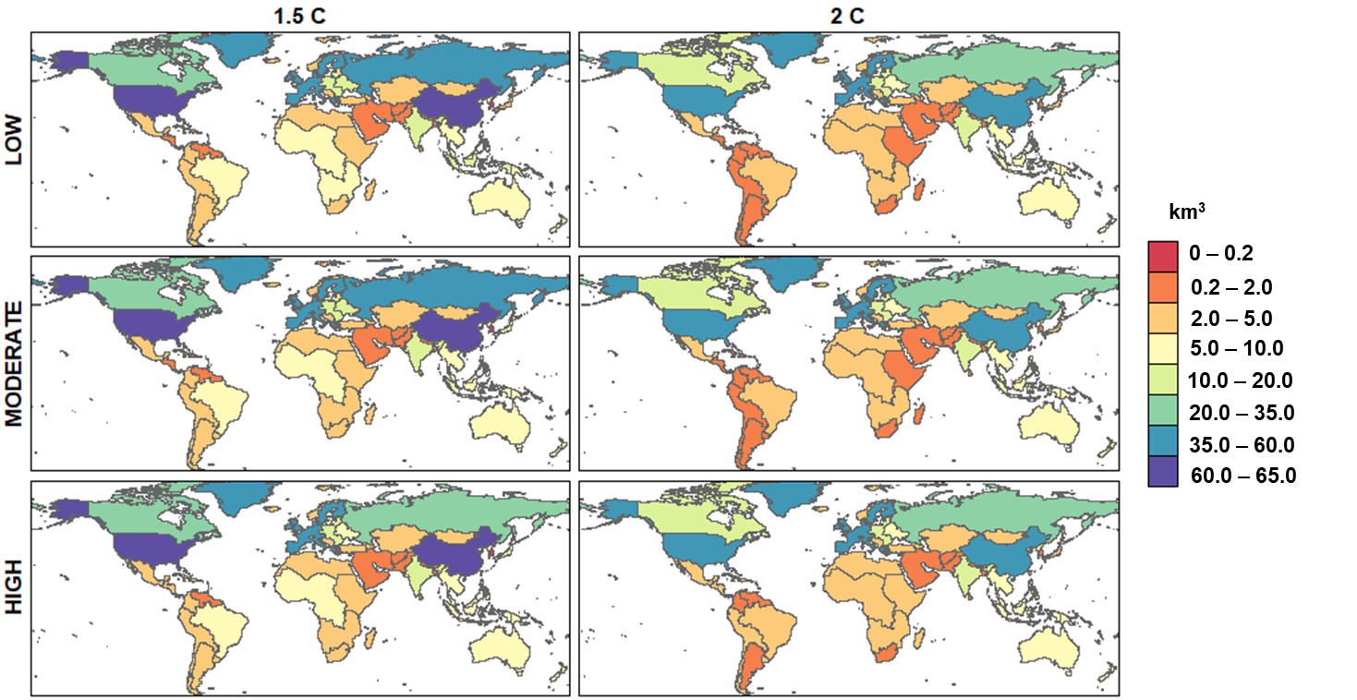
Fig. S13 Water withdrawals for electricity generation across various countries and regions by 2050. China, the US, Russia, and the EU-15 will experience the highest total water withdrawals for electricity generation across all scenarios. This is primarily due to the high levels of nuclear power generation anticipated in these regions to decarbonize their electricity systems, especially under the LOW CDR pathways.

Fig. S14 Total water consumption by electricity generation technologies across modeled scenarios. Here, water used by humans or livestock or lost to evaporation is referred to as water consumption. Unlike the observation under water withdrawals, total water consumption increases as carbon price increases and emission reduction requirements become more stringent. Direct use of water for hydroelectricity generation implies that it has the highest water consumption across all scenarios followed by nuclear and unabated coal across all scenarios. As unabated coal phases down/out, its corresponding water consumption decreases rapidly, especially under the 1.5℃ LOW and MODERATE scenarios. Under the LOW and MODERATE CDR scenarios, the higher requirement for low and zero-carbon electricity sources leads to a noticeable increase in water consumption by solar and refined liquids electricity generation technologies. CCS: carbon capture and storage
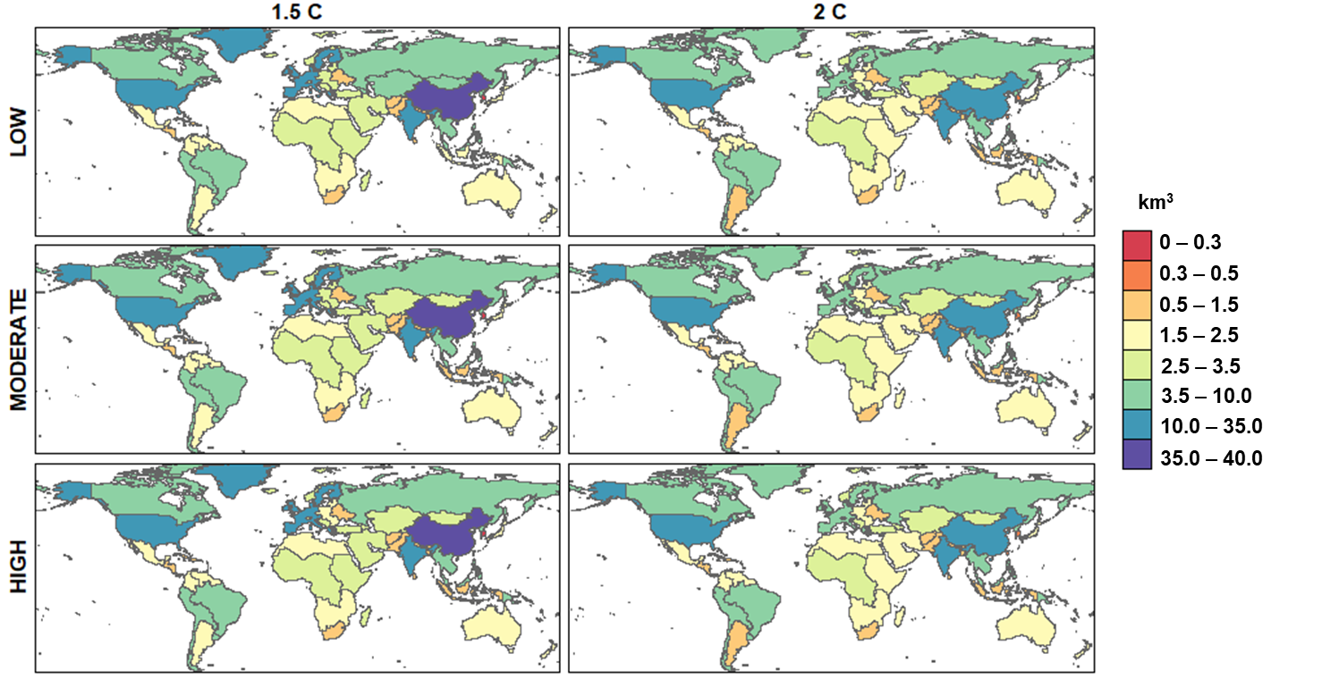
Fig. S15 Water consumption for electricity generation across various countries and regions by 2050. In all modeled scenarios, China, India, and the US exhibit the highest total water consumption for electricity generation. In contrast, countries projected to have minimal hydroelectric capacity by 2050, such as South Korea, Taiwan, and South Africa, demonstrate the lowest water consumption levels in this sector.

Fig. S16 CO₂ sequestration by electricity sector across modeled scenarios. The 1.5℃ pathways are characterized by higher sequestration compared to 2℃ due to the former’s stringent requirements. By 2050, the total sequestration in all three CDR pathways (LOW/MODERATE/HIGH) will be similar under both climate targets but differences arise in the shares of technologies. The LOW CDR pathway has relatively higher sequestration by coal/gas/refined liquids CCS while the presence of large-scale BECCS under HIGH CDR implies that the pathway shows relatively higher shares of sequestration by BECCS technology compared to MODERATE and LOW CDR scenarios. CCS: carbon capture and storage

Fig. S17 Positive emissions from the electricity sector across modeled scenarios. Under the 1.5°C pathway, emissions from coal-based electricity generation technologies exhibit a more rapid decline compared to the 2°C scenarios. This reduction in coal emissions is further intensified in scenarios where CDR technologies have limited availability. CCS: carbon capture and storage

Fig. S18 Capacity additions for fossil fuels (with and without CCS) in our modeled scenarios compared to 1.5ºC scenarios in the IPCC AR6 database ¹. AR6 scenarios are C1 and C2 scenarios that passed vetting according to the AR6 vetting process. n is the number of AR6 scenarios with non-empty data at any point in the century. “HIGH/MODERATE/LOW” represents our 1.5℃ HIGH/MODERATE/LOW scenarios. AR6: Sixth Assessment Report; IPCC: Intergovernmental Panel on Climate Change

Fig. S19 Capacity additions for nuclear power in our modeled scenarios compared to 1.5ºC scenarios in the IPCC AR6 database ¹. AR6 scenarios are C1 and C2 scenarios that passed vetting according to the AR6 vetting process. n is the number of AR6 scenarios with non-empty data at any point in the century. “HIGH/MODERATE/LOW” represents our 1.5℃ HIGH/MODERATE/LOW scenarios. AR6: Sixth Assessment Report; IPCC: Intergovernmental Panel on Climate Change
Fig. S20 Capacity additions for renewable power (non-bio) in our modeled scenarios compared to 1.5ºC scenarios in the IPCC AR6 database ¹. AR6 scenarios are C1 and C2 scenarios that passed vetting according to the AR6 vetting process. n is the number of AR6 scenarios with non-empty data at any point in the century. “HIGH/MODERATE/LOW” represents our 1.5℃ HIGH/MODERATE/LOW scenarios. AR6: Sixth Assessment Report; IPCC: Intergovernmental Panel on Climate Change
Fig. S21 Electricity consumption in final energy compared to 1.5ºC scenarios in the IPCC AR6 database ¹. AR6 scenarios are C1 and C2 scenarios that passed vetting according to the AR6 vetting process. n is the number of AR6 scenarios with non-empty data at any point in the century. “HIGH/MODERATE/LOW” represents our 1.5℃ HIGH/MODERATE/LOW scenarios. AR6: Sixth Assessment Report; IPCC: Intergovernmental Panel on Climate Change

Fig. S22 Electricity sector water withdrawals in our modeled scenarios compared to 1.5ºC scenarios in the IPCC AR6 database ¹. AR6 scenarios are C1 and C2 scenarios that passed vetting according to the AR6 vetting process. n is the number of AR6 scenarios with non-empty data at any point in the century. “HIGH/MODERATE/LOW” represents our 1.5℃ HIGH/MODERATE/LOW scenarios. AR6: Sixth Assessment Report; IPCC: Intergovernmental Panel on Climate Change
Fig. S23 Electricity sector water consumption in our modeled scenarios compared to 1.5ºC scenarios in the IPCC AR6 database ¹. AR6 scenarios are C1 and C2 scenarios that passed vetting according to the AR6 vetting process. n is the number of AR6 scenarios with non-empty data at any point in the century. “HIGH/MODERATE/LOW” represents our 1.5℃ HIGH/MODERATE/LOW scenarios. AR6: Sixth Assessment Report; IPCC: Intergovernmental Panel on Climate Change

Fig. S24 Positive electricity emissions in our modeled scenarios compared to 1.5ºC scenarios in the IPCC AR6 database ¹. AR6 scenarios are C1 and C2 scenarios that passed vetting according to the AR6 vetting process. n is the number of AR6 scenarios with non-empty data at any point in the century. “HIGH/MODERATE/LOW” represents our 1.5℃ HIGH/MODERATE/LOW scenarios. AR6: Sixth Assessment Report; IPCC: Intergovernmental Panel on Climate Change

CDR description
Table S1 provides a brief description of the various CDR approaches investigated in this study
Table S 1 Description of CDR approaches²
CDR approach | Description
AR | Involves planting new forests or restoring previously forested areas to increase carbon uptake and storage in vegetation and soils through natural processes like photosynthesis and biomass accumulation
BECCS | Bioenergy with carbon capture and storage. Biomass feedstocks are grown, harvested and used for energy production in power plants or as biofuels. The CO₂ emissions from biomass combustion are captured before release and permanently stored underground
DACCS | Direct air carbon capture and storage. CO₂ is chemically extracted directly from ambient air and concentrated. The captured CO₂ gas is then transported and injected into secure geological storage sites
ERW | Enhanced rock weathering. Natural chemical weathering of silicate rocks that absorb CO₂ is enhanced by grinding and distributing minerals like basalt. This accelerates natural reactions fixing CO₂ into stable carbonates.  NB: ERW is similar to Ocean Alkalinity Enhancement (OAE) but the former occurs on land while the latter occurs in oceans
Biochar | Biomass like crop residues or wood is heated without oxygen via pyrolysis to produce a stable solid carbon-rich material called biochar. When added to soils, biochar can provide long-term carbon storage and other agronomic benefits
DOCCS | Direct ocean capture with capture and storage. CO₂ is chemically captured from seawater. The extracted CO₂ is transported and injected into the deep ocean at depths greater than 1000 m for secure storage

Model parameterization and underlying equations for demand and supply

In this section, some underlying parameters/modelling assumptions and selected equations are presented. Unless cited otherwise, all information are obtained from Ref. ³, and additional information not discussed or presented here can be obtained from the same source.
Table S 2 Fraction of CO₂ captured by transformation technologies
Supply sector | Subsector | Technology | 1971 | 2100
Refining | Coal to liquids | Coal to liquids ccs level 1 | 0.818 | 0.818
Refining | Coal to liquids | Coal to liquids ccs level 2 | 0.9 | 0.9
Refining | Biomass liquids | Cellulosic ethanol ccs level 1 | 0.26 | 0.26
Refining | Biomass liquids | Cellulosic ethanol ccs level 2 | 0.9 | 0.9
Refining | Biomass liquids | Ft biofuels ccs level 1 | 0.818 | 0.818
Refining | Biomass liquids | Ft biofuels ccs level 2 | 0.9 | 0.9

Table S 3 Primary energy transformation technologies default cost assumptions (1975$/GJ)
Supply sector | Technology | 1971 | 2010 | 2100 | Improvement max | Improvement rate
Gas processing | Natural gas | 0.2 | 0.2 | 0.2
Gas processing | Biomass gasification | 7.030087 | 7.030087 |  | 0.7 | 0.03
Gas processing | Coal gasification | 5.285779 | 5.285779 |  | 0.7 | 0.03
Nuclear fuel gen II | Enriched uranium | 0.124464 | 0.124464 | 0.124464
Nuclear fuel gen III | Enriched uranium | 0.124464 | 0.124464 | 0.124464
Refining | Oil refining | 0.84 | 0.84 | 0.84
Refining | Coal to liquids | 5.294118 | 5.294118 |  | 0.7 | 0.03
Refining | Coal to liquids ccs level 1 | 5.980615 | 5.980615 |  | 0.6 | 0.05
Refining | Coal to liquids ccs level 2 | 6.467671 | 6.467671 |  | 0.6 | 0.05
Refining | Gas to liquids | 3.970588 | 3.970588 |  | 0.7 | 0.03
Refining | Cellulosic ethanol | 4.74 | 4.74 |  | 0.7 | 0.03
Refining | Cellulosic ethanol ccs level 1 | 4.991818 | 4.991818 |  | 0.6 | 0.05
Refining | Cellulosic ethanol ccs level 2 | 6.850562 | 6.850562 |  | 0.6 | 0.05
Refining | Ft biofuels | 7.802308 | 7.802308 |  | 0.7 | 0.03
Refining | Ft biofuels ccs level 1 | 8.516923 | 8.516923 |  | 0.6 | 0.05
Refining | Ft biofuels ccs level 2 | 8.97527 | 8.97527 |  | 0.6 | 0.05
Refining | Corn ethanol | 2.38 | 2.38 | 2.38
Refining | Sugar cane ethanol | 2 | 2 | 2
Refining | Biodiesel | 1.88 | 1.88 | 1.88

Table S 4 Electricity technology capacity factors
Supply sector | Subsector | Technology | 1971 | 2100
Electricity | Coal | Coal (Conventional Pulverized Coal | 0.85 | 0.85
Electricity | Coal | Coal (Conventional Pulverized Coal with CCS) | 0.8 | 0.8
Electricity | Coal | Coal (Integrated Gasification Combined Cycle) | 0.8 | 0.8
Electricity | Coal | Coal (Integrated Gasification Combined Cycle with CCS) | 0.8 | 0.8
Electricity | Gas | Gas (Steam Cycle/Turbine) | 0.8 | 0.8
Electricity | Gas | Gas (Combined Cycle) | 0.85 | 0.85
Electricity | Gas | Gas (Combined Cycle with CCS) | 0.8 | 0.8
Electricity | Refined liquids | Refined liquids (Steam Cycle/Turbine) | 0.8 | 0.8
Electricity | Refined liquids | Refined liquids (Combined Cycle) | 0.85 | 0.85
Electricity | Refined liquids | Refined liquids (Combined Cycle with CCS) | 0.8 | 0.8
Electricity | Biomass | Biomass (conventional) | 0.85 | 0.85
Electricity | Biomass | Biomass (conventional with CCS) | 0.85 | 0.85
Electricity | Biomass | Biomass ((Integrated Gasification Combined Cycle) | 0.8 | 0.8
Electricity | Biomass | Biomass ((Integrated Gasification Combined Cycle with CCS) | 0.8 | 0.8
Electricity | Nuclear | Generation II Light Water Reactor | 0.9 | 0.9
Electricity | Nuclear | Generation III | 0.9 | 0.9
Electricity | Wind | Wind | 0.37 | 0.37
Electricity | Wind | Wind with storage | 0.37 | 0.37
Electricity | Solar | Photovoltaic (PV) | 0.2 | 0.2
Electricity | Solar | PV with storage | 0.2 | 0.2
Electricity | Solar | Concentrated solar power (CSP) | 0.25 | 0.25
Electricity | Solar | CSP with storage | 0.5 | 0.5
Electricity | Geothermal | Geothermal | 0.9 | 0.9
Electricity | Rooftop PV | Rooftop PV | 0.17 | 0.17

Table S 5 Electricity technology capture fractions (portion of CO₂ emissions that are captured)
Supply sector | Subsector | Technology | 1971 | 2020 | 2100
Electricity | Coal | Coal (Conventional Pulverized Coal with CCS) | 0.85 | 0.85 | 0.95
Electricity | Coal | Coal (Integrated Gasification Combined Cycle with CCS) | 0.85 | 0.85 | 0.95
Electricity | Gas | Gas (Combined Cycle with CCS) | 0.85 | 0.85 | 0.95
Electricity | Refined liquids | Refined liquids (Combined Cycle with CCS) | 0.85 | 0.85 | 0.95
Electricity | Biomass | Biomass (conventional with CCS) | 0.85 | 0.85 | 0.95
Electricity | Biomass | Biomass ((Integrated Gasification Combined Cycle with CCS) | 0.85 | 0.85 | 0.95

Table S 6 Electricity technology retirement parameters
Subsector | Technology | Year | Lifetime | Half life | Steepness
Coal | Coal (Conventional Pulverized Coal) | Final-calibration-year | 60 | 30 | 0.1
Gas | Gas (Steam Cycle/Turbine) | Final-calibration-year | 45 | 22.5 | 0.1
Gas | Gas (Combined Cycle) | Final-calibration-year | 45 | 22.5 | 0.1
Refined liquids | Refined liquids (Steam Cycle/Turbine) | Final-calibration-year | 45 | 22.5 | 0.1
Biomass | Biomass (conventional) | Final-calibration-year | 60 | 30 | 0.1
Nuclear | Generation II Light Water Reactor | Final-historical-year | 60 | 30 | 0.1
Wind | Wind | Final-calibration-year | 30
Solar | PV | Final-calibration-year | 30
Solar | CSP | Final-calibration-year | 30
Geothermal | Geothermal | Final-calibration-year | 30
Coal | Coal (Conventional Pulverized Coal) | Initial-future-year | 60
Coal | Coal (Integrated Gasification Combined Cycle) | Initial-future-year | 60
Coal | Coal (Integrated Gasification Combined Cycle with Carbon Capture and Storage) | Initial-future-year | 60
Gas | Gas (Combined Cycle with Carbon Capture and Storage) | Initial-future-year | 45
Refined liquids | Refined liquids (Combined Cycle) | Initial-future-year | 45
Refined liquids | Refined liquids (Combined Cycle with Carbon Capture and Storage) | Initial-future-year | 45
Biomass | Biomass (conventional with CCS) | Initial-future-year | 60
Biomass | Biomass (Integrated Gasification Combined Cycle) | Initial-future-year | 60
Biomass | Biomass (Integrated Gasification Combined Cycle with Carbon Capture and Storage) | Initial-future-year | 60
Nuclear | Generation III | Initial-nonhistorical-year | 60
Wind | Wind with storage | Initial-future-year | 30
Solar | PV with storage | Initial-future-year | 30
Solar | CSP with storage | Initial-future-year | 30
Wind | Wind offshore | Final-calibration-year | 25
Wind | Wind offshore | Initial-future-year | 25
Note: lifetime: maximum lifetime of cohort. If no retirement function is used; the entire cohort is retired in this number of years. half life: number of years at which 50% of the cohort is retired; using the s-curve-shutdown-decider retirement function. steepness: shape parameter used by the s-curve-shutdown-decider retirement function.

Table S 7 Industrial energy use default efficiencies
Technology | Energy input | Secondary output | 1971 | 2020 | 2050 | 2080 | 2100
Biomass | Delivered biomass |  | 0.746423 | 0.797 | 0.81 | 0.823 | 0.828
Biomass cogeneration | Delivered biomass | Electricity | 0.515677 | 0.56 | 0.577 | 0.595 | 0.604
Coal | Delivered coal |  | 0.80808 | 0.891 | 0.909 | 0.926 | 0.936
Coal cogeneration | Delivered coal | Electricity | 0.582005 | 0.629 | 0.644 | 0.661 | 0.67
District heat | District heat |  | 1 | 1 | 1 | 1 | 1
Electricity | Electricity (industry) |  | 0.934197 | 1.015 | 1.046 | 1.078 | 1.094
Gas | Wholesale gas |  | 0.82583 | 0.898 | 0.926 | 0.955 | 0.969
Gas cogeneration | Wholesale gas | Electricity | 0.563321 | 0.612 | 0.63 | 0.649 | 0.659
Hydrogen | Hydrogen enduse |  | 1 | 1 | 1.03 | 1.062 | 1.078
Hydrogen cogeneration | Hydrogen enduse | Electricity | 0.457 | 0.457 | 0.471 | 0.485 | 0.492
Refined liquids | Refined liquids industrial |  | 0.917381 | 1.001 | 1.033 | 1.062 | 1.077
Refined liquids cogeneration | Refined liquids industrial | Electricity | 0.565189 | 0.614 | 0.632 | 0.652 | 0.662
Coal | Delivered coal |  | 1 | 1 | 1 | 1 | 1
Gas | Wholesale gas |  | 1 | 1 | 1 | 1 | 1
Refined liquids | Refined liquids industrial |  | 1 | 1 | 1 | 1 | 1

Table S 8 Carbon storage resource supply curve points (2005$/tCO₂)
Resource | Subresource | Grade | Fraction | Cost
Onshore carbon-storage | Onshore carbon-storage | Grade 1 | 0 | 0
Onshore carbon-storage | Onshore carbon-storage | Grade 2 | 0.005 | 0.1
Onshore carbon-storage | Onshore carbon-storage | Grade 3 | 0.1 | 5
Onshore carbon-storage | Onshore carbon-storage | Grade 4 | 0.6 | 10
Onshore carbon-storage | Onshore carbon-storage | Grade 5 | 0.295 | 75
Onshore carbon-storage | Onshore carbon-storage | Grade 6 | 0 | 3500

Table S 9 Calibration values for the CO₂ removal sector (MtC)
GCAM region | Sector | Year | Value
USA | CO₂ removal | 2015 | 2000
Africa Eastern | CO₂ removal | 2015 | 26.58922
Africa Northern | CO₂ removal | 2015 | 26.30296
Africa Southern | CO₂ removal | 2015 | 25.52156
Africa Western | CO₂ removal | 2015 | 51.65929
Australia (with New Zealand) | CO₂ removal | 2015 | 417.4775
Brazil | CO₂ removal | 2015 | 1012.358
Canada | CO₂ removal | 2015 | 79.87708
Central America and Caribbean | CO₂ removal | 2015 | 86.18576
Central Asia | CO₂ removal | 2015 | 429.8247
China | CO₂ removal | 2015 | 2116.542
EU-12 | CO₂ removal | 2015 | 22.06217
EU-15 | CO₂ removal | 2015 | 71.77459
Europe (Eastern) | CO₂ removal | 2015 | 15.81593
Europe (Non EU) | CO₂ removal | 2015 | 15.84964
European Free Trade Association | CO₂ removal | 2015 | 6.34295
India | CO₂ removal | 2015 | 87.41423
Indonesia | CO₂ removal | 2015 | 16.37849
Japan | CO₂ removal | 2015 | 66.31417
Mexico | CO₂ removal | 2015 | 232.7633
Middle East | CO₂ removal | 2015 | 334.5848
Pakistan | CO₂ removal | 2015 | 7.458686
Russia | CO₂ removal | 2015 | 313.093
South Africa | CO₂ removal | 2015 | 5.567627
South America (Northern) | CO₂ removal | 2015 | 161.9685
South America (Southern) | CO₂ removal | 2015 | 470.9671
South Asia | CO₂ removal | 2015 | 8.830837
South Korea | CO₂ removal | 2015 | 0
Southeast Asia | CO₂ removal | 2015 | 165.692
Taiwan | CO₂ removal | 2015 | 0.307808
Argentina | CO₂ removal | 2015 | 331.3725
Colombia | CO₂ removal | 2015 | 136.5132

Table S 10 CO₂ capture rates for DAC and process heat DAC technology⁴
Supply sector | Subsector | Technology | 1971 | 2100
Process heat DAC | Gas ccs | Gas ccs | 0.95 | 0.95
CO₂ removal | DAC | High temperature DAC (natural gas) | 1 | 1
CO₂ removal | DAC | High temperature DAC (electricity) | 1 | 1
CO₂ removal | DAC | Low temperature DAC (heat pump) | 1 | 1

Table S 11 Parametrizations for DACCS Technologies ⁴
Technology | Scenario | Natural gas (GtCO₂) |  | Electricity (GtCO₂) |  | Non-energy cost (2015 $tCO₂) |  | Water cubic metres per tonne of CO₂ (m³ per tCO₂)
Technology | Scenario | 2020 | 2030 | 2020 | 2030 | 2020 | 2030 | 2020 | 2030
High temperature direct air capture and carbon storage (DACCS) (natural gas) | Shared Socio-economic pathway (SSP) 2-middle of the road |  | 5.3 |  | 1.3 |  | 185 | 4.7
High temperature DACCS (fully electric) | SSP2-middle of the road | _ |  |  | 5 |  | 186 | 4.7
Low temperature DACCS (electric heat pump) | SSP2-middle of the road | _ |  |  | 2.5 |  | 235 | _
Values are assumed to remain constant after 2030

Table S 12 Enhanced Weathering Cost Adder ⁵
 | Upper bound | Best estimate | Units
Investment | $14 | $6 | $/t rock
O&M | $59 | $26 | $/t rock
Total non-cost fuel | $73 | $31 | $/t rock
Total non-cost fuel | $242 | $104 | $/t CO₂
Difference between upper bound + best estimate (2020 cost adder for GCAM assumption; declines to zero by 2050) | $138 |  | $/t CO₂

Table S 13 Electrical energy inputs for enhanced weathering⁵
Best estimate | 0.66 | GJ/tCO₂
Lower bound | 0.23 | GJ/tCO₂
Upper bound | 2.03 | GJ/tCO₂

Table S 14 Electrical Energy Input Derivation for DOCCS paired with reverse osmosis desalination⁵
Row | Value | Units | Source
1 | 0.075 | kWh kg⁻¹ CO₂ captured (capture energy only; standalone capture energy equal to this value) | Ref. ⁶
2 | 277.77 | kWh/GJ | Unit conversion
3 | 3.666667 | kgCO₂/kgC | Unit conversion
4 | 9.89E-04 | GJ electricity / kgC captured | Calculation [1]/[2]*[3]
5 | 13.1 | m³ ocean water / kg captured CO₂ | ref
6 | 48.03 | m³ ocean water / kg captured C | Calculation [5]*[1]
7 | 2.5 | m³ seawater processed / m³ desalinated water produced | GCAM assumption
8 | 5.15E-05 | GJ elec / m³ desalinated water (CO₂ capture only) | Calculation [4]/[6]*[7]
9 | 2.20E-02 - 6.30E-03 | GJ elec / m³ desalinated water (desalination) | GCAM assumption

Table S 15 Non-fuel costs of DOCCS ⁵
Ocean capture scenario | CapEx ($kg⁻¹CO₂) | Non-fuel opex ($ kg⁻¹ CO₂) |  |  | Total ($ kg⁻¹ CO₂) | GDP deflator from 2020 to 1975 | 1975 ($kg⁻¹ C)
Ocean capture scenario | CapEx ($kg⁻¹CO₂) | O&M | Labor, tax, insurance | Replacements | Total ($ kg⁻¹ CO₂) | GDP deflator from 2020 to 1975 | 1975 ($kg⁻¹ C)
Co-located | 0.18 | 0.05 | 0.06 | 0.18 | 0.47 | 3.79 | 0.45
Stand-alone | 1.07 | 0.18 | 0.27 | 0.18 | 1.7 |  | 1.64

Table S 16 Non-energy cost assumptions for DOCCS paired with reverse osmosis desalination ⁵
Row | Description | Value | Units | Source
1 | non-fuel costs of CO₂ capture for co-located DORCS | 0.45 | 1975$/kgC | *
2 | m³ ocean water / kg captured C | 48.03 | m³/kgC | ⁶
3 | m³ seawater processed / m³ desalinated water produced | 2.5 | unitless | GCAM assumption
4 | Non-energy cost adder for CO₂ capture | 0.023 | $1975/m³ desalinated water | Calculation [1]/[2]*[3]
5 | Non-fuel cost of desalinated water (reverse osmosis technology) | 0.38 | $1975/m³ desalinated water | GCAM assumption
6 | Total non-fuel cost of DORCS + reverse osmosis | 0.40 | $1975/m³ desalinated water | Calculation [4]+[5]
*Based on Supplementary Table 2 from Ref. 5

Table S 17 GCAM Assumptions for Direct Ocean Capture⁵
 | Electricity input (GJ/tCO₂) | Non-fuel cost (2020$/tCO₂)
Stand-alone | 16.5 | 1700
Co-located with desalination (carbon capture only) | 0.26 | 470

Table S 18 Biochar supply and demand assumptions⁷
Metric | Value | Unit | Source
Non-energy cost | 45.93 | 2007 USD per ton of feedstock | ⁸
Biomass input | 3.65 | Tons of switchgrass per ton of  biochar | ⁸
Natural gas input | 211.19 | MJ per dry ton of biochar | ⁸
Syngas co-product | 20095 | MJ per dry ton of biochar | ⁸
Net syngas co-product | 19884 | MJ per dry ton of biochar | ⁸
Application rate | 20 | Tons of biochar per hectare | ^{9,10}
Yield improvements | 12 (tropical irrigated)  19 (tropical rainfed)  10 (temperate irrigated)  15 (temperate rainfed) | Percentage
Carbon sequestered | 70 | Percentage | ¹¹

Selected equations are presented below, additional model underlying equations can be obtained directly from Ref. ³
Technology or subsector share
GCAM uses one of two different logit formulations to calculate the shares for each technology or subsector.
The first option, also known as the relative-cost-logit, is:
$$s_{i}=\frac{α_{i}c_{i}^{γ}}{\sum_{j=1}^{N}{α_{j}c_{j}^{γ}}}$$ | (1)
where $s_{i}$ is the share of technology or subsector $i$, $α_{i}$ is the share weight, $c_{i}$ is the cost of technology or subsector $i$, and $γ$ is the logit exponent.
The second option, also known as the absolute-cost-logit, is:
$$s_{i}=\frac{α_{i}exp⁡(βc_{i})}{\sum_{j=1}^{N}{α_{j}exp⁡(βc_{j})}}$$ | (2)
where $s_{i}$ is the share of technology or subsector $i$, $α_{i}$ is the share weight, $c_{i}$ is the cost of technology or subsector $i$, and $β$ is the logit exponent.
Transportation service demand
The demand ($D$) for transportation services (e.g., passenger-km, tonne-km) in region $r$ and time period $t$ is given by the following equation:
$$D_{r,t}=D_{r,t-1}{\left(\frac{Y_{r,t}}{Y_{r,t-1}}\right)}^{α}{\left(\frac{P_{r,t}}{P_{r,t-1}}\right)}^{β}\left(\frac{N_{r,t}}{N_{r,t-1}}\right)$$ | (3)
Where $Y$ is the per-capita GDP, $P$ is the total service price aggregated across all modes, $N$ is the population, and $α$ and $β$ are income and price elasticities, respectively.
Transportation subsector competition
At the subsector level, the subsector competition may add the time value of transportation, as shown in the equation for the price ($P$) of mode $i$, in region $r$ and time period $t$:
$$P_{i,r,t}=\sum_{j=1}^{N}{\left(α_{j,i,r,t}*P_{j,i,r,t}\right)+\frac{W_{r,t}*V_{i,r,t}}{S_{i,r,t}}}$$ | (4)
In the equation above, $j$ refers to any of N technologies within subsector $i$, and $α$ is the share of technology $j$ in subsector $i$. Where this equation differs from the subsectors elsewhere in GCAM is the final term, the wage rate ($W$) multiplied by the “time value multiplier” ($V$), divided by the average speed of the mode ($S$).
Transportation technology cost
The costs of transportation technologies are computed as follows, for technology $j$ in subsector $i$, region $r$, and time period $t$:
$$P_{j,i,r,t}=\frac{P_{f,r,t}*I_{j,i,r,t}+N_{j,i,r,t}}{L_{j,i,r,t}}$$ | (5)
In this equation, $P_{f}$ stands for the fuel price, $I$ is the vehicle fuel intensity, $N$ is the levelized non-fuel cost (expressed per vehicle-km), and $L$ is the load factor (persons or tonnes per vehicle).
Direct Air Capture for Carbon Dioxide Removal
We use GCAM’s (unmodified) logit choice model for economic choice between DACCS technologies. This includes the “choice” to not deploy DACCS and instead use other mitigation or negative emissions technologies (i.e., the “no-DAC” technology). The share $s_{i}$ of any DACCS technology with price pi is computed as follows:
$$s_{i}=\frac{α_{i}*exp⁡(β*p_{i})}{\sum_{j=1}^{N}{α_{j}*exp⁡(β*p_{j})}}$$ | (6)

Where:
$α_{i}$ = the shareweight of the technology.
$β$ = the logit coefficient, which determines how large a cost difference is required to produce a given difference in market share.
Total technology cost
The total cost for a technology is the sum of the cost of the technology, the cost of its inputs, and any GHG value:
$$C=t+\sum_{j=1}^{n}{i_{j}}+\sum_{k=1}^{m}{g_{k}}-\sum_{l=1}^{o}{v_{l}}$$ | (7)
Where $C$ is the total cost, $t$ $ is the exogenously specified technology cost (capturing capital cost and operating & maintenance costs), $i_{j}$ is the cost of input $j$ (e.g., a fuel), $g_{k}$ is the GHG value of gas $k$, and $v_{l}$ is the value of secondary output $l$. Costs vary by region, technology, and year.
Renewable resource supply
The specific supply curve in each region for wind and solar is assigned three parameters, detailed in the following equation:
$$Q=maxSubResource*\frac{P^{CurveExponent}}{({MidPrice}^{CurveExponent}+P^{CurveExponent})}$$ | (8)
Where $Q$ refers to the quantity of electricity produced, $P$ the price, and the remaining parameters are exogenous, with the names in the XML input files corresponding to the names in the equation above. $maxSubResource$ indicates the maximum quantity of renewable energy that could be produced at any price, $CurveExponent$ is a shape parameter, and $MidPrice$ indicates the price at which 50% of the maximum available resource is produced.

References
1. Byers, E., Krey, V., Kriegler, E., Riahi, K. & Schaeffer, R. AR6 Scenario Explorer and Database hosted by IIASA. https://data.ece.iiasa.ac.at/ar6/#/workspaces/2123.
2. Ampah, J. D. et al. Prioritizing Non-Carbon Dioxide Removal Mitigation Strategies Could Reduce the Negative Impacts Associated with Large-Scale Reliance on Negative Emissions. Environ. Sci. Technol. (2024) doi:10.1021/acs.est.3c06866.
3. Bond-Lamberty, B. et al. JGCRI/Gcam-Core: GCAM 6.0. https://zenodo.org/record/6619287 (2022) doi:10.5281/ZENODO.6619287.
4. Fuhrman, J. et al. The role of direct air capture and negative emissions technologies in the shared socioeconomic pathways towards +1.5 °C and +2 °C futures. Environ. Res. Lett. 16, 114012 (2021).
5. Fuhrman, J. et al. Diverse carbon dioxide removal approaches could reduce impacts on the energy–water–land system. Nat. Clim. Change (2023) doi:10.1038/s41558-023-01604-9.
6. Digdaya, I. A. et al. A direct coupled electrochemical system for capture and conversion of CO2 from oceanwater. Nat. Commun. 11, 4412 (2020).
7. Bergero, C., Wise, M., Lamers, P., Wang, Y. & Weber, M. Biochar as a carbon dioxide removal strategy in integrated long-run mitigation scenarios. Environ. Res. Lett. (2024) doi:10.1088/1748-9326/ad52ab.
8. Roberts, K. G., Gloy, B. A., Joseph, S., Scott, N. R. & Lehmann, J. Life Cycle Assessment of Biochar Systems: Estimating the Energetic, Economic, and Climate Change Potential. Environ. Sci. Technol. 44, 827–833 (2010).
9. Jeffery, S., Verheijen, F. G. A., Van Der Velde, M. & Bastos, A. C. A quantitative review of the effects of biochar application to soils on crop productivity using meta-analysis. Agric. Ecosyst. Environ. 144, 175–187 (2011).
10. Ye, L. et al. Biochar effects on crop yields with and without fertilizer: A meta‐analysis of field studies using separate controls. Soil Use Manag. 36, 2–18 (2020).
11. Wang, J., Xiong, Z. & Kuzyakov, Y. Biochar stability in soil: meta‐analysis of decomposition and priming effects. GCB Bioenergy 8, 512–523 (2016).

