Supporting Information (SI)
Buckling Cluster-based H-Bonded Icosahedral Capsules and Their Propagation to a Robust Zeolite-like Supramolecular Framework
Zhan-Hua Zhao, ¹† Bao-Liang Han, ²† Hai-Feng Su, ³ Qi-Lin Guo, ¹ Wen-Xin Wang, ² Jing-Qiu Zhuo, ¹ Yong-Nan Guo, ¹ Jia-Long Liu, ¹ Geng-Geng Luo, ¹* Ping Cui, ² Di Sun²*
¹Key Laboratory of Environmental Friendly Function Materials, Ministry of Education, College of Materials Science and Engineering; Huaqiao University, Xiamen, 361021 (P. R. China)
²Key Laboratory of Colloid and Interface Chemistry, Ministry of Education, School of Chemistry and Chemical Engineering, State Key Laboratory of Crystal Materials, Shandong University, Jinan, 250100 (P. R. China)
³College of Chemistry and Chemical Engineering, Xiamen University, Xiamen, 361005 (P. R. China)
†These authors contributed equally to this work.
*To whom correspondence should be addressed.
*Corresponding author. E-mail: ggluo@hqu.edu.cn; dsun@sdu.edu.cn
Supplementary Methods
- Materials and reagents
Copper(II) trifluoroacetate hydrate, triphenylphosphine (PPh₃), tris(4-fluorophenyl)phosphine (P(C₆H₄F)₃), 2-mercapto-1-phenylimidazole and tetrabutylammonium hexafluorophosphate are purchased from Energy Chemical Reagent Co. Ltd. (Shanghai, China) and used without further purification. HPLC grade solvents (dichloromethane (CH₂Cl₂), methanol (CH₃OH)) are purchased from Sinopharm Chemical Reagent Co. Ltd. (Shanghai, China), and used as received without further purification.
- High-resolution mass spectrometry
High-resolution mass spectra (HR-MS) were recorded on a Bruker impact II high definition mass spectrometer equipped with the quadrupole and time-of-flight (Q-TOF) modules.
- Cryospray ionization mass spectrometry
Cryospray ionization mass spectrometry (CSI-MS) was carried out with a Bruker compact Q-TOF spectrometer and the temperature of the nebulizing and drying gases was set at 0 °C. The data analyses of mass spectra were performed based on the isotope distribution patterns using Bruker Compass Data Analysis software 4.4 SR1 (Version 4.4). The reported m/z values represent the monoisotopic mass of the most abundant peak within the isotope pattern.
- UV/Vis spectroscopy
UV/Vis absorption spectra were recorded on a SHIMADZU UV-2600 UV-vis spectrophotometer.
- Single-crystal X-ray diffraction measurements
Single crystal of 1, 1-d, and 2 with appropriate dimensions was chosen under an optical microscope and quickly coated with high vacuum grease (Dow Corning Corporation) before being mounted on a glass fiber for data collection. Data collection for 1 and 2 was performed on a Agilent Gemini/Xcalibur single-crystal diffractometer equipped with a graphite-monochromated Mo Kα radiation source (λ = 0.71073 Å) at 173 K. Data collection for 1-d was recorded on a Rigaku Oxford Diffraction XtaLAB Synergy-S diffractometer equipped with a HyPix-6000HE Hybrid Photon Counting (HPC) detector operating in shutterless mode and an Oxford Cryosystems Cryostream 800 Plus using Cu Kα (λ = 1.54184 Å) at 173 K from PhotonJet micro-focus X-ray Source. Data reductions were performed using the CrystAlis^{Pro} software. All structures were solved using the charge-flipping algorithm, as implemented in the program SUPERFLIP and refined by full-matrix least-squares techniques against F_{o}² using the SHELXL program through the OLEX2 interface. Hydrogen atoms at carbon were generated geometrically and refined with isotropic temperature factors. The structure was examined using the Addsym subroutine of PLATON to ensure that no additional symmetry could be applied to the models. Selected crystallographic data are summarized in the Table S1-S2. More details on crystallographic information are available at the Cambridge Crystallographic Data Centre with CCDC number 2366513 (1), 2366514 (1-d), and 2366515 (2).
- Computational details
Density functional theory (DFT) calculations were performed by using the quantum chemistry program ORCA 4.0. The Def2-SV(P) basis sets were used for P, S, C, N, H. The Def2-TZVP basis sets were used for Cu. The input coordinates were obtained from the X-ray single crystal structure data. Their optimized geometries were characterized as a minimum by vibrational analysis. The UV-visible spectrum was calculated by means of TD-DFT calculations.
- Powder X-ray diffraction measurements
Powder X-ray diffraction (PXRD) patterns were collected in air at room temperature using an X’Pert PRO diffractometer (Cu-Kα). (λ = 1.5418 Å).

Supplementary Figures and Tables
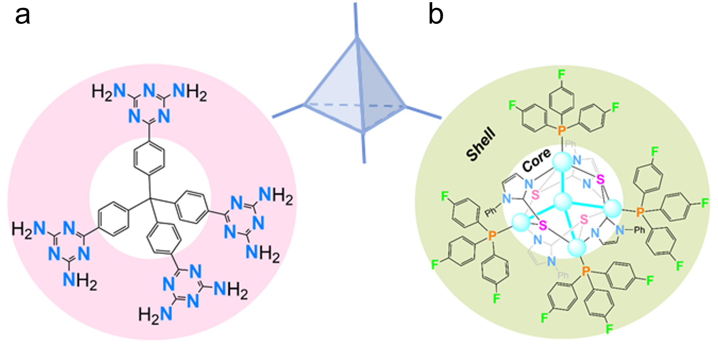
Supplementary Figure 1. Tetrahedrally symmetric building blocks of the pure organic tecton (A) versus cluster tecton (B).

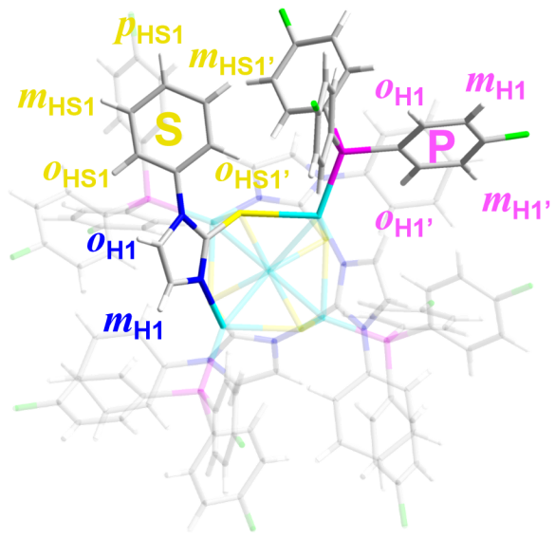
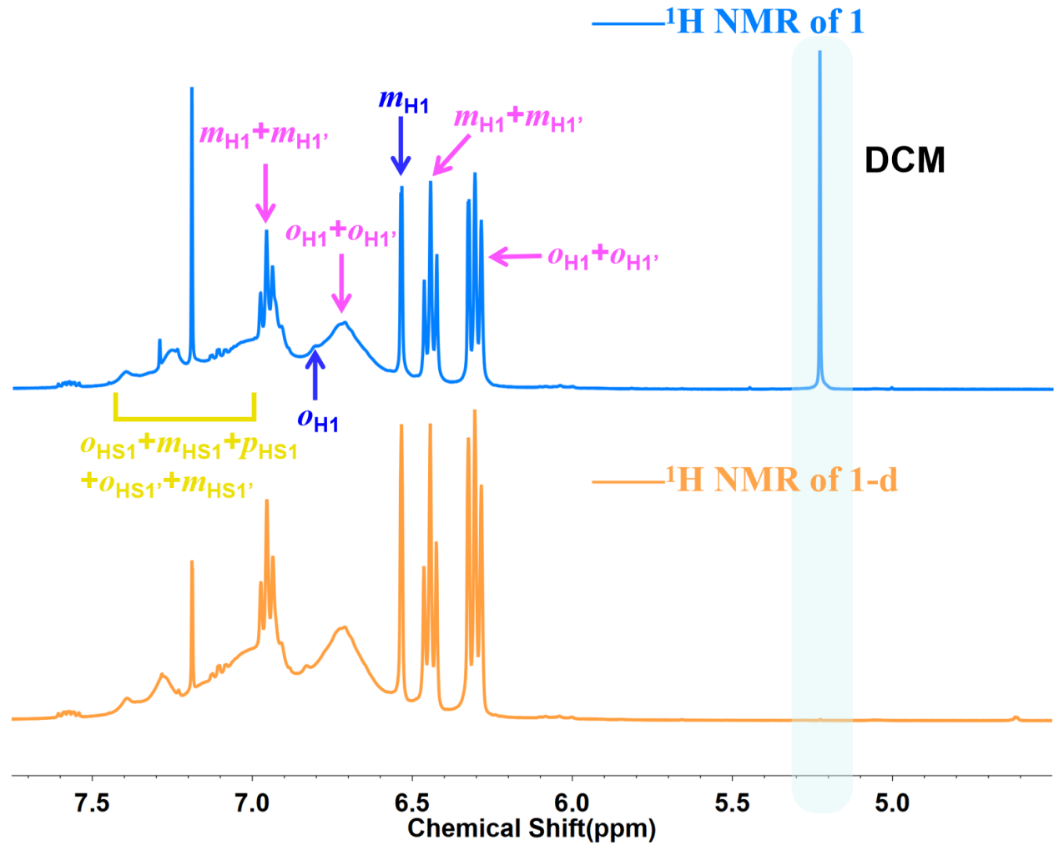
Supplementary Figure 2. ¹H NMR spectra of 1 and 1-d.
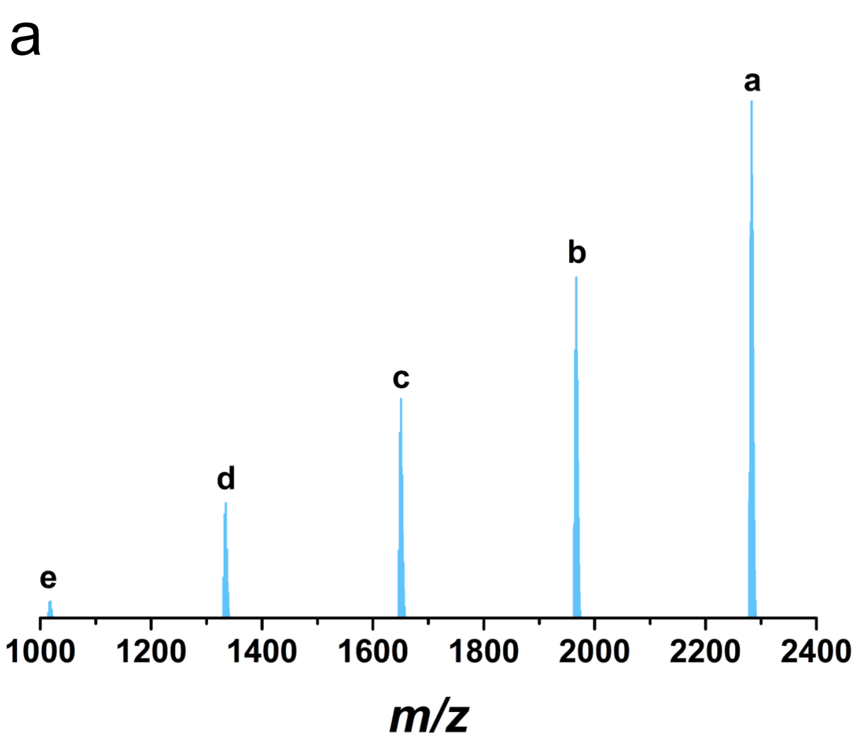
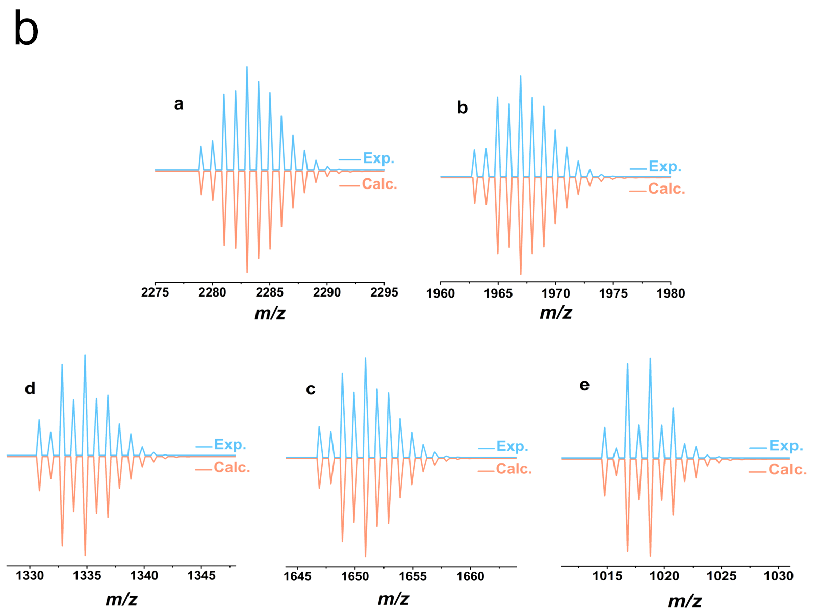

Supplementary Figure 3. a Positive-ion mode ESI-MS of 1 in CH₂Cl₂; b Experimental (blue) and simulated mass spectrometry (orange) for species a-e.

species | Assignment | Exp. | Calc.
a | [Cu₅(C₁₈H₁₂F₃P)₄(C₉H₇N₂S)₄]⁺ | 2283.014 | 2283.031
b | [Cu₅(C₁₈H₁₂F₃P)₃(C₉H₇N₂S)₄]⁺ | 1966.955 | 1966.967
c | [Cu₅(C₁₈H₁₂F₃P)₂(C₉H₇N₂S)₄]⁺ | 1650.902 | 1650.903
d | [Cu₅(C₁₈H₁₂F₃P)(C₉H₇N₂S)₄]⁺ | 1334.841 | 1334.840
e | [Cu₅(C₉H₇N₂S)₄]⁺ | 1018.777 | 1018.776

Comments: As displayed in Figure S3, ESI-MS spectrum of 1 dissolved in CH₂Cl₂ shows a prominent peak for the molecular ion [Cu₅(C₁₈H₁₂F₃P)₄(C₉H₇N₂S)₄]⁺ at m/z = 2283.014 (expected m/z = 2283.031) in positive-ion mode, as confirmed by the simulated isotope patterns. The mass spectrometry result indicates the skeleton of 1 can be remained under the ionization conditions. In addition, it is also shown that the four phosphine ligands are weakly bound and could be removed under MS conditions.
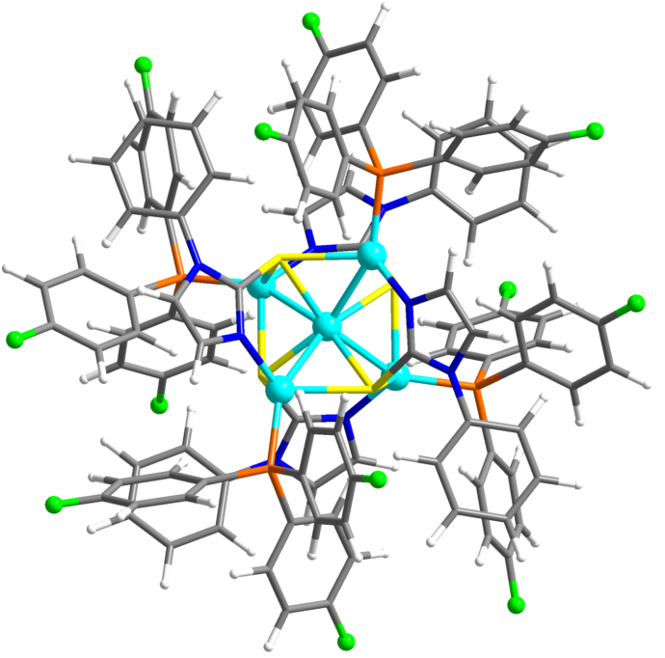

Supplementary Figure 4. DFT-optimized structures of 1. Color codes: Cu, turquoise; S, yellow; P, orange; N, blue; C, grey; H, white.
Supplementary Figure 5. The simulated and experimental optical absorption spectrum of 1.
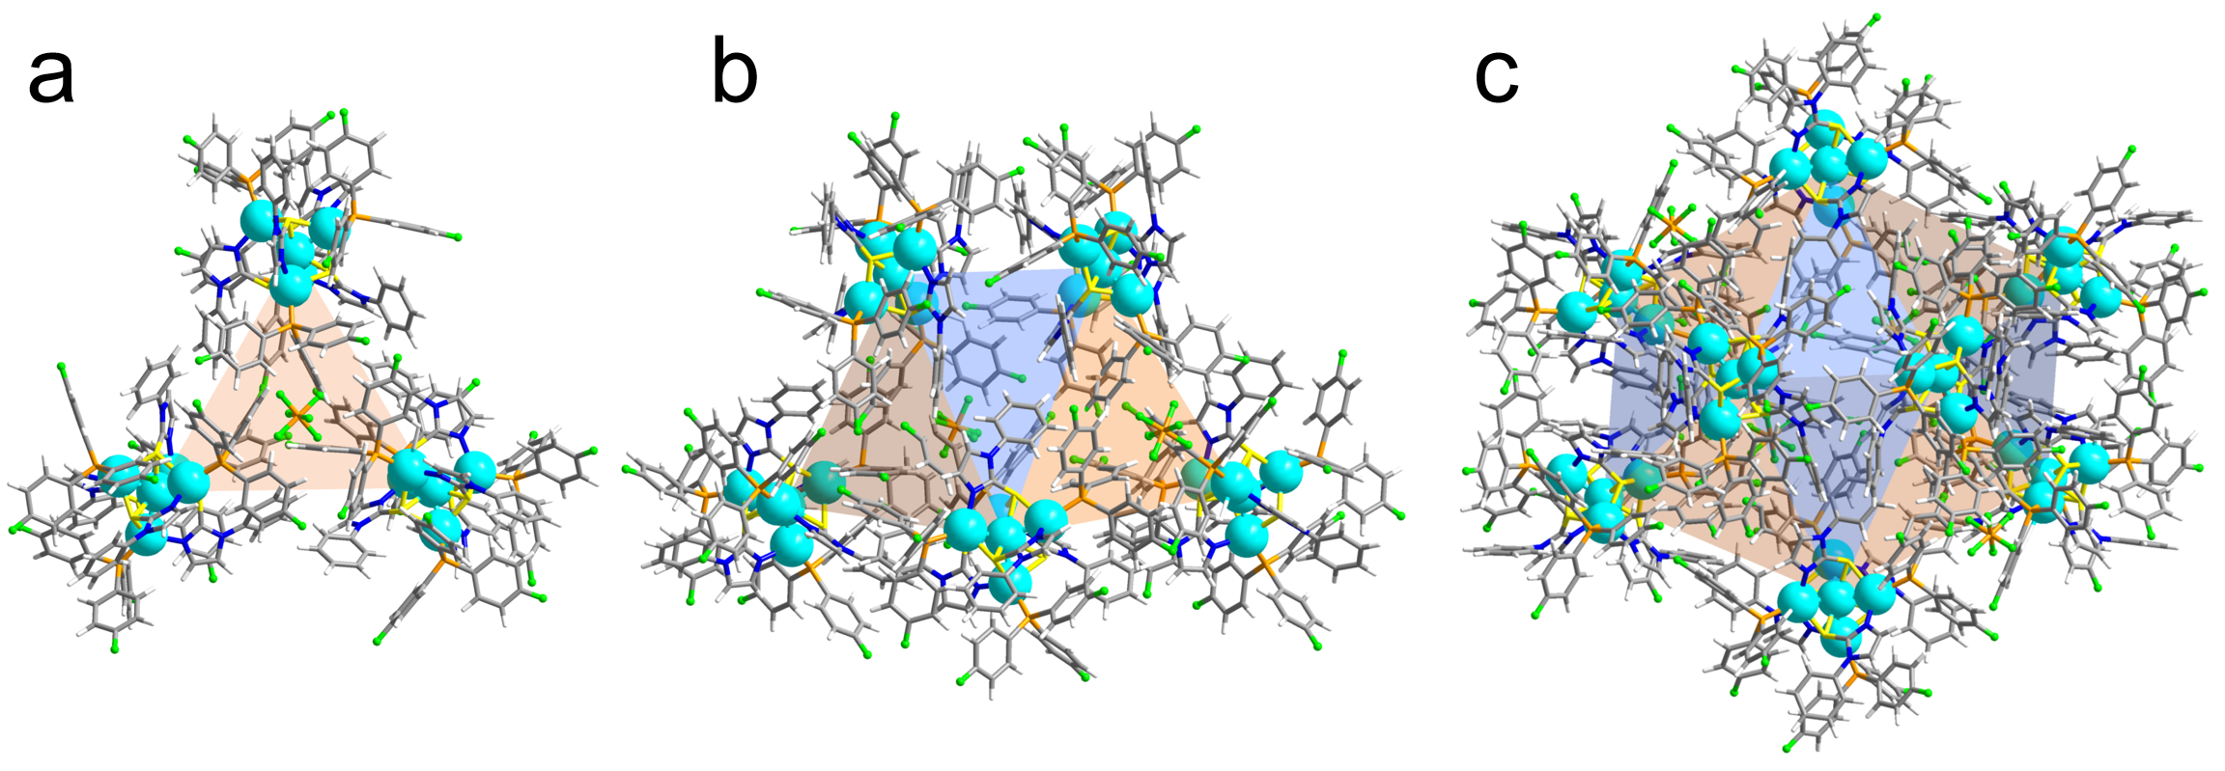
Supplementary Figure 6. The optimized hydrogen-bonded oligomeric structures. a Trimeric {[Cu₅L₄(P(C₆H₄F)₃)₄]₃·PF₆}²⁺. b Pentameric {[Cu₅L₄(P(C₆H₄F)₃)₄]₅·(PF₆)₂}³⁺; c Octameric {[Cu₅L₄(P(C₆H₄F)₃)₄]₈·(PF₆)₄}⁴⁺.
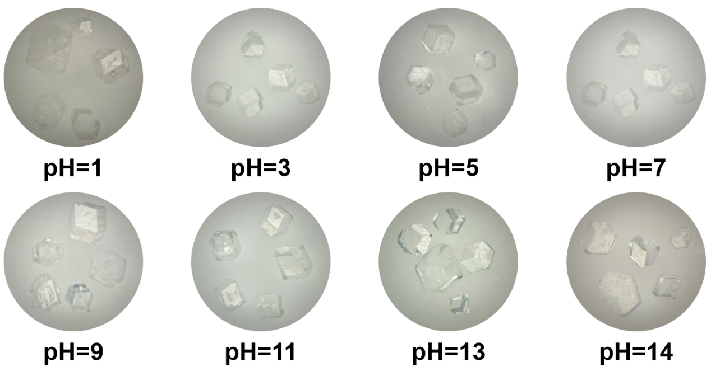
Supplementary Figure 7. Optical microscopy images of crystals 1 after treated with acidic and alkaline solutions (pH = 1-14) for three days.
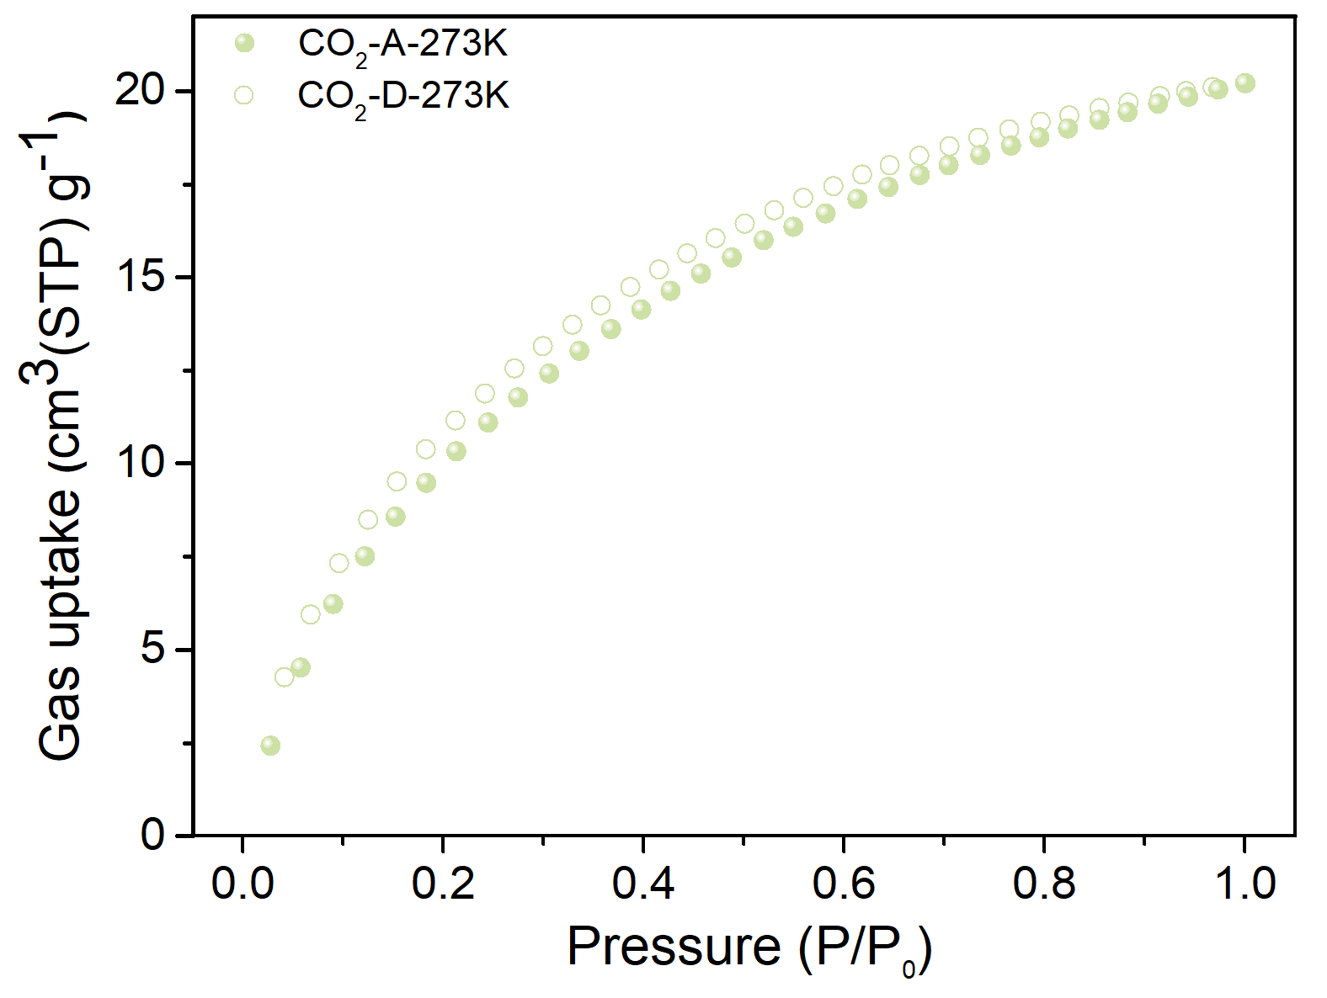
Supplementary Figure 8. CO₂ adsorption-desorption isotherms of 1-d at 273 K.
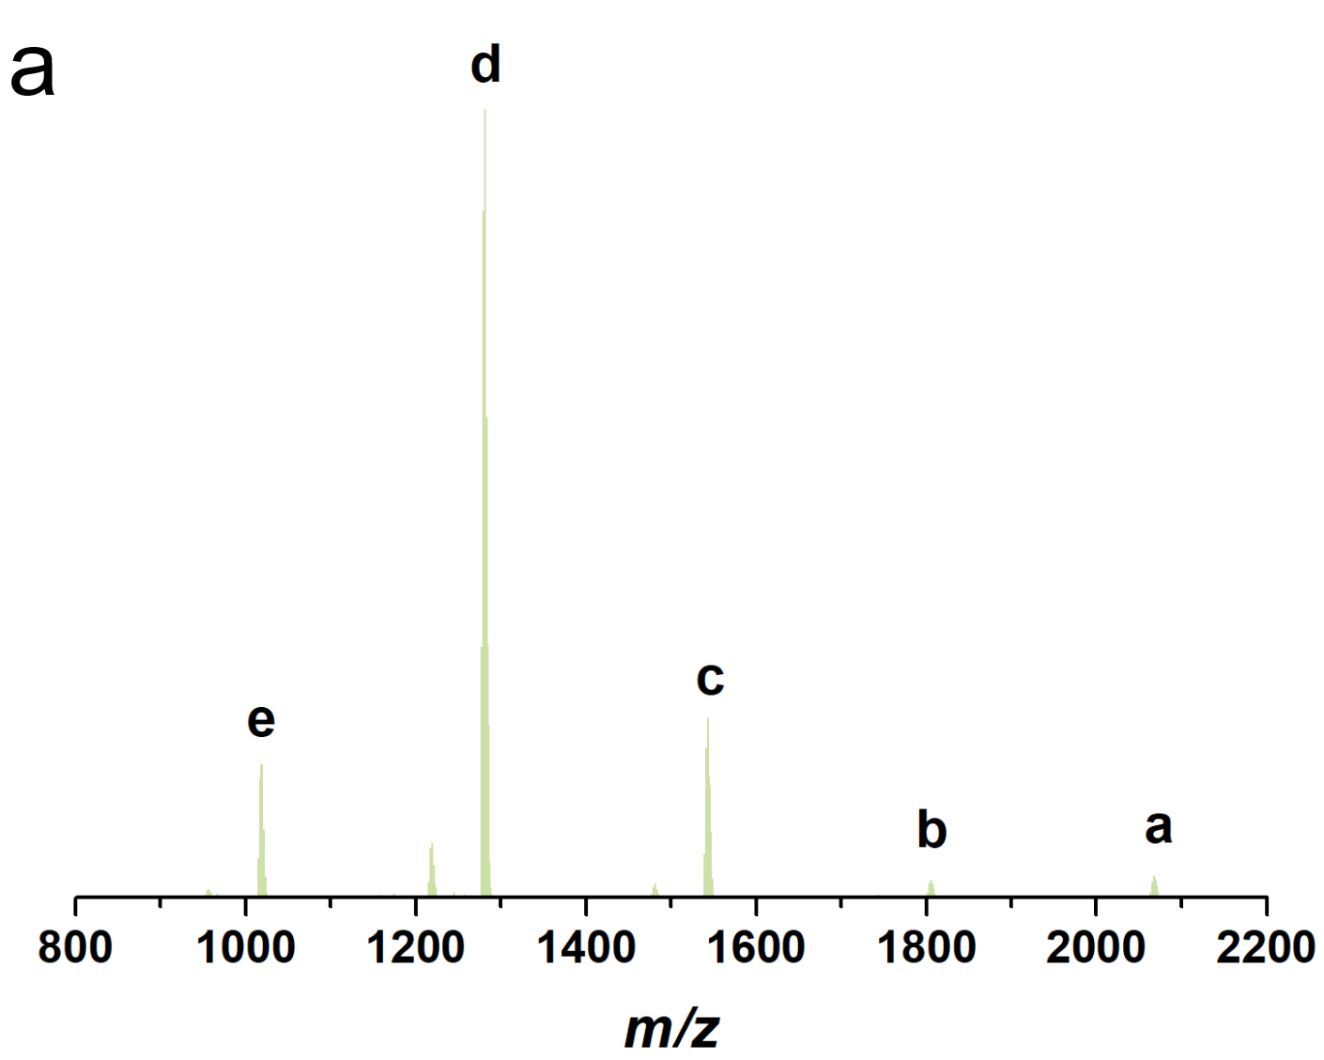
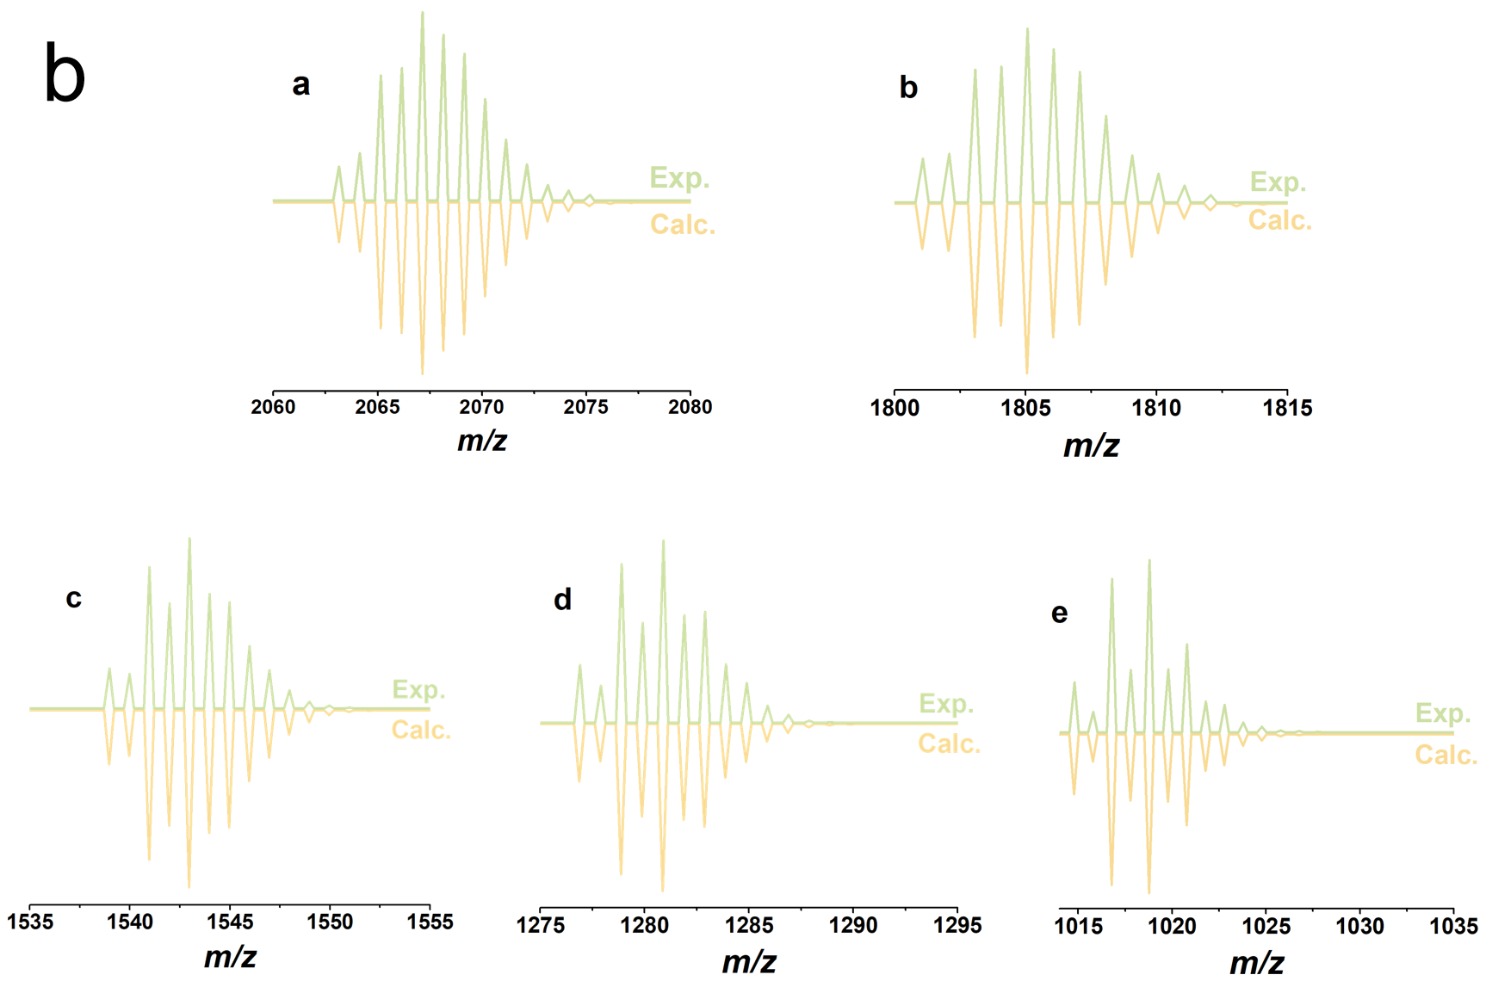
Supplementary Figure 9. a, Positive-ion mode ESI-MS of 2 in CH₂Cl₂; b, Experimental (green) and simulated mass spectrometry (yellow) for species a-e.

species | Assignment | Exp. | Calc.
a | [Cu₅(PPh₃)₄(C₉H₇N₂S)₄]⁺ | 2067.173 | 2067.144
b | [Cu₅(PPh₃)₃(C₉H₇N₂S)₄]⁺ | 1805.078 | 1805.052
c | [Cu₅(PPh₃)₂(C₉H₇N₂S)₄]⁺ | 1542.988 | 1542.960
d | [Cu₅(PPh₃)(C₉H₇N₂S)₄]⁺ | 1280.892 | 1280.868
e | [Cu₅(C₉H₇N₂S)₄]⁺ | 1018.793 | 1018.776
Comments: As displayed in Figure S12, ESI-MS spectrum of 2 dissolved in CH₂Cl₂ shows a peak for the molecular ion [Cu₅(PPh₃)₄(C₉H₇N₂S)₄]⁺ at m/z = 2067.173 (expected m/z = 2067.144) in positive-ion mode, as confirmed by the simulated isotope patterns.

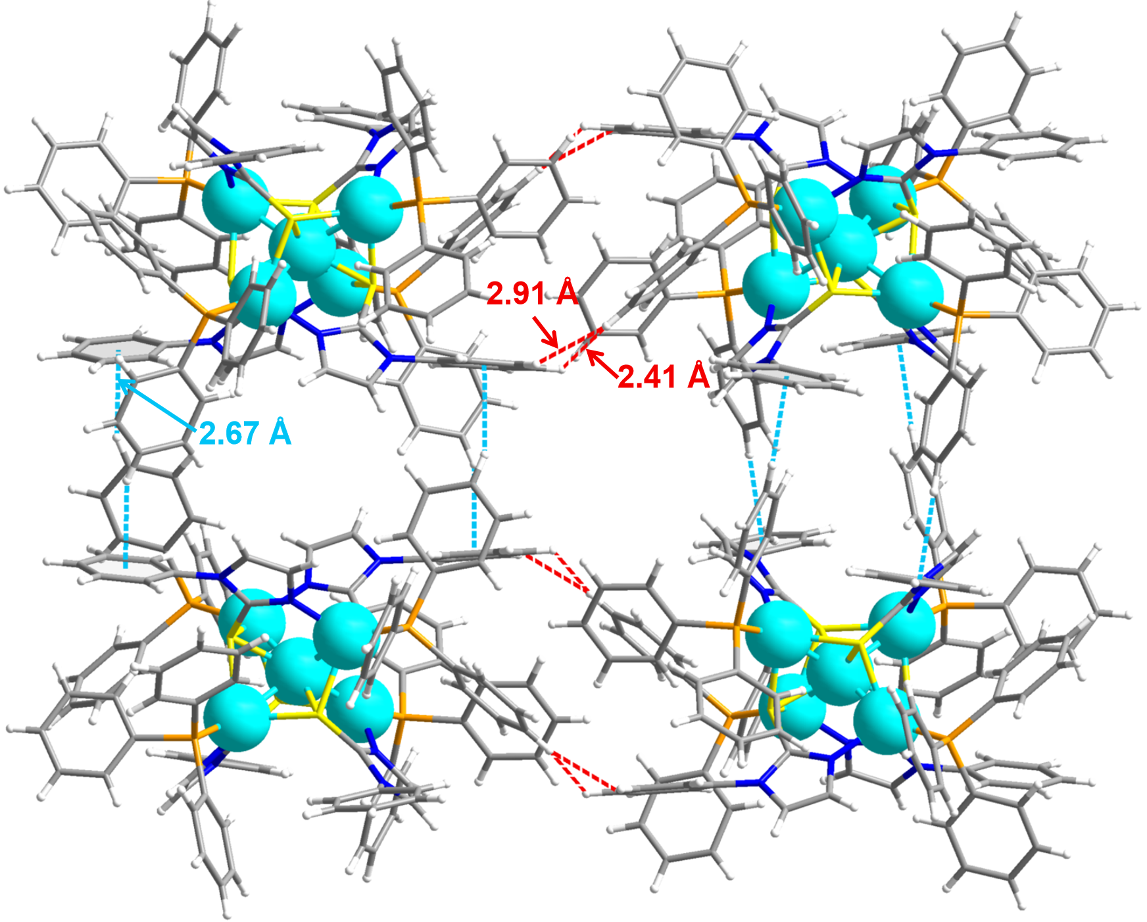
Supplementary Figure 10. Intermolecular noncovalent interactions (C-H···π, blue bonds; H···H, red bonds) among the surface ligands of the 2.
Supplementary Table S1. Crystal data and structure refinement for 1 and 1-d.
Identification code | 1 | 1-d
Empirical formula | C₁₁₀H₇₆Cl_{0.17}Cu₅F₂₂N₈P_{5.33}S₄ | C₁₁₂H₇₆Cu₅F₂₀N₈O₈ P_{5.33}S₄
Formula weight | 2544.81 | 2652.91
Temperature/K | 173(10) | 173.00(10)
Crystal system | cubic | cubic
Space group | P43n | P43n
a/Å | 26.1645(9) | 25.8013(8)
b/Å | 26.1645(9) | 25.8013(8)
c/Å | 26.1645(9) | 25.8013(8)
α/° | 90 | 90
β/° | 90 | 90
γ/° | 90 | 90
Volume/Å³ | 17911.7(18) | 17176.1(16)
Z | 6 | 6
ρ_{calc}g/cm³ | 1.416 | 1.539
μ/mm⁻¹ | 1.103 | 3.207
F(000) | 7691 | 8022
Radiation | Mo Kα(λ= 0.71073) | Cu Kα(λ= 1.54178)
2Θ range for data collection/° | 2.462 to 29.334 | 2.422 to 66.494
Index ranges | -35≤ h ≤ 19, -19≤ k ≤ 16,  -17 ≤ l ≤ 34 | -30≤ h ≤ 21, -29≤ k ≤ 22,  -30 ≤ l ≤ 30
Reflections collected | 19044 | 56321
Independent reflections | 5942[R_{int}=0.0393,  R_{sigma}=0.0467] | 5021[R_{int}=0.0968,  R_{sigma}=0.0443]
Data/restraints/parameters | 5942/0/349 | 5021/444/373
Goodness-of-fit on F² | 1.072 | 1.076
Final R indexes [I>=2σ (I)] | R₁=0.0467,  wR₂=0.1143 | R₁=0.1182,  wR₂=0.2901
Final R indexes [all data] | R₁= 0.0652,  wR₂=0.1271 | R₁= 0.1253,  wR₂=0.2953
Largest diff. peak/hole / e Å⁻³ | 0.931/-0.464 | 0.808/-0.881

Supplementary Table S2. Crystal data and structure refinement for 2.
Identification code | 2
Empirical formula | C₁₁₂H₉₆Cl₈Cu₅F₆N₈P₅S₄
Formula weight | 2552.35
Temperature/K | 173.00(10)
Crystal system | tetragonal
Space group | P4/ncc
a/Å | 22.5084(8)
b/Å | 22.5084(8)
c/Å | 25.0202(14)
α/° | 90
β/° | 90
γ/° | 90
Volume/Å³ | 12675.9(11)
Z | 4
ρ_{calc}g/cm³ | 1.337
μ/mm⁻¹ | 1.178
F(000) | 5192
Radiation | Mo Ka(λ= 0.71073)
2Θ range for data collection/° | 1.862 to 29.492
Index ranges | -26≤ h ≤ 27, -30≤ k ≤ 13, -21 ≤ l ≤ 34
Reflections collected | 31777
Independent reflections | 7795[R_{int}=0.0711,  R_{sigma}=0.0737]
Data/restraints/parameters | 7795/8/336
Goodness-of-fit on F² | 1.053
Final R indexes [I>=2σ (I)] | R₁=0.0560,  wR₂=0.1450
Final R indexes [all data] | R₁= 0.1008,  wR₂=0.1676
Largest diff. peak/hole / e Å⁻³ | 0.597/-0.814

Supplementary Table S3. Emission lifetimes of the crystalline 1 at 365 nm in various temperatures.
Temp. | τ₁(ms) | τ₂(ms) | τ₃(ms) | α₁ | α₂ | α₃ | τ_{average}(ms)
80K | 0.5146 | 3.9525 | 35.393 | 24.25 | 42.96 | 32.79 | 13.4281
110K | 0.5438 | 4.229 | 36.0405 | 24.09 | 41.42 | 34.49 | 14.3130
140K | 0.5064 | 4.4523 | 36.2799 | 26.86 | 39.02 | 34.12 | 14.2520
170K | 0.4373 | 3.4159 | 37.4991 | 25.27 | 35.20 | 39.53 | 16.1363
200K | 0.1601 | 1.5399 | 10.9888 | 22.64 | 37.45 | 39.92 | 4.9997
230K | 13.3449×10⁻³ | 58.4007×10⁻³ | 301.4811×10⁻³ | 38.44 | 34.20 | 27.36 | 107.5880×10⁻³
260K | 2.5843×10⁻³ | 13.1341×10⁻³ | 46.4673×10⁻³ | 41.50 | 43.95 | 14.55 | 13.6059×10⁻³
290K | 2.2153×10⁻³ | 11.2167×10⁻³ | 40.2016×10⁻³ | 41.94 | 53.47 | 4.59 | 8.7719×10⁻³

