Supplementary information for the article:
“Photoinduced Modulation of the Oxidation State of Dibenzothiophene S-Oxide Molecules on an Insulating Substrate”
by M. Hankache, V. Magné, et al.

Table of contents
Supplementary information for the article: “Photoinduced Modulation of the Oxidation State of Dibenzothiophene S-Oxide Molecules on an Insulating Substrate” by M. Hankache, V. Magné, et al. 1
I. On-surface Investigations 2
II. In-solution Investigations 9
1. General methods 9
2. Molecule Synthesis 9
3. Photoreactivity in solution 10
4. NMR spectra 14
III. Crystallographic data 18
References 24

On-surface Investigations

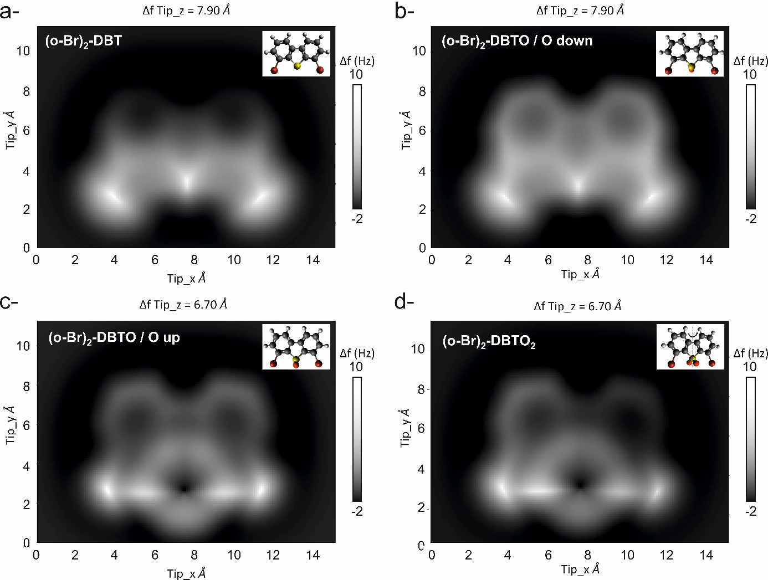
Fig. S1 | Particle probe model of the adsorption configuration of pristine (o-Br)₂-DBTO (images b,c) and deoxygenated (o-Br)₂-DBT (image a) molecules, as well as oxidized (o-Br)₂-DBTO₂ molecule (image d). In solution, the photoreactivity of (o-Br)₂-DBTO molecules results in deoxygenated molecules ((o-Br)₂-DBT, 53% yield) and oxidized structures such as (o-Br)₂-DBTO₂ (8%) and Br₂-OTO (21%), as seen in Fig. 1. The latter Br₂-OTO will not be further investigated since it displays a six-membered ring as central core, which has never been observed experimentally on the surface. To understand how the (o-Br)₂-DBTO molecule is initially adsorbed on the surface, a comparison between experimental images and AFM simulated images of pristine molecules with either oxygen down (image b) or up (image c) was drawn. Alternatively, determining which final product is present on the surface, with respect to the in-solution photoreaction, is possible by comparing experiments with simulated images (a) and (d). The simulated constant height AFM images were obtained using the Probe Particle Model (PPM).^{1,2} A CO-functionalized tip was selected as the type of probe, consistently with the experiments. The four simulated images allow comparisons between three different chemical structures: deoxygenated molecule (o-Br)₂-DBT (a), oxidized molecule (o-Br)₂-DBTO₂ (d) and sulfoxide precursors (o-Br)₂-DBTO with the oxygen atom pointing down (i.e. toward the surface, b) or pointing up (c). The structure and the orientation of each molecule are depicted in the white inset at the top right corner of each image. A small rotation of the structural model for an improved view of the (o-Br)₂-DBTO₂ molecule is indicated by the black arrow in the inset of image (d). The C, H, O, S, and Br atoms are represented by gray, white, red, yellow, and burgundy spheres, respectively. The molecular structures used for PPM simulations (xyz files) were designed and optimized using Avogadro.³ The mean molecular structures are planar to the substrate, and, once imported into PPM, are automatically shifted so that the topmost atom of the compound is positioned with an offset δ= -1.0 Å below zero. Therefore, the displayed simulated images are at different distances. However, the distance between the tip and the carbon backbone of the molecule is always the same. To understand that better, we detail the four configurations (a to d). The carbon scaffold of those compounds being essentially planar, the carbon atoms of compounds a and b (deoxidized (o-Br)₂-DBT and oxidized (o-Br)₂-DBTO with the oxygen pointing towards the sample, respectively) are at nearly equivalent vertical positions which correspond to the topmost position within the molecule. Corresponding PPM simulations are performed at an arbitrary, but similar, height of z = 7.9 Å, i.e. 8.9 Å above the carbon scaffold of each compound. Conversely, the topmost atoms in compounds c and d (oxidized (o-Br)₂-DBTO with the oxygen pointing upwards and (o-Br)₂-DBTO₂, respectively) are oxygen atoms, which are 1.2 Å above the mean carbon scaffold. Thus, to have a consistent 8.9 Å distance to the carbon scaffold the PPM simulations are performed at a height z = 8.9 Å - 1.2 Å + δ= 6.7 Å.
PPM simulations show that models (a) and (b) have a quite similar contrast. Models (c) and (d) have a quite similar contrast too, but significantly different compared to models (a) and (b). A notable repulsive contrast around the oxygen due to the significant oxygen-oxygen repulsion present in both the molecule and the tip now occurs. Upon comparing the simulated and experimental models (see Fig. S3b), the model with the oxygen down matches well the experimental images before illumination, indicating that the (o-Br)₂-DBTO molecule is initially adsorbed with its oxygen facing the surface. Following illumination, model (a) was identified on the surface, whereas model (d) was never observed. This indicates that, in the present case, the photoreaction on the surface only results in deoxygenation, thus yielding (o-Br)₂-DBT as a product.

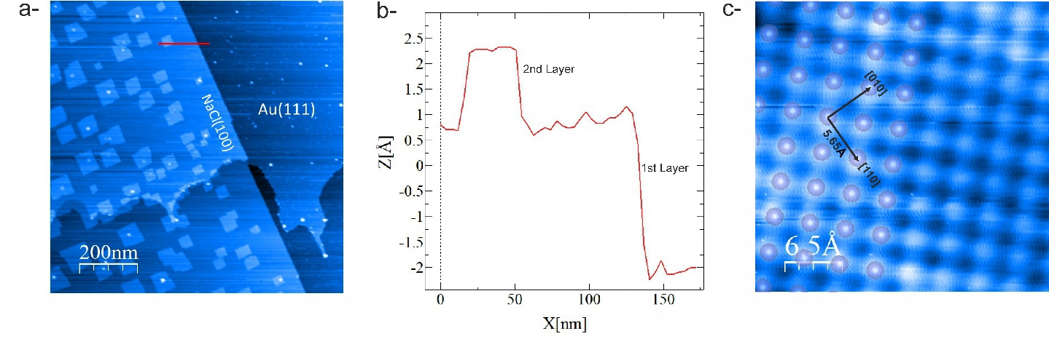Fig. S2 | Surface investigation following the deposition of NaCl thin layers on Au(111). a, Large-scale STM image after the deposition of ∼ 1 ML of NaCl onto Au(111) held at 450 K. The initial NaCl(100) layer exhibits a nearly carpet-like growth, followed by the formation of the second and third layers, as small rectangular islands. Tunneling parameters are I_{t}= 12 pA and V_{b}= -1.2 V. b, The red curve represents the height profile extracted from (a). This profile indicates that the first NaCl layer has an apparent height of ∼2.7 Å, lower than its physical height (2.82 Å), whereas the apparent height of the second rectangular layer corresponds to roughly ∼1.8 Å. This is well-known with this type of surface and results from the increase of the tunnel barrier.⁴ c, Atomically resolved STM image of the NaCl first layer on Au(111). The ionic structure's cations are overlaid as purple spheres. Tunneling parameters are I_{t}= 10 pA and V_{b}= 2.1 V.

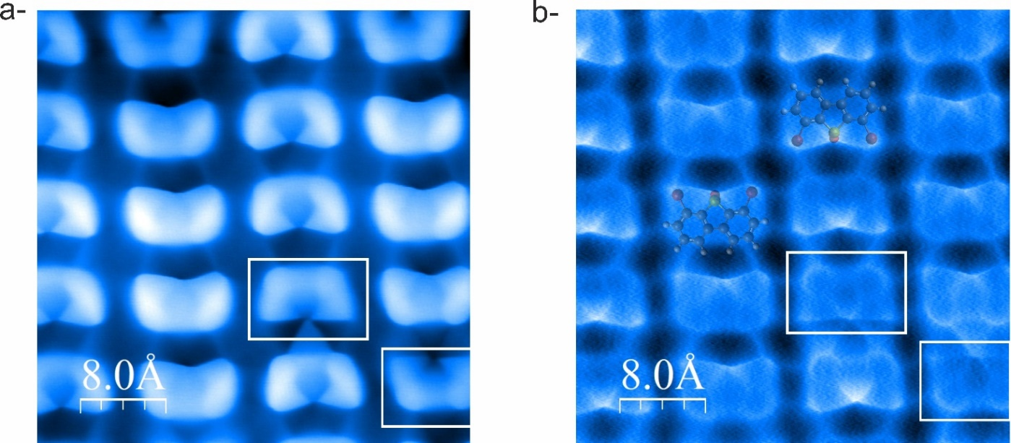
Fig. S3 | Dynamic STM observation. (<I_{t}>= 9.4 pA; V_{b}= 1.5 V and A= 150 pm) a, A typical dynamic STM image of the molecules on NaCl thin layers following UVA irradiation. The image shows 4 columns of molecules where at least two molecules are already deoxygenated and depicted by the white frames. b, Corresponding recorded map of frequency shift variation. Two structural models of (o-Br)₂-DBTO molecules, in two opposite orientations, are shown to be precisely matched with the contrast. A small change in the contrast around the sulfur atom is observed as the molecules flatten out on the surface due to deoxygenation, as shown in the white frames.

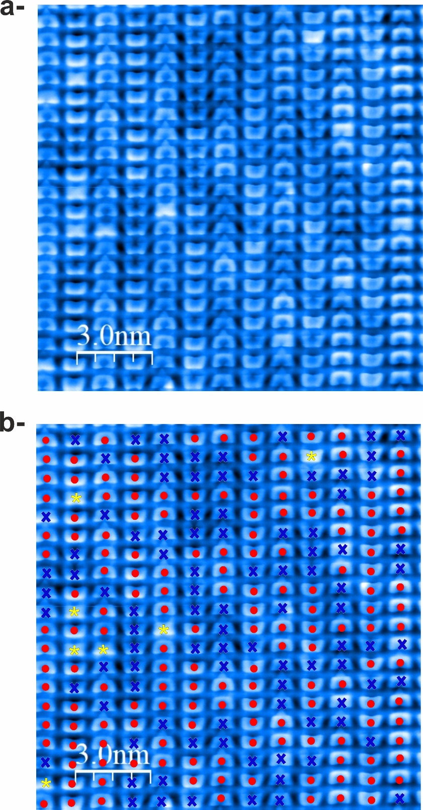
Fig. S4 | Statistical analysis following 190 minutes of UV irradiation. A total of 260 molecules exposed to UV irradiation (280 nm) underwent statistical analysis. a, High-resolution dynamic STM image with a CO-functionalized tip showing the molecules: <I_{t}>= 9.4 pA; V_{b}= 1.5 V and A= 150 pm. b, •, x and * symbols were used on the same image to denote the various molecular structures and/or configurations. The pristine (croissant-shaped) (o-Br)₂-DBTO molecules, which make up 60.7% of the total, are marked with the red • symbol. The deoxygenated (butterfly-shaped) (o-Br)₂-DBT molecules, of which there are 36.5%, are marked with the blue x symbol. Lastly, the yellow * represents a class of molecules that were present before illumination and have a different contrast, most probably due to a defect in either the NaCl thin film or the underlying substrate.
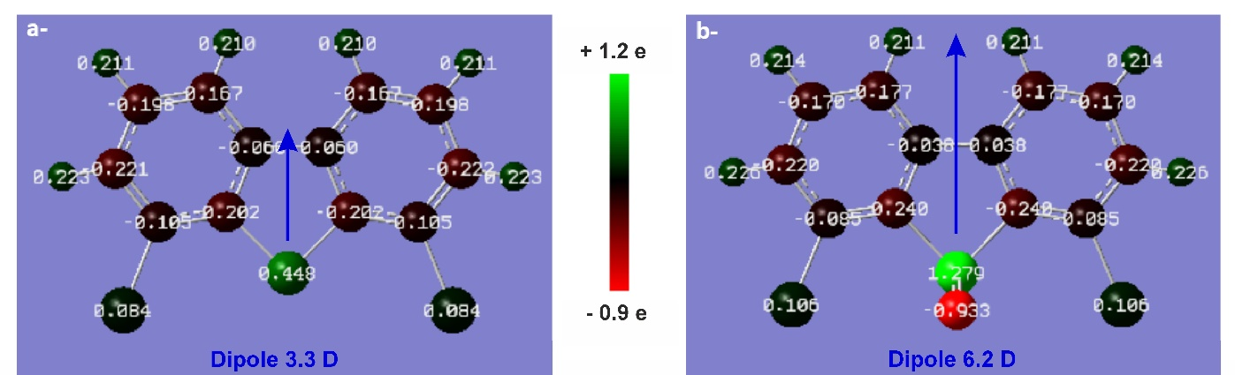Fig. S5 | Density functional theory (DFT) calculations of charge distribution for (a) the deoxygenated molecule (o-Br)₂-DBT, and (b) the pristine molecule (o-Br)₂-DBTO. Natural Bond Orbital (NBO) analysis method was performed. The charge distribution scale ranges from red (negative) to green (positive). Calculations show that the sulfur atom of the deoxygenated (o-Br)₂-DBT molecule (a) bears a less positive charge than the sulfur atom of the pristine form (o-Br)₂-DBTO (b), in line with the change in sulfur oxidation state. The blue arrows indicate the dipole moment of each molecule: 3.3 D for (o-Br)₂-DBT molecule compared to 6.2 D for (o-Br)₂-DBTO molecule.

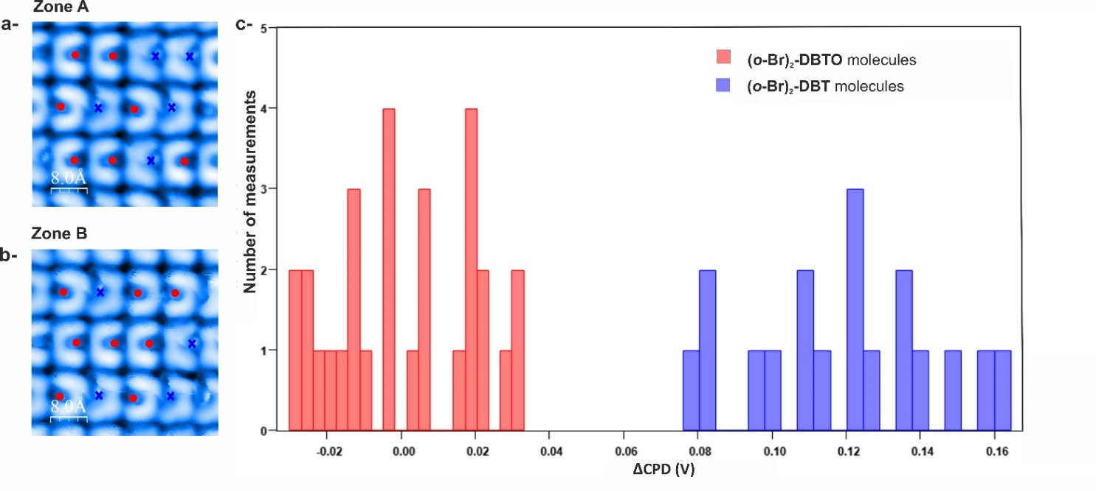Fig. S6 | Bias Spectroscopy study carried out on a total of 24 molecules (2 measurements per molecule). The molecules are divided into two groups: Zone A (a) and Zone B (b). Zone A contains 7 pristine (o-Br)₂-DBTO molecules (depicted by the red • symbol) and 5 deoxygenated (o-Br)₂-DBT ones (depicted by the blue x symbol), while Zone B presents 8 pristine (o-Br)₂-DBTO molecules and 4 deoxygenated (o-Br)₂-DBT ones. Bias spectroscopy measurements were performed above the sulfur atom of each molecule. For every molecule, two ∆f(V) curves were acquired. In order to ensure that the molecules did not shift positions, STM pictures were captured both before and after each set of four curves. After collecting the data, a parabolic fit is obtained, and the LCPD is determined by the highest point of each curve. The LCPD values of pristine molecules are then averaged separately for each line and used as a reference (0). This step was necessary because maintaining consistent tip conditions for every line proved challenging and had small impact on the quantitative values of ∆f* measured between the series of four curves. For this reason, not all lines have the same ∆f* values, but a higher LCPD for deoxygenated molecules than for pristine ones was consistently observed. Finally, the ∆CPD is calculated for each Bias spectroscopy measurement regarding the reference value. The results are displayed in the histogram of image (c).

In-solution Investigations

General methods
Reagents and Solvents
4,6-Dibromodibenzo[b,d]thiophene was purchased from BLD-Pharm and used directly without further purification. Technical grade solvents and reagents were purchased from commercial suppliers and used without further purification. The concentration of the m-chloroperbenzoic acid (mCPBA) batch indicated by the supplier was ≤77%. Dichloromethane (DCM) was dried by passing over two columns of activated alumina, kept over activated 4Å molecular sieves, and degassed by thorough argon sparging. All water was deionized before use. ‘Room temperature’ (RT) can vary between 18 °C and 25 °C. Irradiation of (o-Br)₂-DBTO solution was carried using two 15W UVA fluorescent tubes from Vilber-Lourmat.
Analysis and Characterization
Analytical Thin Layer Chromatography (TLC) was performed on Merck aluminium-backed silica gel 60 F254 plates. Developed TLC plates were visualized by ultraviolet (UV) irradiation (254 nm). Column chromatography was carried out using Merck silica gel 60 Å, 220 - 440 mesh. Fourier Transform Infrared Spectrometry (FTIR) was carried out using a ThermoNicolet 6700 with an Attenuated Total Reflection (ATR) attachment and peaks are reported in terms of frequency of absorption (cm⁻¹). High Resolution Mass Spectrometry HRMS were acquired using a GCT Premier CAB109 TOF mass spectrometer equipped with DCI-CH₄ ionization. HRMS data were quoted to four decimal places (0.1 mDa). All NMR spectra were recorded on either a Bruker AV 300 or Bruker AV 500 and are internally referenced to residual solvent signals (CDCl₃ is referenced at δ 7.26 and 77.16 for ¹H and ¹³C NMR, respectively). All NMR chemical shifts (δ) were reported in parts per million (ppm) and coupling constants (J) are given in Hertz (Hz). The ¹H NMR spectra are reported as follows: δ (multiplicity, coupling constant J, number of protons).

Molecule Synthesis

4,6-dibromodibenzo[b,d]thiophene 5-oxide; (o-Br)₂-DBTO:
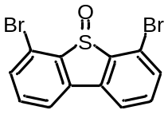
A solution of 4,6-dibromodibenzo[b,d]thiophene (1.03 g, 3.0 mmol, 1 equiv.) in dry DCM (20 mL) in a round bottom flask was cooled to -30 °C. BF₃.OEt₂ (3.0 mL, 24 mmol, 8 equiv.) was added dropwise and stirred for 10 minutes. A suspension of mCPBA (741 mg, 3.3 mmol, 1.1 equiv.) in DCM (5 mL) was then added dropwise. The cool bath was removed and the slurry reaction medium was stirred at room temperature for 24 hours. Aqueous NaOH (1M, 50 mL) and DCM (25 mL) were added, after vigorous stirring both phases were separated and the aqueous fraction was extracted once with DCM (25 mL). Combined organic phases were dried using Na₂SO₄, filtered (rinsing the solids with hot DCM thrice) and the volatiles were removed under vacuum. The crude reaction mixture was then dissolved in a minimum amount of boiling dichloromethane, colorless crystals (420 mg) were obtained upon cooling and standing at room temperature overnight. A second crop of crystals (210 mg) could be obtained from further recrystallization of the filtrate using boiling dichloromethane. Repeating this operation provided a third crop (60 mg). Overall yield: 690 mg, 1.93 mmol, 64%.
¹H NMR (CDCl₃, 300 MHz) δ_{H}7.71 (dd, J = 7.6, 0.9 Hz, 2H), 7.61 (dd, J = 8.0, 0.9 Hz, 2H), 7.46 (app. t, J = 7.8 Hz, 2H). ¹³C{¹H} NMR (75 MHz, CDCl₃) δc 144.4, 139.3, 134.3, 133.8, 123.3, 121.3. HRMS (DCI-CH₄) Calc’d for C₁₂H₇OS [M+H]⁺ 356.8584, found 356.8588. FTIR (neat) νmax/cm⁻¹ 3055, 2993, 1575, 1557, 1462, 1421, 1105, 1044, 1032, 1025, 787. Crystal data: see section III. of the SI.

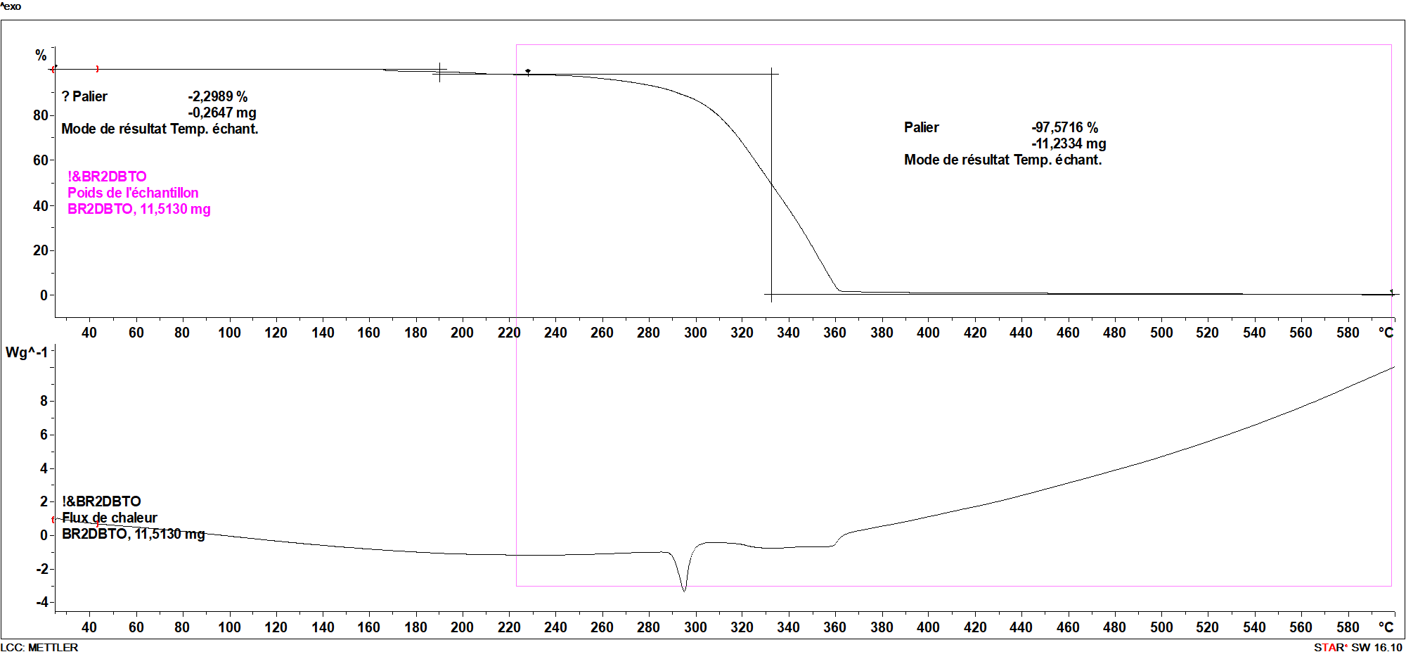
Fig. S7 | Thermogravimetric analysis of (o-Br)₂-DBTO (N₂ atmosphere, ramp from 25 to 600 °C, 10 °C/min)

Photoreactivity in solution

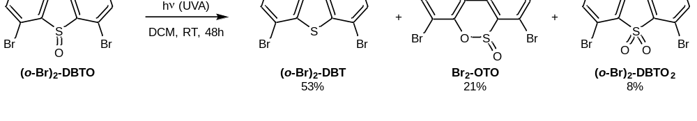
The in-solution irradiation study was carried out as follows:
(o-Br)₂-DBTO (35.8 mg, 0.1 mmol) was dissolved in dry and degassed DCM (10 mL) under an inert atmosphere in a quartz Schlenk. The solution was then irradiated at room temperature using a UVA fluorescent tube (see Fig. S9 for the lamp emission spectrum) for 48 hours at which point TLC analysis showed complete conversion. The volatiles were removed in vacuo and the crude mixture was then purified over silica gel chromatography (gradient from 0 to 50% DCM: Pentane) yielding successively the following products:
Fraction 1: 4,6-dibromodibenzo[b,d]thiophene; (o-Br)₂-DBT (18 mg, 0.053 mmol, 53%). White amorphous solid. Rf: 0.9, 50/50 DCM/Pentane. ¹H NMR (CDCl₃, 300 MHz) δ_{H} 8.07 (dd, J = 7.9, 0.9 Hz, 2H), 7.65 (dd, J = 7.7, 0.9 Hz, 2H), 7.38 (app. t, J = 7.8 Hz, 2H). Data consistent with commercial sample.

Fraction 2: 4,7-dibromodibenzo[c,e][1,2]oxathiine 6-oxide; Br₂-OTO (8 mg, 0.021 mmol, 21%). Colorless solid. Rf: 0.55, 50/50 DCM/Pentane. ¹H NMR (CDCl₃, 300 MHz) δ_{H} 7.96 (dd, J = 7.9, 1.1 Hz, 1H), 7.90 (dd, J = 8.0, 1.4 Hz, 1H), 7.73 (dd, J = 8.0, 1.4 Hz, 1H), 7.68 (dd, J = 8.0, 1.0 Hz, 1H), 7.56 (app. t, J = 7.9 Hz, 1H), 7.23 (app. t, J = 7.9 Hz, 1H). ¹³C{¹H} NMR (151 MHz, CDCl₃) δ_{c} 142.2, 137.7, 135.0, 133.7, 133.3, 129.6, 126.4, 124.2, 124.2, 122.0, 121.3, 116.2. HRMS (DCI-CH₄) Calc’d for C₁₂H₇O₂S [M+H]⁺ 372.8533, found 372.8531. FTIR (neat) νmax/cm⁻¹ 3077, 2927, 1544, 1438, 1383, 1200, 1139, 1126, 1111, 1076, 1049, 1035, 845, 778, 717, 685. Crystal data: Crystals suitable for X-ray diffraction were obtained by diffusion of pentane in a chloroform solution of the titled compound; see section III. of the SI.

Fraction 3: 4,6-dibromodibenzo[b,d]thiophene 5,5-dioxide; (o-Br)₂-DBTO₂ (3 mg, 0.008 mmol, 8%). Colorless solid. Rf: 0.25, 50/50 DCM/Pentane. ¹H NMR (CDCl₃, 600 MHz) δ_{H} 7.72 (dd, J = 7.7, 0.8 Hz, 2H), 7.65 (dd, J = 8.0, 0.8 Hz, 2H), 7.49 (app. t, J = 7.8 Hz, 2H). ¹³C{¹H} NMR (151 MHz, CDCl₃) δ_{c} 136.9, 135.0, 134.9, 113.1, 120.4, 117.7. HRMS (DCI-CH₄) Calc’d for C₁₂H₇O₂S [M+H]⁺ 372.8533, found 372.8531. FTIR (neat) νmax/cm⁻¹ 3085, 3076, 1578, 1564, 1426, 1312, 1162, 780, 748, 664, 593. Crystal data: Crystals suitable for X-ray diffraction were obtained by slow cooling of a saturated hot solution of the titled compound in an ethanol/chloroform mixture; see section III. of the SI. Data consistent with a sample prepared from 4,6-dibromodibenzo[b,d]thiophene mixed with 3 equivalents of mCPBA.

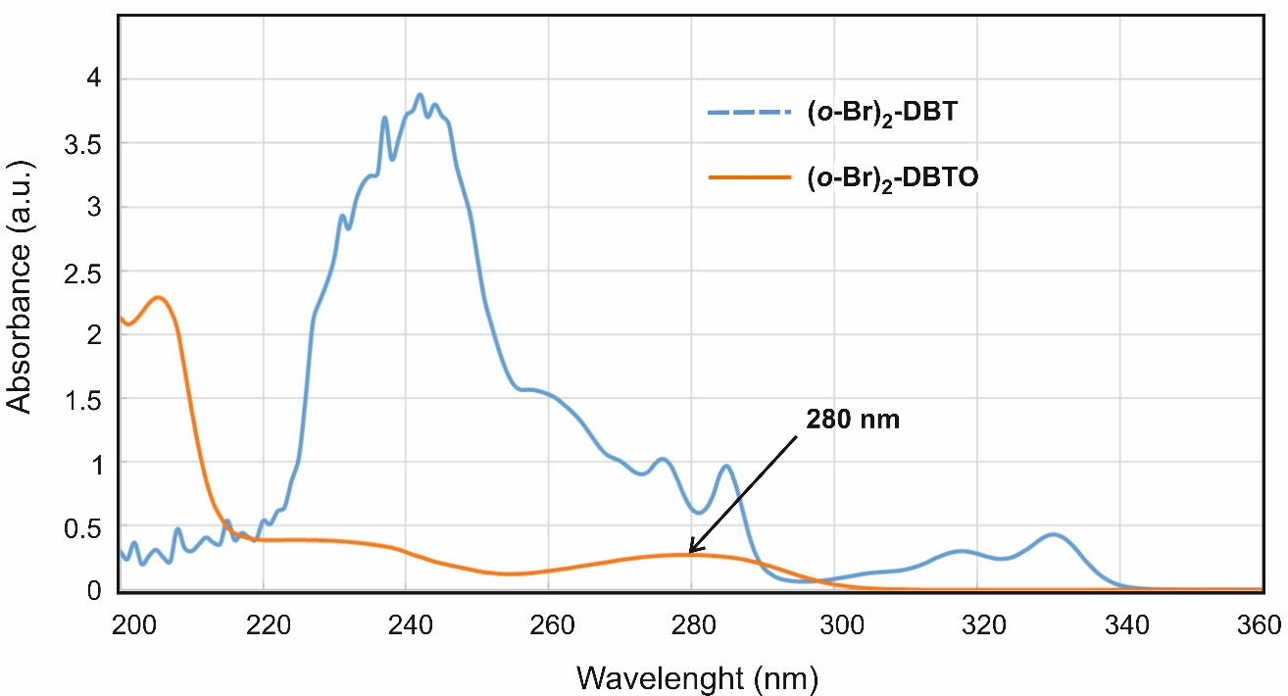
a-
b-
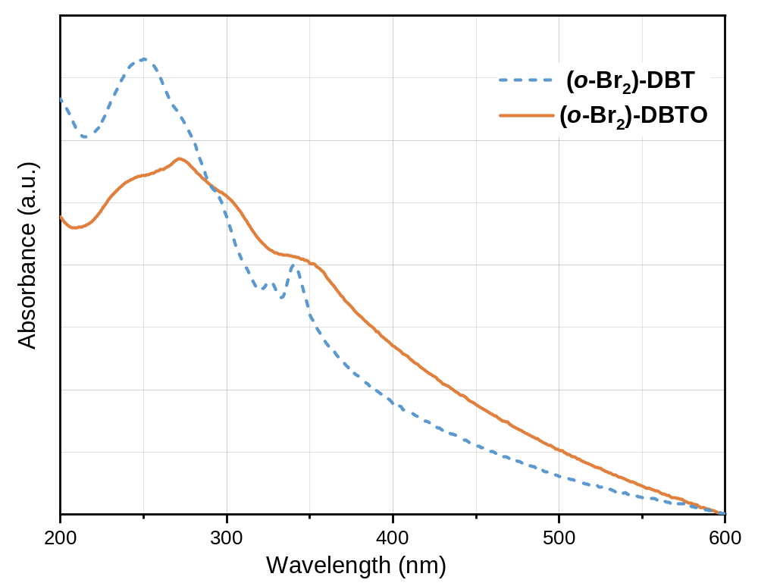
Fig. S8 | Absorption spectra of (o-Br)₂-DBTO and (o-Br)₂-DBT in solution (a) and in the solid state (b). a, The UV-vis optical absorption spectrum of (o-Br)₂-DBTO (orange, solid curve) in dichloromethane (DCM) solution (10⁻³ M) displays a wide absorption band peaking at 280 nm. For the deoxygenated counterpart (o-Br)₂-DBT, the optical absorption spectrum (blue, dotted curve) in DCM (10⁻⁴ M) shows a main peak around 240 nm, with several peaks of lower intensity at λ_{max} = 277, 285, 318 and 332 nm. b, Thin films of (o-Br)₂-DBTO and (o-Br)₂-DBT were obtained by spin coating of 0.1M CHCl₃ solutions on quartz plates.
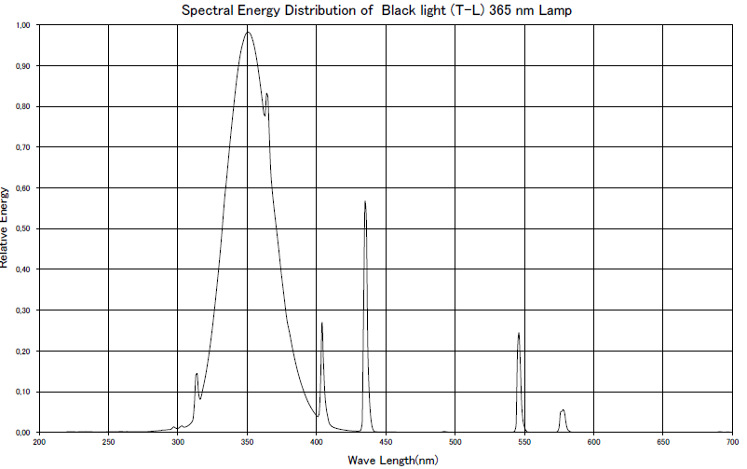
Fig. S9 | Emission spectrum of the UVA fluorescent tube used for in-solution photodeoxygenation reactions.

NMR spectra
a) 4,6-dibromodibenzo[b,d]thiophene 5-oxide; (o-Br)₂-DBTO:
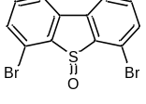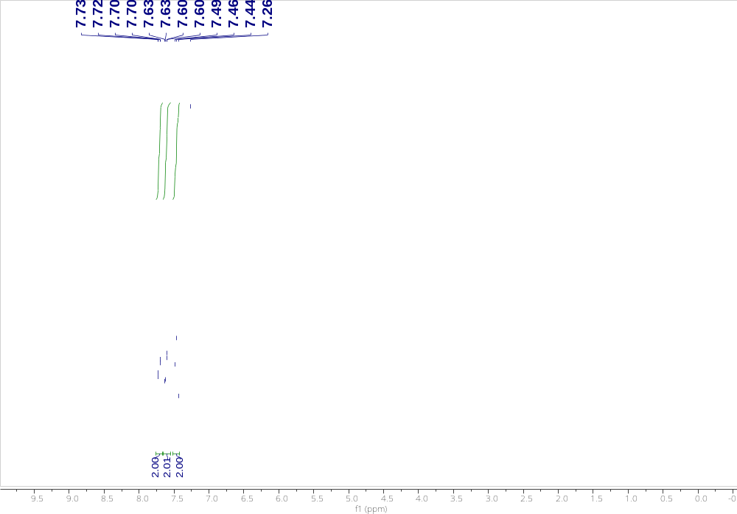
Fig. S10 | ¹H NMR spectrum of (o-Br)₂-DBTO (300 MHz, CDCl₃).
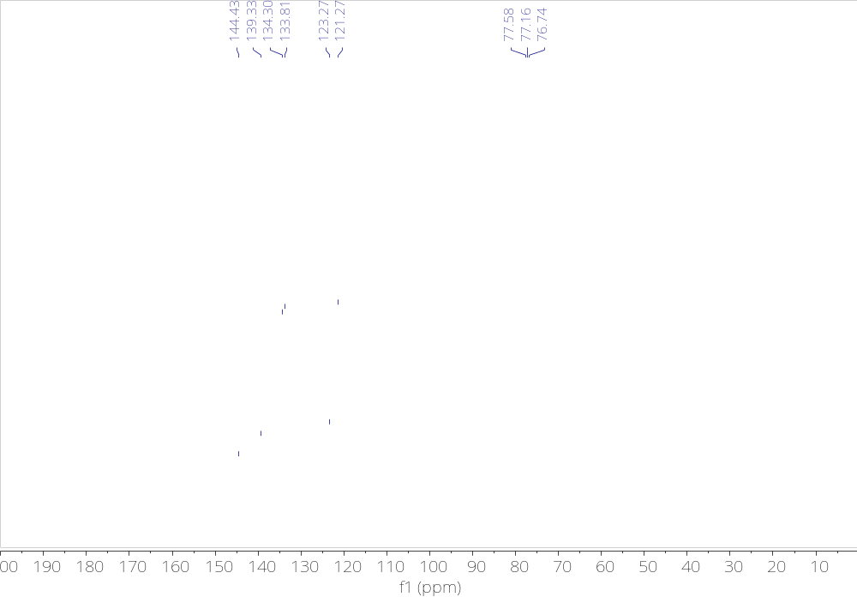
Fig. S11 | ¹³C{¹H} NMR spectrum of (o-Br)₂-DBTO (75 MHz, CDCl₃).
b) 4,6-dibromodibenzo[b,d]thiophene; (o-Br)₂-DBT:
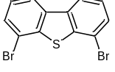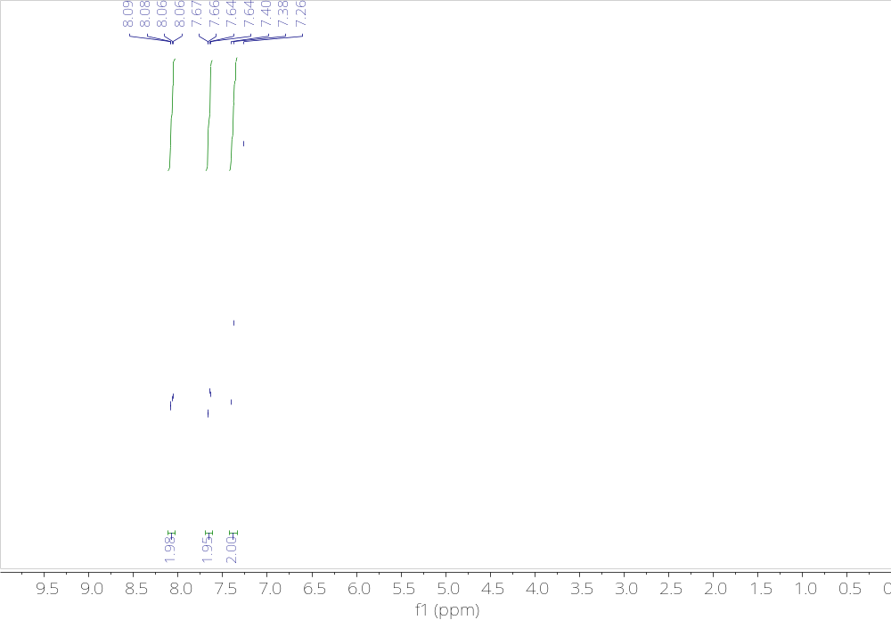
Fig. S12 | ¹H NMR spectrum of (o-Br)₂-DBT (300 MHz, CDCl₃).

c) 4,7-dibromodibenzo[c,e][1,2]oxathiine 6-oxide; Br₂-OTO:
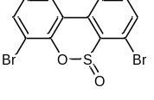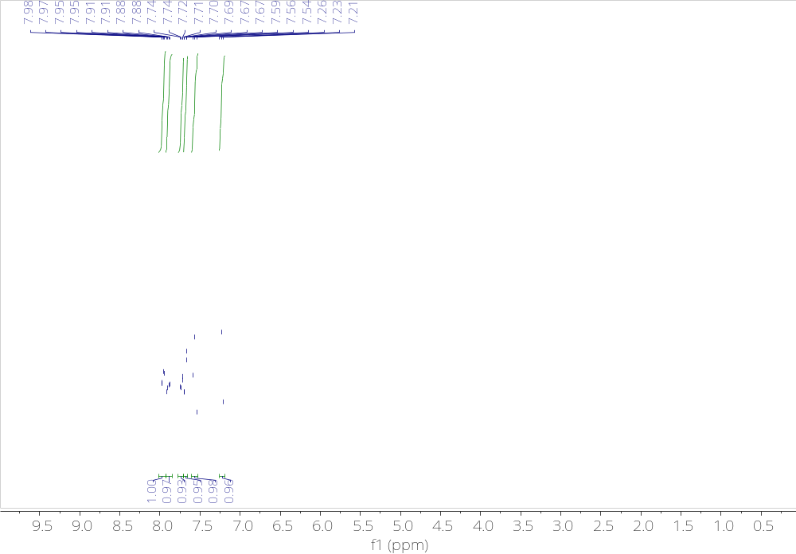
Fig. S13 | ¹H NMR spectrum of Br₂-OTO (300 MHz, CDCl₃).

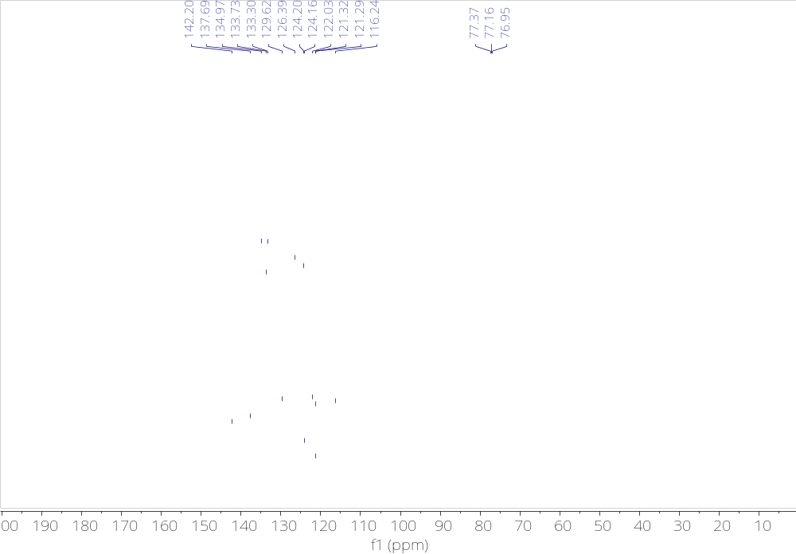
Fig. S14 | ¹³C{¹H} NMR spectrum of Br₂-OTO (151 MHz, CDCl₃).
d) 4,6-dibromodibenzo[b,d]thiophene 5,5-dioxide; (o-Br)₂-DBTO₂:
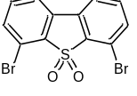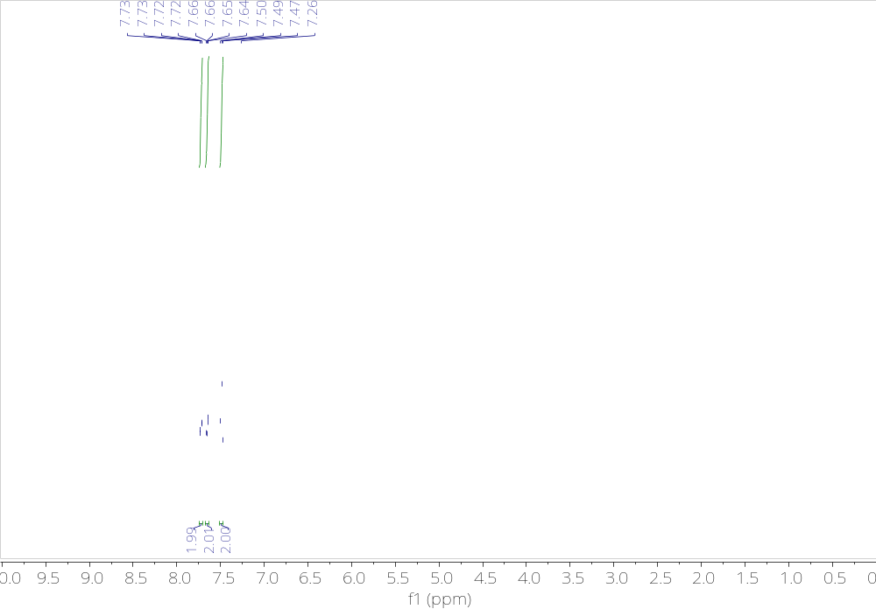
Fig. S15 | ¹H NMR spectrum of (o-Br)₂-DBTO₂ (600 MHz, CDCl₃).

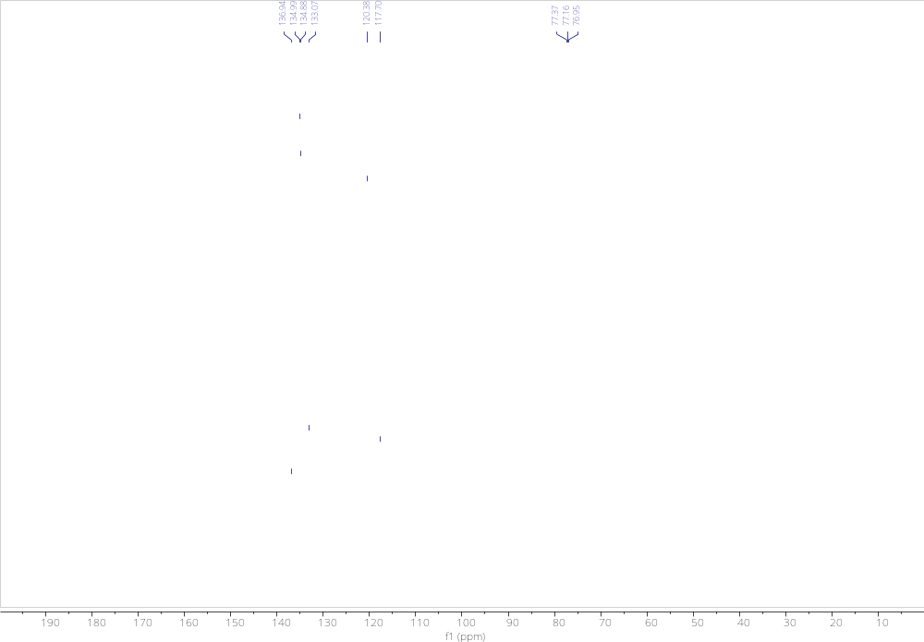
Fig. S16 | ¹³C{¹H} NMR spectrum of (o-Br)₂-DBTO₂ (151 MHz, CDCl₃).

Crystallographic data

Single-crystal X-ray data were collected at low temperature (193(2)K) on a Bruker APEX II Quazar diffractometer equipped with a 30W air-cooled microfocus source ((o-Br)₂-DBTO) or on a Bruker D8 VENTURE diffractometer equipped with a PHOTON III detector (Br₂-OTO and (o-Br)₂-DBTO₂), using MoKα radiation (λ= 0.71037 Å). The structures were solved by intrinsic phasing method⁵ and refined by full-matrix least-squares method on F². ⁶ All non-H atoms were refined with anisotropic displacement parameters and all the hydrogen atoms were refined isotropically at calculated positions using a riding model.

X-ray data for (o-Br)₂-DBTO
CCDC-2366290 contains the supplementary crystallographic data for this compound. These data can be obtained free of charge from The Cambridge Crystallographic Data Centre via https://www.ccdc.cam.ac.uk/structures.
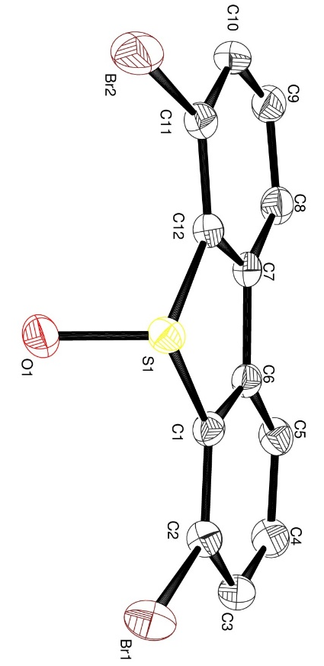
Fig. S17 | Asymmetric Unit

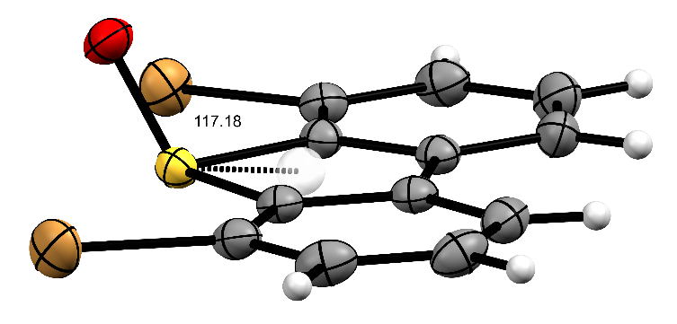
Fig. S18 | Pov-Ray image with ellipsoids at 50% probability showing the 117° angle between the SO bond and the aromatic core of (o-Br)₂-DBTO.

Table S1 | Crystal data and structure refinement for (o-Br)₂-DBTO.

Identification code (o-Br)₂-DBTO
Empirical formula C12 H6 Br2 O S
Formula weight 358.05
Temperature 193(2) K
Wavelength 0.71073 A
Crystal system, space group Monoclinic, P 21/n
Unit cell dimensions a = 7.6547(4) A alpha = 90 deg.
b = 8.0798(4) A beta = 95.204(3) deg.
c = 18.3175(11) A gamma = 90 deg.
Volume 1128.24(11) A^3
Z, Calculated density 4, 2.108 Mg/m^3
Absorption coefficient 7.341 mm^-1
F(000) 688
Crystal size 0.200 x 0.160 x 0.100 mm
Theta range for data collection 2.801 to 29.627 deg.
Limiting indices -10<=h<=10, -11<=k<=10, -25<=l<=24
Reflections collected / unique 15090 / 3176 [R(int) = 0.0292]
Completeness to theta = 25.242 99.9 %
Refinement method Full-matrix least-squares on F^2
Data / restraints / parameters 3176 / 0 / 145
Goodness-of-fit on F^2 1.026
Final R indices [I>2sigma(I)] R1 = 0.0222, wR2 = 0.0492
R indices (all data) R1 = 0.0294, wR2 = 0.0512
Largest diff. peak and hole 0.379 and -0.495 e.A^-3

Table S2 | Atomic coordinates (x 10^4) and equivalent isotropic displacement parameters (A^2 x 10^3) for (o-Br)₂-DBTO.

U(eq) is defined as one third of the trace of the orthogonalized Uij tensor.

x y z U(eq)
Br(1) 1084(1) 3914(1) 2810(1) 31(1)
Br(2) 1657(1) 8117(1) 5906(1) 36(1)
C(1) 3766(2) 5649(2) 3672(1) 19(1)
C(2) 3374(2) 4739(2) 3042(1) 23(1)
C(3) 4676(3) 4417(2) 2577(1) 27(1)
C(4) 6347(2) 5008(3) 2762(1) 30(1)
C(5) 6784(2) 5912(2) 3401(1) 25(1)
C(6) 5473(2) 6225(2) 3858(1) 20(1)
C(7) 5616(2) 7119(2) 4560(1) 21(1)
C(8) 7086(2) 7855(2) 4921(1) 26(1)
C(9) 6903(3) 8683(2) 5575(1) 29(1)
C(10) 5306(3) 8755(2) 5876(1) 29(1)
C(11) 3852(2) 7993(2) 5515(1) 24(1)
C(12) 4002(2) 7191(2) 4861(1) 20(1)
O(1) 989(2) 7444(2) 3996(1) 27(1)
S(1) 2240(1) 6172(1) 4323(1) 20(1)
X-ray data for Br₂-OTO
CCDC-2366291 contains the supplementary crystallographic data for this compound. These data can be obtained free of charge from The Cambridge Crystallographic Data Centre via https://www.ccdc.cam.ac.uk/structures.

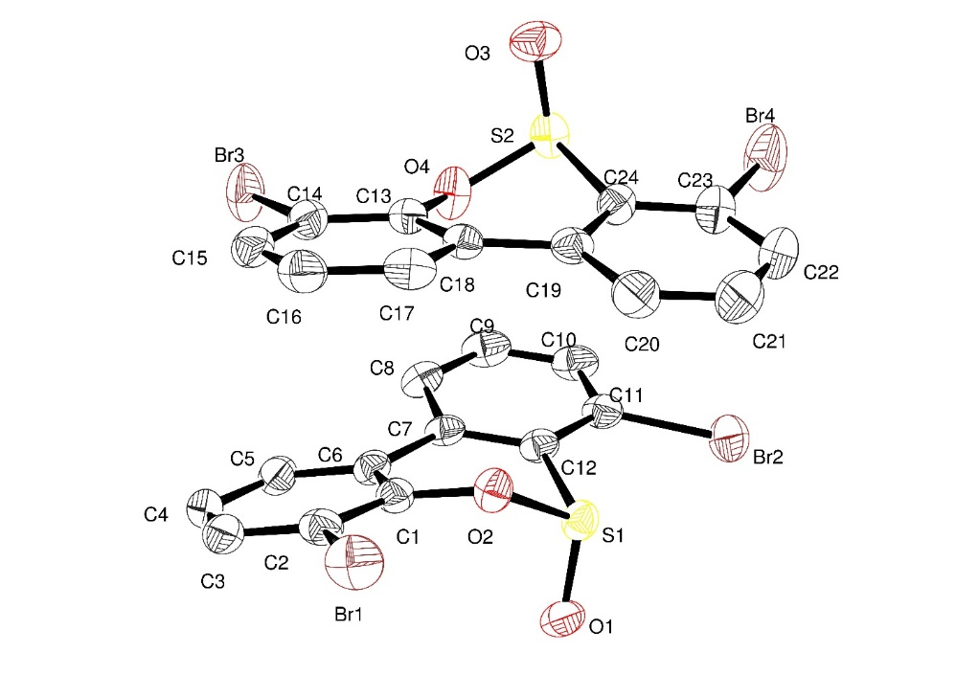
Fig. S19 | Asymmetric unit

Table S3 | Crystal data and structure refinement for Br₂-OTO

Identification code Br₂-OTO
Empirical formula C12 H6 Br2 O2 S
Formula weight 374.05
Temperature 193(2) K
Wavelength 0.71073 A
Crystal system, space group Monoclinic, P 21/c
Unit cell dimensions a = 14.908(6) A alpha = 90 deg.
b = 14.778(9) A beta = 109.731(10) deg.
c = 11.443(4) A gamma = 90 deg.
Volume 2373.1(18) A^3
Z, Calculated density 8, 2.094 Mg/m^3
Absorption coefficient 6.991 mm^-1
F(000) 1440
Crystal size 0.160 x 0.080 x 0.060 mm
Theta range for data collection 2.757 to 25.938 deg.
Limiting indices -18<=h<=18, -18<=k<=18, -14<=l<=12
Reflections collected / unique 41559 / 4603 [R(int) = 0.0582]
Completeness to theta = 25.242 99.9 %
Refinement method Full-matrix least-squares on F^2
Data / restraints / parameters 4603 / 0 / 307
Goodness-of-fit on F^2 1.033
Final R indices [I>2sigma(I)] R1 = 0.0325, wR2 = 0.0754
R indices (all data) R1 = 0.0453, wR2 = 0.0817
Largest diff. peak and hole 1.388 and -1.064 e.A^-3

Table S4 | Atomic coordinates (x 10^4) and equivalent isotropic displacement parameters (A^2 x 10^3) for Br₂-OTO.

U(eq) is defined as one third of the trace of the orthogonalized Uij tensor.

x y z U(eq)
Br(1) 8004(1) 4089(1) 3155(1) 45(1)
Br(2) 8494(1) 3230(1) 9877(1) 46(1)
Br(3) 7312(1) 7962(1) 6510(1) 52(1)
Br(4) 5938(1) 4196(1) 10021(1) 69(1)
C(1) 8608(3) 4833(2) 5594(3) 28(1)
C(2) 8593(3) 4958(3) 4387(3) 31(1)
C(3) 8998(3) 5716(3) 4080(4) 37(1)
C(4) 9411(3) 6361(3) 4976(4) 37(1)
C(5) 9396(3) 6257(3) 6171(4) 34(1)
C(6) 8984(3) 5487(2) 6502(3) 28(1)
C(7) 8912(2) 5369(2) 7751(3) 27(1)
C(8) 8991(3) 6104(3) 8552(3) 34(1)
C(9) 8910(3) 5981(3) 9706(4) 41(1)
C(10) 8741(3) 5136(3) 10105(4) 40(1)
C(11) 8661(3) 4406(3) 9318(3) 33(1)
C(12) 8736(3) 4517(2) 8151(3) 28(1)
C(13) 6618(3) 6155(2) 6343(3) 28(1)
C(14) 6842(3) 6861(3) 5692(4) 33(1)
C(15) 6752(3) 6760(3) 4462(4) 38(1)
C(16) 6419(3) 5946(3) 3873(4) 39(1)
C(17) 6206(3) 5238(3) 4525(4) 36(1)
C(18) 6311(2) 5320(2) 5779(3) 28(1)
C(19) 6162(3) 4561(2) 6521(3) 30(1)
C(20) 6073(3) 3668(3) 6090(4) 43(1)
C(21) 5931(4) 2970(3) 6792(5) 52(1)
C(22) 5882(3) 3115(3) 7955(5) 50(1)
C(23) 5987(3) 3984(3) 8409(4) 41(1)
C(24) 6114(3) 4703(2) 7703(3) 31(1)
O(1) 9679(2) 3320(2) 7370(2) 36(1)
O(2) 8194(2) 4049(2) 5854(2) 31(1)
O(3) 5104(2) 6150(2) 7637(3) 44(1)
O(4) 6761(2) 6294(2) 7605(2) 37(1)
S(1) 8685(1) 3540(1) 7210(1) 30(1)
S(2) 6075(1) 5827(1) 8274(1) 35(1)

X-ray data for (o-Br)₂-DBTO₂
CCDC-2366292 contains the supplementary crystallographic data for this compound. These data can be obtained free of charge from The Cambridge Crystallographic Data Centre via https://www.ccdc.cam.ac.uk/structures.
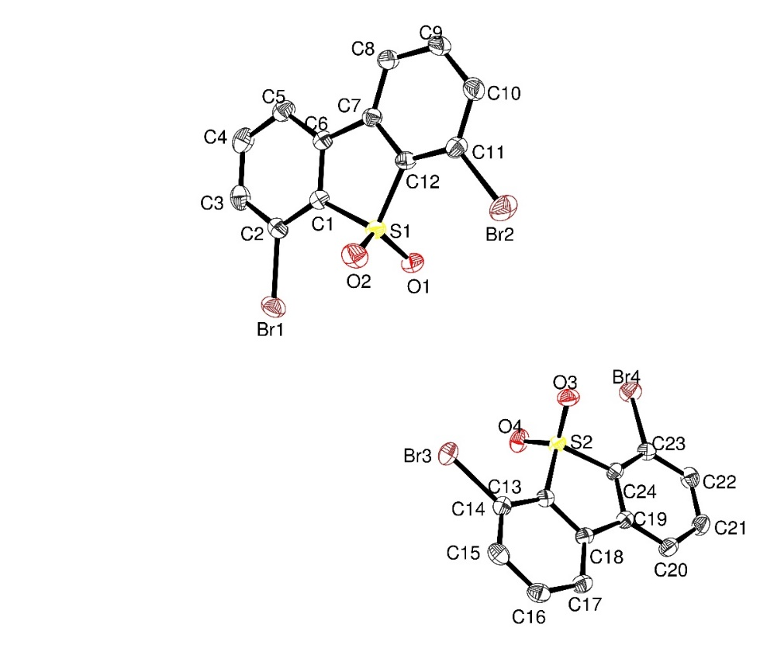
Fig. S20 | Asymmetric unit

Table S5 | Crystal data and structure refinement for (o-Br)₂-DBTO₂.

Identification code (o-Br)₂-DBTO₂
Empirical formula C12 H6 Br2 O2 S
Formula weight 374.05
Temperature 193(2) K
Wavelength 0.71073 A
Crystal system, space group Triclinic, P -1
Unit cell dimensions a = 7.7340(9) A alpha = 116.240(4) deg.
b = 12.7252(16) A beta = 99.561(5) deg.
c = 13.8282(18) A gamma = 97.142(5) deg.
Volume 1173.2(3) A^3
Z, Calculated density 4, 2.118 Mg/m^3
Absorption coefficient 7.071 mm^-1
F(000) 720
Crystal size 0.180 x 0.080 x 0.020 mm
Theta range for data collection 2.740 to 33.224 deg.
Limiting indices -11<=h<=11, -19<=k<=19, -21<=l<=21
Reflections collected / unique 47884 / 8940 [R(int) = 0.0525]
Completeness to theta = 25.242 99.9 %
Refinement method Full-matrix least-squares on F^2
Data / restraints / parameters 8940 / 0 / 307
Goodness-of-fit on F^2 1.002
Final R indices [I>2sigma(I)] R1 = 0.0308, wR2 = 0.0632
R indices (all data) R1 = 0.0547, wR2 = 0.0710
Largest diff. peak and hole 0.454 and -0.846 e.A^-3

Table S6 | Atomic coordinates (x 10^4) and equivalent isotropic displacement parameters (A^2 x 10^3) for (o-Br)₂-DBTO₂.

U(eq) is defined as one third of the trace of the orthogonalized Uij tensor.

x y z U(eq)
C(1) -184(3) 1516(2) 4492(2) 21(1)
C(2) -414(3) 285(2) 3830(2) 24(1)
C(3) -2145(3) -424(2) 3339(2) 29(1)
C(4) -3603(3) 93(2) 3526(2) 31(1)
C(5) -3388(3) 1321(2) 4193(2) 28(1)
C(6) -1659(3) 2043(2) 4677(2) 22(1)
C(7) -1120(3) 3358(2) 5386(2) 21(1)
C(8) -2235(3) 4157(2) 5731(2) 27(1)
C(9) -1461(3) 5384(2) 6375(2) 30(1)
C(10) 394(3) 5811(2) 6681(2) 30(1)
C(11) 1501(3) 5014(2) 6348(2) 25(1)
C(12) 740(3) 3798(2) 5703(2) 21(1)
C(13) 9439(3) 1886(2) 494(2) 21(1)
C(14) 9282(3) 1276(2) 1100(2) 22(1)
C(15) 10828(3) 1112(2) 1635(2) 28(1)
C(16) 12494(3) 1550(2) 1546(2) 28(1)
C(17) 12663(3) 2158(2) 928(2) 26(1)
C(18) 11118(2) 2327(2) 401(2) 21(1)
C(19) 10989(3) 2953(2) -282(2) 21(1)
C(20) 12392(3) 3506(2) -524(2) 27(1)
C(21) 11995(3) 4060(2) -1176(2) 31(1)
C(22) 10234(3) 4048(2) -1601(2) 28(1)
C(23) 8823(3) 3469(2) -1382(2) 24(1)
C(24) 9214(3) 2941(2) -713(2) 21(1)
Br(1) 1585(1) -417(1) 3593(1) 33(1)
Br(2) 4018(1) 5589(1) 6773(1) 40(1)
Br(3) 7015(1) 686(1) 1234(1) 31(1)
Br(4) 6424(1) 3348(1) -2057(1) 34(1)
O(1) 2808(2) 2701(1) 4399(1) 29(1)
O(2) 2872(2) 2489(2) 6082(1) 33(1)
O(3) 6814(2) 3033(1) 466(1) 29(1)
O(4) 6570(2) 1105(1) -1185(1) 30(1)
S(1) 1872(1) 2614(1) 5183(1) 22(1)
S(2) 7683(1) 2196(1) -268(1) 21(1)

References

1. Hapala, P., Temirov, R., Tautz, F. S. & Jelínek, P. Origin of high-resolution IETS-STM images of organic molecules with functionalized tips. Phys. Rev. Lett. 113, 226101 (2014).
2. Hapala, P. et al. Mechanism of high-resolution STM/AFM imaging with functionalized tips. Phys. Rev. B 90, 085421 (2014).
3. Hanwell, M. D. et al. Open Access Avogadro: An Advanced Semantic Chemical Editor, Visualization, and Analysis Platform. J. Cheminf. vol. 4 http://www.jcheminf.com/content/4/1/17 (2012).
4. Sun, X., Felicissimo, M. P., Rudolf, P. & Silly, F. NaCl multi-layer islands grown on Au(111)-(22 × √3) probed by scanning tunneling microscopy. Nanotechnology 19, 495307 (2008).
5. ShelXT, G. M. Sheldrick, University of Göttingen, Acta Crystallogr. Sect. A, 71, 3-8 (2015).
6. ShelXL, G. M. Sheldrick, University of Göttingen, Acta Crystallogr. Sect. C 71, 3-8 (2015).

