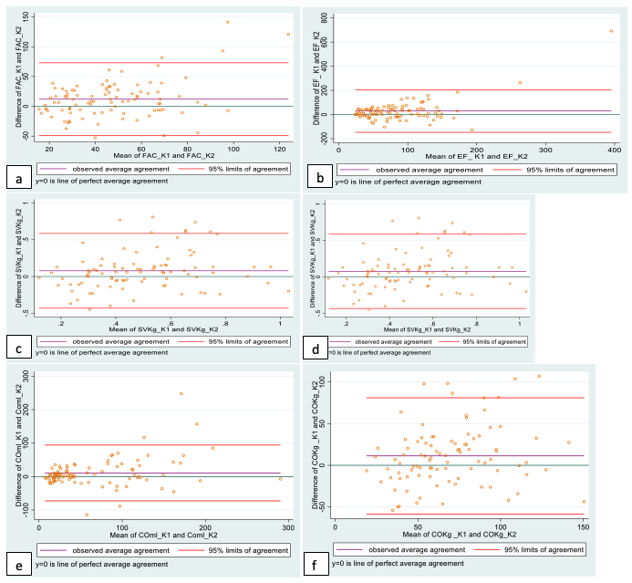

Supplementary Information Figure 1: Bland-Altman plots for Operator 1 repeatability

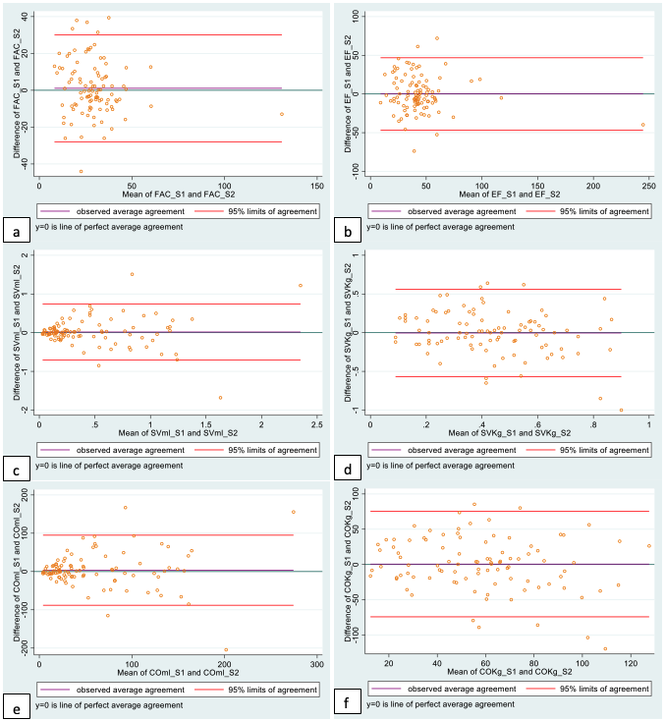

Supplementary Information Figure 2: Bland-Altman plots for Operator 2 repeatability

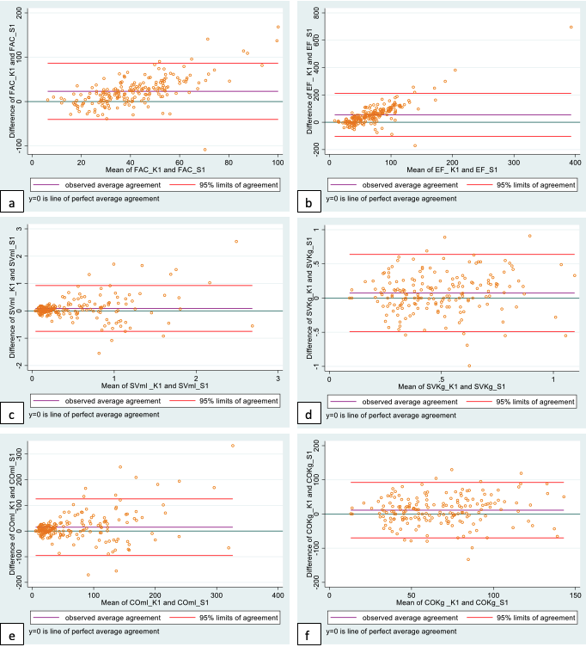

Supplementary Information Figure 3: Bland-Altman plots for Operator 1 vs Operator 2 reproducibility

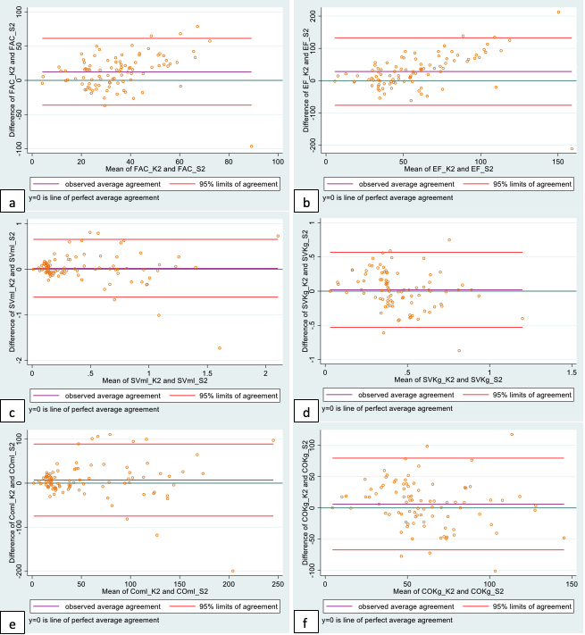

Supplementary Information Figure 4: Bland-Altman plots for Operator 2 vs Operator 1 reproducibility

