Supplementary Information

Association between type 2 diabetes mellitus complications and NAFLD: Insights from the NHANES 2017-2020 and Mendelian randomization study

Running title: Association between type 2 diabetes complications and NAFLD

Sizhe Wan^{1,2†}, Mingkai Li^{1,2†}, Sicun Lu^{1,2}, Zhiyong Zhai^{1,2}, Yuankai Wu^{3*}, Wei Gong^{1,2*}

¹ Department of Gastroenterology, The Shenzhen Hospital of Southern Medical University, Shenzhen, Guangdong, China
² The Third School of Clinical Medicine of Southern Medical University, Shenzhen, Guangdong, China
³ Department of Infectious Diseases, The Third Affiliated Hospital of Sun Yat-sen University
† SW, ML, and SL contributed equally to this study.

Table of contents

Supplementary figures and legends 3
Supplementary Figure 1. 3
Supplementary tables 4
Supplementary Table 1. Details of the GWASs included in the mendelian randomization. 4
Supplementary Table 2. Details of the SNPs included in the discovery group. 5
Supplementary Table 3. Details of the SNPs included in the validation group. 5

Supplementary figures and legends

Supplementary Figure 1.
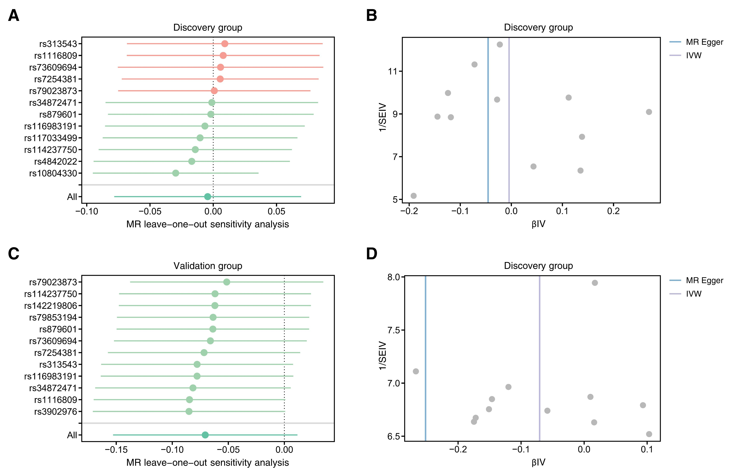
Supplementary Figure 1. MR analysis of T2DM-related kidney disease and NAFLD.
In the discovery group, the leave-one-out analysis in Mendelian randomization of T2DM-related kidney disease and NAFLD showed that no SNP had a significant effect on the outcome (A). Funnel plots for T2DM-related kidney disease and NAFLD are shown (B). In the validation group, the leave-one-out analysis in mendelian randomization of T2DM-related kidney disease and NAFLD showed that no SNP had a significant effect on the outcome (C). Funnel plots for T2DM-related kidney disease and NAFLD are shown (D).

Supplementary tables

Supplementary Table 1. Details of the GWASs included in the mendelian randomization.

Phenotype | Exposure/  Outcome | Ancestry | Sample  size | Number of SNPs
T2DM-related kidney disease | Exposure | European | 1,296 cases and  183,185 controls | 16,380,337
NAFLD | Outcome  (Discovery) | European | 2,568 cases and  409,613 controls | 19,682,629
NAFLD | Outcome  (Validation) | European | 4,761 cases and  373,227 controls | 9,097,254
T2DM, Type 2 diabetes mellitus; NAFLD, Non-alcoholic fatty liver disease

Supplementary Table 2. Details of the SNPs included in the discovery group.

Supplementary Table 3. Details of the SNPs included in the validation group.

